Supplementary Figures and Tables for
The Buffer Value of Trade: Quantifying How Global Integration Stabilizes Food Prices and Farm Incomes

Overview
This Supplementary Information includes Figures D1-4 and Tables D1-3.

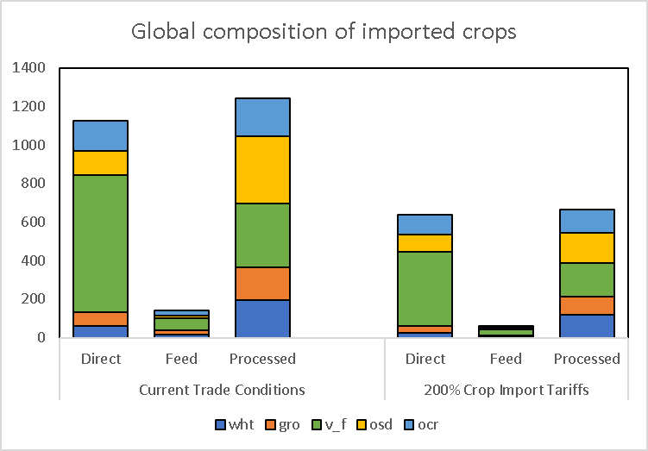
Figure D1. Global crop import levels and composition (in Billion USD) at current tariff levels and hypothetical 200% tariff scenario. The figure shows the global import levels for wheat (wht), coarse grains (gro), vegetables and fruits (v_f) and other crops (ocr),
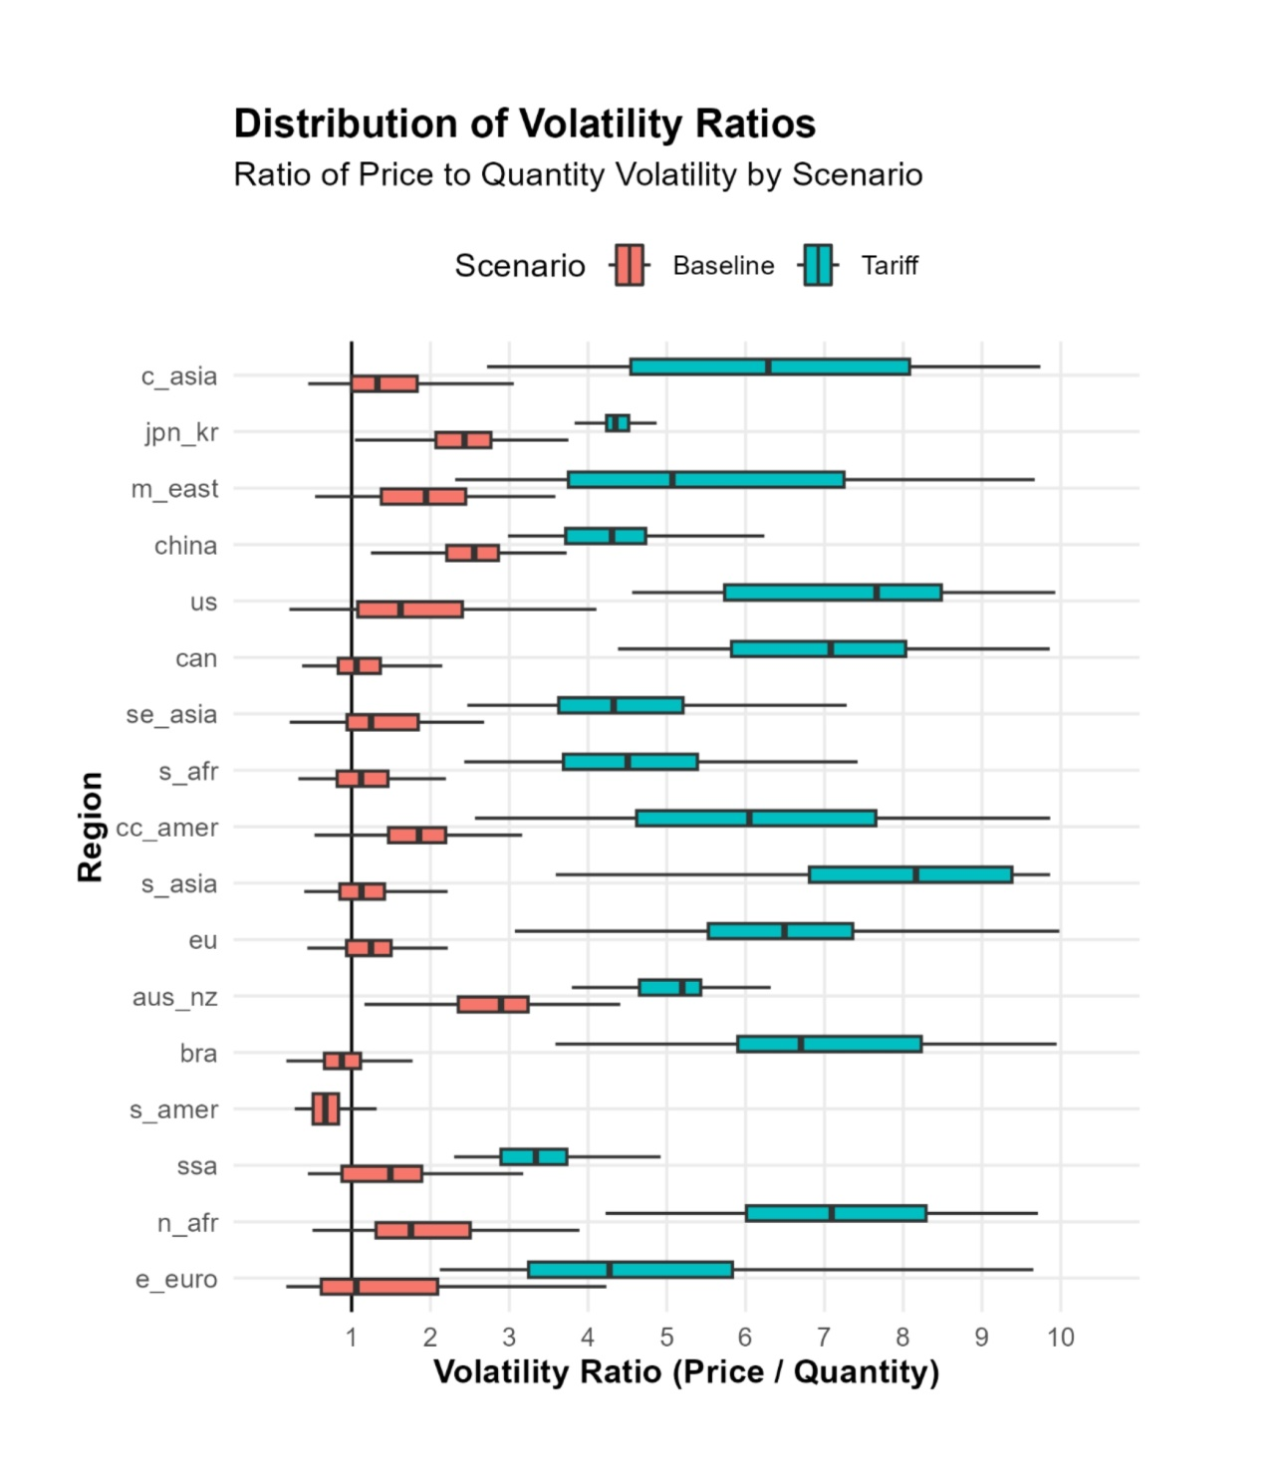
Figure D2. Volatility ratio (consumer price volatility divided by production quantity volatility) under baseline and high-tariff restricted trade scenarios across regions, with 100 randomized samples. Tariff-induced trade restrictions significantly amplify price volatility response to production shocks. Regional abbreviations used in the figures are as follows: e_euro refers to Eastern Europe, n_afr to North Africa, ssa to Sub-Saharan Africa, s_amer to South America, bra to Brazil, aus_nz to Australia and New Zealand, eu to Europe, s_asia to South Asia, cc_amer to Central America, s_afr to South Africa, se_asia to Southeast Asia, can to Canada, us to the United States, china to China, m_east to the Middle East, jpn_kr to Japan and Korea, and c_asia to Central Asia.
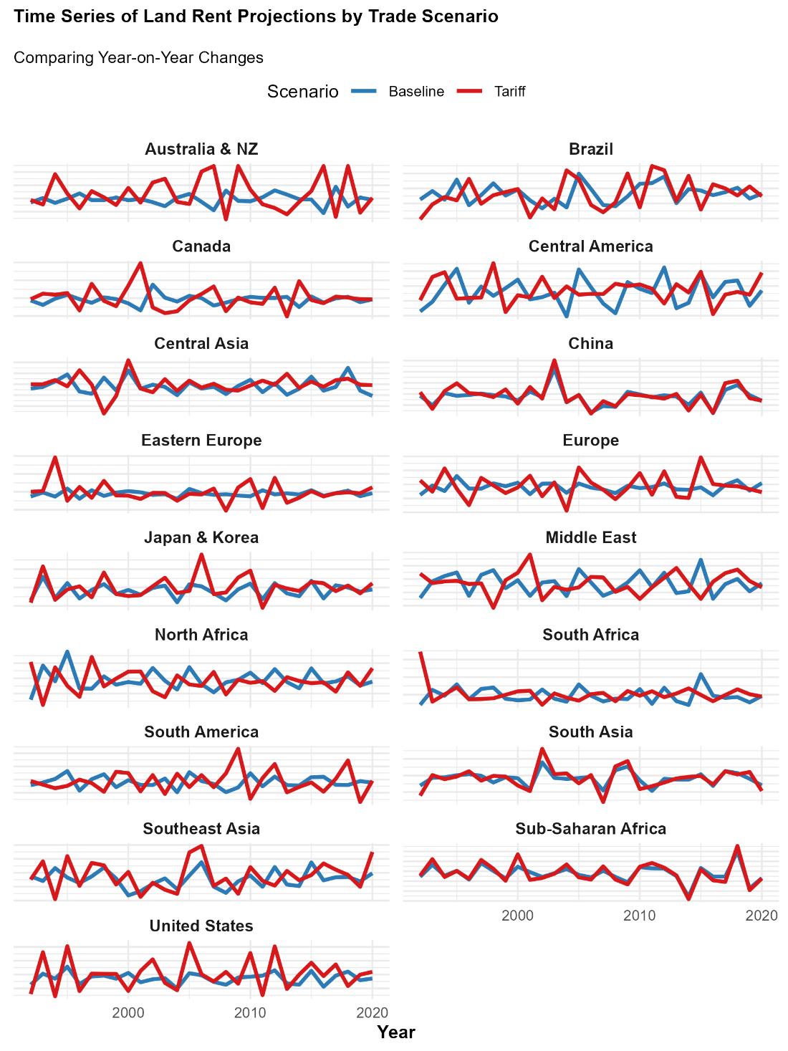
Figure D3. Time series of projected year-on-year changes in consumer price under baseline and high-tariff restricted trade scenarios across region, based on the SIMPLE Multi-Crop 17-region model. Each observation reflects a comparative-static equilibrium outcome generated by applying year-specific yield shocks to a fixed reference economy; the sequence therefore represents consecutive equilibrium simulations rather than a fully dynamic model.

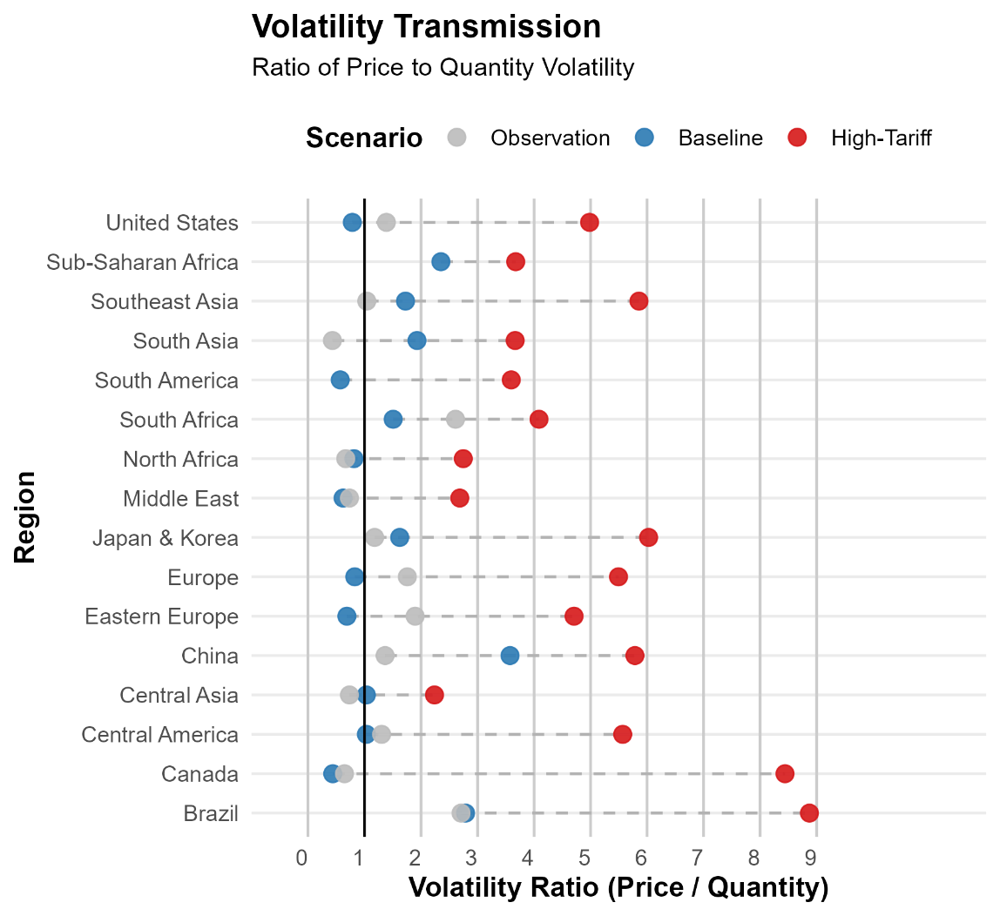
Figure D4. Volatility ratio (consumer price volatility divided by production quantity volatility) under baseline and high-tariff scenarios across regions, compared to FAO-based observations. Baseline projections closely match empirical estimates for most regions, while tariff-induced trade restrictions significantly amplify price responses to production shocks.

Crop and regional mapping
Table D1 Crop mapping between FAO, CPC and SIMPLE/GTAP codes
Item | CPC | Description | GTAP
15 | '0111 | Wheat | 2 | wht
56 | '0112 | Maize (corn) | 3 | gro
27 | '0113 | Rice | 1 | pdr
83 | '0114 | Sorghum | 3 | gro
44 | '0115 | Barley | 3 | gro
71 | '0116 | Rye | 3 | gro
75 | '0117 | Oats | 3 | gro
79 | '0118 | Millet | 3 | gro
97 | '01191 | Triticale | 3 | gro
89 | '01192 | Buckwheat | 3 | gro
94 | '01193 | Fonio | 3 | gro
92 | '01194 | Quinoa | 3 | gro
101 | '01195 | Canary seed | 3 | gro
103 | '01199.02 | Mixed grain | 3 | gro
108 | '01199.90 | Cereals n.e.c. | 3 | gro
367 | '01211 | Asparagus | 4 | v_f
358 | '01212 | Cabbages | 4 | v_f
393 | '01213 | Cauliflowers and broccoli | 4 | v_f
372 | '01214 | Lettuce and chicory | 4 | v_f
373 | '01215 | Spinach | 4 | v_f
366 | '01216 | Artichokes | 4 | v_f
378 | '01219.01 | Cassava leaves | 4 | v_f
567 | '01221 | Watermelons | 4 | v_f
568 | '01229 | Cantaloupes and other melons | 4 | v_f
401 | '01231 | Chillies and peppers; green | 4 | v_f
397 | '01232 | Cucumbers and gherkins | 4 | v_f
399 | '01233 | Eggplants (aubergines) | 4 | v_f
388 | '01234 | Tomatoes | 4 | v_f
394 | '01235 | Pumpkins; squash and gourds | 4 | v_f
430 | '01239.01 | Okra | 4 | v_f
423 | '01241.01 | String beans | 4 | v_f
414 | '01241.90 | Other beans; green | 4 | v_f
417 | '01242 | Peas; green | 4 | v_f
420 | '01243 | Broad beans and horse beans; green | 4 | v_f
426 | '01251 | Carrots and turnips | 4 | v_f
406 | '01252 | Green garlic | 4 | v_f
402 | '01253.01 | Onions and shallots; green | 4 | v_f
403 | '01253.02 | Onions and shallots; dry (excluding dehydrated) | 4 | v_f
407 | '01254 | Leeks and other alliaceous vegetables | 4 | v_f
449 | '01270 | Mushrooms and truffles | 4 | v_f
446 | '01290.01 | Green corn (maize) | 4 | v_f
463 | '01290.90 | Other vegetables; fresh n.e.c. | 4 | v_f
572 | '01311 | Avocados | 4 | v_f
486 | '01312 | Bananas | 4 | v_f
489 | '01313 | Plantains and cooking bananas | 4 | v_f
577 | '01314 | Dates | 4 | v_f
569 | '01315 | Figs | 4 | v_f
571 | '01316 | Mangoes; guavas and mangosteens | 4 | v_f
600 | '01317 | Papayas | 4 | v_f
574 | '01318 | Pineapples | 4 | v_f
603 | '01319 | Other tropical fruits; n.e.c. | 4 | v_f
507 | '01321 | Pomelos and grapefruits | 4 | v_f
497 | '01322 | Lemons and limes | 4 | v_f
490 | '01323 | Oranges | 4 | v_f
495 | '01324 | Tangerines; mandarins; clementines | 4 | v_f
512 | '01329 | Other citrus fruit; n.e.c. | 4 | v_f
560 | '01330 | Grapes | 4 | v_f
515 | '01341 | Apples | 4 | v_f
521 | '01342.01 | Pears | 4 | v_f
523 | '01342.02 | Quinces | 4 | v_f
526 | '01343 | Apricots | 4 | v_f
530 | '01344.01 | Sour cherries | 4 | v_f
531 | '01344.02 | Cherries | 4 | v_f
534 | '01345 | Peaches and nectarines | 4 | v_f
536 | '01346 | Plums and sloes | 4 | v_f
542 | '01349.10 | Other pome fruits | 4 | v_f
541 | '01349.20 | Other stone fruits | 4 | v_f
550 | '01351.01 | Currants | 4 | v_f
549 | '01351.02 | Gooseberries | 4 | v_f
592 | '01352 | Kiwi fruit | 4 | v_f
547 | '01353.01 | Raspberries | 4 | v_f
544 | '01354 | Strawberries | 4 | v_f
552 | '01355.01 | Blueberries | 4 | v_f
554 | '01355.02 | Cranberries | 4 | v_f
558 | '01355.90 | Other berries and fruits of the genus vaccinium n.e.c. | 4 | v_f
461 | '01356 | Locust beans (carobs) | 4 | v_f
587 | '01359.01 | Persimmons | 4 | v_f
591 | '01359.02 | Cashewapple | 4 | v_f
619 | '01359.90 | Other fruits; n.e.c. | 4 | v_f
221 | '01371 | Almonds; in shell | 4 | v_f
217 | '01372 | Cashew nuts; in shell | 4 | v_f
220 | '01373 | Chestnuts; in shell | 4 | v_f
225 | '01374 | Hazelnuts; in shell | 4 | v_f
223 | '01375 | Pistachios; in shell | 4 | v_f
222 | '01376 | Walnuts; in shell | 4 | v_f
216 | '01377 | Brazil nuts; in shell | 4 | v_f
226 | '01379.01 | Areca nuts | 4 | v_f
224 | '01379.02 | Kola nuts | 4 | v_f
234 | '01379.90 | Other nuts (excl. wild edible nuts and groundnuts); in shell; | 4 | v_f
236 | '0141 | Soya beans | 5 | osd
242 | '0142 | Groundnuts; excluding shelled | 5 | osd
329 | '0143 | Cotton seed | 5 | osd
333 | '01441 | Linseed | 5 | osd
292 | '01442 | Mustard seed | 5 | osd
270 | '01443 | Rape or colza seed | 5 | osd
289 | '01444 | Sesame seed | 5 | osd
267 | '01445 | Sunflower seed | 5 | osd
280 | '01446 | Safflower seed | 5 | osd
265 | '01447 | Castor oil seeds | 5 | osd
296 | '01448 | Poppy seed | 5 | osd
299 | '01449.01 | Melonseed | 5 | osd
336 | '01449.02 | Hempseed | 5 | osd
339 | '01449.90 | Other oil seeds; n.e.c. | 5 | osd
260 | '01450 | Olives | 5 | osd
249 | '01460 | Coconuts; in shell | 5 | osd
254 | '01491.01 | Oil palm fruit | 5 | osd
256 | '01491.02 | Palm kernels | 5 | osd
263 | '01499.01 | Karite nuts (sheanuts) | 5 | osd
275 | '01499.02 | Tung nuts | 5 | osd
277 | '01499.03 | Jojoba seeds | 5 | osd
305 | '01499.04 | Tallowtree seeds | 5 | osd
310 | '01499.05 | Kapok fruit | 5 | osd
311 | '01499.06 | Kapokseed in shell | 5 | osd
116 | '01510 | Potatoes | 8 | ocr
125 | '01520.01 | Cassava; fresh | 8 | ocr
122 | '01530 | Sweet potatoes | 8 | ocr
137 | '01540 | Yams | 8 | ocr
136 | '01550 | Taro | 8 | ocr
135 | '01591 | Yautia | 8 | ocr
149 | '01599.10 | Edible roots and tubers with high starch or inulin content; | 8 | ocr
656 | '01610 | Coffee; green | 8 | ocr
667 | '01620 | Tea leaves | 8 | ocr
671 | '01630 | MatÃ© leaves | 8 | ocr
661 | '01640 | Cocoa beans | 8 | ocr
687 | '01651 | Pepper (Piper spp.); raw | 8 | ocr
689 | '01652 | Chillies and peppers; dry (Capsicum spp.; Pimenta spp.); raw | 8 | ocr
702 | '01653 | Nutmeg; mace; cardamoms; raw | 8 | ocr
711 | '01654 | Anise; badian; coriander; cumin; caraway; juniper berries; | 8 | ocr
693 | '01655 | Cinnamon and cinnamon-tree flowers; raw | 8 | ocr
698 | '01656 | Cloves (whole stems); raw | 8 | ocr
720 | '01657 | Ginger; raw | 8 | ocr
692 | '01658 | Vanilla; raw | 8 | ocr
677 | '01659 | Hop cones | 8 | ocr
459 | '01691 | Chicory roots | 8 | ocr
723 | '01699 | Other stimulant; spice and aromatic crops; n.e.c. | 8 | ocr
176 | '01701 | Beans; dry | 8 | ocr
181 | '01702 | Broad beans and horse beans; dry | 8 | ocr
191 | '01703 | Chick peas; dry | 8 | ocr
201 | '01704 | Lentils; dry | 8 | ocr
187 | '01705 | Peas; dry | 8 | ocr
195 | '01706 | Cow peas; dry | 8 | ocr
197 | '01707 | Pigeon peas; dry | 8 | ocr
203 | '01708 | Bambara beans; dry | 8 | ocr
205 | '01709.01 | Vetches | 8 | ocr
210 | '01709.02 | Lupins | 8 | ocr
211 | '01709.90 | Other pulses n.e.c. | 8 | ocr
157 | '01801 | Sugar beet | 6 | c_b
156 | '01802 | Sugar cane | 6 | c_b
161 | '01809 | Other sugar crops n.e.c. | 6 | c_b
328 | '01921.01 | Seed cotton; unginned | 7 | pfb
767 | '01921.02 | Cotton lint; ginned | 7 | pfb
780 | '01922.01 | Jute; raw or retted | 7 | pfb
782 | '01922.02 | Kenaf; and other textile bast fibres; raw or retted | 7 | pfb
771 | '01929.01 | Flax; raw or retted | 7 | pfb
777 | '01929.02 | True hemp; raw or retted | 7 | pfb
778 | '01929.03 | Kapok fibre; raw | 7 | pfb
788 | '01929.04 | Ramie; raw or retted | 7 | pfb
789 | '01929.05 | Sisal; raw | 7 | pfb
800 | '01929.06 | Agave fibres; raw; n.e.c. | 7 | pfb
809 | '01929.07 | Abaca; manila hemp; raw | 7 | pfb
813 | '01929.08 | Coir; raw | 7 | pfb
821 | '01929.90 | Other fibre crops; raw; n.e.c. | 7 | pfb
748 | '01930.01 | Peppermint; spearmint | 8 | ocr
754 | '01930.02 | Pyrethrum; dried flowers | 8 | ocr
836 | '01950.01 | Natural rubber in primary forms | 8 | ocr
826 | '01970 | Unmanufactured tobacco | 8 | ocr

Table D2 Mapping between FAO and SIMPLE regions
FAO | Label | SIMPLE | REG
2 | Afghanistan | 17 | C_Asia
3 | Albania | 1 | E_Euro
4 | Algeria | 2 | N_Afr
7 | Angola | 3 | SSA
9 | Argentina | 4 | S_Amer
1 | Armenia | 1 | E_Euro
10 | Australia | 6 | AUS_NZ
11 | Austria | 7 | EU
52 | Azerbaijan | 1 | E_Euro
13 | Bahrain | 15 | M_East
16 | Bangladesh | 8 | S_Asia
57 | Belarus | 1 | E_Euro
255 | Belgium | 7 | EU
23 | Belize | 9 | CC_Amer
53 | Benin | 3 | SSA
18 | Bhutan | 8 | S_Asia
19 | Bolivia (Plurinational State of) | 4 | S_Amer
80 | Bosnia and Herzegovina | 1 | E_Euro
20 | Botswana | 10 | S_Afr
21 | Brazil | 5 | BRA
27 | Bulgaria | 7 | EU
233 | Burkina Faso | 3 | SSA
29 | Burundi | 3 | SSA
115 | Cambodia | 11 | SE_Asia
32 | Cameroon | 3 | SSA
33 | Canada | 12 | CAN
37 | Central African Republic | 3 | SSA
39 | Chad | 3 | SSA
40 | Chile | 4 | S_Amer
44 | Colombia | 4 | S_Amer
45 | Comoros | 3 | SSA
46 | Congo | 3 | SSA
48 | Costa Rica | 9 | CC_Amer
107 | Côte d'Ivoire | 3 | SSA
98 | Croatia | 1 | E_Euro
49 | Cuba | 9 | CC_Amer
50 | Cyprus | 7 | EU
167 | Czechia | 7 | EU
116 | Democratic People's Republic of Korea | 16 | JPN_KR
250 | Democratic Republic of the Congo | 3 | SSA
54 | Denmark | 7 | EU
72 | Djibouti | 3 | SSA
56 | Dominican Republic | 9 | CC_Amer
58 | Ecuador | 4 | S_Amer
59 | Egypt | 2 | N_Afr
60 | El Salvador | 9 | CC_Amer
61 | Equatorial Guinea | 3 | SSA
178 | Eritrea | 3 | SSA
63 | Estonia | 7 | EU
238 | Ethiopia | 3 | SSA
66 | Fiji | 11 | SE_Asia
67 | Finland | 7 | EU
68 | France | 7 | EU
69 | French Guiana | 4 | S_Amer
74 | Gabon | 3 | SSA
75 | Gambia | 3 | SSA
73 | Georgia | 1 | E_Euro
79 | Germany | 7 | EU
81 | Ghana | 3 | SSA
84 | Greece | 7 | EU
89 | Guatemala | 9 | CC_Amer
90 | Guinea | 3 | SSA
175 | Guinea-Bissau | 3 | SSA
91 | Guyana | 4 | S_Amer
93 | Haiti | 9 | CC_Amer
95 | Honduras | 9 | CC_Amer
97 | Hungary | 7 | EU
99 | Iceland | 7 | EU
100 | India | 8 | S_Asia
101 | Indonesia | 11 | SE_Asia
102 | Iran (Islamic Republic of) | 15 | M_East
103 | Iraq | 15 | M_East
104 | Ireland | 7 | EU
105 | Israel | 15 | M_East
106 | Italy | 7 | EU
109 | Jamaica | 9 | CC_Amer
110 | Japan | 16 | JPN_KR
112 | Jordan | 15 | M_East
108 | Kazakhstan | 1 | E_Euro
114 | Kenya | 3 | SSA
118 | Kuwait | 15 | M_East
113 | Kyrgyzstan | 17 | C_Asia
120 | Lao People's Democratic Republic | 11 | SE_Asia
119 | Latvia | 7 | EU
121 | Lebanon | 15 | M_East
122 | Lesotho | 10 | S_Afr
123 | Liberia | 3 | SSA
124 | Libya | 2 | N_Afr
125 | Liechtenstein | 7 | EU
126 | Lithuania | 7 | EU
256 | Luxembourg | 7 | EU
129 | Madagascar | 3 | SSA
130 | Malawi | 3 | SSA
131 | Malaysia | 11 | SE_Asia
133 | Mali | 3 | SSA
136 | Mauritania | 3 | SSA
137 | Mauritius | 10 | S_Afr
138 | Mexico | 9 | CC_Amer
141 | Mongolia | 17 | C_Asia
273 | Montenegro | 1 | E_Euro
143 | Morocco | 2 | N_Afr
144 | Mozambique | 3 | SSA
28 | Myanmar | 11 | SE_Asia
147 | Namibia | 10 | S_Afr
149 | Nepal | 8 | S_Asia
150 | Netherlands | 7 | EU
156 | New Zealand | 6 | AUS_NZ
157 | Nicaragua | 9 | CC_Amer
158 | Niger | 3 | SSA
159 | Nigeria | 3 | SSA
162 | Norway | 7 | EU
299 | Occupied Palestinian Territory | 15 | M_East
221 | Oman | 15 | M_East
165 | Pakistan | 8 | S_Asia
166 | Panama | 9 | CC_Amer
168 | Papua New Guinea | 11 | SE_Asia
169 | Paraguay | 4 | S_Amer
170 | Peru | 4 | S_Amer
171 | Philippines | 11 | SE_Asia
173 | Poland | 7 | EU
174 | Portugal | 7 | EU
177 | Puerto Rico | 9 | CC_Amer
179 | Qatar | 15 | M_East
117 | Republic of Korea | 16 | JPN_KR
146 | Republic of Moldova | 1 | E_Euro
182 | Réunion | 3 | SSA
183 | Romania | 1 | E_Euro
185 | Russian Federation | 1 | E_Euro
184 | Rwanda | 3 | SSA
194 | Saudi Arabia | 15 | M_East
195 | Senegal | 3 | SSA
272 | Serbia | 1 | E_Euro
186 | Serbia and Montenegro | 1 | E_Euro
197 | Sierra Leone | 3 | SSA
199 | Slovakia | 7 | EU
198 | Slovenia | 1 | E_Euro
25 | Solomon Islands | 11 | SE_Asia
201 | Somalia | 3 | SSA
202 | South Africa | 10 | S_Afr
277 | South Sudan | 3 | SSA
203 | Spain | 7 | EU
38 | Sri Lanka | 8 | S_Asia
276 | Sudan | 3 | SSA
206 | Sudan (former) | 3 | SSA
207 | Suriname | 4 | S_Amer
209 | Swaziland | 10 | S_Afr
210 | Sweden | 7 | EU
211 | Switzerland | 7 | EU
212 | Syrian Arab Republic | 15 | M_East
208 | Tajikistan | 17 | C_Asia
216 | Thailand | 11 | SE_Asia
154 | The former Yugoslav Republic of Macedonia | 1 | E_Euro
176 | Timor-Leste | 11 | SE_Asia
217 | Togo | 3 | SSA
220 | Trinidad and Tobago | 4 | S_Amer
222 | Tunisia | 2 | N_Afr
223 | Turkey | 15 | M_East
213 | Turkmenistan | 17 | C_Asia
226 | Uganda | 3 | SSA
230 | Ukraine | 1 | E_Euro
225 | United Arab Emirates | 15 | M_East
229 | United Kingdom | 7 | EU
215 | United Republic of Tanzania | 3 | SSA
231 | United States of America | 13 | US
234 | Uruguay | 4 | S_Amer
235 | Uzbekistan | 17 | C_Asia
155 | Vanuatu | 11 | SE_Asia
236 | Venezuela (Bolivarian Republic of) | 4 | S_Amer
237 | Viet Nam | 11 | SE_Asia
205 | Western Sahara | 3 | SSA
249 | Yemen | 15 | M_East
251 | Zambia | 3 | SSA
181 | Zimbabwe | 3 | SSA
96 | China, Hong Kong SAR | 14 | CHINA
128 | China, Macao SAR | 14 | CHINA
41 | China, mainland | 14 | CHINA
214 | China, Taiwan Province of | 14 | CHINA

Table D3. standard deviation of consumer food price volatility over 1991-2020
 |  | Current Trade | Limited Trade
East Europe |  | 6.0 | 14.5
North Africa |  | 6.8 | 9.5
Sub Saharan Africa |  | 13.3 | 14.5
South America |  | 4.4 | 7.2
Brazil |  | 10.1 | 10.9
Australia & NZ |  | 6.9 | 32.7
Europe |  | 4.4 | 8.9
South Asia |  | 8.1 | 9.8
Central America |  | 3.6 | 4.5
South Africa |  | 14.6 | 26.9
South-East Asia |  | 5.6 | 8.1
Canada |  | 4.5 | 15.6
United States |  | 4.3 | 9.1
China |  | 12.8 | 13.7
Middle East |  | 2.8 | 4.8
Japan & Korea |  | 4.6 | 7.4
Central Asia |  | 12.1 | 12.8

