Text S1 Water cycle intensity framework (WCI)
Huntington et al. (2018) have demonstrated that the sum of precipitation and evapotranspiration can be used to quantify changes in the terrestrial component of the water cycle, which describes the total amount of water exchanged between the atmosphere and the land and has been extended to a global scale (Godoy and Markonis, 2023). First, we begin our discussion with the equation of the terrestrial water balance:
(1)
where Pre is precipitation, AET is actual evapotranspiration, and Q is actual runoff (surface water flow); is the change in soil water storage. We assume that all storage changes in a time step occur on soil moisture, and by adjusting equation (1), the storage regulated runoff Q' is:
(2)
where Q is always greater than or equal to 0. When AET exceeds Pre, the excess AET can be compensated by the depletion of soil moisture. Therefore, Q' provides more information about the hydrological response of the unit during dry periods than Q. So, the WCI is expressed as follows (Huntington et al., 2018) ：
(3)
where WCI applies to Pre and AET observations and simulations values at any spatiotemporal scale (Huntington et al., 2018). Q' quantifies the difference between the two components of the hydrological cycle, while WCI quantifies their sum. This enables a coupled graphical representation of the overall response of the hydrologic cycle to climate change in the study area (Fig. S1).

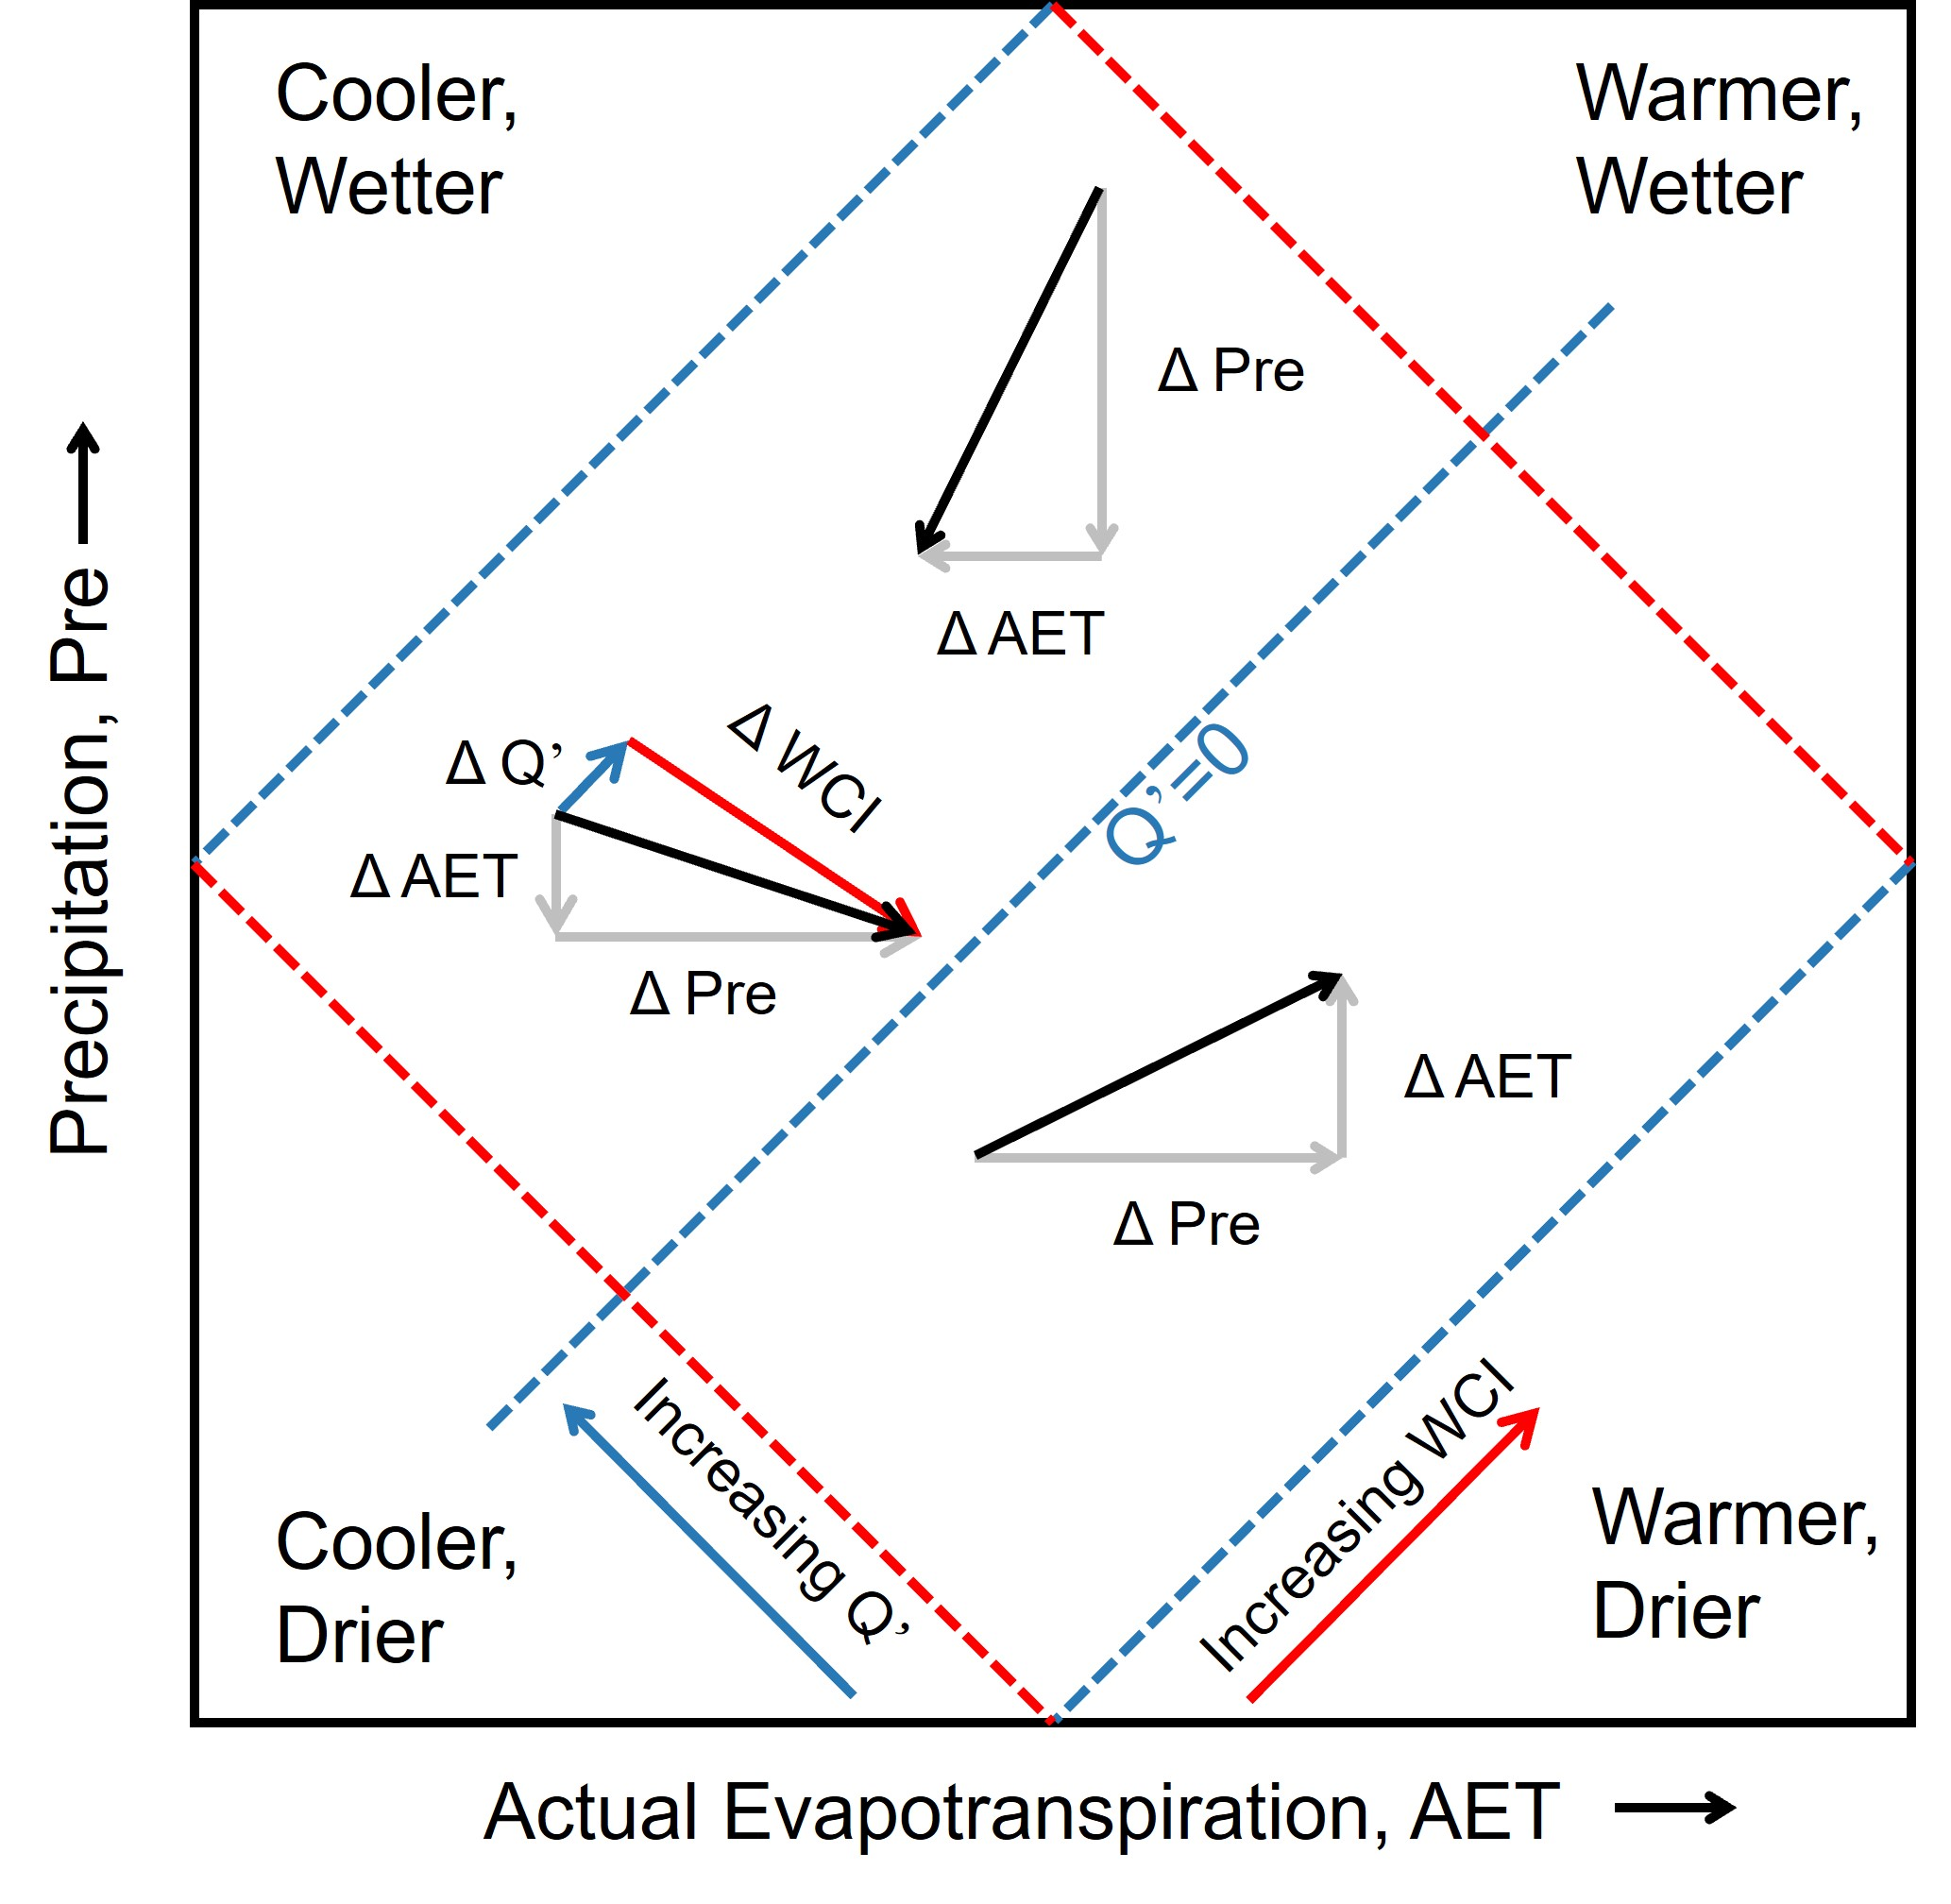
Figure S1. The regional hydrological cycle status in the Pre―AET space. Vectors represent changes in the hydrologic cycle. The blue and red dashed lines indicate the equivalents of Q' and WCI, respectively, and the movement of these lines (blue vector/red vector) describes the changes in hydrologic cycle storage/water cycle intensity. The complementary relationship between ΔQ' and ΔWCI contributes to a more in-depth understanding of hydrologic response to climate change. For example, climate changes in ΔPre and ΔAET will cause changes in regional Q' and WCI (Huntington et al., 2018).

Text S2 Theil-Sen median analysis and Mann–Kendall significance test
Theil-Sen median analysis is a robust nonparametric statistical estimator (Sen, 1968) that is widely applied to estimate the changing rate of long-term series data. This method does not require the data to follow a certain distribution and is not affected by small outliers and missing values. The calculation formula is as follows:
(4)
whereis the changing rate of WCI for the study period. where 𝑥_{𝑚} and 𝑥_{𝑛} show the time series of WCI in months m and n, respectively.
The Mann–Kendall significance test, which is a nonparametric and rank-based test, is defined as follows:
(5)
(6)
(7)
(8)
where 𝑥_{𝑖} and 𝑥_{𝑗} are the values of WCI in months i and j, respectively, n is the time length of WCI, sign is the sign function, the S statistic value is equivalent to the Z statistic value of the standard normal test, the 5% significance level is defined |Z|>1.96.

Text S3 Changepoint detection by BEAST
Bayesian Estimation of abrupt change, seasonality and trend (BEAST) model developed by Zhao et al., (2019) are used to analyze the time series and identify abrupt points in the time series. BEAST decomposes the time series of hydrological cycle elements into several major components: seasonal, trend, and random noise (White et al., 2021). The BEAST model employs Bayesian methods to estimate the number and timing of breakpoints, thereby effectively mitigating issues such as uncertainty, overfitting, and misspecification (Zhao et al., 2019). The BEAST algorithm is reasonable from a hydrometeorology perspective. This is because hydrological elements do not follow a purely linear pattern but exhibit complex nonlinear patterns (Rezaei and Gurdak, 2020). The model equations are as follows.
(9)
where and indicate seasonal and trend signals, represents time. The locations and numbers of the changepoints are hidden and embedded in the seasonal and trend components represented by the parameters and . is the Gaussian random error term for an unknown variance . The posterior probability distribution of Markov Chain Monte Carlo (MCMC) sampling simulation with unknown parameters is obtained by using Bayes' theorem (Hu et al., 2021)：
(10)
The above three terms were explained in detail by Zhao et al. (2019). This method has been successfully applied to the detection of long-term trends in hydrological elements. This research employs the R statistical software for time series decomposition, available from https://github.com/zhaokg/Rbeast.

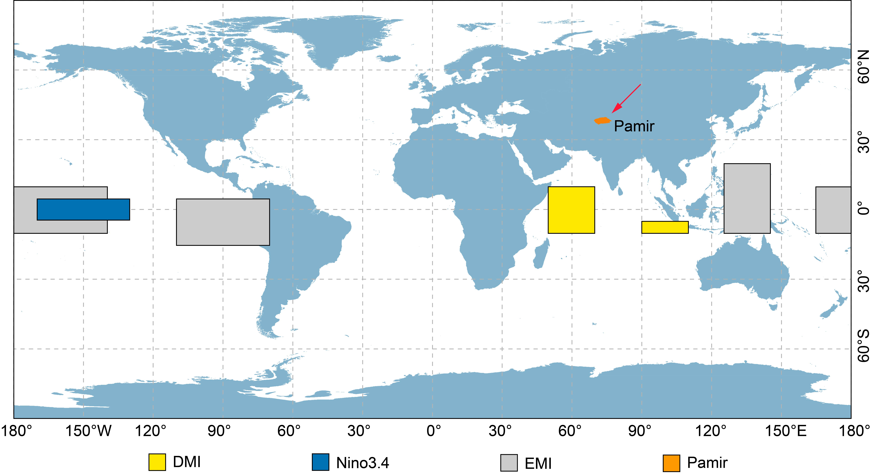
Figure S2. Spatial domains for the calculation of the DMI (yellow boxes), Nino3.4 (blue box), and EMI indices (grey box).

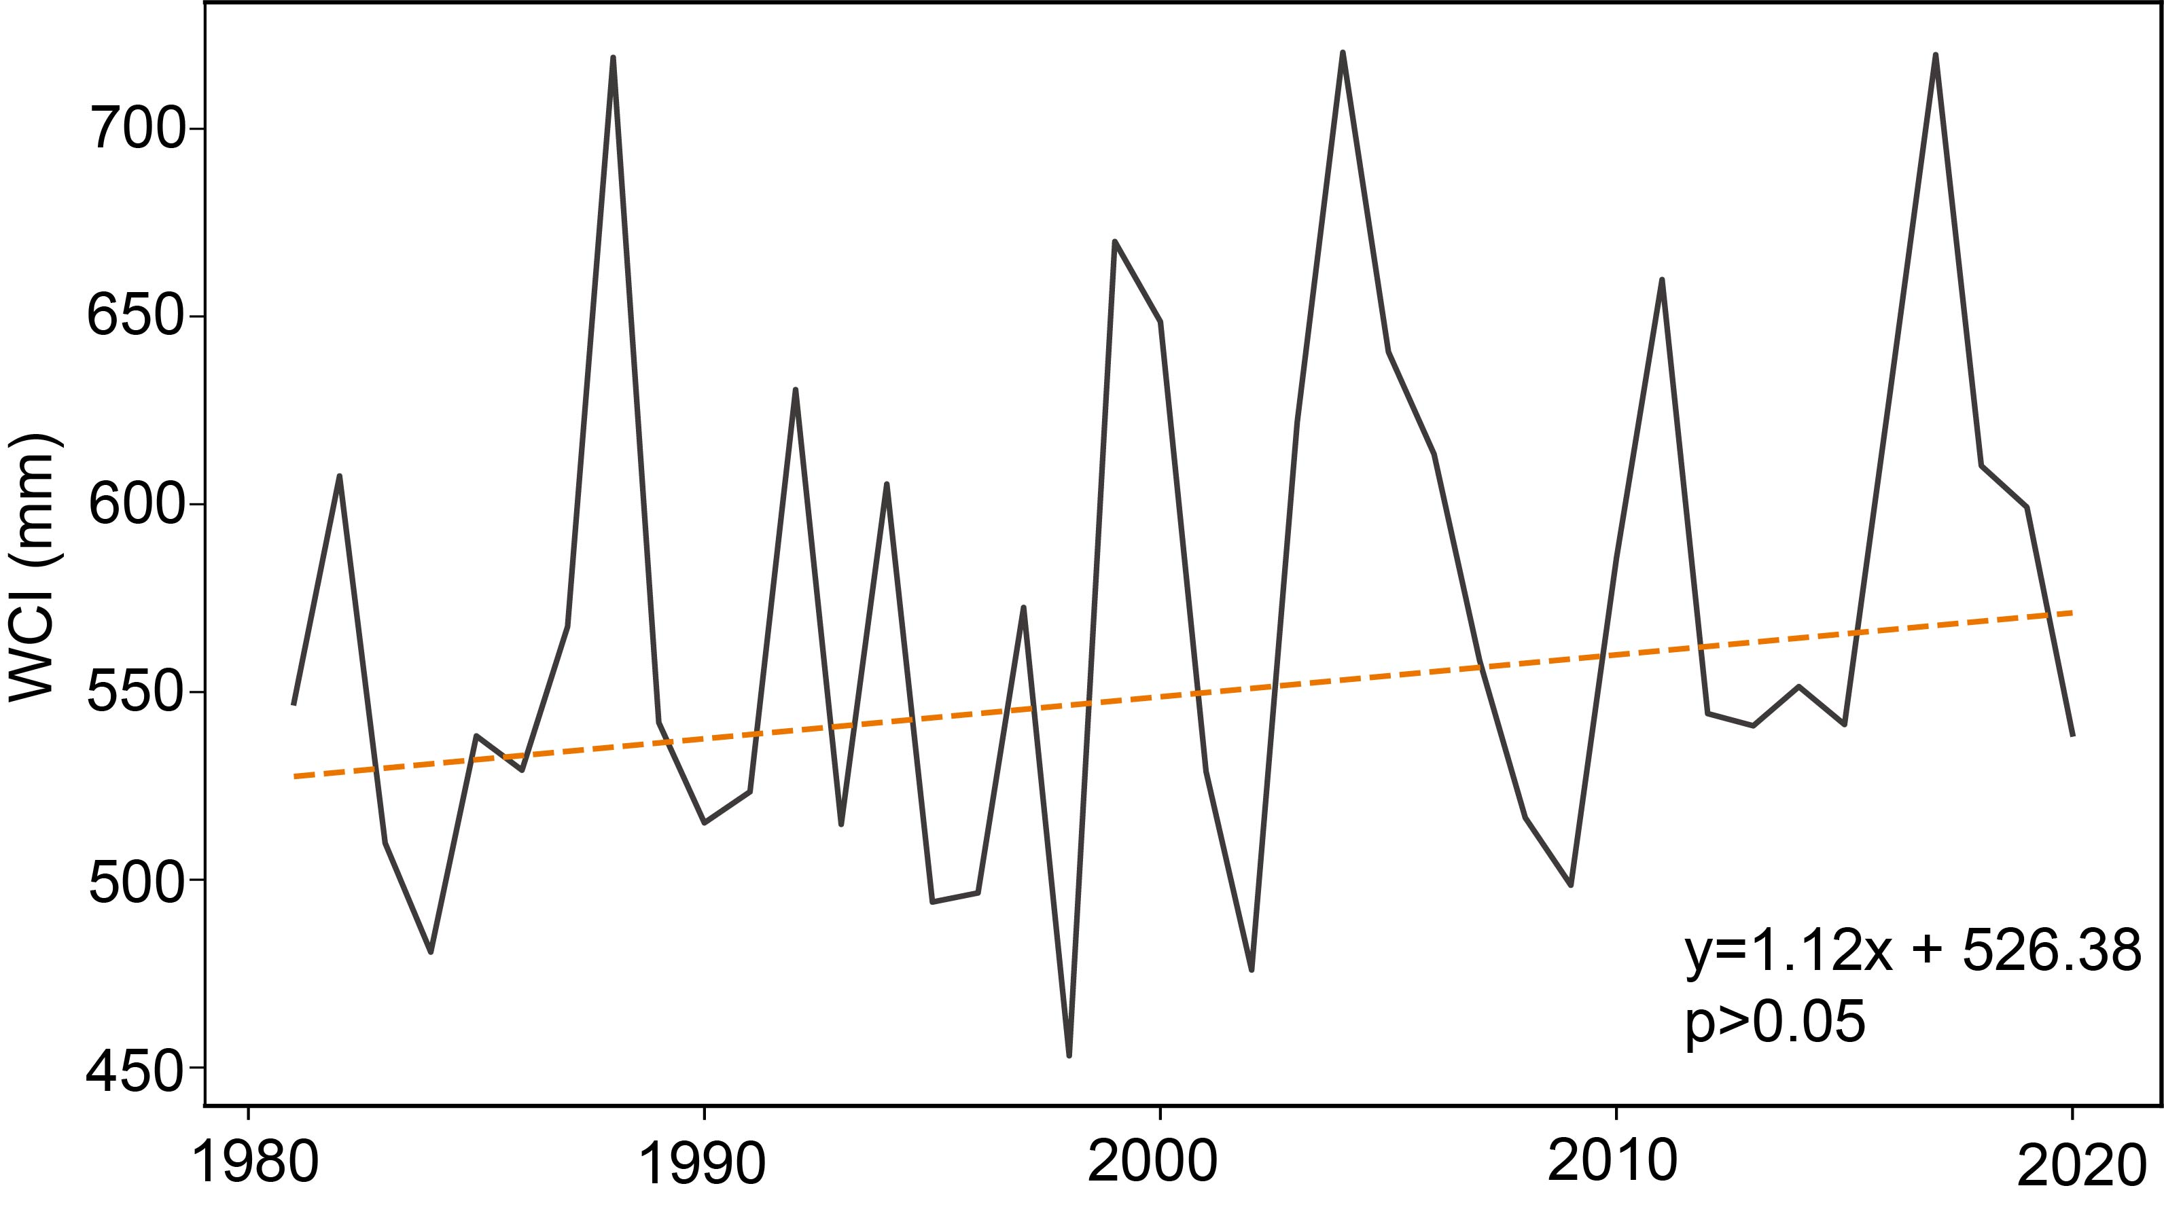
Figure S3. Temporal variation in the WCI in Pamir from 1980 to 2019.

REFERENCE CITED
Hu, T., Myers Toman, E., Chen, G., et al., 2021. Mapping fine-scale human disturbances in a working landscape with Landsat time series on Google Earth Engine. ISPRS Journal of Photogrammetry and Remote Sensing. 176, 250–261. https://doi.org/10.1016/j.isprsjprs.2021.04.008
Huntington, T.G., Weiskel, P.K., Wolock, D.M., et al., 2018. A new indicator framework for quantifying the intensity of the terrestrial water cycle. Journal of Hydrology. 559, 361–372. https://doi.org/10.1016/j.jhydrol.2018.02.048
Rezaei, A., Gurdak, J.J., 2020. Large-scale climate variability controls on climate, vegetation coverage, lake and groundwater storage in the Lake Urmia watershed using SSA and wavelet analysis. Science of The Total Environment. 724, 138273. https://doi.org/10.1016/j.scitotenv.2020.138273
Sen, P.K., 1968. Estimates of the Regression Coefficient Based on Kendall’s Tau. Journal of the American Statistical Association. 63, 1379–1389. https://doi.org/10.1080/01621459.1968.10480934
Vargas Godoy, M.R., Markonis, Y., 2023. Water cycle changes in reanalyses: a complementary framework. Scitific Reports. 13, 4795. https://doi.org/10.1038/s41598-023-31873-5
White, J.H.R., Walsh, J.E., Thoman Jr, R.L., 2021. Using Bayesian statistics to detect trends in Alaskan precipitation. International Journal of Climatology. 41, 2045–2059. https://doi.org/10.1002/joc.6946
Zhao, K., Wulder, M.A., Hu, T., et al., 2019. Detecting change-point, trend, and seasonality in satellite time series data to track abrupt changes and nonlinear dynamics: A Bayesian ensemble algorithm. Remote Sensing of Environment. 232, 111181. https://doi.org/10.1016/j.rse.2019.04.034

