Studying solvent extraction systems for selective isolation of light rare earth elements with high selectivity for Sm and La

Hossein Salehi, Samane Maroufi, Rasoul Khayyam Nekouei, Veena Sahajwalla

Centre for Sustainable Materials Research and Technology, SMaRT@UNSW, School of Materials Science and Engineering, UNSW Sydney, NSW 2052, Australia

23/07/2024

Dear Editor,

I am writing to submit a revised version of our manuscript entitled “Studying solvent extraction systems for selective isolation of light rare earth elements with high selectivity for Sm and La", which was previously submitted to Rare Metals. I would like to thank you and the reviewers for taking the time to read and provide valuable feedback on our work.
We believe that these revisions have significantly improved the manuscript and address the concerns raised by the reviewers. We hope that the manuscript will now be considered for publication in Rare Metals.
Thank you again for your time and consideration.

In response to the reviewers' comments, we have made the following revisions.

Best regards,
Hossein Salehi

Centre for Sustainable Materials Research & Technology (SMaRT),
School of Materials Sci. and Eng., UNSW Sydney
Sydney, NSW 2052
E: h.salehi@unsw.edu.au

Editors' and Reviewers comments

Editorial Office:
(1) We hope collaborated affiliations overseas related to this work.
(2) Please update your figures according to the attached file "Rare Metals Requirements of Figures-new', so that your article can be quickly published online after acceptance.
(3) Please carefully check and confirm all the graphs, tables and references are cited in order and without missing citing, also for the graphs and tables in SI file. And for references, they are required to be cited in the body text in order (excluding the citing number in figure captions and tables).

Response: we appreciate the feedback and the opportunity to make the necessary revisions. We have reviewed the attached file and confirm that the figures meet the journal’s criteria. We have also ensured they are of high quality and appropriately labeled for clarity.
We have carefully checked all graphs, tables, and references in the main text and the supplementary information file. We ensured that all elements are cited in order, without any omissions. We have also ensured that references are cited in the body text sequentially.

Reviewer: 1

Comments to the Author
1. What is the main novelty by this methodology? Many reports were already reported on Sm and La possible separation from other REEs.
2. What are the advantageous by this route? When compared with already available reports in literature?
3. When compare with earlier reports on light rare earth elements processing; what are the main achievements by this route?
Response to comments 1-3: We acknowledge the well-established application of solvent extraction method in the recovery of elements, particularly REEs. Table 5 in the manuscript highlights the limited number of studies focused on LREE effective separation.
Table 5. Comparison of solvent extraction separation results for LREEs by organophosphorus extractants between literature findings and the outcomes of this study
Extraction system | Best separation results achieved | Reference
Cyanex 572 | β_{Pr/La}=13.4, β_{Nd/La}=21.6, β_{Nd/Pr}=1.6 | [1]
PC 88A | β_{Ce/La}=56.3, β_{Nd/La}=12.1 | [2]
Cyanex 572+TBP | β_{Pr/Sm}=3.02, β_{Nd/Sm}=3.01 | [3]
CA12+Cyanex 301 | β_{La/Ce}=0.19, β_{La/Pr}=0.3, β_{La/Nd}=0.13, β_{La/Sm}=0.47, β_{Ce/Pr}=1.62, β_{Ce/Nd}=0.7, β_{Ce/Sm}=2.52, β_{Pr/Nd}=0.43, β_{Pr/Sm}=1.56, β_{Nd/Sm}=3.62 | [4]
Aliquat 336+PC 88A | β_{La/Ce}=2.03, β_{La/Pr}=2.62, β_{La/Nd}=24.9, β_{La/Sm}=117, β_{Ce/Pr}=1.29, β_{Ce/Nd}=12.3, β_{Ce/Sm}=57.7, β_{Pr/Nd}=9.53, β_{Pr/Sm}=44.7, β_{Nd/Sm}=4.7 | [5]
Cyanex 572  PC 88A | β_{Ce/La}=1.53, β_{Pr/Ce}=0.91, β_{Nd/Pr}=0.51, β_{Sm/Nd}=2.59  β_{Ce/La}=2.21, β_{Pr/Ce}=0.63, β_{Nd/Pr}=1.06, β_{Sm/Nd}=2.22 | [6]
PC 88A+Cyanex 272 | β_{Pr/Ce}=2.1, β_{Nd/Pr}=1.59, β_{Sm/Nd}=12.5 | [7]
D2EHPA  PC 88A | β_{Ce/La}=4.5, β_{Pr/La}=13.9, β_{Nd/La}=14.4, β_{Sm/La}=42.1  β_{Ce/La}=7.3, β_{Pr/La}=13.5, β_{Nd/La}=15.0, β_{Sm/La}=149.8 | [8]
Cyanex 272 | β_{Nd/Pr}=5.1, β_{Didymium/La}>100 | [9]
PC 88A | β_{Nd/Pr}=13, β_{Pr/La}=39 | [10]
8-Hydorquinoline+PC 88 A | β_{Nd/Pr}=7.03, β_{Nd/La}=16 | [11]
Cyanex 301 | β_{La/Ce}=1.04, β_{Ce/Nd}=1.65, β_{Ce/Pr}=1.62, β_{La/Pr}=1.06, β_{Pr/Nd}=1.62, β_{La/Nd}=1.72 | [4]
PC 88 A | β_{Pr/La}=13.7 | [12]
D2EHPA + Cyanex 272 | β_{Didymium/La}=14.4 | [13]
Cyanex 572+TBP  PC 88A+TBP | β_{Ce/La}=12, β_{Nd/La}=87, β_{Pr/La}=127, β_{Sm/La}=3191  β_{Sm/Ce}=54, β_{Sm/Nd}=20, β_{Sm/Pr}=14 | This work

A significant gap in the field is the lack of comprehensive research comparing different extractants for the effective separation of these elements. This study introduces several well-known extractants used in the REEs separation industry and provides guidelines for researchers aiming to conduct similar investigations. By explaining the extraction mechanisms and presenting a thorough analysis of the obtained data, we aim to assist readers in understanding the underlying reasons for the distinct extraction behaviors of La, Ce, Pr, Nd, and Sm when in contact with various organic extractants. Establishing all this information into a single, comprehensive work addresses a critical gap in literature.
Regarding pH control methods, as discussed in the introduction, buffering agents and saponification of extractants are the most commonly reported techniques in the literature. Both methods either require preliminary stages before the extraction process or introduce additional materials to the aqueous solution, potentially affecting the extraction behavior of the elements and increasing the overall process cost. Due to the high volume of wastewater generated, this method is being increasingly replaced by alternative techniques such as making use of synergistic effects between extractants [14]. We added relevant references with respect to these two methods:
To date, saponification of the extractant [12, 15] and the addition of buffering and complexing agents [10, 12, 16, 17] to the aqueous phase have been the most reported methods for pH control during solvent extraction. However, the gradual adjustment of pH through the incremental addition of a basic solution has received limited attention due to instrumental challenges, which is introduced and thoroughly investigated herein. (1. Introduction)
The comprehensive analysis of the organic systems in relation to the extraction behavior of the elements at both constant and varying pH, along with the detailed examination of results, reactions, and mechanisms, represents a significant contribution that has not been previously reported in the literature. Additionally, the exceptional separation factors achieved for the separation of Sm and the complete isolation of La from other REEs are noteworthy accomplishments of this study. Optimum separation factors were calculated with β_{Ce/La}=12, β_{Nd/La}=87, β_{Pr/La}=127, and β_{Sm/La}=3191 for the former, and β_{Sm/Ce}=54, β_{Sm/Nd}=20, and β_{Sm/Pr}=14 for the latter. Comparison of these results with the ones reported in literature presented in Table 5 above further showcases the value of this research.

4. This methodology is environmentally sound; prove it.
5. The present journal aims is Sustainable solutions; the proposed methodologies how far sustainable?

Response to comments 4-5: In this research, the raw material was sourced from Ni-MH batteries, as opposed to using dissolved analytical REE salts to study their separation. Despite the high purity of this material, the presence of trace impurities could influence the extraction behavior of the elements. By utilizing waste-derived products, we aim to enhance the recovery loop of REEs from secondary sources and highlight the importance of this sector. The methodology employed in this research emphasizes the "effective separation" of elements. This approach aims to maximize the extraction of targeted elements while minimizing the extraction of others, and to reduce the number of stages required in the process. As a result, this methodology generates less waste and uses less amount of chemicals, making it both environmentally friendly and economically viable.
While acknowledging that no industrial process is entirely without environmental impact, it is important to emphasize that solvent extraction for the individual separation of REEs, when properly optimized and managed, can be an environmentally friendly and sustainable method. This process is advantageous due to its selective separation capabilities, waste minimization, energy efficiency, and potential for reagent recycling.
Solvent extraction is a widely accepted method for the separation of REEs due to its ability to handle large volumes of diluted pregnant solutions efficiently [18]. This process utilizes ionic liquids and extractants that are effective in selectively extracting REEs from various elements, such as transition metals [19, 20]. Innovative techniques such as membrane-assisted solvent extraction demonstrate the capability of selectively recovering pure REEs from industrial scrap magnets, emphasizing its sustainable nature [21]. Additionally, supercritical fluid extraction uses organic extractants with the same basis as solvent extraction, which presents an alternative green separation technology for REE recovery, offering more environmentally friendly options [22, 23].
The extraction process can be optimized to minimize waste by carefully selecting and recycling reagents. This approach reduces both the volume and toxicity of waste generated. Many solvent extraction systems are designed to recycle and reuse organic solvents and extractants, operating as closed-loop hydrometallurgical processes. This reduces the need for fresh chemical inputs and minimizes environmental contamination.
A life cycle assessment (LCA) conducted on the recovery of REEs, Ni, and Co from Ni-MH batteries (manuscript under preparation by the authors), along with reports from other researchers [24, 25], indicates that the environmental footprint of producing mixed REOs from waste batteries is significantly lower than that of production from virgin ore (a glimpse of results is provided below). This highlights the environmental benefits of recycling and reusing materials in the recovery of REEs. Adapting separation techniques for the separation of REEs from recovered products can further contribute to this field and draw more attention to this sector.
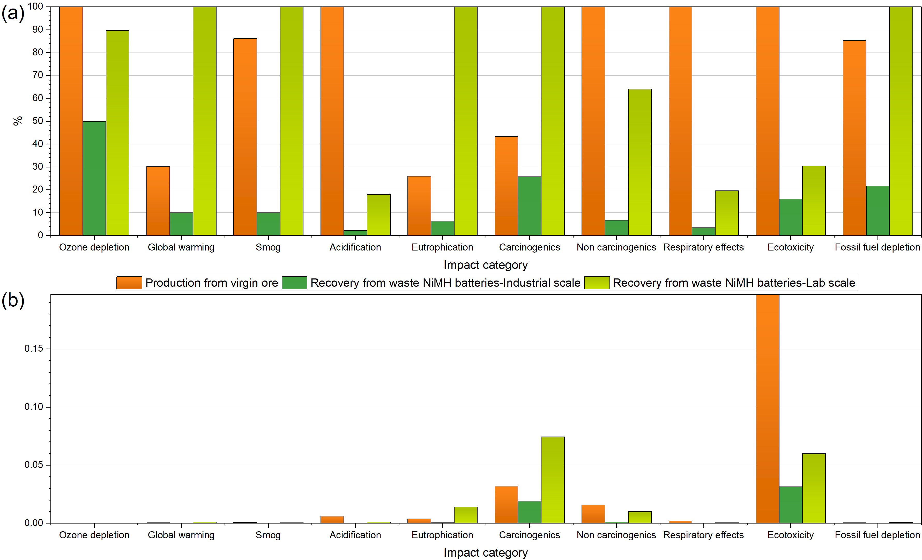

6. Use SI units entire manuscript. For example molarity write as mol/L.

Response: We appreciate the reviewer's attention to detail. As you correctly noted, the SI unit for molarity is mol/L. However, it is commonly abbreviated as "M" in texts, an approach recognized by IUPAC (International Union of Pure and Applied Chemistry (1993). Quantities, Units and Symbols in Physical Chemistry, 2nd edition, Oxford: Blackwell Science. ISBN 0-632-03583-8. Page 42). To make it easier for the reader to navigate, we added this to the abbreviations.

7. Is it economically feasible?

Response: As discussed in response to Comments #4-5, the proposed method in this study emphasizes the "effective separation" of elements, making it feasible to achieve separation with fewer CCE stages. This approach results in less waste generation and reduces the need for reagents, including organic extractants which both make the suggested process economically viable. Moreover, further research will be needed to optimize the results, as this work aims to provide a guideline for selective separation of REEs as a historically challenging process. Regarding the solvent extraction process itself, we incorporated the following part in the introduction section in regard to the economic viability of solvent extraction separation of REEs:
Solvent extraction is widely recognized as a suitable commercial technology for separating REEs due to its capability to handle large volumes of diluted pregnant solutions effectively [18]. Studies have shown that solvent extraction can effectively turn Acid Mine Drainage into a commercially viable feedstock for rare earth production [26]. Furthermore, the development of innovative approaches and sequential step-leaching processes has advanced the field of REE extraction, making solvent extraction a key component in the recovery and separation of REEs from complex aqueous feedstock solutions [27, 28].
Hydrometallurgical methods, including solvent extraction, have been highlighted as efficient techniques for recovering REEs from various sources such as neodymium magnet waste, emphasizing the attractiveness and efficiency of these methods [29]. The economic feasibility of solvent extraction for REEs depends on various factors, including capital and operating costs, market conditions, recovery rates, scale of operation, and regulatory compliance. While the initial investment can be significant, high recovery rates, product purity, and strong market demand for REEs can make the process economically viable. Operating costs, including those for solvents, reagents, energy, labor, and waste management, can be mitigated through efficient recycling and reuse of chemicals. The robust market demand for REEs in industries such as electronics, renewable energy, and automotive sectors further enhances the economic viability of this method, as mentioned in the introduction section. Furthermore, the raw material used in this study was sourced from waste Ni-MH batteries, aligning with the waste-to-wealth strategy by recovering valuable materials that would otherwise be landfilled. This approach not only supports environmental sustainability but also adds an economic benefit by utilizing secondary sources.

8. Summarize the abstract up to 200 words.

Response: As per the reviewer's comment, we have made efforts to summarize the abstract as concisely as possible:
“This study details a comprehensive approach focusing on the effective separation of light REEs via solvent extraction technique. A stock solution containing lanthanum, cerium, neodymium, praseodymium, and samarium was prepared by dissolving their pure mixed oxide (reclaimed from spent Ni-MH batteries) in a diluted HCl solution. Key extractants, including Cyanex 272, Cyanex 572, Cyanex 923, and PC 88A, along with TBP as a phase modifier, were utilized to form organic systems. The extraction behavior and separability of these systems at various pH levels as well as their extraction mechanisms were deeply investigated. The results demonstrated a direct relationship between the extraction trend and the experimental pH value, with enhanced selectivity when TBP was added. Notably, Nd and Pr exhibited similar extraction behaviors, with minor deviations from Ce, making their separation difficult to achieve. Sm extraction followed a distinct trend, allowing for its separation from other elements at pH≤2. In contrast, La exhibited low affinity for coordination with extractants when pH was ≤3.5, facilitating the separation of other elements from La, which could then be isolated in the raffinate. Among the studied organic systems, combinations of Cyanex 572 and PC 88A with TBP demonstrated superior performance in element separation. Optimum separation factors were calculated with β_{Ce/La}=12, β_{Nd/La}=87, β_{Pr/La}=127, and β_{Sm/La}=3191 for the former, and β_{Sm/Ce}=54, β_{Sm/Nd}=20, and β_{Sm/Pr}=14 for the latter. These findings provide valuable insights for selecting extraction systems and designing experiments for the effective solvent extraction separation of light REEs from their mixture.”

9. Using 1 mol/L of extractant concentration in SX processing was too much high concentration; try to study in between 0.01 mol/L to 0.5 mol/L extractant concentration.

Response: We appreciate the reviewer’s suggestion. The primary objective of this study was to compare the extractants' effectiveness in separating LREEs from a mixed solution, rather than optimizing experimental parameters. Optimization of these parameters will be addressed in another study, currently in manuscript preparation. However, regarding the impact of lower extractant concentrations in the organic phase, we direct attention to the accompanying diagram, which is a glimpse of the results obtained in our ongoing study. This figure demonstrates the influence of Cyanex 572-TBP composition on the separation of La, Pr, Nd, and Sm from their mixed solution at pH_{i} 2.5. The main effects analysis indicates that increasing Cyanex 572 concentration from 0.25 to 1 M in the organic phase resulted in decreased extraction efficiency for La, whereas significant increases were observed for Pr, Nd, and Sm. Furthermore, we have provided the summary table below for your attention, indicating the typical concentration of extractants reported by other researchers, which shows the scale of concentration when working with REE-bearing solutions for effective separation:
Extraction system | Experimental condition | Reference
Cyanex 572 | 0.5 M Cyanex 572 | [1]
PC 88A | 10 vol.% PC 88A | [2]
Cyanex 572+TBP | 25 vol.% TBP+75 vol.% Cyanex 572 | [3]
Cyanex 572  Cyanex 572+PC 88A | 10.6 vol.% Cyanex 572  20-40 vol% Cyanex 572+20-25 vol% PC 88A | [6]
PC 88A+Cyanex 272 | 0.5 M PC 88A+0.5 M Cyanex 272 | [7]
D2EHPA  PC 88A | 0.2 M D2EHPA  0.6 M PC 88A | [8]
Cyanex 272 | 0.51 M Cyanex 272 | [9]
PC 88A | 0.6 M PC 88A | [10]
PC 88A | 40 vol.% PC 88A | [12]

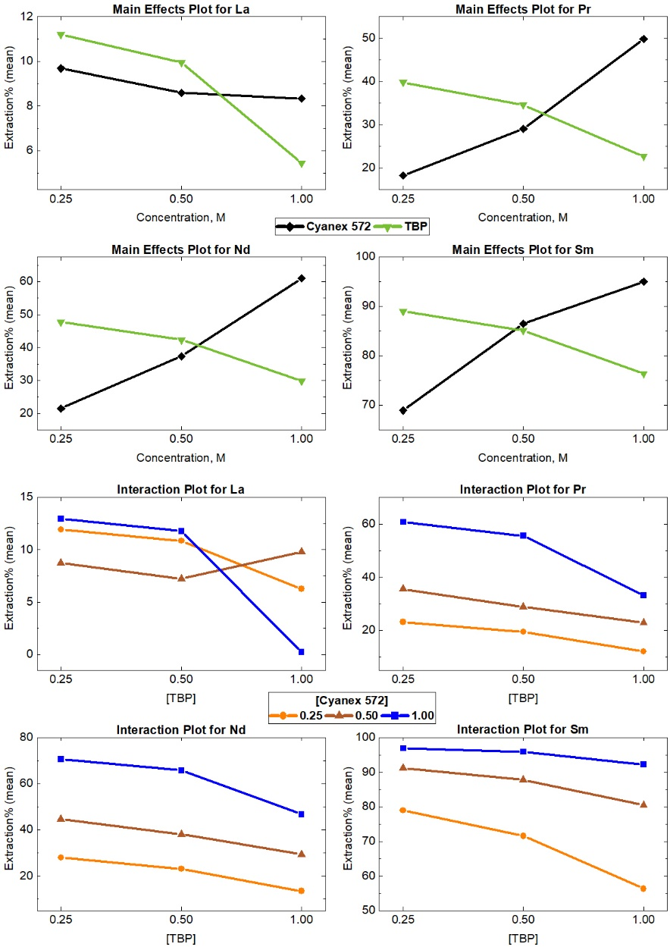

10. Fig. 5 was complex; try to divide it as a Figures a, b, c and divide the results in different figures or made it as Table form.

Response: We appreciate the reviewer’s attention to this matter. Figure 5 was generated to visually compare the separation factors obtained from various experiments. Comprehensive dataset and the potentially separable elements under different experimental conditions were previously presented in Table 4, as seen below:
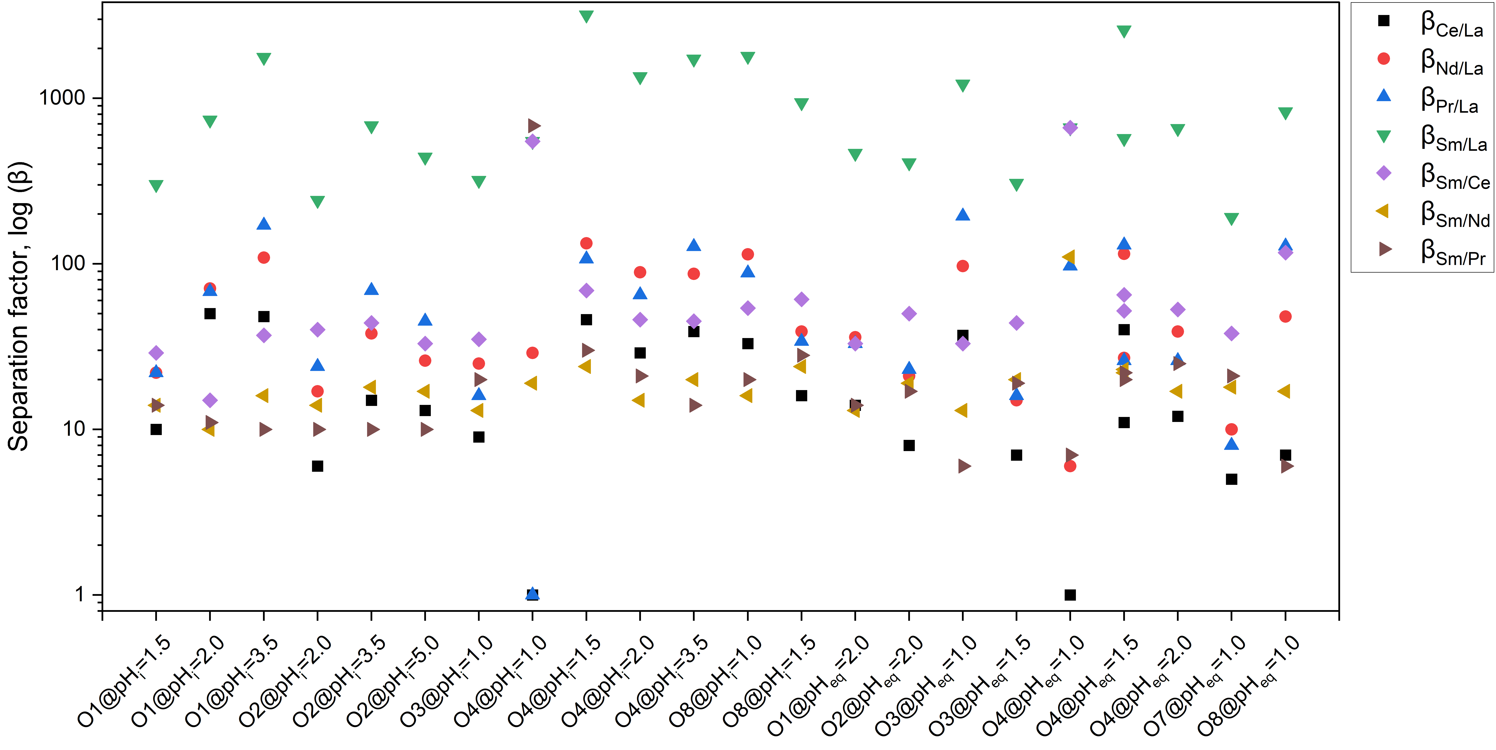
Figure 5. Visual representation of the separation factors values obtained under optimal conditions for the separation of LREEs. Organic systems: O1: 1.0 M Cyanex 272; O2: 1.0 M Cyanex 272+1.0 M TBP; O3: 1.0 M Cyanex 572; O4: 1.0 M Cyanex 572+1.0 M TBP; O7: 1.0 M PC 88A; O8: 1.0 M PC 88A+1.0 M TBP

Table 4. Separation factor values obtained under optimal conditions for the separation of LREEs, along with the corresponding elements potentially separable under each condition. Organic systems: O1: 1.0 M Cyanex 272; O2: 1.0 M Cyanex 272+1.0 M TBP; O3: 1.0 M Cyanex 572; O4: 1.0 M Cyanex 572+1.0 M TBP; O7: 1.0 M PC 88A; O8: 1.0 M PC 88A+1.0 M TBP.
System | pH | β_{Ce/La} | β_{Nd/La} | β_{Pr/La} | β_{Sm/La} | β_{Sm/Ce} | β_{Sm/Nd} | β_{Sm/Pr} | Potentially separable element(s)
O1 | pH_{i}=1.5 | 10 | 22 | 22 | 302 | 29 | 14 | 14 | Sm from La, Ce, Nd, Pr
O1 | pH_{i}=2.0 | 50 | 71 | 68 | 739 | 15 | 10 | 11 | Sm from La
O1 | pH_{i}=3.5 | 48 | 109 | 171 | 1768 | 37 | 16 | 10 | Sm from La  La from Nd, Pr
O2 | pHi=2.0 | 6 | 17 | 24 | 242 | 40 | 14 | 10 | Sm from La, Ce, Nd, Pr
O2 | pHi=3.5 | 15 | 38 | 69 | 683 | 44 | 18 | 10 | Sm from La
O2 | pHi=5.0 | 13 | 26 | 45 | 442 | 33 | 17 | 10 | Sm from La
O3 | pH_{i}=1.0 | 9 | 25 | 16 | 320 | 35 | 13 | 20 | Sm from La, Ce, Nd, Pr
O4 | pH_{i}=1.0 | 1 | 29 | 1 | 550 | 550 | 19 | 681 | Sm from La, Ce, Nd, Pr
O4 | pH_{i}=1.5 | 46 | 133 | 107 | 3191 | 69 | 24 | 30 | Sm from La, Ce, Nd, Pr
O4 | pH_{i}=2.0 | 29 | 89 | 65 | 1354 | 46 | 15 | 21 | Sm from La  La from Nd, Pr
O4 | pH_{i}=3.5 | 39 | 87 | 127 | 1729 | 45 | 20 | 14 | Sm from La  La from Ce, Nd, Pr
O8 | pH_{i}=1.0 | 33 | 114 | 88 | 1797 | 54 | 16 | 20 | Sm from La, Ce, Nd, Pr
O8 | pH_{i}=1.5 | 16 | 39 | 34 | 943 | 61 | 24 | 28 | Sm from La  La from Nd, Pr
O1 | pH_{eq}=2.0 | 14 | 36 | 33 | 466 | 33 | 13 | 14 | Sm from La
O2 | pH_{eq}=2.0 | 8 | 21 | 23 | 408 | 50 | 19 | 17 | Sm from La, Ce, Nd, Pr
O3 | pH_{eq}=1.0 | 37 | 97 | 194 | 1220 | 33 | 13 | 6 | Sm from La
O3 | pH_{eq}=1.5 | 7 | 15 | 16 | 307 | 44 | 20 | 19 | Sm from La  La from Nd, Pr
O4 | pH_{eq}=1.0 | 1 | 6 | 97 | 664 | 664 | 110 | 7 | Sm from La, Ce
O4 | pH_{eq}=1.5 | 40 | 115 | 130 | 2589 | 65 | 23 | 20 | Sm from La, Ce
O4 | pH_{eq}=2.0 | 12 | 39 | 26 | 657 | 53 | 17 | 25 | Sm from La  La from Nd, Pr
O7 | pH_{eq}=1.0 | 5 | 10 | 8 | 191 | 38 | 18 | 21 | Sm from La
O8 | pH_{eq}=1.0 | 7 | 48 | 128 | 829 | 117 | 17 | 6 | Sm from La, Ce
O8 | pH_{eq}=1.5 | 11 | 27 | 26 | 573 | 52 | 22 | 22 | Sm from La  La from Nd, Pr

11. When you apply the lower concentrations of Extractant, even loading of the metal up to 50%; can encroach in various counter-current extraction stages. To set up the CCE stages, you need to study the Extraction Isotherm. If possible try to do it with lower concentration like 0.1 mol/L.

Response: We appreciate the reviewer’s suggestion and refer to our response to comment #9. Additionally, we acknowledge that lower concentrations of extractant are advantageous in CCE processes, primarily due to reduced viscosity of the organic phase, which facilitates easier separation between organic and aqueous phases. However, based on the reports (table provided in the response of comment #9), the scale of extractants’ concentrations is much higher.

Reviewer: 2

Comments to the Author
The author's manuscript is very relevant to the theme of the journal, as they effectively separate light rare earth elements through solvent extraction technology. Prepare a reserve solution containing lanthanum, cerium, neodymium, praseodymium, and samarium by dissolving pure mixed oxides of lanthanum, cerium, neodymium, praseodymium, and samarium (recovered from waste nickel hydrogen batteries) in a diluted HCl solution. The author's experiment is complete, and the evidence is sufficient, but the presentation of the manuscript still needs improvement. It is recommended to publish it after revision. Authors said that the average release of H+ is lower for TBP-inclusive systems is due to the reduced uptake of REEs by the organic system. Please provide the detailed the theoretical evidence.

Response: We would like to appreciate the reviewer’s feedback. We have tried to address all the reviewers’ comments properly in the final version to ensure the improved quality of the data presentation and its scientific aspect.
In response to the final comment, we should point out that according to our experimental data, extraction efficiency of REEs with TBP-inclusive systems was lower than that of extractant only, as evident in Figures 3, 4, and 5:
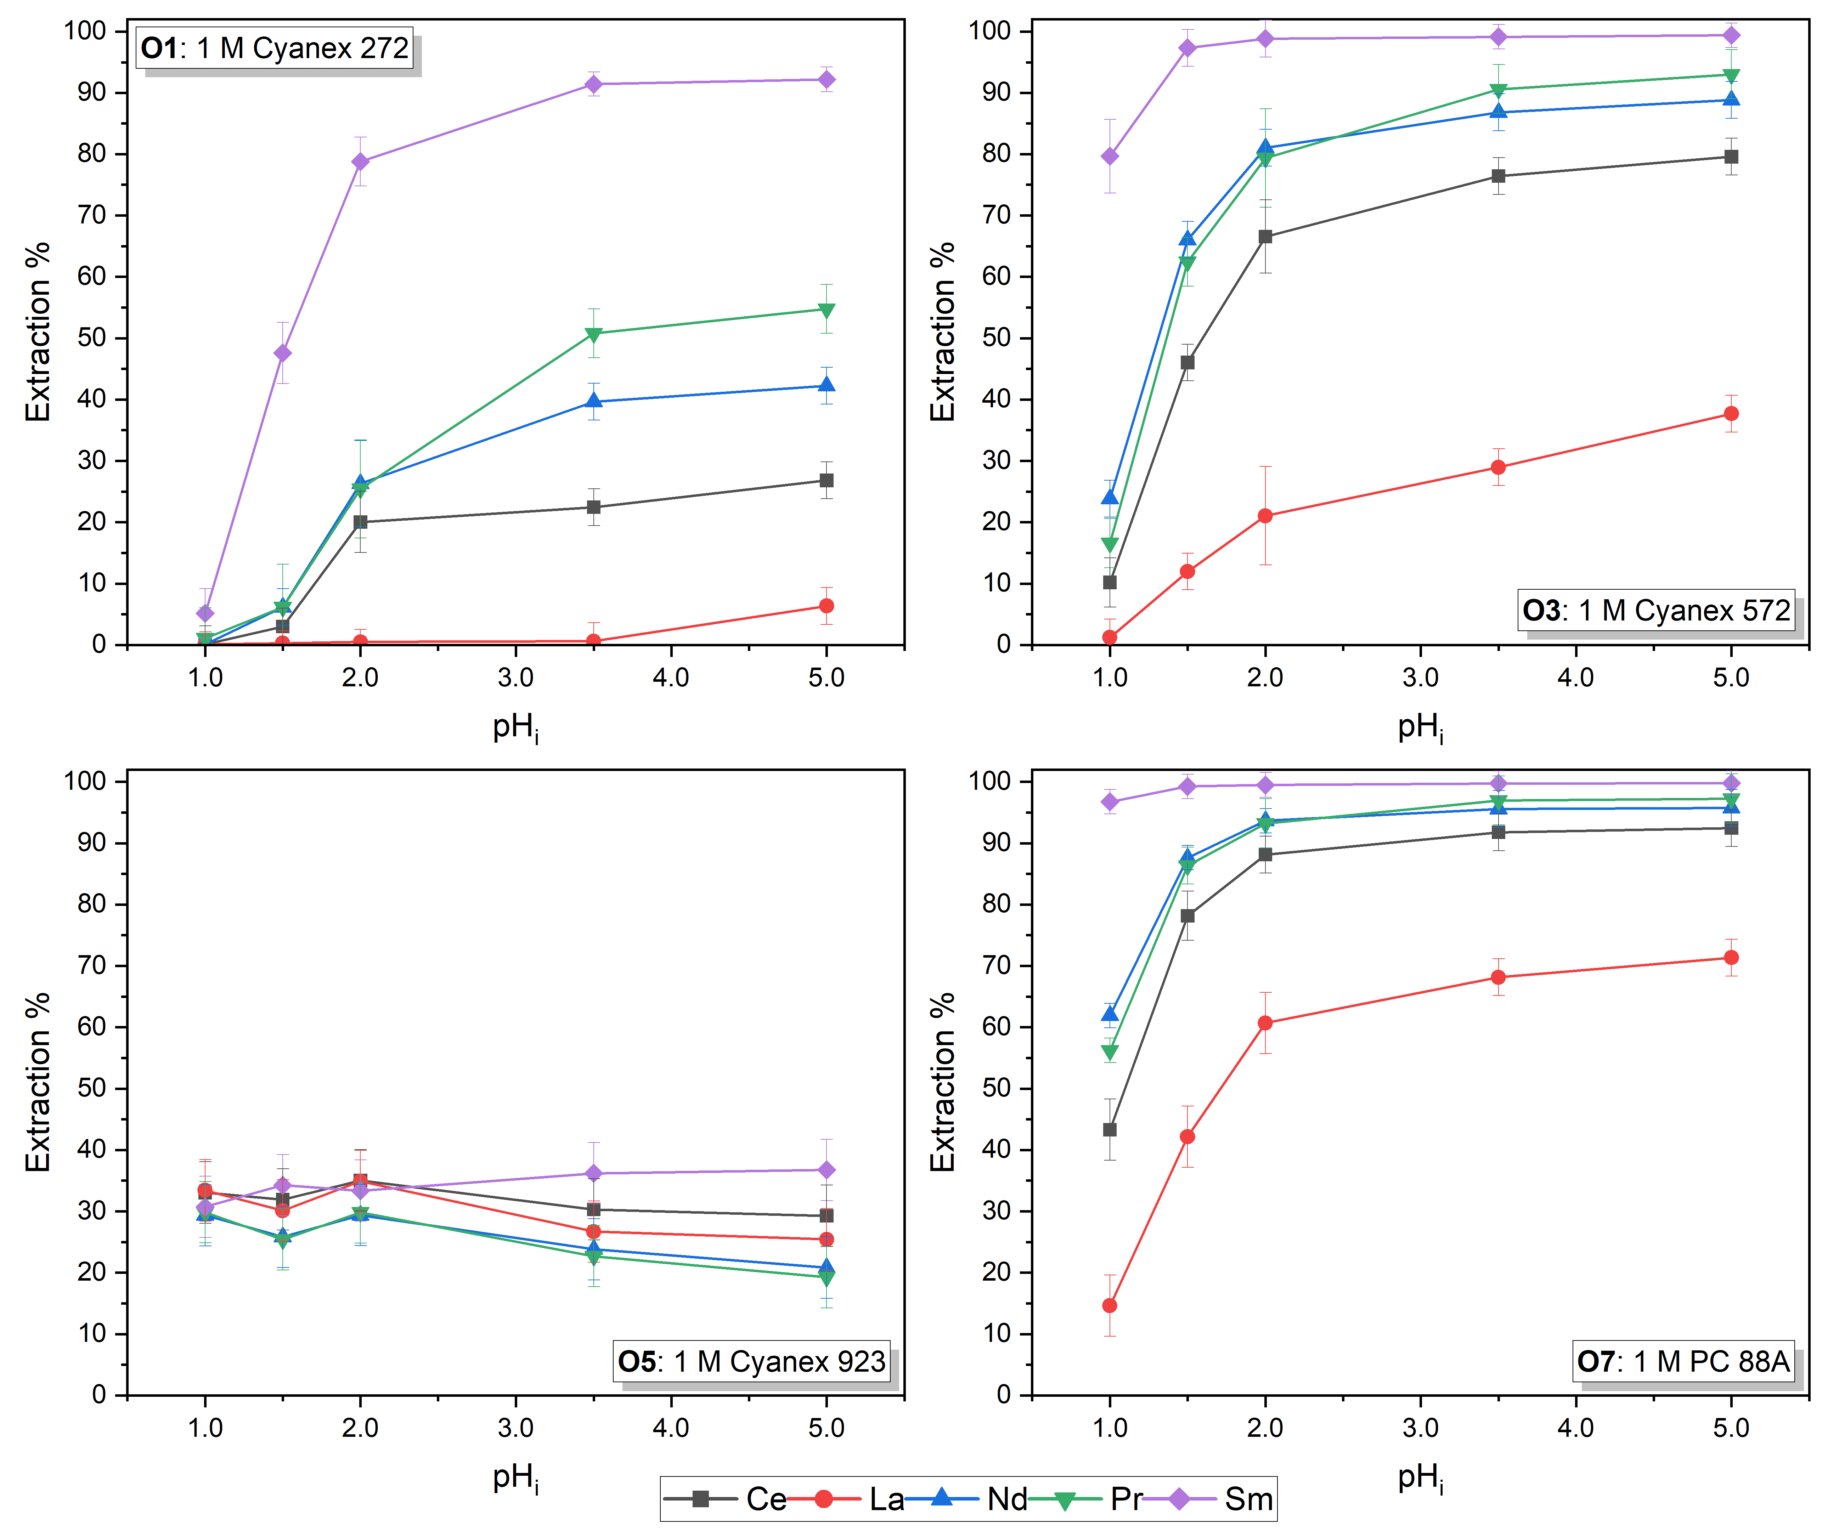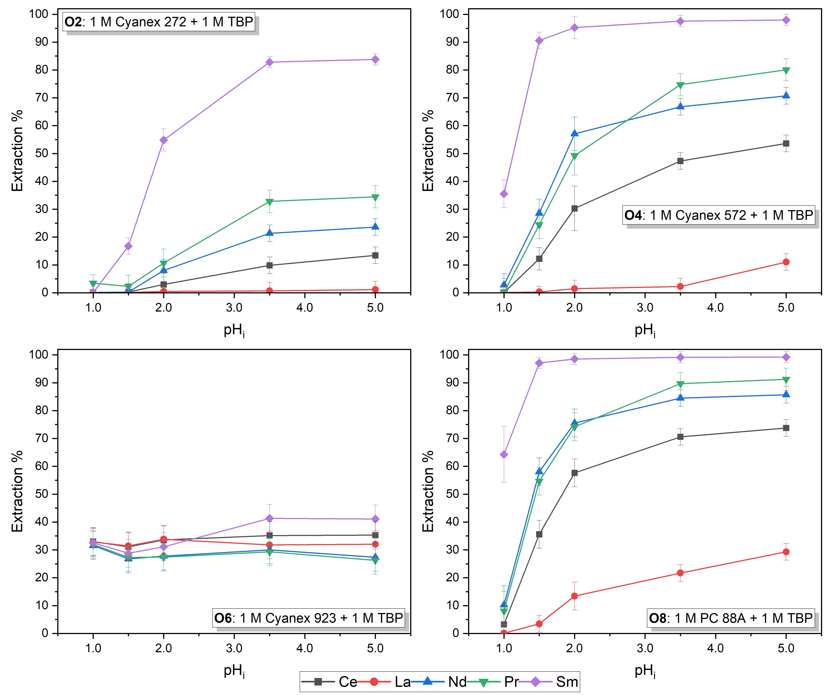
As explained in the reaction mechanism (Eqs. 4-7), REEs in the acidic solutions are in the cationic trivalent form (except for Ce which occurs in the tetravalent form as well).
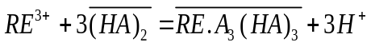 | (4)
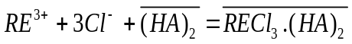 | (5)
 | (6)
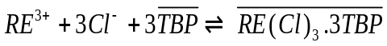 | (7)
Considering that the extraction mechanism of cationic extractants such as PC 88A, Cyanex 572, and Cyanex 272 is extraction of cations which releases H⁺ to the solution, RE³⁺ will be extracted by the extractant only systems based on Eq. 4. The extraction of species with TBP is based on solvation mechanism as represented in Eq. 7. As a result, the presence of TBP in the organic phase triggers solvation mechanism of Eq. 7 which does not include any H⁺ release. Moreover, when TBP was introduced to the organic phase, as shown in Eq. 6, the main extractant ([HA]₂) may also coordinate with TBP for extraction of RE³⁺ cations, leading to reducing the number of available [HA]₂ molecules in the organic phase. Hence, a lower amount of H⁺ was released when TBP was incorporated.

Reviewer: 3

Comments to the Author
1. In the Introduction, authors should summary the processes of separations rather than listing the works directly. It should review the progress of this field, and the advantages and disadvantages of each method are analyzed.

Response: The field of REE separation encompasses a variety of methods, including ion exchange, solvent extraction, extraction by ionic liquids, fractional precipitation, and the application of metal-organic frameworks. In our recently published review paper [30], we dedicated an entire section to discussing the latest advancements in these areas. In that work we discussed and compared the following methods comprehensively: Solvent extraction (Saponification of extractant, Scrubbing the organic phase, Addition of complexing/buffering agent, Synergistic effect between extractants, Novel extractants), Ionic liquids, and other methods such as fractional crystallization, MOFs, and ion exchange. We also discussed the limitations and shortcomings of the separation of lanthanides, as per the following table:
Table 14. Limitations and shortcomings of the individual separation of lanthanides [30]
Area | Limitations and shortcomings
Chemical/physical similarity | Similar ionic radii, chemical properties, and electronic configuration, resulting in decreasing the selectivity of the method towards individual elements
Separation techniques | Difficulty in separating using traditional methods such as ion-exchange, precipitation or solvent extraction  Limited selectivity of available separation methods
Cost and complexity | High cost of reagents and equipment  Complexity of the separation process
Environmental impact | Some methods of separation are not environmentally friendly
Low yield and purity | Low yield and purity of the separated elements due to the challenges of individual separation
Alternative methods | Lack of alternative methods that can effectively separate the lanthanides
Technical expertise | High level of technical expertise required to operate the equipment or perform the separation process
Interference | Presence of other elements that interfere with the separation process
The current work focuses specifically on the solvent extraction separation of REEs, where we have explained the theory and mechanism of separation, incorporating the most recent reports in the field. For those interested in more detailed information on the various available methods, we have referred the reader to our review paper.

2. Following the Q1, the novelty of this work can be proposed based on the analysis of previous separation methods. Therefore, the novelty of this article is not clear.

Response:

We acknowledge the well-established application of solvent extraction method in the recovery of elements, particularly REEs. Table 5 in the manuscript highlights the limited number of studies focused on LREE effective separation.
Table 5. Comparison of solvent extraction separation results for LREEs by organophosphorus extractants between literature findings and the outcomes of this study
Extraction system | Best separation results achieved | Reference
Cyanex 572 | β_{Pr/La}=13.4, β_{Nd/La}=21.6, β_{Nd/Pr}=1.6 | [1]
PC 88A | β_{Ce/La}=56.3, β_{Nd/La}=12.1 | [2]
Cyanex 572+TBP | β_{Pr/Sm}=3.02, β_{Nd/Sm}=3.01 | [3]
CA12+Cyanex 301 | β_{La/Ce}=0.19, β_{La/Pr}=0.3, β_{La/Nd}=0.13, β_{La/Sm}=0.47, β_{Ce/Pr}=1.62, β_{Ce/Nd}=0.7, β_{Ce/Sm}=2.52, β_{Pr/Nd}=0.43, β_{Pr/Sm}=1.56, β_{Nd/Sm}=3.62 | [4]
Aliquat 336+PC 88A | β_{La/Ce}=2.03, β_{La/Pr}=2.62, β_{La/Nd}=24.9, β_{La/Sm}=117, β_{Ce/Pr}=1.29, β_{Ce/Nd}=12.3, β_{Ce/Sm}=57.7, β_{Pr/Nd}=9.53, β_{Pr/Sm}=44.7, β_{Nd/Sm}=4.7 | [5]
Cyanex 572  PC 88A | β_{Ce/La}=1.53, β_{Pr/Ce}=0.91, β_{Nd/Pr}=0.51, β_{Sm/Nd}=2.59  β_{Ce/La}=2.21, β_{Pr/Ce}=0.63, β_{Nd/Pr}=1.06, β_{Sm/Nd}=2.22 | [6]
PC 88A+Cyanex 272 | β_{Pr/Ce}=2.1, β_{Nd/Pr}=1.59, β_{Sm/Nd}=12.5 | [7]
D2EHPA  PC 88A | β_{Ce/La}=4.5, β_{Pr/La}=13.9, β_{Nd/La}=14.4, β_{Sm/La}=42.1  β_{Ce/La}=7.3, β_{Pr/La}=13.5, β_{Nd/La}=15.0, β_{Sm/La}=149.8 | [8]
Cyanex 272 | β_{Nd/Pr}=5.1, β_{Didymium/La}>100 | [9]
PC 88A | β_{Nd/Pr}=13, β_{Pr/La}=39 | [10]
8-Hydorquinoline+PC 88 A | β_{Nd/Pr}=7.03, β_{Nd/La}=16 | [11]
Cyanex 301 | β_{La/Ce}=1.04, β_{Ce/Nd}=1.65, β_{Ce/Pr}=1.62, β_{La/Pr}=1.06, β_{Pr/Nd}=1.62, β_{La/Nd}=1.72 | [4]
PC 88 A | β_{Pr/La}=13.7 | [12]
D2EHPA + Cyanex 272 | β_{Didymium/La}=14.4 | [13]
Cyanex 572+TBP  PC 88A+TBP | β_{Ce/La}=12, β_{Nd/La}=87, β_{Pr/La}=127, β_{Sm/La}=3191  β_{Sm/Ce}=54, β_{Sm/Nd}=20, β_{Sm/Pr}=14 | This work

A significant gap in the field is the lack of comprehensive research comparing different extractants for the effective separation of these elements. This study introduces several well-known extractants used in the REEs separation industry and provides guidelines for researchers aiming to conduct similar investigations. By explaining the extraction mechanisms and presenting a thorough analysis of the obtained data, we aim to assist readers in understanding the underlying reasons for the distinct extraction behaviors of La, Ce, Pr, Nd, and Sm when in contact with various organic extractants. Establishing all this information into a single, comprehensive work addresses a critical gap in literature.
Regarding pH control methods, as discussed in the introduction, buffering agents and saponification of extractants are the most commonly reported techniques in the literature. Both methods either require preliminary stages before the extraction process or introduce additional materials to the aqueous solution, potentially affecting the extraction behavior of the elements and increasing the overall process cost. Due to the high volume of wastewater generated, this method is being increasingly replaced by alternative techniques such as making use of synergistic effects between extractants [14]. We added relevant references with respect to these two methods:
To date, saponification of the extractant [12, 15] and the addition of buffering and complexing agents [10, 12, 16, 17] to the aqueous phase have been the most reported methods for pH control during solvent extraction. However, the gradual adjustment of pH through the incremental addition of a basic solution has received limited attention due to instrumental challenges, which is introduced and thoroughly investigated herein. (1. Introduction)
The comprehensive analysis of the organic systems in relation to the extraction behavior of the elements at both constant and varying pH, along with the detailed examination of results, reactions, and mechanisms, represents a significant contribution that has not been previously reported in the literature. Additionally, the exceptional separation factors achieved for the separation of Sm and the complete isolation of La from other REEs are noteworthy accomplishments of this study. Optimum separation factors were calculated with β_{Ce/La}=12, β_{Nd/La}=87, β_{Pr/La}=127, and β_{Sm/La}=3191 for the former, and β_{Sm/Ce}=54, β_{Sm/Nd}=20, and β_{Sm/Pr}=14 for the latter. Comparison of these results with the ones reported in literature presented in Table 5 above further showcases the value of this research.

3. This work is more like an experimental report rather than article. Fox example, the influencing mechanism of different pH values on the extraction is not clear without experimental support. More experiments or simulations should add to revealed to mentioned mechanism in this work.

Response: The findings of this research offer valuable insights for selecting extraction systems and designing experiments for the effective solvent extraction separation of LREEs from their mixtures. This study systematically evaluates the efficacy and extraction dynamics of eight solvent extraction systems, using both constant and variable pH methods. Regarding the relationship between pH and extraction, Eqs. 4 and 6 illustrate the extraction reaction, where three moles of H⁺ are released with the extraction of one mole of RE³⁺.
(4)
(6)
This release can simply be converted to pH changes (pH=-log[H⁺]). To explain the thermodynamic aspect of the reaction, the equilibrium constant equation (K_{eq}) for these two reactions is provided in Eqs. 9 and 10.
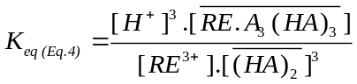 | (9)
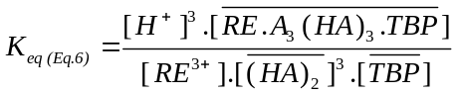 | (10)
As per Eq. 4 and Eq. 6, with each mole of RE(III) extracted by the organic phase, 3 moles of H⁺ are liberated into the aqueous solution. The equilibrium constants (K_{eq}) for Eq. 4 and Eq. 6 are represented by Eq. 9 and Eq. 10, respectively. The introduction of ammonia solution into the organic-aqueous mixture serves to neutralize the released H⁺ ions, thereby shifting the equilibrium position to the right to reestablish equilibrium according to Le Chatelier's principle. This phenomenon resulted in a higher extraction efficiency for all elements in the second series of experiments. The impact was less pronounced for systems containing TBP, likely due to the activation of the solvation mechanism described by Eq. 7, which does not involve release of H⁺ during extraction. (Section 3.2)
These equations demonstrate that increasing the pH (lower [H⁺]) shifts the equilibrium to the right, resulting in higher extraction efficiency, and vice versa. Additionally, Figure 3 shows the effect of different initial pH values on the pH change after extraction and establishes a relationship between these findings and extraction efficiency. The data indicate that greater variation in solution pH correlates with higher extraction efficiency, in line with the mechanisms described in Eqs. 4 and 6.
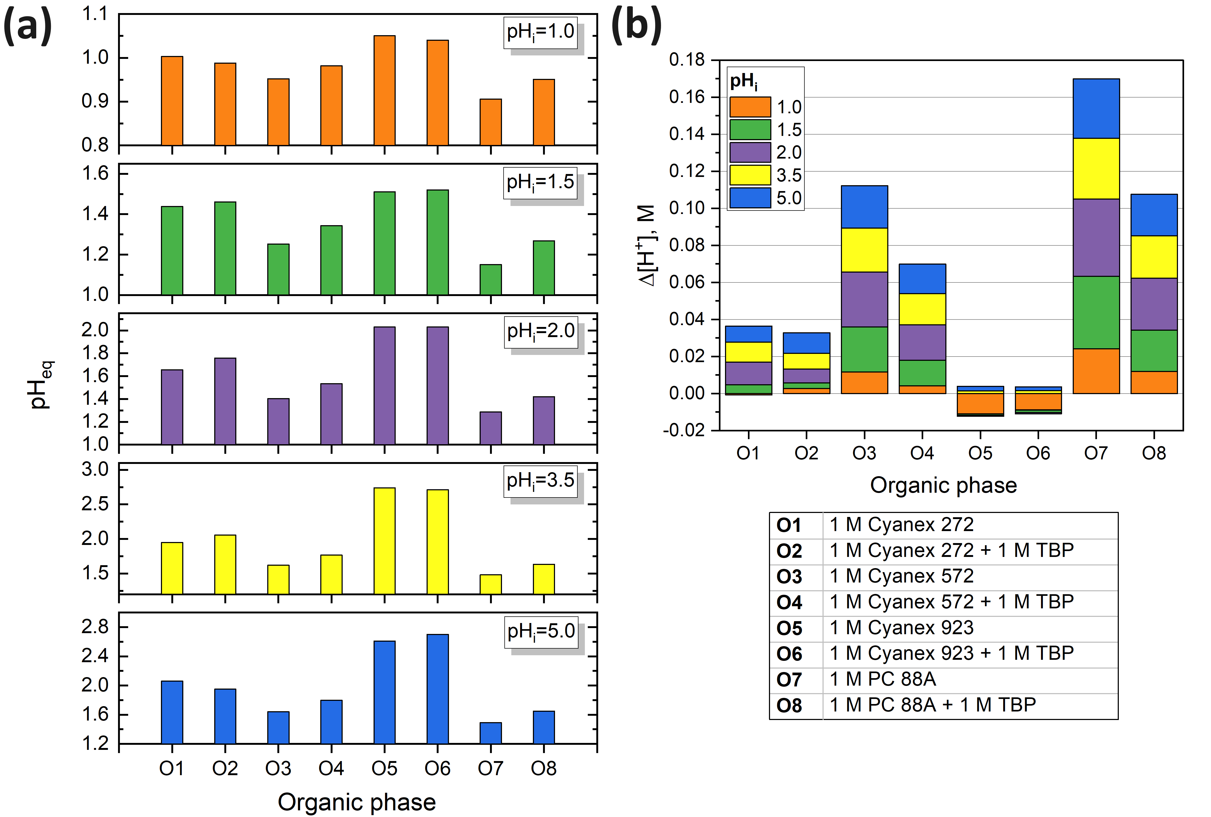
Figure 3. a) Variation of the equilibrium pH of the aqueous phases following solvent extraction experiments; b) Analysis of the changes in [H]⁺ after solvent extraction at varying pH levels

4. Could we obtain some universal rules of extraction by summarizing the experimental data?

Response: Regarding the extraction mechanism by cationic extractants, the theory is well established in the literature, and the governing equations for the process have been introduced. However, certain aspects of the solvent extraction technique remain inadequately understood due to their complexity. For instance, the influence of the extractant's molecular structure, type of diluent, type and concentration of ionic species, interactions between existing elements or species, the effect of impurities in the solution, and effect of ionic strength on the extraction process often lack clear explanations. These factors are frequently studied using trial-and-error methods or one-factor-at-a-time approaches. The aim of this research is to elucidate some of these complex aspects of REEs solvent extraction, and our goal is to provide insights that can assist both academic and industrial researchers in selecting suitable extraction systems and designing their operational parameters based on a comprehensive study in this area.
That said, regarding the current work, we reached some important discoveries that can be applied to the similar aqueous and organic systems (mentioned in the manuscript conclusions):
- Cyanex 923 is not a suitable candidate for REEs extraction in HCl medium.
- Extraction efficiency of all REEs in acidic media increases with increasing pH value
- The addition of TBP to Cyanex 272, Cyanex 572, and PC 88A significantly improves the separation factor between the elements.
- Heavy REEs can be separated from light REEs at highly acidic solutions (pH≤≈1.5).
- The most effective separation method for Ce is oxidative precipitation of Ce(III), where it is oxidized to Ce(IV) and is separated as Ce(OH)₄ at ≈3≤pH.
- Cyanex 572 and PC 88A in combination with TBP are the most suitable organic systems for the separation of adjacent LREEs.

5. Some related works are recommended to read for enhancing the background of this work. (1) https://doi.org/10.1007/s12598-018-1018-x; (2) https://doi.org/10.1007/s12598-023-02262-8; (3) 10.1016/j.pnsc.2023.12.014.

Response: We greatly appreciate the reviewer's suggestion. The proposed articles have enhanced our understanding of the topic, advanced separation techniques using MOFs, and further applications of REEs, which we believe will benefit our readers. We have incorporated these references into the introduction section to improve the quality of our work.

[1] Dzulqornain AM, Cueva-Sola AB, Chung KW, Lee J-Y, Jyothi RK. Strategy for possible separation of light rare earth elements (La, Ce, Pr, Nd) from synthetic chloride solutions by oxidative precipitation, solvent extraction and stripping. Hydrometallurgy. 2024;224:106242.
[2] Jha M, Choubey P, Dinkar O, Panda R, Jyothi R, Yoo K, et al. Recovery of Rare Earth Metals (REMs) from Nickel Metal Hydride Batteries of Electric Vehicles. Minerals. 2021;12:34.
[3] Dashti S, Sadri F, Shakibania S, Rashchi F, Ghahreman A. Separation and solvent extraction of rare earth elements (Pr, Nd, Sm, Eu, Tb, and Er) using TBP and Cyanex 572 from a chloride medium. Minerals Engineering. 2021;161:106694.
[4] Jia Q, Tong S, Li Z, Zhou W, Li H, Meng S. Solvent extraction of rare earth elements with mixtures of sec-octylphenoxy acetic acid and bis(2,4,4-trimethylpentyl) dithiophosphinic acid. Separation and Purification Technology. 2009;64:345-50.
[5] Guo L, Chen J, Shen L, Zhang J, Zhang D, Deng Y. Highly Selective Extraction and Separation of Rare Earths(III) Using Bifunctional Ionic Liquid Extractant. ACS Sustainable Chemistry & Engineering. 2014;2:1968-75.
[6] Wang Y, Li F, Zhao Z, Dong Y, Sun X. The novel extraction process based on CYANEX® 572 for separating heavy rare earths from ion-adsorbed deposit. Separation and Purification Technology. 2015;151:303-8.
[7] Quinn JE, Soldenhoff KH, Stevens GW, Lengkeek NA. Solvent extraction of rare earth elements using phosphonic/phosphinic acid mixtures. Hydrometallurgy. 2015;157:298-305.
[8] Acharya S, Mishra S, Misra PK. Studies on extraction and separation of La(III) with DEHPA and PC88A in petrofin. Hydrometallurgy. 2015;156:12-6.
[9] Kashi E, Habibpour R, Gorzin H, Maleki A. Solvent extraction and separation of light rare earth elements (La, Pr and Nd) in the presence of lactic acid as a complexing agent by Cyanex 272 in kerosene and the effect of citric acid, acetic acid and Titriplex III as auxiliary agents. Journal of Rare Earths. 2018;36:317-23.
[10] De Carvalho Gomes R, Seruff LA, Scal MLW, Vera YM. The Influence of Lactic Acid Concentration on the Separation of Light Rare Earth Elements by Continuous Liquid–Liquid Extraction with 2-Ethylhexyl Phosphonic Acid Mono-2-ethylhexyl Ester. Metallurgical and Materials Transactions B. 2018;49:460-5.
[11] Liu Y, Jeon HS, Lee MS. Separation of Pr and Nd from La in chloride solution by extraction with a mixture of Cyanex 272 and Alamine 336. Metals and Materials International. 2015;21:944-9.
[12] Scal MLW, Seruff LA, Vera YM. Study of the separation of didymium from lanthanum using liquid-liquid extraction: Comparison between saponification of the extractant and use of lactic acid. Minerals Engineering. 2020;148.
[13] Naeem AT, Kashi E, Salehi MA, Habibpour R. Extraction and separation of La(III), Pr(III) and Nd(III) using binary mixture of D2EHPA with Cyanex272, TOPO, and TBP extractants. Metallurgical Research & Technology. 2018;115:612.
[14] Krishnamurthy N, Gupta CK. Extractive Metallurgy of Rare Earths: CRC Press, Taylor & Francis Group; 2016.
[15] Qi D. Hydrometallurgy of Rare Earths: Extraction and Separation: Elsevier; 2018.
[16] Thiele NA, Fiszbein DJ, Woods JJ, Wilson JJ. Tuning the Separation of Light Lanthanides Using a Reverse-Size Selective Aqueous Complexant. Inorg Chem. 2020;59:16522-30.
[17] Sui N, Huang K. Separation of rare earths using solvent extraction consisting of three phases. Hydrometallurgy. 2019;188:112-22.
[18] Battsengel A, Batnasan A, Haga K, Shibayama A. Selective Separation of Light and Heavy Rare Earth Elements from the Pregnant Leach Solution of Apatite Ore with D2EHPA. Journal of Minerals and Materials Characterization and Engineering. 2018;06:517-30.
[19] Vander Hoogerstraete T, Wellens S, Verachtert K, Binnemans K. Removal of transition metals from rare earths by solvent extraction with an undiluted phosphonium ionic liquid: separations relevant to rare-earth magnet recycling. Green Chemistry. 2013;15:919-27.
[20] Larsson K, Binnemans K. Separation of Rare Earths by Solvent Extraction with an Undiluted Nitrate Ionic Liquid. Journal of Sustainable Metallurgy. 2017;3:73-8.
[21] Kim D, Powell LE, Delmau LH, Peterson ES, Herchenroeder J, Bhave RR. Selective Extraction of Rare Earth Elements from Permanent Magnet Scraps with Membrane Solvent Extraction. Environmental Science & Technology. 2015;49:9452-9.
[22] Yao Y, Farac NF, Azimi G. Supercritical Fluid Extraction of Rare Earth Elements from Nickel Metal Hydride Battery. ACS Sustainable Chemistry & Engineering. 2018;6:1417-26.
[23] Yao Y, Farac NF, Azimi G. Recycling of Rare Earth Element from Nickel Metal Hydride Battery Utilizing Supercritical Fluid Extraction. ECS Transactions. 2018;85:405-15.
[24] Iloeje CO, Xavier AS, Graziano D, Atkins J, Sun K, Cresko J, et al. A systematic analysis of the costs and environmental impacts of critical materials recovery from hybrid electric vehicle batteries in the U.S. iScience. 2022;25:104830.
[25] Li Z, Diaz LA, Yang Z, Jin H, Lister TE, Vahidi E, et al. Comparative life cycle analysis for value recovery of precious metals and rare earth elements from electronic waste. Resources, Conservation and Recycling. 2019;149:20-30.
[26] Ren P. RECOVERY OF RARE EARTH ELEMENTS (REES) FROM COAL MINE DRAINAGE SLUDGE LEACHATE.
[27] Dong Z, Mattocks JA, Deblonde GJ-P, Hu D, Jiao Y, Cotruvo Jr JA, et al. Bridging hydrometallurgy and biochemistry: A protein-based process for recovery and separation of rare earth elements. ACS Central Science. 2021;7:1798-808.
[28] Fritz AG, Tarka TJ, Mauter MS. Technoeconomic assessment of a sequential step-leaching process for rare earth element extraction from acid mine drainage precipitates. ACS Sustainable Chemistry & Engineering. 2021;9:9308-16.
[29] Gergoric M, Ravaux C, Steenari B-M, Espegren F, Retegan T. Leaching and Recovery of Rare-Earth Elements from Neodymium Magnet Waste Using Organic Acids. Metals. 2018;8:721.
[30] Salehi H, Maroufi S, Mofarah SS, Nekouei RK, Sahajwalla V. Recovery of rare earth metals from Ni-MH batteries: A comprehensive review. Renewable Sustainable Energy Rev. 2023;178:113248.

