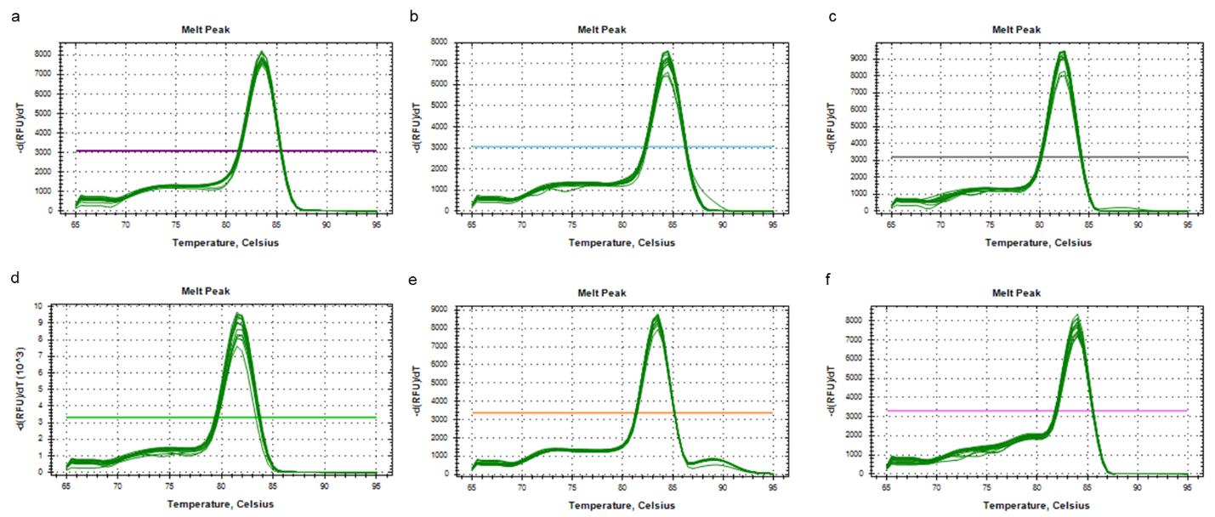
S1
Figure S1 The melt curve of inflammatory genes (a) gapdh; (b) iNOS; (c) tnf-α; (d) il-6; (e) il-1β; and (f) sod-2, during qRT-PCR of LPS-stimulated RAW 264.7 cells.
S2
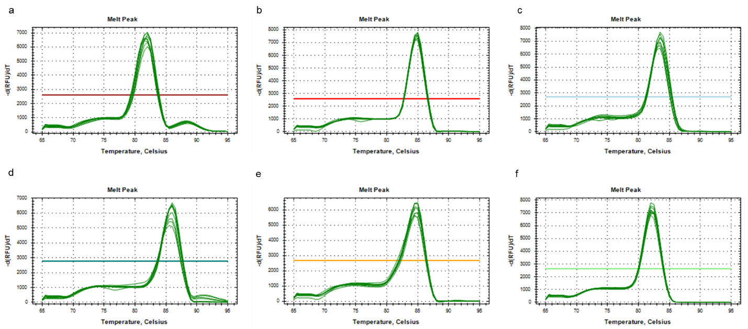
Figure S2 The melt curve of genes (a) ldh; (b) hcrR; (c) hcrA; (d) hcrB; (e) hcrC; and (f) ceh, during qRT-PCR of Lact. plantarum SN13T genes encoding housekeeping gene, transcription regulator, NADPH-dependent FMN reductase family protein, NADPH-dependent FMN reductase and hypothetical protein of hcrABC operon of reductase genes and cinnamoyl ester hydrolase, respectively, involved in the fermentation of Mentha extract.

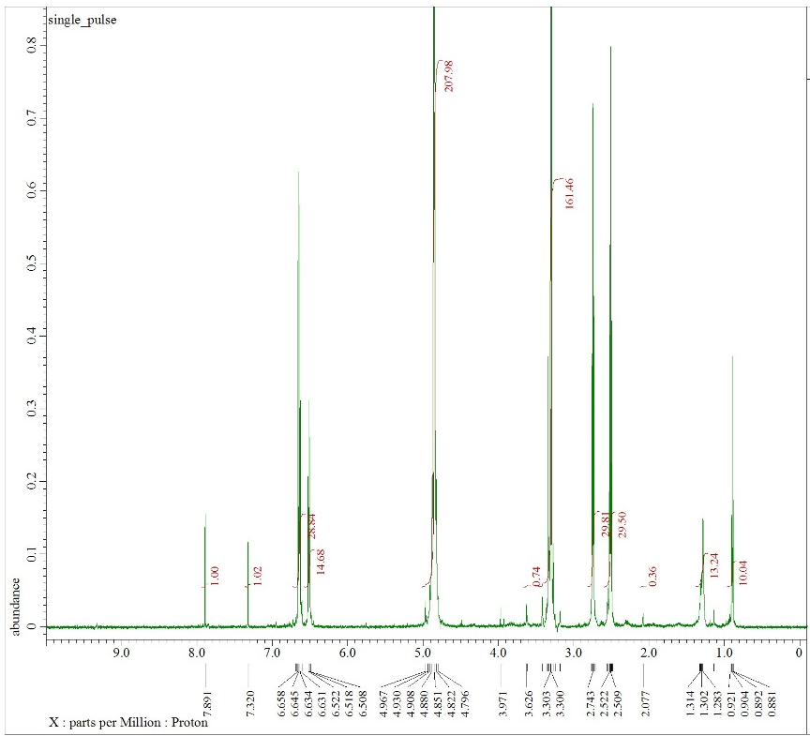
S3 (b)
S3 (a)

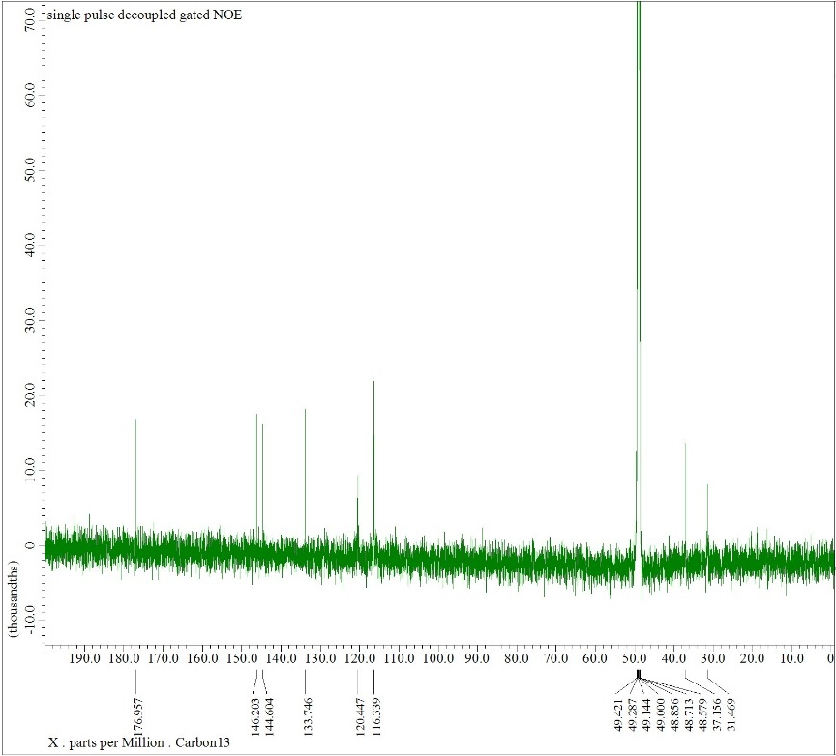
Figure S3 (a) ¹H-NMR spectra and (b) ¹³C-NMR spectra of Dihydrocaffeic acid, purified from fMA-SN13T

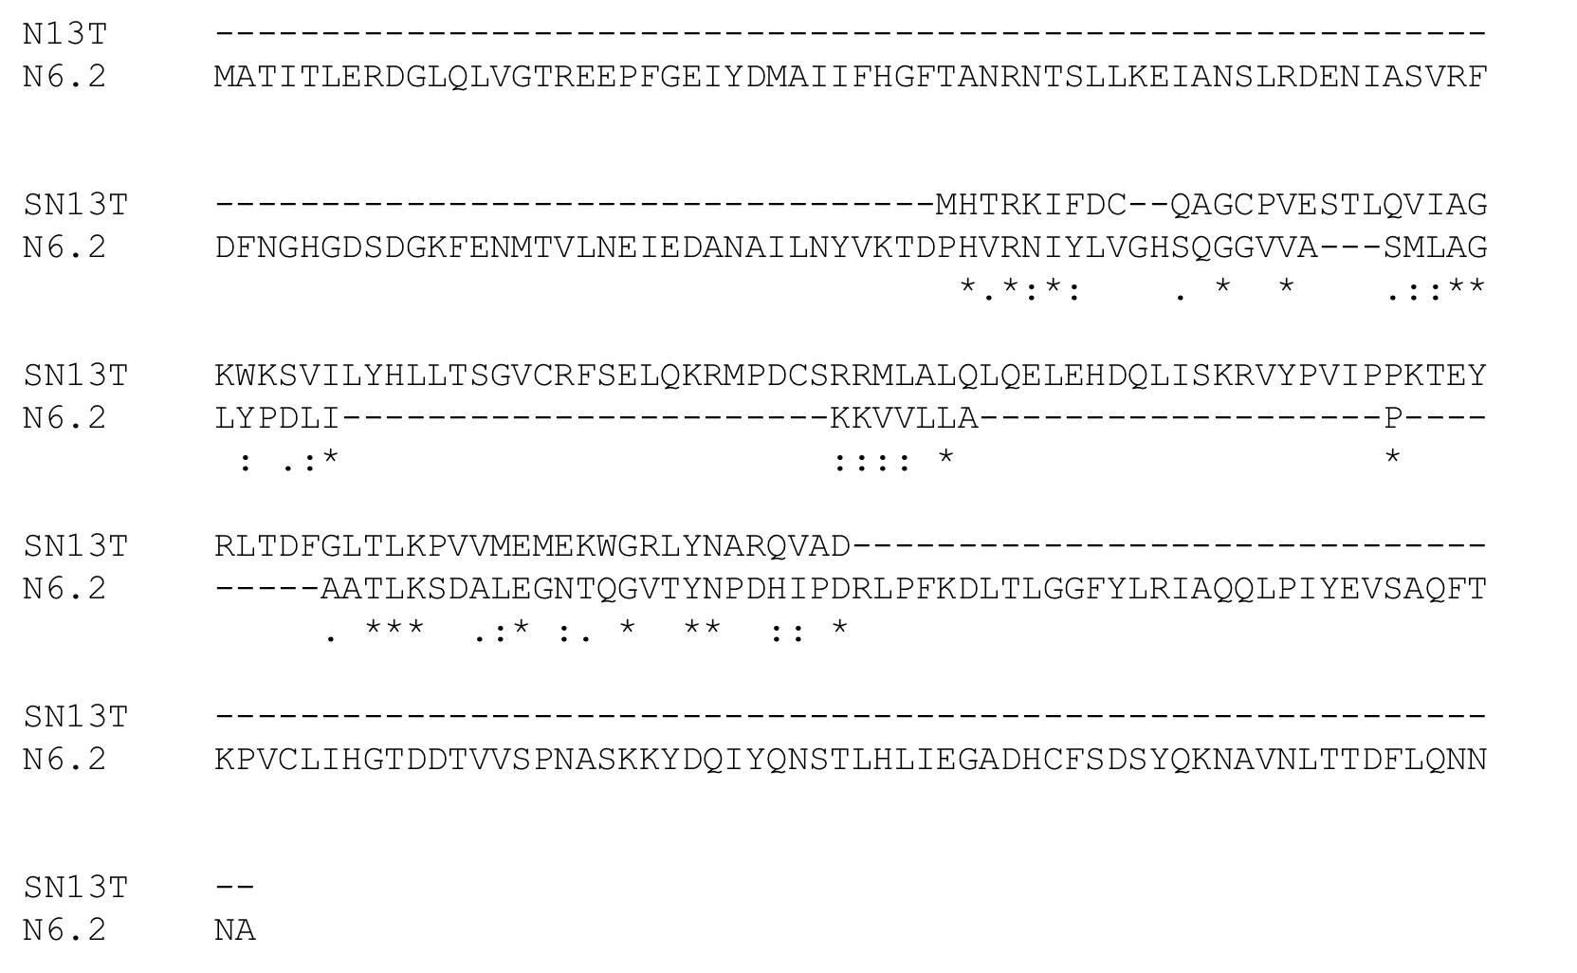
S4 (b)
S4 (a)

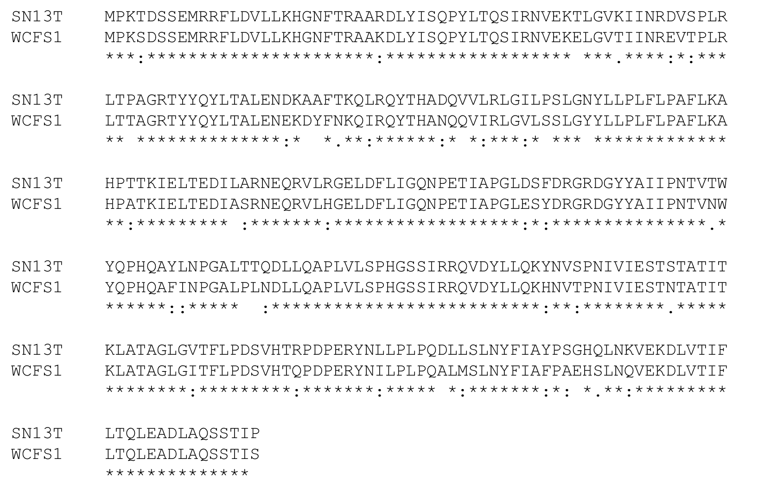

S4 (c)
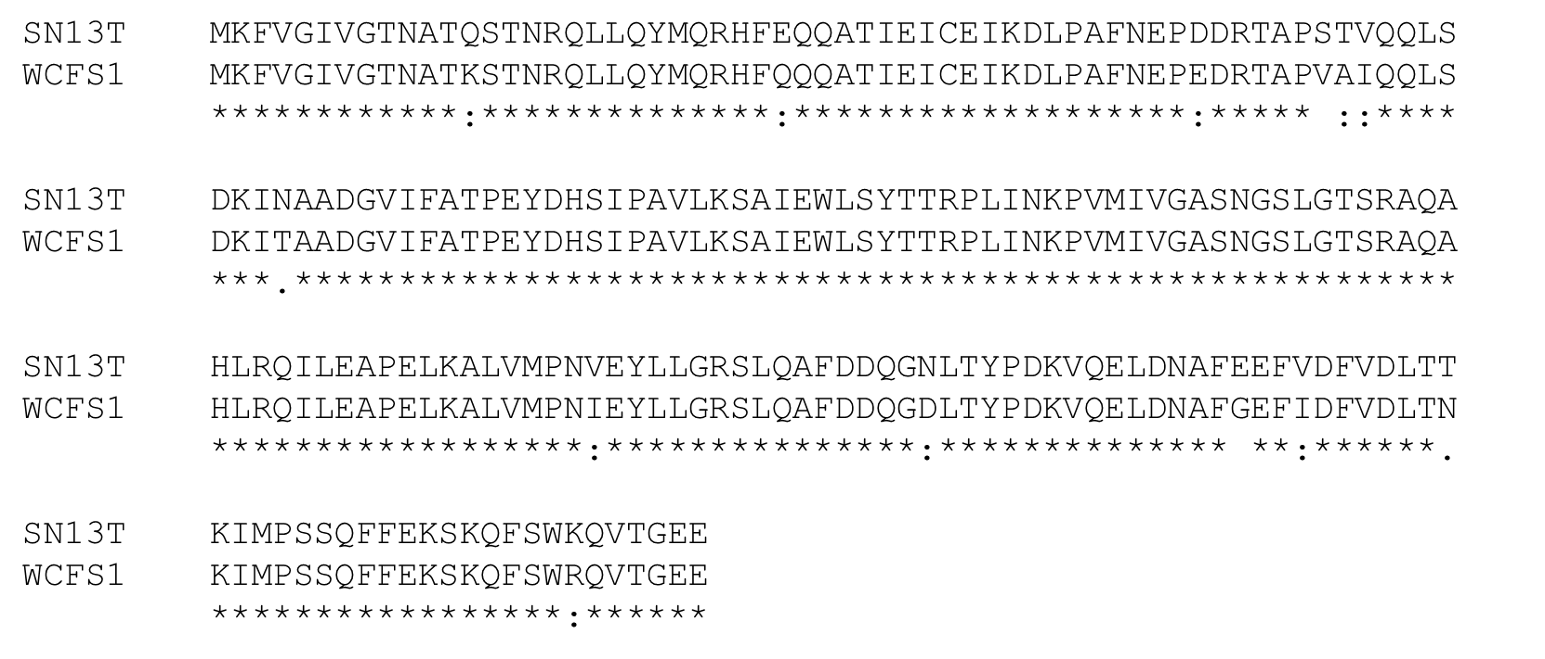
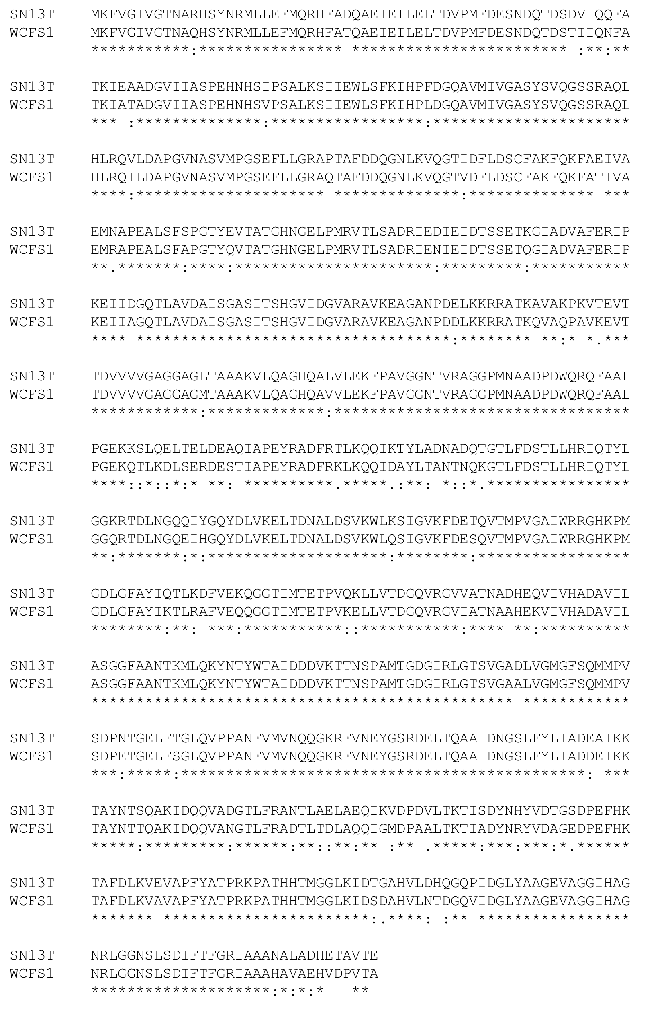
S4 (d)
S4 (e)

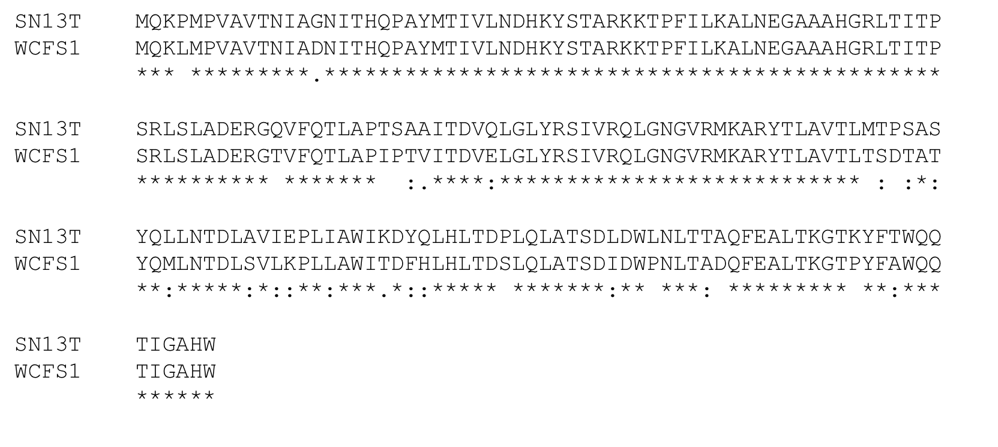
Figure S4 Comparison of amino acid sequences of putative (a) ceh (b) hcrR, (c) hcrA, (d) hcrB and (e) hcrC. Multiple alignments were done using the program ClustalOmega after retrieval of sequences from BLAST homology searches. Residues that are identical (*), conserved (:) or semiconserved (.) in all sequences are indicated. Dashes indicated gaps introduced to maximize similarities.

S5
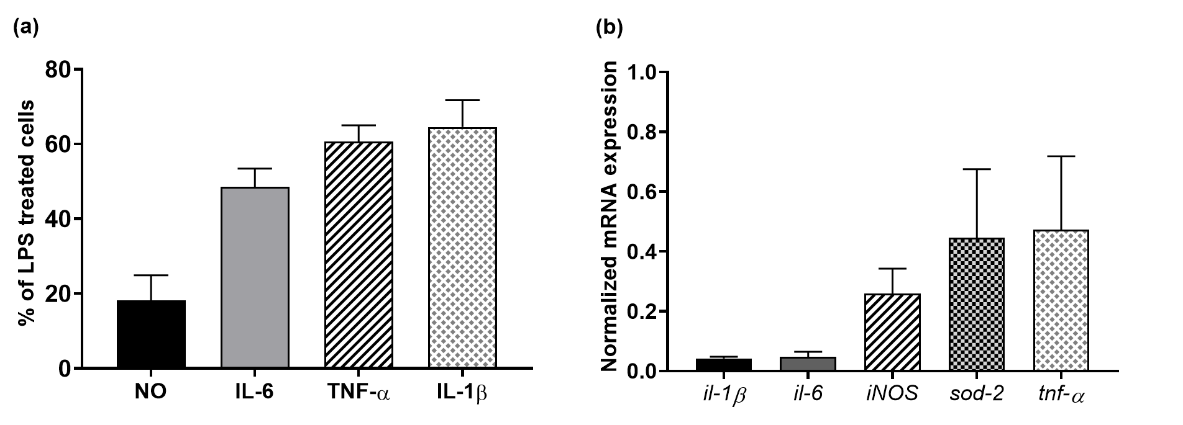
Figure S5 (a) The concentration of inflammatory mediators NO, IL-6, TNF-α and IL-1β in LPS-stimulated RAW 264.7 cells in presence of Dexamethasone (0.5 µg/ml), expressed as percentage of LPS only treated cells (%); (b) Normalized expressions of inflammatory genes il-1β, il-6, iNOS, sod-2 and tnf-α in LPS-stimulated RAW 264.7 cells in presence of Dexamethasone (0.5 µg/ml). Data are expressed as the mean value of triplicate experiments. Error bars represent +/- standard deviation. All data were significantly different, i.e., p < 0.05 vs LPS treated cells.

