S. Figure 11. Minimal inhibitory and minimal bactericidal concentrations of the cell-free supernatant of FiA2 against A. salmonicida (A-F). (1-2) LB broth without and with an inocula of A. salmonicida as negative and positive controls, respectively. (3-12) LB broth containing 4%, 8%, 12%, 13%, 14%, 15%, 16%, 17%, 18%, and 19% of cell-free supernatant of FiA2, respectively, and each of it is inoculated with 1% inoculum of A. salmonicidia. (B, C, and D) tubes 7, 8, and 9, respectively, spread on agar plates; the red arrows on plate C indicate the weak growth of A. salmonicida from the MIC tube. (E) Negative control (tube; 1) tube spread on agar plate. (F) Positive control tube (tube; 2) spread on agar plate.

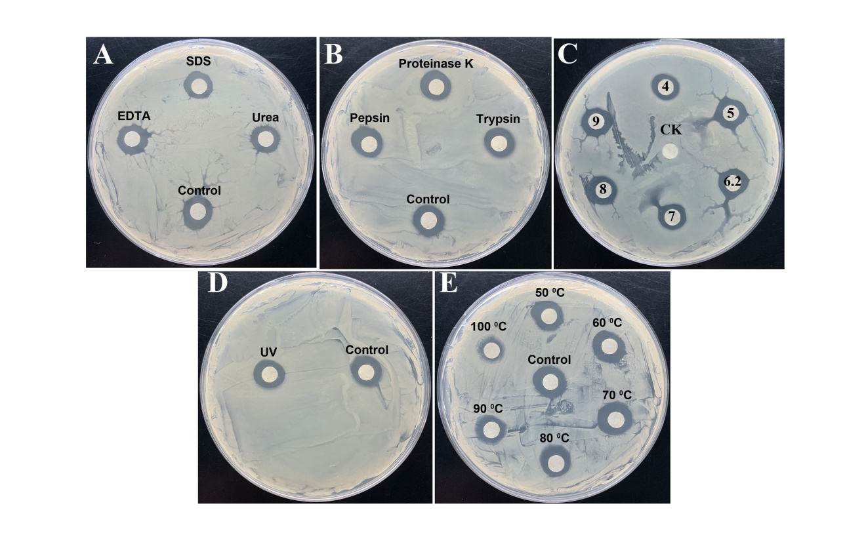
S. Figure. 12 Stability evaluation of bioactive compound of FiA2 by exposing to (A) chemicals, (B) proteases, (C) pH (D) UV, and (E) temperatures. (CK) negative control.

S. Figure 13. Antibacterial activity of 1-Butanol exract of FiA2 against the pathogenic strain. (1 and 2): the crude extract. (3) Sterilized distilled water as a negative control.

