Appendix A.
Supplementary data
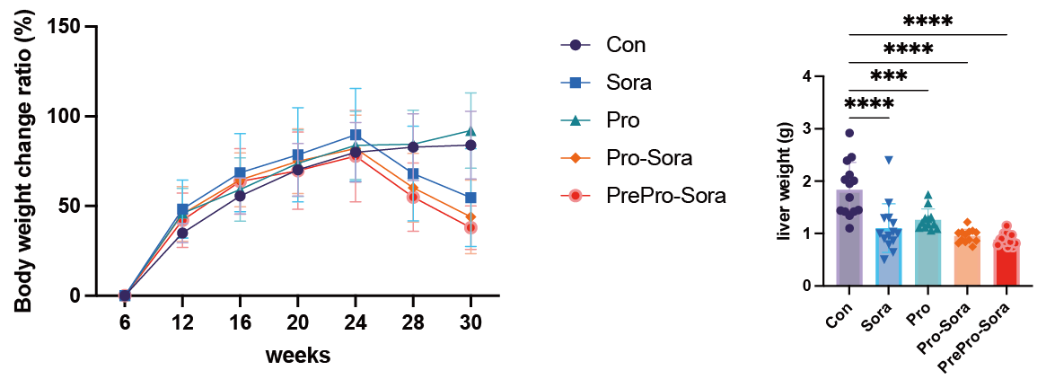
Supplementary Figure 1: Body weight and liver weight of MASLD-HCC mice
Data are presented as the mean ± SD. One-way ANOVA followed by Tukey’s multiple comparison tests were used among Con, Sora, Pro, Pro-Sora and PrePro-Sora groups. ∗p < 0.05; ∗∗p < 0.01; ∗∗∗p < 0.001, ∗∗∗∗p<0.0001.

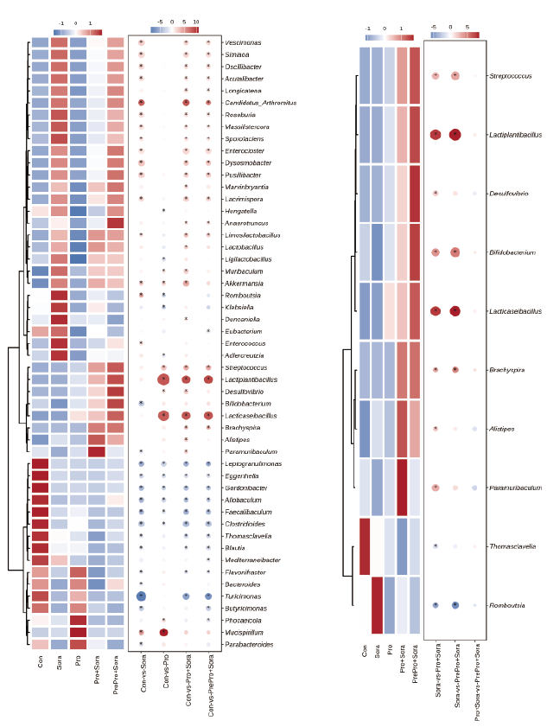
Supplementary Figure 2: Significantly alter genus compared to Con group and compared to Sora group
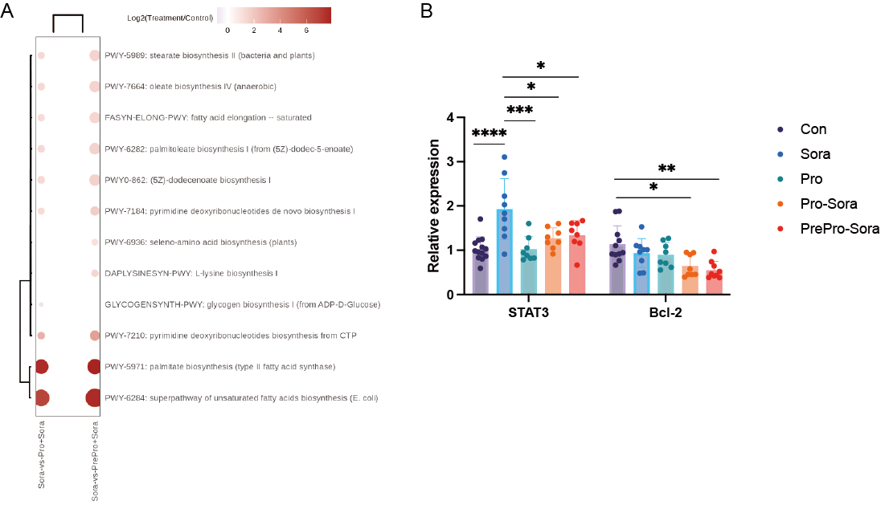
Supplementary Figure 3:
- Significantly enriched KEGG pathways generated from fecal metagenomic data
- Hepatic expression of STAT3 and BCL-2
Data are presented as the mean ± SD. One-way ANOVA followed by Tukey’s multiple comparison tests were used among Con, Sora, Pro, Pro-Sora and PrePro-Sora groups. ∗p < 0.05; ∗∗p < 0.01; ∗∗∗p < 0.001, ∗∗∗∗p<0.0001.

Supplementary Table 1. beta_adnois_pairwise analysis
Name | Compare | R2 | Fvalue | pvalue
Pair wise adnois2 | Pro+Sora and PrePro+Sora | 0.0317 | 0.7861 | 0.5694
Pair wise adnois2 | Sora and PrePro+Sora | 0.0806 | 2.2806 | 0.0473
Pair wise adnois2 | Pro and PrePro+Sora | 0.2868 | 9.6531 | 1E-04
Pair wise adnois2 | Sora and Pro+Sora | 0.071 | 1.8353 | 0.1089
Pair wise adnois2 | Pro and Pro+Sora | 0.2579 | 7.6442 | 1E-04
Pair wise adnois2 | Sora and Pro | 0.2407 | 7.6082 | 1E-04
Pair wise adnois2 | Con and PrePro+Sora | 0.2537 | 8.8372 | 1E-04
Pair wise adnois2 | Con and Pro+Sora | 0.2399 | 7.5748 | 1E-04
Pair wise adnois2 | Con and Sora | 0.1814 | 5.7615 | 1E-04
Pair wise adnois2 | Con and Pro | 0.2557 | 8.2445 | 1E-04

Supplementary Table 2: Primer sequence of RT-qPCR
Gene | Primer sequence
BCL-2 | GGTGGGGTCATGTGTGTGG | CGGTTCAGGTACTCAGTCATCC
FAS | CTGCCTTCGGTTCAGTCTCTT | CAGAATGGCACACCCTCCAA
CD36 | GTCCTGCTGTGTGA | GCTCAAAGATGCTCCATTG
ACC1 | AGTTCATGCTGCCCACATCC | GAGGTTGGAGGCAAAGGACAT
STAT3 | CATCCTGAAGCTGACCCAGG | TATTGCTGCAGGTCGTTGGT

Abbreviation
metabolic dysfunction-associated steatotic liver disease-associated hepatocellular carcinoma | MASLD-HCC
diethynitrosamine | DEN
high-fat high cholesterol diet | HFD
short-chain fatty acids | SCFAs
AMP-activated protein kinase | AMPK
phosphoinositide 3-kinases | PI3K
mechanistic Target of Rapamycin | mTOR
interleukin 17 | IL-17
hematoxylin and eosin | H&E
cleaved Caspase-3 | C-Casp3
immunohistochemistry | IHC
MASLD activity score | NAS
tumor necrosis factor-alpha | TNF-α
interleukin-1 | IL-1
interleukin-16 | IL-6
superoxide dismutase | SOD
glutathione | GSH
fatty acid synthase | FAS
acetyl-CoA carboxylase | ACC
heme oxygenase-1 | HO-1
forkhead box class O 3a | FOXO3A
principal coordinates analysis | PCoA
Oil red O | ORO
low-density lipoprotein cholesterol | LDL-C
high-density lipoprotein cholesterol | HDL-C
alanine aminotransferease | ALT
aspartate aminotransferase | AST
total cholesterol | TC
triglycerides | TG
colorectal cancer | CRC
lactic acid bacteria | LAB

