Recombinant NK1 protein and LEDs: an innovative strategy to counteract resistant Staphylococcus pseudintermedius and Pseudomonas aeruginosa strains
Probiotics and Antimicrobial Proteins
Silvia Di Lodovico^{1†*}, Valeria De Pasquale^{2†}, Francesca Paola Nocera², Morena Petrini³, Paola Di Fermo³, Firas Diban¹, Morena Pinti¹, Luisa De Martino², Simona Tafuri², Luigina Cellini¹, Mara Di Giulio¹, Simonetta D’Ercole³
¹Pharmacy Department, “G. d’Annunzio” University of Chieti-Pescara, Chieti, Italy.
²Veterinary Medicine and Animal Production Department, University of Naples Federico II, Naples, Italy.
³Medical, Oral and Biotechnological Sciences Department, University "G. d'Annunzio" of Chieti, Italy.
†These authors contributed equally to this work.

*Corresponding author: Silvia Di Lodovico, silvia.dilodovico@unich.it

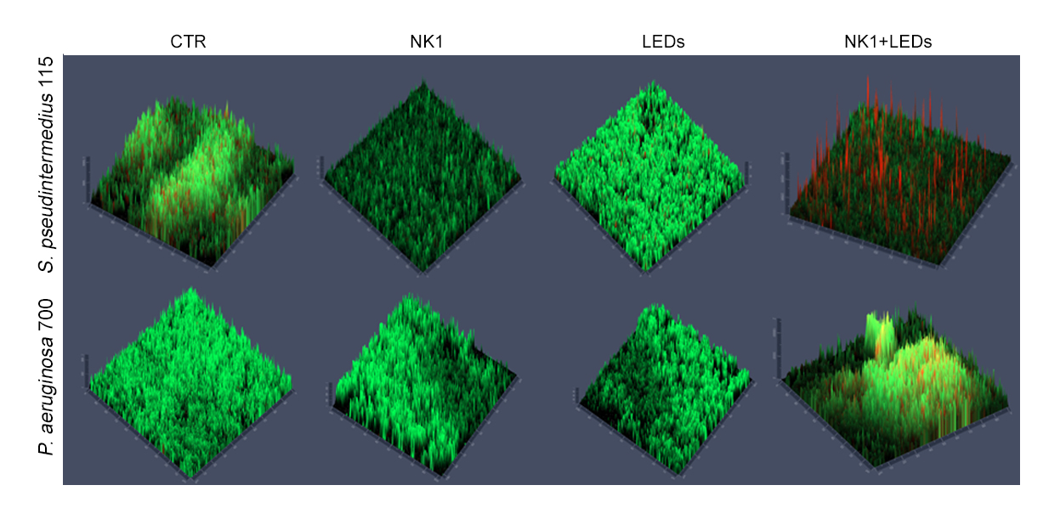
Fig. 1S Z-stack images of CLSM images of S. pseudintermedius and P. aeruginosa biofilms formation in presence of NK1 and LEDs alone and combined each other.

