Supplementary information
A novel strain Bifidobacterium longum subsp. longum HN001 ameliorates high fat diet-induced obesity in mice through microbiome-associated short-chain fatty acids

Chae Hwan Lee^{1,2,3}, Youngji Han^{3,4}, Joo Young Ryu^{1,2,3}, Minseo Jeong¹, Chae Rin Park⁵, Mi Ran Jang⁵, Youn Gil Kwak⁵, Hanvit Cha^{1,3,*}, Jin Hyup Lee^{1,2,3,*}

¹Department of Food and Biotechnology, Korea University, Sejong, Republic of Korea; ²BK21 FOUR Research Group for Omics-based Bio-health in Food Industry, Korea University, Sejong, Republic of Korea; ³Biological Clock-based Anti-aging Convergence RLRC, Korea University, Sejong, Republic of Korea; ⁴Bio-Medical Research Institute, Kyungpook National University Hospital, Daegu, Republic of Korea; ⁵Huons Foodience Co., Ltd,, Chungcheongnam-do , Republic of Korea

* These authors equally contributed to this work as corresponding authors.

Correspondence should be addressed to Hanvit Cha (chahv@korea.ac.kr) or Jin Hyup Lee (jinhyuplee@korea.ac.kr)
Primer list | Sequence (5’-3’)
Gapdh | Forward: CATCACTGCCACCCAGAAGACTG
Gapdh | Reverse: ATGCCAGTGAGCTTCCCGTTCAG
Fasn | Forward: CACAGTGCTCAAAGGACATGCC
Fasn | Reverse: CACCAGGTGTAGTGCCTTCCTC
Acaca | Forward: GTTCTGTTGGACAACGCCTTCAC
Acaca | Reverse: GGAGTCACAGAAGCAGCCCATT
Scd1 | Forward: GCAAGCTCTACACCTGCCTCTT
Scd1 | Reverse: CGTGCCTTGTAAGTTCTGTGGC
Srebf1 | Forward: CGACTACATCCGCTTCTTGCAG
Srebf1 | Reverse: CCTCCATAGACACATCTGTGCC
Lipe | Forward: GCTCATCTCCTATGACCTACGG
Lipe | Reverse: TCCGTGGATGTGAACAACCAGG
Cpt1a | Forward: GGCATAAACGCAGAGCATTCCTG
Cpt1a | Reverse: CAGTGTCCATCCTCTGAGTAGC
Acox1 | Forward: GCCATTCGATACAGTGCTGTGAG
Acox1 | Reverse: CCGAGAAAGTGGAAGGCATAGG
Pnpla2 | Forward: GGAACCAAAGGACCTGATGACC
Pnpla2 | Reverse: ACATCAGGCAGCCACTCCAACA
Cd137 | Forward: GGCCGTTTAGGAAAGGGACA
Cd137 | Reverse: CAGGAGTCATGCAGAGGCAA
Cited1 | Forward: GGTCTCCGGGATCTGTCTCT
Cited1 | Reverse: GAAGCTCATTGGCTCGGTCT
Ucp1 | Forward: GTGGTGAACCCGACAACTTCC
Ucp1 | Reverse: GGCCTTCACCTTGGATCTGAA
PPargc1a | Forward: GACCACAAACGATGACCCTCC
PPargc1a | Reverse: GCTGCGGTTGTGATGGGACT
Supplementary Table 1: Primer list
Sequences of Gapdh, Fasn, Acaca, Scd1, Srebf1, Lipe, Cpt1a, Acox1, and Pnpla2 primers were obtained from Origene (Rockville, MD, USA). Primers for Cd137, Cited1, Ucp1, and Ppargc1a were designed in-house. Primer efficiencies were validated using standard curve analysis: Cd137, 85.7%; Cited1, 92.5%; Ucp1, 91.1%; and Ppargc1a, 92.6%.

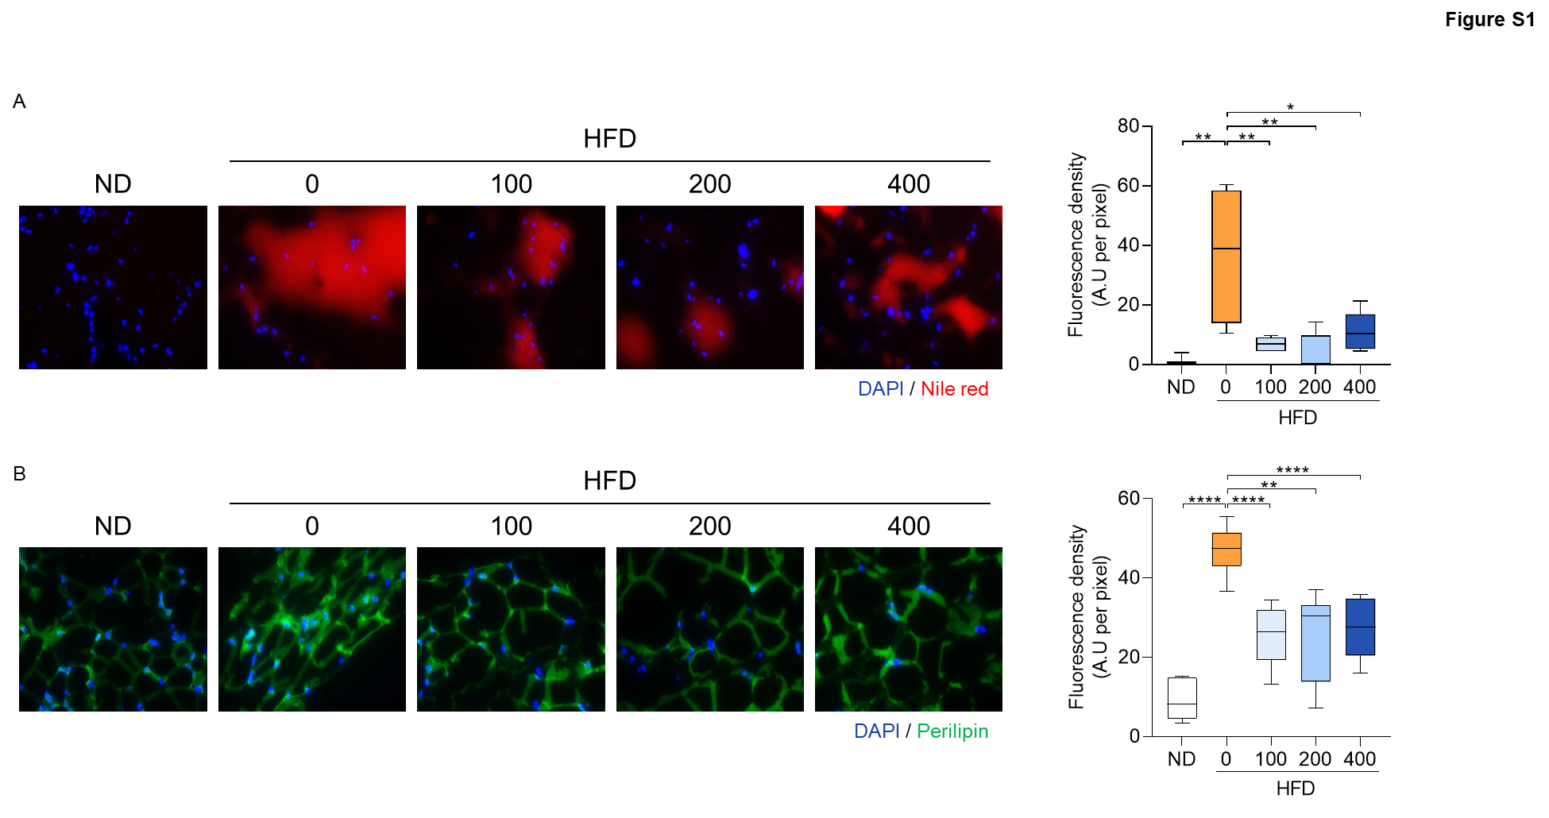
Supplementary Figure 1.
(A) Nile Red staining of white adipose tissue (WAT) sections (200x magnification) and corresponding quantitative analysis.
(B) Immunofluorescence staining of perilipin (green) with DAPI nuclear counterstain (blue) in WAT (200x magnification), along with quantification. All data are presented as mean ± SD; *p < 0.05, **p < 0.01, ***p < 0.001, ****p < 0.0001 (n = 6).
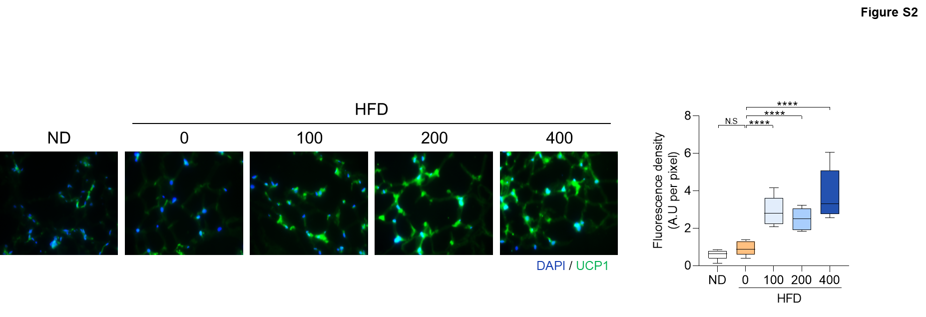Supplementary Figure 2.
Immunofluorescence staining of UCP1 (green) with DAPI nuclear counterstain (blue) in WAT (200x magnification), along with quantitative analysis, Data are presented as mean ± SD; N.S, not significant, ****p < 0.0001 (n = 6).
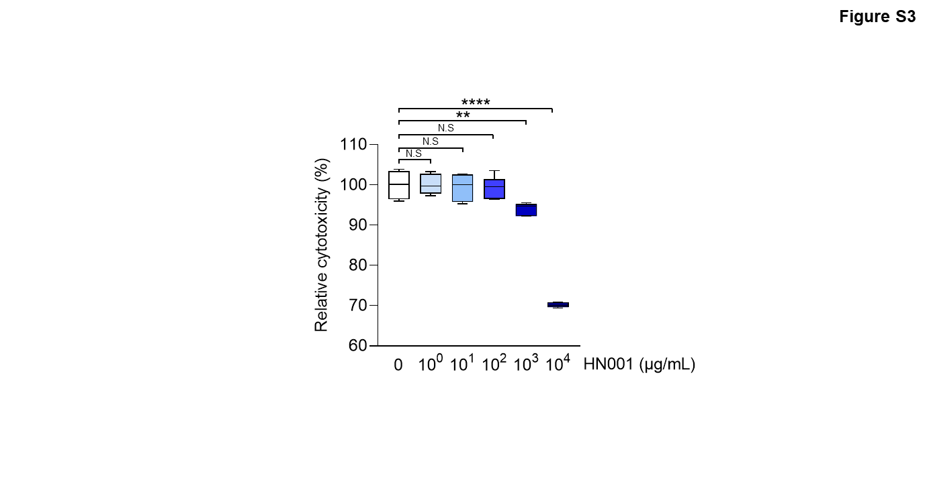 Supplementary Figure 3.
Cell viability following dose-dependent treatment with HN001, assessed using the WST-8 assay. Data are presented as mean ± SD; N.S., not significant, **p < 0.01, ****p < 0.0001 (n = 6).
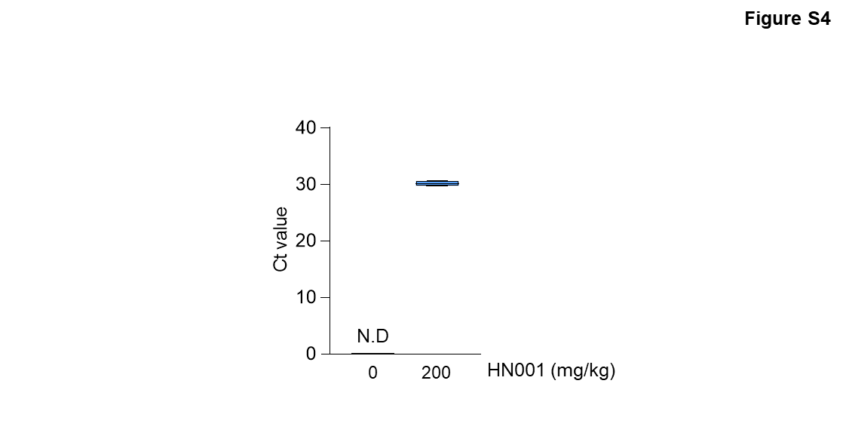
Supplementary Figure 4.
16S rDNA qRT-PCR analysis in the large intestine of mice. N.D, not detectable. Data are presented as mean ± SD (n = 6).

