Fig. S1. Binodal curve of PEG with different molecular weight versus sodium citrate

A) B) C)
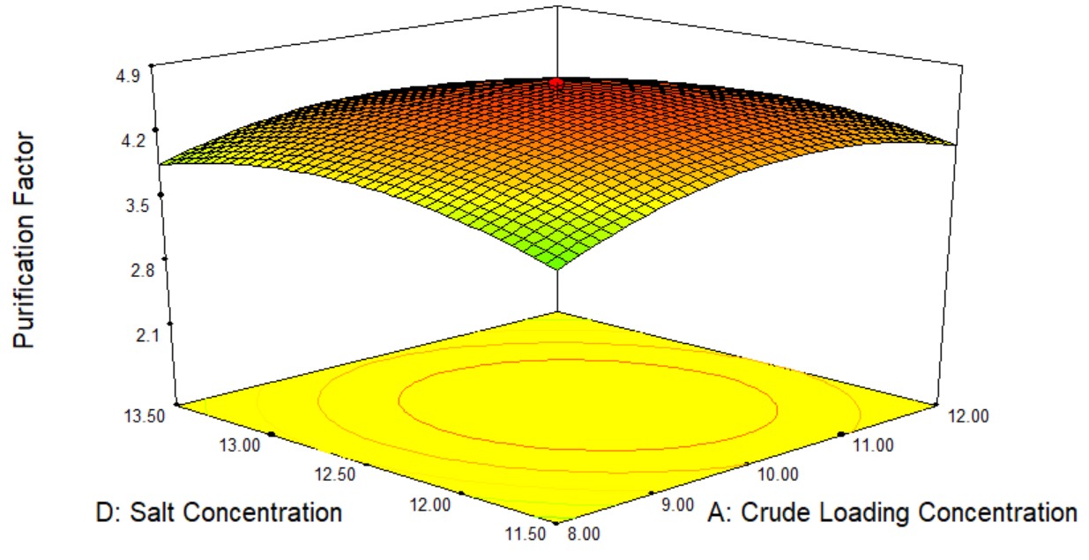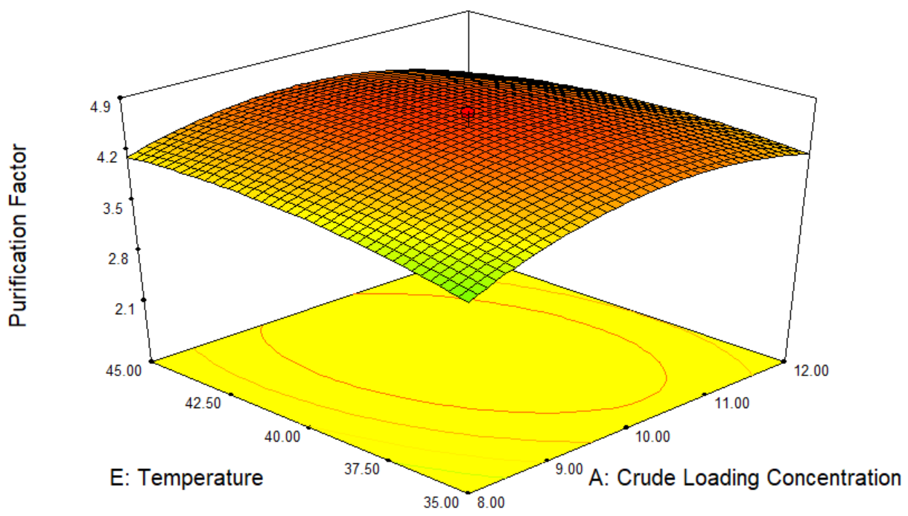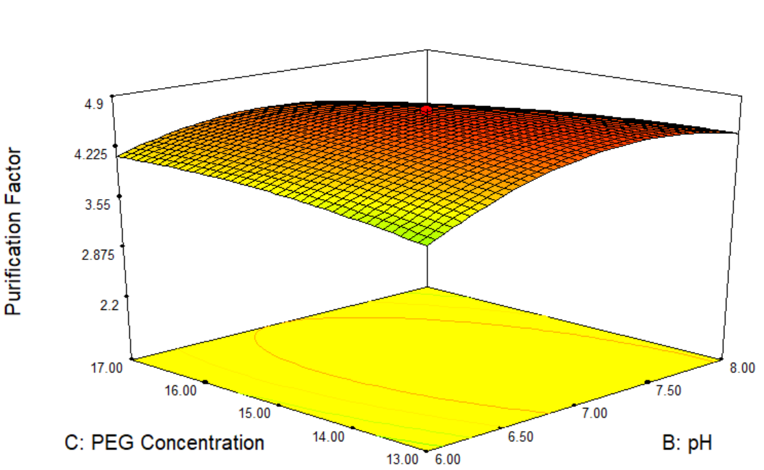

D) E) F)
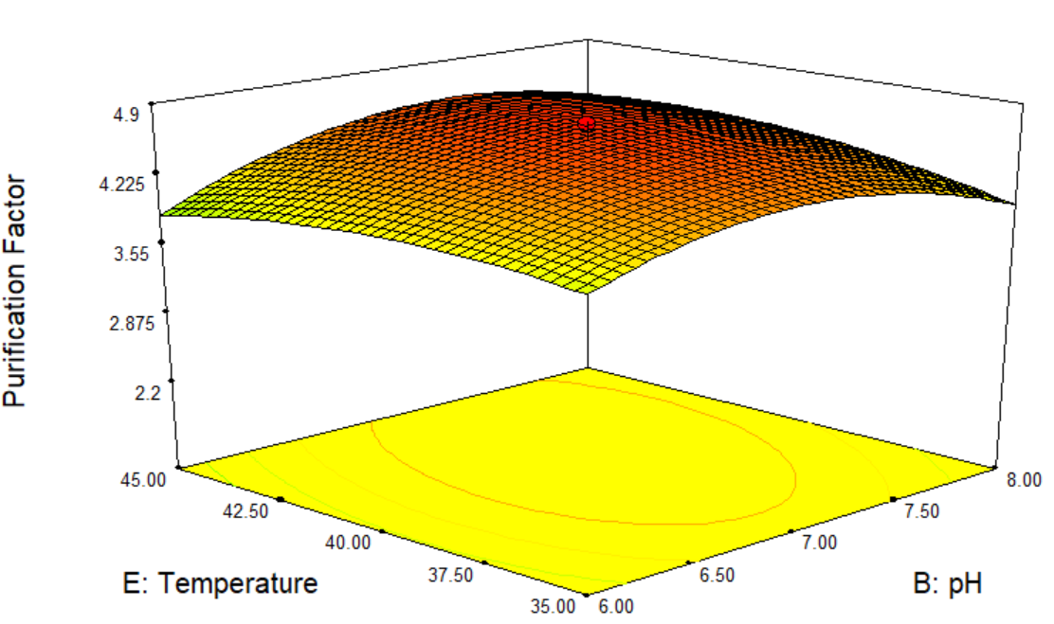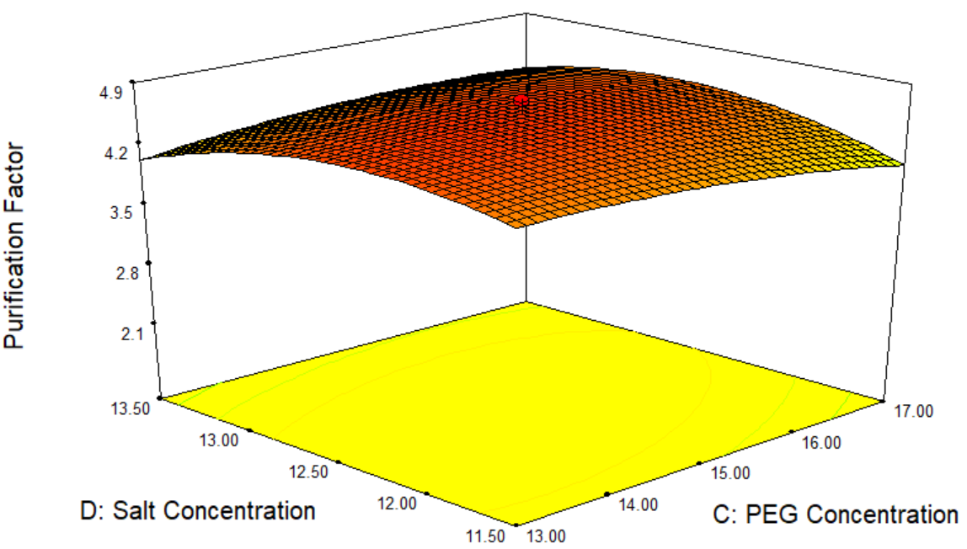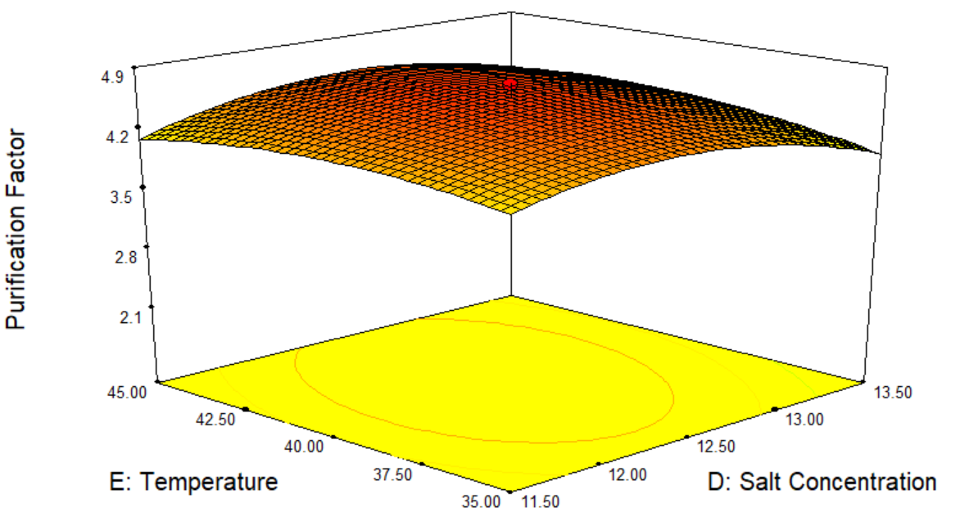

Fig. S2. 3D surface plot for purification factor obtained for the combination of A) Sodium citrate concentration and crude loading concentration, B) Temperature and crude loading concentration, C) PEG concentration and pH, D) Temperature and pH, E) PEG concentration and sodium citrate concentration, and F) Temperature and sodium citrate concentration

A) B) C)
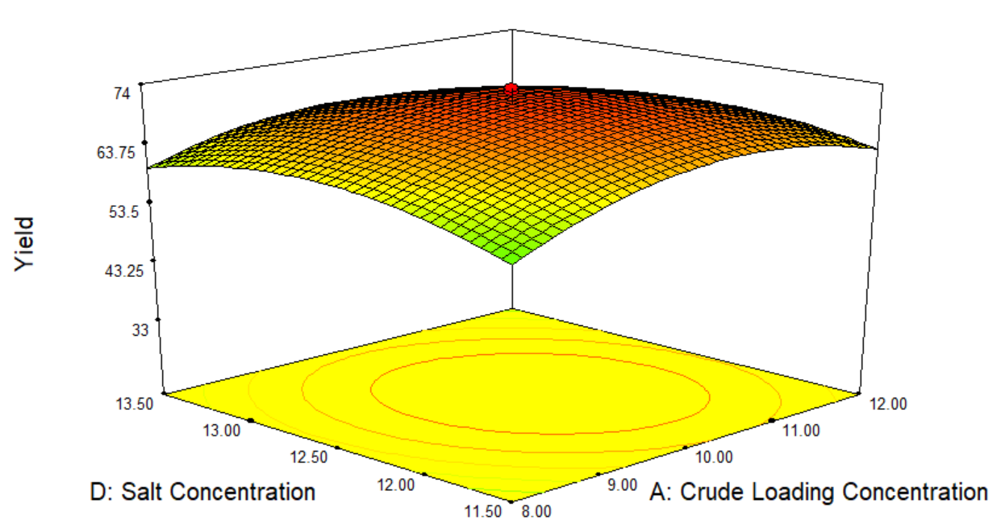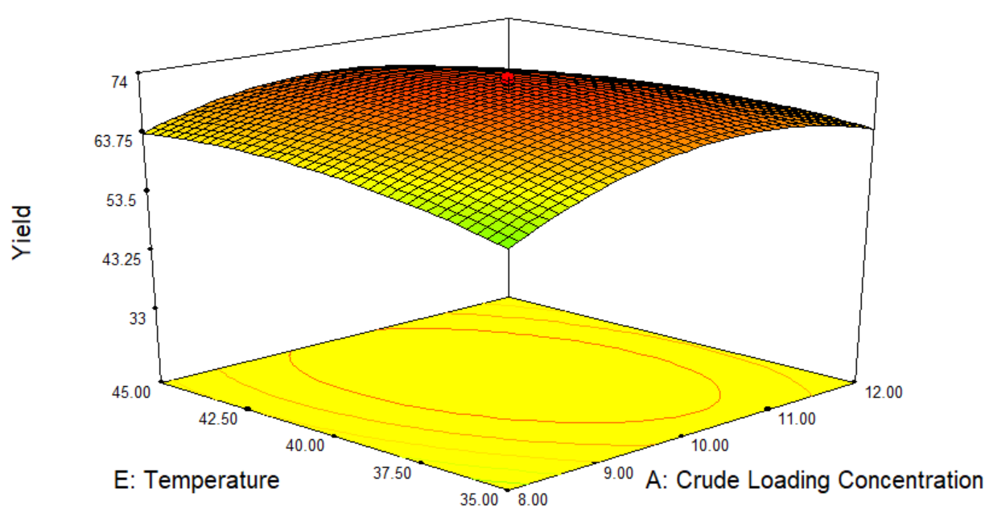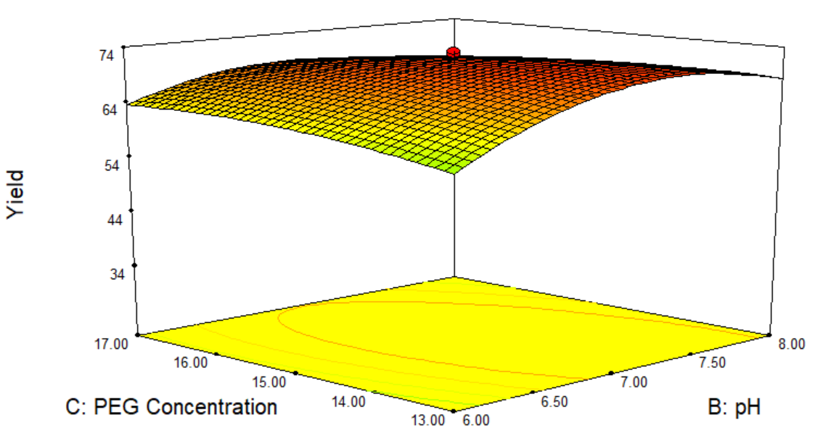

D) E) F)
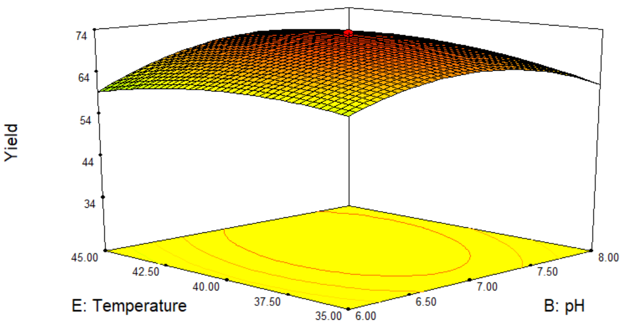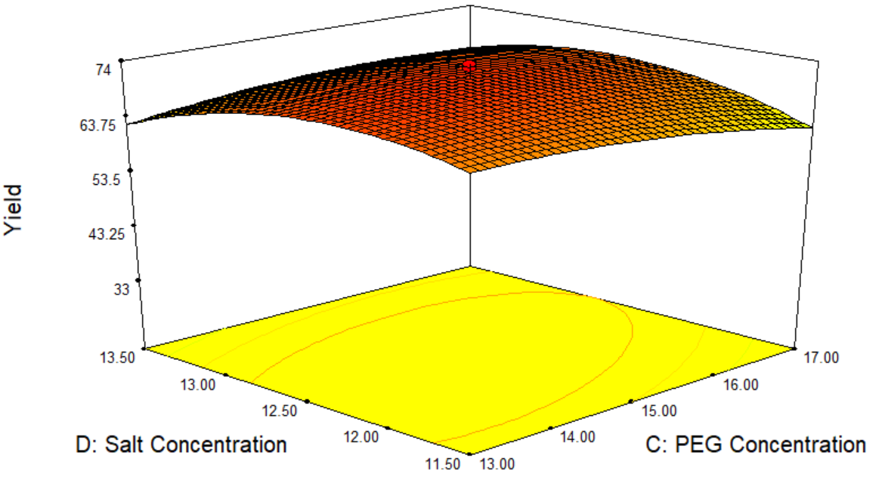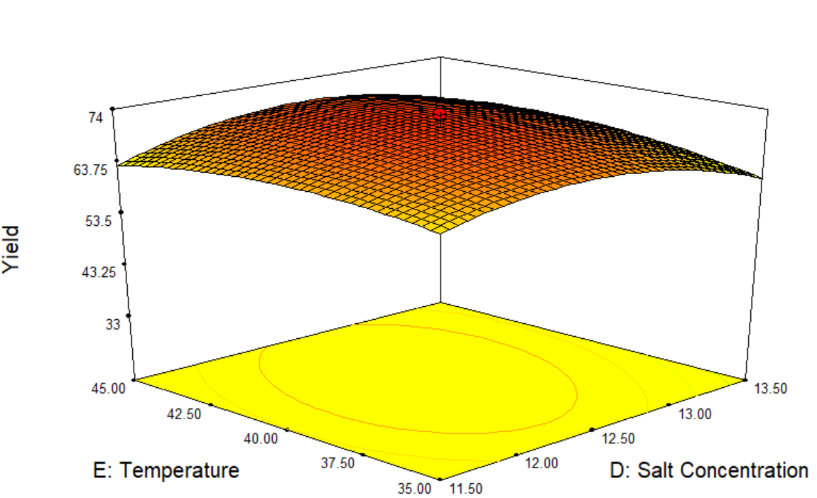

Fig. S3. 3D surface plot for recovery yield obtained for the combination of A) Sodium citrate concentration and crude loading concentration, B) Temperature and crude loading concentration, C) PEG concentration and pH, D) Temperature and pH, E) PEG concentration and sodium citrate concentration, and F) Temperature and sodium citrate concentration

A) B) C)
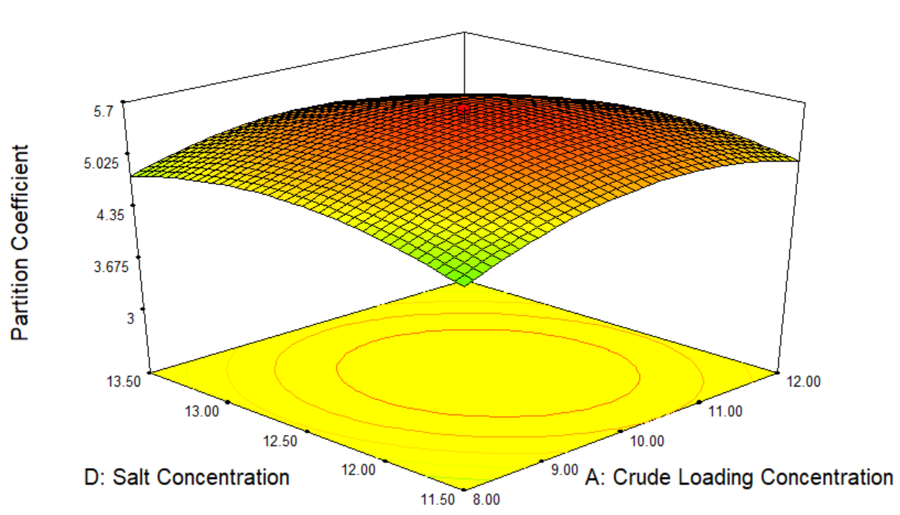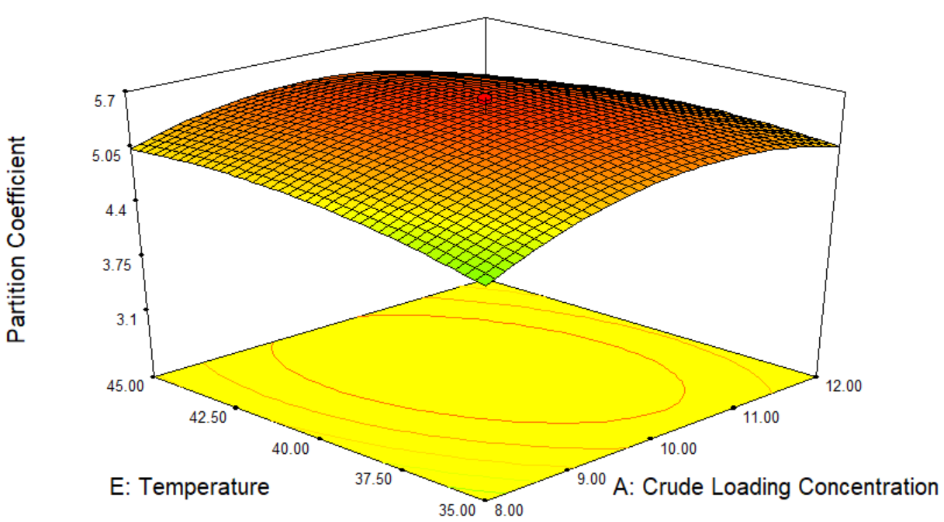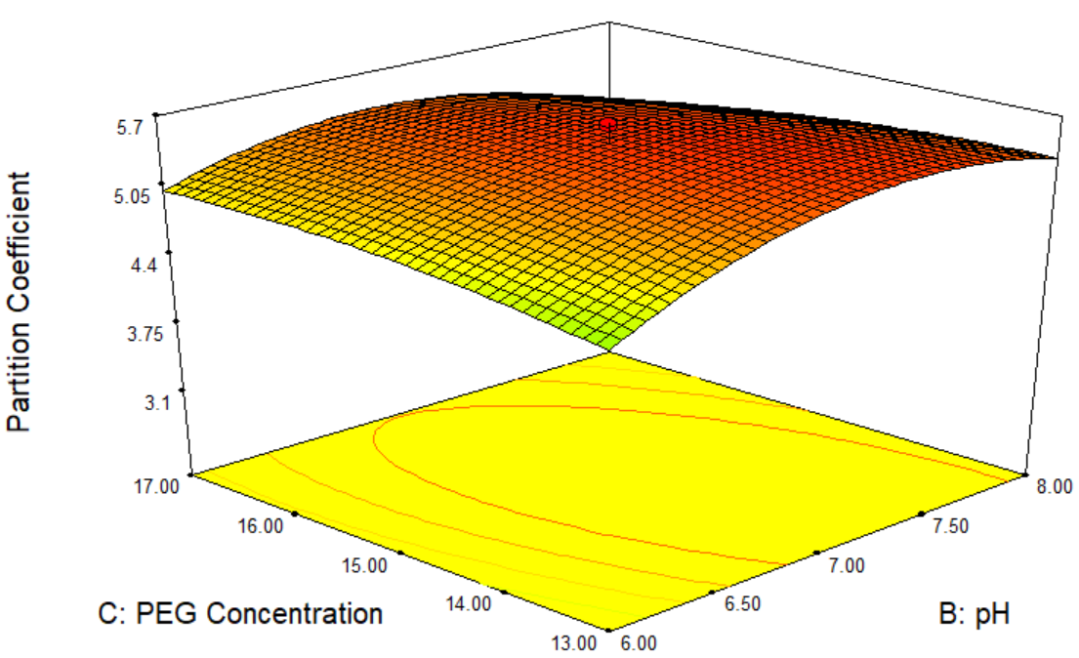

D) E) F)
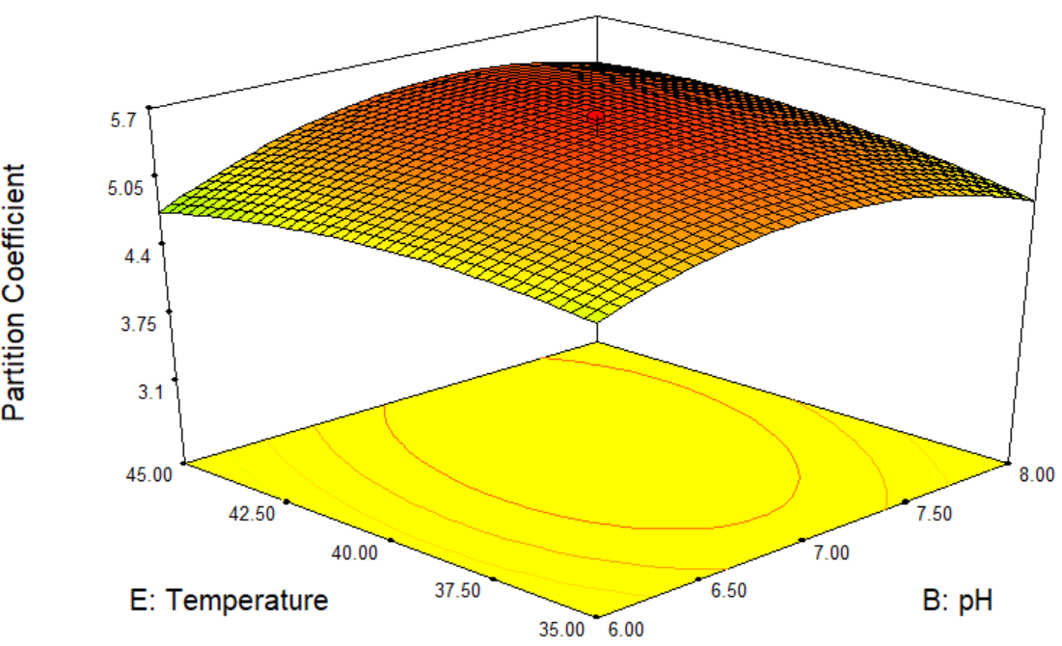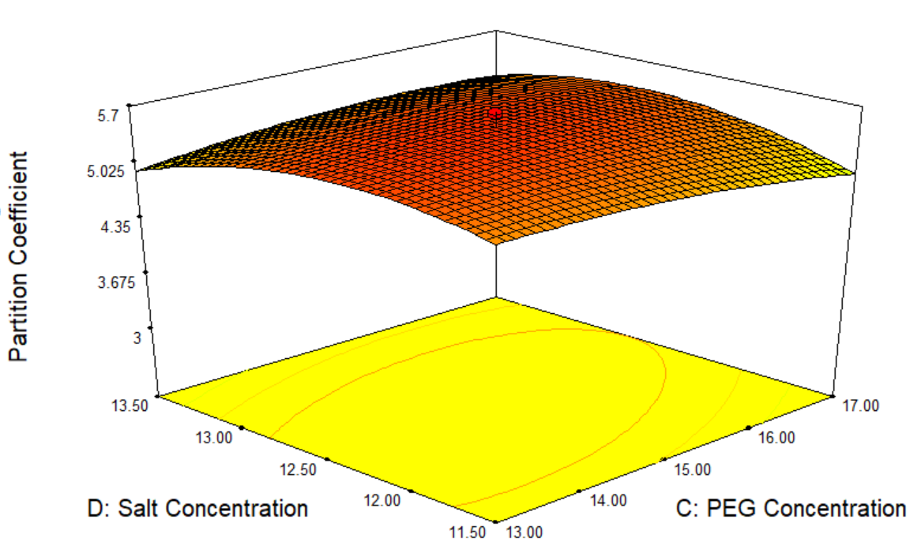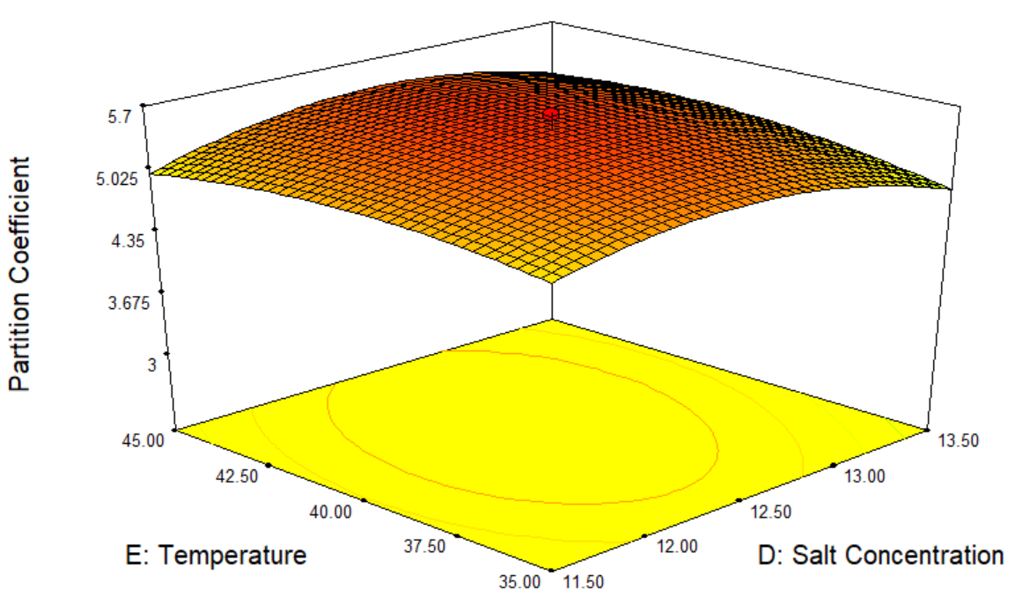

Fig. S4. 3D surface plot for partition coefficient obtained for the combination of A) Sodium citrate concentration and crude loading concentration, B) Temperature and crude loading concentration, C) PEG concentration and pH, D) Temperature and pH, E) PEG concentration and sodium citrate concentration, and F) Temperature and sodium citrate concentration

Table S1. ANOVA for two-level factorial model for (a) purification factor, (b) recovery yield, % and (c) partition coefficient, K when PEG 2000 was used
(a)
Source | Sum of square | Degree of freedom | Mean square | F-value | p-value
Model | 38.936 | 15 | 2.596 | 53.509 | < 0.0001ª
A | 1.125 | 1 | 1.125 | 23.181 | < 0.0001ª
B | 0.533 | 1 | 0.533 | 10.978 | 0.0014ª
C | 0.064 | 1 | 0.064 | 1.310 | 0.2557^{b}
D | 0.008 | 1 | 0.008 | 0.163 | 0.6879^{b}
E | 0.146 | 1 | 0.146 | 3.020 | 0.0860^{b}
AB | 4.494 | 1 | 4.494 | 92.634 | < 0.0001ª
AC | 8.961 | 1 | 8.961 | 184.723 | < 0.0001ª
AD | 0.823 | 1 | 0.823 | 16.971 | < 0.0001ª
AE | 8.149 | 1 | 8.149 | 167.989 | < 0.0001ª
BC | 4.937 | 1 | 4.937 | 101.768 | < 0.0001ª
BD | 1.129 | 1 | 1.129 | 23.270 | < 0.0001ª
BE | 1.235 | 1 | 1.235 | 25.465 | < 0.0001ª
CD | 0.655 | 1 | 0.655 | 13.503 | 0.0004ª
CE | 6.495 | 1 | 6.495 | 133.885 | < 0.0001ª
DE | 0.183 | 1 | 0.183 | 3.770 | 0.0556^{b}
Curvature | 12.532 | 1 | 12.532 | 258.332 | < 0.0001ª
Residual | 3.978 | 82 | 0.049
Lack of Fit | 0.940 | 16 | 0.059 | 1.276 | 0.2393^{b}
Pure Error | 3.038 | 66 | 0.046
Cor Total | 55.445 | 98
Std. Dev. | 0.220
R-Squared | 0.907
Adj R-Squared | 0.890
Pred R-Squared | 0.897
Adeq Precision | 43.669
(b)
Source | Sum of square | Degree of freedom | Mean square | F-value | p-value
Model | 4035.040 | 15 | 269.003 | 54.899 | < 0.0001ª
A | 112.537 | 1 | 112.537 | 22.967 | < 0.0001ª
B | 53.074 | 1 | 53.074 | 10.832 | 0.0015ª
C | 4.051 | 1 | 4.051 | 0.827 | 0.3659^{b}
D | 0.277 | 1 | 0.277 | 0.057 | 0.8125^{b}
E | 17.923 | 1 | 17.923 | 3.658 | 0.0593^{b}
AB | 463.585 | 1 | 463.585 | 94.610 | < 0.0001ª
AC | 901.968 | 1 | 901.968 | 184.078 | < 0.0001ª
AD | 75.225 | 1 | 75.225 | 15.352 | 0.0002ª
AE | 882.458 | 1 | 882.458 | 180.096 | < 0.0001ª
BC | 519.405 | 1 | 519.405 | 106.003 | < 0.0001ª
BD | 132.399 | 1 | 132.399 | 27.021 | < 0.0001ª
BE | 116.556 | 1 | 116.556 | 23.787 | < 0.0001ª
CD | 65.076 | 1 | 65.076 | 13.281 | 0.0005ª
CE | 675.433 | 1 | 675.433 | 137.845 | < 0.0001ª
DE | 15.073 | 1 | 15.073 | 3.076 | 0.0832^{b}
Curvature | 3693.687 | 1 | 3693.687 | 753.825 | < 0.0001ª
Residual | 401.794 | 82 | 4.900
Lack of Fit | 95.400 | 16 | 5.962 | 1.284 | 0.2338^{b}
Pure Error | 306.394 | 66 | 4.642
Cor Total | 8130.520 | 98
Std. Dev. | 2.214
R-Squared | 0.909
Adj R-Squared | 0.893
Pred R-Squared | 0.929
Adeq Precision | 59.973
(c)
Source | Sum of square | Degree of freedom | Mean square | F-value | p-value
Model | 38.922 | 15 | 2.595 | 53.583 | < 0.0001ª
A | 1.127 | 1 | 1.127 | 23.266 | < 0.0001ª
B | 0.531 | 1 | 0.531 | 10.966 | 0.0014ª
C | 0.064 | 1 | 0.064 | 1.323 | 0.2534^{b}
D | 0.008 | 1 | 0.008 | 0.159 | 0.6910^{b}
E | 0.146 | 1 | 0.146 | 3.009 | 0.0866^{b}
AB | 4.489 | 1 | 4.489 | 92.705 | < 0.0001ª
AC | 8.967 | 1 | 8.967 | 185.168 | < 0.0001ª
AD | 0.821 | 1 | 0.821 | 16.962 | < 0.0001ª
AE | 8.143 | 1 | 8.143 | 168.159 | < 0.0001ª
BC | 4.932 | 1 | 4.932 | 101.851 | < 0.0001ª
BD | 1.131 | 1 | 1.131 | 23.355 | < 0.0001ª
BE | 1.238 | 1 | 1.238 | 25.556 | < 0.0001ª
CD | 0.653 | 1 | 0.653 | 13.493 | 0.0004ª
CE | 6.490 | 1 | 6.490 | 134.009 | < 0.0001ª
DE | 0.182 | 1 | 0.182 | 3.758 | 0.0560^{b}
Curvature | 12.533 | 1 | 12.533 | 258.805 | < 0.0001ª
Residual | 3.971 | 82 | 0.048
Lack of Fit | 0.936 | 16 | 0.059 | 1.273 | 0.2411^{b}
Pure Error | 3.035 | 66 | 0.046
Cor Total | 55.426 | 98
Std. Dev. | 0.220
R-Squared | 0.907
Adj R-Squared | 0.890
Pred R-Squared | 0.897
Adeq Precision | 43.704
A= Crude loading, w/w%; B=pH; C= PEG 2000 concentration, w/w %; D= Sodium citrate concentration, w/w %; E= Temperature, °C; a p-value less than 0.05 is significant; b p-value more than 0.05 is not significant

Table S2. ANOVA for two-level factorial model for (a) purification factor, (b) recovery yield, % and (c) partition coefficient, K when PEG 4000 was used
(a)
Source | Sum of square | Degree of freedom | Mean square | F-value | p-value
Model | 38.918 | 15 | 2.595 | 52.749 | < 0.0001ª
A | 1.109 | 1 | 1.109 | 22.555 | < 0.0001ª
B | 0.525 | 1 | 0.525 | 10.676 | 0.0016ª
C | 0.066 | 1 | 0.066 | 1.345 | 0.2495^{b}
D | 0.007 | 1 | 0.007 | 0.142 | 0.7069^{b}
E | 0.138 | 1 | 0.138 | 2.806 | 0.0977^{b}
AB | 4.524 | 1 | 4.524 | 91.977 | < 0.0001ª
AC | 8.918 | 1 | 8.918 | 181.314 | < 0.0001ª
AD | 0.836 | 1 | 0.836 | 17.002 | < 0.0001ª
AE | 8.155 | 1 | 8.155 | 165.797 | < 0.0001ª
BC | 4.914 | 1 | 4.914 | 99.908 | < 0.0001
BD | 1.114 | 1 | 1.114 | 22.642 | < 0.0001ª
BE | 1.260 | 1 | 1.260 | 25.625 | < 0.0001ª
CD | 0.667 | 1 | 0.667 | 13.554 | 0.0004ª
CE | 6.500 | 1 | 6.500 | 132.150 | < 0.0001ª
DE | 0.184 | 1 | 0.184 | 3.736 | 0.0567^{b}
Curvature | 12.433 | 1 | 12.433 | 252.763 | < 0.0001ª
Residual | 4.033 | 82 | 0.049
Lack of Fit | 0.963 | 16 | 0.060 | 1.293 | 0.2283^{b}
Pure Error | 3.071 | 66 | 0.047
Cor Total | 55.384 | 98
Std. Dev. | 0.222
R-Squared | 0.906
Adj R-Squared | 0.889
Pred R-Squared | 0.895
Adeq Precision | 43.268
(b)
Source | Sum of square | Degree of freedom | Mean square | F-value | p-value
Model | 4035.040 | 15 | 269.003 | 54.899 | < 0.0001ª
A | 112.537 | 1 | 112.537 | 22.967 | < 0.0001ª
B | 53.074 | 1 | 53.074 | 10.832 | 0.0015ª
C | 4.051 | 1 | 4.051 | 0.827 | 0.3659^{b}
D | 0.277 | 1 | 0.277 | 0.057 | 0.8125^{b}
E | 17.923 | 1 | 17.923 | 3.658 | 0.0593^{b}
AB | 463.585 | 1 | 463.585 | 94.610 | < 0.0001ª
AC | 901.968 | 1 | 901.968 | 184.078 | < 0.0001ª
AD | 75.225 | 1 | 75.225 | 15.352 | 0.0002ª
AE | 882.458 | 1 | 882.458 | 180.096 | < 0.0001ª
BC | 519.405 | 1 | 519.405 | 106.003 | < 0.0001ª
BD | 132.399 | 1 | 132.399 | 27.021 | < 0.0001ª
BE | 116.556 | 1 | 116.556 | 23.787 | < 0.0001ª
CD | 65.076 | 1 | 65.076 | 13.281 | 0.0005ª
CE | 675.433 | 1 | 675.433 | 137.845 | < 0.0001ª
DE | 15.073 | 1 | 15.073 | 3.076 | 0.0832^{b}
Curvature | 3693.687 | 1 | 3693.687 | 753.825 | < 0.0001ª
Residual | 401.794 | 82 | 4.900
Lack of Fit | 95.400 | 16 | 5.962 | 1.284 | 0.2338^{b}
Pure Error | 306.394 | 66 | 4.642
Cor Total | 8130.520 | 98
Std. Dev. | 2.214
R-Squared | 0.909
Adj R-Squared | 0.893
Pred R-Squared | 0.929
Adeq Precision | 59.973
(c)
Source | Sum of square | Degree of freedom | Mean square | F-value | p-value
Model | 39.128 | 15 | 2.609 | 52.279 | < 0.0001ª
A | 1.094 | 1 | 1.094 | 21.934 | < 0.0001ª
B | 0.554 | 1 | 0.554 | 11.095 | 0.0013ª
C | 0.057 | 1 | 0.057 | 1.133 | 0.2902^{b}
D | 0.011 | 1 | 0.011 | 0.213 | 0.6457^{b}
E | 0.158 | 1 | 0.158 | 3.159 | 0.0792^{b}
AB | 4.554 | 1 | 4.554 | 91.279 | < 0.0001ª
AC | 8.876 | 1 | 8.876 | 177.882 | < 0.0001ª
AD | 0.849 | 1 | 0.849 | 17.023 | < 0.0001ª
AE | 8.231 | 1 | 8.231 | 164.963 | < 0.0001ª
BC | 5.001 | 1 | 5.001 | 100.219 | < 0.0001ª
BD | 1.099 | 1 | 1.099 | 22.019 | < 0.0001ª
BE | 1.204 | 1 | 1.204 | 24.126 | < 0.0001ª
CD | 0.678 | 1 | 0.678 | 13.596 | 0.0004ª
CE | 6.568 | 1 | 6.568 | 131.631 | < 0.0001ª
DE | 0.195 | 1 | 0.195 | 3.914 | 0.0512^{b}
Curvature | 12.514 | 1 | 12.514 | 250.805 | < 0.0001ª
Residual | 4.091 | 82 | 0.050
Lack of Fit | 0.988 | 16 | 0.062 | 1.313 | 0.2163^{b}
Pure Error | 3.104 | 66 | 0.047
Cor Total | 55.733 | 98
Std. Dev. | 0.223
R-Squared | 0.905
Adj R-Squared | 0.888
Pred R-Squared | 0.894
Adeq Precision | 43.090
A= Crude loading, w/w%; B=pH; C =PEG 4000 concentration, w/w %; D= Sodium citrate concentration, w/w %; E= Temperature, °C; a p-value less than 0.05 is significant; b p-value more than 0.05 is not significant

Table S3. ANOVA for two-level factorial model for (a) purification factor, (b) recovery yield, % and (c) partition coefficient, K when PEG 6000 was used
(a)
Source | Sum of square | Degree of freedom | Mean square | F-value | p-value
Model | 39.068 | 15 | 2.605 | 51.726 | < 0.0001ª
A | 1.086 | 1 | 1.086 | 21.565 | < 0.0001ª
B | 0.542 | 1 | 0.542 | 10.754 | 0.0015ª
C | 0.061 | 1 | 0.061 | 1.202 | 0.2762^{b}
D | 0.009 | 1 | 0.009 | 0.179 | 0.6734^{b}
E | 0.146 | 1 | 0.146 | 2.909 | 0.0919^{b}
AB | 4.572 | 1 | 4.572 | 90.797 | < 0.0001ª
AC | 8.851 | 1 | 8.851 | 175.784 | < 0.0001ª
AD | 0.857 | 1 | 0.857 | 17.018 | < 0.0001ª
AE | 8.219 | 1 | 8.219 | 163.232 | < 0.0001ª
BC | 4.964 | 1 | 4.964 | 98.585 | < 0.0001ª
BD | 1.090 | 1 | 1.090 | 21.650 | < 0.0001ª
BE | 1.235 | 1 | 1.235 | 24.533 | < 0.0001ª
CD | 0.685 | 1 | 0.685 | 13.606 | 0.0004ª
CE | 6.557 | 1 | 6.557 | 130.228 | < 0.0001ª
DE | 0.194 | 1 | 0.194 | 3.843 | 0.0534^{b}
Curvature | 12.419 | 1 | 12.419 | 246.634 | < 0.0001ª
Residual | 4.129 | 82 | 0.050
Lack of Fit | 1.001 | 16 | 0.063 | 1.320 | 0.2120^{b}
Pure Error | 3.128 | 66 | 0.047
Cor Total | 55.616 | 98
Std. Dev. | 0.224
R-Squared | 0.904
Adj R-Squared | 0.887
Pred R-Squared | 0.893
Adeq Precision | 42.788
(b)
Source | Sum of square | Degree of freedom | Mean square | F-value | p-value
Model | 4038.784 | 15 | 269.252 | 54.749 | < 0.0001ª
A | 111.953 | 1 | 111.953 | 22.764 | < 0.0001ª
B | 53.476 | 1 | 53.476 | 10.874 | 0.0014ª
C | 3.941 | 1 | 3.941 | 0.801 | 0.3733^{b}
D | 0.307 | 1 | 0.307 | 0.062 | 0.8033^{b}
E | 18.157 | 1 | 18.157 | 3.692 | 0.0581^{b}
AB | 464.772 | 1 | 464.772 | 94.506 | < 0.0001ª
AC | 900.314 | 1 | 900.314 | 183.068 | < 0.0001ª
AD | 75.704 | 1 | 75.704 | 15.393 | 0.0002ª
AE | 884.096 | 1 | 884.096 | 179.771 | < 0.0001ª
BC | 520.662 | 1 | 520.662 | 105.871 | < 0.0001ª
BD | 131.766 | 1 | 131.766 | 26.793 | < 0.0001ª
BE | 115.962 | 1 | 115.962 | 23.580 | < 0.0001ª
CD | 65.522 | 1 | 65.522 | 13.323 | 0.0005ª
CE | 676.866 | 1 | 676.866 | 137.633 | < 0.0001ª
DE | 15.288 | 1 | 15.288 | 3.109 | 0.0816^{b}
Curvature | 3762.528 | 1 | 3762.528 | 765.066 | < 0.0001ª
Residual | 403.269 | 82 | 4.918
Lack of Fit | 96.371 | 16 | 6.023 | 1.295 | 0.2269^{b}
Pure Error | 306.897 | 66 | 4.650
Cor Total | 8204.580 | 98
Std. Dev. | 2.218
R-Squared | 0.909
Adj R-Squared | 0.893
Pred R-Squared | 0.929
Adeq Precision | 60.232
(c)
Source | Sum of square | Degree of freedom | Mean square | F-value | p-value
Model | 38.815 | 15 | 2.588 | 54.102 | < 0.0001ª
A | 1.144 | 1 | 1.144 | 23.920 | < 0.0001ª
B | 0.519 | 1 | 0.519 | 10.855 | 0.0015ª
C | 0.068 | 1 | 0.068 | 1.427 | 0.2357^{b}
D | 0.006 | 1 | 0.006 | 0.133 | 0.7168^{b}
E | 0.140 | 1 | 0.140 | 2.917 | 0.0914^{b}
AB | 4.455 | 1 | 4.455 | 93.139 | < 0.0001ª
AC | 9.016 | 1 | 9.016 | 188.502 | < 0.0001ª
AD | 0.807 | 1 | 0.807 | 16.865 | < 0.0001ª
AE | 8.097 | 1 | 8.097 | 169.284 | < 0.0001ª
BC | 4.896 | 1 | 4.896 | 102.365 | < 0.0001ª
BD | 1.148 | 1 | 1.148 | 24.011 | < 0.0001ª
BE | 1.256 | 1 | 1.256 | 26.256 | < 0.0001ª
CD | 0.640 | 1 | 0.640 | 13.386 | 0.0004ª
CE | 6.448 | 1 | 6.448 | 134.813 | < 0.0001ª
DE | 0.175 | 1 | 0.175 | 3.661 | 0.0592^{b}
Curvature | 12.543 | 1 | 12.543 | 262.244 | < 0.0001ª
Residual | 3.922 | 82 | 0.048
Lack of Fit | 0.912 | 16 | 0.057 | 1.250 | 0.2564^{b}
Pure Error | 3.010 | 66 | 0.046
Cor Total | 55.281 | 98
Std. Dev. | 0.219
R-Squared | 0.908
Adj R-Squared | 0.891
Pred R-Squared | 0.898
Adeq Precision | 43.958
A= Crude loading, w/w%; B=pH; C =PEG 6000 concentration, w/w %; D= Sodium citrate concentration, w/w %; E= Temperature, °C; a p-value less than 0.05 is significant; b p-value more than 0.05 is not significant

Table S4. ANOVA for two-level factorial model for (a) purification factor, (b) recovery yield, % and (c) partition coefficient, K when PEG 8000 was used
(a)
Source | Sum of square | Degree of freedom | Mean square | F-value | p-value
Model | 39.208 | 15 | 2.614 | 50.630 | < 0.0001ª
A | 1.065 | 1 | 1.065 | 20.623 | < 0.0001ª
B | 0.557 | 1 | 0.557 | 10.782 | 0.0015ª
C | 0.056 | 1 | 0.056 | 1.077 | 0.3025^{b}
D | 0.011 | 1 | 0.011 | 0.214 | 0.6448^{b}
E | 0.154 | 1 | 0.154 | 2.991 | 0.0875^{b}
AB | 4.616 | 1 | 4.616 | 89.404 | < 0.0001ª
AC | 8.791 | 1 | 8.791 | 170.272 | < 0.0001ª
AD | 0.876 | 1 | 0.876 | 16.966 | < 0.0001ª
AE | 8.278 | 1 | 8.278 | 160.340 | < 0.0001ª
BC | 5.010 | 1 | 5.010 | 97.035 | < 0.0001ª
BD | 1.069 | 1 | 1.069 | 20.705 | < 0.0001ª
BE | 1.213 | 1 | 1.213 | 23.491 | < 0.0001ª
CD | 0.702 | 1 | 0.702 | 13.600 | 0.0004ª
CE | 6.610 | 1 | 6.610 | 128.029 | < 0.0001ª
DE | 0.203 | 1 | 0.203 | 3.924 | 0.0510^{b}
Curvature | 12.406 | 1 | 12.406 | 240.306 | < 0.0001ª
Residual | 4.233 | 82 | 0.052
Lack of Fit | 1.040 | 16 | 0.065 | 1.343 | 0.1993^{b}
Pure Error | 3.194 | 66 | 0.048
Cor Total | 55.848 | 98
Std. Dev. | 0.227
R-Squared | 0.903
Adj R-Squared | 0.885
Pred R-Squared | 0.891
Adeq Precision | 42.279
(b)
Source | Sum of square | Degree of freedom | Mean square | F-value | p-value
Model | 4016.259 | 15 | 267.751 | 55.767 | < 0.0001ª
A | 115.545 | 1 | 115.545 | 24.066 | < 0.0001ª
B | 51.042 | 1 | 51.042 | 10.631 | 0.0016ª
C | 4.638 | 1 | 4.638 | 0.966 | 0.3286^{b}
D | 0.149 | 1 | 0.149 | 0.031 | 0.8607^{b}
E | 16.750 | 1 | 16.750 | 3.489 | 0.0654^{b}
AB | 457.539 | 1 | 457.539 | 95.296 | < 0.0001ª
AC | 910.448 | 1 | 910.448 | 189.628 | < 0.0001ª
AD | 72.802 | 1 | 72.802 | 15.163 | 0.0002ª
AE | 874.109 | 1 | 874.109 | 182.059 | < 0.0001ª
BC | 513.005 | 1 | 513.005 | 106.848 | < 0.0001ª
BD | 135.660 | 1 | 135.660 | 28.255 | < 0.0001ª
BE | 119.617 | 1 | 119.617 | 24.914 | < 0.0001ª
CD | 62.824 | 1 | 62.824 | 13.085 | 0.0005ª
CE | 668.132 | 1 | 668.132 | 139.158 | < 0.0001ª
DE | 14.000 | 1 | 14.000 | 2.916 | 0.0915^{b}
Curvature | 3696.667 | 1 | 3696.667 | 769.940 | < 0.0001ª
Residual | 393.702 | 82 | 4.801
Lack of Fit | 90.812 | 16 | 5.676 | 1.237 | 0.2653^{b}
Pure Error | 302.889 | 66 | 4.589
Cor Total | 8106.628 | 98
Std. Dev. | 2.191
R-Squared | 0.911
Adj R-Squared | 0.894
Pred R-Squared | 0.930
Adeq Precision | 60.555
(c)
Source | Sum of square | Degree of freedom | Mean square | F-value | p-value
Model | 38.737 | 15 | 2.582 | 54.405 | < 0.0001ª
A | 1.157 | 1 | 1.157 | 24.379 | < 0.0001ª
B | 0.510 | 1 | 0.510 | 10.753 | 0.0015ª
C | 0.072 | 1 | 0.072 | 1.506 | 0.2232^{b}
D | 0.005 | 1 | 0.005 | 0.114 | 0.7368^{b}
E | 0.135 | 1 | 0.135 | 2.844 | 0.0955^{b}
AB | 4.429 | 1 | 4.429 | 93.306 | < 0.0001ª
AC | 9.053 | 1 | 9.053 | 190.716 | < 0.0001ª
AD | 0.796 | 1 | 0.796 | 16.763 | < 0.0001ª
AE | 8.062 | 1 | 8.062 | 169.843 | < 0.0001ª
BC | 4.869 | 1 | 4.869 | 102.576 | < 0.0001ª
BD | 1.162 | 1 | 1.162 | 24.471 | < 0.0001ª
BE | 1.270 | 1 | 1.270 | 26.747 | < 0.0001ª
CD | 0.631 | 1 | 0.631 | 13.283 | 0.0005ª
CE | 6.417 | 1 | 6.417 | 135.187 | < 0.0001ª
DE | 0.170 | 1 | 0.170 | 3.582 | 0.0619^{b}
Curvature | 12.551 | 1 | 12.551 | 264.405 | < 0.0001ª
Residual | 3.892 | 82 | 0.047
Lack of Fit | 0.895 | 16 | 0.056 | 1.232 | 0.2688^{b}
Pure Error | 2.997 | 66 | 0.045
Cor Total | 55.180 | 98
Std. Dev. | 0.218
R-Squared | 0.909
Adj R-Squared | 0.892
Pred R-Squared | 0.898
Adeq Precision | 44.111
A= Crude loading, w/w%; B=pH; C =PEG 8000 concentration, w/w %; D= Sodium citrate concentration, w/w %; E= Temperature, °C; a p-value less than 0.05 is significant; b p-value more than 0.05 is not significant

Table S5. Validation of experimented value and predicted value for purification factor, yield and partition coefficient of BLIS when 10.100 w/w % of crude BLIS, 13.95 w/w% of PEG 6000 and 12.34 w/w% of sodium citrate was used in ATPS at pH 7.3 and 40.99 °C.
Predicted |  |  | Experimental (mean) |  |  | Deviation (%)
Purification Factor | Yield, % | Partition Coefficient, | Purification Factor | Yield, % | Partition Coefficient | Purification Factor | Yield, % | Partition Coefficient
4.638 | 71.901 | 5.541 | 4.359 | 71.251 | 5.073 | 6.016 | 0.904 | 8.446

