Suplementary Fig. 1: Mass spectra of the native gassericins K7 in fractions 3-11 (A), 4-15 (B), 5-14 (C), 5-16 (D) and 5-19 (E). Proteins were in non-reduced state. z = +1

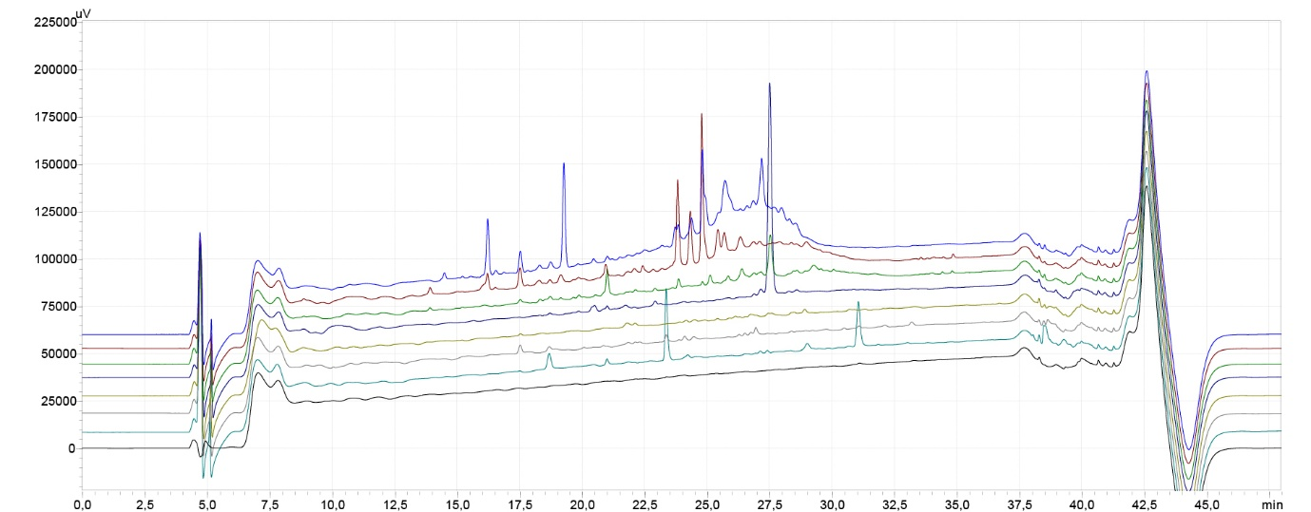

Supplementary Fig. 2. Analytical RP-HPLC chromatogram (214 nm) of relevant active fractions obtained from a typical RP-FPLC purification of L. paragasseri K7. The fractions shown are the same as those in the SDS-PAGE in Fig. 2B. From top to bottom: fractions 13, 14, 15, 16, 17, 18, 19, and the blank run (injection of mobile phase A). GasK7B α in fraction 16 (dark blue) was the best resolved gassericin in this study and the only one for which a peak could be clearly assigned.

Supplementary Fig. 3. Analytical RP-HPLC chromatogram of the pooled sample that contains all four bacteriocins of L. paragasseri K7.

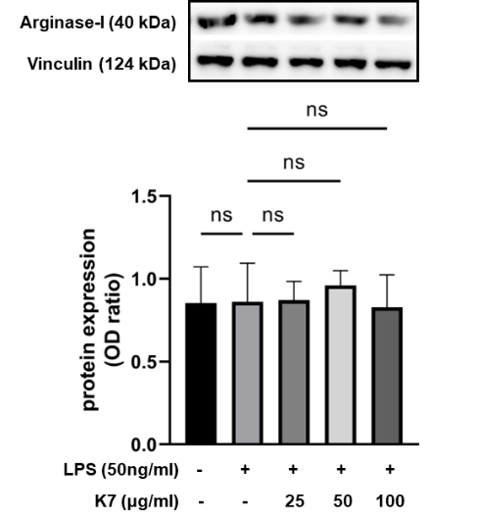
Supplementary Fig. 4: Effect of gassericins K7 on arginase-I expression. Arginase-I expression in RAW 264.7 cells treated with LPS (50ng/mL) and different concentrations of gassericins K7 was detected after 24h treatment. Data are expressed as mean ±SD. Statistical analysis was performed using ANOVA was followed by Dunnett’s multiple comparisons test vs. LPS-treated cells; P value: < 0.1234 (ns); n = 3.

