Effects of compound yeast culture on intestinal morphology, intestinal function, and intestinal microorganisms of lambs
Shixiong Liu ª, Puguo Hao ^{a,c}, Hui Chen ª, Xueqiang Li ^{a,b}, Xiaohui Xu ª, Rui Du ª, Chen Xue ª, Lan Yang ª*†, Dacheng Liu ª*†

Supplementary material

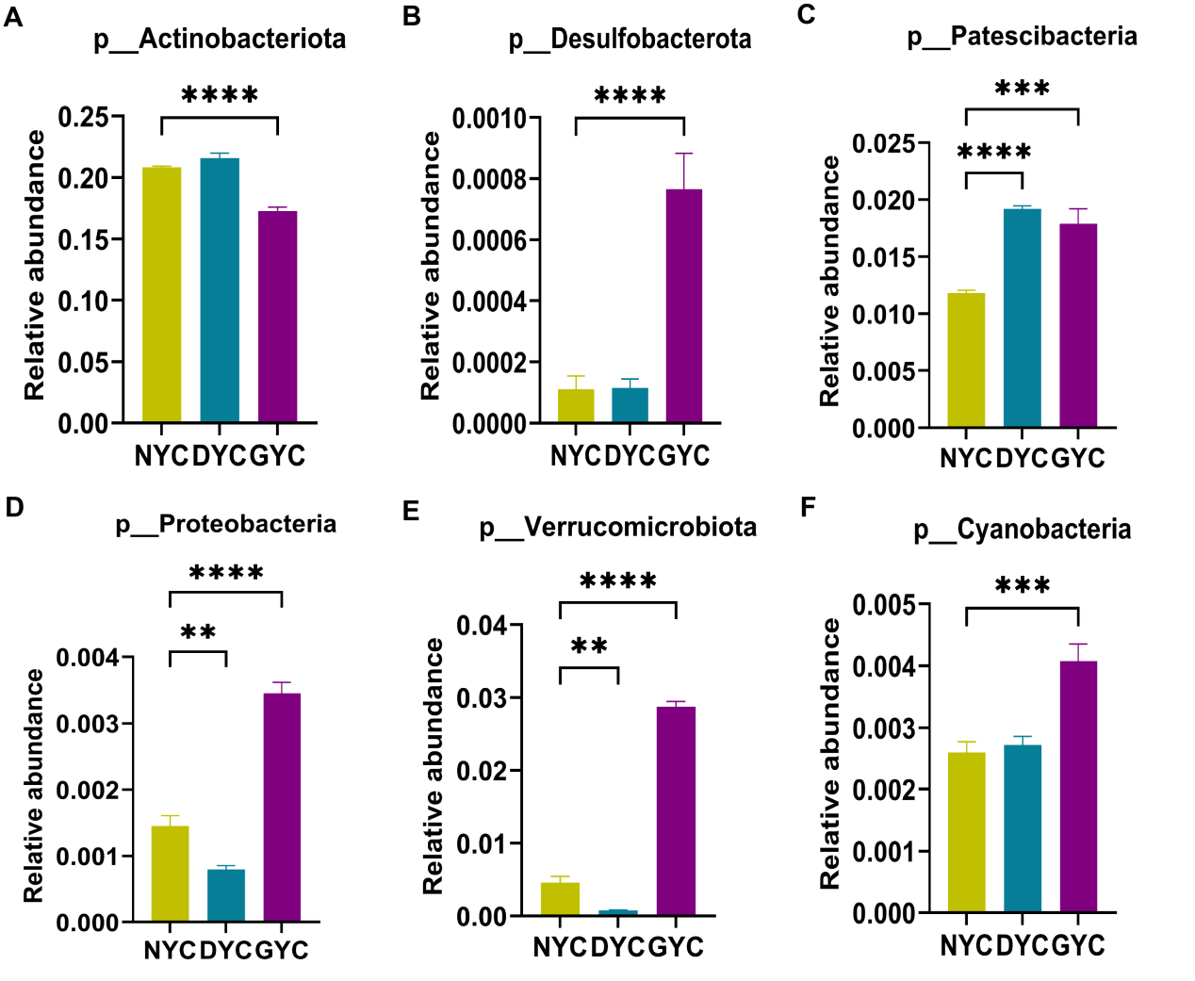
Supplementary Figure S1. The effect of compound yeast culture intake on the level of microbial phyla in the lamb jejunum. SEM = standard error of the mean. NYC = basal diet; DYC=yeast source; GYC=compound yeast culture. Data are expressed as means and SEM, n = 6. Different lowercase letters on the same row indicate significant differences, P < 0.05.
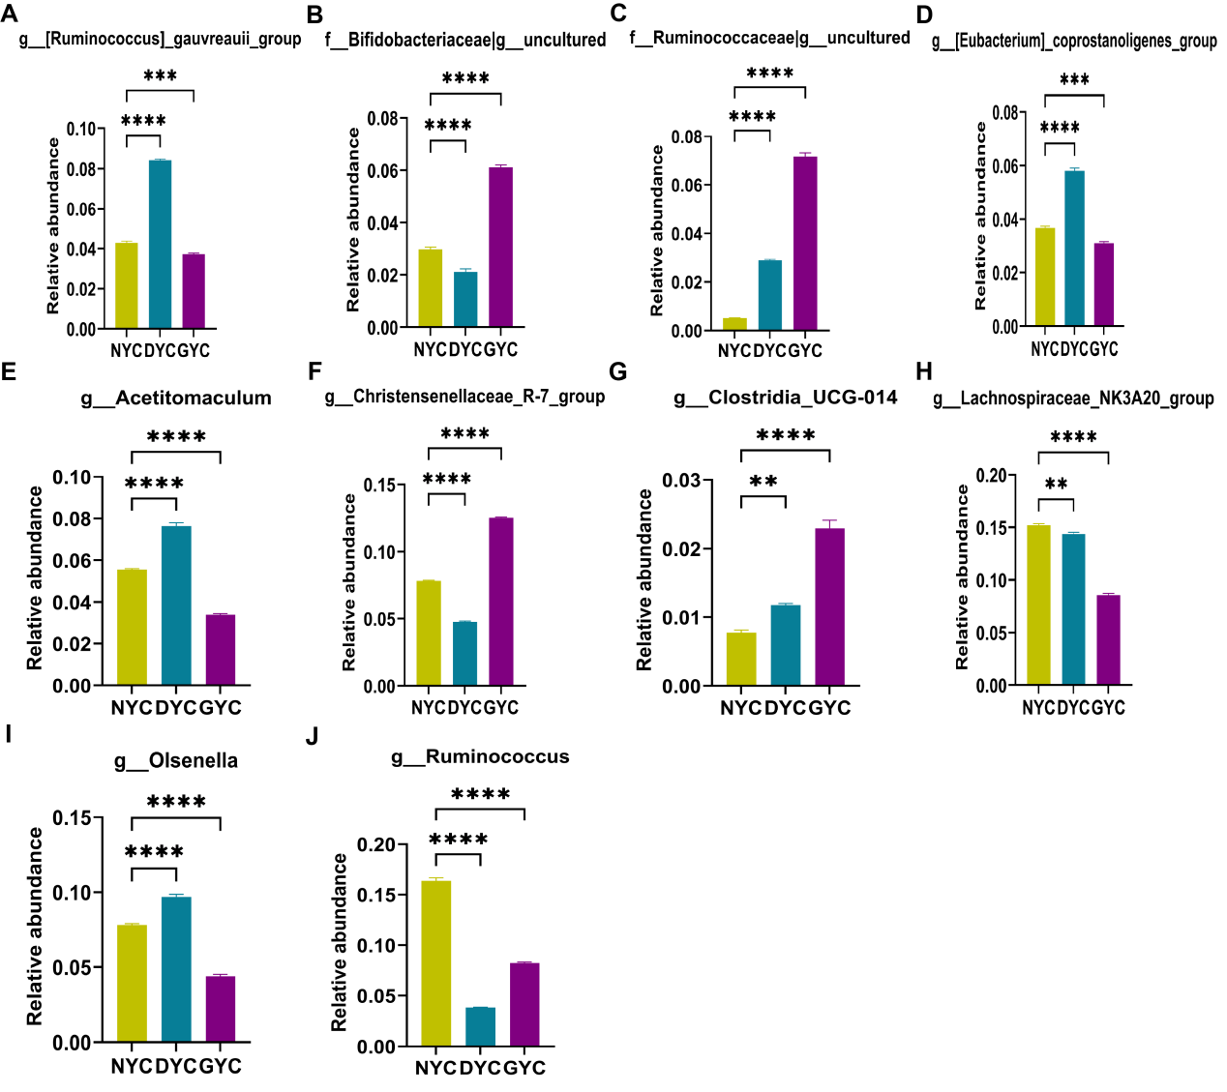
Supplementary Figure S2. The effect of compound yeast culture intake on the microbial genera abundances in the lamb jejunum. SEM = standard error of the mean. NYC = basal diet; DYC=yeast source; GYC=compound yeast culture. Data are expressed as means and SEM, n = 6. Different lowercase letters on the same row indicate significant differences, P < 0.05.

