Table 1. PDB ID and details of selected ESKAPEE target proteins
Sr No | Target Proteins | PDB ID | Organism
1 | tyrosyl-tRNA synthetase | 1JIJ | Staphylococcus aureus
2 | Sortase family protein | 2MLM | Staphylococcus aureus CA-347
3 | Dihydropteroate Synthase | 2VEG | Streptococcus pneumoniae
4 | Penicillin Binding Protein 2 | 4CJN | Staphylococcus aureus subsp. aureus Mu50
5 | beta-galactosidase | 4CU6 | Streptococcus pneumoniae TIGR4
6 | n-acetyl-beta-d-glucosaminidase | 5A6A | Streptococcus pneumoniae TIGR4
7 | Anthranilate-CoA ligase | 5OE3 | Pseudomonas aeruginosa PAO1
8 | PilO protein | 5UVR | Pseudomonas aeruginosa
9 | Beta-lactamase | 6G9T | Escherichia coli
10 | Penicillin-Binding Protein | 6HR9 | Pseudomonas aeruginosa PAO1
11 | DNA gyrase subunit B | 6KZV | Escherichia coli
12 | Pencillin Binding Protein 4 | 6MKH | Enterococcus faecalis
13 | Glycoside hydrolase | 6ORG | Streptococcus pneumoniae TIGR4
14 | Beta-lactamase VIM-2 | 6RPN | Pseudomonas aeruginosa
15 | Quinolone resistance protein NorA | 7LO8 | Staphylococcus aureus
16 | Serine hydroxymethyltransferase | 7V3D | Enterococcus faecium
17 | Beta-lactamase | 8FQT | Acinetobacter baumannii
18 | Pyruvate kinase | 8IAX | Streptococcus pneumoniae R6
19 | ATP phosphoribosyltransferase | 8OY0 | Acinetobacter baumannii
20 | Metallo-Beta-Lactamase Type 2 | 8SK2 | Klebsiella pneumoniae

Table 2. Binding energy and interaction analysis of top 10 AMPs as potential drug candidates against tyrosyl-tRNA synthetase of Staphylococcus aureus (PDB ID: 1JIJ)
Sr no | Sequence | Peptides | Database Id | Docking Score (kcal/mol) | Interactions
1 | WNWSKSF | Darobactin | AP03168 | -8.4 | LYS34, GLY38, ALA39, THR42, HIS50, ASP80, ARG88, GLN190, VAL191, ASP195
2 | TYVSYT | Aneurinifactin | DBAASPN_10400 | -7.7 | ALA39, ASP40, HIS47, THR75, LYS84, GLU86, GLN174, GLN196
3 | LVTLVFV | Pheromone cCF10 | DBAASPR_15143 | -7.7 | GLY38, ASP40, THR42, ASP80, GLU86, GLN91, ASN99, GLY193
4 | DDFLCAGGCL | Alliumin | DRAMP01009 | -7.6 | GLY38, ALA39, ASP40, THR42, HIS47, LEU70, ASP80, ASN99, GLN91, TYR170, ASP195
5 | TPFKISIHL | Jellein-2 | DRAMP03000 | -7.4 | GLY38, ALA39, ASP40, THR42, ALA43, HIS47, GLY49, PRO53, LYS84, GLU86, ARG88, VAL89, GLN174, ILE200, TRP241
6 | SVAGRAQGM | Antimicrobial peptide 1 (Cn-AMP1) | DRAMP00929 | -7.2 | GLY38, ASP40, THR42, ASP80, GLU86, GLN91, ASN99, GLY193
7 | IIIQYEGHKH | Rondonin | DBAASPR_3240 | -6.6 | GLY38, HIS47, PRO53, ASP80, LYS84, ASN99, GLY192, GLY193, ASP195, GLN196
8 | GLTRLFSVIK | Andricin B | DBAASPR_10839 | -6.5 | CYS37, ASP40, THR42, ALA43, PRO53, ASP80, LYS84, ARG88, GLN91, ASN99, TYR170, GLN196
9 | GLLSSLGLNL | Dynastin 2 | DBAASPR_3923 | -6.4 | LEU5, LYS30, GLU62, HIS117
10 | DDHSAGT | Iturin-like lipopeptide | DBAASPN_18477 | -6.1 | LYS 30, GLU 31, GLY 64, HIS 65, ARG 66

Table 3. Binding energy and interaction analysis of top 10 AMPs as potential drug candidates against Sortase family protein of Staphylococcus aureus CA-347 (PDB ID: 2MLM)
Sr no | Sequence | Peptides | Database Id | Docking Score (kcal/mol) | Interactions
1 | DDFLCAGGCL | Alliumin | DRAMP01009 | -7.3 | ALA 34, ALA 46, ASN 56, SER 58, ASP 112, GLU 113, LYS 117, TRP 136
2 | AFPGLSF | Segetalin D | DRAMP34519 | -7 | GLU 47, ASN 56, VAL 106, LEU 111, GLU 113, THR 122, ILE 124, ARG 139
3 | FPVTWPTKWLKG | Pinb-Q | PPepDB_3183 | -6.8 | ALA 34, PRO 36, ALA 46, GLU 47, TYR 129
4 | FLPIIGKLLSGLL | Vespid chemotactic peptide VT1 | DBAASPR_5609 | -6.6 | ALA 34, PRO 36, LEU 39, ALA 46, SER 58, LEU 111, THR 122, ILE 124, VAL 135, TRP 136
5 | PFKISIHL | Jellein-1 | DRAMP02999 | -6.4 | PRO 33, ALA 34, GLU 48, ASN 56, THR 106, LEU 111, GLU 113, ILE 124, ARG 139
6 | NGWLLI | Desotamide A | DBAASPN_11147 | -6.3 | ALA 34, ALA 46, GLU 47, ASN 56, ALA 60, GLU 113, ILE 124, CYS 126
7 | ISVCITVC | Patellamide D | DRAMP18297 | -6.3 | ALA 34, ALA 46, GLU 47, ASN 56, ALA 60, TRP 136, ARG 139
8 | FIGAIARLLSKIF | BmKn2 | AP01978 | -6.1 | ALA 34, PRO 36, ALA 46, CYS 126, TYR 129
9 | TESYFVFSVGM | Antimicrobial peptide 2 | DBAASPR_3226 | -6.1 | ALA 34, ALA 46, ASN 56, SER 58, ALA 60
10 | WNDTGKDADGAEY | Taromycin A | DRAMP18299 | -6 | ALA46, GLU47, ASN56, SER58, THR122

Table 4. Binding energy and interaction analysis of top 10 AMPs as potential drug candidates against Dihydropteroate Synthase of Streptococcus pneumoniae (PDB ID: 2VEG)
Sr no | Sequence | Peptides | Database Id | Docking Score (kcal/mol) | Interactions
1 | FLPIIGKLLSGLL | Vespid chemotactic peptide VT1 | DBAASPR_5609 | -7.6 | ASN 17, GLN 38, ILE 150, GLY 205, ARG 236, ARG 238, ARG 282, HIS 284, PRO 253
2 | LMCTHPLDCSN | Trapa natans antifungal peptide | AP01803 | -7.3 | ASP 91, PRO 152, ARG 236, ARG 238, VAL 251, ASN 252
3 | ISVCITVC | Patellamide D | DRAMP18297 | -7.1 | ASN 17, ARG 236, LYS 237, HIS 284
4 | DDFLCAGGCL | Alliumin | DRAMP01009 | -7 | GLU 55, PRO 253, GLU 254, ARG 282, HIS 284
5 | TVVTQA | Fusaricidin B | DRAMP18219 | -6.9 | GLU 55, ARG 282, ARG 286, LYS 237
6 | EKYTEAPEYI | Ala-6-fenycin | AP02450 | -6.8 | GLN 34, GLN 38, ASP 91, ILE 150, PHE 151, ARG 236, ARG 282, HIS 284
7 | TPFKISIHL | Jellein-2 | DRAMP03000 | -6.8 | ASN 17, ILE 150, PHE 151, PRO 152, ARG 236, LYS 237, ARG 238, PRO 253, ARG 282
8 | LVTLVFV | pheromone cCF10 | DBAASPR_15143 | -6.7 | PHE 151, ARG 236, LYS 237, ARG 238, ARG 262, ARG 282, HIS 284
9 | WNDTGKDADGAEY | Taromycin A | DRAMP18299 | -6.6 | ASN17, GLN34, ASP91, GLY 205, ARG236, ARG282, HIS284
10 | GLLKRIKTLL | Anoplin | 2MJQ_A | -6.3 | ASN 17, GLN 38, ARG 236, LYS 237

Table 5. Binding energy and interaction analysis of top 10 AMPs as potential drug candidates against Penicillin Binding Protein 2 of Staphylococcus aureus subsp. aureus Mu50 (PDB ID: 4CJN)
Sr no | Sequence | Peptides | Database Id | Docking Score (kcal/mol) | Interactions
1 | FLPIIGKLLSGLL | Vespid chemotactic peptide VT1 | DBAASPR_5609 | -7.3 | THR 165, GLU 239, ASP 323
2 | DDHSAGT | Iturin-like lipopeptide | DBAASPN_18477 | -7.1 | LYS 215, THR 216, PRO 258, ILE 259
3 | FPVTWPTKWWKS | Pinb-B | DRAMP04600 | -7 | SER 149, ARG 151, LYS 215, THR 216, SER 240, PRO 258, HIS 293, MET 372
4 | AFPGLSF | Segetalin D | DRAMP34519 | -5.6 | LYS 148, GLU 150, LYS 153, LEU 155, ASN 159, GLU 239, LYS 318
5 | MRTGNAD | Microcin 7 | DRAMP18656 | -5.3 | ILE 192, LYS 215, THR 216, PRO 258, MET 372
6 | FFPLALLCKVFKKC | Japonicin-1CDYa | DRAMP01245 | -5.1 | LYS 148, GLU 150, ARG 151, GLY 152, LYS 153, GLU 161, ASP 320, LYS 322, ASP 323
7 | SLLSLIRKLIT | Decoralin | AP00723 | -4.7 | GLU 150, ASN 159, LYS 318, LYS 319, ASP 320, GLN 325
8 | TYVSYT | Aneurinifactin | DBAASPN_10400 | -4.6 | LYS 148, GLU 161, LYS 318, ASP 320, GLY 321, LYS 322, ASP 323
9 | TGVAWRIT | Lectin | DRAMP02449 | -4.5 | LYS 153, GLU 161, LYS 318, LYS 319, ASP 320, GLY 321, LYS 322, ASP 323, ASP 552
10 | FIGAIARLLSKIF | BmKn2 | AP01978 | -4.2 | GLU150, LYS153, GLY321, LYS322, ASP323

Table 6. Binding energy and interaction analysis of top 10 AMPs as potential drug candidates against BETA-GALACTOSIDASE of Streptococcus pneumoniae TIGR4 (PDB ID: 4CU6)
Sr no | Sequence | Peptides | Database Id | Docking Score (kcal/mol) | Interactions
1 | KYGDVPLY | Bifidin | DRAMP18248 | -9 | GLU148, LYS 151, ARG356, LYS419, ASN461, TYR462, LYS484, GLN493, ARG549
2 | ITVCISVC | Patellamide | DRAMP18310 | -8.8 | LYS151, LYS311, ARG356, LYS419, LEU421, GLU489, GLN493, GLU497, ASP885
3 | APKGVQGPNG | YD1 (bacteriocin) | DRAMP18361 | -8.5 | ASP153, ASP298, LYS311, ASN312, LYS419, LEU421, GLU460, TYR462, GLN490, ARG549, ASP882, LYS884
4 | FLPIIGKLLSGLL | Vespid chemotactic peptide VT1 | DBAASPR_5609 | -8.2 | ASP627, GLU662, TYR678, GLY679, LYS687, THR690, ASN827, ALA828, ASN829, GLU830, TYR832, GLU834
5 | TYVSYT | Aneurinifactin | DBAASPN_10400 | -7.8 | TRP 693, ARG 697, GLN 752, ASN 793, GLY 819, ARG 820, THR 821, TYR 822,
6 | DDFLCAGGCL | Alliumin | DRAMP01009 | -7.6 | LYS 443, SER 751, GLN 752, VAL 754, SER 755, LYS 757, ASN 793, GLU 851, LYS 854
7 | SVAGRAQGM | Antimicrobial peptide 1 (Cn-AMP1) | DRAMP00929 | -7.5 | PRO 659, GLU 660, ARG 661, THR 688, ALA 691, THR 694, ARG 789, LYS 809, ALA 828, ASN 829, TYR 832, LEU 833, GLU 834
8 | NGWLLI | Desotamide A | DBAASPN_11147 | -7.5 | PRO 659, GLU 626, GLU 662, ALA 826, ALA 828, ALA 829, TYR 832, GLU 834
9 | AFPGLSF | Segetalin D | DRAMP34519 | -7.4 | ILE 442, LYS 443, HIS 445, TRP 753, SER 755, LYS 758, ARG 820, THR 821
10 | SLLSLIRKLIT | Decoralin | AP00723 | -6.5 | LYS 443, SER 751, TRP 753, VAL 756, LYS 757, SER 795, ASP 850, GLU 851

Table 7. Binding energy and interaction analysis of top 10 AMPs as potential drug candidates against N-ACETYL-BETA-D-GLUCOSAMINIDASE of Streptococcus pneumoniae TIGR4 (PDB ID: 5A6A)
Sr no | Sequence | Peptides | Database Id | Docking Score (kcal/mol) | Interactions
1 | EPFKISIHL | Jellein-3 | DRAMP03001 | -10.3 | SER 93, ARG 94, GLU 123, ARG 138, HIS 169, SER 171, TYR 308, TYR 309, TRP 373, ASP 375, ASN 376, HIS 615,
2 | AVPDVAFNAYG | Big defensin (RPD-1) | DRAMP02397 | -9.7 | ASP 222, GLU 223, TYR 280, TYR 309, GLN 310, SER 436
3 | SVAGRAQGM | Antimicrobial peptide 1 (Cn-AMP1) | DRAMP00929 | -9.6 | ARG 94, SER 171, ALA 172, HIS 169, ASP 375, ASN 612
4 | WPISFVP | Euryjanicin A | DRAMP34774 | -9.3 | TYR 309, ASN 376, ASN 434, ASP 375
5 | TYVSYT | Aneurinifactin | DBAASPN_10400 | -9.2 | ARG 94, GLU 123, ARG 138, HIS 169, HIS 225, TRP 306, TRP 339, TRP 373, ASP 375, ASN 376, GLY 377, PHE 600, THR 610, ALA 611, ASN 612
6 | EKYTEAPEYI | Ala-6-fenycin | AP02450 | -8.8 | ARG 94, HIS 169, ASP 189, TYR 308, TYR 309, ASP 375 ASN 376, GLY 437, ARG 561, HIS 615, GLN 910
7 | YTIFDIFGA | Chevalierin C | PPepDB_2890 | -8.6 | ASP 556, GLY 564
8 | WNDTGKDADGAEY | Taromycin A | DRAMP18299 | -6 | ARG 53, PRO 55, ALA 82, ASP 85, LYS 213, ARG 215, LYS 216, GLY 260, CYS 263, VAL 301, THR 302, ASP 329
9 | FIPLVSGLFSRLL | Temporin-1KM | DBAASPR_5681 | -6 | PRO 55, ALA 82, GLN 154, ASP 299, ARG 300, THR 302, ASP 329, LYS 366
10 | FISAIASMLGKFL | Ranatuerin-6 | DBAASPR_1015 | -5.3 | LYS 54, GLN 154, THR 214, ARG 215, LYS 216, GLY 260, HIS 262, CYS 263, ASP 299, VAL 301, THR 302, ASP 329, LYS 366

Table 8. Binding energy and interaction analysis of top 10 AMPs as potential drug candidates against PilO protein of Pseudomonas aeruginosa (PDB ID: 5UVR)
Sr no | Sequence | Peptides | Database Id | Docking Score (kcal/mol) | Interactions
1 | FLPFVGKLLSGLL | Temporin-LF1 | DBAASPR_8038 | -5.8 | PRO 110, THR 117, ARG 118, SER 123, PHE 127, ARG 169, ILE 170
2 | NGVQPKY | Leucrocin I | DBAASPR_4726 | -5.7 | SER 165, VAL 171, THR 172, LEU 173, ASP 175, PHE 176, TYR 198
3 | FFPIVGKLLSGLF | Temporin-CG2 | DBAASPR_1882 | -5.2 | TYR 141, ILE 170, VAL 171, THR 172, LEU 173, HIS 174, PHE 176, TYR 198
4 | TVVTQA | Fusaricidin B | DRAMP18219 | -5.1 | ARG 118, LEU 167, PRO 168, ARG 169, ILE 170, TYR 198
5 | ELLVDLL | Gageostatin A | DBAASPN_5449 | -5.1 | VAL 109, GLU 114, ARG 118, PRO 145
6 | PGMGIYLPM | Cyclopeptide F | DBAASPR_2980 | -4.9 | SER 165, LEU 173, PHE 176
7 | GSTLLSLL | Pseudofactin II | DRAMP35601 | -4.8 | VAL 109, PRO 110, TYR 141, ARG 169, ILE 170, ARG 199
8 | ASILTNAS | Bacteriocin | DRAMP00217 | -4.7 | ASP 115, ARG 118, PRO 168, TYR 198, TYR 200
9 | GLLSSLGLNL | Dynastin 2 | DBAASPR_3923 | -4.7 | GLU 114, ASP 115, ARG 118
10 | ELLSRVD | Bacaucin-1 | DBAASPS_13906 | -4.5 | SER165, SER166, LEU173, PHE176, ILE193

Table 9. Binding energy and interaction analysis of top 10 AMPs as potential drug candidates against Anthranilate-CoA ligase of Pseudomonas aeruginosa PAO1 (PDB ID: 5OE3)
Sr no | Sequence | Peptides | Database Id | Docking Score (kcal/mol) | Interactions
1 | AFPGLSF | Segetalin D | DRAMP34519 | -7.4 | ASN 84, ALA 170, PRO 171, VAL 254, ASP 382
2 | FLPLLASLFSRLL | Temporin-10a | DBAASPR_4934 | -7.4 | ILE 83, ASN 84, ALA 91, TYR 163, THR 164, ALA 170, PHE 208, PHE 209, GLU 305
3 | TYVSYT | Aneurinifactin | DBAASPN_10400 | -7.1 | ILE 83, ALA 91, ILE 95, THR 164, GLY 169, PRO 171, PHE 208, GLY 302, ALA 303, THR 304, TYR 378, ARG 397
4 | FFFLSRIF | Temporin-SHf | DRAMP20778 | -6.9 | PRO 171, PHE 209, TYR 211, ALA 278, ALA 303
5 | EPFKISIHL | Jellein-3 | DRAMP03001 | -6.8 | ASN 84, TYR 163, THR 164, PHE 209, THR 304, GLU 305, ARG 372, ARG 397
6 | SVAGRAQGM | Antimicrobial peptide 1 (Cn-AMP1) | DRAMP00929 | -6.8 | ARG 33, ASN 34, SER 37, TYR 163, ALA 303, THR 304, ARG 372
7 | DYHHGVRVL | Bacteriocin serracin-P | DRAMP00250 | -6.7 | ASN 84, THR 164, LYS 206, THR 380, ASP 382
8 | FFPLALLCKVFKKC | Japonicin-1CDYa | DRAMP01245 | -6.6 | ASN 34, SER 37, TYR 163, LYS 206, GLY 279, ALA 303, THR 304, GLU 306
9 | AHCLAIGRK | Defensin | DRAMP02778 | -6.4 | ASN 84, LYS 86, GLY 169, PRO 171, GLY 279, THR 304
10 | FLPIIGKLLSGLL | Vespid chemotactic peptide VT1 | DBAASPR_5609 | -6.3 | ASN 84, PRO 171, TYR 211, ALA 278, TYR 362, ARG 372, ARG 397

Table 10. Binding energy and interaction analysis of top 10 AMPs as potential drug candidates against Penicillin-Binding Protein of Pseudomonas aeruginosa PAO1 (PDB ID: 6HR9)
Sr no | Sequence | Peptides | Database Id | Docking Score (kcal/mol) | Interactions
1 | APKGVQGPNG | YD1 | DBAASPR_9921 | -6.5 | ALA 181, TRP 185, THR 218, ALA 220, LEU 381, GLY 382, LEU 434, THR 437
2 | EKYTEAPEYI | Ala-6-fenycin | AP02450 | -6 | ALA 220, LYS 255, PRO 433, ARG 438, VAL 439, ASP 440, ARG 441, VAL 442, PRO 443, GLY 445
3 | MRTGNAD | Microcin 7 | DRAMP18656 | -5.9 | THR 256, PRO 433, SER 435, MET 436, THR 437, ARG 438, ARG 441, VAL 442
4 | EPFKISIHL | Jellein-3 | DRAMP03001 | -5.5 | PHE 182, ALA 220, LEU 381, LEU 434, MET 436, THR 437, ARG 438, ASP 440, ARG 441, PRO 443, ASP 444
5 | FLPLIGKVLSGIL | Temporin-G | DRAMP01744 | -5.5 | ALA 220, PHE 182, LEU 381, LEU 434, MET 436, THR 437, ARG 438, ARG 441, ASP 440, PRO 443
6 | FLPIIGKLLSGLL | Vespid chemotactic peptide VT1 | DBAASPR_5609 | -5.4 | TRP 185, LYS 255, LYS 430, VAL 432, THR 437, ASP 440, VAL 442
7 | SLLSLIRKLIT | Decoralin | DRAMP03056 | -5.3 | PHE 182, TRP 185, ALA 220, LYS 225, ASN 427, THR 437, ARG 438, ARG 441, VAL 442, PRO 443, ASP 444
8 | TYVSYT | Aneurinifactin | DBAASPN_10400 | -5.3 | ALA 220, THR 437, ARG 438, VAL 439, ARG 441, PRO 443
9 | IIIQYEGHKH | Rondonin | DBAASPR_3240 | -5.2 | PHE 182, TRP 185, ALA 220, PRO 433, LEU 434, SER 435, MET 436, THR 437, ARG 438, ASP 440, ARG 441, VAL 442, PRO 443, ASP 444
10 | TCSYTMEA | Cn-AMP3 | PPepDB_1560 | -5.1 | ALA 220, PRO 433, SER 435, MET 436, THR 437, ARG 441, PRO 443

Table 11. Binding energy and interaction analysis of top 10 AMPs as potential drug candidates against DNA gyrase subunit B of Escherichia coli (PDB ID: 6KZV)
Sr no | Sequence | Peptides | Database Id | Docking Score (kcal/mol) | Interactions
1 | DDFLCAGGCL | Alliumin | DRAMP01009 | -8 | HIS 38, ASP 45, ASN 46, ASP 49, GLU 50, ASP 73, ARG 76, THR 165, LYS 189, ARG 190, GLU 193
2 | DDHSAGT | Iturin-like lipopeptide | DBAASPN_18477 | -7.4 | HIS 38, GLU 42, ASP 45, ASP 49, GLU 50, THR 165, ARG 190
3 | TGVAWRIT | Lectin | DRAMP02449 | -7.3 | HIS 38, VAL 43, ASP 45, ASN 46, ALA 47, ASP 49, GLU 50, ARG 76, HIS 99, VAL 118, ARG 190
4 | RGSALTHLP | RP9 | DBAASPR_9190 | -7.2 | LYS 11, ALA 47, ASP 49, GLU 50, ARG 76, ILE 78, HIS 99, THR 96, VAL 120
5 | NGWLLI | Desotamide A | DBAASPN_11147 | -7.1 | HIS 38, GLU 42, VAL 43, ASP 45, ASN 46, ALA 47, ILE 48, ASP 49, VAL 118, ARG 190
6 | WAIVLL | Baceridin | DRAMP18309 | -7 | HIS 38, GLU 42, ASN 46, ASP 49, ALA 100
7 | ISVCITVC | Patellamide D | DRAMP18297 | -6.9 | HIS 38, ASN 46, ILE 78, GLY 119, LYS 189, GLU 193
8 | EKYTEAPEYI | Ala-6-fenycin | AP02450 | -6.6 | GLY 28, HIS 38, PHE 41, GLU 42, ASN 46, ILE 48, ASP 49, GLU 193, ASN 198
9 | IFGAIWKGISSLL | Pantinin-2 | AP02214 | -6.3 | GLY 24, MET 25, TYR 26, GLY 28, ASP 45, ASN 46, HIS 99, VAL 118, ARG 190, ASN 198
10 | GLLSGTSVRGSI | Odorranain-V1 | DBAASPR_1522 | -6 | THR 62, SER 70, GLN 72, ARG 168, GLN 135, ILE 140, ARG 206

Table 12. Binding energy and interaction analysis of top 10 AMPs as potential drug candidates against Penicillin Binding Protein 4 of Enterococcus faecalis (PDB ID: 6MKH)
Sr no | Sequence | Peptides | Database Id | Docking Score (kcal/mol) | Interactions
1 | FLPIIGKLLSGLL | Vespid chemotactic peptide VT1 | DBAASPR_5609 | -7.8 | THR 465, SER 482, TYR 605, GLU 624, GLY 659, SER 663, ASP 666
2 | AAGMGFFGAR | Urechistachykinin II | DRAMP04531 | -7 | TYR 605, GLU 635, SER 637
3 | ITVCISVC | Patellamide | DRAMP18310 | -6.5 | SER 482, VAL 467, SER 658, THR 620
4 | LMCTHPLDCSN | Tn-AFP1 | DRAMP00425 | -6.4 | SER 424, SER 482, GLY 604, GLY 621
5 | TCSYTMEA | Cn-AMP3 | PPepDB_1560 | -5.9 | SER 424, TYR 605, THR 622, GLU 635, SER 658, GLY 659, ASP 666
6 | WNWSKSF | Darobactin | AP03168 | -5.1 | SER 424, GLY 604, TYR 606, GLY 621, GLU 624, GLU 635, SER 637, SER 663
7 | GSTLLSLL | Pseudofactin II | DRAMP35601 | -4.7 | GLY 621, THR 622, THR 665
8 | GLTRLFSVIK | Andricin B | DBAASPR_10839 | -4.5 | ASN 504, PHE 506, PHE 508, THR 519
9 | DEKGPKWKR | Odorranain-N1 | AP01301 | -4.8 | SER 424, ASN 484, TYR 606, GLY 621, THR 622, GLU 624, GLU 635, SER 637, GLY 659, ASN 661, GLY 662, ASP 666
10 | DDHSAGT | Iturin-like lipopeptide | DBAASPN_18477 | -6.1 | SER 424, THR 465, SER 482, TYR 605, THR 620, THR 622, SER 637, SER 658, SER 663, THR 665

Table 13. Binding energy and interaction analysis of top 10 AMPs as potential drug candidates against Glycoside hydrolase of Streptococcus pneumoniae TIGR4 (PDB ID: 6ORG)
Sr no | Sequence | Peptides | Database Id | Docking Score (kcal/mol) | Interactions
1 | TGVAWRIT | Lectin | DRAMP02449 | -7.4 | LEU 16, GLY 20, TYR 323, GLU 352, THR 353, ARG 382, TYR 415, LYS 444
2 | WNDTGKDADGAEY | Taromycin A | DRAMP18299 | -7.3 | ASP21, GLY67, LYS69, LYS70, ASP119, ALA166, GLY350, GLU352, ARG382, LYS416, TYR448
3 | WNWSKSF | Darobactin | AP03168 | -7.3 | LEU 16, ALA 17, GLY 20, ARG;319, TYR 323, GLU 362, ARG 382, LYS 386, LYS 416, TYR 448
4 | DDFLCAGGCL | Alliumin | DRAMP01009 | -7.1 | ALA 17, TYR 18, LYS 69, LYS 70, LYS 117, LYS 164, ALA 166, TYR 282, ARG 319, ASP 320
5 | SVAGRAQGM | Antimicrobial peptide 1 (Cn-AMP1) | DRAMP00929 | -7.1 | ALA 17, GLY 20, ASP 21, GLU 22, LYS 69, ASP 119, LYS 164, ARG 319, GLU 352, ARG 382, LYS 444, TYR 448
6 | KTCENLADDY | Gymnin | PPepDB_2082 | -7.1 | LEU 16, LYS 69, ASP 326, THR 353, LYS 444, TYR 448
7 | FKFLARTGKFL | PN5 | AP03449 | -6.9 | THR 14, ALA 17, ASP 21, LYS 69, ASP 117, LYS 386
8 | GLLDALSGILGL | Frenatin-1 | DRAMP01360 | -6.9 | LEU 16, ALA 17, TYR 18, GLY 20, ASP 21, LYS 64, LYS 69, LYS 70, LYS 164, ASP 349, GLU 352, ARG 382, TYR 415, LYS 416, LYS 444, TYR 448,
9 | EKYTEAPEYI | Ala-6-fenycin | AP02450 | -6.8 | GLY 20, ASP 21, LYS 64, GLU 65, LYS 69, ARG 319, ASN 320, GLU 325, ASP 326, LEU 32, GLY 350, GLU 352, ARG 382, LYS 444
10 | IIIQYEGHKH | Rondonin | DBAASPR_3240 | -6.1 | GLY 20, LYS 69, ARG 319, TYR 323, LEU 329, GLU 352, THR 353, ARG 382

Table 14. Binding energy and interaction analysis of top 10 AMPs as potential drug candidates against Beta-lactamase of Escherichia coli (PDB ID: 6G9T)
Sr no | Sequence | Peptides | Database Id | Docking Score (kcal/mol) | Interactions
1 | ISVCITVC | Patellamide D | DRAMP18297 | -7.1 | GLU 61, ILE 121, GLN 120, ARG 204, GLY 214, ASP 217, ALA 220, HIS 221, THR 316, SER 318, THR 319, SER 343, ASN 346, ARG 349
2 | SVAGRAQGM | Antimicrobial peptide 1 (Cn-AMP1) | DRAMP00929 | -7 | GLU 61, GLN 120, ILE 121, ARG 204, GLY 214, THR 319, ASP 217, GLY 320, SER 289, SER 318, GLY 320, ASN 346
3 | FLPIIGKLLSGLL | Vespid chemotactic peptide VT1 | DBAASPR_5609 | -6.9 | GLN 120, ARG 204, VAL 209, SER 289, HIS 210, SER318, GLY 320
4 | GLVSNLGI | Dynastin-4 | DBAASPR_4079 | -6.7 | GLN 120, ILE 121, ASP 123, VAL 209, HIS 210, TYR 150, VAL 211, SER 212, ALA 220, GLY 317, SER 318, SER 343, TYR 344, ASN 346
5 | DEKGPKWKR | Odorranain-N1 | AP01301 | -6.7 | GLN 120, TRP 201, ARG 204, PRO 208, VAL 209, HIS 210, VAL 211, ALA 220, SER 289, SER 318, GLY 320
6 | MRTGNAN | Microcin C7 | DRAMP00192 | -6.6 | GLU 61, GLN 120, ILE 121, VAL 125, ARG 204, GLY 214, ASP 217, SER 289, SER 318, THR 319, GLY 320, ASN 346
7 | ILGIITSLLKSL | Orancis-protonectin | DRAMP03046 | -6.5 | GLN 120, ARG 204, SER 343, SER 318, THR 319, GLY 320, TYR 344
8 | IIIQYEGHKH | Rondonin | DBAASPR_3240 | -6.1 | GLU 61, GLN 120, ASN 152, ARG 204, ILE 121, ASP 217, ALA 220, HIS 221, ALA 292, LYS 315, THR 316, GLY 317, GLY 320
9 | FISQIISTARI | YZ103 | DBAASPS_21827 | -5.9 | GLU 61, SER 64, TYR 150, ASN 152, TYR 199, VAL 211, SER 212, ASP 217, HIS 221, GLY 222, SER 318, THR 319, ASN 346, ARG 349
10 | ELLSRVD | Bacaucin | DRAMP35607 | -5.7 | LEU 119, GLN 120, ILE 121, TYR 150, VAL 211, PRO 213, GLY 214, ASP 217, ALA 220, HIS 221, LEU 293, THR 316, GLY 317, SER 318, THR 319

Table 15. Binding energy and interaction analysis of top 10 AMPs as potential drug candidates against Beta-lactamase VIM-2 of Pseudomonas aeruginosa (PDB ID: 6RPN)
Sr no | Sequence | Peptides | Database Id | Docking Score (kcal/mol) | Interactions
1 | FLPIIGKLLSGLL | Vespid chemotactic peptide VT1 | DBAASPR_5609 | -8.4 | TYR47, GLN48, VAL66, PRO68, SER204, ARG206, THR206, SER207, PRO243
2 | DDFLCAGGCL | Alliumin | DRAMP01009 | -7.8 | PHE62, TYR67, GLU202, SER204, THR206, SER207, VAL211
3 | FIGAIARLLSKIF | BmKn2 | AP01978 | -7 | VAL53, TRP64, LEU88, ILE99
4 | WNDTGKDADGAEY | Taromycin A | DRAMP18299 | -5.9 | GLY31, THR35, SER37, ASP63, ALA65, VAL66, SER204, ARG205, THR206, SER207, ALA208
5 | DNGEAGRAAR | Antimicrobial ribonuclease | DRAMP03473 | -5.9 | VAL36, ASP63, ARG205, THR206, SER207
6 | AGFVLKGYTKTSQ | Salmocidin-IIb | DRAMP02342 | -5.9 | ASP 117, ASN 148, GLU 202, SER 204, ARG 205, SER 207, VAL 211, ARG 262, ASP 263
7 | TCSYTMEA | Cn-AMP3 | PPepDB_1560 | -5.8 | ASP63, ALA65, ALA206, ARG206, THR206, SER207, VAL211
8 | SVAGRAQGM | Antimicrobial peptide 1 (Cn-AMP1) | DRAMP00929 | -5.3 | SER61, TRP87, ASP117, GLY121, GLU146, ASN148, ALA212
9 | GLFDIIKKIAESI | Aurein 1.1 | AP00012 | -5.3 | ARG 205, THR 206, SER 207, ALA 208, VAL 211, ARG 262, ASP 263, TYR 267
10 | EKYTEAPEYI | Ala-6-fenycin | AP02450 | -4.9 | VAL36, ALA65, VAL66, PRO68, SER204, ARG205, THR206, SER207

Table 16. Binding energy and interaction analysis of top 10 AMPs as potential drug candidates against Quinolone resistance protein NorA of Staphylococcus aureus (PDB ID: 7LO8)
Sr no | Sequence | Peptides | Database Id | Docking Score (kcal/mol) | Interactions
1 | AFPGLSF | Segetalin D | DRAMP34519 | -9.4 | ILE 19, ALA 48, GLU 222, THR 223, SER 226, PRO 237, SER 241, PHE 303, ASP 307
2 | TYVSYT | Aneurinifactin | DBAASPN_10400 | -9.2 | ILE 19, ILE 23, LEU 26, ALA 48, PHE 140, GLU 222, THR 223, ILE 244, ARG 310, ASN 340
3 | DDFLCAGGCL | Alliumin | DRAMP01009 | -8.9 | ILE19, ALA48, ASN137, ILE141, GLY145, SER219, GLU222, THR223, SER241
4 | PFKISIHL | Jellein-1 | DRAMP02999 | -8.3 | ALA 48, ILE 141, PRO 144, GLU 222, THR 223, SER 226, ASP 307, SER 337, ASN 340
5 | EPFKISIHL | Jellein-3 | DRAMP03001 | -8.2 | ILE 19, ALA 48, ASN 137, ILE 141, GLY 145, SER 219, GLU 222, THR 223, SER 241
6 | FIGAIARLLSKIF | BmKn2 | AP01978 | -7.8 | ILE 19, ALA 48, PHE 140, ILE 141, ASN 137, THR 223, ASN 340, PHE 341, PRO 344
7 | FFPLALLCKVFKKC | Japonicin-1CDYa | DRAMP01245 | -7.8 | VAL 44, ILE 240, ILE 244, GLU 222, THR 223, GLY 248, PHE 303, ASN 340, PHE 341, PRO 344, LEU 345
8 | FLPIIGKLLSGLL | Vespid chemotactic peptide VT1 | DBAASPR_5609 | -7.4 | ILE 19, ALA 48, GLU 222, SER 226, PRO 237, SER 241, ASP 307
9 | LFKEILEKIKAKL | P17 | DBAASPR_4109 | -7.4 | ILE 19, ALA 48, GLN 51, GLU 222, THR 223, SER 226, ILE 244, ARG 310, ASN 340
10 | WNDTGKDADGAEY | Taromycin A | DRAMP18299 | -6.9 | PRO 27, ASP 32, ALA151, SER 154

Table 17. Binding energy and interaction analysis of top 10 AMPs as potential drug candidates against Serine hydroxymethyltransferase of Enterococcus faecium (PDB ID: 7V3D)
Sr no | Sequence | Peptides | Database Id | Docking Score (kcal/mol) | Interactions
1 | FLPIIGKLLSGLL | Vespid chemotactic peptide VT1 | DBAASPR_5609 | -8.7 | ARG 21, GLN 22, VAL 35, GLN 43, ARG 359, THR 366, THR 367, GLY 369
2 | DDFLCAGGCL | Alliumin | DRAMP01009 | -8.4 | GLU 18, GLN 22, SER 31, VAL 35, GLY 94, ASN 98, LEU 117, HIS 122, HIS 125, ALA 171, HIS 200, LYS 226, ARG 232
3 | NGWLLI | Desotamide A | DBAASPN_11147 | -8 | GLU 27, SER 31, ASN 98, LEU 117, HIS 122, THR 124, HIS 125, ALA 171, ASP 197, HIS 200, LYS 226, LYS 342, ARG 359
4 | FFFLSRIF | Temporin-SHf | DRAMP20778 | -7.7 | SER 31, GLU 32, HIS 122, GLY 194, ALA 171, ASN 341, LYS 342, ASN 343, ARG 359
5 | AFPGLSF | Segetalin D | DRAMP34519 | -7.6 | SER 31, SER 93, GLY 94, SER 95, GLN 96, HIS 122, HIS 200, HIS 225, LYS 226, ASN 341. LYS 342, ASN 343, SER 344, ARG 359
6 | WNDTGKDADGAEY | Taromycin A | DRAMP18299 | -7.4 | GLU18, Gln 22, ILE29, SER31, GLU32, Val 35, Gln 43, SER93, SER172, HIS225, LYS226, ARG232, ASN341
7 | TGVAWRIT | Lectin | DRAMP02449 | -7.2 | ARG 21, GLU 27, SER 31, GLU 32, ASN 33, SER 93, GLY 94, SER 95, ASN 98, LEU 117, HIS 122, ARG 232, ASN 343, ARG 359,
8 | FIGAIARLLSKIF | BmKn2 | AP01978 | -7.1 | SER31, GLN43, ALA199, HIS262, ARG359
9 | KTCENLADDY | Gymnin | PPepDB_2082 | -6.9 | GLU 18, GLU 27, SER 31, GLU 32, HIS 92, SER 93, GLN 96, ASN 98, HIS 122, THR 124, ALA 171, ASP 197, HIS 200, THR 223, HIS 225, LYS 226, ARG 232, GLU 330, LYS 342, ARG 359,
10 | SLLSLIRKLIT | Decoralin | AP00723 | -6.6 | TRP 12, ILE 15, GLU 18, ARG 21, SER 31, GLU 32, PHE 34, VAL 35, MET 40, SER 93, SER 95, LEU 117, HIS 122, LEU 123, HIS 225, ARG 232, ARG 359

Table 18. Binding energy and interaction analysis of top 10 AMPs as potential drug candidates against Beta-lactamase of Acinetobacter baumannii (PDB ID: 8FQT)
Sr no | Sequence | Peptides | Database Id | Docking Score (kcal/mol) | Interactions
1 | FLPIIGKLLSGLL | Vespid chemotactic peptide VT1 | DBAASPR_5609 | -7.7 | GLN 120, ASN 152, GLU 273, ARG 341, ASN 344
2 | NGWLLI | Desotamide A | DBAASPN_11147 | -7.4 | GLN 120, ASN 152, LEU 119, VAL 212, ASN 288, VAL 293, SER 316, ARG 341, PRO 343, ASN 344
3 | AFPGLSF | Segetalin D | DRAMP34519 | -7.2 | LEU 119, GLN 120, ASP 123, ASN 152, VAL 212, ALA 220, SER 316, THR 317, GLY 319, ARG 341, ASN 344
4 | YCSYTMEA | Cn-AMP3 | PPepDB_2176 | -7 | LEU 119, TYR 150, ASP 224, ASN 288, GLU 290, SER 316, ASN 318, ARG 341, PRO 343, ASN 344
5 | FKFLARTGKFL | PN5 | AP03449 | -6.9 | PHE 121, PRO 122, VAL 212, ARG 148, TYR 150, GLU 273, SER 287, ALA 220, ASN 152, LYS 313, SER 316, ARG 341, PRO 343, ASN 344, GLU 346,
6 | SVAGRAQGM | Antimicrobial peptide 1 (Cn-AMP1) | DRAMP00929 | -6.8 | ASN 152, ASN 288, THR 314, ASN 318, ARG 341, PRO 343, ASN 344
7 | IFGAIWNGIKSLF | IsCT2 | AP01980 | -6.6 | SER 64, ASP 123, GLN 120, ALA 220, ASN 318, ARG 341, ASN 344
8 | KTCENLADDY | Gymnin | PPepDB_2082 | -6.1 | SER 64, GLN 120, ASN 152, ALA 220, VAL 393, SER 316, THR 317, ARG 341, ASN 344, GLU 345
9 | NGVQPKY | Leucrocin I | DBAASPR_4726 | -6.1 | LYS 67, TYR 150, ASN 152, SER 316, PRO 343, ASN 344, GLU 345,
10 | SLLSLIRKLIT | Decoralin | AP00723 | -6 | SER 64, GLN 120, ASN 152, VAL 212, ASN 288, SER 316, THR 317, ASN 318, ARG 341, PRO 343

Table 19. Binding energy and interaction analysis of top 10 AMPs as potential drug candidates against Pyruvate kinase of Streptococcus pneumoniae R6 (PDB ID: 8IAX)
Sr no | Sequence | Peptides | Database Id | Docking Score (kcal/mol) | Interactions
1 | TESYFVFSVGM | Antimicrobial peptide 2 | DBAASPR_3226 | -8.5 | ARG 54, HIS 59, ASP 88, THR 89, GLU 64, LYS 248, GLU 250, ASP 274, ASN 345
2 | DNGEAGRAAR | Antimicrobial ribonuclease | DRAMP03473 | -8.1 | LEU 11, SER 58, HIS 59, THR 89, GLY 273, THR 306, SER 340, GLY 341, ASN 345
3 | FLPLLASLFSRLL | Temporin-10a | DBAASPR_4934 | -7.9 | LYS3, LYS32, ILE46, ALA50, GLU435, MET439, ILE445, PRO446, MET447, GLU468, GLY470
4 | WNDTGKDADGAEY | Taromycin A | DRAMP18299 | -7.7 | ARG232, GLY241, HIS242, LYS300, THR384, THR407, LYS408, THR409, HIS411, THR412, ARG414, LEU415, PHE430, ASP431, THR434, VAL485, ALA489, ARG491
5 | TYVSYT | Aneurinifactin | DBAASPN_10400 | -7.4 | ASN2, LYS3, LYS6, ALA48, GLU47, LYS81, LYS82, LYS361, ILE445, PRO446, MET447
6 | YTIFDIFGA | Chevalierin C | PPepDB_2890 | -7.2 | MET1, ASN2, LYS3, LYS81, LYS82, LYS361, MET439, VAL444, ILE445, PRO446, ALA469, LEU471
7 | GLVSNLGI | Dynastin-4 | DBAASPR_4079 | -7.2 | ASN 56, GLY 60, LYS 184, GLU 250, ALA 271, GLU 310, ASN 345
8 | PFKISIHL | Jellein-1 | DRAMP02999 | -7.1 | LYS3, LYS32, ILE46, GLU47, ALA50, ASN51, ALA357, LYS361, PRO446, GLY470
9 | FLPIIGKLLSGLL | Vespid chemotactic peptide VT1 | DBAASPR_5609 | -6.8 | ALA298, ASN240, THR409, HIS411, THR412, ARG414, VAL486, VAL490
10 | ASILTNAS | Bacteriocin | DRAMP00217 | -6.5 | ALA 14, ASN 41

Table 20. Binding energy and interaction analysis of top 10 AMPs as potential drug candidates against Metallo-Beta-Lactamase Type 2 of Klebsiella pneumoniae (PDB ID: 8SK2)
Sr no | Sequence | Peptides | Database Id | Docking Score (kcal/mol) | Interactions
1 | DDFLCAGGCL | Alliumin | DRAMP01009 | -7.6 | PHE 70, GLU 152, LYS 216, SER 217, GLY 219, ASN 220, LEU 221, GLY 222, HIS 250
2 | ILGTILGLLKGL | Protonectin | DRAMP03044 | -7.5 | ASP 124, SER 217, GLY 219, ASN 220, LEU 221, GLY 222, HIS 250
3 | FPVTWPTKWLKG | Pinb-Q | PPepDB_3183 | -7.3 | GLN 123, GLU 152, GLY 219, ASN 220
4 | AAGMGFFGAR | Urechistachykinin II | DRAMP04531 | -7.1 | PHE 70, GLN 123, GLU 152, HIS 189, SER 217, GLY 219, ASN 220, ASP 223
5 | SVAGRAQGM | Antimicrobial peptide 1 (Cn-AMP1) | DRAMP00929 | -6.8 | HIS 122, GLN 123, ASP 124, ILE 210, SER 217, GLY 219, ASN 220, SER 251
6 | TPFKISIHL | Jellein-2 | DRAMP03000 | -6.7 | PHE 70, HIS 122, ASP 124, SER 217, GLY 219, ASN 220, LEU 221, GLYL 222, HIS 250
7 | LVTLVFV | pheromone cCF10 | DBAASPR_15143 | -6.5 | PHE 70, HIS 189, LYS 211, ALA 215, LYS 216, SER 217, GLY 219, ASN 220
8 | EKYTEAPEYI | Ala-6-fenycin | AP02450 | -6.2 | PHE 70, GLN 123, ASP 124, GLU 152, LYS 216, SER 217, GLY 219, LEU 221, ASP 223, HIS 250
9 | GIPILAIM | Chevalierin A | PPepDB_2440 | -6.2 | TRP 93, HIS 122, GLN 123, GLU 152, LYS 211, ALA 215, SER 217, GLY 219, ASN 220, HIS 250
10 | TVVTNA | Fusaricidin A | DRAMP18218 | -6.1 | GLN 123, SER 217, GLY 219, ASN 20, HIS 250

Table 21. Binding energy and interaction analysis of top 10 AMPs as potential drug candidates against ATP phosphoribosyltransferase of Acinetobacter baumannii (PDB ID: 8OY0)
Sr no | Sequence | Peptides | Database Id | Docking Score (kcal/mol) | Interactions
1 | RYPAVGYT | Lacrain | AP02727 | -9.1 | ASN 120, GLN 119, SER 274, TYR 277, TYR 286, SER 317
2 | MRTGNAD | Microcin 7 | DRAMP18656 | -8.2 | LEU 57, THR 88, TYR 109, ASN 120, GLN 129, GLU 271, SER 274, TYR 277, TYR 286, GLN 296, TYR 300, GLY 315, SER 370
3 | AFPGLSF | Segetalin D | DRAMP34519 | -6.5 | ASP 18, ILE 56, ARG 65, ILE 68, LEU 69, TYR 77, GLY 81, ALA 82
4 | YTIFDIFGA | Chevalierin C | PPepDB_2890 | -6.1 | GLU 33, LEU PRO 36, LEU 37, ALA 39, THR 40, LEU 45, GLU 50, ALA 223
5 | TGVAWRIT | Lectin | DRAMP02449 | -6.1 | ASN 16, ILE 56, ILE 68, GLU 79, GLY 81, ALA 82, ALA 204, SER 205, LYS 208
6 | EKYTEAPEYI | Ala-6-fenycin | AP02450 | -5.7 | PHE 17, LYS 27, LYS 54, ILE 56, ARG 65, ILE 68, TYR 77,
7 | YCSYTMEA | Cn-AMP3 | PPepDB_2176 | -5.7 | PHE 17, LYS 27, LYS 54, ILE 56, ARG 65, ILE 68, TYR 77,
8 | FLPIIGKLLSGLL | Vespid chemotactic peptide VT1 | DBAASPR_5609 | -5.3 | ILE 56, ILE 68, ASN 80, ALA 204
9 | WNDTGKDADGAEY | Taromycin A | DRAMP18299 | -5.2 | LEU31, LYS32, LEU37, ALA39, THR40, ALA41, ASN44, HIS61, ALA223
10 | IIIQYEGHKH | Rondonin | DBAASPR_3240 | -5.2 | LEU 31, LYS 32, PRO 36, THR 40, LEU 45, PRO 49, VAL 224

Table 22. Antimicrobial Killing (%) of Selected peptides Against ESKAPEE pathogens
Sr No | Pathogens | % Killing
Sr No | Pathogens | Taromycin A |  | Alliumin |  | CN-AMP 1 |  | VCP-VT1
Sr No | Pathogens | 100µM | 200µM | 100µM | 200µM | 100µM | 200µM | 100µM | 200µM
1 | E. faecium | 22 | 20 | 13 | 12 | 26 | 33 | 89 | 100
2 | E. faecalis | 41 | 55 | 1 | 28 | 2 | 19 | 71 | 85
3 | S. aureus | 6 | 60 | 1 | 13 | 11 | 16 | 52 | 94
4 | K. pneumoniae | 0 | 14 | 0 | 22 | 0 | 0 | 0 | 0
5 | A. baumannii | 21 | 23 | 38 | 54 | 30 | 39 | 98 | 98
6 | P. aeruginosa | 25 | 46 | 17 | 41 | 0 | 44 | 15 | 67
7 | E. cloacae | 5 | 27 | 13 | 21 | 18 | 26 | 25 | 35
8 | E. coli | 5 | 28 | 0 | 26 | 12 | 23 | 1 | 32

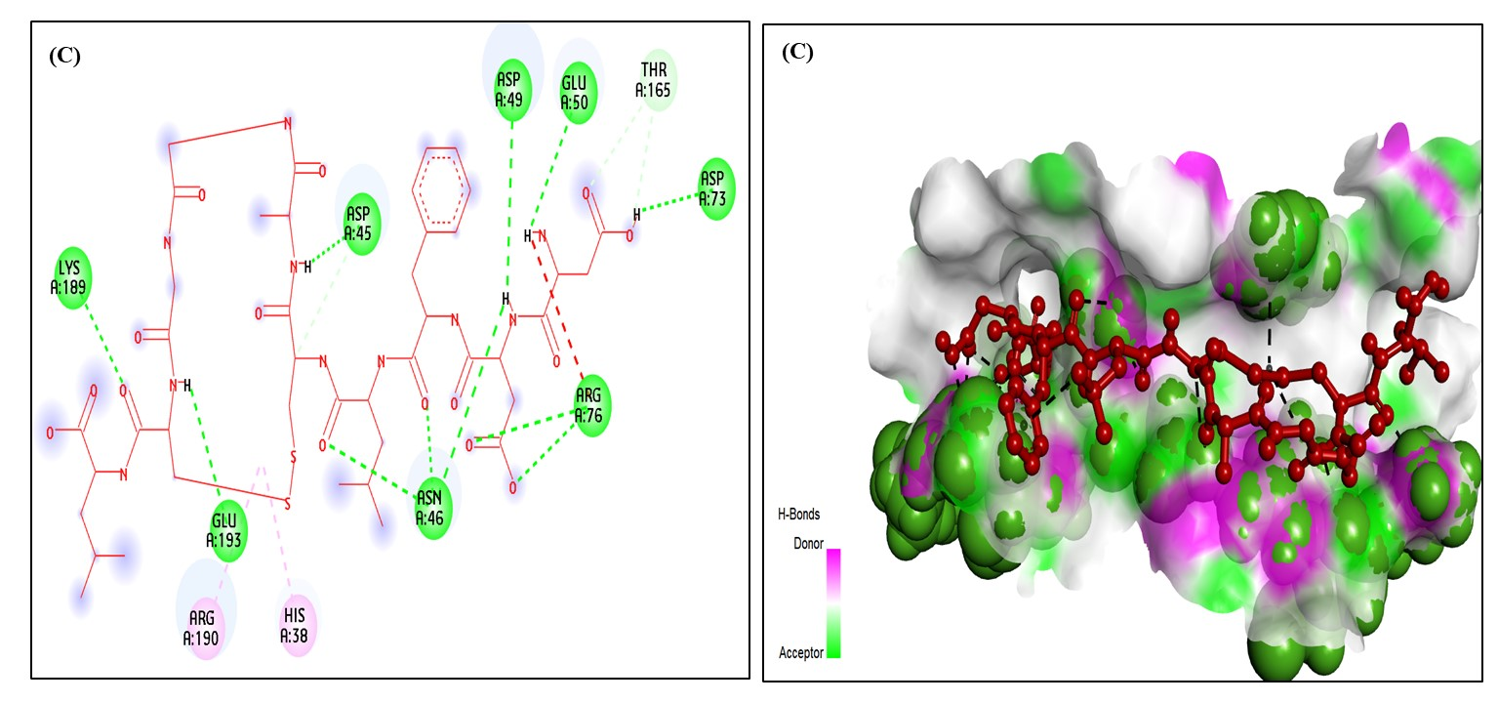
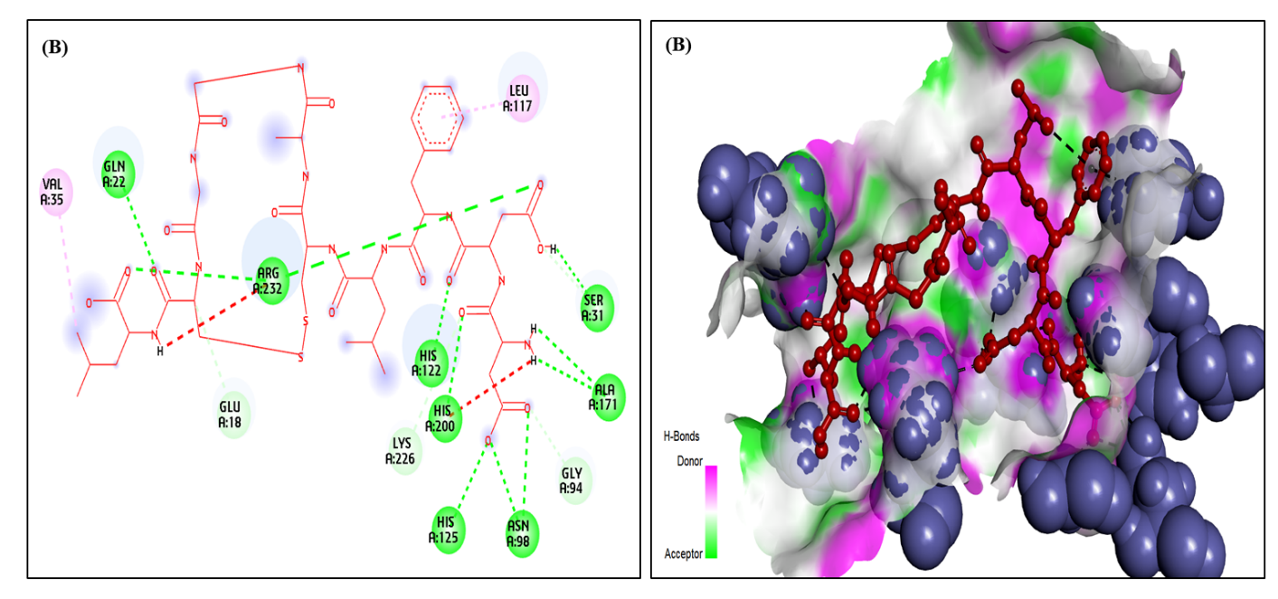
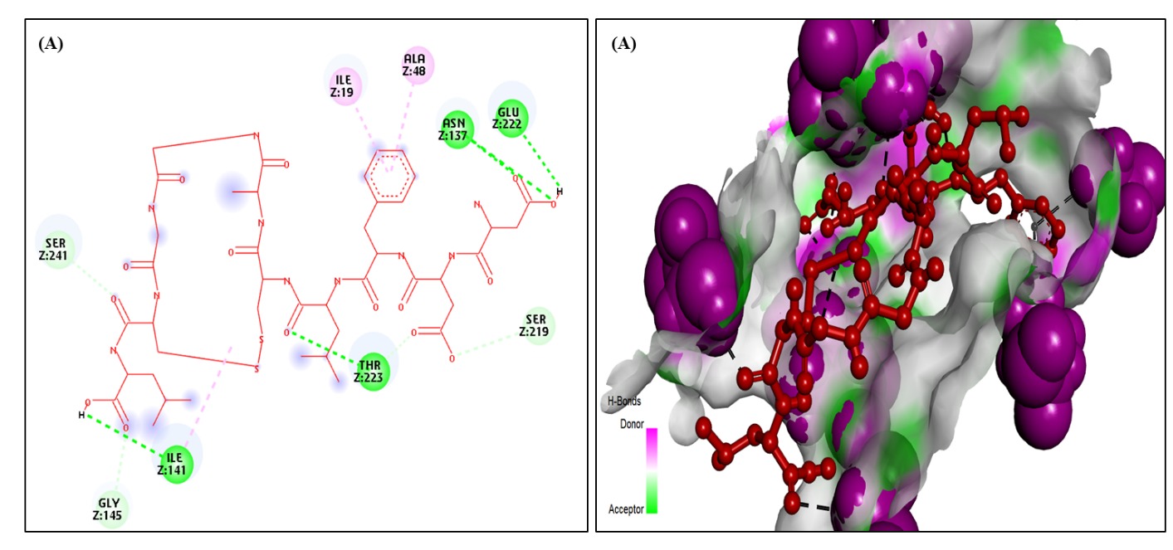
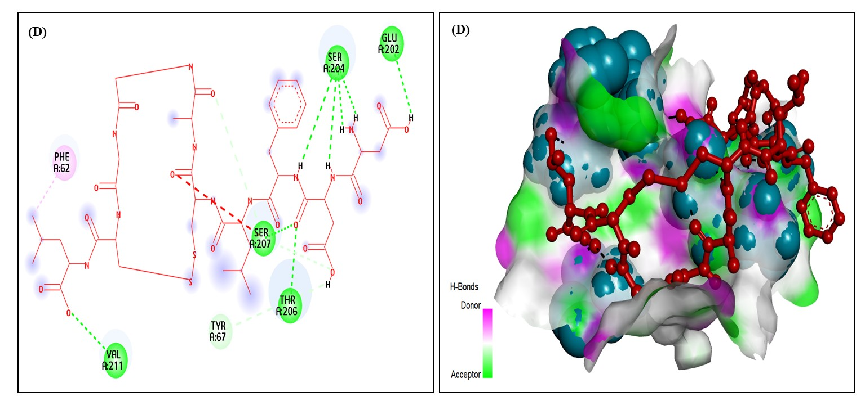
Supplementary Figure 1. Binding interaction of Alliumin with proteins. (A): S. aureus (PDB ID: 7LO8), (B): E. faecium (PDB ID: 7V3D), (C): E. coli (PDB ID: 6KZV), (D): P. aeruginosa (PDB ID: 6RPN). The left panels show the interaction analyses and the right panels the binding pockets.

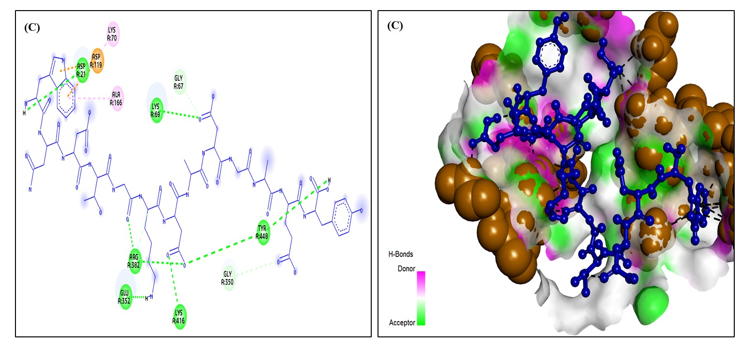
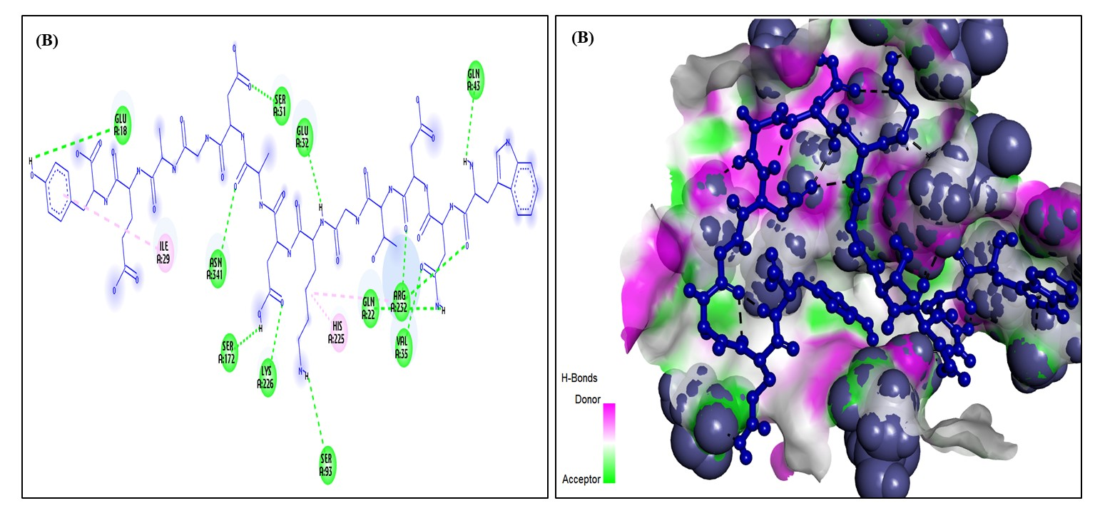
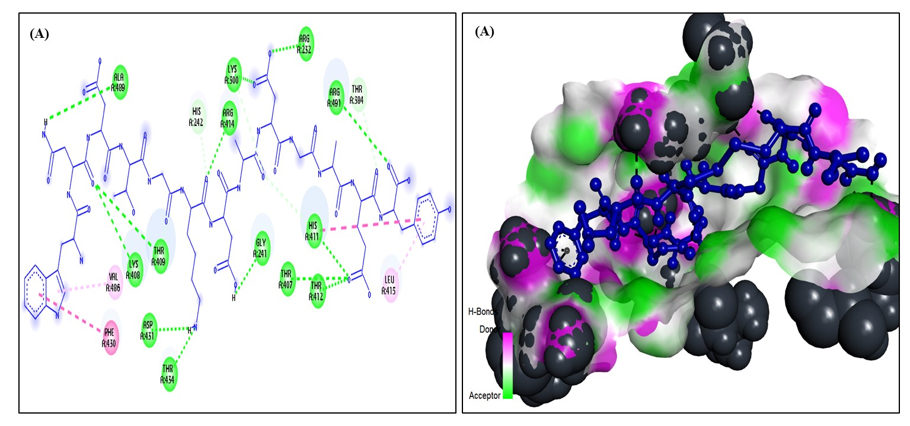
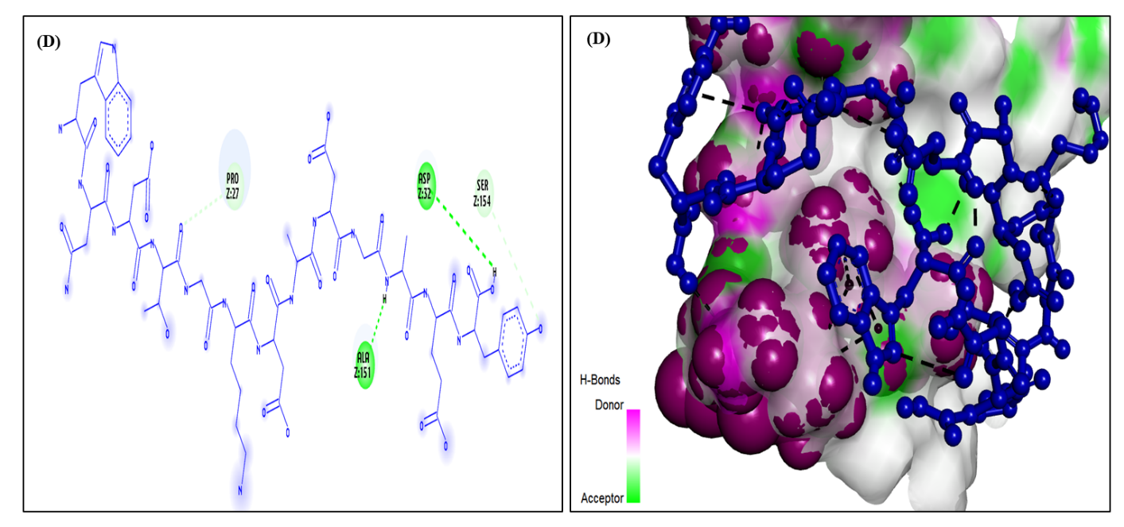
Supplementary Figure 2. Binding interactions of Taromycin A with proteins. (A): S. pneumoniae (PDB ID: 8IAX), (B): E. faecium (PDB ID: 7V3D), (C): S. pneumoniae (PDB ID: 6ORG), (D): S. aureus (PDB ID: 7LO8). The left panels show the interaction analyses and the right panels the binding pockets.

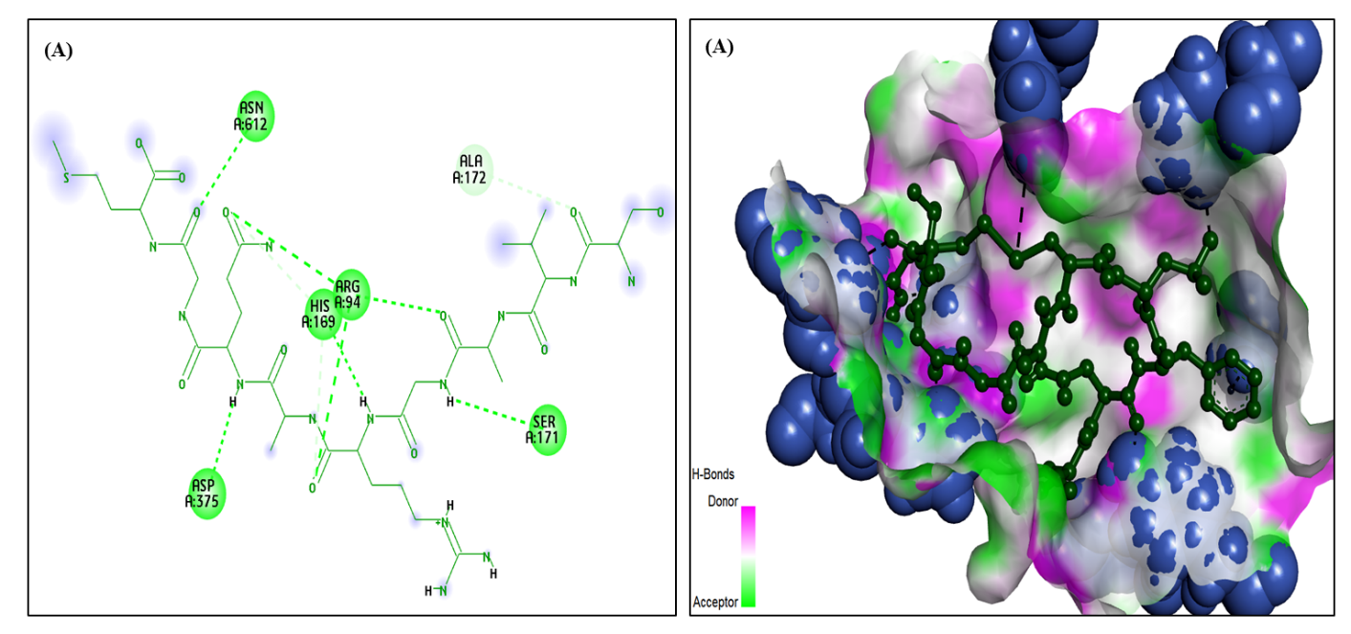
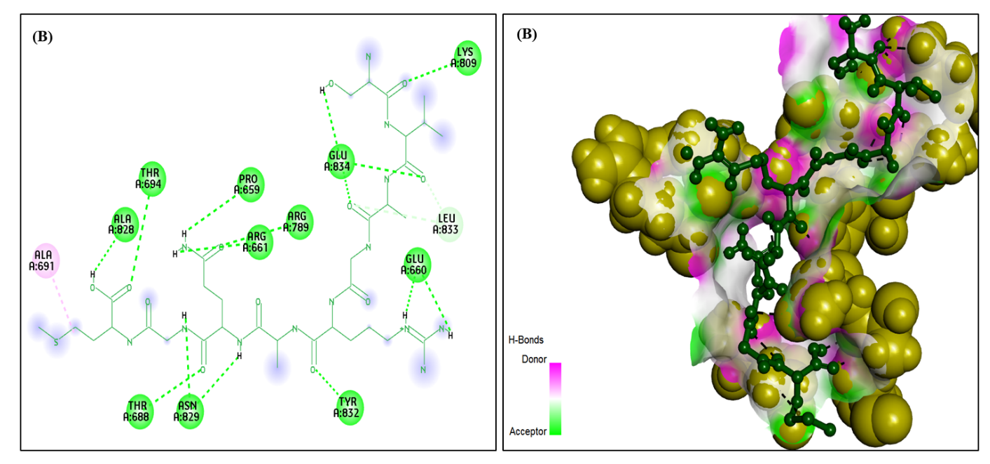
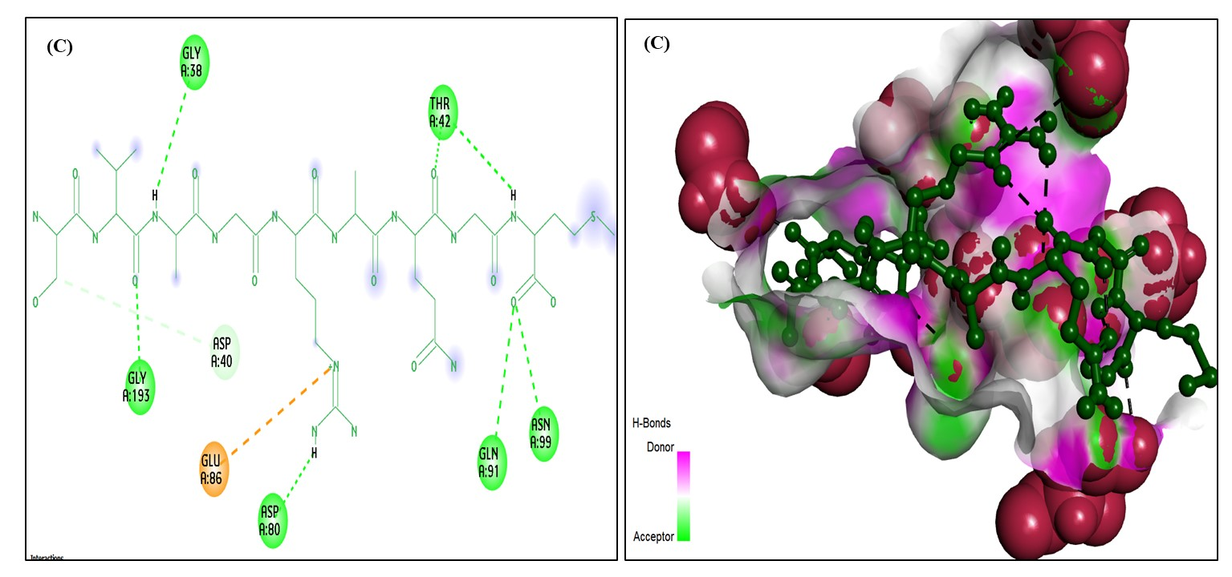
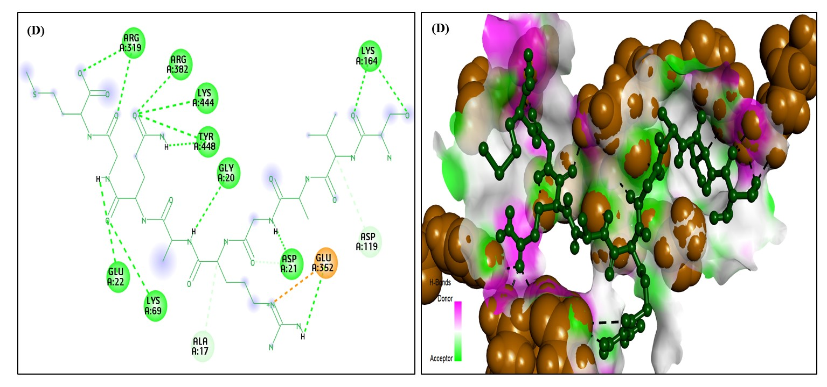
Supplementary Figure 3. Binding interactions of Antimicrobial peptide 1 (CN-AMP1) with proteins. (A): S. pneumoniae (PDB ID: 5A6A), (B): S. pneumoniae TIGR4 (PDB ID: 4CU6), (C): S. aureus (PDB ID: 1JIJ), (D): S. pneumoniae TIGR4 (PDB ID: 6ORG). The left panels show the interaction analyses and the right panels the binding pockets.

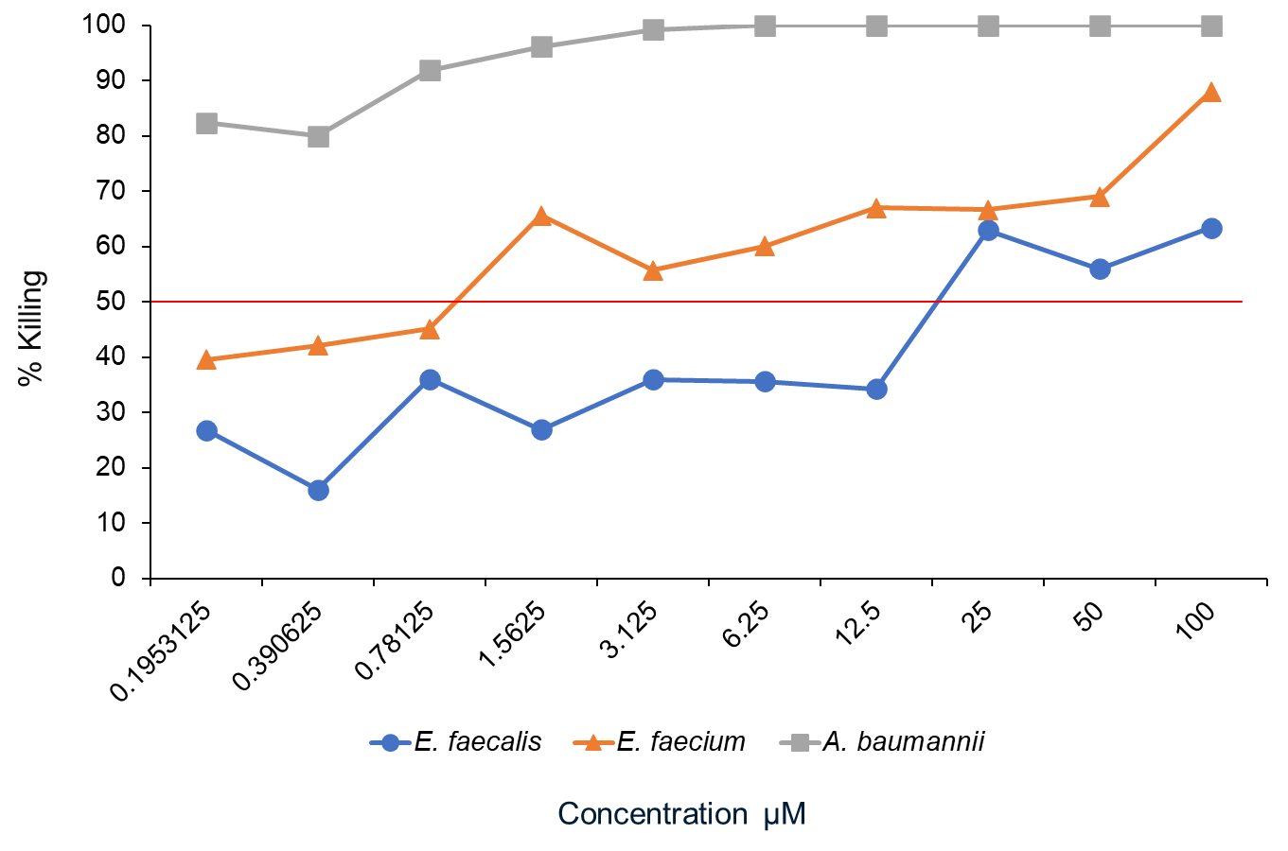

Supplementary Figure 4. Titrated curve for positive control antibiotic (ceftriaxone).

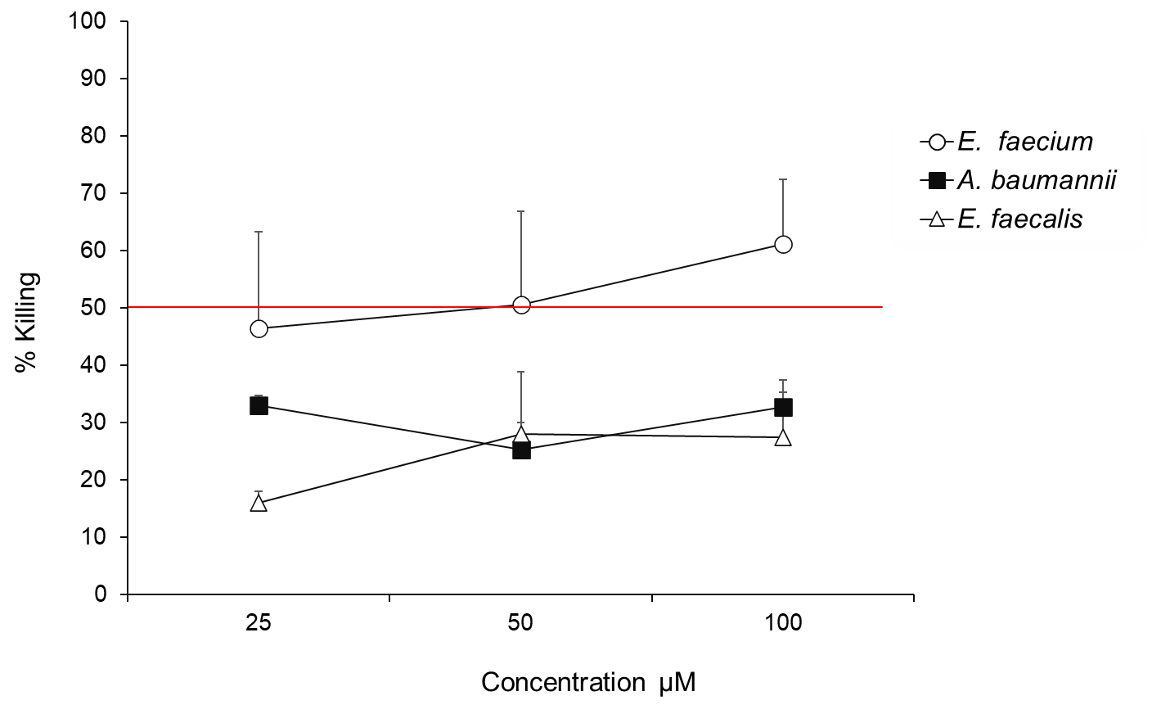
Supplementary Figure 5. Percentage killing of ESKAPE pathogens with CN-AMP 1 peptide (100µM). Symbols represent the mean, and the error bars represent the standard error of the means of at least N = 4 experiments.
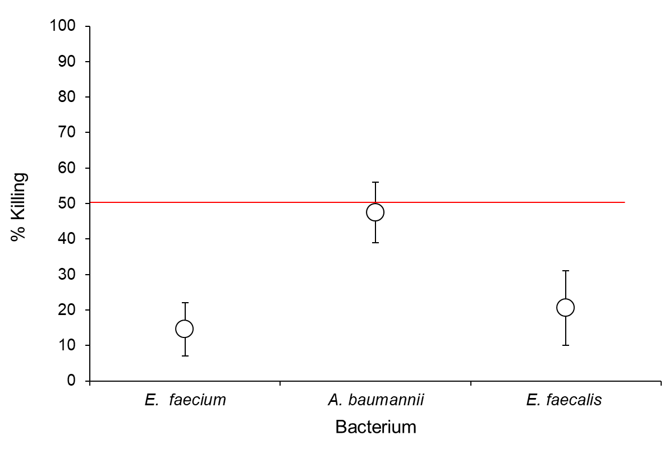
Supplementary Figure 6. Percentage killing of ESKAPE pathogens with Alliumin peptide (100µM). Symbols represent the mean, and the error bars represent the standard error of the means of at least N = 4 experiments.

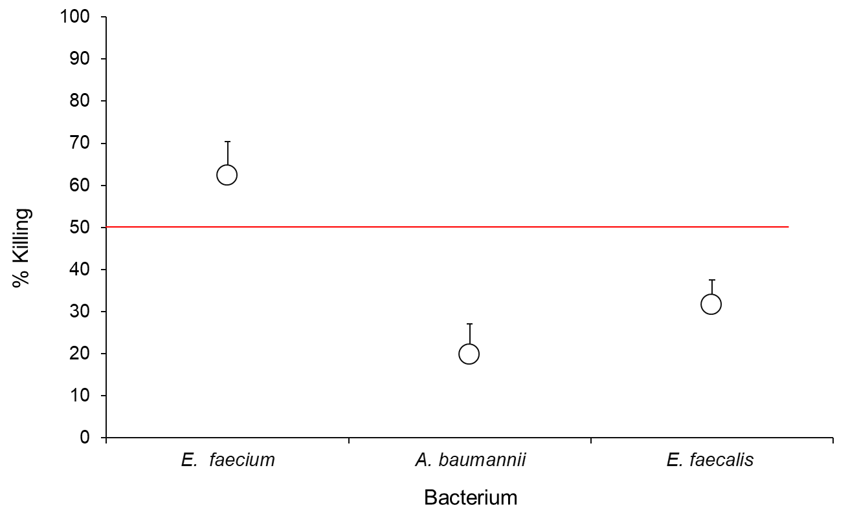
Supplementary Figure 7. Percentage killing of ESKAPE pathogens with Taromycin A peptide (100µM). Symbols represent the mean, and the error bars represent the standard error of the means of at least N = 4 experiments.

