Supplemental

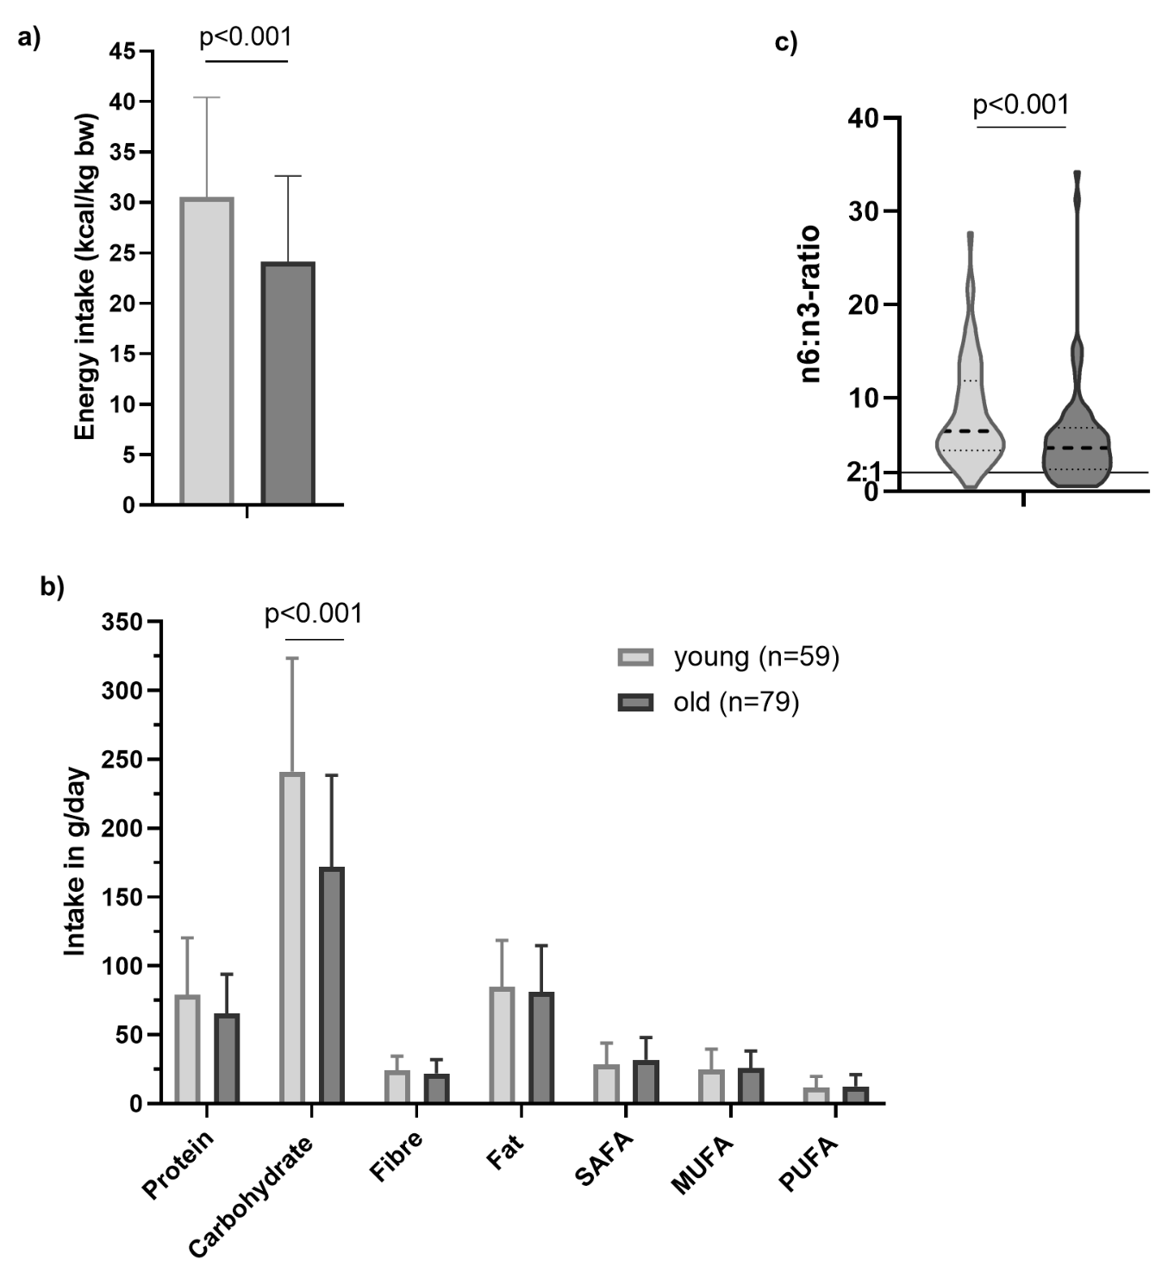
Supplemental figure 1 Comparisons between old and young participants regarding a) energy intake in kilocalorie (kcal) per kilogram body weight (kg bw) per day, b) nutritional intake in gram (g) per day and c) distribution of daily omega (n)-6 to n-3 intakes with line at 2:1 indicating ideal intakes; MUFA mono-unsaturated fatty acids, PUFA poly-unsaturated fatty acids, SAFA saturated fatty acids

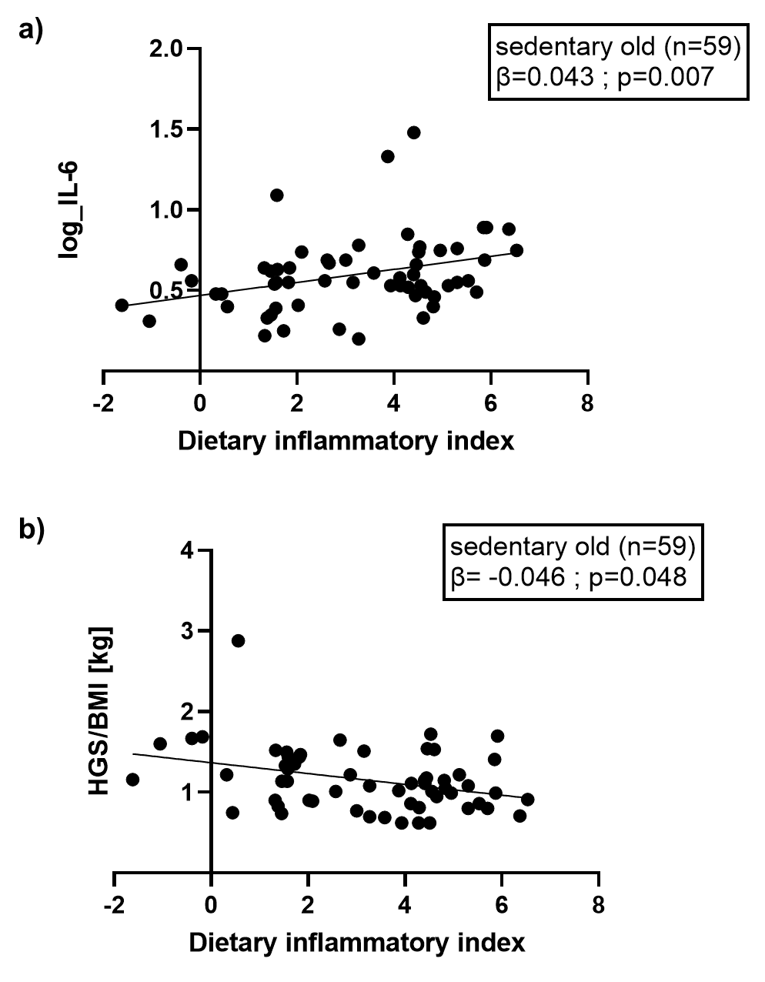
Supplemental figure 2 Regression analysis adjusted for sex between dietary inflammatory index and a) log-transformed interleukin 6 (IL-6) and b) handgrip strength of the dominant hand normalized to body mass index (HGS/BMI) in a sub-sample characterized as sedentary old adults

