Supporting Information to the paper:

Towards Sustainable Lithium-Ion Batteries: A State-of-the-Art Review on Silicon Anodes, Economics, and Recycling

M. L. Protopapa^{1,}*, E. Burresi², A. Fiore¹, L. Mirenghi², B. Palazzo³, M. Schioppa¹, M. A. Tagliente², V. Valenzano¹, N. Taurisano¹, G.B. Appetecchi⁴

¹ENEA - Italian National Agency for New Technologies, Energy and the Sustainable Economic Development, SSPT-EC-RMP Lab, Brindisi Research Center, S.S. 7 Appia km. 706, 72100 Brindisi, Italy.
²ENEA - Italian National Agency for New Technologies, Energy and the Sustainable Economic Development, SSPT-TIMAS-CMS Lab, Brindisi Research Center, S.S. 7 Appia km. 706, 72100 Brindisi, Italy.
³ENEA - Italian National Agency for New Technologies, Energy and the Sustainable Economic Development, SSPT-TIMAS-MCC Lab, Brindisi Research Center, S.S. 7 Appia km. 706, 72100 Brindisi, Italy.
⁴ENEA - Italian National Agency for New Technologies, Energy and the Sustainable Economic Development, TERIN-DECC-ACEL Lab, Casaccia Research Center, Via Anguillarese 301, Rome, 00123, Italy.

*Corresponding author: Tel.: +39 0831 201 438; Fax: +39 0831 201 439; E-mail address: lucia.protopapa@enea.it.

Appendix A
A1. Lithium-ion battery operating principles
It is useful to briefly define the key parameters that characterize batteries. The electrical energy a battery can deliver depends on the cell potential (V) and capacity (A·h·kg⁻¹), both of which are determined by the system's chemistry (Tarascon & Armand, 2001). Theoretically, the energy supplied by an electrochemical power source is the product of its capacity and operating voltage, expressed in Joules (J) or Watt-hours (Wh). By definition, a battery's specific energy and energy density represent the amount of energy stored per unit mass (Wh·kg⁻¹) and per unit volume (Wh·L⁻¹), respectively.
Among the most popular high-power batteries in use since 1859, Pb-gel cells must be mentioned (Kramm et al, 2009). They were conceived in France and widely used on cars, motorcycles, and other motor vehicles, all over the world. The battery energy density of Pb-gel cells was in the range 30-35 Wh kg⁻¹ with life cycles (l-c) of 200-300, and a nominal cell voltage (n.c. V) of 2 V when fully charged and at a fast charge time of 8-16 hours. As it will be stated below, the Pb-gel cells present very poor features in comparison with modern chemical batteries.
With the advancement of technology and the diversification of electronic and mechanical applications in the second half of 20th century, there has been an increase in consumer demand for batteries with longer operation times, smaller size, lighter weight, fast-recharge ability, high safety, and low cost, inspiring chemists, physicists, material scientists, and engineers to develop new designs and concepts of electrochemical storage technologies (Fichtner et al., 2022). Since the 1960s, the most effective rechargeable battery design has used lithium ions as internal charge carriers (Megahed & Scrosati, 1994; Reddy et al., 2020). Indeed, the utilization of high-capacity electrode materials is mandatory for the successful realization of high energy density batteries (Megahed & Scrosati, 1994). Lithium metal is the obvious option, but suffers of high chemical reactivity, resulting in dendrite growth-up which can lead to cell short-circuit with dangerous events (burning, explosion). Therefore, Li° metal is replaced by an electrode (generally graphite) able of reversibly intercalate lithium ions, thus generating the concept of lithium-ion battery (LIB). Nowadays, daily life for millions of people is powered by LIBs. The increasing popularity of this technology can be attributed to its light weight, high energy density, compact design, and ability to recharge in terms of cycling stability. It can be found in many smart portable electronic devices such as laptops, cell phones, hybrid and electric vehicles and renewable energy supply systems (Goodenough & Park, 2013; Xie & Lu, 2020).
A battery is an electrochemical power source, specifically a device capable of converting chemical energy into electrical energy, and vice versa. In general, it consists of two electrodes (positive and negative), with a separator (porous material) between them (Elmahallawy et al., 2022). The two electrodes host the electroactive materials. The separator is filled with liquid electrolyte, i.e., a liquid phase solution containing a dissociated salt, source of ions. The chemical energy is stored in the electroactive species of the two electrodes, and it is converted into electric energy by means of electrochemical reduction-oxidation (redox) reactions. The oxidation half-reaction happens at the anode with the release of electrons, while the reduction half-reaction happens at the cathode when electrons are taken up (Pop et al., 2005). The operating principle can be expressed in the form of a closed electrical circuit, in which the electrodes provide both the electrons and the ions responsible for the transfer of charges between two points in the circuit. When the cell is connected to an external load, the current flows spontaneously through the circuit.
As a challenge to environmental footprint, SONY introduced the world’s first commercial LIB in 1991, using a lithiated cobalt oxide cathode and a non-graphitic carbon anode (LiCoO₂/carbon) (Casimir et al., 2016; Megahed & Ebner, 1995).
Since 90’, multiple efforts have been devoted to improving storage materials, electrolytes, and cell designs to produce rechargeable batteries with high energy density and efficiency (Blomgren, 2017; Fichtner et al., 2022). Despite having a larger capacity, LIB is smaller than a typical nickel-metal hydride battery. Efforts to increase their unique charging/discharging capabilities, resilience, and efficiency have been focused on research.
Lithium is the lightest metallic element, with a density of 0.534 g cm⁻³, and possesses a high specific capacity (3.86 A h g⁻¹)(Reddy et al., 2020). In addition, it has the lowest reduction potential of all known elements, -3.04 V relative to the standard hydrogen electrode (SHE), which makes it an ideal anode material for high-voltage and high-energy batteries (Reddy et al., 2020). However, the electrochemical potential of Li⁺/Li lies above the lowest unoccupied molecular orbital (LUMO) of non-aqueous electrolytes, leading to continuous electrolyte reduction unless a passivating SEI is formed. Due to the high reactivity and large volume change of lithium metal, which can result in dendrite growth and a cell short circuit, the SEI is prone to damage and repairs unevenly on the surface of Li metal (Goodenough & Kim, 2010). For this reason, it was claimed that two distinct intercalation hosts based on petroleum coke and graphite electrode could reversibly intercalate lithium ions and other alkali-metal ions at a low potential, while maintaining the electrode’s structural integrity thanks to the layered structure.
The basic scheme of a common lithium-ion cell is made up of a negative and positive electrode, a separator, an electrolyte, and two current collectors (positive and negative). The electrodes store the lithium ion. The electrolyte carries positively charged lithium ions from the negative to the positive electrode and vice versa, through the separator. Current collectors are conductive foils at each electrode of the battery, which are connected to the terminals of the cell. The cell terminals serve as conduits for electric current between the battery, the external device, and the energy source that charges the battery. During discharge, lithium ions migrate from the anode to the cathode through the electrolyte, while free electrons generated at the anode travel through the external circuit. This flow of electrons creates an electric current that powers the device. The electrons move from the negative current collector (anode side), through the external load, and are received by the positive current collector (cathode side), completing the circuit. The separator blocks the direct flow of electrons from an electrode to the other one, enabling the exchange of lithium ions from one side to the other.
Conventional LIBs contain layered lithium-based transition metal (Co, Ni, Mn) oxides${LiMO}_{2}$, able of reversibly intercalate Li⁺ ions, used as positive electrode and carbonaceous compounds (generally graphite) as negative electrode (Reddy et al., 2020). Fig. 1 presents a basic scheme of the lithium-ion battery working principle using graphite as the anode and cobalt oxide as the cathode.
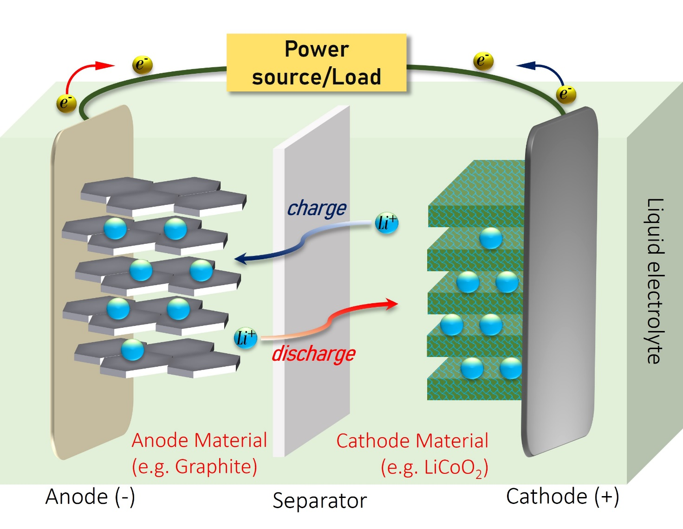Fig. 1 Sketched picture of the working principles of a LIB.
As a rechargeable electrochemical power source, Li-ion battery is composed of electrode materials which can store Li-ions reversibly. The two host materials have the capability of ‘intercalate/insert’ and ‘de-intercalate/de-insert’ the Li⁺ species within and from their structures, through a process of lithiation/de-lithiation by means of electrochemical reactions. In this process, lithium ions diffuse back and forth through the electrolyte between the negative and positive electrode. The term ‘de-intercalation’ simply refers to a de-insertion process of ions into a layered host compound, whereas the pure de-insertion terminology is more suitable for those compounds having a 3D framework containing cavities connected by narrow channels (Yu et al., 2013).
In the full discharged state, the Li⁺ ions are in the positive electrode material, which is the source of lithium ions necessary for the conversion of electrical energy into chemical energy. The charging process can be viewed as an oxidation process. Therefore, the power source accelerates the lithium ions to move from the positive electrode toward the negative one. In particular, Li⁺ ions de-intercalate from the positive electrode material into the electrolyte and migrate through the electrolyte to the negative electrode that reduces, for subsequent storage. To ensure charge neutrality, electrons migrate from the positive electrode material via an external conductor into the negative electrode material. The two half-reactions are the following:
At the positive electrode (cathode): ${LiMO}_{2}→{Li}^{+}+{MO}_{2}+e^{-}$
At the negative electrode (anode): $C_{6}+{Li}^{+}+e^{-}→{LiC}_{6}$
Because of these reactions, boundary phases, the so-called SEI and cathode electrolyte interphase (CEI), are formed at the interfaces between electrolyte/positive electrode surface and electrolyte/negative electrode surface, respectively. These interphases, which allow for reversible battery cycling, are composed of insoluble electrochemically induced decomposition products of electrolyte components and Li⁺ ions. After the formation of the SEI and CEI, further Li⁺ ions de-intercalate from the positive electrode material into the electrolyte and migrate through it to the negative electrode material to be subsequently incorporated into the latter. The Gibbs free energy, in this case, grows until it reaches the value associated to the full-charge state. In a charged cell at the open circuit condition (OCV), the lithium ions are fully intercalated into the negative electrode and an electric field is produced by the difference in the electrochemical potential between the two electrodes (Elmahallawy et al., 2022; Fichtner et al., 2022).
The battery begins to discharge when an electrical load is connected between its terminals. Thus, as the circuit is closed, a spontaneous process governed by the negative value of the Gibbs free energy (ΔG < 0) occurs. While the battery is discharging and providing an electric current, the negative electrode (anode) releases lithium ions to the positive one (cathode), generating a flow of electrons from one side to the other. During this process, called discharge, electrons flow from the anode through the external circuit and recombine at the cathode side with the Li⁺ ions, which are extracted from the active anode material (de-intercalation) and travelled across the electrolyte.
In this case, the two half-reactions at the electrode active materials are the following:
At the negative electrode (anode): ${LiC}_{6}→C_{6}+{Li}^{+}+e^{-}$
At the positive electrode (cathode): ${{MO}_{2}+Li}^{+}+e^{-}→{LiMO}_{2}$
After discharge, the Li⁺ ions are re-stored in the positive electrode material from which they originally came. The back-and-forth movement of Li⁺ ions reminds of the movement of a rocking chair (which is why this principle was called the ‘rocking-chair’). Different aging processes take place in LIBs, which reduces the performance of the battery over the period of use and depends strongly on the cell chemistry. For this reason, the right choice of the electrolyte has an enormous influence on these aging mechanisms and underlines once more the importance of tailor-made electrolytes.
In practice, a modern LIB consists of two active electrodes, typically mixed lithium nickel-cobalt-manganese oxide (LiCo_{1-x-y}Ni_{x}Mn_{y}O₂) cathode and graphite (C₆) anode, separated by a porous material loaded in a non-aqueous liquid electrolyte mainly composed of a lithium salt (LiPF₆) in a mixture of ethylene carbonate (EC) and, at least, one linear carbonate selected from dimethyl carbonate (DMC), diethyl carbonate (DEC), ethyl methyl carbonate (EMC) and many additives. During the charge process, Li⁺ species move from the LiCo_{1-x-y}Ni_{x}Mn_{y}O₂ lattice structure to the anode to form lithiated graphite (LiC₆). On the contrary, during the discharge process, these ions move back to the Co_{1-x-y}Ni_{x}Mn_{y}O₂ host framework, while electrons are released to the external circuit (Xie & Lu, 2020).

A2. A brief history of rechargeable batteries

Historically, the first full rechargeable battery commercialized by SONY, combining the petroleum coke anode with Goodenough’s LiCoO₂ cathode, reached a specific energy (SE, even known as gravimetric density or, in brief, capacity) of ≈80 Wh kg⁻¹, and an energy density (or volumetric energy density) of 200 Wh L⁻¹. More generally, the battery-based on the combination Lithium Cobalt Oxide (LCO) cathode/graphite anode (in the market since 1991)- possesses a SE up to 240 Wh kg⁻¹, l-c of 500-1000, n.cV of 3.6 V but in the range 3.0-4.2 V.
The finding of Sanyo’s researchers and Dahn’s work with EC as co-solvent set the scene for the development of LIBs with a graphite anode and increased the voltage and energy density to 4.2 V and 400 Wh L⁻¹, respectively (Winter et al., 2018). Only few years later, Guyomard and Tarascon reported a new electrolyte formulation, LiPF₆ in EC/DMC, for its improved oxidation stability (Guyomard, and Tarascon, 1993). This kind of electrolyte formulation remains one of the most popular liquid electrolytes until today, affording LiCoO₂-based LIBs three times higher energy density (250 Wh kg⁻¹, 600 Wh L⁻¹) than that of the first-generation devices by SONY (Winter et al., 2018; Xie & Lu, 2020).
On the other side it stands the battery-based on the combination lithium-ion manganese oxide (LMO, spinel structure LiMn₂O₄)-cathode/graphite-anode, in the market since 1996, which shows SE of 100-150 Wh kg⁻¹, l-c 300-700, n. cV of 3.8 V in the range 3.0-4.2 V/cell [www.batteryuniversity.com]. The comparison between the two manufactured cells (LiCoO₂-based and LMO) defines the first one suitable for very high specific energy applications (it serves as energy cell) with limited specific power performance and rather expensive for the presence of cobalt in the cathode. The second manufactured cell results instead more performing for high power density applications at expenses of the specific energy, safer than LCO for the absence of Co, but less relevant in the nowadays production.
Examining the same parameters of several batteries present within the worldwide market, two kinds of batteries attract our attention: the lithium nickel cobalt aluminium oxide (NCA) battery, better known as Li-NCA oxide cathode/graphite anode, since 1999 and the lithium nickel manganese cobalt oxide (NMC) battery (Li-Mn_Co cathode/Lithium titanium oxide -LTO-anode) since 2008. The former (SE of 200-260 Wh kg⁻¹, n.cV of 3.6 V, and l-c of 500) has been used for high energy densities applications, while the latter (SE of 150-220 Wh kg⁻¹ , n.cV 3.7 V and l-c of 1000-2000) provides both high energy and high power applications, that is why it is used as hybrid cell and has gained an increasing attention as leading system in the market (Battery University, 2025). LIBs’ impact is set to extend beyond portable electronics into domains critical for the sustainability of society. To meet the ever-growing demand for electrified transportation and large-scale energy storage solutions, continued materials discoveries and game-changing chemistry hold the key to unleashing the full potential of lithium-ion batteries toward seriously enhanced cost efficiency, power and energy densities, and safety. Silicon is a promising alternative to the conventional graphite anode for LIBs, with its extremely high theoretical specific capacity of 4200 mA h g⁻¹, for the phase of Li₂₂Si₄ at room temperature, but the commercialization of silicon-based anodes is hindered by a few difficulties, including the formation of unstable SEI layer and enormous volume expansion up to 300% that can cause the pulverization and loss of electrical contact with current collector (M. Kim et al., 2023).

Appendix B

Natural graphite as strategic raw material for green transition
The motivation of the necessity of finding technological alternatives to graphite as anode materials are expressed in the following discussion.
The issue of electrification in the automotive sector and mobility, in general, is closely linked to the development of new types of batteries (not only LIBs), as well as looking for new solutions for the use of storage systems for intermittent green technologies. The employ of these storage technologies involves the use of different inorganic critical materials, the most relevant ones are antimony, cadmium, cobalt, copper, graphite, lithium, manganese, nickel, lead, silicon and zinc. Among these materials, EU inserted natural graphite used in LIBs in the 2017 list of critical raw materials (EUR-Lex - 52017DC0490 - EN - EUR-Lex, 2017). Equally, silicon, which is considered to improve the energy density of future LIB types (RMIS - Raw Materials Information System), is highlighted as critical.
Due to its different properties, natural graphite is a material applied in a broad spectrum of industrial sectors (Study on the EU’s List of Critical Raw Materials, 2020- Publications Office of the EU), such as refractories, lubricants, batteries, friction materials and so on. Graphite is a good conductor of heat and electricity; it can firmness and strength up to temperature more than 3600 °C (Cermak et al., 2020; Raghavan & Kumaresan, 2022). It has a good lubricating properties and resistance to corrosion and chemical inertness (Jara et al., 2019).
There are three types of natural graphite for commercial use, classified by purity and particle size: i) flake graphite (with a distinct flake structure that is categorised by the industry in terms of size as fine, medium or large), ii) amorphous graphite (with no flake structure and typically lower carbon grade) and iii) vein graphite (a speciality product produced only in Sri Lanka) (Study on the EU’s List of Critical Raw Materials 2020 - Publications Office of the EU).
The most abundant natural graphite, occurring at the lowest grade, is amorphous also called microcrystalline graphite. Here, the term “amorphous” means that some very fine nano-dimensioned particles in graphite are present (Jara et al., 2019). The grade of microcrystalline graphite varies among 20-40% in graphite content, and its purity fluctuates from 70 % to 85 % carbon after being processed. In Table I, a summary of the main properties of the three types of natural graphite are reported (Jara et al., 2019).
Graphite Type | Vein (Lump) | Flake | Amorphous
Description | Predominantly produced in fractional tonnages, with a carbon grade > 98%. This is the rarest and greatest valued form on a price per ton basis. | Good crystallinity, carbon content ranging from 80 to 95 %. Flake graphite has a distinctly flaky morphology. | A seam mineral, typically with higher impurity and more ash content.  Carbon content is typically < 85%.
Lithium-ion batteries | No | Lithium-ion | No
Technical, metallurgical and common uses | No technical uses; Refractories, crucibles, molds, castings | For several electrical work such as Electrodes for aluminum and steel production, as a brake lining.  Refractories, crucibles, molds, castings. Batteries: Lithium-ion | No technical uses; Refractories, crucibles, molds, castings
Advantages | Economically significant in terms of C-content | Less cost, impurities, crystallinity, and porosity | Low cost
Disadvantages | Rare and costly | Inconsistent quality | Weak crystalline; Small economic sources; high cost
Table I. Properties of the main types of natural graphite. (Kenan, 1991; Kavanagh and Schlög 1988).
Chemical and thermal processing of natural graphite concentrate can yield a superior purity grade, with carbon content exceeding 99%, while also tailoring its physical and chemical attributes to suit specific applications. (Study on the EU’s List of Critical Raw Materials, 2020- Publications Office of the EU).
It is worth noting that the use of natural graphite has a not negligible environmental impact due to all the extraction and purification process, employing acids such as hydrofluoric and hydrochloric, which leads to potential pollution of waterways. At all stages of the ore processing, large quantities of pollutants are released into the air. Since the yield compared to the concentrates is only 30 to 40 %, this leads to a large production of waste, potentially dangerous for environment and for the human health (Commissaire Général au Development Durable, CGDD, 2022).
For specific applications, natural graphite can notably be replaced by synthetic graphite, which is obtained from petroleum or carbon (the raw material comes from the oil industry or coal), after industrial refining processes. In terms of energy intensity, 18.2 kWh/t are needed to prepare natural graphite, which generates between 2.2 and 3.8 t of CO₂ eq/t, while 26.2 kWh/t are needed to produce synthetic graphite, generating between 4.9 and 5.5 t of CO₂eq/t (Commissaire Général au Development Durable, CGDD, 2022). Compared to synthetic graphite, natural graphite has significant merit in production cost/time and energy consumption.
Regarding the world annual consumption of graphite in 2018 this is about 1.1 Mt for natural graphite and 1.5 Mt for synthetic graphite. During 2015-2016, the total graphite production in the world was about 2.5 million (close to the consumption in 2018) tons and the major-production countries were China (66 %), India (14 %), Brazil (7 %), Turkey (3 %), Canada (3 %) and North Korea (3 %).
Total estimates of renewable graphite reserves amounted to 300 Mt in 2019; recoverable graphite in inferred resources exceeded 800 Mt worldwide (Geological Survey, 2020). According to USGS data, Chinese graphite reserves accounted for about 24% of the world total (Qizhong and Damm, 2020). Fig. 2 (a) reports graphite demand trend for the years 2015-2025, highlighting the importance of graphite demand in the next years.
For natural graphite, 47% is used in refractories mainly for furnaces and crucibles; 9% for batteries (use is increasing); for synthetic graphite: 44% is used to produce electrodes needed for the manufacture of steel, silicon or aluminium; 8% for batteries (also in this case the use is increasing) (Le Graphite Naturel (C)-Éléments de Criticité, 2016). Specifically, in EU countries in 2016, the market is dominated by refractories applications (54%), followed by applications as friction material (8 %) and in Li-ion battery (5%)(Study on the EU’s List of Critical Raw Materials, 2020- Publications Office of the EU). Fig. 2 (b) depicts graphite application by type.

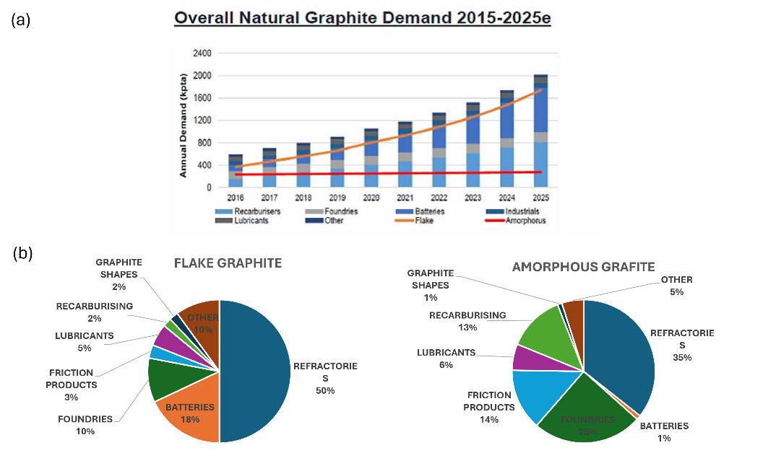

Fig. 2 (a) Overall natural graphite demand in the period 2015-2025. Adapted from Spencer and Hill, 2016. (b) Graphite applications by type (Roskill, 2019; Qizhong and Damm, 2020).
Natural graphite is mined in several countries, but production is concentrated in China, which dominates the world natural graphite production with a share of 71% in 2017 (World Mining Data, 2019). China is also the dominant supplier of natural graphite worldwide, accounting for 59% of the value of world exports in 2017 (Study on the EU’s List of Critical Raw Materials, 2020- Publications Office of the EU). This centralization in the production and export of graphite from China leads to its criticality, especially in relation to importing countries, such as the European zone but also from United States. Indeed, in China there are many mines, about 150, but this number is in sharp decline following the tightening of anti-pollution regulations and closures/restructurings imposed by the State. There are fewer small mines and more large integrated groups. China’s current production is only half of its annual production capacity (Commissaire Général au Development Durable, CGDD, 2022).
In the field of the green technologies, natural graphite is used to manufacture the anode in batteries and fuel cells for electric vehicles and energy storage systems. In this field, it is worth noting also the use of natural graphite in the brushes of electric motors. In fact, the uptake of electromobility is expected to decarbonise the transport sector, especially in combination with the decarbonisation of power generation. On the other hand, energy storage systems are essential for development of renewable, intermittent energy sources in order to decarbonise the power production sector.
Since China considers graphite as a strategic material for its economy and its national energy strategy, it does not grant many licenses to exploit its mines, greatly increasing the import of this honeycomb mainly from Africa: in particular large quantities of flake graphite suitable for processing in battery-grade come from Mozambique (93% - 70%, according to 2019 data) and Madagascar, in order to meet the surging demand in the world’s largest LIB industry.
Regarding the construction of anodes for LIBs, spherical graphite is the battery-grade graphite employed in those electrodes. Spherical graphite is produced with stringent quality requirements from high-carbon fine and medium-flake graphite by successive stages of mechanical milling (micronising), spherodisation, purification to achieve a carbon content of 99.95% or higher, and coating with carbon. The process increases graphite surface area and conductivity making it highly suitable for use as anode material. Spherical graphite production yields generally range from 30% to 40% of the initial weight of the feed flake material (Study on the EU’s List of Critical Raw Materials, 2020) - Publications Office of the EU).
Moreover, the demand for graphite under the 2DS (2 degrees scenario following the Paris Agreements) in 2050 for batteries, mainly LIBs, is estimated to be five times higher than the total natural graphite produced in 2018. Global production of natural and synthetic graphite is expected to double in 2028 compared to 2018, mainly due to the rapid growth of the battery industry (Worldwide Governance Indicators). Furthermore, almost all of the world's output of spherical graphite for LIB anode material is carried out in China, which is either consumed domestically or exported to Japan and South Korea. China dominates the anode materials market and hosts the largest overall capacity (370 kt or 78% of the worldwide capacity) for anode materials used in Li-ion batteries.
To understand the impact of the usage of the carbon in the green technologies, it is important to take in account the global emission for the processing and manufacturing of the minerals involved to decarbonization of the electricity sector. Emissions from the production and operation of renewable energy and storage technologies are just 6 percent of coal and gas generation (Hund et al., 2020).
In case of graphite production for energy technologies, they account between 300-400 cumulative MtCO₂eq (Megatons of carbon dioxide equivalent) up to 2050 under 2DS. The growth of graphite usage in green technologies applications (J. Zhang et al., 2023) is expected to increase five-fold by 2050 under a 2DS scenario that limits global warming to two degrees; hence natural and synthetic graphite can both contribute to the clean energy transition increasing thoughtfully the demand by next years. Both natural and synthetic graphite can be used in several applications in the field of green technologies.
To effectively measure the consumption of critical materials, specifically graphite, in batteries introduced to the market, it is beneficial to examine a case study like the European Community market. It is advisable to detail the weight distribution of different graphite-anode-based LIBs across the 28 EU countries. Additionally, an assessment of the critical materials utilized in all battery types, including lead-acid batteries, shows that the market is still dominated by lead, followed by manganese, antimony, lithium, graphite, copper, and cobalt. It is worth noting that the role of graphite and copper has been growing since 2009 up to now.

Appendix C

A possible solution to sustainability challenges: silicon from PV waste
C.1 Overview about installed PV and decommissioning
Global warming, decarbonization programs and energetic transition are strong motivators for the development of novel green technologies devices for renewable energy production and storage, such as photovoltaic technology and batteries (Protopapa et al., 2021; Ratynski et al., 2019), which have had a huge growth of installation and usage in worldwide in the last years. According to IRENA data (IRENA, 2022), in 2021 the worldwide installed capacity of renewable energy aimed at the production of electricity is about 3077 GW, which is increased subsequently around 294 GW in one year until to reach 3371 GW in 2022. In Fig. 3a) the rate of the total renewable energy installed in various world countries is reported.
For Europe, the total capacity installed in 2021 is around 651 GW, increasing around 42 GW from 2020 and reaching 708 GW in 2022. Regarding the photovoltaic capacity installed worldwide, it was around 713 GW in 2020, reaching 855 GW in 2021 and 1046 GW, breaking the threshold of the terawatts of installed PV panels. Total photovoltaic energy (GW) and PV energy change (GW/year) in worldwide are reported in Fig. 3b) and c) respectively, as power installed in function of the year.
In Europe the PV capacity installed in 2020 is 160 GW, which increases to 187 in 2021 and 225 in 2022.
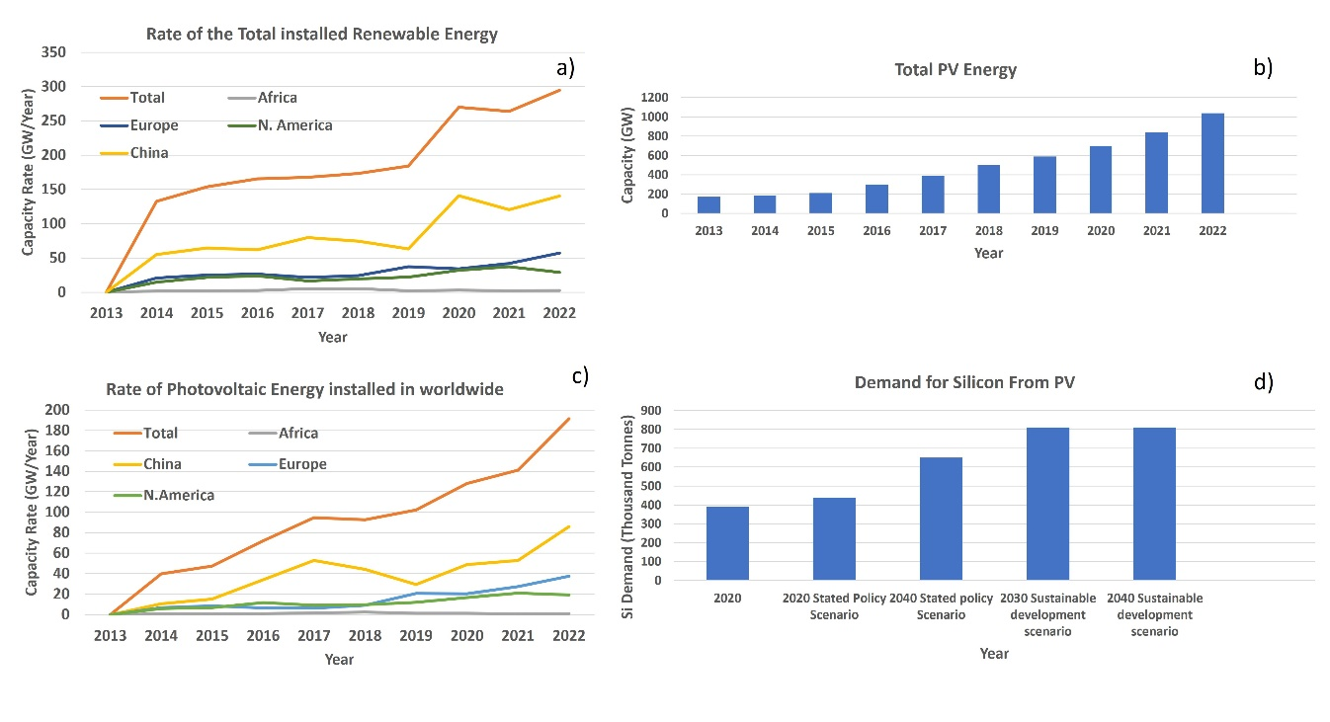

Fig. 3 a) Rate of the total renewable energy installed in some world countries, calculated as capacity change per year (IRENA, 2023). The rate measures the amount of new renewable energy capacity installed each year. b) Total photovoltaic energy installed in worldwide (IRENA, 2023); c) rate of the total photovoltaic energy installed in worldwide and in some world countries (IRENA, 2023), and d) demand for silicon from solar PV by scenario, 2020-2040 (IEA, 2021).

Moreover, despite the COVID-19 pandemic, preliminary reported market data shows that the global PV market again grew significantly in 2022, when the total cumulative installed capacity for PV reached over 1 TW (Fig. 3b). China remains the leader in terms of cumulative capacity with 392.4 GW installed, almost one third of the global PV installed capacity.
Particularly interesting are plants installed in Africa where the solar PV capacity could be reaching 70 GW by 2030 (Daher et al., 2023; IRENA, 2016). Here for the future, PV technologies are considered one of the most prominent means to access to electricity (IRENA, 2016).
However, the threshold of 1 TW can be exceeded by considering that PV capacity is expected to rise further to 1.6 TW by 2030 and 4.5 TW by 2050 (IRENA and IEA-PVPS, 2016; Protopapa et al., 2021). The European Photovoltaic Industry Association (EPIA) predicted that, by 2040, PV energy might contribute up to 12.6% of the world's electricity need (Marwede & Reller, 2012), implying that significant amounts of PV modules will be installed in the future.
By considering the PV installation in the European Union (EU) in 2022, Germany took the lead with 66.5 GW, a significant increase for the third year in a row. Italy with 25.0 GW and The Netherlands with 22.5 GW experienced significant market additions for the third time in a row, followed by Spain that installed 18.2 GW, France 17.4 GW, Poland with 11.1 GW and UK with 14.4 GW. In this way, until now, PV saving as much as 875 million tons of CO₂ (IEA-PVPS, 2022). However, much remains to be done to fully decarbonize, and PV capacity should increase by at least one order of magnitude to cope with the targets defined during the COP21 in Paris, France.
In addition, the crisis of the critical raw materials involves the construction of supply chains of the critical materials from the same end-of life devices (IRENA, 2022). As example for PV panels the operating time is about 20-25 years, so after this period, they should suffer one of more recovery process to eliminate the landfilling, by giving a new value to the recovered materials (IRENA, 2022; Protopapa et al., 2021; IRENA, 2016). Some experiments in the past proved that the rate of degradation in the efficiency of crystalline silicon photovoltaic (c-Si PV) panels was around 0.5% per year, much lower than the initially estimated loss of 1% per year (Jordan & Kurtz, 2013). It is worth mentioning that in principle the PV technology can produce electricity over 30 years even though the performance of PV systems can be influenced by reducing the efficiency of the conversion of sunlight to electricity. Anyway, discolouration of the encapsulant, delamination, abrasion and cracks of the front glass, bubbles on the back sheet of PV modules, corrosion, snail trails, hotspots and potential induced degradation, reducing effective operating life of PV solar to 20-25 years (Daher et al., 2023).
So far, several countries already account for the decommissioning of PV plants in their total cumulative capacity statistics by subtracting the decommissioned capacity. However, it is believed that many countries do not track nor decommissioning nor repowering properly. It is assumed that real decommissioning is relatively unusual given the age of the oldest installations after the real market started in 2005. Replacement of components, and in particular, PV modules and inverters, is part of the usual maintenance and operation business, but in general it does not impact the total cumulative capacity. Recycling numbers can provide a glimpse of what is happening in this field. However, recycling schemes are not yet common, and the availability of data must be improved (IRENA, 2016).
Accordingly, the resource supply risk for raw materials, including silicon and related materials (such as polymers and metals), is increasing due to the large increase in PV installations, which has already restricted the sustainable development of the PV industry. However, it has been predicted that the worldwide solar PV waste could unlock between 1.7 and 8 million tonnes of raw materials (as plastics and Si, Ag, Cu, Al), and other valuable components by 2030, rising further to about 78 million tons by 2050 (IRENA, 2016). This number will dramatically increase to 60–78 million tons by 2050 due to the limited-service lifetime (25–30 years) of PV modules (IRENA and IEA-PVPS, 2016). The interest about managing of the waste of PV panels is linked both to the recovery of raw materials and to avoid landfilling.
It is worth mentioning that the demand for silicon for PV is drastically increasing, reaching around 800 thousand tonnes by 2040 (see Fig. 3d) (IEA, 2021). The massive use of silicon for different applications, such as in the microelectronics and in the solar panel industries, has led to the inclusion of silicon in the list of critical materials drawn up by the European Union.
While for third countries like China, which produce and export critical materials, the problem of the silicon supply chain is acute but not crucial, in the case of importing countries, such as the EU, this issue is dramatically on the agenda. Therefore, EU needs to mitigate the risks for supply chains of raw materials by bolstering its economic resilience. This is essential especially considering the recent COVID-19 pandemic and the subsequent energy crisis stemming from the conflict between Russia and Ukraine. The EU’s strategy, including the substantial Recovery Fund, is aimed at addressing the decades-old challenge to climate change.
The EU is actively regulating the supply chain of critical raw materials (CRMs), including silicon, which are essential for the energy transition, notably in wind power, hydrogen storage, and batteries. The EU's recent legislative initiative (EUR-Lex - 52023DC0165 - EN - EUR-Lex, 2023) aims to diversify and fortify the refining, processing and recycling stages of CRMs. Furthermore, the EU has introduced a new category called Strategic Raw Materials (Study on the EU’s List of Critical Raw Materials, 2020 - Publications Office of the EU), which are crucial to the Europe’s green and digital ambitions. These Strategic raw materials are subject to specific criteria to ensure a balanced and secure supply: a minimum of 10% of the EU's annual consumption must be sourced from extraction within the Union, at least 40% from processing, and a minimum of 15% from recycling activities. Additionally, no single third country should supply more than 65% of the EU's annual consumption of each SRM at any stage of processing, promoting a more diversified and secure supply chain.
All these precautions planned by EU highlight the emergency of building up alternative supply chains with respect to the traditional one, tied particularly to the import from producing country. In order to cover the increased demand for raw materials, it is getting crucial as example planning a recovery chain of silicon (as well as plastic and metals) from End-of-Life (EoL) PV panel, but also from waste coming from silicon industry (CN103647043A - Method for Preparing Negative Electrode Material of Lithium Ion Secondary Battery - Google Patents, 2013). Indeed, databases such as Orbit and Espacenet contain several patents regarding the use of silicon wastes as active material in other devices, such as LIBs. There are many other reasons to avoid the landfilling of the EoL PV panels, some of which recover tremendous importance since they concern environmental aspects. Solar cell devices contain harmful chemicals which, if leached from damaged PV under persistent rains, can be released into the environment, potentially causing adverse effects on ecosystems. As an example, Nover et al. (Nover et al., 2017) observed potential leaching of metals such as Al, Cu, Ni, and Pb from crystalline silicon (c-Si) or amorphous silicon (a-Si) module pieces depending on pH condition via long-term leaching test. Tammaro et al. (Tammaro et al., 2016) observed that Al and Pb leaching from c-Si panels exceeded specified levels in 20 samples and 17 samples, respectively, after performing leaching experiments on 26 samples. Only one sample did not exceed legal limits for drinking water neither for urban nor industrial discharge to the soil.
C.2 Recovery methods for silicon from PV waste
Regarding the European Region, several guidelines about PV recycling have been adopted by The European Community Directive on Waste Electrical and Electronic Equipment (WEEE), which define the best methodologies for the PV recycling together to the design of new materials which should improve the recycling process.
A silicon photovoltaic module (Fig. 4) is made up of an aluminium frame, a layer of temperate glass which cover the upper side of the PV, the layer of the silicon cells (around 300 micron), metallic connectors (such as copper ribbons and silver conductive fingers), and a polymer backsheet made predominantly of Tedlar or Polyethylene Terephthalate (PET) (Protopapa et al., 2021). PV panels single components and particularly backhand can be recognized trough optical methods (Raman and IR spectroscopy) which can be considered powerful equipment to detect in the most cases the presence of fluorinated polymers. Backsheets are fixed with solar cells by means of special adhesive such as ethylene-vinyl acetate (EVA).
Hence, the fractions containing precious resources are PET, silicon, and metals, which are currently landfilled or downgraded as additive in steel, while it would be desirable to develop recycling processes, specific for each panel structure, useful to recover and valorize valuable materials.

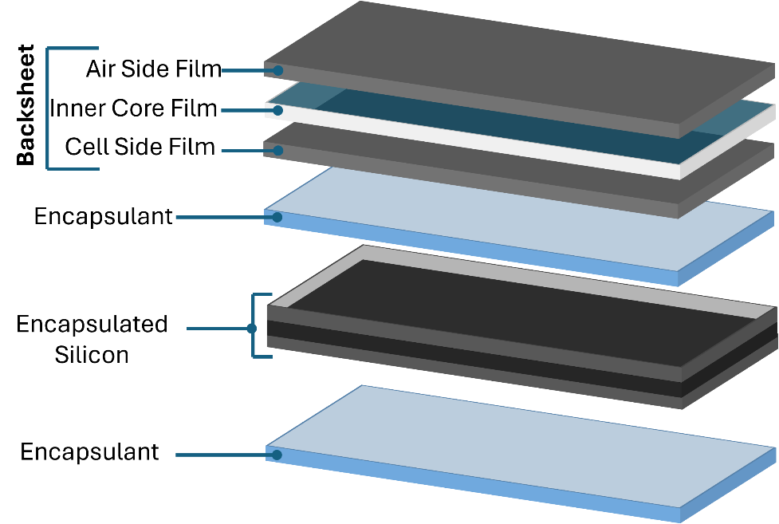

Fig. 4 Scheme of a PV module highlighting its multilayer structure. Adapted from Protopapa et al., 2021.

In the recent years, many efforts have been focused on resource recovery from EoL PV modules, in particular regarding crystalline silicon. Currently, some methods, such as chemical dissolution and thermal decomposition, are proposed to remove the adhesive EVA that remains after separating the valuable aluminium frame from the PV panel.
Regarding the bottom part of the panel, the backsheet, several kinds of polymers are being used to protect the silicon cell (Protopapa et al., 2021). Some of them contain fluorine to improve the resistance to the external climate condition, so increasing the operating life. These polymers are much more difficult to recover both for the difficulty of developing an efficient and sustainable process of recovery and because currently there is no real economic interest in doing so.
In addition, the choice of the materials recovering approach, or the presence of specific compounds can influence the methodology of treatment of the whole EoL PV panel. As example, the formation of hydrogen fluoride (HF) is a strong constraint to the thermal decomposition of PV which contain fluorinated polymers as backsheet. Hydrogen fluoride is a very toxic compound, which cannot be dispersed in the environment. So, the plants which want to burn the fluorinated backsheets, must be equipped with systems for the controlling of the fumes. In fact, hydrogen fluoride is produced burning EoL PVs (Ardente et al., 2019; Aryan et al., 2017) in inert condition (pyrolysis), which can be subsequently removed from the gas phase via wet or dry systems where alkaline reagents are added to retain the halogens in solid form (e.g., CaF₂) (Aryan et al., 2018; Biganzoli et al., 2015; Vehlow, 2015). The combustion in air should avoid the HF formation.
Anyway, PV panels could be previously delaminated to separate the silicon cell from the backsheet; then, in case of its presence, recyclable PET could be recovered from the backsheet, while the silicon cell could be thermally treated to recover silicon powder by eliminating the encapsulant polymeric material.
Generally, the sorting of the panels, based on the recognition of the constituent materials, would allow sending batches of intact or shredded PVs to the most suitable recycling plants for their treatment, where the process parameters and treatment technologies would be optimized, based on the particular type of PV module, to reduce energy consumption and protect the environment (Berger et al., 2010; Granata et al., 2014).
It is worth noting that the sorting method, and the recovery processes will strongly influence recovered silicon properties (i.e. chemical purity with respect to other elements, oxidation grade, granulometry and dimensions), and consequently, not only its suitability as anode materials but also its overall performance.

Appendix D

Silicon-carbon composite anode for LIBs
D1. 0D carbon-based sources
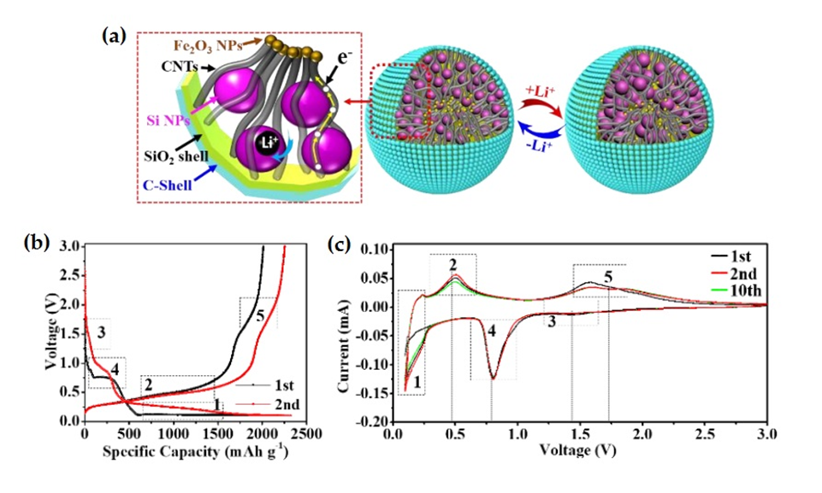
Fig. 5 (a) Schematic illustration of the yolk-shell Si/C structure; (b) Charging/discharging profiles of the yolk-shell Si/C structure at a current of 0.2 mA g⁻¹; (c) The first, second and tenth consecutive CV curves of the yolk-shell Si/C structure. (Copyright Angew. Chem., 2019) (L. Zhang et al., 2019).
Carbon coating is an effective approach for improving the performance of silicon anodes, by increasing electrical conductivity and buffering volume expansion of silicon, preventing uncontrolled side reactions between the active material and the electrolyte (F. Wang et al., 2019; Xu et al., 2021).
Researchers have extensively investigated i) core-shell and ii) yolk-shell structures, using nanosized Si powder and carbon sources to synthesize anode materials. In general, properly engineered Si/C core–shell or yolk–shell structures can improve the electrical conductivity of silicon anodes by providing buffering layers that protect the silicon cores, thereby enhancing their electrochemical performance (Moon, 2020; Rage et al., 2021).
In 2015, Kim et al. proposed a pyrolytic reaction to prepare 3D Si/C core-shell nanoparticles and a laser ablation technique to synthesize a corresponding electrode, with a homogeneous carbon layer 5-7 nm thick, and a carbon layer lattice spacing of 0.34 nm (J. S. Kim et al., 2015). The resulting 3D Si/C core-shell anode exhibited improved electrochemical performances, with a high specific capacity of ≈1200 mA h g⁻¹ over 300 cycles and a good rate capability of 1170 mA h g⁻¹ at 8 A g⁻¹. Later, Huo’s group described a scalable top-down strategy for fabricating an ant-nest-like Si nanoskeleton from magnesium-silicon alloy, followed by a carbon coating to form a core-shell structured porous Si/C composite, which exhibited a high reversible capacity of 1271 mA h g⁻¹ at 2100 mA g⁻¹, with 90% capacity retention after 1000 cycles (An et al., 2019). So, due the conductive coating layer on the Si particle’s surface, the core-shell structure shows increased rate performance. For Si/C core-shell structure, however, Si NP volume expansion during the discharge process is inevitable, affecting the integrity of the carbon shell and the SEI layer, and resulting in continuous electrolyte consumption and low CE.
On the other hand, Si/C yolk-shell structures provide appropriate spacing and can effectively accommodate Si deformation via an additional artificial cavity between the core and the shell (Moon, 2020). As a result, the gap between the carbon shell and the Si NPs is greatly expanded, allowing for volume expansion without compromising the electrode performance. Moreover, the conductive shell promotes the transport of lithium ions and electrons, providing a stable SEI layer for excellent particle interaction (Moon, 2020). Recently, Zhang et al. suggested a novel design for yolk-shell Si/C anodes, using a carbon-coated rigid SiO₂ outer shell to confine multiple Si NPs (yolk) and a flexible carbon nanotube (CNT) network filled with Fe₂O₃ NPs (L. Zhang et al., 2019) (Fig. 5).The CNTs, acting as a conductive “highway”, can bridge the gap between the inner Si-yolk and outer shell, effectively increasing the electrode’s total conductivity. Additionally, the new rigid C/SiO₂ double-shell increases electrode safety by providing greater mechanical strength than a thin carbon shell. Finally, the filled Fe₂O₃ NPs and CNTs offer additional capacity to the electrode, boosting the tap density. When combined with a commercially available cathode, this newly designed anode exhibited excellent electrochemical performance.
In summary, by creating interspacing between Si cores and C shells, critical issues for Si anodes in LIBs may be significantly addressed, resulting in enhanced cycling stabilities. As a result, Si/C yolk-shell anode research has been more exhaustive than Si/C core-shell research.
As a matter of fact, not only 0D silicon but also 2D and 3D ones can be covered by carbon: thin coating of 2D and 3D silicon structures can be included in composites obtained starting from 0D carbon source.
As assessed above, 2D-structured Si materials such as Si nanosheets can facilitate ion and charge transport exhibiting inherent good ionic conductivity. That property can be improved by embedding them into a uniform carbon layer, resulting in outstanding reversible capacities and excellent rate capabilities (Zhao et al., 2023). In 2018, Chen et al. developed a scalable approach to produce mesoporous ultrathin Si nanosheets via the magnesio-thermic reduction of mesoporous silica (Chen et al., 2018). After carbon encapsulation, the resulting Si/C composite exhibited significantly enhanced electrochemical performance, delivering high reversible capacity (1575.5 mA h g⁻¹ at 400 mA g⁻¹ even after 100 cycles), outstanding cycle stability (capacity retention of 92% at 400 mA g⁻¹ after 100 cycles), and good rate capability (1296.6 mA h g⁻¹ at 4 A g⁻¹). Here, the outstanding electrochemical performances were attributed to the unique material structure, in which the carbon effectively prevents the cracking and pulverization of silicon nanosheets, mitigating silicon volume expansion.
Finally, according to several research findings, simple carbon coatings can improve the characteristics of 3D porous Si material. 3D silicon structures can inherently provide space for volume expansion, resulting in significantly improved performances for Si anodes (Cheng et al., 2023). Moreover, the synthesis of 3D Si materials includes easy and low-cost manufacturing technique, involving mainly a template approach and a chemical pore-forming method. In 2017, Vrankovic et al. designed a Si/C anode by encapsulating highly porous silicon (obtained by reduction of silica) in an organic carbon and polymer-derived silicon oxycarbide (C/SiOC) matrix (Vrankovic et al., 2017). The porous silicon morphology provides free volume for the accommodation of volume variations, preventing macroscopic changes during initial Li-Si alloying. Moreover, a carbon layer also operates as an electrical contact, whereas the SiOC matrix considerably reduces the interface between the electrolyte and the electrode material, avoiding the formation of a SEI on Si. Therefore, the obtained Si/C composite recorded a specific capacity of ≈ 2900 mA h g⁻¹.

D2. Si-based composites with 1D carbon sources
According to the literature, 1D carbon nanomaterials (nanotubes and nanofibers) may reduce silicon mechanical stress in the radial direction caused by volume expansion, preventing the pulverization of the electrode material. Additionally, 1D carbon structures can also promote the transmission of charged species along the axial direction, owing to their high surface area and electrical conductivity (J. H. Kim et al., 2023; Yang et al., 2023). Wang et al. described, for the first time, the synthesis of novel 1D heterostructures able to integrate vertically aligned multiwall CNTs and nanoscale amorphous/nanocrystalline Si droplets. These Si droplets were directly deposited onto the CNTs with well-defined spacing through a single, two-step liquid injection chemical vapor deposition (CVD) process (W. Wang & Kumta, 2010).
The specified spacing of nanoscale Si, together with their tethered CNT architecture, enables silicon to undergo reversible electrochemical alloying and dealloying with Li ions while maintaining contact with the underlying CNTs. As a result, the hybrid anode exhibited a high reversible capacity of ≈ 2050 mA h g⁻¹ and high Coulombic efficiency over the first 25 discharge/charge cycles. However, the cycling tests demonstrated a rapid reduction in performance due to the fragmentation of the connected Si particles, weakening of the Si-CNTs interface, and continuous SEI growth. Therefore, while this hybrid structure prevented Si particle agglomeration and enabled electron and Li ions mobility, it did not solve the pulverization and SEI issues.
The challenges of Si pulverization and SEI can be addressed by coating Si nanoparticles with a carbon shell before compositing with 1D carbon nanomaterials. Recently, Zhang et al. designed a robust 3D structural composite composed of 1D CNTs framework, anchored with double-carbon coated Si nanoparticles, in which the double layer carbon coating was created with the assistance of a sulphur-sacrificing agent, providing protection on the surface of silicon particles (H. Zhang et al., 2019) (Fig. 6). The crosslinked CNTs framework provided electrically conductive pathways as well as void inside the carbon shell, which can adequately accommodate the Si volume variation during the lithiation process. As a result, the 3D Si/CNTs electrode (resulted from the ordered aggregation of 1D carbon and 0 D silicon) exhibited a high reversible capacity of 943 mA h g⁻¹ after 1000 cycles.
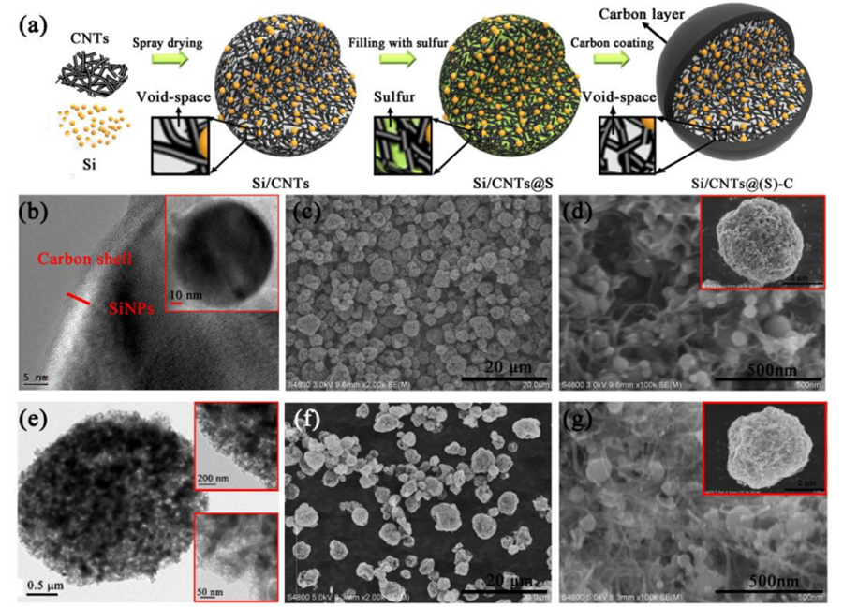
Fig. 6 (a) Schematic illustration of the Si/CNT@(S)-C design; (b) TEM image of SiNPs with carbon shell; (c)-(d) SEM images of Si/CNTs showing the micrometer-sized 3D porous particles and high magnification morphology; (e) TEM image of Si/CNTs; (f)-(g) SEM of Si/CNTs@S revealing the filling of sulfur. (Copyright Chemical Engineering Journal, 2019) (H. Zhang et al., 2019).
In addition to encapsulation, researchers are investigating the possibility of growing Si NPs onto the surface of 1D carbon structures, in order to enhance electrochemical performances. Carbon nanofibers (CNFs) show high thermal and chemical stability, good electrical conductivity, and excellent stress resistance, making them suitable for a wide range of applications including composite materials, Li-ion battery anode materials, and hydrogen storage materials (Yadav et al., 2020). As an example, Pandey et al. prepared Si-coated vertically aligned carbon nanofibers on a Li foil with a nominal thickness of 0.5 µm, in which a significant mass of Si NPs is present at CNFs tips (Pandey et al., 2015). Due to the open vertical 3D nanostructure, which allows gel polymers to easily penetrate and provides space for Si volume expansion, the resulting electrode demonstrated excellent specific capacity, good rate performance, and long cycling stability. Nowadays, there are several alternative ways to combine Si materials with CNFs, including Si NPs anchored onto CNFs, branched CNFs on Si nanowires, branched CNFs on Si particles, and Si core-carbon shell fibers (M. Gao et al., 2021; Ghanooni Ahmadabadi et al., 2020; Li et al., 2019; Yan et al., 2021).

D3. Si-based composites with 2D carbon sources
Due to their superior mechanical, optical, and electric properties, two-dimensional carbon materials, including carbon nanosheets and graphene, have attracted increasing interest in high-performance LIBs (Shi et al., 2021). Here, graphene, as a representative of 2D carbon materials, has been extensively used as anode because of its high specific surface area, high conductivity, and excellent electron and ions transmission capacity, leading to Si/graphene composite with increased performances and cycling stability (Mand Khan et al., 2023; Sehrawat et al., 2021).
In general, by providing appropriate interspacing, 2D carbon structures may effectively buffer the dramatic Si volume expansion during lithiation/delithiation processes, maintaining the structural stability of the electrode. Moreover, the inclusion of graphene and its derivatives into Si material significantly improves the conductivity of the electrode, ensuring superior electrochemical device performances (Sehrawat et al., 2021). Finally, it was demonstrated that adding small amounts of impurities to graphene, such as nitrogen (N), can modify its electronic structure, providing more active sites for lithium ions and improving the efficiency of lithium storage. Indeed, N-doped graphene not only has a very high capacity and excellent rate performance, but it also enables quick charging and discharging in the range of 10s to an hour.
In 2010, Chou et al. mixed commercial Si NPs with graphene for the first time, creating a Si/graphene composite (Chou et al., 2010) and, since then, researchers have optimized the design of these Si/graphene composites.
As an example, Cong et al. developed a Si/CNF/graphene composite (Fig. 7) as a potentially high-performant anode in LIBs, which was prepared by simple physical infiltration followed by a thermal reduction treatment of graphene oxide (rGO) (Cong et al., 2021). CNF was used to maintain the structural stability and prevent the peeling off of silicon nanoparticles from the electrodes. The resulting Si/CNF/graphene composite exhibited the initial specific capacity of 1894.54 mA h g⁻¹ at a current density of 0.1 A g⁻¹. After 100 cycles, the reversible specific capacity was maintained at 964.68 mA h g⁻¹, and the Coulombic efficiency could reach 93.8 % at the same current density. The authors attributed the improved electrochemical performance of the Si/CNF/graphene to the ability of the composite to accommodate the drastic changes in the volume of silicon NPs, forming a stable SEI, improving the conductivity of the electrode, and providing a fast and efficient channel for electron and ion transport.
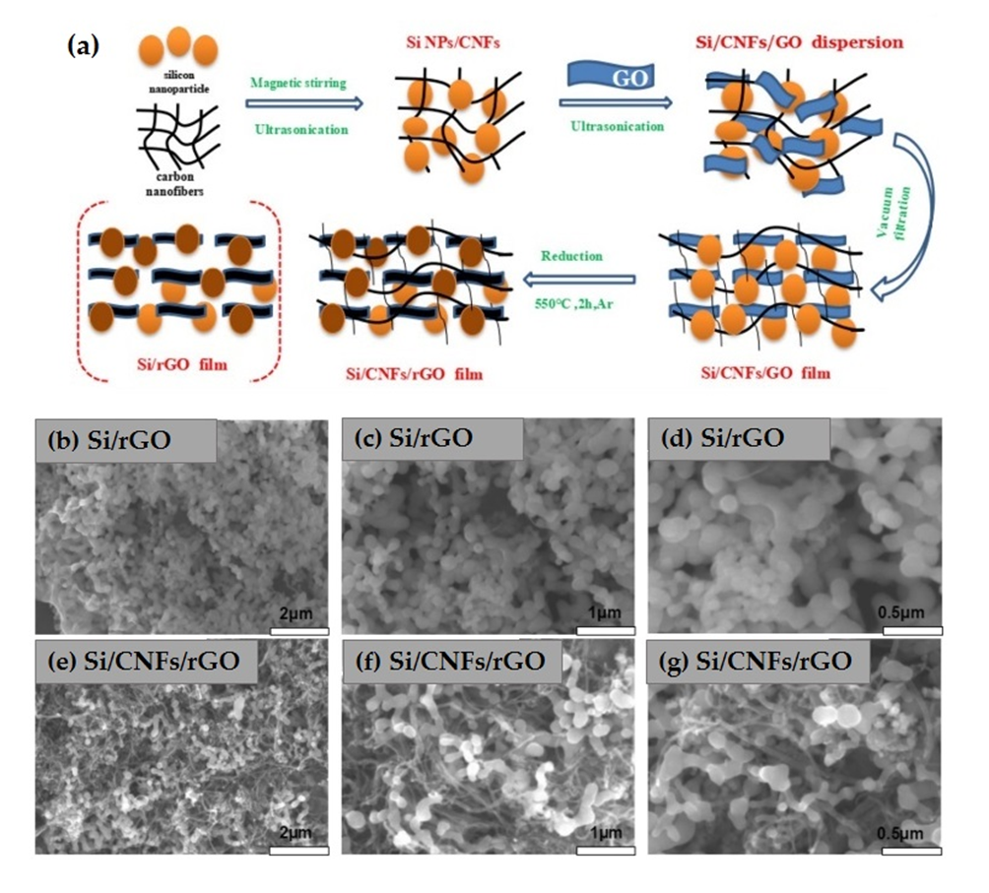
Fig. 7 Preparation process of Si/CNF/rGO and Si/rGO composite films; (b)-(d) SEM images of the Si/rGO and (e)-(g) Si:CNF/rGO = 1:1 composite. (Copyright Nature Scientific Reports) (Cong et al., 2021).

In another study, Cong et al. reported a nitrogen-doped graphene/carbon-encapsulated Si nanoparticle/carbon nanofiber composite prepared by method of surface modification, electrostatic self-assembly, cross-linking with heat treatment, and further carbonization as a potential high-performance anode for LIBs (Cong et al., 2022). While the uniformly dispersed CNFs in the composite served as conductive networks for the quick transport of ions and electrons, the tightly connected organic material of N-doped graphene and CNFs prevented the crushing and shedding of Si particles and maintained the integrity of the electrode structure. As a result, at a current density of 100 mA g⁻¹, the composite electrode recorded a high reversible specific capacity of 1371.4 mA h g⁻¹ after 100 cycles.
Finally, Salvatierra et al. designed a Si nanowires/graphene electrode using a two-step approach for the preparation of porous Si nanowires by etching of Si wafers, followed by the entanglement of graphene nanoribbons and Si nanowires using simple filtration methods (Salvatierra et al., 2016). The resulting composite structure provided a specific capacity of ≈ 1500 mA h g⁻¹ at 1 A g⁻¹ for over 300 cycles, meeting requirements for high performance devices.
Overall, graphene and 2D carbon-based materials, as conductive networks, or buffering mediums, have the potential to significantly improve the electrochemical performance of Si electrodes.

D4. Si-based composites with 3D and multi-dimensional carbon sources
When compared to other dimensional carbon structures, the unique 3D carbon materials can provide a more effective conducting network, and the void-porous structure can allow adequate space for active material’s volume change (Dou et al., 2019). Nowadays, template procedures and chemical etching are the most frequently employed methods for preparing 3D carbon-matrix composite materials.
In recent years, metal-organic frameworks (MOFs) have attracted the scientific community’s interest as templates for porous-structured electrodes, due to their adaptable structures and large pore sizes (Kaur et al., 2022). In 2020, Gao et al. demonstrated an in-situ encapsulation of Si NPs in compact zeolite imidazolate (ZIFs) carbon framework, followed by an annealing process for carbonization to generate a composite containing Si NPs encapsulated in carbon (R. Gao et al., 2020). Using this method, a compact and stable interface was achieved between the Si NPs and the carbon shell, while the porous structure provided good channels for Li ion insertion and diffusion. Moreover, the MOF-derived carbon shell offers appropriate space for Si volume expansion while efficiently reducing the direct contact between Si and the electrolyte. As a result, the composite electrode exhibited excellent electrochemical performance, delivering a specific capacity of 3174 mA h g⁻¹ at 200 mA g⁻¹, and an outstanding reversible capacity of 820 mA h g⁻¹ at 5000 mA g⁻¹ even after 1000 cycles. Although the 3D porous structure obtained via the template method can enhance the electrochemical performance of electrodes, its practical application remains limited due to the complexity of the preparation process, low production yields, and high manufacturing costs. For this reason, to avoid complex template methods, increasing number of studies have been conducted to produce a 3D carbon-matrix porous anode using the chemical etching strategy. In 2017, Shen et al. developed a simple approach to design and manufacture a Si/C spherical composite by encapsulating Si NPs into a mesoporous carbon matrix via a one-step hydrothermal method and subsequent high-temperature carbonization (Shen et al., 2017). The derived composite was indicated as “pomegranate structure” (Fig. 8), in which Si NPs of 50-100 nm act as seeds embedded within the mesoporous “pomegranate carbon chamber” with pores of 3-4 nm. In addition, to ensuring better electrical conductivity for active Si, this unique structure can also tolerate the significant volume change of Si NPs as well as facilitate the fast diffusion of Li ions, resulting in excellent cycling stability of 581 mA h g⁻¹ at a current density of 0.2 A g⁻¹ after 100 cycles, and high-rate capacity of 421 mA h g⁻¹ even at a high current density of 1 A g⁻¹. However, while the 3D porous carbon structures can improve electrochemical performances, the low mechanical strength can cause electrode powdering and there’s no way to achieve stable long cycling. Consequently, the practical application of the 3D carbon-matrix porous structure as anodes in LIBs is still a long way off.

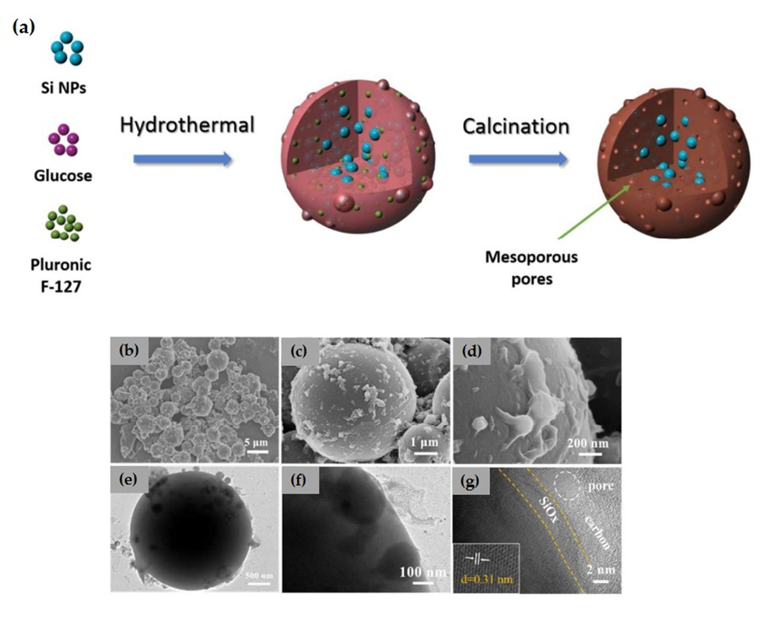
Fig. 8 (a) Design and fabrication of microspheres Si/C composite; (b)-(d) SEM images and (e)-(g) TEM images of Si/C microspheres. (Copyright Journal of Materials Chemistry A) (Shen et al., 2017).

To further enhance the electrochemical performance of Si materials, researchers have also looked at Si composites using multi-dimensional carbon sources (Dou et al., 2019). For example, Wang et. al proposed a novel self-supported electrode based on carbon-coated Si nanowires grown in-situ on highly conductive and flexible carbon fabric substrates through a nickel-catalyzed one-pot atmospheric pressure chemical vapor deposition (CVD) (X. Wang et al., 2017). Here, the researchers reported that, after an activation process at 100 mA g⁻¹ for 15 cycles, the resulting composite electrode exhibited a discharge capacity of 2061 mA h g⁻¹ a 1 A g⁻¹ even after 500 after cycles, due the high-quality of Si nanowires and unique electrode architecture.
Later, to further address the poor conductivity and volume expansion of Si anodes, Wang et al. designed a dual-C enhanced Si-based composite using diatomite, a widely available, low-cost, and environmentally friendly mineral, in which cavities were fully coated with commercial flaky graphite and amorphous carbonaceous materials, acting as the adhesives between porous Si and conductive graphite (J. Wang et al., 2016). The resulting Si/C electrode delivered a high specific capacity of about 470 mA h g⁻¹ at an ultrahigh current density of 5 A g⁻¹, with excellent capacity retention in the following 300 cycles. The scientists ascribed the superior electrochemical characteristics to diatomite’s natural pores as well as the inclusion of highly conductive graphite and amorphous carbonaceous materials.
Overall, multi-dimensional carbon materials can increase the mechanical and electrochemical characteristics of Si-based electrodes, leading to better cycling performances. However, as the dimensionality of carbon source increases, the synthetic techniques become more complex and expensive, significantly limiting their practical applications.

Appendix E
Advances in the choice of current collectors
Considering acquired the basic structure of a typical LIB (Appendix A) made of five components -one couple of the electrodes (positive anode/ negative cathode), two current collectors one for each electrode, one separator, a liquid electrolyte, some connection tags- the attention will be focused on current collectors features and properties, considering the antagonistic needs which must be faced in the realization of an electrolytic cell of high-power density better than high-energy density or vice versa.
Current collectors (in brief CCs) represent a passive component in LIBs, however being so important because play the triple role of collecting the electrons involved in the electrochemical reaction, of bridging the flow of electrons from the active materials toward external battery terminals and of being the substrate where the active material is grown. CCs also possess the not secondary task to release the thermal heat generated during the electrochemical process, thereby preventing the undesired effect of heat accumulation, such as the possibility of an increase of the working temperature (Shi et al., 2023).
The importance of conceiving CCs prior to battery manufacturing has often been overlooked or even ignored in recent years. However, the development of high-performance CCs with innovative designs or architectures is emerging as a key factor in enhancing the overall performance of LIBs. For instance, the integration and direct attachment of active materials onto the CC marks a substantial advancement. This approach minimizes the need for binders and additives, thereby offering multiple benefits, including reduced production costs and improved conductivity (Yang et al., 2020).
In order to guarantee excellent battery performance, the CCs must meet the following features: (1) high electrical conductivity, to ensure rapid transfer of charge carriers inside the electrodes; (2) high thermal conductivity to quickly dissipate the heat generated inside the battery; (3) high chemical inertia to maintain stability during complex electrochemical reactions; (4) small size and light weight to reach the right compromise between high energy and high power; (5) low costs to meet the requirements of a large-scale production and commercialization; (6) high mechanical robustness to ensure stability of the electrodes during charge and discharge cycles (Lamiel et al., 2022).
Currently commercially available LIBs batteries use metallic materials for the CCs, in particular aluminium foil for the cathode and copper foil for the anode. Their planar and smooth morphology significantly restricts advancements in battery performance, particularly with respect to safety, cycle life, and rate performance. In addition to traditional metal foils, researchers have extensively examined and employed various materials such as carbon-based substances, alloys, and other innovative materials. Furthermore, the surface characteristics and shape of CCs are crucial in determining their rate of electron transfer. Consequently, there is a growing interest in modifying the surface and implementing three-dimensional designs or patterns on current collectors to improve their interface properties.
Regarding the upgrading of CCs in LIBs and in the LMB (lithium metal battery) variant, where the anode is made of metallic lithium, there are two schools of thought that are highlighted in the international literature ranging from 2009 to the present day. LMB exhibit superior energy and power density compared to conventional LIBs. Consequently, research into the CCs of LIBs could serve as a valuable reference for enhancing the performance of LIBs. The first school of thought, referred to as the Chinese-Asian perspective, focuses on the outcomes derived from the interaction between the Cu and the active material within an LMB. Cu was chosen for the anode and Al for the cathode, leaving out the other types of collectors made of iron, titanium and chromium after having compared the different properties of the collector-substrate interface at changing the active material. Authors have themselves admitted that in LMB there is the occurance of the so-called phenomenon of delithiation during the charging cycles with anode degranulation. This further aggravates the electrical conductivity of the battery and this is why in 2021 Y. Liu et al. (Liu et al., 2021) suggest the creation of a copper-based CC having a three-dimensional porous structure capable of effectively preventing delithiation and its volumetric expansion. This concept is taken up by Yang et al. (Yang et al., 2024) which propose an alternative copper sheet as CC for the future generation of LIBs, based on a 3-D porous construction able to effectively prevent lithium depletion and its volumetric expansion. This is a popular strategy for designing porous CCs that can dynamically adapt to volume changes during the plating and stripping process and release stress relaxation very fast. Even one-dimensional solutions such as nanofibers and wireless nano roots are also proposed, for an alternative porous and structural design approach.
Structured CCs are broadly classified into two types: planar-plate-based and 3D framework-based. The former involves enhancing a flat, solid collector (like Cu foil) by adding a three-dimensional porous structure on its surface, which doesn't alter the collector's interior. This means the flat plate acts as a foundation for the added porous layer. On the other hand, the latter type consists of a three-dimensional, porous skeleton that independently supports the electrode materials, eliminating the need for a flat, supportive base. Both CCs structures can be realized as single component or as a multicomponent (Yang et al., 2020).
From a comparison between planar foil and 3D framework-based CCs, a clear improvement in the performance of the batteries in terms of energy conversion and conservation is observed when a planar-plant-based CCs structure is employed. Most of the research dedicated to developing specialized plate-based surface CCs is aimed at refining commercial Cu foil collectors, underscoring their vast potential for practical applications. Conversely, 3D framework-based structures provide ample buffer space to alleviate issues related to volumetric expansion and subsequent disintegration, thereby offering notable improvements in cyclic capacity, rate capability, and longevity. As porous foam and fiber network structures evolve, it is expected that 3D porous CCs will soon transition into commercial use, despite the higher costs linked to their production methods.
The second school of thought based on academic papers, mainly American- European contributes, emphasizes the necessity of utilizing all six available materials for CCs: aluminum, copper, nickel, titanium, stainless steel, and carbon-based materials. These materials come in various forms, such as flat foils, foams, and meshes. Choudhury et al. (Choudhury et al., 2021) propose cost-effective production methods that aim to reduce the overall weight of the battery. A significant challenge is the potential increase in cell resistance, as the resistance of the CC is inversely related to its thickness. This issue may be mitigated by employing multiple tabs and ensuring optimal electrical contact between each tab and the CC, thereby minimizing the distance the electronic current must travel.
The upcoming generation of LIBs necessitates CCs that are more electrochemically stable, conductive, lightweight, and cost-effective. To meet these objectives, it is essential to refine porous collectors by optimizing pore size and shape. This includes both “patented” structures, such as planar-plate surfaces and 3D-structured CCs, and the development of new coated CCs utilizing lighter, more conductive materials. While carbonaceous CCs are a viable substitute for traditional metallic CCs (based on Aluminum and Copper), it is crucial to ensure robust bonding and contacts between carbonaceous CCs and electrode tabs (Zhu et al., 2021). Although polymers typically have a lower density compared to carbonaceous materials and offer superior mechanical performance, their reduced electronic conductivity compromises thermal stability and the efficient dissipation of heat generated during the operation of LIBs (Lepage et al., 2019).

Appendix F
Silicon anode battery technology: TRL and market penetration
Due to its extraordinarily high capacity and extended service life, silicon anode materials are expected to dominate anode material research and development for the next generation of high-energy density LIBs. The global silicon-based battery market size is expected to grow from USD 55 million in 2023 to USD 414 million by 2028, at a CAGR (Compound Annual Growth Rate) of 49,5% (Top Silicon Battery Companies | Silicon Battery Industry Players). Silicon batteries can be used in various applications, from automotive to medical equipment, energy, aviation, and consumer electronics. Excellent performance, long life, and greater safety make these batteries ideal for electric vehicles, energy storage, and aerospace applications. In terms of silicon anode battery development, Amprius Technologies, Inc. (US) (Amprius Technologies Silicon Anode Batteries), Enovix Corporation (US)(Enovix | 3D Silicon Lithium-Ion Battery - Enovix), Enevate Corporation (US) (Home - Enevate), and NanoGraf Corporation (US) (NanoGraf Corporation) are among the leading companies in the worldwide silicon battery market. Additionally, Sila Technologies, Inc. (US) (Sila | Next-Gen Lithium-Ion Battery Materials), Group14 Technologies, Inc. (US) (Group14 | Lithium-Silicon Battery Materials), BTR New Material Group Co., Ltd. (China) (BTR New Material Group Co., Ltd.), and E-magy (Netherlands) (E-Magy - The Battery Industry Is On With Silicon) are some of the top silicon anode material providers in this market, that remains in its early stages of development. Many businesses have yet to commercialize their products, highlighting the sector's emerging nature and significant growth potential. Below, the technology developed by some of the world’s major companies involved in the manufacturing of silicon-based anodes for lithium-ion batteries are briefly described.
- Amprius Technologies, Inc. (US) (Amprius Technologies Silicon Anode Batteries)
American Amprius, founded in 2008, is one of the top 10 silicon-based anode companies in the world. The company develops ultra-high energy density LIBs and its silicon nanowire anodes and is known for its 100% silicon nanowire technology. By growing in-situ aligned silicon nanowires’ template from the surface of the current collector, for creating a silicon nanoarray anode, the failure problem caused by the significant volume change of typical silicon particles during the lithium-ion insertion/extraction is overcome. Each silicon nanowire in Amprius Technologies’s silicon batteries is directly connected to the current collector foil: in this way it is not necessary to use binders, additives, or other gluing materials to make the connection to the foil. This technology is similar to a welding connection and it has an extremely low electrical resistance, which combined with the high capacity of silicon, allowed Amprius to develop cells that outperform the current generation of graphite-based anode batteries by 50% to 100%, depending on size and shape. The commercially available 370 Wh/kg Amprius’ silicon anode battery displayed an extremely fast charge rate of 0-80% state of charge in less than six minutes, as well as an exceptional cycle life that is constantly increasing. This has been proved in real-world applications with multiple organizations, including US National Laboratories and major aerospace companies.
- Enovix Corporation (US) (Enovix | 3D Silicon Lithium-Ion Battery - Enovix)
Enovix Corporation is a developer and manufacturer of innovative silicon-anode LIBs. The company has developed 100% silicon anodes and a revolutionary 3D cell architecture for excellent energy density and high cycle life. Enovix products are encased in precision stainless steel and manufactured with a high-speed precision stacking process. Consequently, this proprietary 3D cell architecture enables Enovix to use silicon as the only active lithium cycling material in the anode. The company also focuses on R&D for large-density and large-sized batteries for electric vehicles (EVs) and storage systems, planning to increase the applications of its silicon lithium batteries in wearable devices, mobile communication devices, and computing. The Enovix's innovative 3D cell architecture enables for more effective use of the battery's volume, boosting the packing efficiency of the silicon active material, enabling superior thermal performance and abuse tolerance, and supporting the use of a 100% active silicon anode. The use of silicon in this architecture results in a battery with excellent energy density and capacity.
- NanoGraf Corporation (US) (NanoGraf Corporation)
Founded in 2012, NanoGraf Corporation is an advanced materials company developing silicon-based composite materials for the next generation of LIBs. The company has developed a proprietary composition for a silicon oxide-based chemistry that provides greater stability, allowing cell manufacturers to pack more silicon into the battery. The patented manufacturing technique used by NanoGraf sets it apart from competitors that rely on expensive and complex vapor deposition-based processes. Indeed, the company uses a wet chemistry method that is highly scalable and has previously been successful in a multi ton-scale pilot manufacturing line. The resulting silicon-based anode materials are suitable for current electrode mixing and coating equipment, and they have been tested in large-scale battery manufacturing facilities all over the world. NanoGraf’s technology employs a patented doped silicon alloy material architecture to achieve category-leading performance as well as answers to long-standing Si anode technical challenges. The specific blend of silicon-based alloys and a protective inorganic and organic coating assists in the stabilization of the active material during charge and discharge processes. Whereas conventional graphite-based anodes have a capacity of 372 mA h g⁻¹, NanoGraf’s material may be adapted to achieve capacities ranging from 550 mA h g⁻¹to over 1400mA h g⁻¹, offering better cell level energy density and exceptional rate capabilities.
- Sila Technologies, Inc. (US) (Sila | Next-Gen Lithium-Ion Battery Materials)
Sila Technologies, a next-generation battery materials company, focuses on the research and development of silicon anode materials. In 2023, the company announced the availability of its high performing nanocomposite silicon anode for mass production, Titan SiliconTM. Titan SiliconTM can deliver a 20% energy density boost over the industry’s best performing cells and will achieve a 40% increase in future releases, improving battery charging time from 10% to 80% in just 20 minutes. In addition, Titan SiliconTM provides significant advantages while maintaining minimal swell, equivalent to graphite anodes, without losing cycle life or safety. The Sila silicon anode material is entirely compatible with existing battery production methods and factories, and it can adapt in order to maintain cycle and service life, charging performance, and safety. Finally, Sila provides full or partial graphite replacement according to industry performance goals and product roadmaps, and both solutions are now powering products on the market.
- Group14 Technologies, Inc. (US) (Group14 | Lithium-Silicon Battery Materials)
Group14 Technologies is a battery storage technology company that develops silicon-carbon composite materials for LIB markets. The company's battery materials innovation provides new levels of energy performance to lithium-ion-powered products and vehicles, enabling clients to have significantly more lithium capacity in batteries while retaining a high cycle life and safety. SCC55TM, a silicon-carbon composite powder developed by Group14 Technologies, employs a unique hard carbon-based scaffolding to retain silicon in its amorphous, nano-sized and carbon-encased form. This architecture features integrated intra-particle void spaces with a low surface area, and is produced using readily available, non-exotic, ultra-high-purity materials. As a result, the best-in-class anode material has remarkable first-cycle efficiency and extended life when cycling Li-ion batteries. SCC55TM material is manufactured by Group14 Technologies using a distinctive two-step process that includes DryrolysisTM (synthesizing porous hard carbon scaffold) and SiligenesisTM (producing easily tuneable amorphous silicon) processes. DryrolysisTM is a very effective and ecologically friendly method of synthesizing carbon to create the ideal carbon scaffold. This innovative technique, which combines dry polymerization with thermal processing, is highly scalable and removes the need for solvent. This platform produces an appropriate carbon scaffold for a silicon-carbon composite, which is perfect for retaining amorphous, nano-sized silicon. Finally, DryrolysisTM, is achieved in a single step and in a single reactor. On the other hand, SiligenesisTM is a unique technique for producing both silicon and tailored internal void spaces inside carbon scaffolding, utilizing a non-exotic precursor that converts into silicon within the porous carbon scaffold. In addition to providing silicon in its ideal form, SiligenesisTM also accommodates silicon's expansion and contraction within remaining intraparticle void spaces of the composite, improving electrochemical performance.
- BTR New Material Group Co., Ltd. (China) (BTR New Material Group Co., Ltd.)
BTR New Material Group Co., established in August 2000, is a professional manufacturer of cathode and anode materials for LIBs. It is a state-level high-tech enterprise integrating R&D, production and sales. The core products are anode materials, cathode materials and graphene materials for LIBs. Among them, anode products include natural graphite, artificial graphite, silicon-based and other new anode materials. In particular, the specific capacity of third-generation silicon-carbon anode materials has improved to 1500 mA h g⁻¹, and the specific capacity of some silicon-oxygen anode materials has also exceeded 1600 mA h g⁻¹. BTR now has a silicon-based anode material production capacity of 6000 tons per year, and a project with a production capacity of 40000 tons under construction, making it one of the top ten silicon-based anode companies in the world. It is expected to completed and operational by the end of December 2023, with an annual output of 15000 tons, and to reach full production by 2028.
- E-magy (Netherlands) (E-Magy - The Battery Industry Is On With Silicon)
E-magy is a promising technology company that supplies nano-porous silicon for high-energy LIBs, using low-cost upgraded metallurgical grade silicon that is abundantly available and environmentally friendly. The nano-porous silicon is produced in fully operational production facility near Amsterdam, which is capable of generating up to 25 tons per year on an industrial scale. The company implements an efficient silicon crystallization technique, as well as industry-standard post-processing procedures, allowing its nano-porous silicon to be compatible with existing LIB production processes and factory equipment. The porous silicon structure developed by E-magy mitigates volume variations and overcomes one of the most challenging barriers to achieving a long cycle life. Tests performed in cooperation with renowned German institute ZSW have shown a negligible pouch cell thickness variation of <5% after 100 cycles, with an 80% weight silicon anode.
As a conclusion of this paragraph, it is worth noting that to the best of our knowledge, no company has still begun to employ recovered Si as anode materials, despite recent papers and few patents in the field.
Our research lies in this field of recent corporate interest, which has produced an innovative and solvent-free method (patent accepted) to recover and purify silicon from PV panels at the end of their life and reuse it in the form of micrometric powder (in addition to carbon nanopowders and graphite powders) in the design of new electrodes.
References
Amprius Technologies Silicon Anode Batteries, https://amprius.com/ (Accessed 16 March 2024)
An, W., Gao, B., Mei, S., Xiang, B., Fu, J., Wang, L., Zhang, Q., Chu, P. K., Huo, K., 2019. Scalable synthesis of ant-nest-like bulk porous silicon for high-performance lithium-ion battery anodes. Nature Communications, 10 (1), 1447. https://doi.org/10.1038/s41467-019-09510-5
Ardente, F., Latunussa, C. E. L., Blengini, G. A., 2019. Resource efficient recovery of critical and precious metals from waste silicon PV panel recycling. Waste Management, 91, 156–167. https://doi.org/10.1016/j.wasman.2019.04.059
Aryan, V., Danz, P., Maga, D., Font-Brucart, M., 2017. END-OF-LIFE PATHWAYS FOR PHOTOVOLTAIC BACKSHEETS, Final Project Report presented by Fraunhofer institute for Environmental, Safety and Energy Technology UMSICHT. https://www.coveme.com/files/immagini/green-solutions/Final_Report_End-of-Life_Pathways_For_Photovoltaic_Backsheets.pdf (accessed 16 March 2025).
Aryan, V., Font-Brucart, M., Maga, D., 2018. A comparative life cycle assessment of end-of-life treatment pathways for photovoltaic backsheets. Progress in Photovoltaics: Research and Applications, 26(7), 443–459. https://doi.org/10.1002/pip.3003
Battery University https://batteryuniversity.com/ (accessed 16 March 2025).
Berger, W., Simon, F. G., Weimann, K., Alsema, E. A., 2010. A novel approach for the recycling of thin film photovoltaic modules. Resources, Conservation and Recycling, 54(10), 711–718. https://doi.org/10.1016/j.resconrec.2009.12.001
Biganzoli, L., Racanella, G., Rigamonti, L., Marras, R., Grosso, M., 2015. High temperature abatement of acid gases from waste incineration. Part I: experimental tests in full scale plants. Waste Management, 36, 98–105. https://doi.org/10.1016/j.wasman.2014.10.019
Blomgren, G. E., 2017. The Development and Future of Lithium Ion Batteries. Journal of The Electrochemical Society, 164(1), A5019–A5025. https://doi.org/10.1149/2.0251701jes
BTR New Material Group Co., Ltd. https://www.btrchina.com/en/ (Accessed 16 March 2024)
Casimir, A., Zhang, H., Ogoke, O., Amine, J. C., Lu, J., Wu, G., 2016. Silicon-based anodes for lithium-ion batteries: Effectiveness of materials synthesis and electrode preparation. Nano Energy, 27, 359–376. https://doi.org/10.1016/j.nanoen.2016.07.023
Cermak, M., Perez, N., Collins, M., Bahrami, M., 2020. Material properties and structure of natural graphite sheet. Scientific Reports 10(1), 1–12. https://doi.org/10.1038/s41598-020-75393-y
Chen, S., Chen, Z., Xu, X., Cao, C., Xia, M., Luo, Y., 2018. Scalable 2D Mesoporous Silicon Nanosheets for High-Performance Lithium-Ion Battery Anode. Small, 14(12), 1703361. https://doi.org/10.1002/smll.201703361
Cheng, Z., Jiang, H., Zhang, X., Cheng, F., Wu, M., Zhang, H., 2023. Fundamental Understanding and Facing Challenges in Structural Design of Porous Si-Based Anodes for Lithium-Ion Batteries. Advanced Functional Materials, 33(26), 2301109. https://doi.org/10.1002/adfm.202301109
Chou, S. L., Wang, J. Z., Choucair, M., Liu, H. K., Stride, J. A., Dou, S. X., 2010. Enhanced reversible lithium storage in a nanosize silicon/graphene composite. Electrochemistry Communications, 12(2), 303–306. https://doi.org/10.1016/j.elecom.2009.12.024
Choudhury, R., Wild, J., Yang, Y., 2021. Engineering current collectors for batteries with high specific energy. Joule, 5(6), 1301–1305. https://doi.org/10.1016/j.joule.2021.03.027
CN103647043A - Method for preparing negative electrode material of lithium ion secondary battery - Google Patents, 2013. https://patents.google.com/patent/CN103647043A/en (Accessed 21 February 2024).
Commissaire Général au Development Durable, CGDD, 2022. La mobilité bas-carbone Choix technologiques, enjeux matières et opportunités industrielles PLAN DE PROGRAMMATION DES RESSOURCES MINÉRALES DE LA TRANSITION BAS-CARBONE. https://www.ort.bourgogne-franche-comte.developpement-durable.gouv.fr/IMG/pdf/rapport_cgdd_01_mobilite_bas_carbone_fevrier2022.pdf
Cong, R., Choi, J. Y., Song, J. B., Jo, M., Lee, H., Lee, C. S., 2021. Characteristics and electrochemical performances of silicon/carbon nanofiber/graphene composite films as anode materials for binder-free lithium-ion batteries. Scientific Reports, 11(1), 1–11. https://doi.org/10.1038/s41598-020-79205-1
Cong, R., Jo, M., Martino, A., Park, H. H., Lee, H., Lee, C. S., 2022. Three-dimensional network of nitrogen-doped carbon matrix-encapsulated Si nanoparticles/carbon nanofibers hybrids for lithium-ion battery anodes with excellent capability. Scientific Reports, 12(1), 1–15. https://doi.org/10.1038/s41598-022-20026-9
Daher, D. H., Aghaei, M., Quansah, D. A., Adaramola, M. S., Parvin, P., Ménézo, C., 2023. Multi-pronged degradation analysis of a photovoltaic power plant after 9.5 years of operation under hot desert climatic conditions. Progress in Photovoltaics: Research and Applications, 31(9), 888–907. https://doi.org/10.1002/PIP.3694
Dou, F., Shi, L., Chen, G., Zhang, D., 2019. Silicon/Carbon Composite Anode Materials for Lithium-Ion Batteries. Electrochemical Energy Reviews, 2(1), 149–198. https://doi.org/10.1007/S41918-018-00028-W
Elmahallawy, M., Elfouly, T., Alouani, A., Massoud, A. M., 2022. A Comprehensive Review of Lithium-Ion Batteries Modeling, and State of Health and Remaining Useful Lifetime Prediction. IEEE Access, 10, 119040–119070. https://doi.org/10.1109/ACCESS.2022.3221137
E-magy - The Battery Industry Is On With Silicon. https://e-magy.com/ (Accessed 16 March 2025)
Enevate. https://www.enevate.com/ (Accessed 16 March 2025)
Enovix | 3D Silicon Lithium-ion Battery - Enovix. https://www.enovix.com/ (Accessed 16 March 2025)
EUR-Lex - 52017DC0490 - EN - EUR-Lex. 2017. https://eur-lex.europa.eu/legal-content/EN/TXT/?uri=CELEX%3A52017DC0490
EUR-Lex - 52023DC0165 - EN - EUR-Lex. 2023. https://eur-lex.europa.eu/legal-content/EN/TXT/?uri=COM%3A2023%3A165%3AFIN
Fichtner, M., Edström, K., Ayerbe, E., Berecibar, M., Bhowmik, A., Castelli, I. E., Clark, S., Dominko, R., Erakca, M., Franco, A. A., Grimaud, A., Horstmann, B., Latz, A., Lorrmann, H., Meeus, M., Narayan, R., Pammer, F., Ruhland, J., Stein, H., Vegge, T., Weil, M., 2022. Rechargeable Batteries of the Future—The State of the Art from a BATTERY 2030+ Perspective. Advanced Energy Materials, 12(17), 2102904. https://advanced.onlinelibrary.wiley.com/doi/10.1002/aenm.202102904
Gao, R., Tang, J., Yu, X., Tang, S., Ozawa, K., Sasaki, T., Qin, L. C., 2020. In situ synthesis of MOF-derived carbon shells for silicon anode with improved lithium-ion storage. Nano Energy, 70, 104444. https://doi.org/10.1016/J.NANOEN.2019.104444
Gao, M., Tang, Z., Wu, M., Chen, J., Xue, Y., Guo, X., Liu, Y., Kong, Q., Zhang, J., 2021. Self-supporting N, P doped Si/CNTs/CNFs composites with fiber network for high-performance lithium-ion batteries. Journal of Alloys and Compounds, 857, 157554. https://doi.org/10.1016/j.jallcom.2020.157554
Geological Survey U.S., 2020, Mineral commodity summaries 2020: U.S. Geological Survey, p. 200, https://doi.org/10.3133/mcs2020
Ghanooni Ahmadabadi, V., Shirvanimoghaddam, K., Kerr, R., Showkath, N., Naebe, M., 2020. Structure-rate performance relationship in Si nanoparticles-carbon nanofiber composite as flexible anode for lithium-ion batteries. Electrochimica Acta, 330, 135232. https://doi.org/10.1016/j.electacta.2019.135232
Goodenough, J. B., Kim, Y., 2010. Challenges for rechargeable Li batteries. Chemistry of Materials, 22(3), 587–603. https://doi.org/10.1021/CM901452Z
Goodenough, J. B., Park, K. S., 2013. The Li-ion rechargeable battery: A perspective. Journal of the American Chemical Society, 135(4), 1167–1176. https://doi.org/10.1021/JA3091438
Granata, G., Pagnanelli, F., Moscardini, E., Havlik, T., Toro, L., 2014. Recycling of photovoltaic panels by physical operations. Solar Energy Materials and Solar Cells, 123, 239–248. https://doi.org/10.1016/j.solmat.2014.01.012
Group14|Lithium-Silicon Battery Materials. https://grup14.technology/en/ (Accessed 16 March 2025)
Guyomard, D.; Tarascon, J. M., 1993. Rechargeable Li_{1+x}Mn₂O₄/carbon Cells with a New Electrolyte Composition. J. Electrochem. Soc., 140, 3071−3081. https://doi.org/10.1149/1.2220987
Hund, K., Porta, D. La, Fabregas, T. P., Laing, T., Drexhage, J., 2020. CLIMATE-SMART MINING FACILITY Minerals for Climate Action: The Mineral Intensity of the Clean Energy Transition. Ed Washington, DC: World. https://pubdocs.worldbank.org/en/961711588875536384/Minerals-for-Climate-Action-The-Mineral-Intensity-of-the-Clean-Energy-Transition.pdf
IEA, 2021. Demand for silicon from solar PV by scenario, 2020-2040, https://www.iea.org/data-and-statistics/charts/demand-for-silicon-from-solar-pv-by-scenario-2020-2040 (Accessed 16 March 2025)
IEA-PVPS, 2022. Snapshot of Global PV Markets 2022. Report T1-42:2022, 1–23. https://iea-pvps.org/wp-content/uploads/2022/04/IEA_PVPS_Snapshot_2022-vF.pdf (Accessed 16 March 2025)
IRENA and IEA-PVPS, 2016. End-of-Life Management: Solar Photovoltaic Panels, International Renewable Energy Agency and International Energy Agency Photovoltaic Power Systems. https://www.irena.org/publications/2016/Jun/End-of-life-management-Solar-Photovoltaic-Panels (Accessed 16 March 2025)
IRENA, 2016. Solar PV in Africa: Costs and Markets Climate Technology Centre & Network | Fri, 09/08/2017. https://www.irena.org/publications/2016/Sep/Solar-PV-in-Africa-Costs-and-Markets (Accessed 16 March 2025)
IRENA, 2022. Renewable Capacity Statistics 2022. /Publications/2022/Apr/Renewable-Capacity-Statistics-2022, 20–22. https://www.irena.org/publications/2022/Apr/Renewable-Capacity-Statistics-2022 (Accessed 16 March 2025)
IRENA, 2023. Renewable energy statistics 2023, International Renewable Energy Agency, Abu Dhabi. https://www.irena.org/Publications/2023/Jul/Renewable-energy-statistics-2023 (Accessed 16 March 2025)
Jara, A.D., Betemariam, A., Woldetinsae, G., Kim, J. Y., 2019. Purification, application and current market trend of natural graphite: A review. International Journal of Mining Science and Technology, 29(5), 671–689. https://doi.org/10.1016/J.IJMST.2019.04.003
Jordan, D.C., Kurtz, S.R. 2013. Photovoltaic Degradation Rates -- An Analytical Review. Progress in photovoltaics: research and applications, 21, 12-29. https://onlinelibrary.wiley.com/doi/10.1002/pip.1182
Kaur, R., Chhabra, V.A., Chaudhary, V., Vikrant, K., Tripathi, S.K., Su, Y., Kumar, P., Kim, K. H., Deep, A. 2022. Metal-organic frameworks and their derivatives as anode material in lithium-ion batteries: Recent advances towards novel configurations. International Journal of Energy Research, 46(10), 13178–13204. https://doi.org/10.1002/ER.8046.
Kavanagh, A.,Schlögl, R., 1988. The morphology of some natural and synthetic graphite. Carbon, 26(1), 23-32. https://www.sciencedirect.com/science/article/pii/000862238890005X
Kenan, W. M. (1991). Annual minerals review. Graphite. American Ceramic Society Bulletin, 70(5), 865-866.
Kim, J.H., Kim, S., Han, J. H., Seo, S. Bin, Choi, Y.R., Lim, J., Kim, Y. A., 2023. Perspective on carbon nanotubes as conducting agent in lithium-ion batteries: the status and future challenges. Carbon Letters, 33(2), 325–333. https://doi.org/10.1007/S42823-022-00449-0
Kim, J.S., Pfleging, W., Kohler, R., Seifert, H. J., Kim, T.Y., Byun, D., Jung, H.G., Choi, W., Lee, J. K. 2015. Three-dimensional silicon/carbon core–shell electrode as an anode material for lithium-ion batteries. Journal of Power Sources, 279, 13–20. https://doi.org/10.1016/J.JPOWSOUR.2014.12.041
Kim, M., Ahn, H., Choi, J., Kim, W. B., 2023. A Rational Design of Silicon-Based Anode for All-Solid-State Lithium-Ion Batteries: A Review. Energy Technology, 11(6), 2201321. https://onlinelibrary.wiley.com/doi/10.1002/ente.202201321
Kramm, F. and Niepraschk, H., 2009. Secondary batteries – lead– acid systems | Valve-Regulated Batteries: Gel, in: Garche, J. (Ed), Encyclopedia of Electrochemical Power Sources, Elsevier B.V., Volume 4, pp 727-734.
Lamiel, C., Hussain, I., Ma, X., Zhang, K., 2022. Properties, functions, and challenges: current collectors. Materials Today Chemistry, 26, 101152. https://doi.org/10.1016/j.mtchem.2022.101152
Le graphite naturel (C)-éléments de criticité, 2016. https://www.mineralinfo.fr/sites/default/files/2023-03/fiche_criticite_graphite_naturel_170109.pdf (accessed 16 March 2025)
Lepage, D., Savignac, L., Saulnier, M., Gervais, S., Schougaard, S. B., 2019. Modification of aluminum current collectors with a conductive polymer for application in lithium batteries. Electrochemistry Communications, 102, 1–4. https://doi.org/10.1016/j.elecom.2019.03.009
Li, Y., Wang, R., Zhang, J., Chen, J., Du, C., Sun, T., Liu, J., Gong, C., Guo, J., Yu, L., Zhang, J., 2019. Sandwich structure of carbon-coated silicon/carbon nanofiber anodes for lithium-ion batteries. Ceramics International, 45(13), 16195–16201. https://doi.org/10.1016/j.ceramint.2019.05.141
Liu, Y., Gao, D., Xiang, H., Feng, X., Yu, Y., 2021. Research Progress on Copper-Based Current Collector for Lithium Metal Batteries. In Energy and Fuels (Vol. 35, Issue 16, pp. 12921–12937). American Chemical Society. https://doi.org/10.1021/acs.energyfuels.1c02008
Mand Khan, B., Chun Oh, W., Nuengmatch, P., Ullah, K., 2023. Role of graphene-based nanocomposites as anode material for Lithium-ion batteries. Materials Science and Engineering: B, 287, 116141. https://doi.org/10.1016/J.MSEB.2022.116141
Marwede, M., Reller, A., 2012. Future recycling flows of tellurium from cadmium telluride photovoltaic waste. Resources, Conservation and Recycling, 69, 35–49. https://doi.org/10.1016/J.RESCONREC.2012.09.003
Megahed, S., Ebner, W., 1995. Lithium-ion battery for electronic applications. Journal of Power Sources, 54(1), 155–162. https://doi.org/10.1016/0378-7753(94)02059-C
Megahed, S., Scrosati, B., 1994. Lithium-ion rechargeable batteries. Journal of Power Sources, 51(1–2), 79–104. https://doi.org/10.1016/0378-7753(94)01956-8
Moon, G. D., 2020. Yolk–Shell Nanostructures: Syntheses and Applications for Lithium-Ion Battery Anodes. Nanomaterials, 10(4), 675. https://doi.org/10.3390/NANO10040675
NanoGraf Corporation. https://www.nanograf.com/ (Accessed 17 March 2025)
Nover, J., Zapf-Gottwick, R., Feifel, C., Koch, M., Metzger, J. W., Werner, J. H., 2017. Long-term leaching of photovoltaic modules. Japanese Journal of Applied Physics, 56(8), 08MD02. https://doi.org/10.7567/JJAP.56.08MD02
Pandey, G. P., Klankowski, S. A., Li, Y., Sun, X. S., Wu, J., Rojeski, R. A., & Li, J., 2015. Effective Infiltration of Gel Polymer Electrolyte into Silicon-Coated Vertically Aligned Carbon Nanofibers as Anodes for Solid-State Lithium-Ion Batteries. ACS Applied Materials and Interfaces, 7(37), 20909–20918. https://doi.org/10.1021/acsami.5b06444ACS
Pop, V., Bergveld, H.J., Notten, P.H.L., Regtien, P. P.L., 2005. State-of-the-art of battery state-of-charge determination. Measurement Science and Technology, 16(12), R93-R110. https://doi.org/10.1088/0957-0233/16/12/R01
Protopapa, M. L., Burresi, E., Palmisano, M., Pesce, E., Schioppa, M., Capodieci, L., Penza, M., Della Sala D., Vincenti, N., Accili, A., Campadello, L., 2021. Optical methods to identify end-of-life PV panel structure. Resources, Conservation and Recycling, 171, 105634. https://doi.org/10.1016/j.resconrec.2021.105634
Qizhong, Z., Damm, S., 2020. Supply and Demand of Natural Graphite. Ed German Mineral Resources Agency (DERA) at the Federal Institute for Geosciences and Natural Resources (BGR), Berlin, Germany.
Rage, B., Delbegue, D., Louvain, N., Lippens, P.E., 2021. Engineering of Silicon Core-Shell Structures for Li-ion Anodes. Chemistry – A European Journal, 27(66), 16275–16290. https://doi.org/10.1002/CHEM.202102470
Raghavan, K.S., Kumaresan, V., 2022. Thermal Properties of Natural Graphite Flake Enhanced Phase Change Material from ‘T-History’ Method. International Journal of Thermophysics, 43(3), 1–14. https://doi.org/10.1007/S10765-021-02957-Z
Ratynski, M., Hamankiewicz, B., Krajewski, M., Boczar, M., Ziolkowska, D., Czerwinski, A., 2019. Impact of natural and synthetic graphite milling energy on lithium-ion electrode capacity and cycle life. Carbon, 145, 82–89. https://doi.org/10.1016/J.CARBON.2019.01.019
Reddy, M.V., Mauger, A., Julien, C.M., Paolella, A., Zaghib, K., 2020. Brief History of Early Lithium-Battery Development. Materials, 13(8), 1884. https://doi.org/10.3390/MA13081884
RMIS - Raw Materials Information System. https://rmis.jrc.ec.europa.eu/ (Accessed 17 March 2024)
Roskill Information Services, 2019: Natural and synthetic graphite: Global Industry, Markets and Outlook. p. 548; London, UK.
Salvatierra, R. V., Raji, A. R. O., Lee, S. K., Ji, Y., Li, L., Tour, J. M., 2016. Silicon Nanowires and Lithium Cobalt Oxide Nanowires in Graphene Nanoribbon Papers for Full Lithium Ion Battery. Advanced Energy Materials, 6(24), 1600918. https://doi.org/10.1002/AENM.201600918
Sehrawat, P., Shabir, A., Abid, Julien, C.M., Islam, S.S., 2021. Recent trends in silicon/graphene nanocomposite anodes for lithium-ion batteries. Journal of Power Sources, 501, 229709. https://doi.org/10.1016/J.JPOWSOUR.2021.229709
Shen, T., Xia, X.H., Xie, D., Yao, Z.J., Zhong, Y., Zhan, J.Y., Wang, D.H., Wu, J.B., Wang, X.L., Tu, J.P., 2017. Encapsulating silicon nanoparticles into mesoporous carbon forming pomegranate-structured microspheres as a high-performance anode for lithium ion batteries. Journal of Materials Chemistry A, 5(22), 11197–11203. https://doi.org/10.1039/c7ta03294c
Shi, Q., Lu, C., Cao, Y., Hao, Y., Bachmatiuk, A., Rümmeli, M.H., 2023. Recent developments in current collectors for lithium metal anodes. Materials Chemistry Frontiers, 7(7), 1298–1311. https://doi.org/10.1039/d3qm00029j
Shi, Q., Zhou, J., Ullah, S., Yang, X., Tokarska, K., Trzebicka, B., Ta, H.Q., Rümmeli, M.H., 2021. A review of recent developments in Si/C composite materials for Li-ion batteries. Energy Storage Materials, 34, 735–754. https://doi.org/10.1016/J.ENSM.2020.10.026
Sila|Next-Gen Lithium-Ion Battery Materials. https://www.silanano.com/ (Accessed 17 March 2024).
Spencer, R., & Hill, L. (2016). A flake’s chance in cell: quantifying graphite demand. Specialty Minerals & Metals, Industry Overview Nov 20th, 35.
Study on the EU’s list of critical raw materials, 2020. European Commission: Directorate-General for Internal Market, Industry, Entrepreneurship and SMEs, Blengini, G., El Latunussa, C., Eynard, U., Torres De Matos, C. et al., Study on the EU's list of critical raw materials (2020) – Final report, Publications Office of the European Union, 2020, https://data.europa.eu/doi/10.2873/11619
Tammaro, M., Salluzzo, A., Rimauro, J., Schiavo, S., Manzo, S., 2016. Experimental investigation to evaluate the potential environmental hazards of photovoltaic panels. Journal of Hazardous Materials, 306, 395–405. https://doi.org/10.1016/J.JHAZMAT.2015.12.018
Tarascon, J. M., Armand, M., 2001. Issues and challenges facing rechargeable lithium batteries. Nature, 414(6861), 359–367. https://doi.org/10.1038/35104644
Top Silicon Battery Companies | Silicon Battery Industry Players. https://www.marketsandmarkets.com/ResearchInsight/silicon-anode-battery-market.asp (Accessed 17 March 2025)
Vehlow, J., 2015. Air pollution control systems in WtE units: An overview. Waste Management, 37, 58–74. https://doi.org/10.1016/J.WASMAN.2014.05.025
Vrankovic, D., Graczyk-Zajac, M., Kalcher, C., Rohrer, J., Becker, M., Stabler, C., Trykowski, G., Albe, K., & Riedel, R., 2017. Highly Porous Silicon Embedded in a Ceramic Matrix: A Stable High-Capacity Electrode for Li-Ion Batteries. ACS Nano, 11(11), 11409–11416. https://doi.org/10.1021/ACSNANO.7B06031
Wang, F., Chen, G., Zhang, N., Liu, X., Ma, R., 2019. Engineering of carbon and other protective coating layers for stabilizing silicon anode materials. Carbon Energy, 1(2), 219–245. https://doi.org/10.1002/CEY2.24
Wang, J., Liu, D. H., Wang, Y.Y., Hou, B.H., Zhang, J.P., Wang, R.S., Wu, X.L., 2016. Dual-carbon enhanced silicon-based composite as superior anode material for lithium ion batteries. Journal of Power Sources, 307, 738–745. https://doi.org/10.1016/J.JPOWSOUR.2016.01.040
Wang, W., Kumta, P. N., 2010. Nanostructured hybrid silicon/carbon nanotube heterostructures: Reversible high-capacity lithium-ion anodes. ACS Nano, 4(4), 2233–2241. https://doi.org/10.1021/NN901632G
Wang, X., Li, G., Seo, M.H., Lui, G., Hassan, F.M., Feng, K., Xiao, X., Chen, Z., 2017. Carbon-Coated Silicon Nanowires on Carbon Fabric as Self-Supported Electrodes for Flexible Lithium-Ion Batteries. ACS Applied Materials and Interfaces, 9(11), 9551–9558. https://doi.org/10.1021/ACSAMI.6B12080
Winter, M., Barnett, B., Xu, K., 2018. Before Li Ion Batteries. Chemical Reviews, 118(23), 11433–11456. https://doi.org/10.1021/ACS.CHEMREV.8B00422
World Mining Data 2019, Reichl, C., Schatz, M, Zsak, G., 2019. Iron and Ferro Alloy Metals, non Ferrous Metals, Precious Metals, Industrial Minerals, Mineral Fuels. Austrian Federal Ministry of Sustainability and Tourism. https://www.world-mining-data.info/wmd/downloads/PDF/WMD2019.pdf
Worldwide Governance Indicators. https://www.worldbank.org/en/publication/worldwide-governance-indicators (Accessed 17 March 2025)
Xie, J., Lu, Y.C., 2020. A retrospective on lithium-ion batteries. Nature Communications, 11(1), 1–4. https://doi.org/10.1038/s41467-020-16259-9
Xu, K., Liu, X., Guan, K., Yu, Y., Lei, W., Zhang, S., Jia, Q., & Zhang, H., 2021. Research Progress on Coating Structure of Silicon Anode Materials for Lithium-Ion Batteries. ChemSusChem, 14(23), 5135–5160. https://doi.org/10.1002/CSSC.202101837
Yadav, D., Amini, F., Ehrmann, A., 2020. Recent advances in carbon nanofibers and their applications – A review. European Polymer Journal, 138, 109963. https://doi.org/10.1016/J.EURPOLYMJ.2020.109963
Yan, Y., Guo, H., Wang, Z., Li, X., Yan, G., Wang, J., 2021. Electrospinning-Enabled Si/C Nanofibers with Dual Modification as Anode Materials for High-Performance Lithium-Ion Batteries. Acta Metallurgica Sinica (English Letters), 34(3), 329–336. https://doi.org/10.1007/s40195-020-01087-z
Yang, Q., Deng, N., Zhao, Y., Gao, L., Cheng, B., Kang, W., 2023. A review on 1D materials for all-solid-state lithium-ion batteries and all-solid-state lithium-sulfur batteries. Chemical Engineering Journal, 451, 138532. https://doi.org/10.1016/j.cej.2022.138532
Yang, Y., Dong, H., Xie, H., Yu, K., Song, Q., Ning, Z., Wang, J., 2024. Preparation of the Porous Copper Foil Current Collector for High-Performance Lithium-Ion Batteries by Electro-Codeposition: Effect of Stirring Speed. Journal of The Electrochemical Society, 171(6), 060513.
https://doi.org/10.1149/1945-7111/ad51a7
Yang, Y., Yuan, W., Zhang, X., Ke, Y., Qiu, Z., Luo, J., Tang, Y., Wang, C., Yuan, Y., Huang, Y., 2020. A review on structuralized current collectors for high-performance lithium-ion battery anodes. Applied Energy, 276,115464. https://doi.org/10.1016/j.apenergy.2020.115464
Yu, L., Cai, D., Wang, H., Titirici, M.M., 2013. Synthesis of Microspherical LiFePO₄-Carbon Composites for Lithium-Ion Batteries. Nanomaterials, 3(3), 443–452. https://doi.org/10.3390/NANO3030443
Zhang, H., Zhang, X., Jin, H., Zong, P., Bai, Y., Lian, K., Xu, H., Ma, F., 2019. A robust hierarchical 3D Si/CNTs composite with void and carbon shell as Li-ion battery anodes. Chemical Engineering Journal, 360, 974–981. https://doi.org/10.1016/J.CEJ.2018.07.054
Zhang, J., Liang, C., Dunn, J. B., 2023. Graphite Flows in the U.S.: Insights into a Key Ingredient of Energy Transition. Environmental Science and Technology, 57(8), 3402–3414. https://doi.org/10.1021/ACS.EST.2C08655
Zhang, L., Wang, C., Dou, Y., Cheng, N., Cui, D., Du, Y., Liu, P., Al-Mamun, M., Zhang, S., Zhao, H., 2019. A Yolk–Shell Structured Silicon Anode with Superior Conductivity and High Tap Density for Full Lithium-Ion Batteries. Angewandte Chemie, 131(26), 8916–8920. https://doi.org/10.1002/ANGE.201903709
Zhao, H., Yang, F., Li, C., Li, T., Zhang, S., Wang, C., Zhang, Z., Wang, R., 2023. Progress and perspectives on two-dimensional silicon anodes for lithium-ion batteries. ChemPhysMater, 2(1), 1–19. https://doi.org/10.1016/J.CHPHMA.2022.03.005.
Zhu, P., Gastol, D., Marshall, J., Sommerville, R., Goodship, V., Kendrick, E., 2021. A review of current collectors for lithium-ion batteries. Journal of Power Sources, 485, 229321. https://doi.org/10.1016/j.jpowsour.2020.229321

