Supplementary data
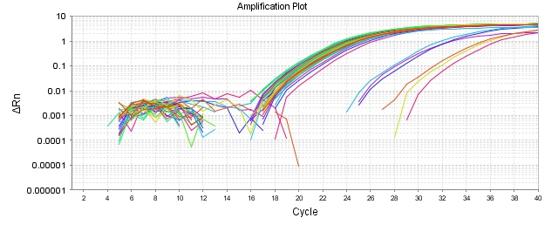
Fig S1. Amplification of the gene encoding α1

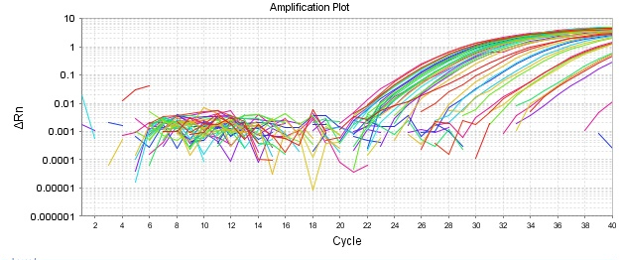
Fig S2. Amplification of the gene encoding α2

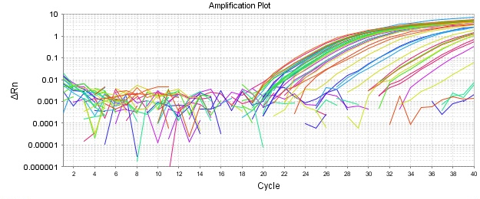
Fig S3. Amplification of the gene encoding α3

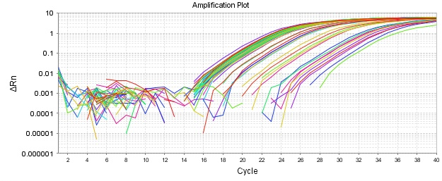
Fig S4. Amplification of the gene encoding β1

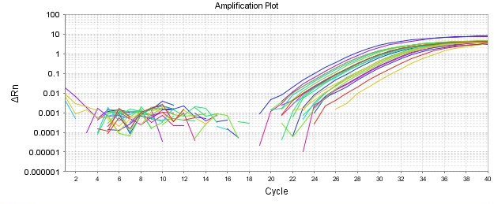
Fig S5. Amplification of the gene encoding NF-κB

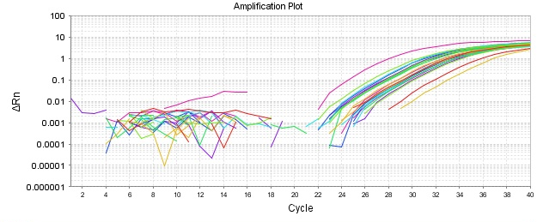
Fig S6. Amplification of the gene encoding TNFR1

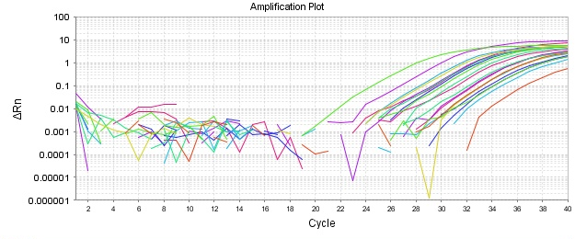
Fig S7. Amplification of the gene encoding IL-1β

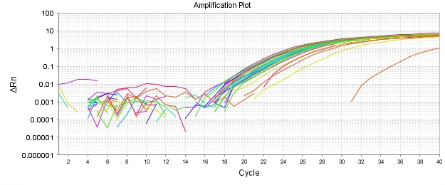
Fig S8. Amplification of the gene encoding β-actin

Fig S9. Ct values of β-actin for the 6 h and 24 h cohorts. Graphs a - c show Ct values from samples collected 6 hours after infusion, and graphs d - f show Ct values from the 24-hour cohort. No differences were observed between vehicle and ouabain-treated groups. Unpaired t-test.
Fig S10. Representative full-length western blot images of Na⁺,K⁺-ATPase α1 in hippocampus and prefrontal cortex. Full, uncropped western blot membranes are shown for hippocampus (upper panels) and prefrontal cortex (lower panels), including all experimental samples from vehicle (Veh) and ouabain-treated (Oua) groups. Molecular weight markers (Mwt) are indicated on the left.
Fig S11. Representative full-length western blot images of Na⁺,K⁺-ATPase α2 in hippocampus and prefrontal cortex. Full, uncropped western blot membranes are shown for hippocampus (upper panels) and prefrontal cortex (lower panels), including all experimental samples from vehicle (Veh) and ouabain-treated (Oua) groups. Molecular weight markers (Mwt) are indicated on the left.
Fig S12. Representative full-length western blot images of Na⁺,K⁺-ATPase α3 in hippocampus and prefrontal cortex. Full, uncropped western blot membranes are shown for hippocampus (upper panels) and prefrontal cortex (lower panels), including all experimental samples from vehicle (Veh) and ouabain-treated (Oua) groups. Molecular weight markers (Mwt) are indicated on the left.

Fig S13. Representative full-length western blot images of Na⁺,K⁺-ATPase β1 in hippocampus and prefrontal cortex. Full, uncropped western blot membranes are shown for hippocampus (upper panels) and prefrontal cortex (lower panels), including all experimental samples from vehicle (Veh) and ouabain-treated (Oua) groups.
Fig S13 Representative full-length western blot images of β-actin (42 kDa) in hippocampus and prefrontal cortex. Full, uncropped western blot membranes are shown for hippocampus (upper panels) and prefrontal cortex (lower panels), including all experimental samples from vehicle (Veh) and ouabain-treated (Oua) groups. β-actin was used as a loading control and was detected on the same membranes after stripping and reprobing. All samples were processed under identical experimental conditions.

