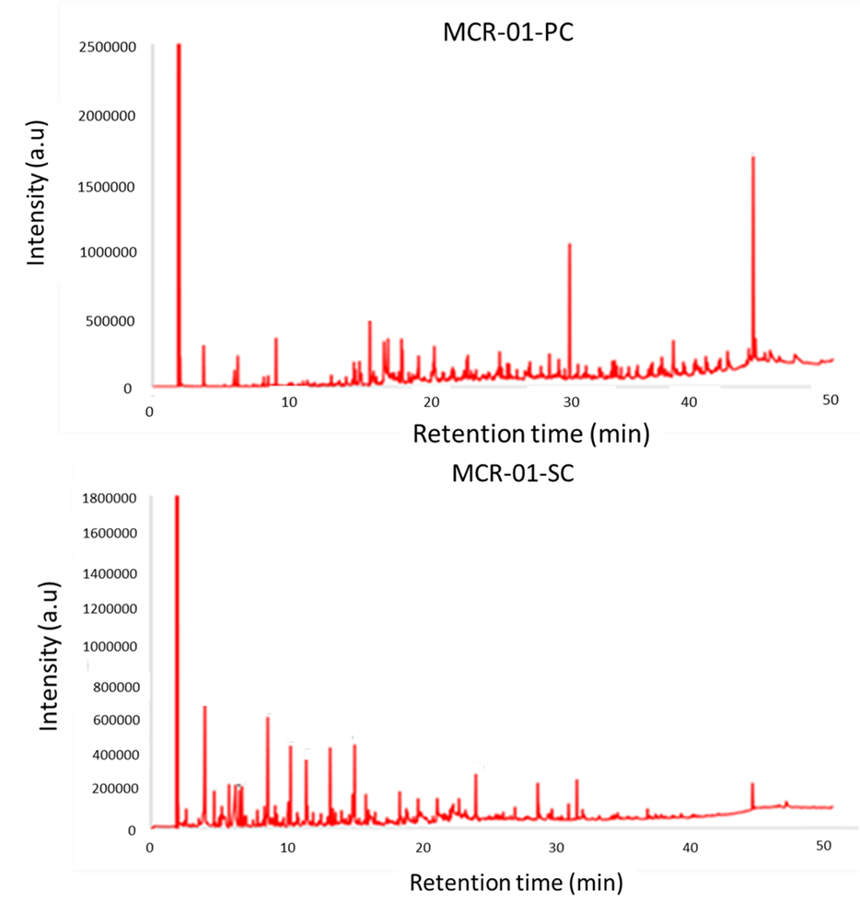
Figure SI1: GC/MS chromatograms of the primary condensate (PC) and secondary condensate (SC) from the fast pyrolysis of bone-dried (2.69 wt%) trommel fines feedstock
Identity of the major peaks in Figure SI3
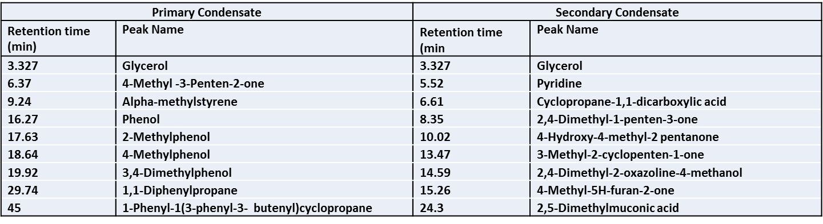

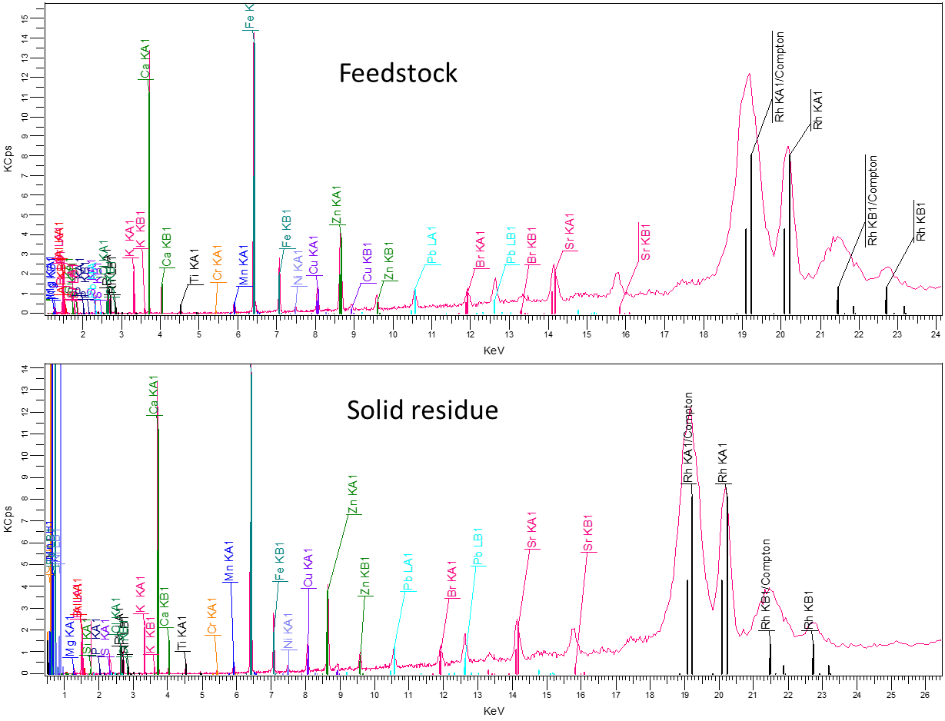
Figure SI2: XRF outlines of the trommel fines feedstock with 2.69 wt% moisture and its solid residues after fast pyrolysis, showing the presence of main elements in the ash

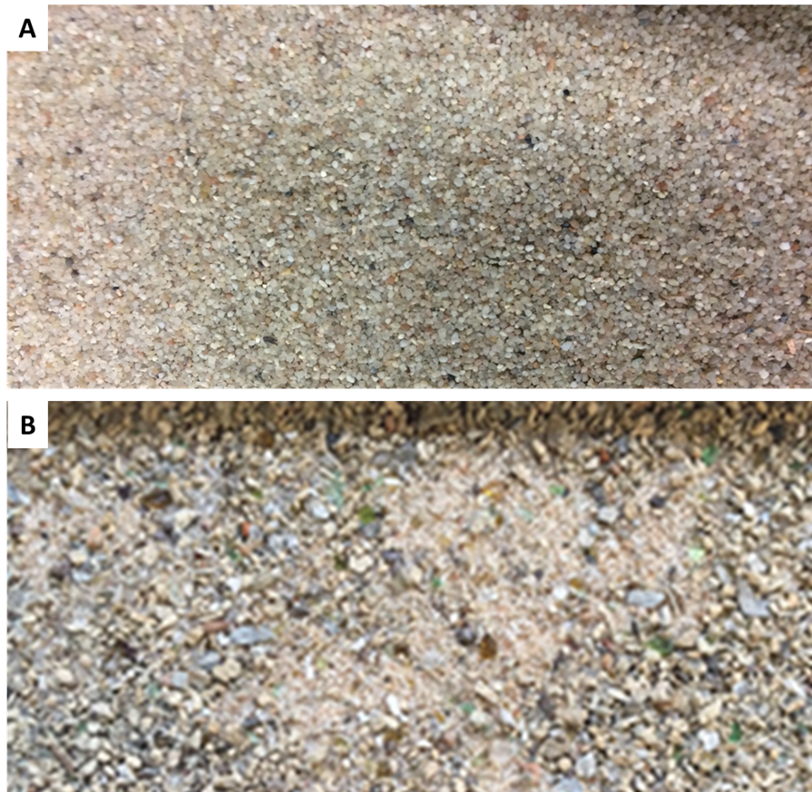
Figure SI3: Photographs of reactor bed materials, [A] fresh bed; [B] bed material after fast pyrolysis of trommel fines showing glasses and stones, etc.

