Supplementary Material

Table S1. Peak assignments in ¹³C NMR solid-state spectra from organic matter samples (Knicker, 2011; Knicker and Lüdemann, 1995). Reference used: Tetramethylsilane = 0 ppm.

Chemical shift (ppm) | Spectral region | Assignment
0–45 | Alkyl | Methyl and methylene carbons
45–60 | N-alkyl | Methoxyl and N-alkyl carbons, C-α of most amino acids
60–90 | O-alkyl | Carbohydrates carbons (C-2 to C-6 in hexose), higher alcohols and C-α of some amino acids
90–110 | Anomeric | Anomeric carbons in carbohydrates, C-2 and C-6 of syringyl units of lignin
110–140 | Aromatic | Aromatic carbons, C-2 and C6 of guaiacyl units of lignin, olefinic carbons
140–160 | Heteroaromatic | COR and CNR heteroaromatic and furanic carbons
160-220 | Carboxyl | Carbons of carboxyl, carbonyl, ester and amide groups

Day | Windrow | %G₂₄ | %G₇₂ | %GI₂₄ | %GI₇₂
9 | 1 | 105 (0.00) | 105 (0.00) | 118 (27.5) | 118 (27.5)
9 | 2 | 105 (17.5) | 105 (4.60) | 150 (27.6) | 158 (11.6)
9 | 3 | 118 (2.31) | 109 (0.00) | 164 (13.5) | 159 (9.20)
157 | 1 | 106 (5.24) | 106 (5.24) | 119 (8.21) | 119 (8.21)
157 | 2 | 106 (5.24) | 102 (5.24) | 102 (4.88) | 106 (4.88)
157 | 3 | 100 (0.00) | 100 (0.00) | 103 (9.50) | 103 (9.50)
Table S2. % G (germination percentage) and GI (germination index) during composting in the three windrows. Mean values and standard deviation (in brackets) for different sampling locations within the same windrow of the measured variables N=3.

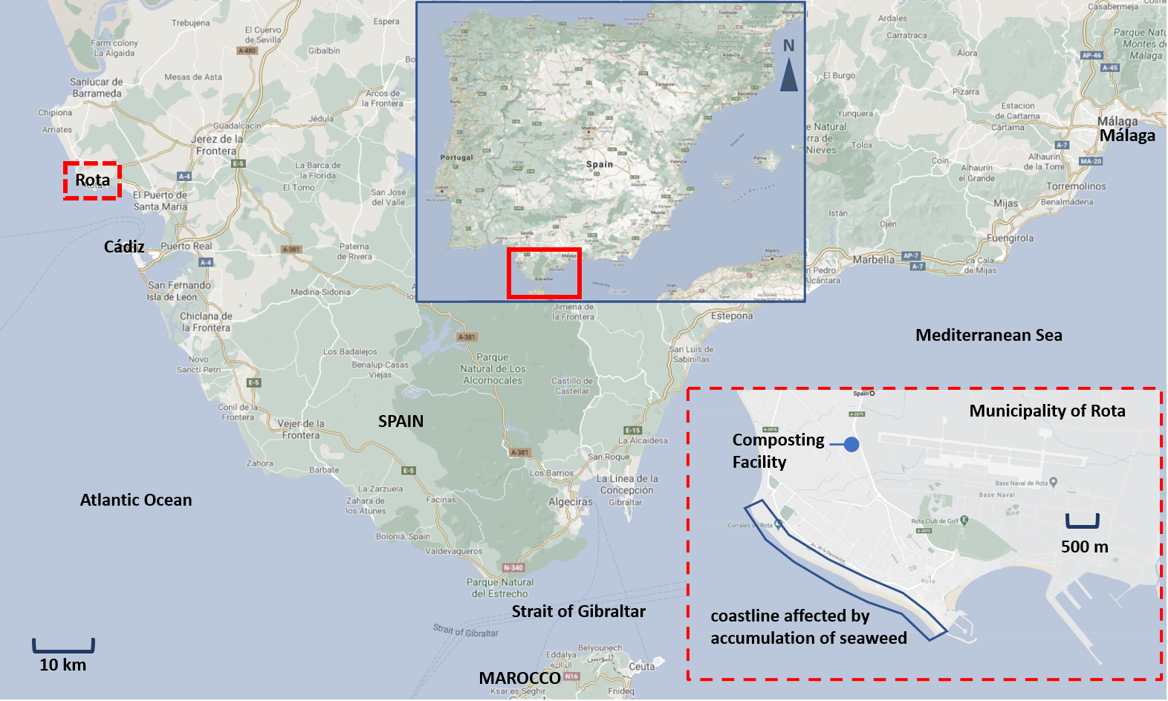
Figure S1. Localization of the coastline affected by accumulation of seaweed and the composting facility

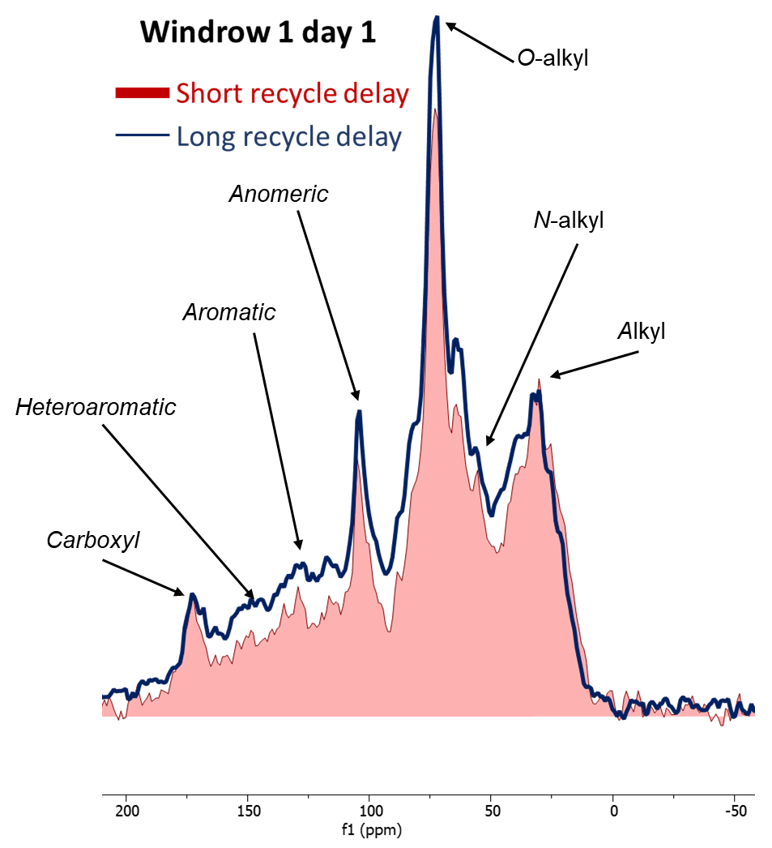

Figure S2. Comparison between ¹³C CPMAS NMR sequences with long (500 ms) and short (300 ms) recycle delays applied to the same sample with high content of crystalline cellulose.

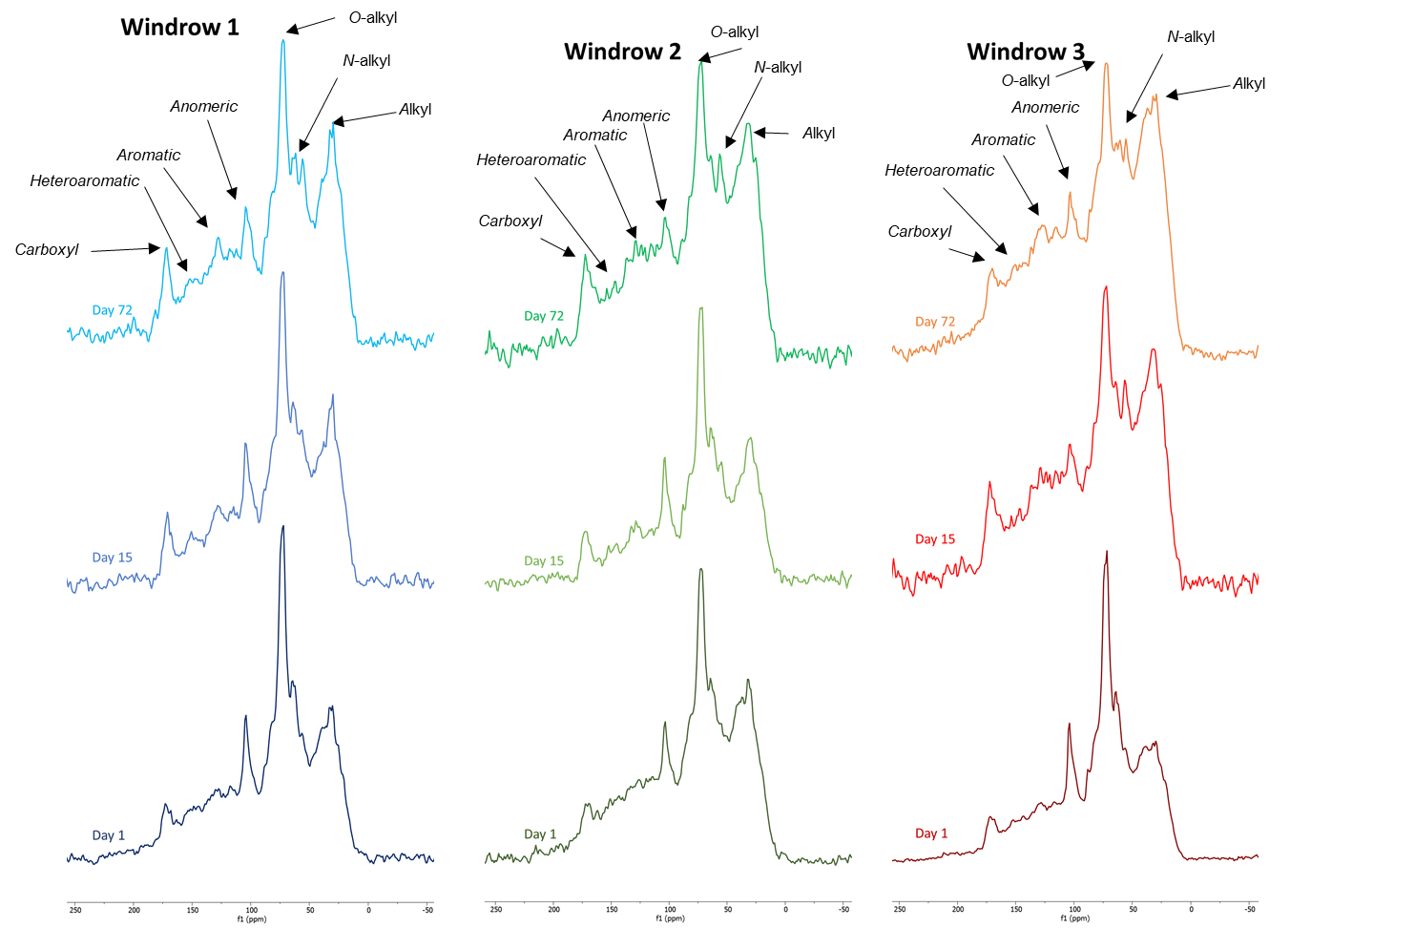
Figure S3. ¹³C CPMAS spectra of the samples collected from the 3 windrows at 3 different sampling times. Samples from day 1 were acquired using a longer recycle delay (500 ms).
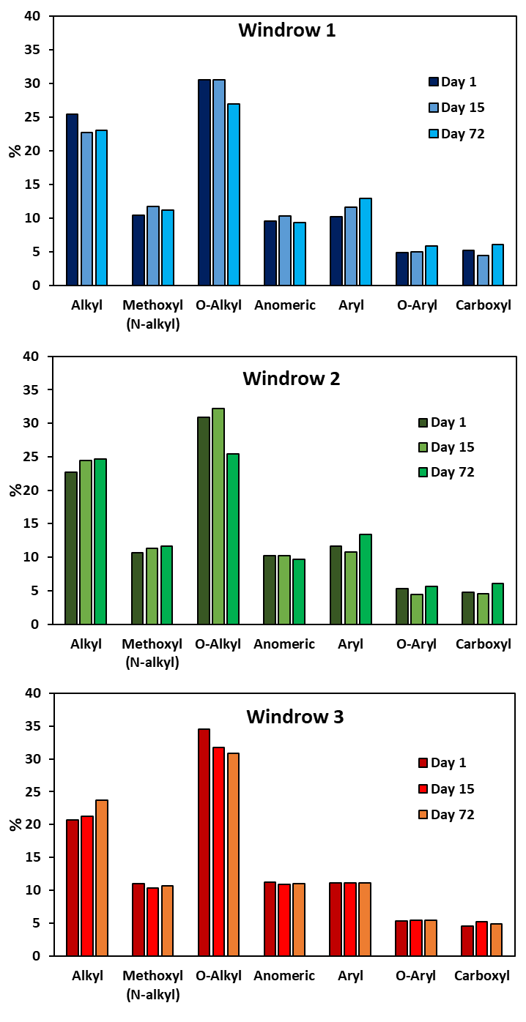
Figure S4. Integration values expressed as relative contribution of the seven spectral regions of ¹³C NMR spectra established in table 2 for the three windrows at the three different sampling times.

