Supplementary Material
Oxidative Depolymerization of Lignosulfonates for Muconic Acid Production Using Recombinant Pseudomonas putida CJ475
Selda Bekirovska,^{1,†} Fredrik Lund,^{2,†} Lucy I. Ajakaiye Jensen,^{1,†} Christian P. Hulteberg,^{1,}* Marie F. Gorwa-Grauslund,² Omar Y. Abdelaziz^{3,4,}*
¹Division of Chemical Engineering, Department of Process and Life Science Engineering, Lund University, SE-221 00 Lund, Sweden
²Division of Applied Microbiology, Department of Chemistry, Lund University, SE-221 00 Lund, Sweden
³Department of Chemical Engineering, King Fahd University of Petroleum & Minerals, Dhahran 31261, Saudi Arabia
⁴Interdisciplinary Research Center for Refining & Advanced Chemicals, King Fahd University of Petroleum & Minerals, Dhahran 31261, Saudi Arabia
*christian.hulteberg@ple.lth.se (C.P.H.)
*omar.abdelaziz@kfupm.edu.sa (O.Y.A.)
†These authors contributed equally to this work.

Table S1 The gradient method applied in the UPLC analysis
Time (min) | A-100% Water | B-100% Acetonitrile | C-0.1M Formic acid(aq)
0 | 87% | 3% | 10%
12 | 75% | 15% | 10%
15 | 75% | 15% | 10%
20 | 10% | 80% | 10%
20.1 | 0% | 90% | 10%
25 | 0% | 90% | 10%
25.1 | 87% | 3% | 10%
35 | 87% | 3% | 10%

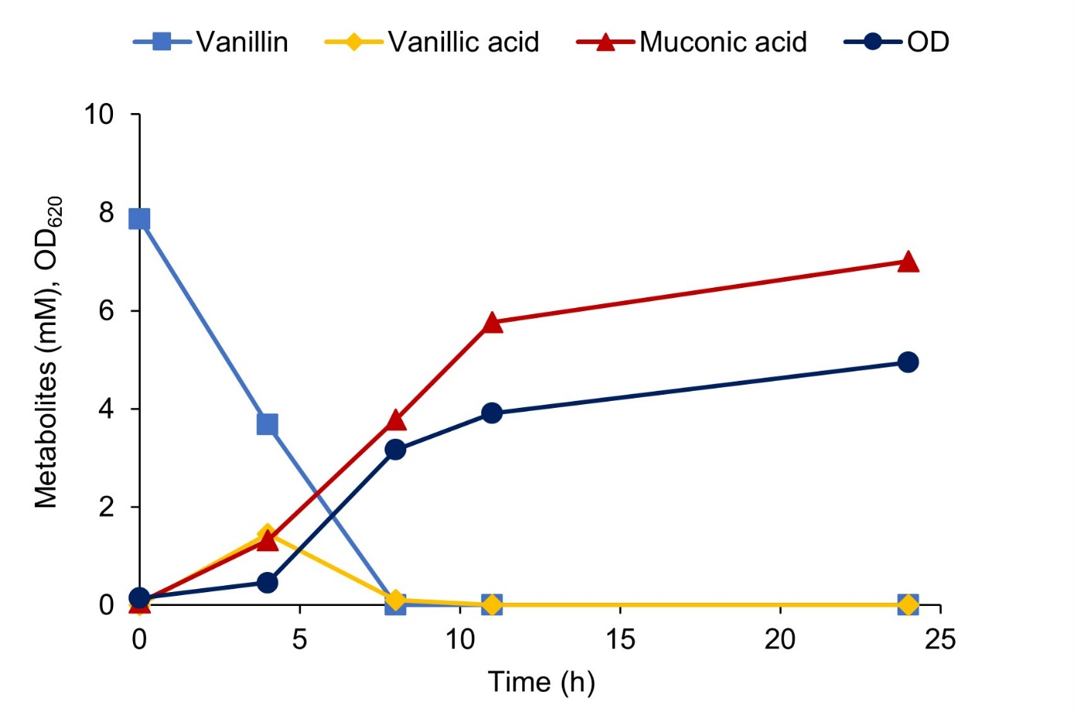
Fig. S1 Shake flask bioconversion of 8 mM synthetic vanillin in M9 medium supplemented with 10 g/L glucose using P. putida CJ475

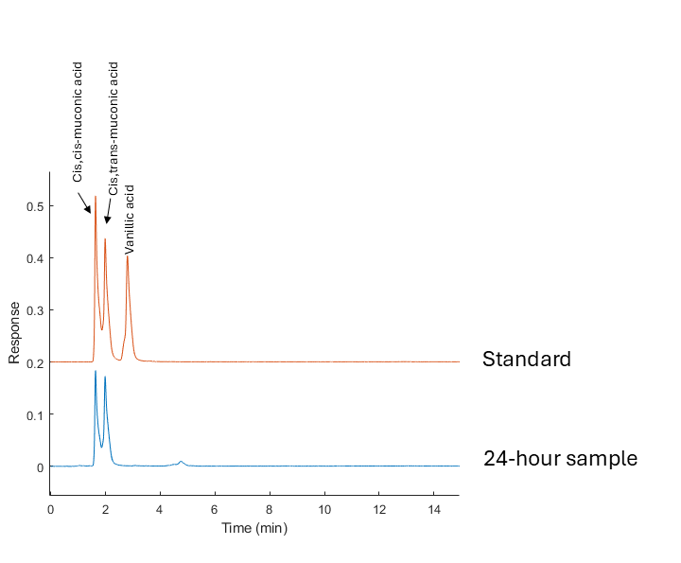
Fig. S2 UPLC chromatogram of a 3 mM muconic acid and vanillic acid standard, together with a chromatogram of the 24-hour sample from the bioconversion of the extracted mixture.

Identification of muconic acid isomers by ¹H-NMR
Cell-free broth was filtered (0.22-μm pore size, cellulose acetate filters; Fisher Scientific) and then mixed with D₂O at a 9:1 (v/v) ratio. The sodium salt of 3-(trimethylsilyl) propionic-2,2,3,3-d4 acid (TSP-d4) was added to the sample as the internal standard. The spectra were recorded using a 600 MHz Bruker magnet, equipped with a NEO console and a 5mm QCI H/P/C-N-D cryoprobe at 298.2K. All the experiments were set-up, run and processed using Topspin 4.1.4. Water suppression was achieved by the pre-saturation in the default Bruker noesy-1d (noesygppr1d) pulse sequence. In order to further evaluate the peaks in the 1D spectrum, a COSY and TOCSY spectrum was also recorded using the clipcosyesgpph [1] and dipsi2esgpph [2, 3] pulse sequences, respectively.

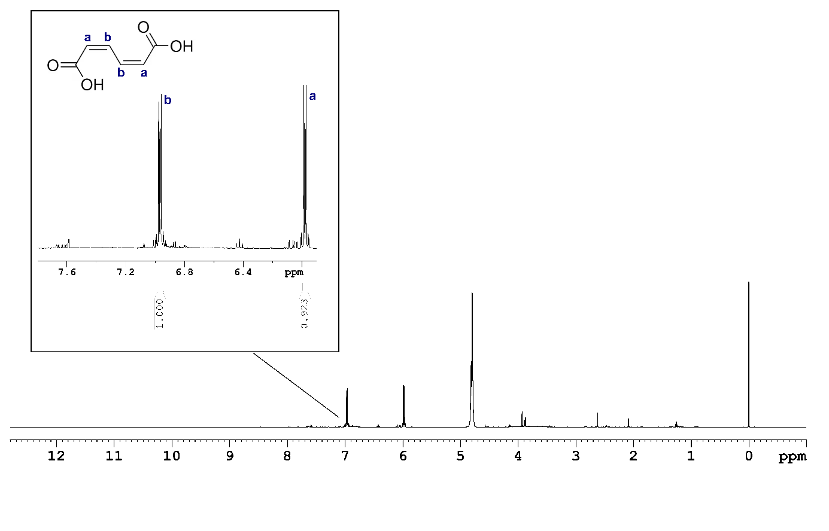Fig. S3 ¹H NMR spectra of the 24-hour sample from the bioconversion of the extracted depolymerized lignosulfonate fraction containing cis,cis-muconic acid and sodium salt of 3-(trimethylsilyl) propionic-2,2,3,3-d4 acid (TSP-d₄) as an internal standard (0 ppm). The large signal at 4.8 ppm is due to the solvent.
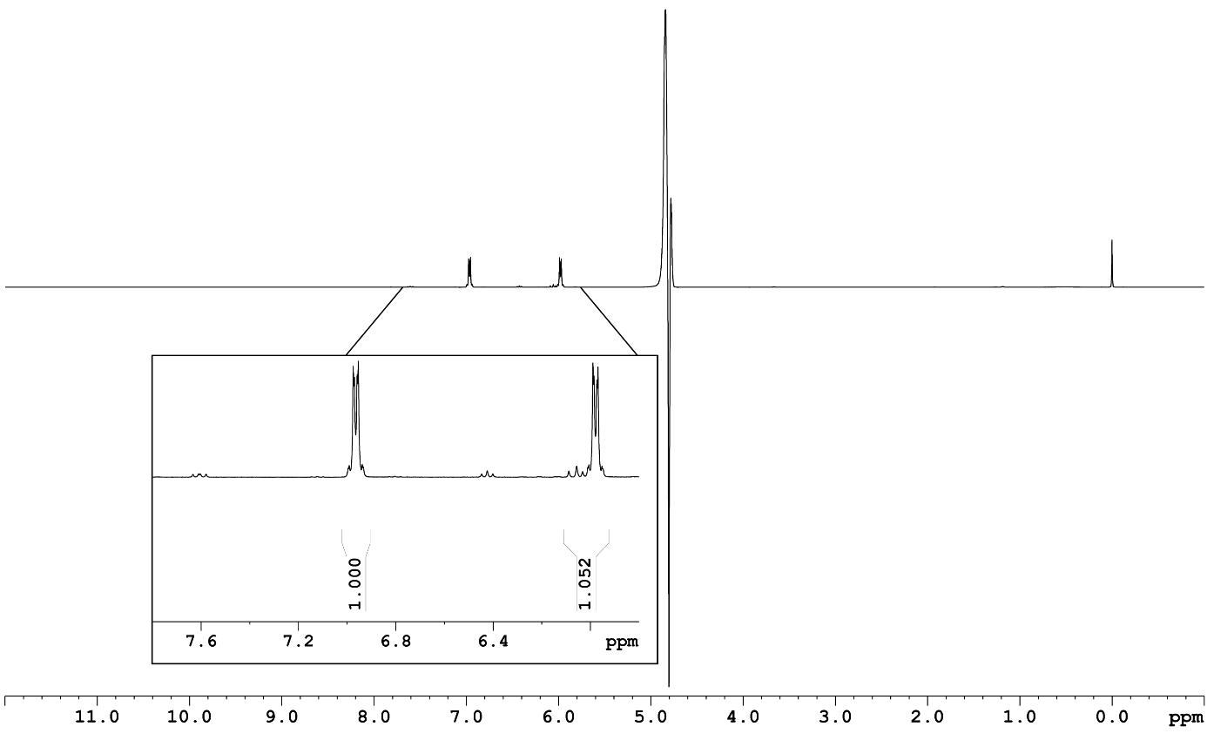
Figure S4. ¹H NMR spectra of a cis,cis-muconic acid standard in M9 media pH 7.0 containing sodium salt of 3-(trimethylsilyl) propionic-2,2,3,3-d₄ acid (TSP-d₄) as an internal standard (0 ppm). The large signal at 4.8 ppm is due to the solvent.

References
1. Koos, M.R.M., Kummerlöwe, G., Kaltschnee, L., Thiele, C.M., Luy, B.: CLIP‐COSY: Reine Inphase‐Signale und schnelle Akquisition COSY‐artiger Korrelationen. Angewandte Chemie. 128, 7785–7789 (2016). https://doi.org/10.1002/ange.201510938
2. Shaka, A.J., Lee, C.J., Pines, A.: Iterative schemes for bilinear operators; application to spin decoupling. Journal of Magnetic Resonance (1969). 77, 274–293 (1988). https://doi.org/10.1016/0022-2364(88)90178-3
3. Hwang, T.L., Shaka, A.J.: Water Suppression That Works. Excitation Sculpting Using Arbitrary Wave-Forms and Pulsed-Field Gradients. J Magn Reson A. 112, 275–279 (1995). https://doi.org/10.1006/jmra.1995.1047

