Enhancing Cream Cheese Nutritional Value and Shelf Life with the Incorporation of Free and Microencapsulated Onion Peel Extract
Sara M. Ferreira ^{1,2}, Bárbara M. Pereira ^{1,2}, J. M. Oliveira^{3,4,5}, Loleny Tavares^{3,4,5} and Lúcia Santos ^{1,2,}*
¹ LEPABE - Laboratory for Process Engineering, Environment, Biotechnology and Energy, Faculty de Engineering, University of Porto, Rua Dr. Roberto Frias, 4200-465 Porto, Portugal;
² ALiCE - Associate Laboratory in Chemical Engineering, Faculty de Engineering, University of Porto, Rua Dr. Roberto Frias, 4200-465 Porto, Portugal;
³ ESAN - School of Design, Management and Production Technologies Northern Aveiro, University of Aveiro, Estrada do Cercal 449, 3720-509, Oliveira de Azeméis, Santiago de Riba-UI, Portugal
⁴ CICECO-Aveiro - Institute of Materials, Campus Universitário de Santiago, University of Aveiro, 3810-193 Aveiro, Portugal;
⁵ EMaRT Group - Emerging: Materials, Research, Technology, School of Design Management and Production Technologies Northern Aveiro, University of Aveiro, Estrada do Cercal, 449, 3720-509 Oliveira de Azeméis, Portugal;
*Corresponding author: Tel.: +351 225 081 682, Fax: +351 225 081 440, lsantos@fe.up.pt

Materials and Methods
For the determination of the peroxide value (PV), 50 μL of a pre-prepared solution containing thiocyanate at a concentration of 300 g.L⁻¹ were added to a mixture of 0.2 g of the sample and 9.8 mL of a solution of chloroform:methanol in a ratio of 7:3 (V/V); the mixture was vortexed for 4 seconds. Next, 50 μL of an iron chloride solution were added and the mixture was stirred. Subsequently, the mixture was left to incubate at room temperature for 5 minutes without exposure to light. The absorbance was then measured at a wavelength of 500 nm, and the peroxide value (PV) was calculated using Equation S.1,
 | $$PV = m×\frac{A_{sample}-A_{blank}}{m_{s}×55.84×2}$$ | Equation S.1

where m is the slope of the calibration curve (12.25), 55.84 corresponds to the atomic weight of iron, factor 2 converts PV from milliequivalents per oxygen to milliequivalents peroxide, A_{sample} refers to the absorbance of the sample, A_{blank} refers to the absorbance of the blank, and ms corresponds to the weight of cream cheese used.
To determine the secondary oxidation, the p-anisidine reagent was prepared by adding 0.25 g of p-anisidine to 100 mL of glacial acetic acid. Each sample was diluted with 25 mL of isooctane and then mixed before measuring its absorbance at 350 nm. Then, 5 mL of the solution were placed into each falcon tube and 1 mL of p-anisidine reagent was added. For the blank, 5 mL of isooctane were combined with 1 mL of p-anisidine reagent. The mixture was left incubating for 10 minutes before measuring its absorbance at 350 nm. Finally, the p-anisidine value was calculated using Equation S.2,
 | $$p-AV= 25×\frac{{1.2 × (A}_{sample}-A_{blank})}{m_{s}}$$ | Equation S.2

Results and Discussion
Table S.1. Thermogravimetric analysis results.
Sample | Weight loss at 105 °C (%) | Weight loss at 250 °C (%) | Weight loss at 300 °C (%) | Weight loss at 370 °C (%) | Weight loss at 400 °C (%)
EC | 1.04 | 1.54 | 6.03 | 89.60 | 92.51
OPE | 31.59 | 44.03 | 50.06 | 57.06 | 60.37
Microencapsulated OPE | 1.57 | 5.75 | 14.55 | 90.85 | 91.98
EC – Ethyl Cellulose; OPE – Onion Peel Extract; MPs – microparticles
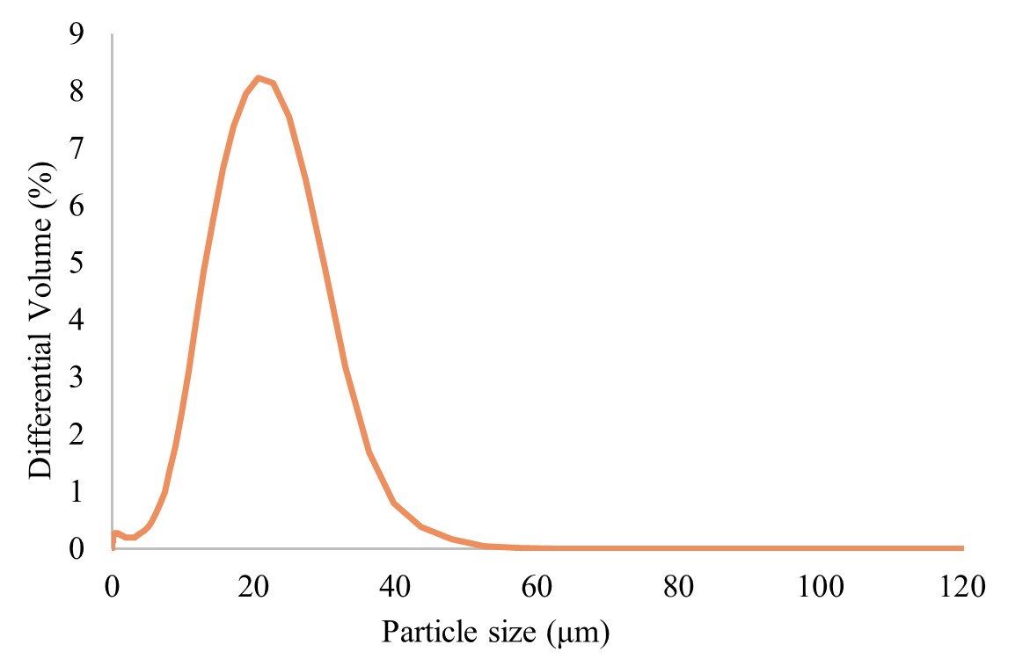

Fig. S.1 Particle Size Distribution of the microparticles with onion peel extract.
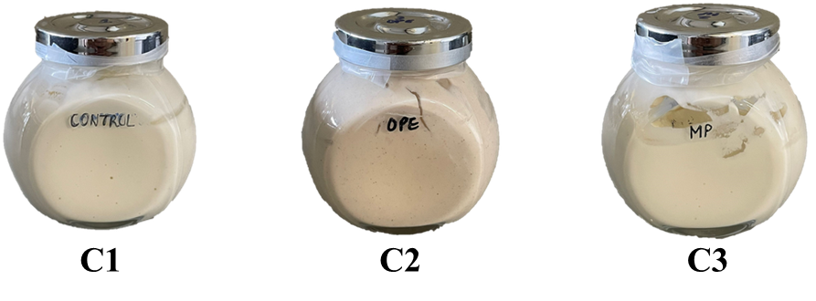

Fig. S.2 Cream cheese samples on the day of production. Negative control cream cheese (C1), cream cheese with OPE (C2), and cream cheese with OPE Microparticles (C3).

