Development of organo-mineral nitrogen fertilizers derived from cocoa pod husks.
Julieth A. Moreno Carrillo^{1,2}, Carlos Alberto Peláez², Jhon Jairo Fernández¹, Alexander
Santamaria¹
.
¹ Química de recursos energéticos y medio ambiente, Instituto de química, Facultad de
Ciencias Exactas y Naturales, Universidad de Antioquia UdeA, Calle 70 Nº 52-21,
Medellín 050010, Colombia
² Grupo Interdisciplinar de estudios moleculares, Instituto de química, Facultad de Ciencias
Exactas y Naturales, Universidad de Antioquia UdeA, Calle 70 Nº 52-21, Medellín 050010,
Colombia

Corresponding Author
Alexander Santamaria¹
Alexander.santamaria@udea.edu.co

Supplementary material

Table S1. Microbiological characterization of aerobic base materials

Sample | Mesophiles (u.f.c/g) | Termophiles (u.f.c/g) | Molds  (u.f.c/g) | Yeasts (u.f.c/g) | Enterobacteria  (u.f.c)
CB300 | 2.03x10⁸ | 1.00x10³ | 4.00x10² | 0.00 | 20
C+B300 | 1.00x10² | 1.00x10² | 2.00x10² | 2.80x10⁴ | 3.40x10²
C | 1.00x10⁸ | 2.00x10² | 2.00x10² | 5.10x10⁴ | 7.00x10²
C+B400 | 9.20x10⁷ | 1.20x10² | 1.80x10² | 9.00x10² | 2.10x10²
CB400 | 2.10x10⁸ | 1.00x10² | 5.00x10² | 10 | 0.00

Table S2. Macronutrients and heavy metals of carbon-based materials
Samples | Macronutrients (%) |  |  |  | Heavy metal (mg/kg)
Samples | K₂O | CaO | MgO | Na | Cr | Cd | Pb | Ni | Hg | As
CPH | 4.2 | 0.8 | 1.0 | 0.0 | - | - | - | - | - | -
B400 | 11.5 | 1.7 | 1.8 | 0.0 | N.D | < 0.1 | N.D | 14.1 | < 0.01 | < 0.01
C | 7.0 | 1.0 | 1.2 | 0.0 | < 1.0 | 3.8 | < 0.5 | 7.6 | < 0.01 | < 0.01
CB300 | 8.7 | 1.1 | 1.4 | 0.1 | < 1.0 | <2.0 | < 0.5 | 9.7 | < 0.01 | < 0.01
CB400 | 7.5 | 0.6 | 1.1 | 0.1 | < 1.0 | <2.0 | < 0.5 | 7.6 | < 0.01 | < 0.01
C+B300 | 8.6 | 0.8 | 1.4 | 0.1 | < 1.0 | 3.8 | < 0.5 | 6.9 | < 0.01 | < 0.01
C+B400 | 10.7 | 1.1 | 1.6 | 0.1 | < 1.0 | <2.0 | < 0.5 | 8.3 | < 0.01 | < 0.01
Limit-1* | - | - | - | - | 1200.0 | 39.0 | 20.0 | - | 17.0 | 41.0
Limit-2** |  |  |  |  | 2.0 | 3.0 | 120.0 | 50.0 | 1.0 | 40.0
*Taken from Colombian NTC 5167, ** (EU) 2019/1009 [1] ^{, ND = no detected}

Table S3. Interpretation of the Korsmeyer-Peppas exponent, adapted from [2]
Exponent (n) | Transport Mechanism
0 < n < 0.45 | Hindered Fickian diffusion, representative of systems characterized by diffusive regime with hampered release
n = 0.45 | The release is of Fickian nature and is attributed exclusively to diffusion or First order kinetic
0.45 < n < 1 | Anomalous or non-Fickian transport, where release is influenced by diffusion, relaxation, and /or swelling of the coating.
n = 1 | Type II transport is a controlled release by relaxation or erosion (typical zero-order release).
n > 1 | Type II super transport is characterized by a release dominated by rapid swelling or significant erosion of the matrix.

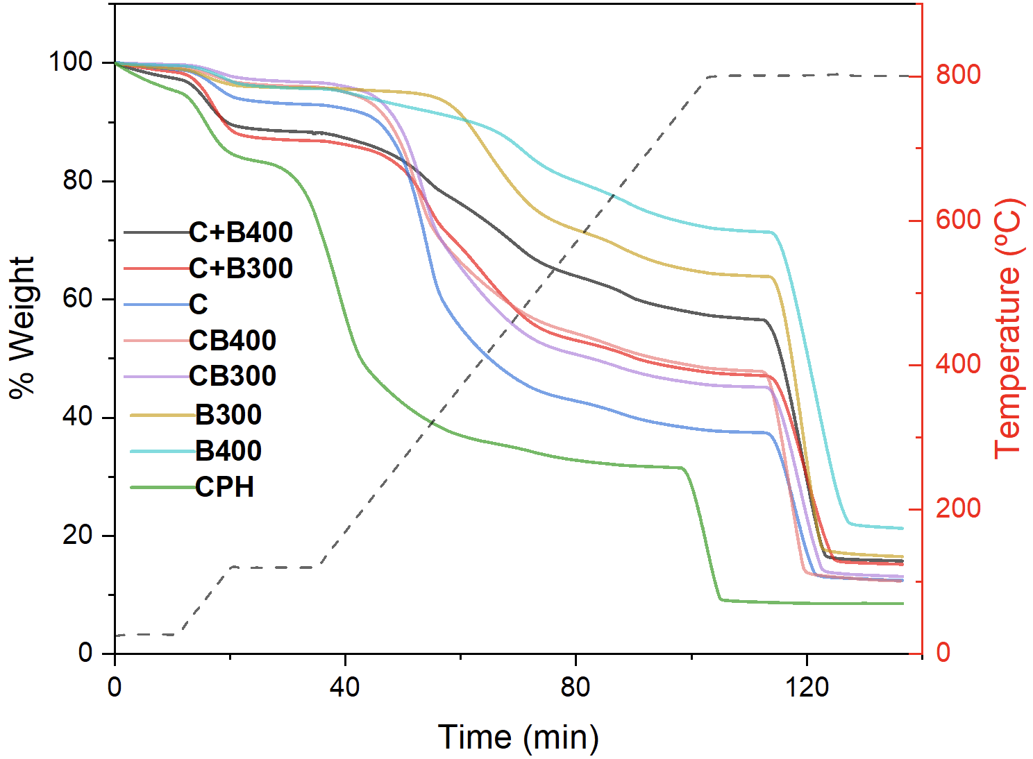
Time (days)
Figure S1. Thermogravimetric analysis of carbon-based materials: a) thermal profile as a function of time; b) weight derivative as a function of temperature.

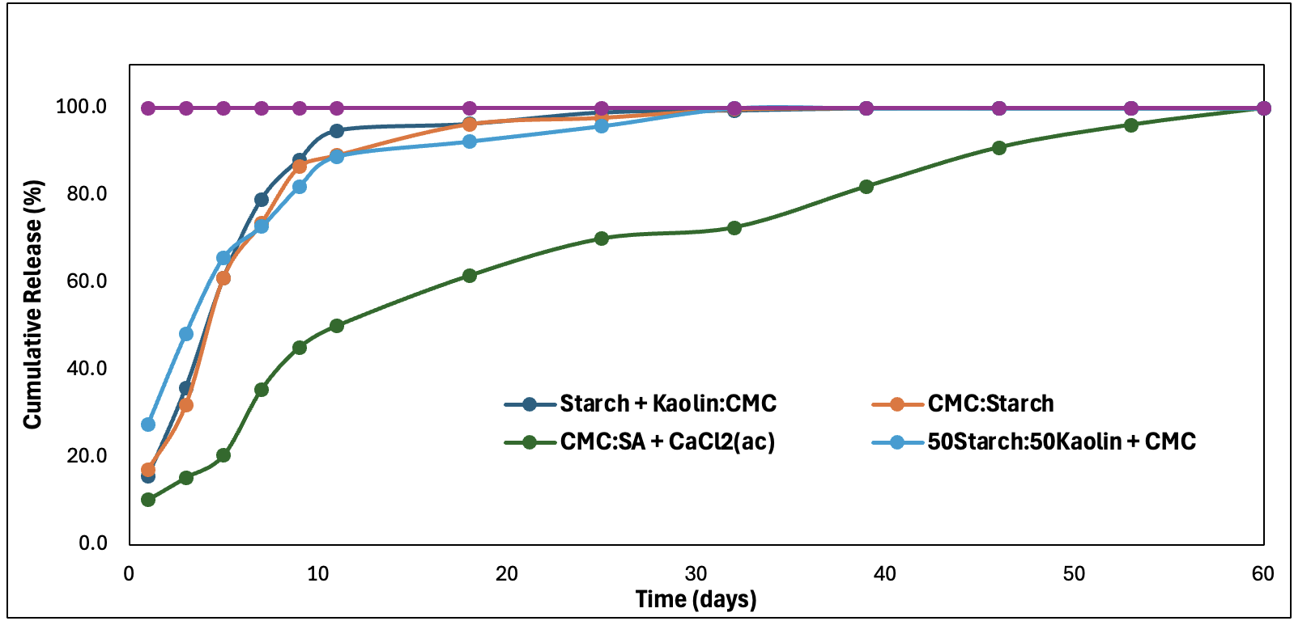
Figure S2. Urea release of different coatings formulations in a petri dish experiment.

Of all the coatings evaluated, the CMC:SA + CaCl₂(aq) coating exhibited the slowest release profile, reaching a cumulative release of 70% at 30 days and a complete release around day 60. In contrast, the coatings containing starch, kaolin, and CMC in their formulations showed faster release, reaching a cumulative release of 85–90% in the first 10 days and almost complete release by 30 days.

Figure S3. Schematic reactions between urea and oxygenated functional groups on carbon-based materials [3]

References

[1] European Parliament, Regulation (EU) 2019/1009 of the European Parliament and of the Council laying down rules on the making available on the market of EU fertilising products. 2019.
[2] M. Fosca, J. V. Rau, and V. Uskoković, “Factors influencing the drug release from calcium phosphate cements,” 2022. doi: 10.1016/j.bioactmat.2021.05.032.
[3] M. Wang, A. Xiang, Z. Gao, K. Zhang, Y. Ren, and Z. Hu, “Study on the nitrogen-releasing characteristics and mechanism of biochar-based urea infiltration fertilizer,” Biomass Convers. Biorefin., vol. 13, no. 11, 2023, doi: 10.1007/s13399-021-01848-5.

