Supporting Information
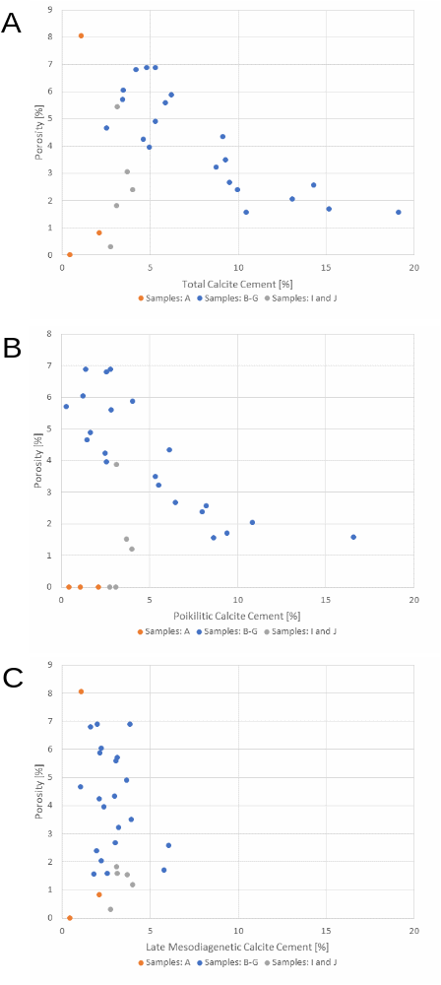
Fig. SI1: Porosity as a function of total calcite cement concentration (A), poikilitic calcite cement concentration (B), and late mesodiagenetic calcite cement concentration (C). Samples B-G: lower cross-bedded and laminated aeolian sandstones, samples I and J: upper cross-bedded sandstones, sample A: fluvial sandstones.

According to Figure 10, the sample block has three distinct areas in which different dominating diagenetic products, i.e., quartz, calcite, and clay/iron oxide control the porosity/permeability pattern. Figures SI1 and SI2 show that the permeability/porosity pattern in the lower cross-bedded and laminated aeolian sandstones (samples: B-G) are controlled by the amount of poikilitic calcite cement. In contrast, the porosity/permeability of the upper cross-bedded aeolian sandstone (samples I and J) and the fluvial sandstones (sample A) are controlled by the amount of quartz cement and clay/iron oxides, as they do not show any correlation between calcite cement concentrations and porosity/permeability.
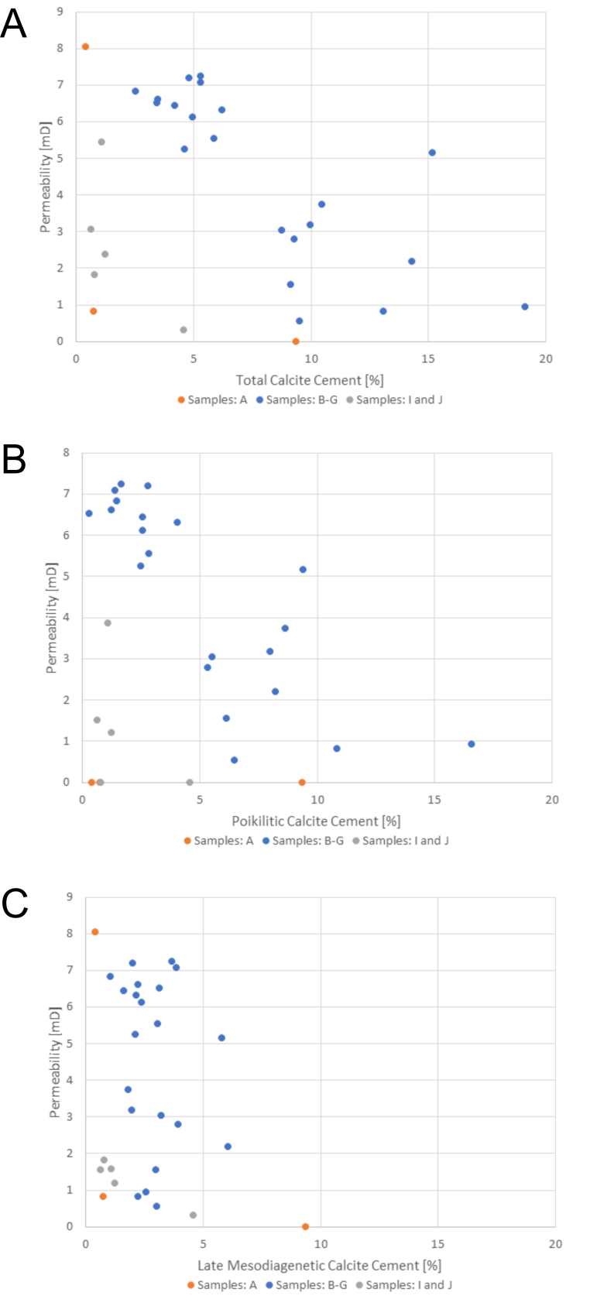
Fig. SI2: Permeability as a function of total calcite cement concentration (A), poikilitic calcite cement concentration (B), and late mesodiagenetic calcite cement concentration (C). Samples B-G: lower cross-bedded and laminated aeolian sandstones, samples I and J: upper cross-bedded sandstones, sample A: fluvial sandstones.

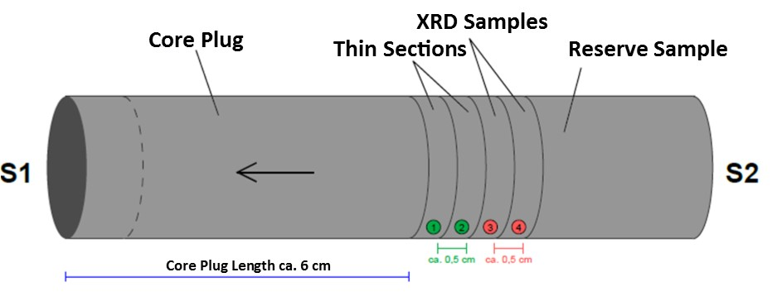
Fig. SI 3: Visualization of a sample plug and subsample configuration utilized for different analytical methods.

Table SI1: Permeability data and petrographic results of thin-section microscopy and image analysis. Sample ID refers to plug positions, cf. Fig. 5

Sample  ID | κ  [mD] | Porosity  [%] | Total  Calcite  cement  [%] | Poikilitic  Calcite  Cement  [%] | Late mesodiagenetic calcite cement [%]
A1 | 0.76 | 2.10 | 0.81 | 0.00 | 0.81
A6 | 9.37 | 0.44 | 0.00 | 0.00 | 0.00
A12 | 0.39 | 1.09 | 8.05 | 0.00 | 8.05
B13 | 5.15 | 1.69 | 15.20 | 9.40 | 5.80
C1 | 0.93 | 1.57 | 19.14 | 16.57 | 2.57
C6 | 0.82 | 2.04 | 13.08 | 10.85 | 2.23
C14 | 0.54 | 2.66 | 9.54 | 6.50 | 3.04
D6 | 2.19 | 2.57 | 14.32 | 8.25 | 6.07
D12 | 5.54 | 5.59 | 5.88 | 2.82 | 3.06
E1 | 2.79 | 3.49 | 9.31 | 5.36 | 3.95
E5 | 1.55 | 4.33 | 9.13 | 6.13 | 2.99
E6 | 7.08 | 6.88 | 5.29 | 1.41 | 3.87
E7 | 6.31 | 5.88 | 6.21 | 4.05 | 2.16
E8 | 6.44 | 6.79 | 4.20 | 2.57 | 1.63
E13 | 7.20 | 6.88 | 4.83 | 2.81 | 2.01
F1 | 6.82 | 4.65 | 2.55 | 1.49 | 1.06
F4 | 6.52 | 5.71 | 3.44 | 0.30 | 3.13
F6 | 5.25 | 4.23 | 4.62 | 2.50 | 2.12
F8 | 7.23 | 4.89 | 5.31 | 1.65 | 3.66
F9 | 6.12 | 3.96 | 4.97 | 2.59 | 2.38
F11 | 6.60 | 6.04 | 3.47 | 1.24 | 2.23
G1 | 3.04 | 3.22 | 8.75 | 5.55 | 3.20
G6 | 3.17 | 2.38 | 9.97 | 8.00 | 1.97
G12 | 3.73 | 1.56 | 10.49 | 8.66 | 1.83
I1 | 0.64 | 3.70 | 3.05 | 1.51 | 1.54
I6 | 1.26 | 4.01 | 2.38 | 1.20 | 1.18
I12 | 1.09 | 3.13 | 5.44 | 3.87 | 1.57
J1 | 4.60 | 2.76 | 0.30 | 0.00 | 0.30
J5 | 0.79 | 3.12 | 1.81 | 0.00 | 1.81

Table SI2: Overview of permeability model input parameters and comparison with the model output for evaluating the SGS model algorithm results. Each sedimentary layer (cf. Fig. 7) was modeled separately, thus each realization is composed of four separately calculated permeability models. Each realization of every permeability model is associated with a random seed number, which allows for the reproduction of the exact result under the same model conditions (see section 2.3.3). As the table shows, the SGS algorithm was able to reproduce the permeability input parameters min, max, delta, mean, standard deviation, and variance giving high confidence in the accuracy of the model and the validity of each realization. Note that the output parameters, mean, standard deviation, and variance of layer 1 for the permeability cannot be used to evaluate the model fit. The discrepancy between the output and input data for mean, standard deviation, and variance is the result of the extreme bimodal nature of permeability data in this layer, which did not allow the use of a standard normal score transformation (see section 2.3.3).
Permeability Model
Realization | Layer | Seed # | Model | Min  [mD] | Max  [mD] | Delta  [mD] | N | Mean  [mD] | Std  [mD] | Var  [mD]
1 | 1 | 22689 | Output | 0.26 | 140.26 | 140.00 | 50192 | 1.70 | 4.42 | 19.57
1 | 1 | 22689 | Input | 0.26 | 140.26 | 140.00 | 95 | 5.02 | 19.59 | 383.87
1 | 2 | 577 | Output | 1.83 | 12.73 | 10.91 | 25218 | 4.33 | 2.22 | 4.94
1 | 2 | 577 | Input | 1.83 | 12.73 | 10.91 | 49 | 4.41 | 2.06 | 4.26
1 | 3 | 26884 | Output | 0.12 | 13.71 | 13.59 | 61420 | 2.75 | 2.39 | 5.69
1 | 3 | 26884 | Input | 0.12 | 13.71 | 13.59 | 134 | 2.53 | 2.43 | 5.92
1 | 4 | 18566 | Output | 0.30 | 9.37 | 9.07 | 25486 | 2.12 | 1.99 | 3.98
1 | 4 | 18566 | Input | 0.30 | 9.37 | 9.07 | 25 | 2.24 | 2.03 | 4.11
2 | 1 | 30001 | Output | 0.26 | 140.26 | 140.00 | 50192 | 1.57 | 4.67 | 21.83
2 | 1 | 30001 | Input | 0.26 | 140.26 | 140.00 | 95 | 5.02 | 19.59 | 383.87
2 | 2 | 16035 | Output | 1.83 | 12.73 | 10.91 | 25218 | 4.45 | 1.88 | 3.54
2 | 2 | 16035 | Input | 1.83 | 12.73 | 10.91 | 49 | 4.41 | 2.06 | 4.26
2 | 3 | 1854 | Output | 0.12 | 13.71 | 13.59 | 61420 | 2.71 | 2.43 | 5.93
2 | 3 | 1854 | Input | 0.12 | 13.71 | 13.59 | 134 | 2.53 | 2.43 | 5.92
2 | 4 | 25766 | Output | 0.30 | 9.37 | 9.07 | 25486 | 1.92 | 2.01 | 4.05
2 | 4 | 25766 | Input | 0.30 | 9.37 | 9.07 | 25 | 2.24 | 2.03 | 4.11
3 | 1 | 4205 | Output | 0.26 | 140.26 | 140.00 | 50192 | 1.74 | 4.82 | 23.19
3 | 1 | 4205 | Input | 0.26 | 140.26 | 140.00 | 95 | 5.02 | 19.59 | 383.87
3 | 2 | 4173 | Output | 1.83 | 12.73 | 10.91 | 25218 | 4.62 | 2.03 | 4.12
3 | 2 | 4173 | Input | 1.83 | 12.73 | 10.91 | 49 | 4.41 | 2.06 | 4.26
3 | 3 | 21588 | Output | 0.12 | 13.71 | 13.59 | 61420 | 2.69 | 2.46 | 6.08
3 | 3 | 21588 | Input | 0.12 | 13.71 | 13.59 | 134 | 2.53 | 2.43 | 5.92
3 | 4 | 17829 | Output | 0.30 | 9.37 | 9.07 | 25486 | 2.16 | 2.07 | 4.27
3 | 4 | 17829 | Input | 0.30 | 9.37 | 9.07 | 25 | 2.24 | 2.03 | 4.11

Table SI3: Overview of calcite cement model input parameters and comparison with the model output for evaluating the SGS model algorithm. Each sedimentary layer (cf. Fig. 7) was modeled separately therefor for each realization is composed of four separately calculated calcite cement models. Each realization of every calcite cement model is associated with a random seed number which allows for the reproduction of the exact result under the same model conditions (see section 2.3.3). As the table shows the SGS algorithm was able to reproduce the calcite cement input parameters min, max, delta, mean, standard deviation, and variance exactly to well, giving high confidence in the accuracy of the model and the validity of each realization, especially for layers 2 and 3.

Calcite Cement Model
Realization | Layer | Seed # | Model | Min  [vol.%] | Max  [vol.%] | Delta  [vol.%] | N | Mean  [vol.%] | Std  [vol.%] | Var  [vol.%]
1 | 1 | 16037 | Output | 0.30 | 5.44 | 5.14 | 50192 | 2.98 | 1.54 | 2.38
1 | 1 | 16037 | Input | 0.30 | 5.44 | 5.14 | 5 | 2.60 | 1.89 | 3.56
1 | 2 | 23232 | Output | 2.55 | 10.49 | 7.94 | 25218 | 5.95 | 2.85 | 8.14
1 | 2 | 23232 | Input | 2.55 | 10.49 | 7.94 | 9 | 5.95 | 3.00 | 8.97
1 | 3 | 4856 | Output | 4.20 | 19.14 | 14.94 | 61420 | 12.40 | 4.55 | 20.74
1 | 3 | 4856 | Input | 4.20 | 19.14 | 14.94 | 12 | 9.68 | 4.79 | 22.98
1 | 4 | 2300 | Output | 0.00 | 8.05 | 8.05 | 25486 | 3.46 | 3.20 | 10.27
1 | 4 | 2300 | Input | 0.00 | 8.05 | 8.05 | 3 | 2.95 | 4.43 | 19.67
2 | 1 | 11659 | Output | 0.30 | 5.44 | 5.14 | 50192 | 3.15 | 1.53 | 2.35
2 | 1 | 11659 | Input | 0.30 | 5.44 | 5.14 | 5 | 2.60 | 1.89 | 3.56
2 | 2 | 4025 | Output | 2.55 | 10.49 | 7.94 | 25218 | 6.00 | 2.88 | 8.29
2 | 2 | 4025 | Input | 2.55 | 10.49 | 7.94 | 9 | 5.95 | 3.00 | 8.97
2 | 3 | 1892 | Output | 4.20 | 19.14 | 14.94 | 61420 | 11.58 | 4.54 | 20.65
2 | 3 | 1892 | Input | 4.20 | 19.14 | 14.94 | 12 | 9.68 | 4.79 | 22.98
2 | 4 | 32185 | Output | 0.00 | 8.05 | 8.05 | 25486 | 3.31 | 3.14 | 9.88
2 | 4 | 32185 | Input | 0.00 | 8.05 | 8.05 | 3 | 2.95 | 4.43 | 19.67
3 | 1 | 3190 | Output | 0.30 | 5.44 | 5.14 | 50192 | 3.19 | 1.58 | 2.49
3 | 1 | 3190 | Input | 0.30 | 5.44 | 5.14 | 5 | 2.60 | 1.89 | 3.56
3 | 2 | 17742 | Output | 2.55 | 10.49 | 7.94 | 25218 | 5.87 | 2.85 | 8.11
3 | 2 | 17742 | Input | 2.55 | 10.49 | 7.94 | 9 | 5.95 | 3.00 | 8.97
3 | 3 | 5569 | Output | 4.20 | 19.14 | 14.94 | 61420 | 12.21 | 4.81 | 23.12
3 | 3 | 5569 | Input | 4.20 | 19.14 | 14.94 | 12 | 9.68 | 4.79 | 22.98
3 | 4 | 32067 | Output | 0.00 | 8.05 | 8.05 | 25486 | 3.19 | 3.18 | 10.13
3 | 4 | 32067 | Input | 0.00 | 8.05 | 8.05 | 3 | 2.95 | 4.43 | 19.67

Table SI4: Overview of porosity model input parameters and comparison with the model output for evaluating the SGS model algorithm. Each sedimentary layer (cf. Fig. 7) was modeled separately, therefore for each realization is composed of four separately calculated porosity models. Each realization of every porosity model is associated with a random seed number which allows for the reproduction of the exact result under the same model conditions (see section 2.3.3). As the table shows, the SGS algorithm was able to reproduce the porosity input parameters min, max, delta, mean, standard deviation, and variance exactly to very well, giving high confidence in the accuracy of the model and the validity of each realization.

Porosity Model
Realization | Layer | Seed # | Model | Min  [vol.%] | Max  [vol.%] | Delta  [vol.%] | N | Mean  [vol.%] | Std  [vol.%] | Var  [vol.%]
1 | 1 | 9530 | Output | 2.76 | 4.01 | 1.25 | 50192 | 3.51 | 0.47 | 0.22
1 | 1 | 9530 | Input | 2.76 | 4.01 | 1.25 | 5 | 3.34 | 0.50 | 0.25
1 | 2 | 18743 | Output | 1.56 | 6.04 | 4.48 | 25218 | 4.09 | 1.45 | 2.11
1 | 2 | 18743 | Input | 1.56 | 6.04 | 4.48 | 9 | 4.07 | 1.48 | 2.19
1 | 3 | 10783 | Output | 1.57 | 6.88 | 5.31 | 61420 | 3.04 | 1.59 | 2.53
1 | 3 | 10783 | Input | 1.57 | 6.88 | 5.31 | 12 | 4.20 | 2.12 | 4.48
1 | 4 | 22073 | Output | 0.44 | 2.10 | 1.66 | 25486 | 1.18 | 0.61 | 0.37
1 | 4 | 22073 | Input | 0.44 | 2.10 | 1.66 | 3 | 1.21 | 0.84 | 0.70
2 | 1 | 1330 | Output | 2.76 | 4.01 | 1.25 | 50192 | 3.55 | 0.48 | 0.23
2 | 1 | 1330 | Input | 2.76 | 4.01 | 1.25 | 5 | 3.34 | 0.50 | 0.25
2 | 2 | 24392 | Output | 1.56 | 6.04 | 4.48 | 25218 | 4.26 | 1.47 | 2.18
2 | 2 | 24392 | Input | 1.56 | 6.04 | 4.48 | 9 | 4.07 | 1.48 | 2.19
2 | 3 | 16564 | Output | 1.57 | 6.88 | 5.31 | 61420 | 3.30 | 1.67 | 2.79
2 | 3 | 16564 | Input | 1.57 | 6.88 | 5.31 | 12 | 4.20 | 2.12 | 4.48
2 | 4 | 27416 | Output | 0.44 | 2.10 | 1.66 | 25486 | 1.11 | 0.61 | 0.37
2 | 4 | 27416 | Input | 0.44 | 2.10 | 1.66 | 3 | 1.21 | 0.84 | 0.70
3 | 1 | 6782 | Output | 2.76 | 4.01 | 1.25 | 50192 | 3.50 | 0.49 | 0.24
3 | 1 | 6782 | Input | 2.76 | 4.01 | 1.25 | 5 | 3.34 | 0.50 | 0.25
3 | 2 | 32756 | Output | 1.56 | 6.04 | 4.48 | 25218 | 4.14 | 1.44 | 2.07
3 | 2 | 32756 | Input | 1.56 | 6.04 | 4.48 | 9 | 4.07 | 1.48 | 2.19
3 | 3 | 2353 | Output | 1.57 | 6.88 | 5.31 | 61420 | 3.04 | 1.61 | 2.60
3 | 3 | 2353 | Input | 1.57 | 6.88 | 5.31 | 12 | 4.20 | 2.12 | 4.48
3 | 4 | 2583 | Output | 0.44 | 2.10 | 1.66 | 25486 | 1.12 | 0.61 | 0.38
3 | 4 | 2583 | Input | 0.44 | 2.10 | 1.66 | 3 | 1.21 | 0.84 | 0.70

