Supplementary Information
Article Title: Mediation of arsenic mobility by organic matter in mining-impacted sediment from sub‐Arctic lakes: Implications for environmental monitoring in a warming climate
Clare B. Miller^{a,b*}, Michael B. Parsons, Heather E. Jamieson, Omid H. Ardakani, R. Timothy Patterson, Jennifer M. Galloway
ª Centre for Ore Deposit and Earth Sciences (CODES), University of Tasmania, Hobart TAS 7001, Australia.
^{b} Department of Geological Sciences and Geological Engineering, Queen's University, Kingston, ON, K7L 3N6, Canada
* Corresponding author. Tel +61 3 6226 2425 E-mail address: clare.miller@utas.edu.au (C.B. Miller)

Methods SM1: Detailed methodology for programmed pyrolysis (Rock-Eval 6 ®; Vinci Technologies, France).

Sediment sub-samples (Hambone Lake n = 6; Powder Mag Lake n = 30; Bulldog Lake n = 37) were first subjected to pyrolysis under an inert atmosphere (N₂). During pyrolysis, the quantity of free/volatile hydrocarbons present in the sample (S1, mg HC·g⁻¹) and the amount of hydrocarbon released by the thermal cracking of OM (S2, mg HC·g⁻¹) were detected with a Flame Ionization Detector. Simultaneously, S3CO₂ (mg CO₂·g⁻¹) and S3CO (mg CO·g⁻¹), derived from thermal cracking of oxygen-bearing compounds, were measured by infrared spectroscopy (Lafargue et al., 1998; Carrie et al., 2012). Following the pyrolysis stage, the sample was transferred to an oxidation oven and all remaining OM (S4CO₂, mg CO₂·g⁻¹; S4CO, mg CO·g⁻¹) and residual carbon (RC, %) was measured. Total organic carbon (TOC; wt %), was determined from the sum of all carbon released during pyrolysis and oxidation (TOC = pyrolysable organic carbon (PC %) + residual organic carbon (RC%)). The hydrogen index (HI = S2 × 100/TOC, mg HC/g TOC) and oxygen index (OI = S3 × 100/TOC, mg CO₂·g⁻¹ TOC) were calculated. Organic matter fractions S1, S2, and S3 were converted to weight % values by multiplying by 0.083 (Sanei and Goodarzi, 2006).

Table ST1: Model compounds for post-hoc Linear Combination Fitting XANES analysis
 | Formula | As Species | Source | Edge Position | As wt. %*
Arsenopyrite | FeAsS | As(-I)-S | Deloro, ON, Canada | 11,867.0 | 46.01
Realgar | As₄S₄ | As(II)-S | Hunan, China | 11,867.5 | 70.03
Orpiment | As₂S₃ | As(III)-S | Moldawa, Hungary | 11,867.7 | 60.90
Hematite-As(III) | 0.026As·Fe₂O₃^{A} | Fe₂O₃-As(III) | A | 11869.7 | 1.21*
HFO-As(V) | 0.0012As·Fe(OH)₃^{A} | Fe(OH)₃-As(V) | A, B | 11873.2 | 0.08*
* Determined by ICP-MS; ^{A} Adsorption procedures by Liu et al. (2006); ^{B} Synthesized following Schwertmann & Cornell (2000) and Liu et al. (2006)

Table ST2: Concentrations of As, S, Fe, Mn and organic matter fractions (S1, S2, S3, TOC) in the Powder Mag Lake (POW) sediment core (64.05114° N, 111.15042° W).
Sample | Depth | As | S | Fe | Mn | S1 | S2 | S3 | TOC
Units | cm | mg·kg⁻¹ | wt. % | wt. % | mg·kg⁻¹ | mg HC/g^{A} | mg HC/g^{A} | mg HC/g^{A} | wt. %
Detection Limit | -- | 0.1 | 0.02 | 0.01 | 1.0 | 0.01 | 0.01 | 0.01 | --
POW 0-1 | 0.5 | IS^{B} | IS | IS | IS | 37.0 | 65.1 | 44.0 | 21.5
POW 1-2 | 1.5 | 210 | 1.29 | 1.71 | 102 | 28.2 | 48.6 | 29.3 | 15.6
POW 2-3 | 2.5 | 195 | 1.06 | 1.75 | 97.0 | 19.0 | 35.3 | 20.1 | 11.3
POW 3-4 | 3.5 | 271 | 1.28 | 2.29 | 108 | 10.1 | 26.6 | 14.7 | 8.67
POW 4-5 | 4.5 | 260 | 1.20 | 2.19 | 112 | 7.57 | 23.7 | 11.4 | 7.46
POW 5-6 | 5.5 | 191 | 0.98 | 1.86 | 106 | 8.54 | 28.5 | 12.7 | 8.69
POW 6-7 | 6.5 | 163 | 0.84 | 1.73 | 110 | 10.7 | 35.6 | 14.3 | 10.3
POW 7-8 | 7.5 | 114 | 0.65 | 1.50 | 102 | 10.5 | 35.0 | 13.8 | 9.97
POW 8-9 | 8.5 | 77.2 | 0.46 | 1.33 | 96.0 | 9.26 | 30.3 | 11.7 | 8.58
POW 9-10 | 9.5 | 69.5 | 0.50 | 1.28 | 95.0 | 10.3 | 35.9 | 13.3 | 9.88
POW 10-11 | 10.5 | 87.4 | 0.61 | 1.45 | 111 | 13.3 | 43.3 | 16.5 | 12.1
POW 11-12 | 11.5 | 89.7 | 0.62 | 1.52 | 120 | 13.3 | 46.0 | 17.8 | 13.0
POW 12-13 | 12.5 | 89.0 | 0.65 | 1.57 | 116 | 12.2 | 40.3 | 16.1 | 11.6
POW 13-14 | 13.5 | 81.2 | 0.56 | 1.86 | 109 | 12.7 | 38.9 | 16.0 | 11.4
POW 14-15 | 14.5 | 79.7 | 0.58 | 1.72 | 112 | 13.4 | 44.2 | 17.5 | 12.7
POW 15-16 | 15.5 | 66.0 | 0.60 | 1.54 | 114 | 13.8 | 45.6 | 17.5 | 12.9
POW 16-17 | 16.5 | 66.6 | 0.62 | 1.53 | 122 | 13.0 | 42.6 | 16.3 | 12.0
POW 17-18 | 17.5 | 58.0 | 0.60 | 1.64 | 123 | 13.6 | 47.5 | 18.1 | 13.4
POW 18-19 | 18.5 | 66.0 | 0.63 | 1.68 | 126 | 14.4 | 50.1 | 21.3 | 15.1
POW 19-20 | 19.5 | 70.7 | 0.67 | 1.84 | 134 | 15.3 | 54.7 | 23.8 | 16.8
POW 20-21 | 20.5 | 68.9 | 0.67 | 1.95 | 150 | 16.7 | 62.2 | 27.2 | 19.1
POW 21-22 | 21.5 | 52.6 | 0.51 | 1.78 | 148 | 13.4 | 47.3 | 20.7 | 14.7
POW 22-23 | 22.5 | 59.7 | 0.63 | 1.91 | 158 | 13.2 | 52.6 | 25.7 | 17.5
POW 23-24 | 23.5 | 56.8 | 0.60 | 1.88 | 149 | 12.1 | 45.1 | 21.5 | 15.0
POW 24-25 | 24.5 | 54.6 | 0.59 | 2.06 | 149 | 13.8 | 51.4 | 25.0 | 17.2
POW 25-26 | 25.5 | 52.5 | 0.58 | 2.15 | 155 | 12.7 | 48.9 | 24.0 | 16.3
POW 26-27 | 26.5 | 42.4 | 0.50 | 1.84 | 147 | 12.0 | 45.8 | 21.9 | 15.1
POW 27-28 | 27.5 | 44.5 | 0.52 | 1.80 | 125 | 14.2 | 52.8 | 22.7 | 16.3
POW 28-29 | 28.5 | 58.8 | 0.71 | 1.80 | 128 | 17.8 | 65.6 | 27.1 | 19.4
POW 29-30 | 29.5 | 52.6 | 0.72 | 1.65 | 122 | 17.2 | 63.9 | 25.4 | 18.6
^{A} mg HC/g – milligrams of hydrocarbon per gram of sediment; ^{B} IS – insufficient sample.

Table ST3: Concentrations of As, S, Fe, Mn and organic matter fractions (S1, S2, S3, TOC) from the Bulldog Lake (BUL) sediment core (64.03785° N, 111.18337° W)
Sample | Depth | As | S | Fe | Mn | S1 | S2 | S3 | TOC
Units | cm | mg·kg⁻¹ | wt. % | wt. % | mg·kg⁻¹ | mg HC/g^{A} | mg HC/g^{A} | mg HC/g^{A} | wt. %
Detection Limit | -- | 0.1 | 0.02 | 0.01 | 1.0 | 0.01 | 0.01 | 0.01 | --
BUL 0-1 | 0.5 | 590 | 0.46 | 4.09 | 993 | 12.3 | 35.9 | 23.8 | 13.3
BUL 1-2 | 1.5 | 351 | 0.83 | 2.94 | 609 | 10.8 | 29.3 | 16.1 | 10.2
BUL 2-3 | 2.5 | 1,010 | 1.02 | 2.86 | 462 | 11.1 | 30.6 | 17.1 | 11.0
BUL 3-4 | 3.5 | 805 | 0.72 | 2.47 | 449 | 12.5 | 33.8 | 17.2 | 11.6
BUL 4-5 | 4.5 | 566 | 0.58 | 2.15 | 442 | 12.0 | 35.1 | 17.0 | 11.8
BUL 5-6 | 5.5 | 305 | 0.44 | 1.92 | 412 | 13.2 | 35.7 | 16.7 | 11.8
BUL 6-7 | 6.5 | 198 | 0.35 | 1.80 | 406 | 12.5 | 36.4 | 16.3 | 11.6
BUL 7-8 | 7.5 | 114 | 0.30 | 1.51 | 381 | 12.6 | 35.9 | 15.7 | 11.4
BUL 8-9 | 8.5 | 103 | 0.27 | 1.47 | 343 | 11.2 | 32.4 | 15.0 | 10.5
BUL 9-10 | 9.5 | 90.4 | 0.27 | 1.54 | 346 | 10.8 | 32.8 | 14.8 | 10.5
BUL 10-11 | 10.5 | 87.9 | 0.27 | 1.58 | 363 | 10.6 | 34.7 | 15.5 | 11.1
BUL 11-12 | 11.5 | 83.5 | 0.28 | 1.63 | 357 | 11.7 | 34.7 | 16.0 | 11.4
BUL 12-13 | 12.5 | 74.5 | 0.26 | 1.70 | 317 | 10.5 | 31.2 | 14.7 | 10.3
BUL 13-14 | 13.5 | 71.2 | 0.23 | 1.80 | 306 | 9.80 | 28.1 | 13.7 | 9.34
BUL 14-15 | 14.5 | 62.7 | 0.23 | 1.71 | 279 | 9.42 | 27.4 | 13.2 | 9.06
BUL 15-16 | 15.5 | 55.8 | 0.21 | 1.69 | 286 | 8.54 | 25.9 | 11.9 | 8.48
BUL 16-17 | 16.5 | 57.6 | 0.22 | 1.69 | 300 | 9.10 | 26.6 | 12.5 | 8.70
BUL 17-18 | 17.5 | 49.7 | 0.21 | 1.70 | 254 | 8.85 | 25.4 | 12.2 | 8.36
BUL 18-19 | 18.5 | 46.5 | 0.19 | 1.69 | 253 | 7.39 | 21.7 | 10.4 | 7.17
BUL 19-20 | 19.5 | 41.4 | 0.14 | 1.67 | 247 | 7.82 | 23.1 | 10.5 | 7.36
BUL 20-21 | 20.5 | 34.2 | 0.15 | 1.57 | 207 | 7.67 | 23.4 | 10.6 | 7.44
BUL 21-22 | 21.5 | 34.4 | 0.15 | 1.55 | 216 | 7.78 | 23.3 | 10.5 | 7.36
BUL 22-23 | 22.5 | 34.3 | 0.18 | 1.53 | 212 | 8.41 | 27.0 | 11.8 | 8.43
BUL 23-24 | 23.5 | 36.2 | 0.19 | 1.5 | 221 | 8.60 | 26.9 | 11.6 | 8.36
BUL 24-25 | 24.5 | 33.1 | 0.19 | 1.42 | 212 | 9.39 | 28.5 | 12.6 | 8.97
BUL 25-26 | 25.5 | 33.0 | 0.19 | 1.35 | 196 | 10.1 | 29.4 | 12.8 | 9.19
BUL 26-27 | 26.5 | 36.4 | 0.22 | 1.47 | 218 | 10.4 | 29.9 | 13.2 | 9.46
BUL 27-28 | 27.5 | 34.5 | 0.22 | 1.46 | 219 | 10.5 | 30.9 | 13.5 | 9.68
BUL 28-29 | 28.5 | 33.1 | 0.21 | 1.39 | 209 | 9.78 | 30.0 | 12.9 | 9.23
BUL 29-30 | 29.5 | 33.0 | 0.20 | 1.36 | 201 | 10.6 | 30.6 | 13.3 | 9.56
BUL 30-31 | 30.5 | 36.4 | 0.20 | 1.40 | 200 | 10.5 | 30.6 | 13.1 | 9.49
BUL 31-32 | 31.5 | 34.5 | 0.23 | 1.50 | 197 | 11.0 | 31.2 | 13.6 | 9.70
BUL 32-33 | 32.5 | 33.1 | 0.23 | 1.45 | 216 | 10.6 | 30.7 | 13.3 | 9.53
BUL 33-34 | 33.5 | 35.6 | 0.23 | 1.38 | 213 | 11.6 | 34.1 | 14.7 | 10.6
BUL 34-35 | 34.5 | 34.2 | 0.20 | 1.37 | 195 | 9.68 | 28.6 | 12.4 | 8.87
BUL 35-36 | 35.5 | 36.8 | 0.19 | 1.41 | 188 | 8.99 | 26.7 | 11.5 | 8.26
BUL 36-37 | 36.5 | 37.5 | 0.19 | 1.31 | 175 | 9.09 | 27.3 | 11.5 | 8.35
^{A} mg HC/g – milligrams of hydrocarbon per gram of sediment.

Table ST4: Concentrations of As, S, Fe, Mn and organic matter fractions (S1, S2, S3, TOC) from Hambone Lake sediment grab samples.
Sample | Units | Detection Limit | HAM1 |  | HAM2 |  | HAM3 |  | HAM4 | HAM5 | HAM6
Distance from discharge* | m | -- | 540 | 515 |  | 310 |  | 230 |  | 125 | 250
Sediment sample depth | cm | -- | 0-15 | 0-15 |  | 0-15 |  | 0-15 |  | 0-15 | 0-15
As | mg·kg⁻¹ | 0.01 | 622 | 576 |  | 304 |  | 195 |  | 303 | 80
S | wt. % | 0.02 | 1.2 | 1.8 |  | 0.99 |  | 0.97 |  | 1.02 | 0.21
Fe | wt. % | 0.01 | 1.59 | 1.80 |  | 1.32 |  | 1.34 |  | 1.20 | 0.84
S1 | mg HC/g^{A} | 0.01 | 16.7 | 19.6 |  | 11.9 |  | 11.4 |  | 13.6 | 5.48
S2 | mg HC/g^{A} | 0.01 | 50.8 |  | 52.7 |  | 45.4 |  | 53.4 | 59.7 | 17.3
S3 | mg HC/g^{A} | 0.01 | 21.4 |  | 25.8 |  | 16.2 |  | 19.0 | 19.9 | 6.49
TOC | wt. % | -- | 14.5 |  | 16.0 |  | 11.8 |  | 14.0 | 15.1 | 4.73
* Location shown on Figure 1; ^{A} mg HC/g – milligrams of hydrocarbon per gram of sediment.

Table ST5: Arsenic speciation (HG-AFS) and concentrations of dissolved As, S, Fe, Mn in porewaters extracted from the Powder Mag Lake (POW) sediment core (64.05114° N, 111.15042° W).
Sample | Depth | pH | S^{A} | Fe^{A} | Mn^{B} | As_{tot} ^{C} | As (III)^{C} | As (V)^{C} | As_{R} ^{D}
Units | cm | s.u. | mg·L⁻¹ | mg·L⁻¹ | mg·kg⁻¹ | µg·L⁻¹ | µg·L⁻¹ | µg·L⁻¹ | µg·L⁻¹
Detection Limit | -- |  | 0.05 | 0.005 | 0.1 | 0.09 | 0.09 | 0.09 | --
POW 0-1 | 0.5 | 7.4 | 71.3 | 2.18 | 372 | 383 | 80.0 | 284 | 18.6
POW 1-2 | 1.5 | 7.0 | 66.1 | 0.90 | 460 | 304 | 53.5 | 189 | 60.9
POW 2-3 | 2.5 | 7.5 | 72.6 | 0.30 | 463 | 58.9 | 7.30 | 41.1 | 10.4
POW 3-4 | 3.5 | 7.4 | 73.2 | 1.04 | 507 | 28.8 | 7.50 | 13.4 | 8.00
POW 4-5 | 4.5 | 7.4 | 77.5 | 0.38 | 381 | 89.0 | 30.3 | 49.7 | 9.00
POW 5-6 | 5.5 | 7.0 | 83.2 | 0.09 | 345 | 57.3 | 14.4 | 37.9 | 5.00
POW 6-7 | 6.5 | 7.2 | 88.7 | 0.03 | 335 | 16.0 | 2.60 | 10.0 | 3.50
POW 7-8 | 7.5 | 7.1 | 94.0 | 1.21 | 413 | 10.4 | 2.10 | 6.20 | 2.10
POW 8-9 | 8.5 | 6.4 | 99.4 | 0.04 | 267 | 8.70 | 2.50 | 4.40 | 1.90
POW 9-10 | 9.5 | 6.3 | 106 | 0.02 | 323 | 4.20 | 1.00 | 1.70 | 1.50
POW 10-11 | 10.5 | 6.5 | 111 | 1.65 | 478 | 2.30 | 0.40 | 0.70 | 1.20
POW 11-12 | 11.5 | 6.7 | 112 | 3.76 | 544 | 2.40 | 0.40 | 1.00 | 0.90
POW 12-13 | 12.5 | 6.7 | 114 | 0.06 | 524 | 1.80 | 0.40 | 0.40 | 0.90
POW 13-14 | 13.5 | 6.7 | 117 | 1.42 | 518 | 1.80 | 0.30 | 0.30 | 1.20
POW 14-15 | 14.5 | 6.7 | 118 | 0.87 | 558 | 1.30 | 0.20 | 0.20 | 0.90
POW 15-16 | 15.5 | 6.4 | 119 | 0.86 | 525 | 1.30 | 0.20 | 0.20 | 0.90
POW 16-17 | 16.5 | 6.5 | 116 | 20.3 | 819 | 1.50 | 0.30 | 0.40 | 0.80
POW 17-18 | 17.5 | 6.5 | 117 | 1.63 | 585 | 0.80 | 0.30 | 0.10 | 0.40
POW 18-19 | 18.5 | 6.2 | 116 | 8.16 | 723 | 0.50 | 0.20 | 0.20 | 0.10
POW 19-20 | 19.5 | 6.3 | 116 | 1.87 | 639 | 2.40 | 0.90 | 0.30 | 1.20
POW 20-21 | 20.5 | 6.2 | 113 | 0.17 | 566 | 1.80 | 1.70 | 0.10 | 0.00
POW 21-22 | 21.5 | 6.3 | 109 | 30.8 | 915 | 0.60 | 0.30 | 0.10 | 0.20
POW 22-23 | 22.5 | 6.1 | 102 | 6.27 | 818 | 3.40 | 1.60 | 0.30 | 1.50
POW 23-24 | 23.5 | 6.7 | 99.4 | 13.8 | 825 | 1.60 | 0.40 | 0.20 | 0.90
POW 24-25 | 24.5 | 6.1 | 94.0 | 2.04 | 655 | 5.20 | 3.10 | 0.30 | 1.70
POW 25-26 | 25.5 | 6.3 | 92.1 | 24.8 | 843 | 2.20 | 0.90 | 0.40 | 0.90
POW 26-27 | 26.5 | 6.0 | 87.8 | 18.4 | 810 | 1.40 | 0.70 | 0.20 | 0.50
POW 27-28 | 27.5 | 6.4 | 83.6 | 32.9 | 823 | 2.70 | 0.90 | 0.30 | 1.50
POW 28-29 | 28.5 | 6.2 | 78.3 | 26.7 | 767 | 4.70 | 0.80 | 3.00 | 0.80
POW 29-30 | 29.5 | 5.9 | 71.9 | 5.09 | 629 | 3.20 | 2.10 | 0.30 | 0.90
^{A} ICP-OES; ^{B} ICP-MS; ^{C} HG-AFS; ^{D} Calculated from HG-AFS results

Table ST6: Arsenic speciation (HG-AFS) and concentrations of dissolved As, S, Fe, Mn in porewaters extracted from the Bulldog Lake (BUL) sediment core (64.03785° N, 111.18337° W)
Sample | Depth | pH | S^{A} | Fe^{A} | Mn^{B} | As_{tot} ^{C} | As (III)^{C} | As (V)^{C} | As_{R} ^{D}
Units | cm | s.u. | mg·L⁻¹ | mg·L⁻¹ | mg·kg⁻¹ | µg·L⁻¹ | µg·L⁻¹ | µg·L⁻¹ | µg·L⁻¹
Detection Limit | -- |  | 0.05 | 0.005 | 0.1 | 0.09 | 0.09 | 0.09 | --
BUL 0-1 | 0.5 | 5.7 | 0.22 | 5.02 | 2756 | 74.3 | 32.84 | 27.9 | 13.5
BUL 1-2 | 1.5 | 5.8 | 1.77 | 0.22 | 1646 | 67.7 | 11.35 | 30.7 | 25.6
BUL 2-3 | 2.5 | 5.7 | 2.87 | 1.82 | 1473 | 82.7 | 12.42 | 67.7 | 2.61
BUL 3-4 | 3.5 | 5.9 | 5.52 | 0.02 | 1309 | 21.4 | 3.77 | 9.92 | 7.73
BUL 4-5 | 4.5 | 5.7 | 10.8 | 0.02 | 932 | 33.2 | 2.46 | 20.0 | 10.8
BUL 5-6 | 5.5 | 5.7 | 10.0 | 0.11 | 797 | 22.2 | 2.06 | 17.1 | 3.04
BUL 6-7 | 6.5 | 5.8 | 6.54 | 0.18 | 34.8 | 37.6 | 3.58 | 28.8 | 5.25
BUL 7-8 | 7.5 | 5.7 | 2.32 | 0.12 | 610 | 30.5 | 2.68 | 24.6 | 3.18
BUL 8-9 | 8.5 | 5.6 | 4.34 | 0.16 | 28.0 | 24.3 | 2.06 | 20.5 | 1.72
BUL 9-10 | 9.5 | 5.6 | 1.75 | 0.13 | 213 | 20.5 | 1.79 | 13.2 | 5.55
BUL 10-11 | 10.5 | 5.6 | 5.19 | 0.18 | 78.8 | 20.4 | 1.99 | 17.6 | 0.75
BUL 11-12 | 11.5 | 5.7 | 1.96 | 0.14 | 223 | 16.8 | 2.24 | 14.2 | 0.30
BUL 12-13 | 12.5 | 5.8 | 2.50 | 0.13 | 66.7 | 16.8 | 1.30 | 11.6 | 3.84
BUL 13-14 | 13.5 | 5.9 | 2.40 | 0.15 | 25.5 | 17.2 | 1.50 | 14.4 | 1.27
BUL 14-15 | 14.5 | 5.7 | 1.45 | 0.08 | 378 | 9.42 | 1.08 | 6.25 | 2.09
BUL 15-16 | 15.5 | 5.8 | 3.37 | 0.13 | 53.7 | 12.1 | 1.23 | 10.1 | 0.80
BUL 16-17 | 16.5 | 5.6 | 2.01 | 0.04 | 65.2 | 11.8 | 1.93 | 8.71 | 1.18
BUL 17-18 | 17.5 | 5.6 | 3.86 | 0.02 | 24.5 | 12.2 | 1.12 | 8.33 | 2.72
BUL 18-19 | 18.5 | 5.7 | 2.03 | 0.02 | 66.7 | 10.4 | 1.15 | 6.45 | 2.75
BUL 19-20 | 19.5 | 5.7 | 1.26 | 0.10 | 18.1 | 11.6 | 3.73 | 6.85 | 1.06
BUL 20-21 | 20.5 | 5.7 | 0.40 | 0.01 | 198 | 12.2 | 4.92 | 5.24 | 2.07
BUL 21-22 | 21.5 | 5.8 | 0.59 | 0.07 | 27.5 | 13.2 | 5.18 | 5.67 | 2.34
BUL 22-23 | 22.5 | 5.7 | 0.45 | 0.03 | 46.9 | 16.1 | 11.14 | 2.27 | 2.69
BUL 23-24 | 23.5 | 5.7 | 1.52 | 0.02 | 43.8 | 12.8 | 2.62 | 7.68 | 2.53
BUL 24-25 | 24.5 | 5.7 | 1.03 | 0.02 | 74.4 | 12.0 | 3.21 | 4.08 | 4.73
BUL 25-26 | 25.5 | 5.7 | 0.55 | 0.03 | 175 | 17.3 | 10.80 | 2.25 | 4.27
BUL 26-27 | 26.5 | 5.7 | 0.80 | 0.01 | 139 | 16.9 | 3.09 | 11.3 | 2.52
BUL 27-28 | 27.5 | 5.7 | 0.80 | 0.01 | 67.4 | 13.2 | 5.55 | 3.71 | 3.89
BUL 28-29 | 28.5 | 5.8 | 0.63 | 0.01 | 187 | 15.4 | 8.77 | 2.21 | 4.40
BUL 29-30 | 29.5 | -- | 0.22 | -- | -- | -- | -- | -- | --
BUL 31-32 | 31.5 | 5.7 | 1.77 | 0.03 | 50.4 | 16.0 | 3.28 | 8.95 | 3.73
BUL 32-33 | 32.5 | 5.7 | 2.87 | 0.09 | 36.4 | 15.2 | 6.08 | 7.53 | 1.55
BUL 33-34 | 33.5 | 5.9 | 5.52 | 0.04 | 17.4 | 19.2 | 11.76 | 6.33 | 1.06
BUL 34-35 | 34.5 | 5.7 | 10.6 | 0.01 | 265 | 13.2 | 13.07 | <0.09 | --
BUL 35-36 | 35.5 | 5.8 | 10.0 | 0.02 | 63.0 | 19.9 | 10.46 | 3.94 | 5.45
BUL 36-37 | 36.5 | 5.7 | 6.54 | < 0.005 | 230 | 14.4 | 11.63 | 0.32 | 2.43
^{A} ICP-OES; ^{B} ICP-MS; ^{C} HG-AFS; ^{D} Calculated from HG-AFS results

Table ST7: Solid-phase arsenic speciation in selected lake sediments based on linear combination fitting of XANES spectra. Spectra and results of LCF

Depth | As(-I)-S | As(III)-Sª | As(III)-Oª | As(V)-Oª | Fitted Sum^{b} | R value^{c} | Reduced χ²
Reference | Arsenopyrite | Orpiment | Hematite-As(III) | HFO-As(V) | -- | -- | --
cm | % | % | % | % | % | -- | --
Powder Mag Lake
1 - 2 | -- | 28.0 | 25.0 | 47.0 | 101.6 | 0.00281 | 0.00092
3 - 4 | 16.0 | 41.0 | 24.0 | 19.0 | 101.1 | 0.00234 | 0.00068
6 - 7 | -- | 37.0 | 29.0 | 34.0 | 100.9 | 0.00372 | 0.00115
Bulldog Lake
0 – 1 | -- | 5.00 | 40.0 | 55.0 | 100.6 | 0.00119 | 0.00043
1 – 2 | 22.0 | 55.0 | 14.0 | 9.00 | 101.0 | 0.00346 | 0.00102
2 – 3 | 14.0 | 60.0 | 17.0 | 10.0 | 101.0 | 0.00545 | 0.00170
5 – 6 | -- | 44.0 | 26.0 | 30.0 | 101.3 | 0.00347 | 0.00107
Hambone Lake
HAM1 | 56.0 | 10.0 | 26.0 | 8.00 | 100.0 | 0.01035 | 0.00236
HAM2 | 63.0 | -- | 28.0 | 9.00 | 98.2 | 0.00936 | 0.00193
HAM5 | 28.0 | 25.0 | 21.0 | 25.0 | 100.5 | 0.00681 | 0.00170
ª Component sums were normalized to 100%; ^{b} Fitted sum of all references before normalization to a sum of 100%; ^{c} Mean square misfit between the data and the fit.

Figure SF1: XANES analysis of merged selected sediment samples and results of linear combination fitting (best fit and the residual) for Bulldog Lake, Powder Mag Lake, and Hambone Lake.
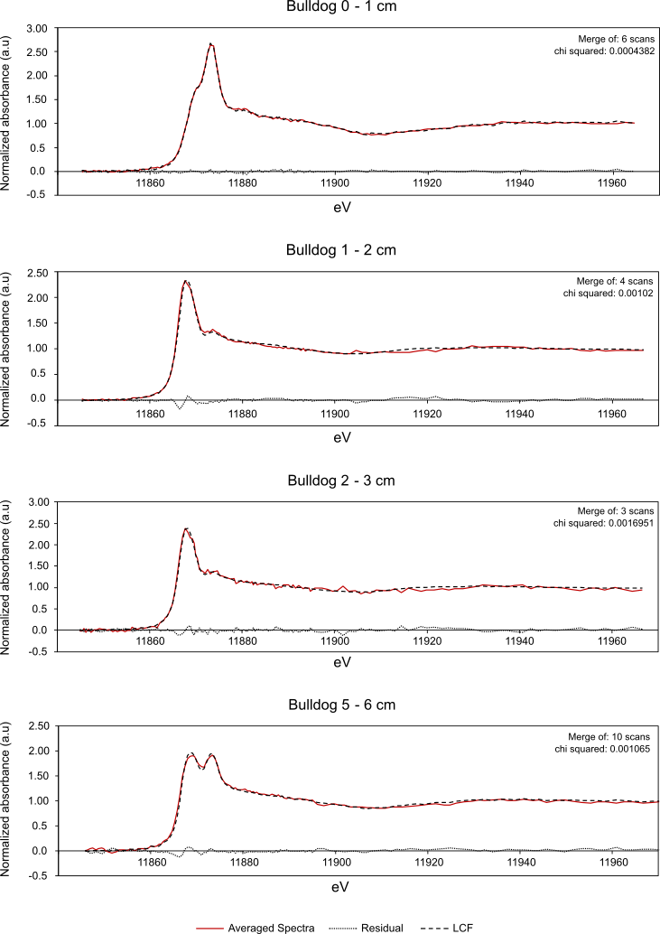
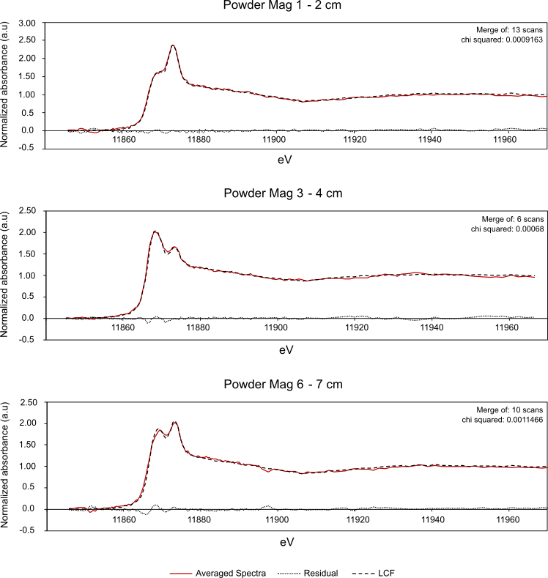

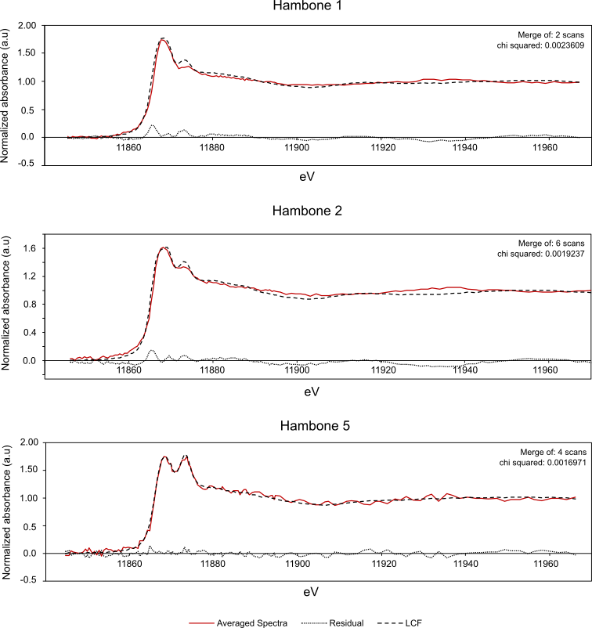

Figure SF2: Additional µXRF maps with corresponding µXRD spectra from Bulldog (a, b, c) and Hambone (d, e) lakes; (a) Qtz – quartz, Lep – lepidocrocite, Mgh – maghemite; (b) Gt – goethite, Mkw – mackinawite; (c) Tnt – titanite, Fh – ferrihydrite, Gt – goethite; (d) Gt – goethite; (e) Mkw – mackiniwite, Mgh – maghemite.
