Supplementary information
Characterizing groundwater salinity patterns in a coastal sand aquifer at Magilligan, Northern Ireland, using geophysical and geotechnical methods

Jesús F. Águila^{1*}, Mark C. McDonnell¹, Raymond Flynn¹, Gerard A. Hamill¹, Alastair Ruffell¹, Eric M. Benner¹, Georgios Etsias¹, Shane Donohue²
¹ School of Natural and Built Environment, Queen's University Belfast, Belfast, Northern Ireland, United Kingdom
² School of Civil Engineering, University College Dublin, Dublin, Ireland
*Corresponding author,
Email address: jesus.fdz.aguila@hotmail.com

This document includes additional figures that support the paper. Figure S1, Figure S2 and Figure S3 expand on the information presented in Figure 2 and Figure 3, while Figure S4 illustrates (as an example) the results obtained in one of the dissipation tests carried out with the Hydraulic Profiling Tool system in the study area.

Fig. S1 Sleeve friction resistance (top) and pore pressure ratio (bottom) measured in the seven CPT soundings. The data were projected on a vertical plane (cross-section) from south to north

Fig. S2 Soil Behaviour Type charts (Robertson et al., 1986) plotted from the data obtained in the CPT soundings T2 (a), T3 (b), T4 (c), T5 (d) and T6 (e). Responses in the uppermost 17 m-19 m suggest sand deposits, while deeper units are finer grained

Fig. S3 Soil Behaviour Type charts (Robertson et al., 1986) plotted from the data obtained in the CPT soundings T2 (a), T3 (b), T4 (c), T5 (d) and T6 (e). Responses in the uppermost 17 m-19 m suggest sand deposits, while deeper units are finer grained

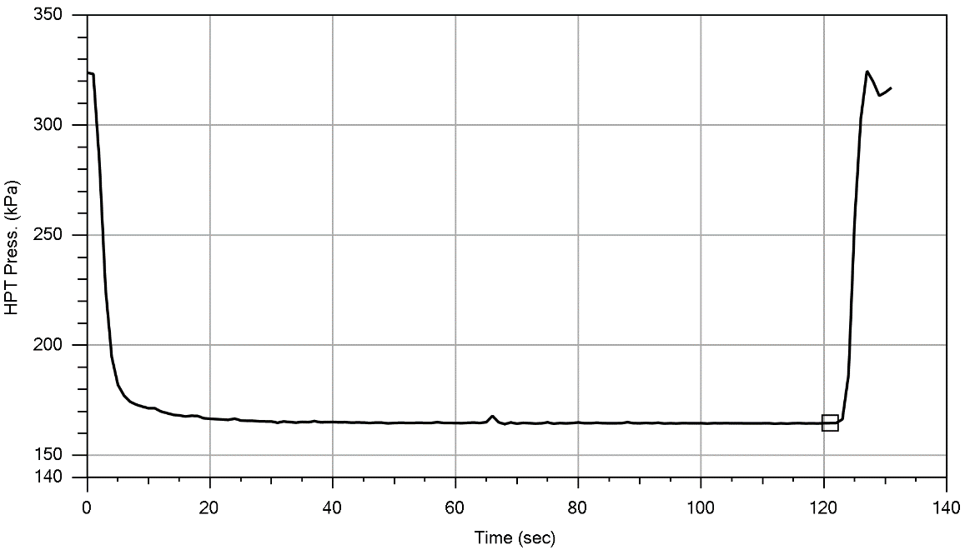
HPT flow turned on
HPT flow turned off
Stabilized formation pressure (hydrostatic)
Fig. S4 Dissipation test conducted at a depth of 5.9 m in the HPT sounding T6. Stabilized formation pressure is reached after about 120 s stopping the HPT flow

Fig. S5 Electrical conductivity of water samples collected at several distances from the origin of the ERT profile P6.

