Upscaling calcite dissolution rates in a tight reservoir sandstone
Sina Hale, Elisabete Trindade Pedrosa, Arne Jacob, Marcel Reinhardt, Frieder Enzmann, Michael Kersten, Christoph Butscher, Philipp Blum
Corresponding author: Sina Hale (sina.hale@kit.edu), Karlsruhe Institute of Technology (KIT), Institute of Applied Geosciences (AGW), Kaiserstr. 12, 76131 Karlsruhe, Germany
Supplementary Information related to the µm- to mm-scale
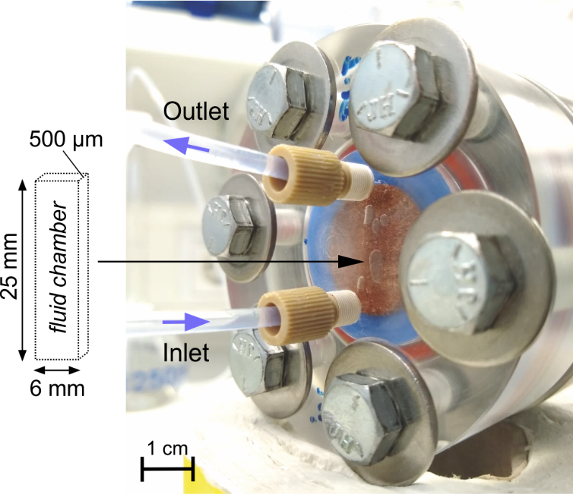
Fig. SI1 Photo of the closed micro-cell while running. The mounted sandstone sample slice (diameter 2.54 cm) was embedded in semi-transparent resin and polished. The fluid is circulating on top of the core sample slice through the fluid chamber (size indicated).
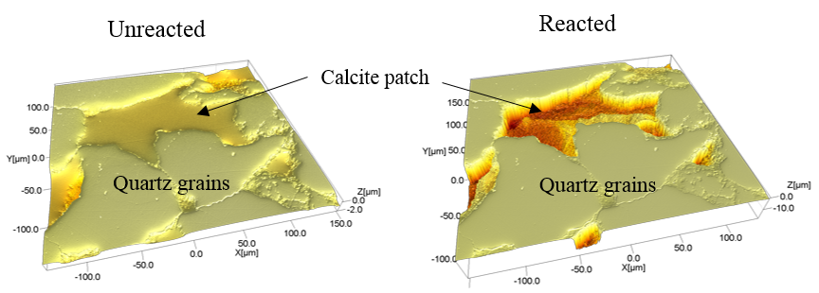
Fig. SI2 Example of the topography maps measured by vertical scanning interferometry (VSI), showing the retreat of a calcite patch located in between several quartz grains before and after a dissolution experiment.

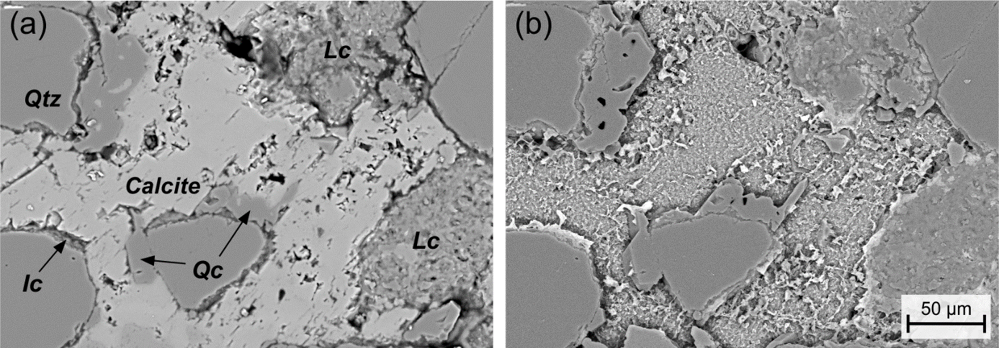
Fig. SI3 Backscattered electron images of (a) the unreacted sandstone sample surface showing the calcite cement surrounded by grains of quartz (Qtz), quartz cement (Qc), clay-rich lithoclasts (Lc) and illite coatings; (b) the same surface after 120 min reacted with the NaCl/HCl solution (pH 4.0).

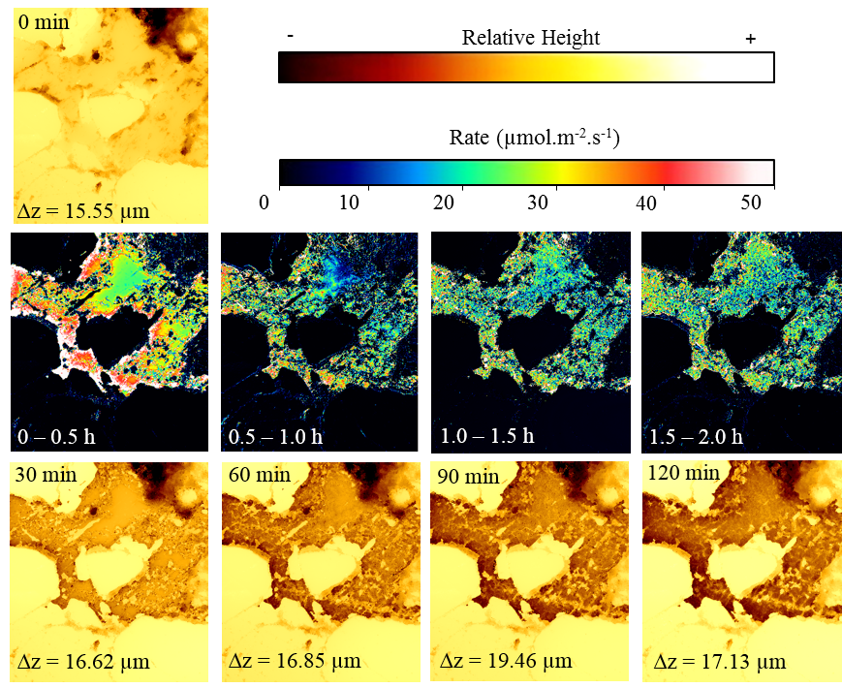
Fig. SI4 Surface topography and rate maps of calcite cement patch m1. Maps size is 267 × 296 µm².

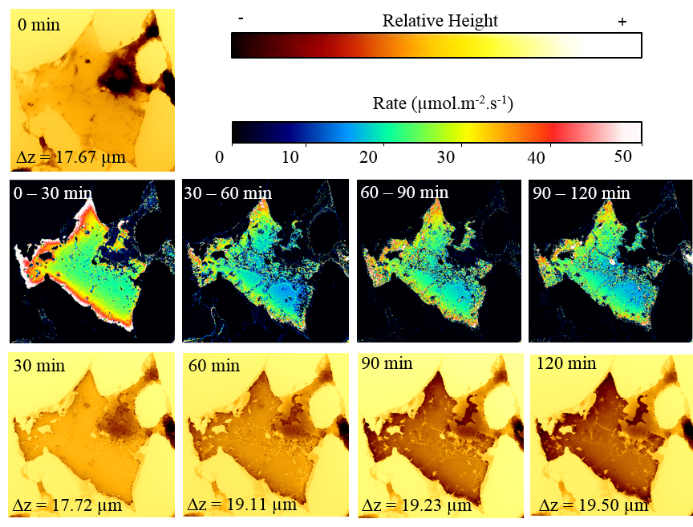
Fig. SI5 Surface topography and rate maps of calcite cement patch m2. Maps size is 283 × 281 µm².
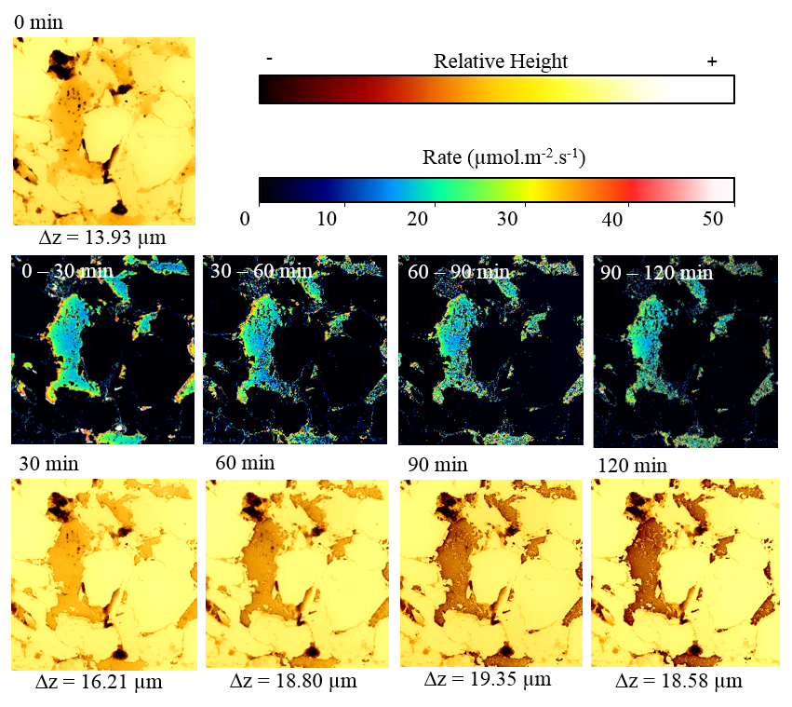
Fig. SI6 Surface topography and rate maps of calcite cement patch m3. Maps size is 720 × 740 µm².
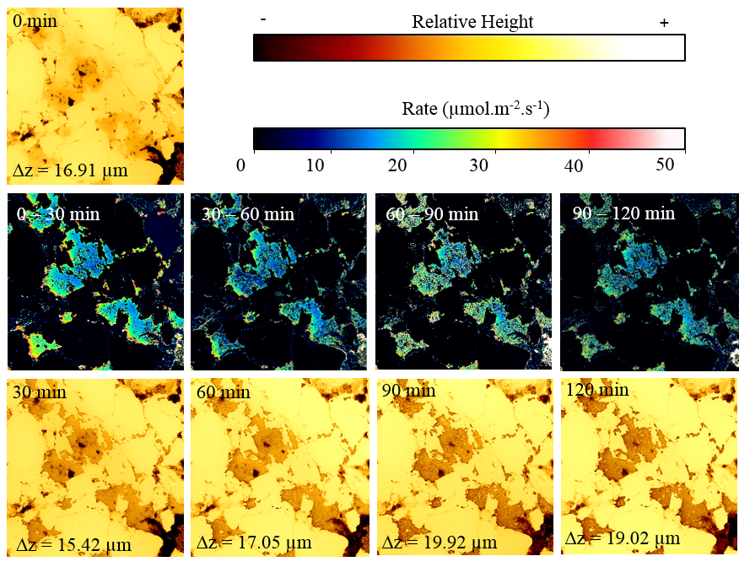
Fig. SI7 Surface topography and rate maps of calcite cement patch m4. Maps size is 282 × 268 µm².

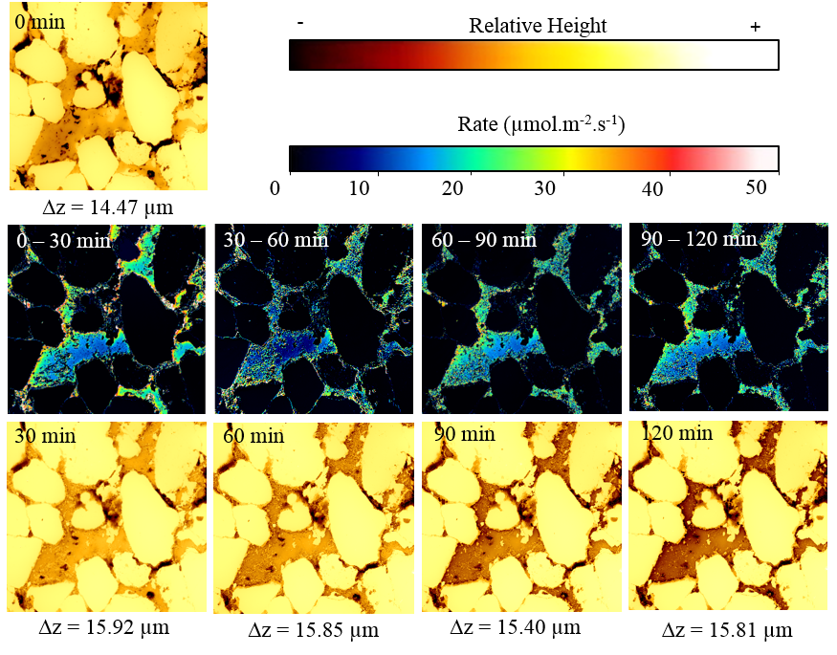
Fig. SI8 Surface topography and rate maps of calcite cement patch m5. Maps size is 282 × 268 µm².

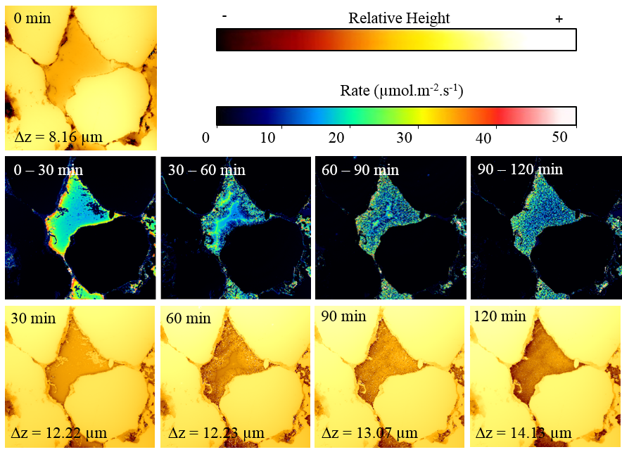
Fig. SI9 Surface topography and rate maps of calcite cement patch m6. Maps size is 754 × 718 µm².

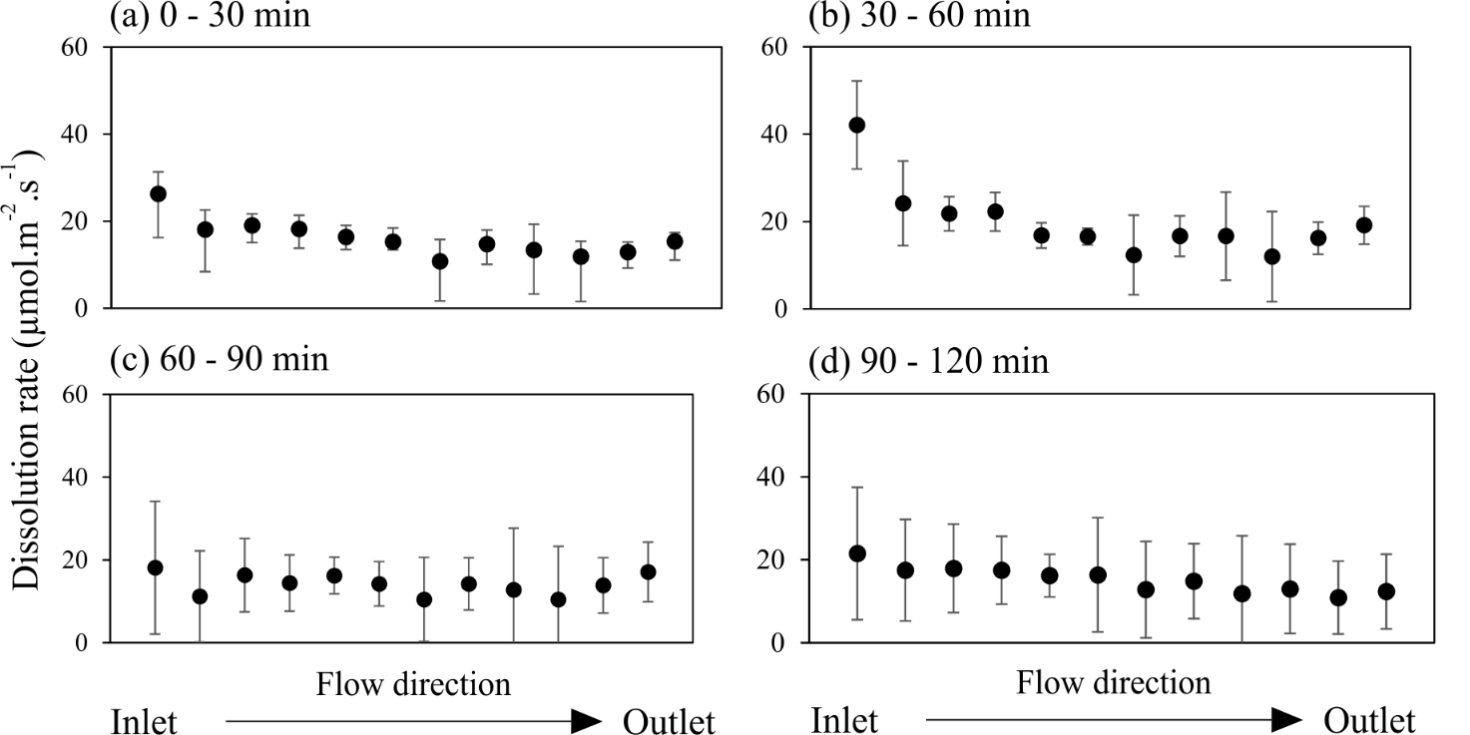
Fig. SI10 Average dissolution rate and standard deviation for all areas of interest within the investigated calcite cement patches, ordered by their relative position inside the fluid cell (cf. Fig. 3a).

Supplementary Information related to the cm-scale

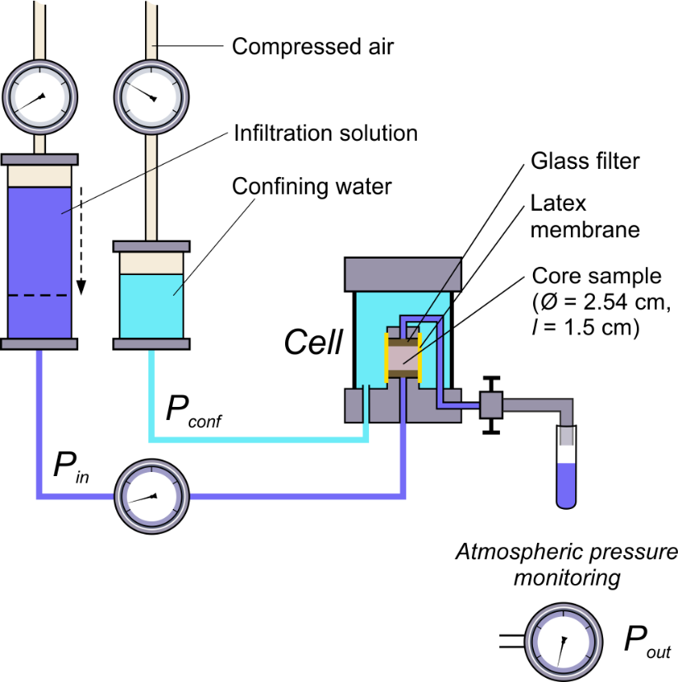
Fig. SI11 Setup of the flow-through experiment with the triaxial permeability cell under low differential pressure (< 0.5 bar) and ambient conditions.
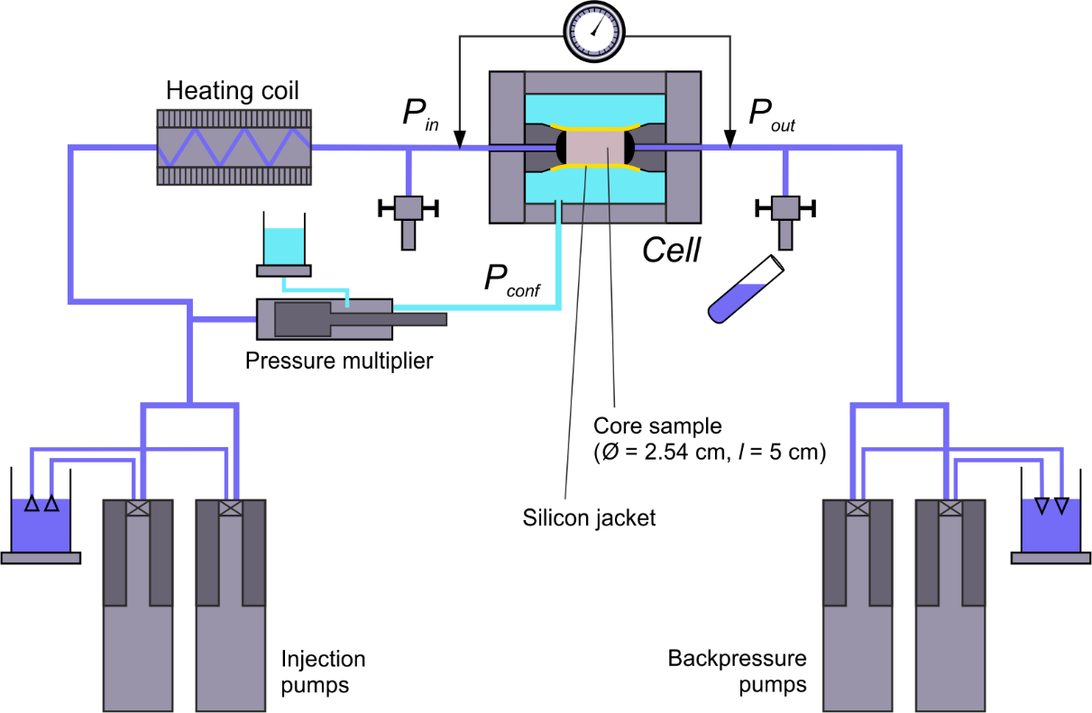
Fig. SI12 Flow-through autoclave ICARE4 for percolation experiments under elevated differential pressure (1 – 20 bar) and back pressure (> 50 bar).

In order to assess the relative significance of reaction and transport in the core experiments, a core-scale Damköhler number was determined analog to Salehikhoo et al. (2013) using the relation
$Da=\frac{τ_{adv}}{τ_{react}}=\frac{HRT ∙ r_{Cc, total}}{V_{P }∙ C_{Ca,eq}}$ ,
with $r_{Cc, total}$ the total calcite dissolution rate (in mol s⁻¹), $HRT$ the hydraulic residence time of the fluid, $V_{P}$ the pore volume of the sample, and $C_{Ca,eq}$ the calcium equilibrium concentration calculated with PHREEQC (1.8 × 10⁻⁴ mol L⁻¹). Essentially, the hydraulic residence time of the fluid is compared to the time required for the entire core to approach equilibrium. A low Damköhler number indicates that the reaction is slow in comparison to the fluid transport through the sample, whereas a high Damköhler number indicates a local equilibrium regime.
The Péclet number is also a dimensionless parameter and indicates the relative significance of advective and diffusive transport by
$Pe=\frac{Q∙L}{ϕ_{open}∙S∙D_{m}}$ .
Here, $Q$ denotes the volumetric flow rate, $ϕ_{open}$ the open porosity, $S$ the sample cross-section area, and $D_{m}$ the molecular diffusion coefficient of calcium (7.50 × 10⁻¹⁰ m² s⁻¹, Luquot and Gouze 2009). For the characteristic length $L$, the typical pore diameter of the sandstone (10⁻⁶ m) was used (cf. Jacob et al. 2021).

Table SI1 Calculated Péclet and Damköhler numbers and required experimental parameters.
Sample | $HRT$ [s] | $V_{P }$[L] | $r_{Cc, total}$ [mol s⁻¹] | $Q$ [m³ s⁻¹] | $ϕ_{open}$ [-] | $S$ [m²] | $Pe$ [-] | $Da$ [-]
E6 | 382 | 3.4 × 10⁻³ | 1.3 × 10⁻⁹ | 8.9 × 10⁻⁹ | 0.135 | 5.0 × 10⁻⁴ | 0.1754 | 0.83
F11 | 1848 | 9.1 × 10⁻⁵ | 1.9 × 10⁻¹¹ | 6.0 × 10⁻¹¹ | 0.011 | 5.2 × 10⁻⁴ | 0.0139 | 2.11
C14 | 17050 | 3.5 × 10⁻⁴ | 1.3 × 10⁻¹¹ | 2.1 × 10⁻¹¹ | 0.046 | 5.2 × 10⁻⁴ | 0.0012 | 3.66
G12 | 26845 | 6.4 × 10⁻⁴ | 1.7 × 10⁻¹¹ | 3.0 × 10⁻¹¹ | 0.081 | 5.2 × 10⁻⁴ | 0.0010 | 3.95
Micro-cell | 3.8 |  |  | 2.0 × 10⁻⁸ | 1.00 | 3.0 × 10⁻⁶ | 8.8889

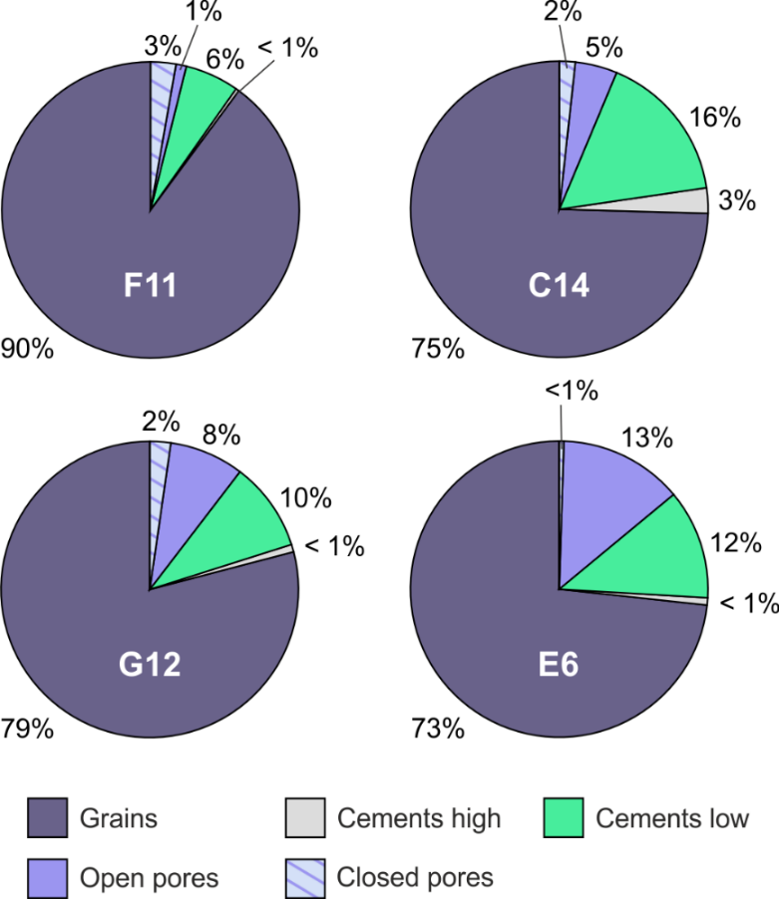
Figure SI13 Volumetric fractions of the phases identified by X-ray micro-computed tomography (µXCT) imaging of the different core plugs. The calcite cement of the sandstone is represented by the phase “Cements low”. The phase “Pores” is subdivided into open and closed pore space. The highly absorbing cement phase (“Cements high”) containes various mineral phases, e.g., barite, hematite and amorphous oxides.

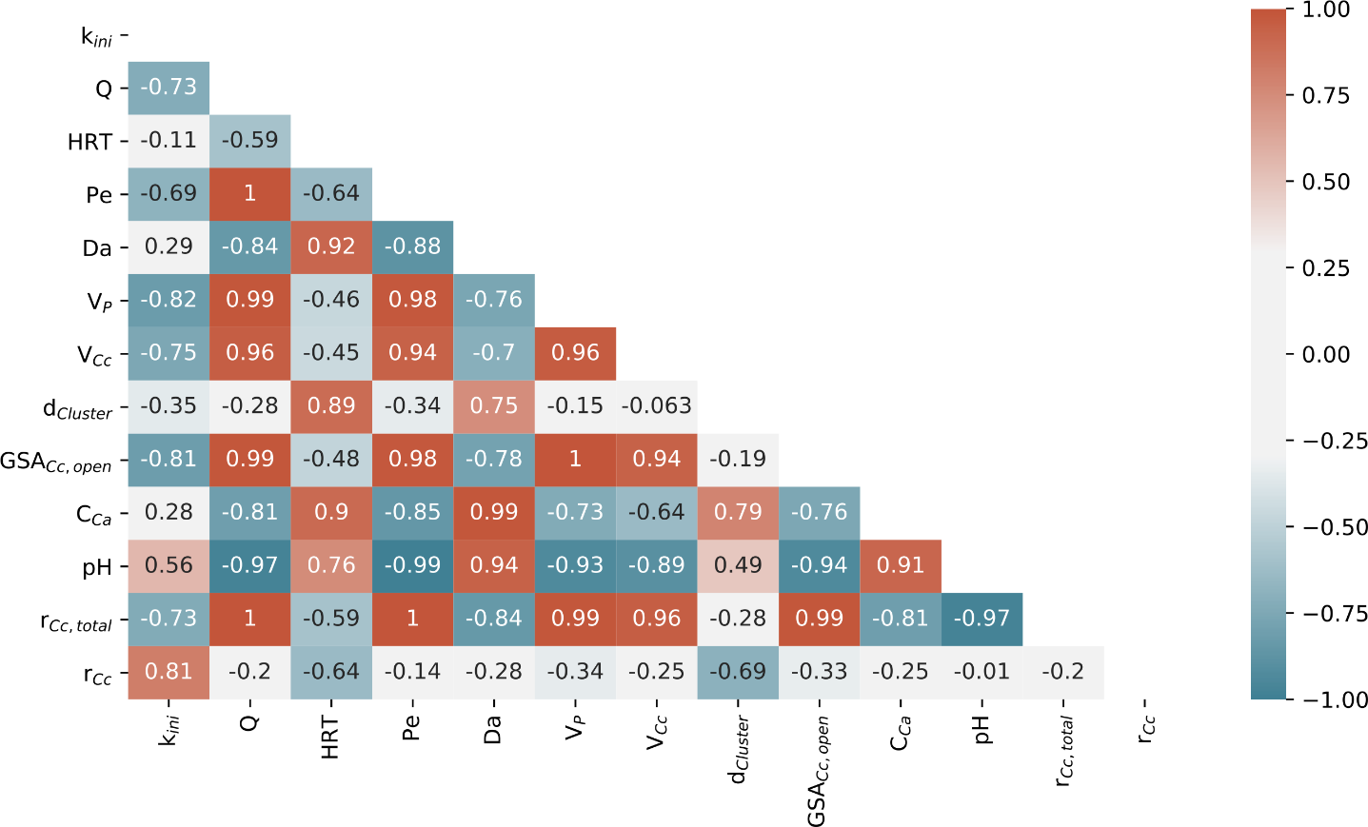
Figure SI14 Correlation matrix including thirteen different parameters related to the fluid transport conditions, the calcite cement accessibility and geometry, and the calcite dissolution kinetics in the flow-through experiments on the core-scale. The numbers specify the Pearson correlation coefficient between two variables (k_{ini} = initial sample permeability, Q = volumetric flow rate, HRT = hydraulic residence time, Pe = Péclet number, Da = Damköhler number, V_{P}= pore volume, V_{Cc} = calcite volume, d_{Cluster} = median calcite cluster diameter, GSA_{Cc,open} = geometric calcite surface area in contact to the open pore space, C_{Ca} = calcium concentration, pH = outlet pH, r_{Cc,total} = total dissolution rate, r_{Cc} = surface normalized dissolution rate).

References
Jacob A, Peltz M, Hale S, et al (2021) Simulating permeability reduction by clay mineral nanopores in a tight sandstone by combining computer X-ray microtomography and focussed ion beam scanning electron microscopy imaging. Solid Earth 12:1–14. https://doi.org/10.5194/se-12-1-2021
Luquot L, Gouze P (2009) Experimental determination of porosity and permeability changes induced by injection of CO2 into carbonate rocks. Chem Geol 265:148–159. https://doi.org/10.1016/j.chemgeo.2009.03.028
Salehikhoo F, Li L, Brantley SL (2013) Magnesite dissolution rates at different spatial scales: The role of mineral spatial distribution and flow velocity. Geochim Cosmochim Acta 108:91–106. https://doi.org/10.1016/j.gca.2013.01.010

