Seasonal spatial distribution, source identification and risk assessment of metals in sediments along the Alanya/Antalya coastline of the Mediterranean Sea
Erhan Cengiz¹ · Murat Şirin² · Cafer Mert Yeşilkanat³ · Gökhan Apaydın⁴

¹ Department of Fundamental Sciences, Rafet Kayış Engineering Faculty, Alanya Alaaddin Keykubat University, 07425 Alanya/Antalya, Turkey
² Department of Environmental Protection Technologies, Vocational School of Technical Sciences, Recep Tayyip Erdogan University, 53100 Rize, Turkey
³ Department of Mathematics and Science Education, Faculty of Education, Artvin Çoruh University, 08100 Artvin, Turkey
⁴ Department of Physics, Faculty of Science, Karadeniz Technical University, 61080 Trabzon, Turkey

Corresponding author: Tel/Fax: +90–242–5106120/+90–242–5106124
E-mail address: erhan.cengiz@alanya.edu.tr (E. Cengiz)
Orcid ID: https://orcid.org/0000-0002-4094-5784

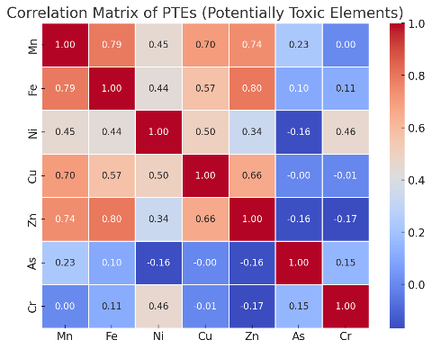
Fig. S1 PCC matrix of PTEs in the Alanya coasts of Mediterranean Sea

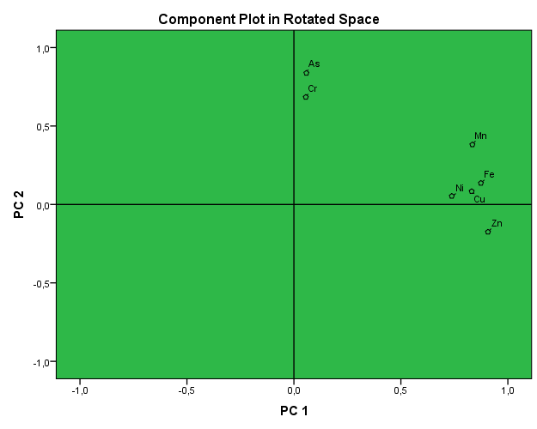
Fig. S2 PCA loading plots for rotated components of heavy metals in sediments

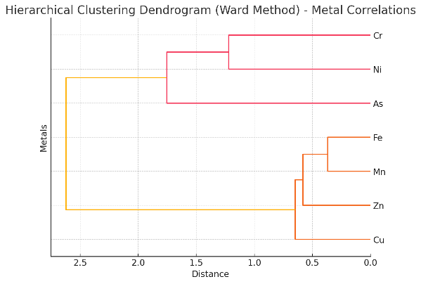
Fig. S3 HCA analysis of PTEs in the Alanya coasts of Mediterranean

Table S1 The geographical coordinates for the sampling locations
Station Code | Sampling locations | Latitude (degree) | Longitude (degree)
1 | Alara stream | 36.665163 | 31.646916
2 | Okurcular stream | 36.642592 | 31.703083
3 | Fuğla stream | 36.611119 | 31.775751
4 | Kargı stream | 36.596833 | 31.807279
5 | Koca stream | 36.558845 | 31.950700
6 | Gümüş stream | 36.542951 | 32.007175
7 | Hacet stream | 36.539959 | 32.023084
8 | Hacet stream | 36.535245 | 32.032284
9 | Dim stream | 36.521218 | 32.054027
10 | Mahmutlar stream | 36.491554 | 32.089456
11 | Sedre stream | 36.412614 | 32.168852

Table S2 Comparison of the certified and the measured values (mg/kg dry weight) for the sediment (NW–WQB–1) certified reference material (CRM)
Elements | Lake Ontario sediment
Elements | Certified values | Measured values | Percentage of recovery (%)
Mn | 2240 (1847–2633) | 2265 | 101.1
Ni | 57.6 (47.6–67.6) | 59.6 | 103.5
Fe | 43200 (33700–52700) | 43100 | 99.8
Cu | 74.0 (62.1–85.9) | 76.4 | 103.2
Zn | 258 (208–308) | 262 | 101.6
Cr | 46.8 (35.2–58.4) | 49.2 | 105.1
As | 23 (21.16–24.84) | 22.8 | 99.1

Table S3 Pollution and ecological risk assessment indices used in this study
Indices | Equations | Explanations | Contamination or risk degree
Enrichment factor (EF) | $$EF={\left[\frac{Ci}{Cref}\right]sample}/{\left[\frac{Ci}{Cref}\right]background}$$ | C_{i} is the content of element (i); C_{ref} is the content of reference element (Fe) for geochemical normalization (Varol et al., 2022; Akoto and Anning 2021). | EF < 2 →Minimal enrichment  2≤ EF <5 →Moderate enrichment  5 ≤ EF < 20 → Significant enrichment  20 ≤ EF < 40 → Very high enrichment  EF≥ 40 →Extremely high enrichment
Geo–accumulation index (Igeo) | $${\left(I_{geo}\right)}_{n}=\log_{2}\left(\frac{C_{n}}{1.5×B_{n}}\right)$$ | C_{n} and B_{n} are concentration of the nth heavy metal, and background value of the nth heavy metal in the Earth’s crust, respectively (Akoto and Anning 2021; Muller 1969; Kusin et al. 2018). | Igeo ≤ 0→ Unpolluted  0 < Igeo < 1→ Unpolluted to moderately contaminated  1 < Igeo < 2→ Moderately polluted  2 < Igeo < 3→ Moderately to seriously polluted  3 < Igeo < 4→ Seriously polluted  4 < Igeo < 5→ Seriously to excessively polluted  5< Igeo → Excessively polluted
Contamination factor (Cf) | $$C_{f}^{i}=\frac{C^{i}}{C_{n}^{i}}$$ | C_{n}^{i} is pre-industrial value of element (i); C^{i} is the content of element (i) (Hakanson, 1980; Gope et al. 2017). | Cf < 1 →Minimal contamination  1 < Cf < 3 →Moderate contamination  3 < Cf < 6 →Substantial contamination  Cf ≥ 6 →Very high contamination
Modified degree of contamination (mC_{d}) | $$mC_{d}=\frac{\sum_{i=1}^{i=n}{C_{f}}}{n}$$ | C_{f} is the contamination factor value of each element; n is the number of elements (Hakanson 1980; Gope et al. 2017). | mCd＜1.5→Very low  1.5 <mCd＜2 →Low  2 <mCd＜4→Moderate  4 <mCd＜8→High  8 <mCd＜16→ Very high  16 <mCd＜32→ Extremely high  32 <mCd →Ultra high
Pollution load index (PLI) | $$PLI=\left(Cf1×Cf2×…×Cfn\right)1/n$$  $${\left(PLI\right)}_{zone}=\sqrt[m]{{\left(PLI\right)}_{1}×{\left(PLI\right)}_{2}×{\left(PLI\right)}_{3}×⋯×{\left(PLI\right)}_{m}}$$ | C_{f} is the contamination factor value of each element; n is the number of elements (Tomlinson et al. 1980; Men et al. 2018; Hoang et al., 2021). | PLI=PLI_{zone} = 0 →No contamination  0 < PLI=PLI_{zone} < 1 →Baseline contamination  PLI=PLI_{zone} > 1 →High contamination
Ecological risk factor (E_{r}) | $$E_{r}^{i}=T_{r}^{i}×C_{f}^{i}$$ | T_{r}^{i} is the toxicity response coefficient of element (i), they are 1, 5, 5, 1, 2 and 10 for Mn, Ni, Cu, Zn, Cr and As, respectively. C_{f}^{i} is the contamination factor of element (i) (Hakanson, 1980; Wu et al. 2019a). | E_{r} < 15 →Low potential ecological risk  15 ≤ E_{r} < 30 →Moderate potential ecological risk  30 ≤ E_{r} < 60 →Considerable potential ecological risk  60 ≤ E_{r} < 120 →High potential ecological risk  E_{r} ≥ 120 →Very high potential ecological risk
Potential ecological risk index (PERI) | $$PERI=\sum_{i=1}^{n}{E_{r}^{i} }$$ | E_{r}^{i} is the ecological risk factor of element (i); n i the number of studied elements (Hakanson, 1980; Wu et al. 2019a). | RI < 50 →Low ecological risk  50 ≤ RI < 100 →Moderate ecological risk  100 ≤ RI < 200 →Considerable ecological risk  RI ≥ 200 →Very high ecological risk

Table S4 Exposure indices of human health risk assessment
Indices | Unit | Definition | Adults
C | mg/kg | Concentration of metal of interest in the soil | –
IR_{ing} | (mg/d) | Ingestion rate | 100
CF |  | Conversion factor | 0.000001
EF | (d/yr) | Exposure frequency | 350
ED | (yr) | Exposure duration | 30
SA | cm² | Exposed area through dermal contact | 5700
AF | mg/cm²/d | Adhesion factor of the skin | 0.07
CF | kg/mg | Conversion coefficient | 10⁻⁶
ABS | – | Dermal absorption factor | 0.001
BW | kg | Average body weight | 70
AT | d | Average exposure time | 10500

Table S5 The RfD for non–carcinogenic metals and SF for carcinogenic metals
 | RfD |  |  | SF
Elements | Ingest | Dermal |  | Ingest | Dermal
Mn | 1.40E-01 | 1.84E-03
Fe | 7.00E-01 | 1.40E-01
Cr | 3.00E-03 | 6.00E-05 |  | 0.50E+00 | 20.0E+00
Ni | 2.00E-02 | 5.40E-03 |  | 0.91E+00 | 42.50E+00
Cu | 4.00E-02 | 1.20E-02 |  | – | –
Zn | 3.00E-01 | 7.50E-02 |  | – | –
As | 3.00E-04 | 1.23E-04 |  | 1.50E+00 | 3.66E+00

Table S6 Comparison of heavy metal concentrations (mg/kg) in sediments with the previous studies
Study Area | Mn | Fe | Ni | Cu | Zn | Cr | As | References
Turkey  (Eastern Black Sea Coast) | 399 | ‒ | 13.8 | 31.8 | 70.2 | 18.5 | 22.2 | (Alkan et al. 2015)
Egyptian  (Mediterranean coast) | 381 | 13,256 | 25.93 | 8.46 | 22.19 | 82.74 | 13.17 | (Soliman et al. 2015)
Turkey  (Eastern Black Sea Coast) | ‒ | ‒ | ‒ | 576.31 | 357.02 | – | 97.33 | (Baltas et al. 2017)
Iranian  (Caspian Sea) | ‒ | ‒ | 16.6 | 16.8 | 29.5 | 17.9 | 7.4 | (Gholizadeh and Patimar 2018)
Egyptian  (Red sea) | 198.76 | 8,451.62 | 17.52 | 9.43 | 44.15 | – | 11.43 | (Nour et al. 2019)
Turkey  (Eastern Black Sea Coast) | 446.9 | ‒ | 23.4 | 3107.3 | 4259.5 | 40.2 | 208.2 | (Alkan et al. 2020)
Saudi Arabia  (Red sea) | 184 | 3,374 | 14 | 30 | 24 | 39 | 6.6 | (El-Sorogy et al. 2020)
Turkey  (Middle and Eastern Black Sea Coast) | 565.38 | 46,000 | 34.38 | 104.06 | 109.88 | 87.31 | 32.31 | (Apaydın et al. 2022)
Turkey  (Eastern Mediterranean coast–Antalya Gulf) | 671.02 |  | 108.59 | 37.72 | 77.23 | 891.88 | 30.77 | (Yalçın et al., 2023)
Turkey  (Alanya coast of the Mediterranean) | 281.00 | 14,275.47 | 30.06 | 34.39 | 66.23 | 59.56 | 11.66 | Present study

References
Hakanson, L. (1980). An ecological risk index for aquatic pollution control. A sedimentological approach. Water research, 14(8), 975–1001.
Gope, M., Masto, R. E., George, J., Hoque, R. R., & Balachandran, S. (2017). Bioavailability and health risk of some potentially toxic elements (Cd, Cu, Pb and Zn) in street dust of Asansol, India. Ecotoxicology and Environmental Safety, 138, 231–241.
Varol, M., Ustaoglu, F., Tokatlı C., 2022. Ecological risks and controlling factors of trace elements in sediments of dam lakes in the Black Sea Region (Turkey). Environ. Res. 205, 112478.
Akoto, R., & Anning, A. K. (2021). Heavy metal enrichment and potential ecological risks from different solid mine wastes at a mine site in Ghana. Environmental Advances, 3, 100028.
Muller, G. (1969). Index of geoaccumulation in sediments of the Rhine River. Geojournal, 2, 108–118.
Kusin, F. M., Azani, N. N. M., Hasan, S. N. M. S., & Sulong, N. A. (2018). Distribution of heavy metals and metalloid in surface sediments of heavily-mined area for bauxite ore in Pengerang, Malaysia and associated risk assessment. Catena, 165, 454–464.
Wu, H., Yang, F., Li, H., Li, Q., Zhang, F., Ba, Y., Cui, L., Sun, L., Lv, T., & Wang, N. (2019). Heavy metal pollution and health risk assessment of agricultural soil near a smelter in an industrial city in China. International journal of environmental health research, 1–13.
Tomlinson, D. L., Wilson, J. G., Harris, C. R., & Jeffrey, D. W. (1980). Problems in the assessment of heavy-metal levels in estuaries and the formation of a pollution index. Helgoländer meeresuntersuchungen, 33(1), 566.
Men, C., Liu, R., Wang, Q., Guo, L., & Shen, Z. (2018). The impact of seasonal varied human activity on characteristics and sources of heavy metals in metropolitan road dusts. Science of the total Environment, 637, 844–854.
Hoang, H.G., Lin, C., Chiang, C.F., Bui, X.T., Lukkhasorn, W., Bui, T.P.T., Tran, H.T., Vo, T.D.H., Le, V.G., Nghiem, L.D., 2021. The Individual and Synergistic Indexes for Assessments of Heavy Metal Contamination in Global Rivers and Risk: a Review. Curr. Pollut. Rep. 7, 247-262.

