Table S1. GWQI weight values of physicochemical parameters and classification of results (Adimalla and Taloor, 2020; Şener et al. 2021)
Parameters | GWQI weight value |  | Classification
Parameters | Weight (wi) | Relative weight (Wi) | GWQI | Type of water (Sahu and Sikdar 2008)
pH | 4 | 0,0889 | < 50 | Excellent water
TDS | 5 | 0,1111 | 50–100.1 | Good water
Ca | 3 | 0,0667 | 100–200.1 | Poor water
Mg | 3 | 0,0667 | 200–300.1 | Very poor water
Na | 4 | 0,0889 | > 300 | Water unsuitable for drinking purposes
SO₄ | 4 | 0,0889
Cl | 4 | 0,0889
NO₃ | 5 | 0,1111
Pb_{T} | 5 | 0,1111
Fe_{T} | 3 | 0,0667
As_{T} | 5 | 0,1111
Valid N (listwise) | ∑wi= 45 | ∑wi= 1

Table S2. Reference doses and slope factors of NO₃ and As with default values for drinking water (USEPA 2001; IRIS 2005; USEPA 2005)
 | As |  | NO₃
 | Adult | Child | Adult | Child
IR (l/day) | 2 | 1 | 2 | 1
ED (years) | 30 | 6 | 30 | 6
EF days/years-oral | 365 | 365 | 365 | 365
EF days/years-dermal | 350 | 350 | 350 | 350
BW (kg) | 70 | 15 | 70 | 15
^{AT (days)} | 10950 | 2190 | 10950 | 2190
*RfDoral (mg/kg/d) | 0.0003 | 0.0003 | 1.6 | 1.6
CSForal (mg/kg/d)⁻¹ | 1.5 | 1.5
*RfDdermal (mg/kg/d) | 0.00012 | 0.00012 | 0.8 | 0.8
CSFdermal (mg/kg/d)⁻¹ | 3.66 | 3.66
Kp (cm/h) | 0.001 | 0.001 | 0.001 | 0.001
SA (cm²) | 18000 | 6600 | 18000 | 6600
ET (s/day) | 2.6 | 1 | 2.6 | 1

Table S3. HQ _{noncancer} and HI values for NO₃ and As (adult)
Sample Number | As / adult |  |  | NO₃ / adult |  |  | HI / adult
Sample Number | HQ noncancer-oral | HQ noncancer-dermal | HQ _{noncancer}-total | HQ noncancer-oral | HQ noncancer-dermal | HQ _{noncancer}-total | HI / adult
N1 | 2.9143 | 0.1635 | 3.0778 | 0.9096 | 0.0408 | 0.9505 | 4.0282
N2 | 3.6667 | 0.2057 | 3.8724 | 1.0480 | 0.0470 | 1.0951 | 4.9674
N3 | 4.5810 | 0.2570 | 4.8379 | 1.1566 | 0.0519 | 1.2085 | 6.0464
N4 | 3.9619 | 0.2222 | 4.1842 | 1.8645 | 0.0837 | 1.9481 | 6.1323
N5 | 6.1429 | 0.3446 | 6.4874 | 0.7466 | 0.0335 | 0.7801 | 7.2676
N6 | 4.0952 | 0.2297 | 4.3250 | 0.4186 | 0.0188 | 0.4374 | 4.7623
N7 | 4.2381 | 0.2377 | 4.4758 | 0.6593 | 0.0296 | 0.6889 | 5.1647
N8 | 4.5429 | 0.2548 | 4.7977 | 0.6445 | 0.0289 | 0.6734 | 5.4711
N9 | 5.2152 | 0.2926 | 5.5078 | 0.9170 | 0.0412 | 0.9581 | 6.4659
N10 | 4.7619 | 0.2671 | 5.0290 | 0.8238 | 0.0370 | 0.8607 | 5.8897
N11 | 4.9429 | 0.2773 | 5.2201 | 0.6638 | 0.0298 | 0.6935 | 5.9137
N12 | 5.6581 | 0.3174 | 5.9755 | 0.8671 | 0.0389 | 0.9061 | 6.8815
N13 | 6.0571 | 0.3398 | 6.3969 | 0.1954 | 0.0088 | 0.2041 | 6.6010
N14 | 6.4619 | 0.3625 | 6.8244 | 0.4538 | 0.0204 | 0.4741 | 7.2985

Table S4. HQ _{noncancer} and HI values for NO₃ and As (child)
Sample Number | As / child |  |  | NO₃ / child |  |  | HI / child
Sample Number | HQ noncancer-oral | HQ noncancer-dermal | HQ _{noncancer}-total | HQ noncancer-oral | HQ noncancer-dermal | HQ _{noncancer}-total | HI / child
N1 | 6.8000 | 0.1076 | 6.9076 | 2.1225 | 0.00002 | 2.1225 | 9.0301
N2 | 8.5556 | 0.1354 | 8.6909 | 2.4454 | 0.00002 | 2.4454 | 11.1364
N3 | 10.6889 | 0.1691 | 10.8580 | 2.6988 | 0.00003 | 2.6988 | 13.5568
N4 | 9.2444 | 0.1463 | 9.3907 | 4.3504 | 0.00002 | 4.3504 | 13.7411
N5 | 14.3333 | 0.2268 | 14.5601 | 1.7421 | 0.00003 | 1.7421 | 16.3022
N6 | 9.5556 | 0.1512 | 9.7067 | 0.9767 | 0.00002 | 0.9767 | 10.6834
N7 | 9.8889 | 0.1565 | 10.0454 | 1.5383 | 0.00002 | 1.5384 | 11.5837
N8 | 10.6000 | 0.1677 | 10.7677 | 1.5038 | 0.00003 | 1.5038 | 12.2715
N9 | 12.1689 | 0.1925 | 12.3614 | 2.1396 | 0.00003 | 2.1396 | 14.5010
N10 | 11.1111 | 0.1758 | 11.2869 | 1.9221 | 0.00003 | 1.9221 | 13.2090
N11 | 11.5333 | 0.1825 | 11.7158 | 1.5488 | 0.00003 | 1.5488 | 13.2646
N12 | 13.2022 | 0.2089 | 13.4111 | 2.0233 | 0.00003 | 2.0234 | 15.4345
N13 | 14.1333 | 0.2236 | 14.3569 | 0.4558 | 0.00003 | 0.4559 | 14.8128
N14 | 15.0778 | 0.2386 | 15.3163 | 1.0588 | 0.00004 | 1.0588 | 16.3751

Table S5. R_{cancer} values for As
Sample Number | Arsenic
Sample Number | Adult |  | Child
Sample Number | R_{cancer} - oral ingestion | R_{cancer} - dermal | R_{cancer} - oral ingestion | R_{cancer} - dermal
N1 | 0.001311 | 0.000072 | 0.003060 | 0.000047
N2 | 0.001650 | 0.000090 | 0.003850 | 0.000059
N3 | 0.002061 | 0.000113 | 0.004810 | 0.000074
N4 | 0.001783 | 0.000098 | 0.004160 | 0.000064
N5 | 0.002764 | 0.000151 | 0.006450 | 0.000100
N6 | 0.001843 | 0.000101 | 0.004300 | 0.000066
N7 | 0.001907 | 0.000104 | 0.004450 | 0.000069
N8 | 0.002044 | 0.000112 | 0.004770 | 0.000074
N9 | 0.002347 | 0.000128 | 0.005476 | 0.000085
N10 | 0.002143 | 0.000117 | 0.005000 | 0.000077
N11 | 0.002224 | 0.000122 | 0.005190 | 0.000080
N12 | 0.002546 | 0.000139 | 0.005941 | 0.000092
N13 | 0.002726 | 0.000149 | 0.006360 | 0.000098
N14 | 0.002908 | 0.000159 | 0.006785 | 0.000105

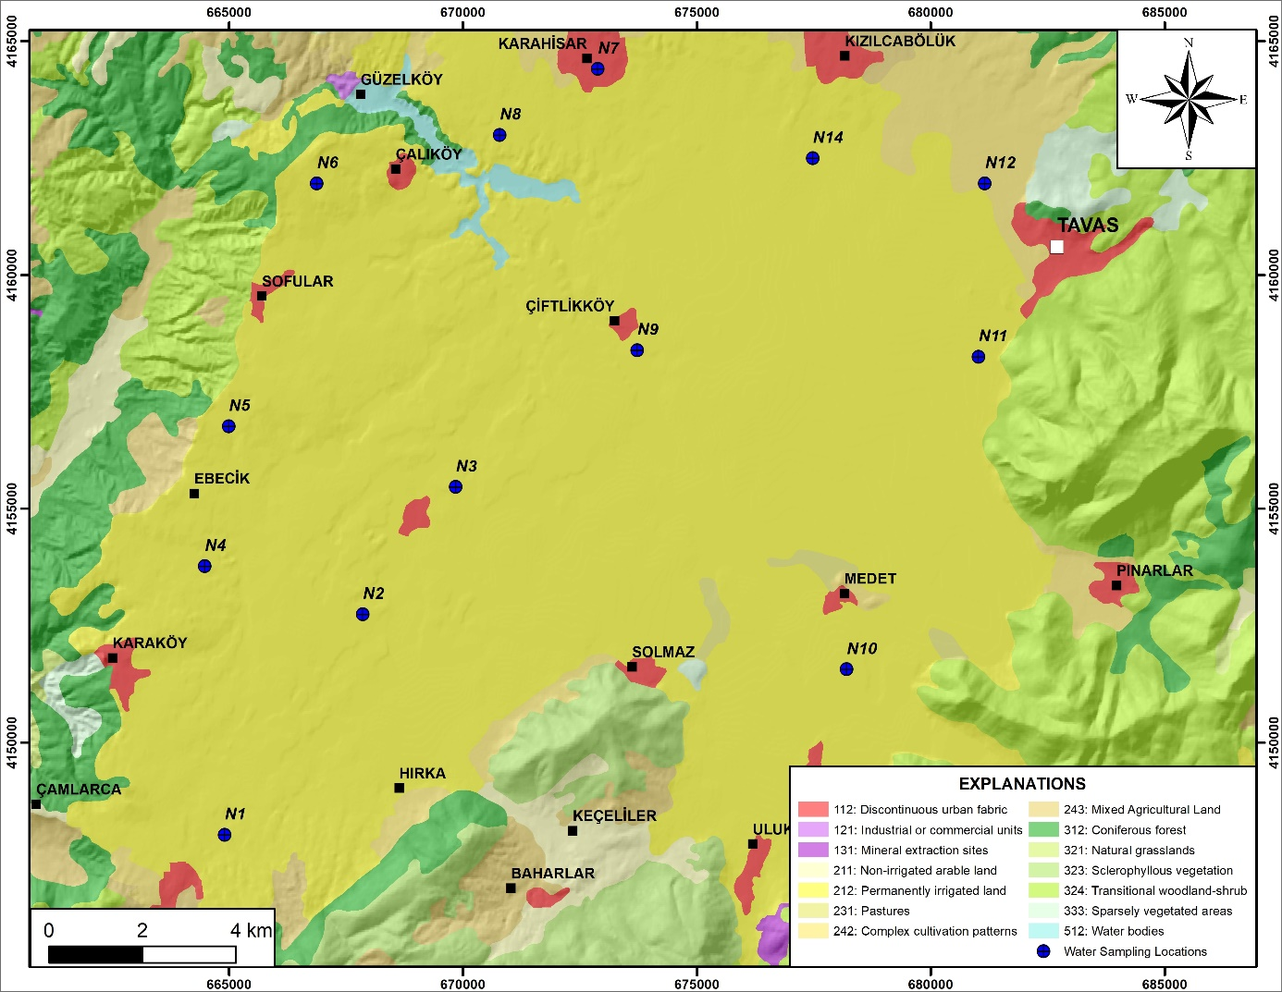
Fig. S1. Land use map of the study area

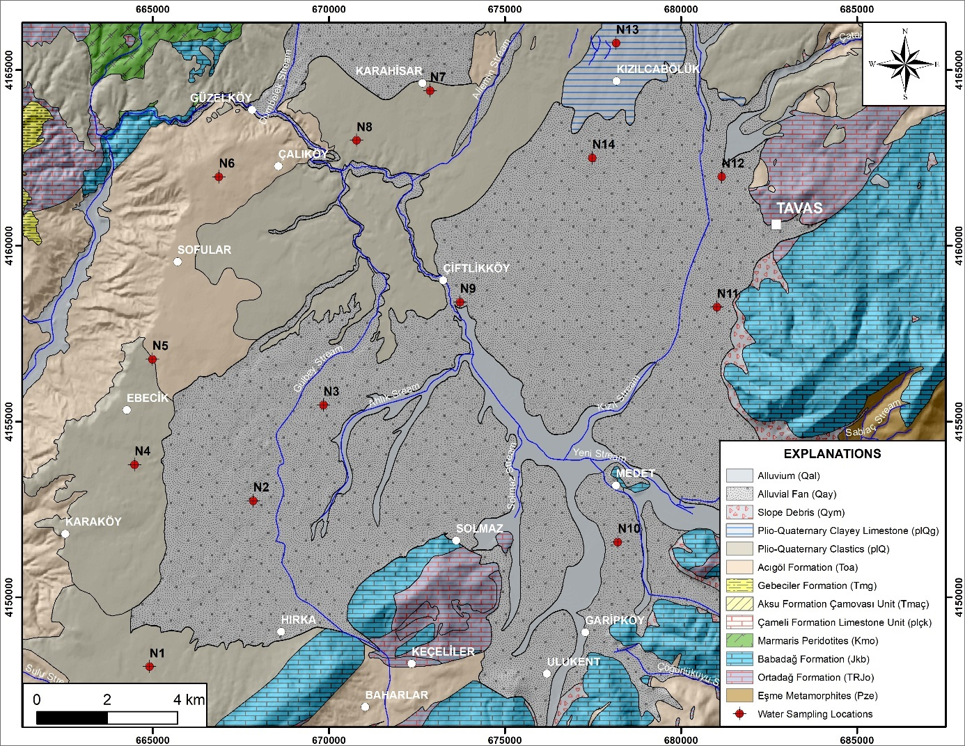

Fig. S2. Geological map of the study area
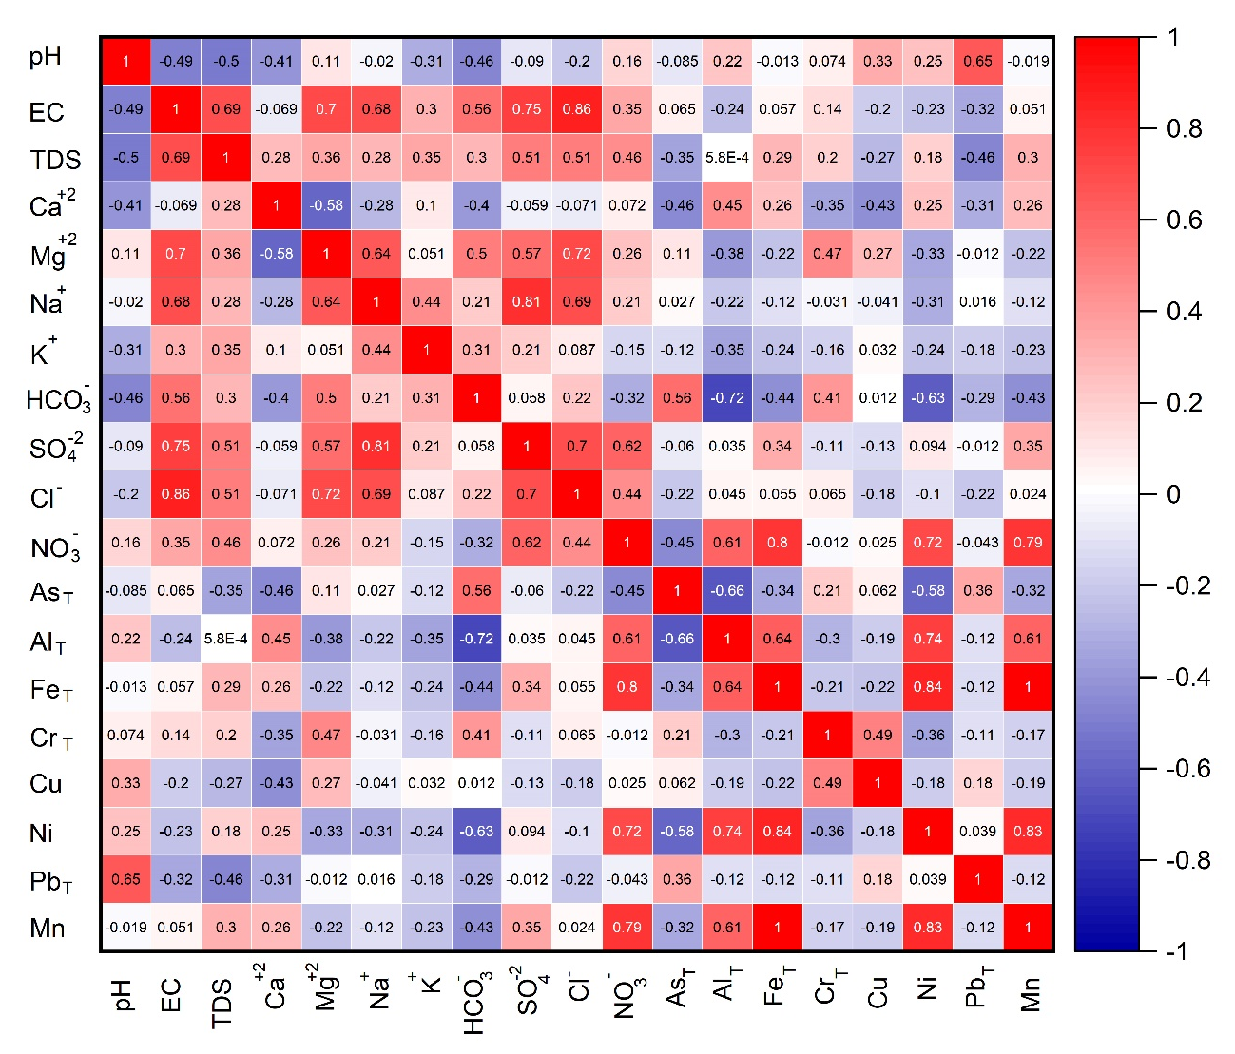
Fig. S3. Pearson correlation among the various physicochemical parameters of groundwater
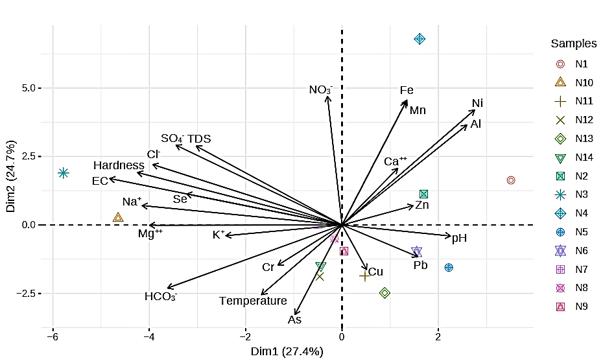
Fig S4. Principal component analysis (PCA) biplot of groundwater quality parameters

