Moisture–Dependent Evolution of NMR–Derived Pore Structure in Saline and Non–Saline Soils during Freeze–Thaw Cycles
Environmental Earth Sciences
Yipeng Qiuª, Zhiqi Guª , Siyu Nie^{a,c,*}, Yuanchun Zou^{b}
ª School of Water Conservancy Engineering, Changchun Institute of Technology, Changchun 130012, China
^{b} State Key Laboratory of Black Soils Conservation and Utilization & Heilongjiang Xingkai Lake Wetland Ecosystem National Observation and Research Station & Key Laboratory of Wetland Ecology and Environment & Jilin Provincial Joint Key Laboratory of Changbai Mountain Wetlandand Ecology, Northeast Institute of Geography and Agroecology, Chinese Academy of Sciences, Changchun 130102, China
^{c} Northeast Institute of Geography and Agroecology, Chinese Academy of Sciences, Changchun 130102, China
Corresponding author: Siyu Nie
E–mail: niesiyu@ccit.edu.cn

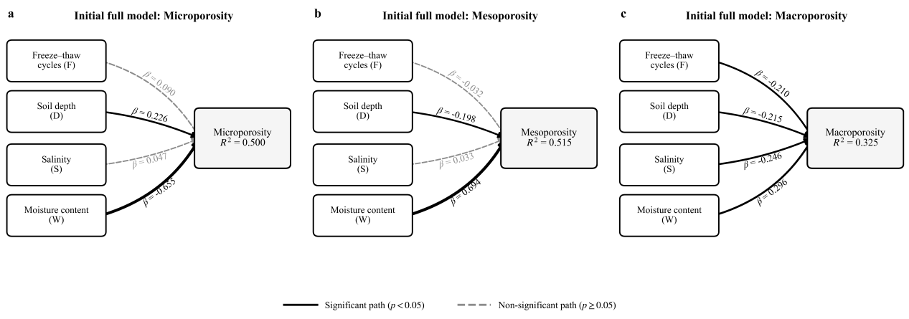
Fig. S1 Initial full SEM-based path models showing the associations of freeze–thaw cycle number (F), soil depth (D), salinity (S), and moisture content (W) with (a) microporosity, (b) mesoporosity, and (c) macroporosity. Values beside the arrows indicate standardized path coefficients (β). Solid arrows represent statistically significant paths (p < 0.05), whereas dashed arrows represent non-significant paths (p ≥ 0.05). R² indicates the proportion of variance explained by each model.

