Long-term spatiotemporal assessment of stable isotopic composition of precipitation across South Korea (2019–2023)

Sang-Ho Moon^{a,†}, Yongcheol Kim^{b}, Hee Sun Moon^{a,c*}, Hyoung Chan Kimª, and Jaehoon Jung^{b}

ªGroundwater Environment Research Center, Geo-Environment Research Division, KIGAM (Korea Institute of Geoscience and Mineral Resources), Daejeon 34132, Korea
^{b}Groundwater Resources Research Center, Geo-Environment Research Division, Korea Institute of Geoscience and Mineral Resources, Daejeon 34132, Korea
c Department of Geological Sciences, Korea University of Science and Technology, Daejeon 34113, Republic of Korea

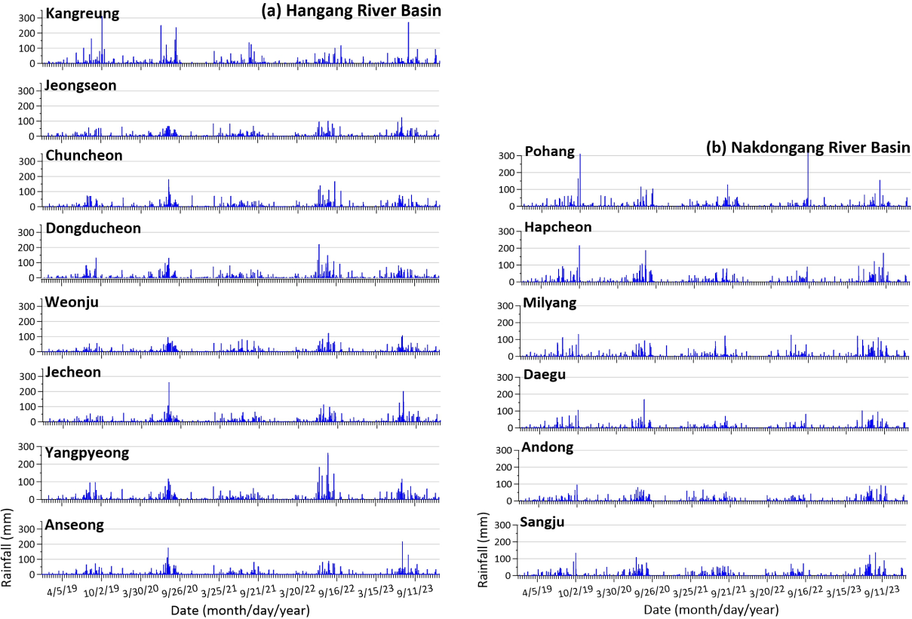
SFig. 1. Precipitation events in (a) Hangang and (b) Nakdonggang River basins of South Korea from 2019 to 2023.

