Supplementary Material

Table 1: list of in-house potential probiotic cultures collected for synthesis of silver nanoparticles
Name | Accession number | Food Source
Lactobacillus pentosus S6 | KU92122 | Siddu
Lactobacillus plantarum F22, | KT865223 | Chhang
Lactobacillus crustorum F11 | KT865221 | Human milk
Lactobacillus paraplantarum KM1 | KX671558 | Milk
Source: Microbiology research laboratory, Deptt. Of Basic Sciences, UHF Nauni, Solan, H.P, India

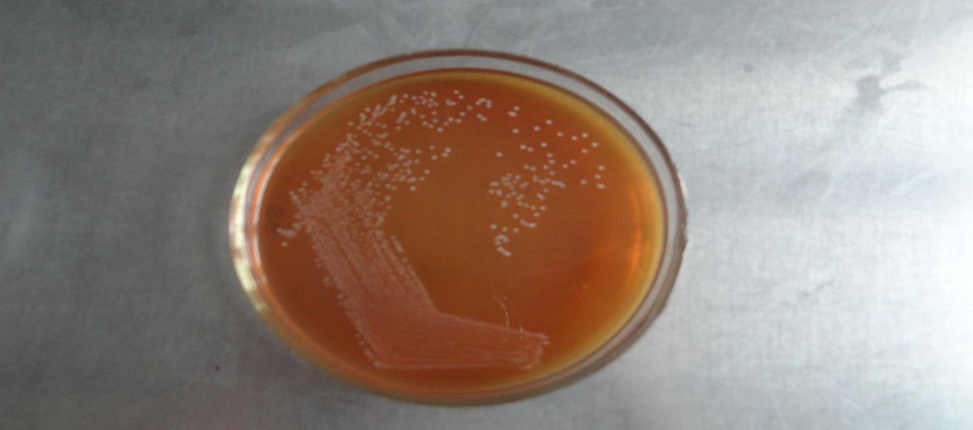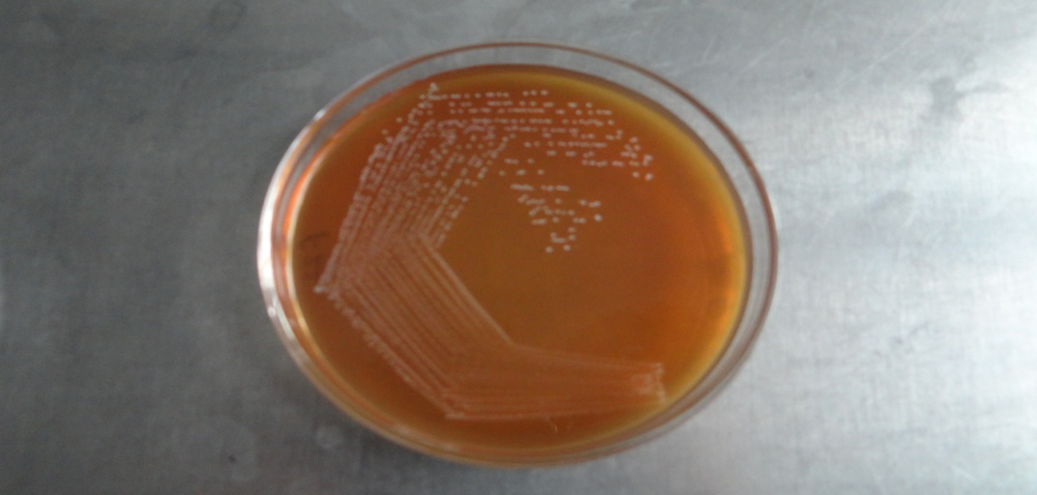
- Lactobacillus crustorum F11 b. Lactobacillus plantarum F22

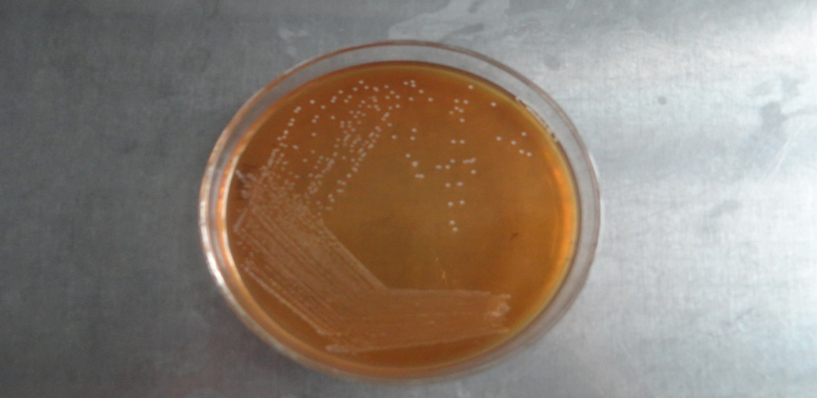
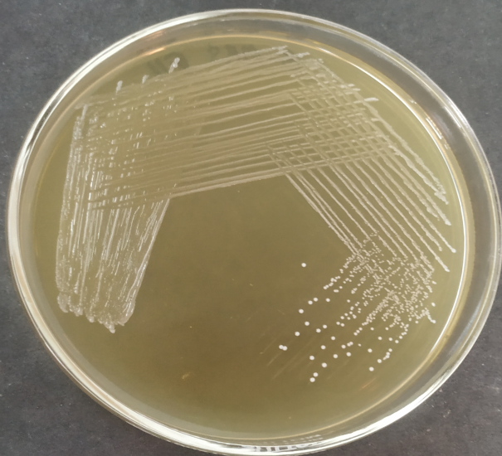

c. Lactobacillus pentosus S6 d. Lactobacillus paraplantarum KM1

Figure 1 : Colony morphology of in-house probiotic cultures selected for synthesis of silver nanoparticles

