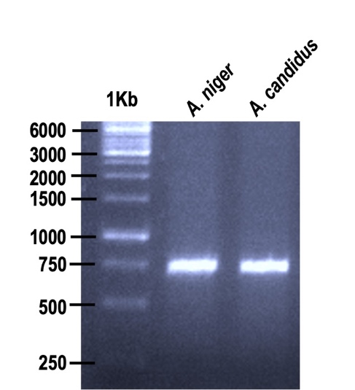
Supplementary Figure S1: Agarose gel electrophoresis denoting the polymerase chain reaction (PCR) amplicon of approximately 740 bp in length for Aspergillus niger (CGJM4174) and Aspergillus candidus (CGJM4177). Lane 1 denotes molecular marker (1Kb DNA ladder) (Thermo Fisher Scientific, Waltham, MA, USA).

