Deoxycholic Acid-Grafted Chitosan Nanocarriers for Enhancing Oral Bioavailability and Hepatoprotection of Silybin

Swarali Kadam¹, Gasper Fernandes¹, Naitik Jain¹, Srinivas Mutalik^{1*}

¹ Department of Pharmaceutics, Manipal College of Pharmaceutical Sciences, Manipal Academy of Higher Education, Manipal 576104, Karnataka, India

*Corresponding Author
Dr Srinivas Mutalik
Professor and Principal
Manipal College of Pharmaceutical Sciences
Manipal Academy of Higher Education
Manipal 576104, Karnataka, India
Email: ss.mutalik@manipal.edu

Figures

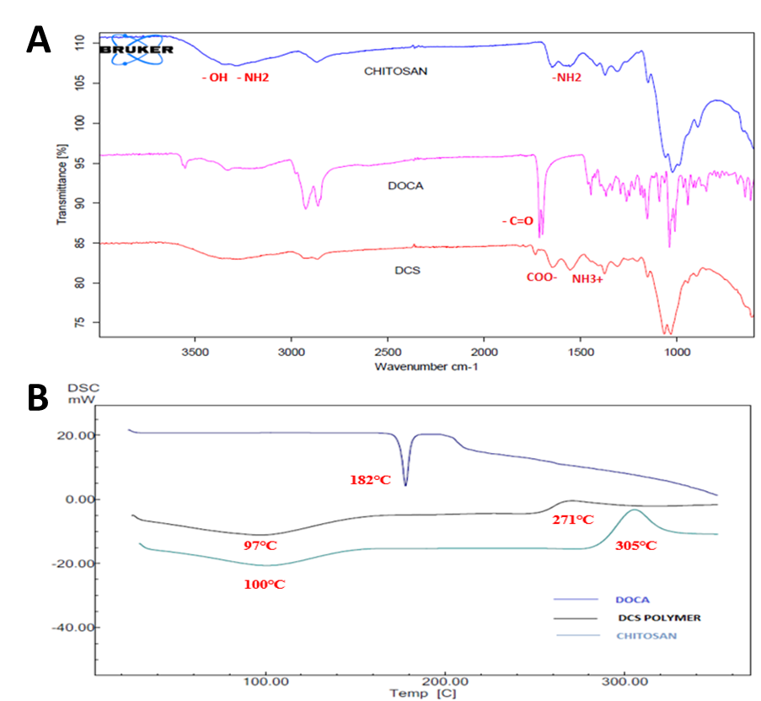
Fig S1. (A) FTIR spectra (B) DSC spectra of chitosan, deoxycholic acid (DOCA) and deoxycholic acid modified chitosan (DCS).

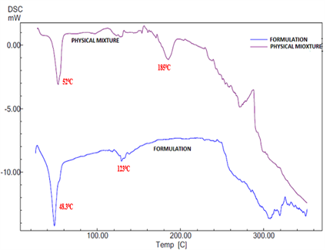
Fig S2. DSC spectra of Physical Mixture and DCS-LC NPs

Tables
Table S1. Responses obtained during Optimization of independent variables involved in synthesis of DCS-LC NPs
S. No. | Amount of DCS (mg) | Amount of Lipid (mg) | % of Surfactant
1. | 17.5 | 200 | 0.6
2. | 30 | 125 | 0.6
3. | 17.5 | 125 | 0.35
4. | 5 | 50 | 0.35
5. | 5 | 125 | 0.1
6. | 5 | 125 | 0.6
7. | 17.5 | 125 | 0.35
8. | 1.5 | 125 | 0.35
9. | 17.5 | 125 | 0.35
10. | 5 | 200 | 0.35
11. | 17.5 | 125 | 0.35
12. | 30 | 50 | 0.35
13. | 17.5 | 50 | 0.1
14. | 17.5 | 50 | 0.6
15. | 17.5 | 200 | 0.1
16. | 30 | 125 | 0.1
17. | 30 | 200 | 0.35

Table S2. ANOVA table for the Quadratic model of the two responses (Particle size and Entrapment efficiency).
Content | Particle Size |  | Entrapment Efficiency
Source | Sum of squares | Status | Sum of squares | Status
Model | 57067.45 | Significant | 328.36 | Significant
A-Amount Of Chitosan | 7335.03 |  | 23.46
B- Amount Of Lipid | 375.93 |  | 304.18
C- Amount Of Surfactant | 2450.00 |  | 0.7140
Ab | 16312.40 |  | 43.42
Ac | 12611.29 |  | 33.98
Bc | 17982.81 |  | 9.44
Residual | 6361.13 |  | 371.77
Lack Of Fit | 3863.19 | Not Significant  (p= 0.5121) | 33.98 | Not Significant  (p= 0.3435)

Table S3. Actual and predicted values of optimized formulation
 | Independent variables |  |  |  | Responses
 | Amount of DCS (mg) | Amount of Lipid (mg) |  | Amount of Surfactant (%) | Particle size (nm) | Entrapment efficiency (%)
Composition suggested by the software | 18 | 50 | 0.6 |  | 99.37 | 87.65
Practically performed composition (SIL = 5mg) | 18 | 50 | 0.6 |  | 95.83 | 85.03
Residual error (%) | - | - | - |  | 3.56 | 2.98

Table S4. Observed values of particle size, Zeta potential and PDI of DCS-LC NPs
Formulation | Amount of SIL  (mg) | Particle Size  (nm) | PDI | Zeta potential  (mV) | % EE
Blank DCS-LC NPs | - | 90.2 | 0.24 | 25.6 | -
DCS-LC NPs | 5 | 95.83 | 0.26 | 17.2 | 85.03 %
DCS-LC NPs | 7.5 | 187.2 | 0.20 | 18.6 | 89.54 %

Table S5: Kinetic modeling of in vitro drug release from DCS-LC NPs.
Model | DCS-LC NPs
Model | pH 1.2 | pH 6.8 | pH 7.4
Zero order | R² = 0.8516 | R² = 0.4724 | R² = 0.4726
First order | R² = 0.9374 | R² = 0.5992 | R² = 0.7026
Higuchi | R² = 0.9782 | R² = 0.6838 | R² = 0.6756
Korsmeyer-Peppas | R² = 0.9776  n = 0.53 | R² = 0.9981  n = 1.1 | R² = 1  n = 1.2

