Article title: Brief mindfulness-based interventions: teacher and course attendee perspectives on content
Journal title: Mindfulness
Kelly Birtwell*^{1,2}, Rebecca Morris^{1,2}, Christopher J. Armitage^{1,3}
¹School of Health Sciences, Faculty of Biology, Medicine and Health, University of Manchester, Manchester Academic Health Science Centre, Manchester, England
²NIHR School for Primary Care Research, Manchester, England
³Manchester University NHS Foundation Trust, Manchester Academic Health Science Centre, Manchester, England
*Corresponding author:
Kelly Birtwell: Kelly.birtwell@outlook.com

Supplemental resource one

1. Mindfulness course experience
Teachers (N=22): Clients and courses taught | Adults: 19 (86.4%)  Adults and children: 3 (13.6%)  MBCT/MBSR only: 6 (27.3%)  MBCT/MBSR and other approaches (including one-to-one mindfulness teaching): 9 (40.9%)  8-week course (name of course not specified): 2 (9.1%)  Other mindfulness courses (not specified): 5 (22.7%)
Attendees (N=20): Courses attended | MBCT/MBSR only: 6 (30%)  MBCT/MBSR and other courses: 2 (10%)  8-week course (name of course not specified): 5 (25%)  Breathworks courses: 2 (10%)  Other mindfulness courses (not specified): 5 (25%)

2. Details of courses taught or attended other than standardised 8-week courses
Question | Response
Types of courses attended in addition to standardised 8-week courses | “Mindfulness course of 6 classes run by NHS”  “Everyday Mindfulness”  “4-WEEK MINDFULNESS COURSE”  “private course of 4 sessions”
Types of courses taught in addition to standardised 8-week courses  (10 teachers) | “a rolling 'Everyday Mindfulness Group 1 hr per week for 9 months”  “MBSR Intensive, 5 day retreat of the 8-week course. Teach a 6-week Mindfulness course developed from Thich Nhat Hanh's teachings, called Be Calm Be Happy. Newly developed Mindfulness-based Creativity 8-week course and 1- and 2-day retreats”  “Mindful Communication, community college course, 20 sections (Mindfulness is also used in literature, writing, and internship courses to reinforce mindfulness ideas and opportunities for practice)”  “education courses aimed at beginners which could be studied at a lighter level, also included compassion over 10 wk period”  “bespoke workplace course”  “carers groups, university students and staff, drug and alcohol rehabilitation group, hospice patients, carers and staff”  “Mindfulness for stress - not the MBSR as such but an adapted version”  “Frantic World”  “4-wk Intro to Mindfulness.”  “modified 5 week MBCT courses with shorter practices”

3. Reasons given by course attendees for attending a mindfulness course
All 20 mindfulness course attendees responded to this open question. Respondents stated more than one reason for attending.

Reasons for attending the course | Number of survey participants stating each reason
Mental health reasons | 14 (70%)
Curiosity / interest | 4 (20%)
Spiritual reasons | 2 (10%)
Work / training | 3 (15%)
Personal use | 1 (5%)
Resilience / wellbeing | 4 (20%)
Support existing practice | 2 (10%)
4. Minimum number of sessions suggested by participants for a brief mindfulness course
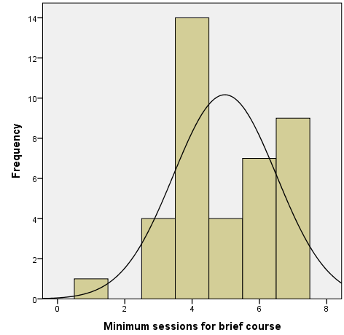

5. Minimum session duration suggested by participants for a brief mindfulness course
