Supplementary Materials
A biobehavioural approach to understand how mindfulness-based cognitive therapy reduces dispositional negative self-bias
Kirschner at. al

Supplementary Methods

Measures
Visual Prompts For The Visual Analogue Scales Used In The Manipulation Checks

Supplementary Figure S1. Figure S2 depicts the visual analogue prompts used to assess the effectiveness of the self-compassion manipulation on participants’ state self-compassion and self-criticism.

Supplementary Results
MBCT Related Changes In Depression Symptoms And Dispositional Self-Compassion And Self-Criticism

Changes in self-compassion, self-criticism and self-reported depression scores are depicted in main Figure 2 A (remitted depressed MBCT) and main Figure 2 B (remitted depressed control). A significant increase in self-compassion could be found post MBCT, t(24) = 2.35, p = .028, 95 % CI [.21, 3.33], d = .47. In line with these findings, there was a significant increase on the reassuring self subscale of the FSCRS post MBCT, t(23) = 4.21, p < .001, 95 % CI [2.43, 7.14], d = .86. Moreover, MBCT led to a significant decrease in self-criticism. This was quantified by significant reductions on the inadequate self, t(23) = 4.54, p < .001, 95 % CI [-9.88, -3.69], d = .93, and on the hated self, t(23) = 2.55, p = .018, 95 % CI [-4.08, -.42], d =.52, subscales of the FSCRS. Finally, there was a significant decrease self-reported depressive system scores post MBCT, t(24) = 5.55, p < .001, 95 % CI [-11.41, -5.23], d = 1.11. In contrast, no changes in self-compassion, self-criticism, or self-reported depression scores have been found for the remitted depressed control group between the first and second assessment, all p > .05.

MBCT-Related Changes In Self-Reported Sate Self-Compassion And Self-Criticism In Response To LKM-S
Changes In Self-Compassion
The scores for the state self-compassion ratings are depicted in Figure S3 A&B. There was a significant Treatment X Group interaction, F(1, 48) = 7.63, p = .008, η²_{p} = .14. Follow up analyses revealed, that both groups demonstrated significant increases in state self-compassion following the self-compassion induction at the first and second assessment (MBCT Group T1: F(1,24) = 6.76, p = .016, η²_{p} = .22; 95% CI [1.38, 12.05]; T2: F(1,24) = 7.16, p = .013, η²_{p} = .23; 95% CI [.93, 7.23]; Control Group T1: F(1,24) = 5.60, p = .026, η²_{p} = .19, 95% CI [.77, 11.31]; T2: F(1,24) = 15.96, p = .001, η²_{p} = .39; 95% CI [5.09, 15.98]). Interestingly, between subject follow-up analyses showed that there was no difference between the groups in their state levels of self-compassion before the self-compassion manipulation at the first assessment (F(1,48) = .38, p = .541, η²_{p} > .01; 95% CI [-15.36, 8.17]). However, a significant difference in state levels of self-compassion before the self-compassion manipulation was found at the second assessment, with higher scores in the remitted depressed MBCT group (F(1,48) = 5.29, p = .026, η²_{p} = .10; 95% CI [1.69, 25.07]). This result indicates that post-treatment, the MBCT group showed an elevation in self-reported state self-compassion before the self-compassion induction.

Supplementary Figure S2. MBCT-related changes in self-reported sate self-compassion and self-criticism. Error bars = ± 1SE

Changes In State Self-Criticism
Figure S3 C&D shows the state self-criticism ratings for both groups. The Time (pre/ post induction) X Treatment (pre/ post MBCT) X Group (remitted depressed MBCT, remitted depressed control) ANOVA revealed a main of treatment with lower self-criticism scores post Treatment, F(1, 48) = 6.98, p = .011, η²_{p} = .13. In addition, there was a trend for a Treatment X Group interaction, F(1, 48) = 3.62, p = .063, η²_{p} = .07. Follow up analyses revealed that post MBCT the MBCT group showed decreased self-criticism scores before the self-compassion induction as compared to pre MBCT, F(1, 24) = 5.11, p = .033, η²_{p} = .18, 95% CI [-25.33, -1.15]. No other significant effects emerged for self-reported state self-criticism change (all p = .05).

Changes In Physiological Arousal And Parasympathetic Activation
Skin Conductance Level Effects
The first panel of main Figure 4 shows the pattern of change in skin conductance level for the two groups. The focus (others vs. self) x Time (first vs. second assessment) x group ANOVA revealed a significant Time x Group interaction, F(1,42) = 10.33, p = .003, η²_{p} = .20. Follow-up analyses revealed that the remitted depressed control group demonstrated significantly higher SCL in response to the self-compassion exercise at the second as compared to the first testing session, F(1, 21) = 6.25, p = .021, η²_{p} = .23, 95% CI [.02, .19]. In contrast, there was a decrease in SCL in response to the self-compassion intervention after the MBCT course as compared to before, F(1, 21) = 5.15, p = .034, η²_{p} = .19, 95% CI [-.29, .-.013]. An examination of the between-subject follow-up effects revealed no group differences at the first assessment F(1, 43) = 1.10, p = .300, η²_{p} = .04, 95% CI [-.058, .18]. However, there was a group differences at the second assessment, F(1, 45) = 4.99, p = .030, η²_{p} = .09, 95% CI [-.30, -.01], with lower SCL in response to the self-compassion manipulation in the MBCT group. In addition, there was a main effect of focus, F(1,42) = 55.77, p < .001, η²_{p} = .57, indicating general lower SCL levels when focusing on the self during the exercise. No other effects reached significance.
Heart Rate Effects.
Pattern of change in heart rate for the two groups at the first and second assessment are depicted in the second panel of main Figure 4. The three-way ANOVA indicated a significant Time X Group interaction, F(1,43) = 9.35, p = .004, η²_{p} = .179. The heart rate results suggest that the remitted depressed MBCT group had a decrease in heart rate throughout the self-compassion manipulation post-treatment as compared to pre-treatment (F(1,20) = 9.24, p = .006, η²_{p} = .32, 95% CI [-2.59, -.48]), whereas the remitted depressed control group demonstrated no change in their heart rate responses to the self-compassion manipulation, F(1,23) < 1, p = .413, η²_{p} = .02, 95% CI -.43, 1.00]. When examining the between subject follow up effects, no differences emerged at the first assessment, F(1,44) = 2.35, p = .132, η²_{p} = .05, 95% CI [-.23, 1.72], indicating that there was no group differences in heart rate responses to the self-compassion manipulation before the treatment. After MBCT, relative to the remitted depressed control group, the remitted depressed MBCT group demonstrated a tendency towards a decreased in heart rate in response to the self-compassion manipulation, F(1,43) = 2.99, p = .091, η²_{p} = .07, 95% CI [-2.41, .18]. No other main effects reached significance.
Heart Rate Variability Effects
The three-way ANOVA yielded a significant Time X Group interaction, F(1,43) = 12.23, p = .001, η²_{p} = .22. Follow-up analyses revealed that the remitted depressed MBCT group on average demonstrated higher heart rate variability in response to the self-compassion manipulation after they completed the MBCT course as compared to their responses before the course, F(1,20) = 12.11, p = .002, η²_{p} = .38, 95% CI [11.58, 46.25] (see main Figure 4 C). In contrast, no differences in heart rate variability responses to the self-compassion induction between the first and second assessment was found for the remitted depressed control group, F(1,23) = 1.34, p = .251, η²_{p} = .06, 95% CI [-20.17, 5.53] (see main Figure 5 C). Critically, further exploration showed that the two groups did not differ in their heart rate variability responses to the self-compassion manipulation at the first testing session, F(1, 44) = 1.86, p = .180, η²_{p} = .04, 95% CI -5.58, 28.88], but at the second testing session, F(1, 44) = 47.84, p < .001, η²_{p} = .53, 95% CI [33.41, 60.91], with higher heart rate variability demonstrated by the MBCT group.

Associations Between Psychophysiological Change, Change In Dispositional Self And Symptom Reduction.
Associations between treatment-related physiological change, change in dispositional self (e.g. changes in trait self-compassion and self-criticism) and symptom reduction (e.g. changes in BDI-scores) are depicted in figure S3 (across groups) and figure S4 (MBCT group only).

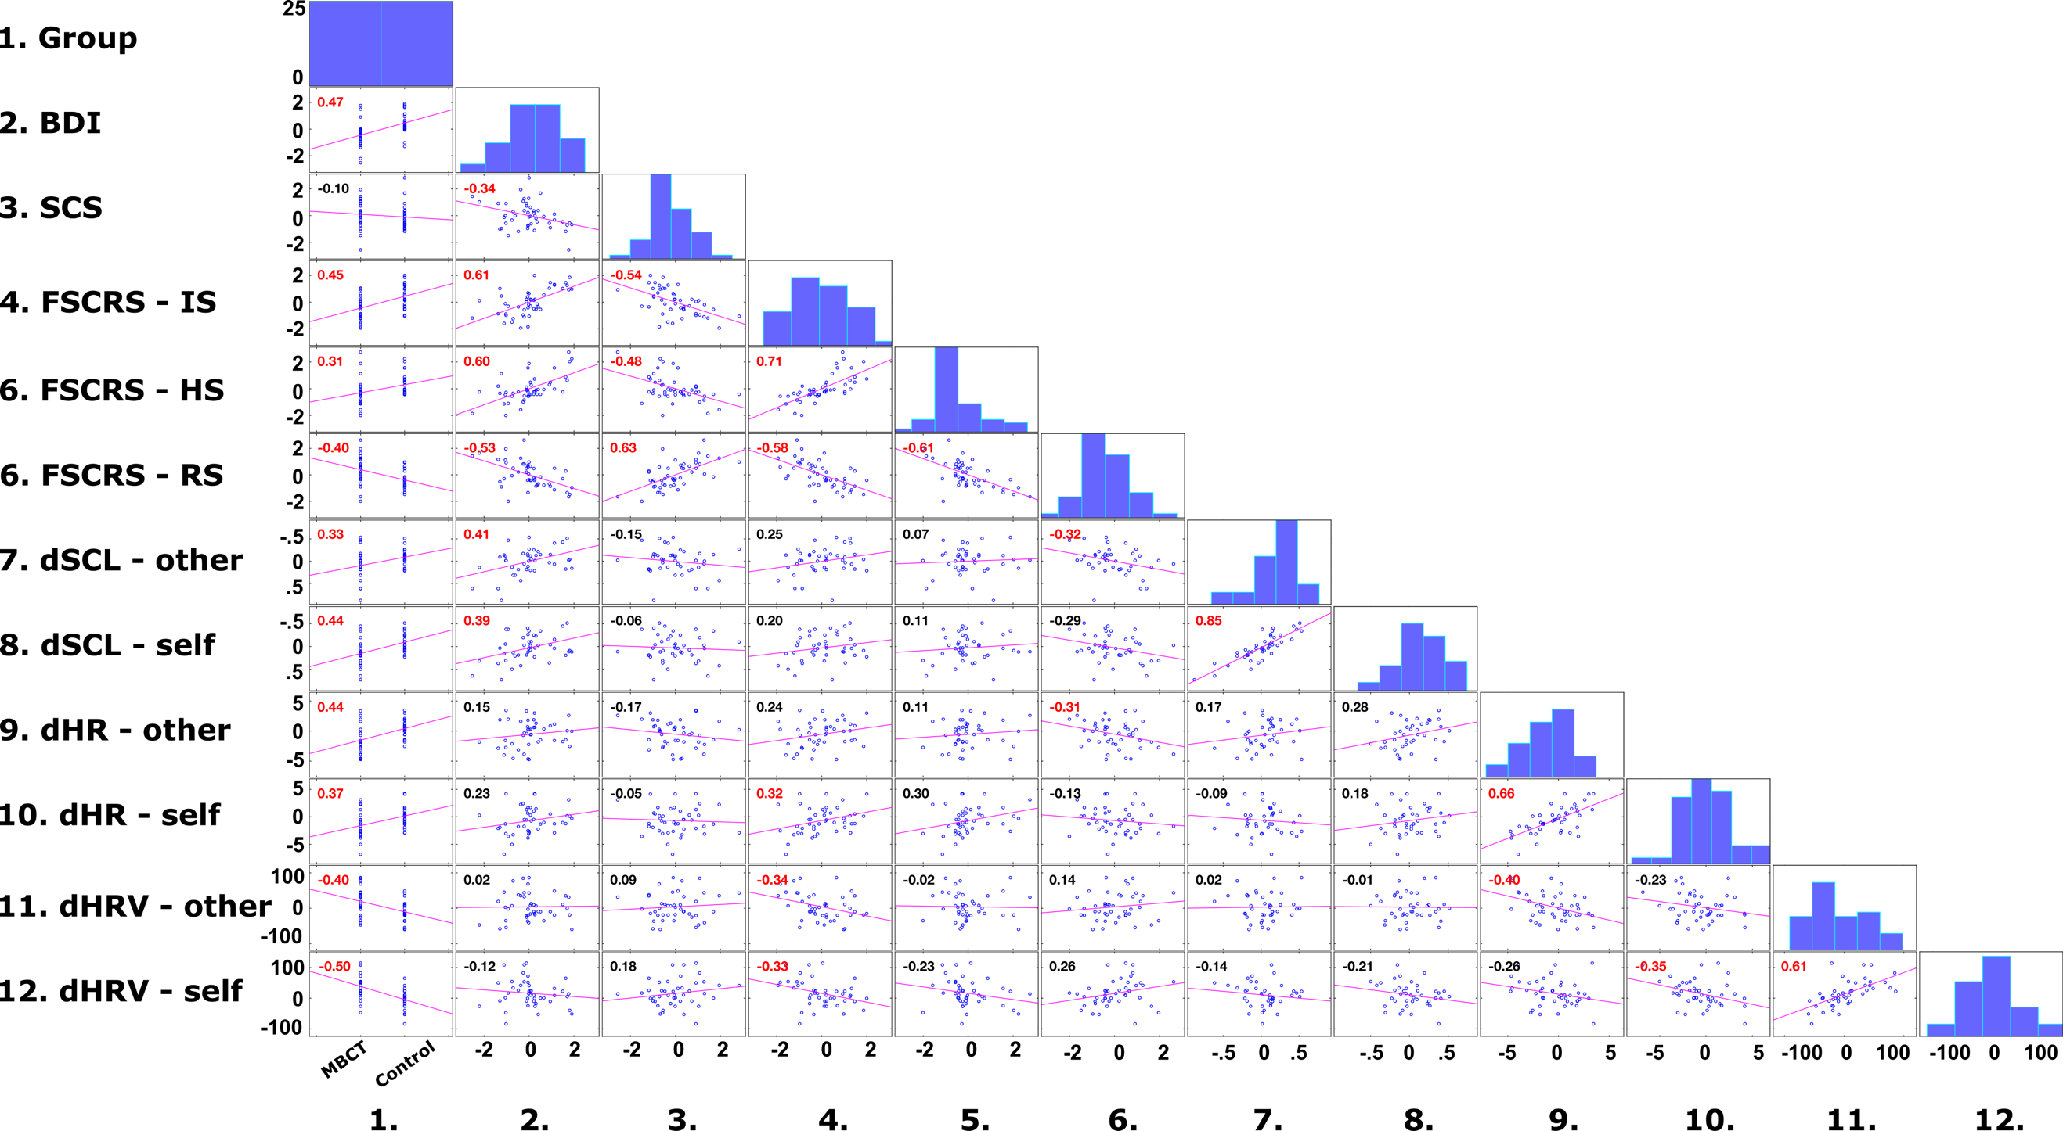
Supplementary Figure S3. Correlations between psychophysiological change scores across groups. Histograms of the variables are depicted along the matrix diagonal. Scatterplots of variable pairs are shown off-diagonal. The slopes of the least-squares reference lines in the scatter plots are equal to the displayed correlation coefficients. Significant correlations are highlighted in red. Note. residualized gain scores were used as quantification of changes for the questionnaire (Figure S3 continued) data from testing session 1 and 2; difference waves as indicator of testing session related change in physiological responses (e.g. post change score – pre-change score) were used as quantification of physiological changes in response to the self-compassion exercise. BDI = Beck Depression Inventory; SCS = Self-Compassion Scale; FSCRS = Forms of Self-Criticizing/Attacking & Self-Reassuring Scale; IS = Inadequate Self; HS = Hated Self; RS = Reassuring Self; dSCL – other / self = treatment related changes in skin conductance level (SCL) during other- / self-focus; dHR – other / self = treatment related changes in heart rate (HR) during other- / self-focus; dHRV – other / self = treatment related changes in heart rate variability (HRV) during other- / self-focus.

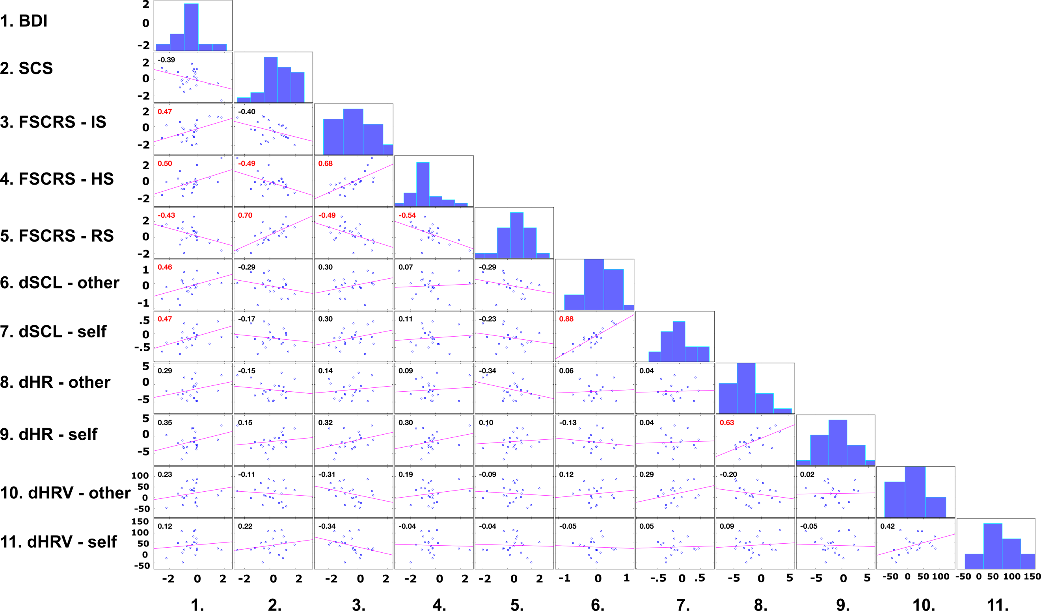

Supplementary Figure S4. Correlations between psychophysiological change scores within the MBCT group. Histograms of the variables are depicted along the matrix diagonal. Scatterplots of variable pairs are shown off-diagonal. The slopes of the least-squares reference lines in the scatter plots are equal to the displayed correlation coefficients. Significant correlations are highlighted in red. Note. residualized gain scores were used as quantification of treatment related changes for the questionnaire data; difference waves as indicator of MBCT-related change in physiological responses (e.g. post change score – pre-change score) were used as quantification of physiological changes in response to the self-compassion exercise. BDI = Beck Depression Inventory; SCS = Self-Compassion Scale; FSCRS = Forms of Self-Criticizing/Attacking & Self-Reassuring Scale; IS = Inadequate Self; HS = Hated Self; RS = Reassuring Self; dSCL – other / self = treatment related changes in skin conductance level (SCL) during other- / self-focus; dHR – other / self = treatment related changes in heart rate (HR) during other- / self-focus; dHRV – other / self = treatment related changes in heart rate variability (HRV) during other- / self-focus.

Reanalysis Of Main Treatment Related Group Effects While Controlling for Differences in Depressive Symptoms and Inadequate Self
To control for a potential sampling bias, we included depressive symptoms and the inadequate self subscale of the FSCRS as continuous covariates in the ANOVA’s investigating treatment related group effects. Here, the MBCT specific elevation in self-reported state self-compassion before the self-compassion induction remained significant (F(1, 47) = 11.84, p = .001). Similar, all group effects related to changes in physiological arousal and parasympathetic activation remained significant (SCL: F(1, 41) = 6.8, p = .013; HR: F(1, 43) = 7.16, p = .011; HRV: F(1, 43) = 12.95, p > .001; HRV focus on the self: F(1, 47) = 13.09, p > .001).

