Online Supplement
Appendix 1: Between-person mediation analysis of the MMT
Between-person descriptive statistics for EMA variables are shown in Table S1, and associations among mediators at the between-person level are presented in Figure S1. Most key paths were significant and in the expected direction, including the direct effect of Decentering on Wellbeing. However, Decentering and Reappraisal were significantly inversely associated. Savoring and wellbeing were also not statistically significantly associated. The MMT indirect pathway of interest through the key variables was not statistically significant, nor were several other indirect pathways at the between-level (see Table S2). The only significant indirect effects were between 1) Decentering, Positive Affect, and Wellbeing, and 2) Decentering, Reappraisal, Positive Affect, and Wellbeing.
Thus, an analysis of individual differences throughout the study indicated that there was support for some of the key paths hypothesized by MMT, but people who used decentering more often tended to use reappraisal less often, and there was no association between overall use of savoring and wellbeing. In addition, the overall use of reappraisal, positive affect, and savoring generally did not account for the association between decentering and wellbeing.

Table S1. Descriptive Statistics for Between-Person Variables
 | M (SD) | 1 | 2 | 3 | 4 | 5
- Decentering | 10.42 (1.70) | -
- Reappraisal | 1.81 (0.61) | -.25** | -
- Positive Affect | 9.92 (2.94) | .39*** | .25** | -
- Savoring | 2.15 (0.84) | .25** | .45*** | .82*** | -
- Wellbeing | 5.43 (1.67) | .48*** | .18** | .89*** | .74*** | -
** p<.01
*** p<.001

Table S2. Between-person Indirect Effects
Pathway | Estimate | Credibility Intervals
D-R-WB | .002 | -.021, .020
D-PA-WB | .358* | .273, .454
D-S-WB | .003 | -.003, .016
D-R-PA-WB | -.065* | -.105, -.035
D-R-S-WB | -.006 | -.018, -.001
D-PA-S-WB | .032 | -.008, .068
D-R-PA-S-WB | -.006 | -.015, .001

Note. Estimates are unstandardized. D = Decentering; R = Reappraisal; PA = Positive Affect; S = Savoring; WB = Wellbeing.
* denotes significant indirect effect according to Bayesian 95% credibility intervals that do not contain zero.

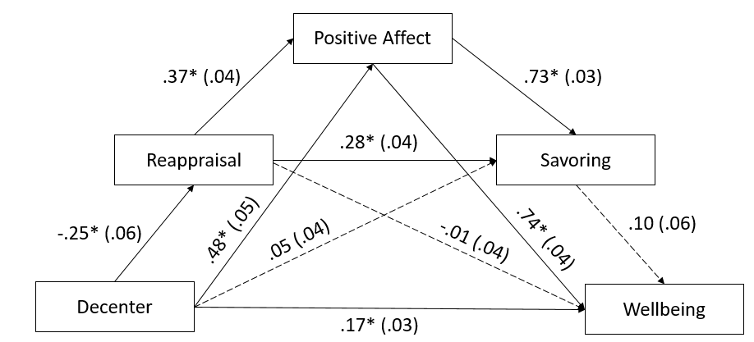
Fig S1 Regression Paths for Between-Person Model
Note. Dashed lines indicate non-significant paths. Standardized coefficients are shown with posterior SD in parentheses.
* = significant association according to Bayesian 95% credibility interval

