Figure S1 Interaction plots showing differential outcomes based on recent practice
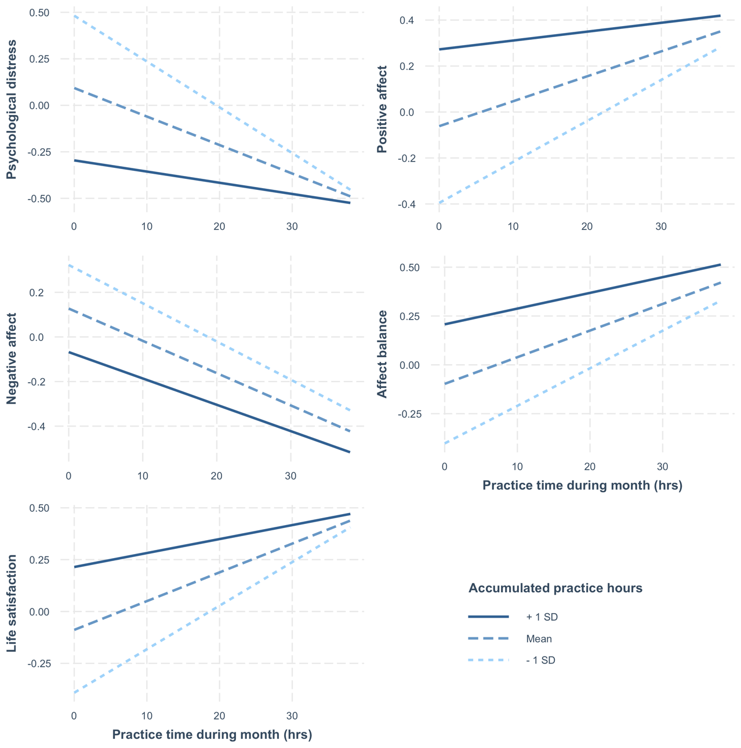
Note. Interaction effect is statistically significant for psychological distress (p<.001), positive affect (p<.001), affect balance (p=.011), and satisfaction with life (p<.001).
Y-axis is standardized for all outcome variables.

Table S1 Comparison of key variables for Facebook-recruited participants
Variable | Targeted  sample | Convenience sample | Test statistic
 | n (%) | n (%)
Total participants | 251 (15.1) | 1413 (84.9)
Gender – Female | n (70.5) | n (69.8) | χ²(1)=0.03
Retreat experience | n (25.5) | n (42.9) | χ²(1)=27.71***
 | M (SD) | M (SD)
Age | 49.8 (14.7) | 44.6 (15.2) | χ²(57)= 77.76*
Active practice years | 6.1 (9.3) | 5.8 (7.4) | χ²(164)=179.16
Accumulated practice hours | 748.7 (1326.8) | 876.3 (1268.8) | χ²(1242)=1136.0
Psychological distress (K10) | 19.54 (7.2) | 19.0 (6.5) | χ²(34)=35.60
Positive affect (SPANE) | 20.42 (4.4) | 21.3 (4.4) | χ²(24)=28.31
Negative affect (SPANE) | 15.1 (4.2) | 15.5 (4.4) | χ²(23)=18.88
Affect balance (SPANE) | 5.3 (7.9) | 5.8 (7.9) | χ²(42)=29.10
Satisfaction with life (SWLS) | 2.7 (0.8) | 2.9 (0.8) | χ²(3)=6.95
Note. Targeted sample was recruited via Facebook in a one-month campaign.
* indicates p < .05. ** indicates p < .01. *** indicates p<.001

Table S2 Multivariable linear regression results with accumulated lifetime and past month practice hours predicting outcome measures
Measure / predictor | Model | β | 95% C.I. | t | p | R²
Psychological distress
Accumulated hours | Main effect | -0.210 | [-0.272 to -0.148] | -6.64 | <.001 | .100
Past month hours | Main effect | -0.135 | [-0.196 to -0.073] | -4.27 | <.001 | .100
Accumulated hours | Interaction | -0.297 | [-0.370 to -0.224] | -7.99 | <.001 | .111
Past month hours | Interaction | -0.160 | [-0.223 to -0.098] | -5.02 | <.001 | .111
Accumulated & past month | Interaction | 0.097 | [0.054 to 0.141] | 4.38 | <.001 | .111
Positive affect
Accumulated hours | Main effect | 0.199 | [0.136 to 0.262] | 6.19 | <.001 | .073
Past month hours | Main effect | 0.095 | [0.032 to 0.157] | 2.95 | .003 | .073
Accumulated hours | Interaction | 0.265 | [0.190 to 0.339] | 6.95 | <.001 | .080
Past month hours | Interaction | 0.113 | [0.050 to 0.177] | 3.49 | <.001 | .080
Accumulated & past month | Interaction | -0.073 | [-0.117 to -0.029] | -3.23 | <.001 | .080
Negative affect
Accumulated hours | Main effect | -0.144 | [-0.207 to -0.081] | -4.49 | <.001 | .069
Past month hours | Main effect | -0.144 | [-0.207 to -0.081] | -4.49 | <.001 | .069
Accumulated hours | Interaction | -0.169 | [-0.243 to -0.095] | -4.46 | <.001 | .069
Past month hours | Interaction | -0.151 | [-0.215 to -0.087] | -4.64 | <.001 | .069
Accumulated & past month | Interaction | 0.028 | [-0.017 to 0.072] | 1.22 | .221 | .069
Affect balance
Accumulated hours | Main effect | 0.197 | [0.134 to 0.260] | 6.12 | <.001 | .087
Past month hours | Main effect | 0.128 | [0.066 to 0.191] | 4.02 | <.001 | .087
Accumulated hours | Interaction | 0.250 | [0.175 to 0.324] | 6.55 | <.001 | .091
Past month hours | Interaction | 0.142 | [0.079 to 0.206] | 4.41 | <.001 | .091
Accumulated & past month | Interaction | -0.058 | [-0.103 to -0.014] | -2.57 | .010 | .091
Satisfaction with life
Accumulated hours | Main effect | 0.166 | [0.105 to 0.227] | 5.31 | <.001 | .070
Past month hours | Main effect | 0.126 | [0.064 to 0.187] | 4.02 | <.001 | .070
Accumulated hours | Interaction | 0.233 | [0.160 to 0.305] | 6.32 | <.001 | .077
Past month hours | Interaction | 0.145 | [0.083 to 0.207] | 4.57 | <.001 | .077
Accumulated & past month | Interaction | -0.074 | [-0.117 to -0.032] | -3.41 | <.001 | .077
Note. β = standardized canonical coefficient; 95 CI = 95% confidence interval; t = t-test value; p = p-value; R² = proportion of outcome variables variance explained by predictors.

Table S3 Means, standard deviations, and partial order correlations adjusting for age
 | M | SD | 1 | 2 | 3 | 4 | 5 | 6 | 7
1. Practice hours past month | 9.88 | 10.45
2. Duration of active practice (years) | 5.25 | 5.78 | .31**
3.Accumulated lifetime practice hours | 855.9 | 1277 | .65** | .78**
4.Psychological distress | 19.12 | 6.57 | -.25** | -.21** | -.25**
5. Positive affect | 21.16 | 4.41 | .22** | .26** | .26** | -.63**
6. Negative affect | 15.47 | 4.33 | -.23** | -.15** | -.21** | .70** | -.62**
7. Affect balance | 5.69 | 7.87 | .25** | .23** | .26** | -.74** | .90** | -.89**
8. Satisfaction with life | 2.83 | 0.82 | .23** | .22** | .24** | -.50** | .56** | -.45** | .56**
Note. M and SD are used to represent mean and standard deviation, respectively.
* indicates p < .05. ** indicates p < .01.

Table S4 Frequency distribution of reported mobile apps
Mobile app | n | % of app users
Insight Timer | 412 | 45.6
Headspace | 185 | 20.5
Calm | 138 | 15.3
Waking Up | 109 | 12.1
Smiling Mind | 93 | 10.3
Ten Percent Happier | 61 | 6.8
Openground | 37 | 4.1
Plum Village | 36 | 4.0
Dhamma.org | 15 | 1.7
MyLife | 13 | 1.4
Note. Only mobile apps reported by at least 10 participants are included.

