Supplementary Material for

Specific reduction in the cortisol awakening response after socio-affective mental training

Veronika Engert^{1,2*}, Katja Hoehne¹, Tania Singer³

¹Institute for Psychosocial Medicine, Psychotherapy and Psychooncology, Jena University Hospital, Friedrich-Schiller University, Jena, Germany
²Social Stress and Family Health Research Group, Max Planck Institute for Human Cognitive and Brain Sciences, Leipzig, Germany
³Social Neuroscience Lab, Max Planck Society, Berlin, Germany

Author Note
Correspondence concerning this article should be addressed to Veronika Engert, Jena University Hospital, Institute of Psychosocial Medicine, Psychotherapy and Psychooncology, Stoystr. 3, 07743 Jena, Germany.
Email: veronika.engert@med.uni-jena.de.

This file includes
Supplementary Method 4
Measures 4
Experience sampling 4
Data analyses 5
Table S1: Number of missing and available cortisol and sleep data per measure and testing time-point 5
Table S2: Number of possible, replaced and non-replaced missing data points for cortisol and sleep data 6
Table S3: Number of participants with available experience sampling data (and winsorized outliers) per module and testing time point 7
Fig. S1: Two-day average raw cortisol data per cohort and testing time-point 7
Additional analysis of change in diurnal cortisol 7
Analyses of subjective experience 8
Supplementary Results 9
Additional analysis of change in diurnal cortisol 9
Table S4: Omnibus F-tests in a LMM examining CAR change from T1 to T3 in TC1, TC2 and RCC 10
Fig. S2: Effect of mental training on the cortisol awakening response (T1-T3) 11
Fig. S3: Mean diurnal slope change trajectories in all training cohorts over time 12
Analyses of subjective experience 13
Table S5: Omnibus F-tests in a LMM examining training effects on (A) affect, (B) arousal, (C) stress event ratio, (D) stress intensity and (E) stress coping 13
Fig. S4: Effect of mental training on summary scores of subjective experience (T0-T3) 15
Supplementary References 16

Supplementary Method
Measures
Experience sampling. Daily self-report data on subjective experience was collected using a customized mobile application. On each of the two sampling days per testing time-point (T0-T3), sampling started upon wakeup, and followed a time schedule in which samples were prompted six times in intervals of 2 hr until 12 hr after waking up (i.e., at 2, 4, 6, 8, 10 and 12 hr). The timeline for subjective sampling thus included more measuring time-points than the one for cortisol sampling.
At each probe throughout the day, participants provided ratings of momentary subjective experience on measures of affect and arousal, and the occurrence of stress, including a rating of stress intensity and individual coping success. The Affect Grid (Russell et al., 1989) was used to measure current affect and arousal. Its single item scale assesses the dimensions pleasure-displeasure and arousal-sleepiness (both on a scale from 1 to 9). The Affect Grid has been shown to have adequate reliability, as well as convergent and discriminant validity (Russel et al., 1989). At each sampling time-point, participants reported on the occurrence of a (concurrent or preceding) stressor in a yes/no format. If they had experienced a stressful event since taking their last sample, they additionally indicated how stressed they felt, and how successfully they were able to cope with the experienced stress (both on visual analog scales ranging from 1 to 20).
Affect, arousal, stress intensity and stress coping were averaged over the six samples per day and the two consecutive sampling days per testing time-point. For the occurrence of stress, a stress event ratio was calculated by using the number of stress events on both days and dividing it by the number of samples answered per testing time-point (a higher stress event ration signifying the experience of a higher number of stressful events). This was done to take into account the fact that not every participant responded to every sample. To avoid influential outliers, all subjective stress summary scores were winsorized to 3 SDs from the mean.

Data analyses
Numbers of missing and available cortisol and sleep data per measure and testing time-point are summarized in Table S1, of replaced and non-replaced missing data points for cortisol and sleep data in Table S2, and of missings per subjective experience variable and testing time-point in Table S3. The averaged raw (unlogged) cortisol data per testing time-point and cohort are depicted in Fig. S1.

Table S1
Number of missing and available cortisol and sleep data per measure and testing time-point
Reason for missing data | Missing n | Available n (women)
T0
Exclusion | 2 | 330 (196)
Dropout | 1 | 329 (195)
No saliva sampling | 9 | 320 (190)
No sleep data | 1 | 319 (189)
No CAR data | 0 | 320 (190)
No diurnal slope data | 4 | 316 (188)
No AUC_{g} data | 11 | 309 (184)
T1
Exclusion | 2 | 330 (196)
Dropout | 16 | 314 (186)
No saliva sampling | 7 | 309 (182)
No sleep data | 3 | 306 (181)
No CAR data | 0 | 309 (182)
No diurnal slope data | 8 | 301 (178)
No AUC_{g} data | 19 | 290 (173)
T2
Exclusion | 2 | 330 (196)
Dropout | 19 | 311 (185)
No saliva sampling | 2 | 309 (184)
Testing completed (TC3) | 75 | 234 (139)
No sleep data | 4 | 230 (137)
No CAR data | 0 | 234 (139)
No diurnal slope data | 7 | 227 (134)
No AUC_{g} data | 15 | 219 (128)
T3
Exclusion | 3 | 329 (195)
Dropout | 27 | 302 (177)
No saliva sampling | 1 | 301 (177)
Testing completed (TC3) | 75 | 226 (132)
No sleep data | 8 | 218 (129)
No CAR data | 0 | 226 (132)
No diurnal slope data | 10 | 216 (130)
No AUC_{g} data | 18 | 208 (123)
Note. Total N = 332.

Table S2
Number of possible, replaced and non-replaced missing data points for cortisol and sleep data
 | T0 | T1 | T2 | T3
Cortisol
n possible data points¹ | 4480 (100%) | 4326 (100%) | 3276 (100%) | 3164 (100%)
n replaced missing data points | 191 (4.26%) | 187 (4.32%) | 183 (5.59%) | 210 (6.64%)
n non-replaced missing data points | 45 (1.00%) | 68 (1.57%) | 50 (1.53%) | 62 (1.96%)
Sleep (awakening time, sleep duration)
n possible data points | 319 (100%) | 306 (100%) | 230 (100%) | 218 (100%)
n replaced missing data points | 9 (2.82%) | 4 (1.31%) | 5 (2.17%) | 10 (4.9%)
Note. ¹n possible data points was counted after subtracting cases that were excluded, dropped out of the study or did not sample any saliva at a respective testing time-point.

Table S3. Number of participants with available experience sampling data (and winsorized outliers) per module and testing time point
 | Affect | Arousal | Stress event ratio | Stress intensity | Stress coping
Testing time point
T0 | 281 | 281 | 281 (4) | 201 (1) | 201
T1 | 276 | 276 (1) | 276 (7) | 187 | 187 (1)
T2 | 213 | 213 (1) | 213 (6) | 136 (1) | 136
T3 | 207 | 207 | 207 (3) | 121 (1) | 121 (1)
Note. Total n = 332.

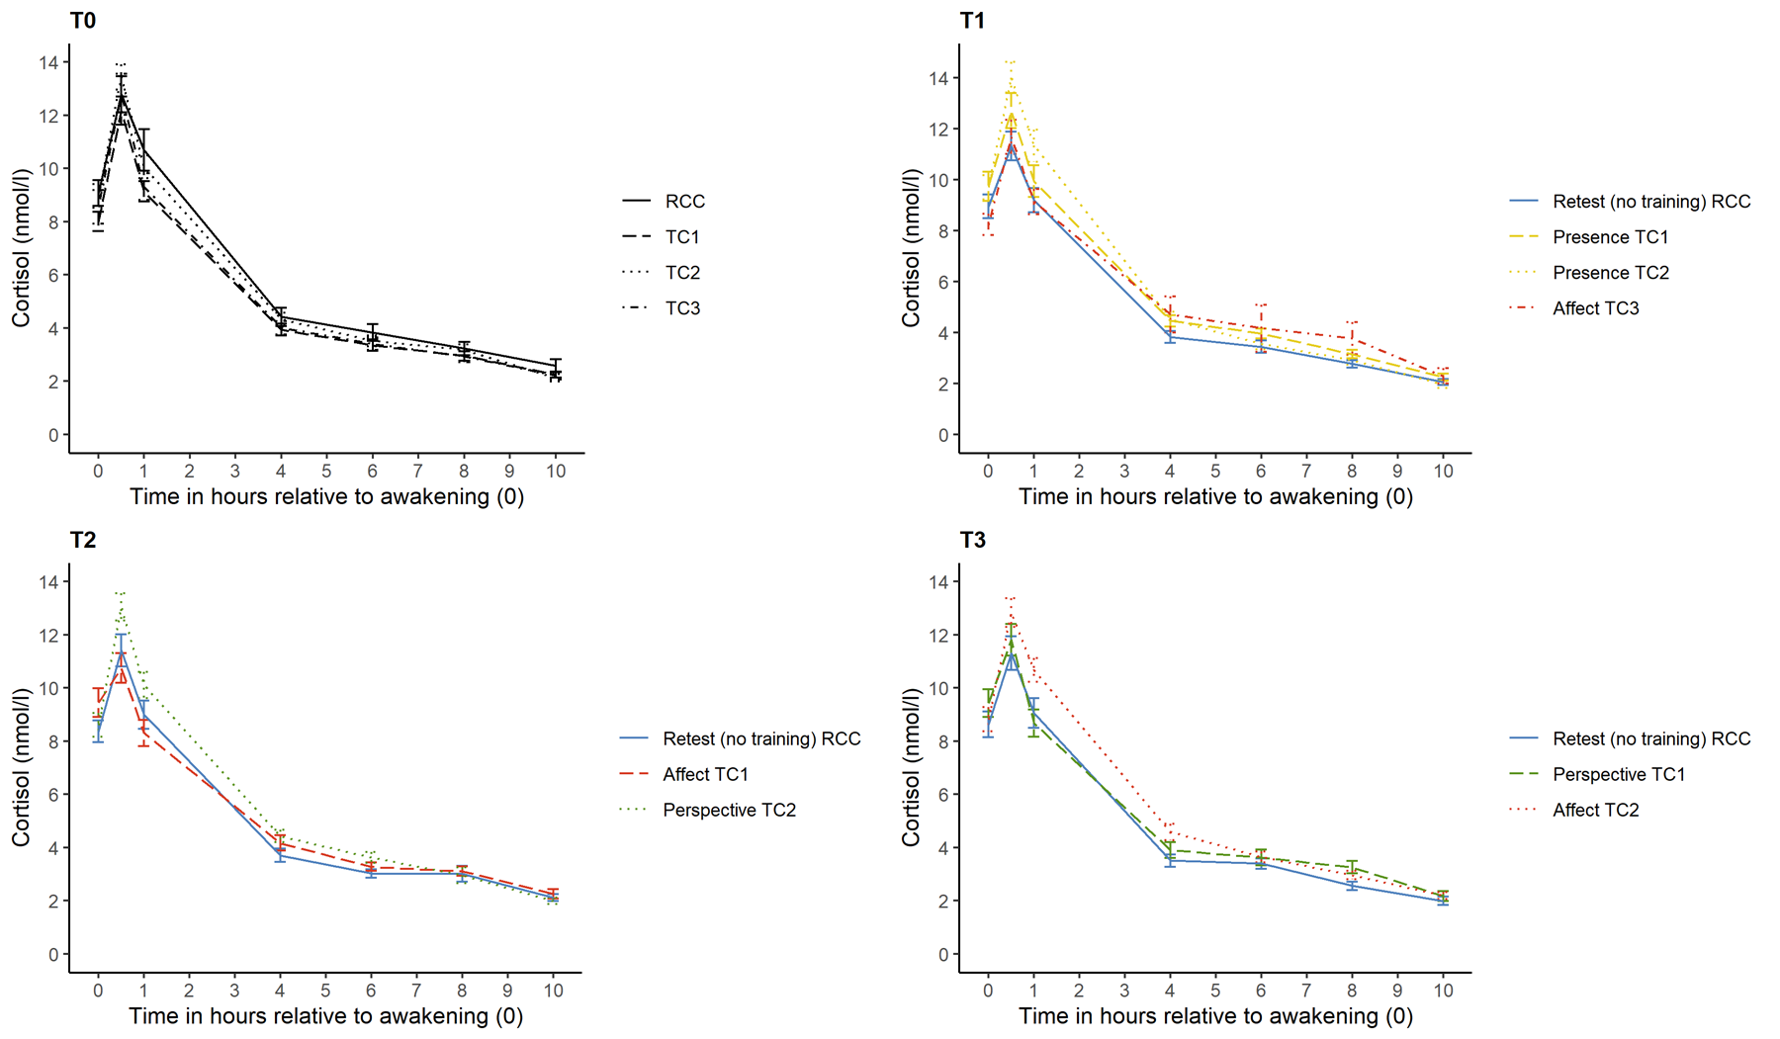
Fig. S1
Two-day average raw cortisol data per cohort and testing time-point

Additional analysis of change in diurnal cortisol. Given the unexpected pattern of CAR change in the RCC (i.e., steep reduction from T0 to T1, slight increase from T1 to T2, no change from T2 to T3; see Fig. 4 A), we ran an exploratory analysis considering change from T1 to T3. This allowed to evaluate the effect of Affect and Perspective training against a more stable control group (T1 to T3). In detail, using a multivariate linear mixed model (LMM), Affect and Perspective training (in TC1 and TC2) were compared against each other and no training (in the RCC). Post-hoc comparisons were calculated using pairwise least significance difference (LSD) tests. Age, sex and S1 were entered as covariates into the model.
Analyses of subjective experience. Again, all analyses were conducted using the Statistical Package for the Social Sciences (SPSS, version 25), with an α-threshold of ≤ 0.05. For completeness, significant and trend-level results (defined as .05 < p <.10) are reported. Hypotheses were tested with LMMs. Since the present study is part of a large-scale investigation with numerous sub-projects (the ReSource Project), sample sizes could not be tailored to this study. However, our sample size is considerably larger than typically seen in mental training studies.
Replicating our main modeling approach, training-induced change in affect, arousal, stress event ratio, stress intensity and stress coping were operationalized by subtracting values from a set of consecutive training blocks (i.e., T1 - T0, T2 - T1, T3 - T2). These difference scores allowed modeling change directly as a function of the training module that each participant practiced in a respective time interval (or retest). Furthermore, they avoid biasing module change estimates by including different participants before and after a module. Fixed effect factors for module (Presence, Affect, Perspective, retest), interval (T0 to T1, T1 to T2, T2 to T3), and the interaction of module by interval were included into the model. Hereby, we could test whether potential change was dependent on a specific training module (main effect of module), on the time of testing (main effect of interval), or the sequence in which training modules were taught (module by interval interaction). In the case of a training effect, pairwise least significance difference (LSD) post-hoc comparisons were calculated. Post-hoc comparisons were not corrected for multiple comparisons because within the multilevel model framework estimates are “shrunk” towards a common mean. This “partial pooling” accounts for the dependence of estimates calculated within the same model without compromising power (Gelman et al., 2012). In all models, potential confounding variables (age, sex, time of awakening and sleep duration) were successively added to the model. In the case of an improvement of model fit indices, the respective variable was included as a control variable in the final model. This procedure led to the inclusion of time of awakening in the affect, arousal, stress event ratio and stress intensity models, and of age, sex and sleep duration as control variables in the stress event ratio model. To facilitate interpretation, continuous predictors were mean-centered. The full model included the following terms:
DV_{ij} = ß₀ + ß₁*control variable_{i/j} + ß₂₋₄*module_{i} + ß₅₋₇*interval_{j} + ß₈₋₁₁*module_{i}*interval_{j} + rand(ID),
where DV = dependent variable (affect, arousal, stress event ratio, stress intensity, stress coping); control variable = age, sex, time of awakening, sleep duration; ß₀ = intercept; i = subject ID; j = measurement interval (T1 - T0, T2 - T1, T3 - T2); rand(ID) = random intercept per subject.

Supplementary Results
Additional analysis of change in diurnal cortisol
A main effect of module (F₂₃₇ = 3.25, p = .041) in the LMM focusing on change from T1 to T3 revealed that the CAR was significantly reduced after Affect training (in TC1 and TC2) compared to no training (in the RCC; MD = -0.12, SE = 0.05, d = 0.36, p = .011), and marginally reduced after Affect relative to Perspective training (in TC1 and TC2; MD = -0.12, SE = 0.07, d = -0.25, p = .068). There was no difference in CAR after Perspective relative to no training (in the RCC; MD = 0.00, SE = 0.05, d = 0.95, p > .011) (Table S4, Fig. S2). Also, time of testing and training sequence had no significant influence (Table S4).
Table S4
Omnibus F-tests in a LMM examining CAR change from T1 to T3 in TC1, TC2 and RCC
 | F (df) | p
Fixed effects
Intercept | 0.06 (206) | > .90
Interval | 0.96 (218) | > .30
Module | 3,25 (237) | .041
Interval*module | 1.41 (373) | > .20
S1 | 309.32 (407) | < .001
Age | 2.85 (202) | .093
Sex | 0.38 (205) | > .50
S1 | 19.24 (410) | < .001
 | Estimate (SE)
Covariance parameters
AR1 diagonal | 0.20 (0.02)
AR1 rho | -0.44 (0.06)
Note. CAR = cortisol awakening response; RCC: retest control cohort; S1 = awakening sample; TC1: training cohort 1; TC2: training cohort 2; SE = standard error.

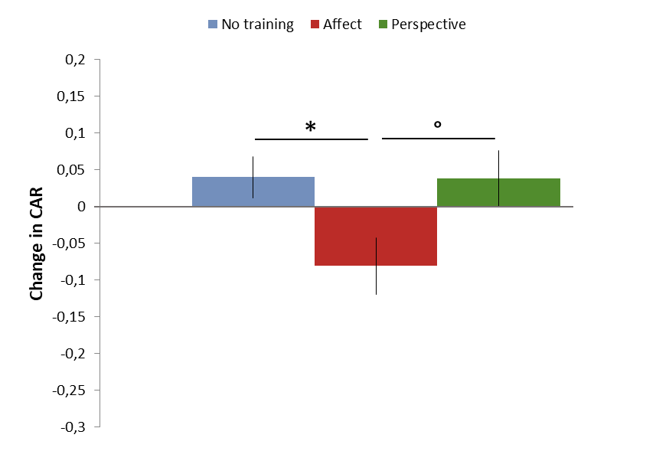
Fig. S2
Effect of mental training on the cortisol awakening response (T1-T3). A LMM investigating change in CAR from T1 to T3, shows a significant reduction in CAR after Affect relative to no training (p = 0.011), and a marginal reduction relative to Perspective training (p = 0.068). Mean difference scores depicted by the model are plotted; error bars represent standard errors. °: trend at 0.05 < p ≤ 0.10; *: significant at p ≤ 0.05

Because there was a marginal effect of training sequence on the diurnal slope (F₅₉₁ = 2.49, p = 0.059), we here additionally plot diurnal slope change trajectories in all cohorts over time (Fig. S3). These show opposite developments of diurnal slope in TC1 and TC2 depending on whether Affect was trained before or after the Perspective Module.

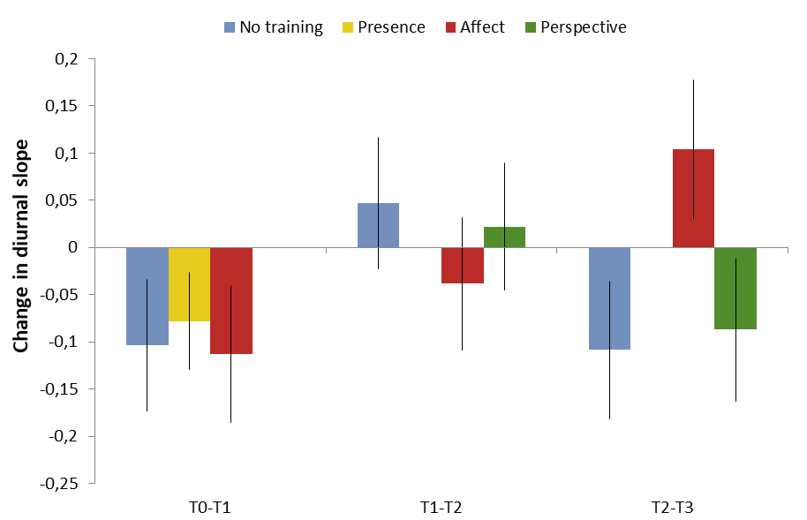
Fig. S3
Mean diurnal slope change trajectories in all cohorts over time. Depending on whether Affect was trained before (in TC1) or after Perspective (in TC2), TC1 and TC2 showed opposite developments of diurnal cortisol slope

Analyses of subjective experience
Summary scores of diurnal subjective experience did not change over the duration of the ReSource study, that is, there was no influence of type of training (all F ≤ 2.38, all p ≥ 0.070), time of testing (all F ≤ 1.98, all p > 0.10) and training sequence (all F ≤ 2.34, p ≥ 0.072; Table S5, Fig. S4).

Table S5
Omnibus F-tests in a LMM examining training effects on (A) affect, (B) arousal, (C) stress event ratio, (D) stress intensity and (E) stress coping
 | (A) Affect |  | (B) Arousal
 | F (df) | p | F (df) | P
Fixed effects
Intercept | 18.38 (474) | < 0.001 | 5.64 (525) | < 0.001
Interval | 1.37 (457) | > 0.25 | 1.47 (461) | > 0.20
Module | 0.27 (541) | > 0.80 | 2.28 (561) | 0.079
Interval*module | 1.03 (569) | > 0.35 | 1.08 (568) | > 0.35
S1 | 1.37 (641) | > 0.20 | 17.51 (637) | < 0.001
 | Estimate (SE) |  | Estimate (SE)
Covariance parameters
AR1 diagonal | 0.78 (0.05) |  | 0.91 (0.06)
AR1 rho | -0.45 (0.05) |  | -0.49 (0.04)
 | (C) Stress event ratio |  | (D) Stress intensity
 | F (df) | p | F (df) | p
Fixed effects
Intercept | 4.76 (323) | < 0.05 | 0.42 (232) | > 0.50
Interval | 0.23 (455) | > 0.75 | 1.98 (266) | > 0.10
Module | 1.05 (552) | > 0.35 | 1.04 (284) | > 0.35
Interval*module | 2.34 (564) | 0.072 | 0.70 (301) | > 0.50
Age | 1.24 (302) | > 0.25
Sex | 2.14 (306) | > 0.10
Sleep duration | 0.03 (637) | > 0.85
S1 | 10.18 (635) | < 0.01 | 0.43 (326) | > .50
 | Estimate (SE) |  | Estimate (SE)
Covariance parameters
AR1 diagonal | 0.04 (0.00) |  | 11.09 (0.98)
AR1 rho | -0.49 (0.04) |  | -0.51 (0.06)
 | (E) Stress coping
 | F (df) |  | p
Fixed effects
Intercept | 0.49 (222) |  | > 0.45
Interval | 0.49 (279) |  | > 0.60
Module | 2.38 (287) |  | 0.070
Interval*module | 0.37 (313) |  | > 0.75
 | Estimate (SE)
Covariance parameters
AR1 diagonal | 12.40 (1.02)
AR1 rho | -0.41 (0.07)
Note. S1 = awakening sample; SE = standard error.

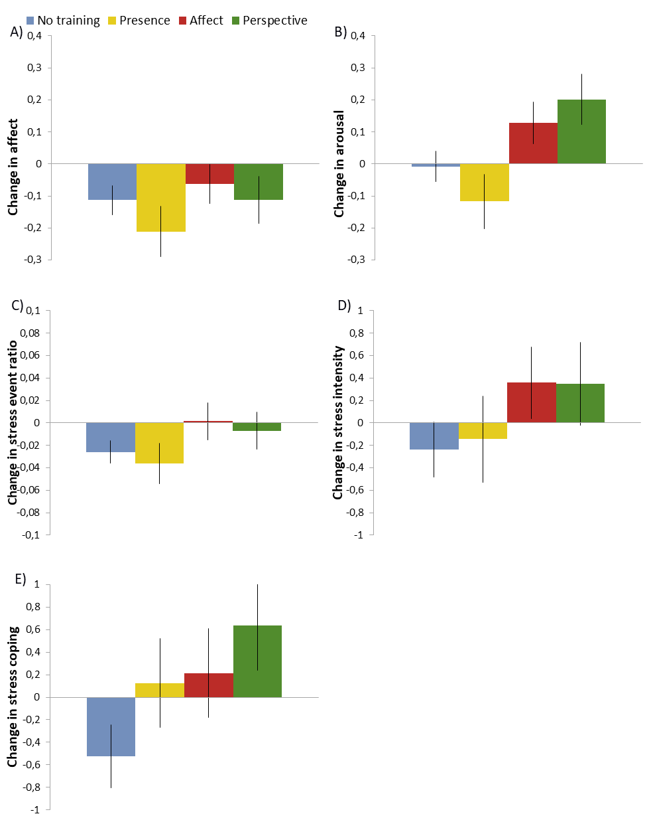
Fig. S4
Effect of mental training on summary scores of subjective experience (T0-T3). No significant effects of mental training were found on (A) affect, (B) arousal, (C) stress event ratio, (D) stress intensity and (E) stress coping. Mean difference scores depicted by the model are plotted; error bars represent standard errors
Supplementary References
Russell, J.A., Weiss, A., Mendelsohn, G.A., 1989. Affect Grid: A single-item scale of pleasure and arousal. Journal of Personality and Social Psychology, 57, 493–502.

