Change in Mindfulness Profiles after Mindfulness-Based Cognitive Therapy for Major Depressive Disorder

Supplementary materials
The supplementary materials consists of supplementary results and supplementary tables. The supplementary results consists of a detailed description on model selection, results of the sensitivity analysis regarding the freely estimated variant 4-profile LTA model, and the results of the sensitivity analysis concerning the imputed datasets.

Details on model selection

Cross-sectional LPAs
Cross-sectional LPAs showed, based on the BIC, that a 4-profile solution fitted the data best pre- and post-treatment, followed by a 3-profile solution (Table 2). The BLRT was significant up to five latent profiles at baseline, and six latent profiles at post-treatment, while the SABIC favored 7 profiles at baseline and 6 post-treatment (Table 2). However, model solutions with 6 or more profiles contained groups at pre- and post-treatment with less than 25 participants, which is considered a minimal group size regarding reliability used in LPAs (Lubke & Neale, 2006). Upon deciding on the number of profiles we also considered theory and previous research. In most previous LPAs in non-clinical (Bravo et al., 2016; Bravo et al., 2018; Calvete et al., 2020; Ford et al., 2020; Kimmes et al., 2017; Lecuona et al., 2022; Pearson et al., 2015; Sahdra et al., 2017; Stanmyre et al., 2022; Zhang et al., 2019) and clinical samples (Gu et al., 2020; Lam et al., 2018; Wang et al., 2022) a 4-profile solution was consistently reported as most optimal, and those four profiles related in a meaningful way to measures of mental health relevant to MDD (Gu et al., 2020). Thus, based on the BIC for the baseline LPAs, and previous cross-sectional studies we started the LTA from a 4-profile solution and compared this to a 3- and 5-profile solution.

Deciding upon the number of profiles for the LTA model
The BIC, AIC, and entropy for the LTA models are presented in Table 3. While considering invariant (mean-restricted) models, the BIC was in favor of the 4-profile solution while the AIC was in favor of the 5-profile solution. For the variant models (means freely estimated) the BIC was in favor of the 3-profile solution while the AIC was in favor of a 5-profile solution. When inspecting the profile solutions of the different models two things became clear: At first, free estimation of the FFMQ subscale means at each time point did result into almost identical profile structures at both time points for the 3-, 4-, and 5-profile LTA models. In other words, free estimation did not change the meaning of those profiles (Table 5/6, Figure 1/2, Supplementary Table S1-S4, Supplementary Figure S1-S4. Secondly, when comparing the 3-, 4-, and 5-profile solutions it could be concluded that going from three to four profiles yields one extra distinct profile with meaningful scores across the different FFMQ facets (a ‘Non-judgmentally aware’ profile arises (Figure 1-2, Supplementary Figure S1-S2)). In addition, a considerable number of the 25 possible transition paths of the 5-profile LTA model have transition probabilities close to zero (invariant 5-profile model: 3 paths; variant 5-profile model: 6 paths, compared to invariant 4-profile model: 1 path; variant 4-profile model: 4 paths), which may complicate estimation of distal outcomes across transition paths because parameters in (nearly) empty paths cannot be estimated. Taken together, the 4-profile LTA model was deemed to be the most meaningful and pragmatic solution.

Longitudinal measurement invariance
Longitudinal measurement invariance for the 4-profile LTA model did not hold based upon the chi-square difference test on loglikelihood-values (Table 4). However, as mentioned above, the profiles from the variant 4-profile model (means freely estimated) look very similar at both time points (Figure 2, Table 6). Because the profiles before and after MBCT in the variant model are almost identical in terms of FFMQ subscale scores, it seems acceptable to assume that those profiles have the same meaning over time. Therefore, we decided to first run the restricted invariant 4-profile LTA model, which facilitates interpretation. Moreover, we assessed the relation between transitions over time to treatment outcome with this model. To be complete, results from the free variant 4-profile LTA model will be reported as a sensitivity analysis. Differences in results between these two approaches will be explicated.

Sensitivity analysis: freely estimated 4-profile LTA model
The freely estimated variant LTA model (for structure and latent profile membership, see Table 6; Figure 2) resulted in more patients whose mindfulness profile did not change (versus those for whom their profile changed) when compared to the restricted invariant LTA model (Supplementary Table S5; Table 7). In fact for only 59 out of 500 patients (12%) change in profile took place within variant LTA model. Other differences between the models are that (i) for the variant model no change in the ‘Judgmentally observing’ profile to another profile took place (transition probability of 1.00), whereas 26% changed from ‘Judgmentally observing’ to ‘High mindfulness’ in the restricted invariant LTA model, and (ii) within the variant model a small number of patients (n = 10; 2% of all patients) did actually change to ‘Very low mindfulness’ and 6 patients with ‘High mindfulness’ (5.1%) changed to ‘Non-judgmentally aware’.
Next, we assessed whether (and how) specific transition paths were related to treatment outcome in terms of residualized change scores of mental health outcomes, which are presented in Supplementary Table S6. Many transition paths had to be excluded to successfully estimate the residualized change scores across the different paths because transition probabilities of those paths were (near) zero. For convenience, latent transition probabilities were reported to three decimal points (Supplementary Table S5/S17-S18) because this level of precision is meaningful as it shows which transition paths were nearly zero and, as a result, needed to be excluded. We ran the model several times. First, we included all paths with transition probabilities of ≥ 0.05which led to nonconvergence of the model. Then, we ran the model by excluding all paths with transition probabilities < 0.083, which resulted in successful model estimation. We subsequently checked systematically whether one-by-one inclusion of the paths < 0.083 resulted in successful parameter estimation, but this was not the case. Thus, we only estimated residualized change scores across 5 transition paths, of which 4 were paths that consisted of patients that did not change in mindfulness profile. Results show that patients whose profile changed from ‘Very low mindfulness’ to ‘High mindfulness’ showed a greater than average improvement in mental health (compared to the full sample) in terms of decrease in depressive symptoms (and change in other mental health outcomes) whereas patients who kept a ‘Very low mindfulness’ profile after MBCT scored worse in terms of decrease in depressive symptoms compared to the group average. This is in line with findings from the invariant model (Supplementary Table S6-S7). Of note, patients who already had a ‘High mindfulness’ profile before MBCT and kept this ‘High mindfulness’ profile after MBCT also showed greater than average improvement in terms of depressive symptoms (Supplementary Table S6), which differed from the invariant model. Patients with one of the other two profiles ‘Judgmentally observing’ or ‘Non-judgmentally aware’ at baseline that kept that profile did not differ in improvement in depressive symptoms compared to the group average (Supplementary Table S6). Results for the secondary outcome measures were by a large degree in line with depressive symptoms. For some secondary outcomes (i.e., worry, SCS total score) no change in the ‘Judgmentally observing’ profile was related to less than average improvement in mental health in terms of residualized change on those outcomes, consistent with the invariant LTA model.
Thus, we compared invariant and variant LTA models and found that the profiles were similar. However, because most patients improved on all facets of mindfulness after MBCT (Table 1), the model estimation within the variant model resulted in slightly higher means for all mindfulness facets in each profile after MBCT. This may have resulted in relatively more assignment to the same profile before and after MBCT within the variant model. By restricting the model to held means equal across time, the invariant model assigned relatively more patients to a ‘higher’ profile post-MBCT (e.g. ‘High mindfulness) which is more useful to study change over time. This transition to a ‘higher’ profile (considered to represent better mental health) seems to be clinically relevant as this transition was related to a more than average improvement in mental health.

Sensitivity analyses: LTA models using imputed datasets
We first ran invariant and variant 3-,4-,5- profile LTA models on all available data in Mplus, using FIML with MLR estimator. As described within the methods section, if too many data is missing (Mplus Support recommends 0.80 coverage or higher), this approach may lead to unreliable results. Indeed, using all available data within the LTA models resulted in a considerable lower entropy (≥ 0.5 decrease) and lower posterior classification probabilities, i.e. less reliable assignment of patients. Therefore, to assess robustness of results, analyses were repeated with 10 datasets for which missing values were imputed in Mplus. First, latent profile analyses were run to determine the optimal number of profiles at baseline and post-MBCT. Fit indices (Supplementary Table S9) of those models are in line with previous analyses and therefore LTA analyses were run for 3, 4, and 5 latent statuses. With the TYPE = IMPUTATION option within Mplus LTAs for the 10 imputed datasets were conducted in one run. The AIC favors the invariant and variant five-profile solution, while the BIC favors the invariant 5-profile solution and variant 4-profile solution (Supplementary Table S10). Thus, similar to the original analysis, fit criteria for the sensitivity analysis provided mixed results. But, profile solutions of LTA models with imputed datasets were very similar to those found with the primary (n = 500) LTAs (Supplementary Table S11-S16) and the 4-profile solution does show acceptable fit (Supplementary Table S10). Therefore it was decided to continue with the 4-profile LTA solutions.
The transition probabilities of the invariant and variant 4-profile LTA models based on the 10 imputed datasets (Supplementary Table S17-S18) were similar to the original analysis (Table 6, Supplementary Table S5). Thus, a similar trend for change in profiles across time was observed for the original and sensitivity analysis. The only minor difference that could be observed was within the variant LTA models. Within the imputed datasets, the transition probability for ‘Very low mindfulness’ to ‘High mindfulness’ was a bit lower compared to the original variant model, whereas the transition probability for ‘Very low mindfulness’ to ‘Non-judgmentally aware’ was a bit higher (Supplementary Table S5, Supplementary Table S18).
Next, we attempted to estimate the distal outcomes across the transition paths of the invariant and variant LTA models of imputed datasets. The TYPE = IMPUTATION option within Mplus could not be used because upon estimation of the BCH weights for the 10 imputed datasets (separate runs), profile order did not hold across replications (a known limitation of Mplus). To overcome this limitation we ran invariant and variant LTA models for the individual 10 datasets with user-specified starts for the profile-specific means (starts = 0), but this resulted in slightly different model solutions with slightly lower loglikelihood values. Therefore, we decided to estimate the means of residualized change scores across transition paths for invariant and variant models of the first 3 imputed datasets (Supplementary Table S19-S24). The results of these analyses are in line with the original analyses within the full dataset. In general, transition into a profile considered to be related to better mental health at baseline (e.g. from ‘Judgmentally observing’ to ‘High mindfulness’) was related to greater-than-average improvement in mental health, whereas no change in profile was related to less-then-average improvement.
Of note, in some cases using the imputed data led to a less certain estimation of distal outcomes across transition paths (larger standard errors), or even in nonconvergence. To be more specific. For imputed dataset 1, all distal outcomes could be estimated across the profiles within the invariant model, but for the ‘Very low mindfulness’ to ‘High mindfulness’ path, the means of distal outcomes were more extreme than the original scores of the dataset (e.g. for depressive symptoms the mean for this path was -29.4 while the dataset ranged from -23.0 to 26.4), and had large standard errors indicating uncertainty within this transition path. For imputed dataset 2 and 3, it was necessary to close the path from ‘Very low mindfulness’ to ‘High mindfulness’ to ensure that the model converged (Supplementary Table S19-S21). OtherwiSE, the model would not terminate due to a zero-estimated variance within the model. For the variant LTA models with the three imputed datasets, similar difficulties were encountered: a greater uncertainty in some transition paths (large standard errors) and sometimes the necessity of closing additional paths for model convergence (Supplementary Table S22-S24).

Supplementary Tables
Supplementary Table S1
Latent profile membership counts and mean scores on mindfulness facets of the five facet mindfulness questionnaire (FFMQ) across the latent profiles for the 3-class LTA model for which means were restricted across time points.
 | Profile 1 | Profile 2 | Profile 3
Latent profile membership count (n) and proportions at baseline and post-treatment
 | n (proportion) | n (proportion) | n (proportion)
Baseline | 227.97 (0.46) | 163.25 (0.33) | 108.78 (0.22)
Post-treatment | 132.28 (0.26) | 108.13 (0.22) | 259.59 (0.52)
Mindfulness facets (unstandardized scores) at baseline
 | Mean [CI 95%]  (SE, variance) | Mean [CI 95%]  (SE, variance) | Mean [CI 95%]  (SE, variance)
Observing | 2.84 [2.65, 3.04]  (0.10, 0.41) | 4.05 [3.79, 4.30]  (0.13, 0.25) | 3.94 [3.83, 4.04]  (0.05, 0.42)
Describing | 3.00 [2.88, 3.12]  (0.06, 0.58) | 3.38 [3.16, 3.59]  (0.11, 0.67) | 3.75 [3.61, 3.90]  (0.07, 0.46)
Acting with awareness | 2.54 [2.42, 2.66]  (0.06, 0.44) | 2.83 [2.66, 3.01]  (0.09, 0.41) | 3.36 [3.27, 3.44]  (0.05, 0.43)
Non-judging | 2.76 [2.64, 2.89]  (0.06, 0.51) | 2.46 [2.28, 2.64]  (0.09, 0.38) | 3.48 [3.37, 3.58]  (0.05, 0.46)
Non-reactivity | 2.32 [2.24, 2.41]  (0.04, 0.27) | 2.40 [2.30, 2.50]  (0.05, 0.23) | 3.26 [3.14, 3.38]  (0.06, 0.27)
Mindfulness facets (unstandardized scores) at post-treatment
 | Mean [CI 95%]  (SE, variance) | Mean [CI 95%]  (SE, variance) | Mean [CI 95%]  (SE, variance)
Observing | 2.84 [2.65, 3.04]  (0.10, 0.34) | 4.05 [3.79, 4.30]  (0.13, 0.24) | 3.94 [3.83, 4.04]  (0.05, 0.33)
Describing | 3.00 [2.88, 3.12]  (0.06, 0.44) | 3.38 [3.16, 3.59]  (0.11, 0.60) | 3.75 [3.61, 3.90]  (0.07, 0.45)
Acting with awareness | 2.54 [2.42, 2.66]  (0.06, 0.32) | 2.83 [2.66, 3.01]  (0.09, 0.31) | 3.36 [3.27, 3.44]  (0.05, 0.30)
Non-judging | 2.76 [2.64, 2.89]  (0.06, 0.38) | 2.46 [2.28, 2.64]  (0.09, 0.24) | 3.48 [3.37, 3.58]  (0.05, 0.38)
Non-reactivity | 2.32 [2.24, 2.41]  (0.04, 0.28) | 2.40 [2.30, 2.50]  (0.05, 0.19) | 3.26 [3.14, 3.38]  (0.06, 0.25)

Supplementary Table S2
Latent profile membership counts and mean scores on mindfulness facets of the five facet mindfulness questionnaire (FFMQ) across the latent profiles for the 3-class LTA model for which means were freely estimated at each time point

 | Profile 1 | Profile 2 | Profile 3
Latent profile membership count (n) and proportions at baseline and post-treatment
 | n (proportion) | n (proportion) | n (proportion)
Baseline | 140.98 (0.28) | 208.36 (0.42) | 150.66 (0.30)
Post-treatment | 141.34 (0.28) | 157.80 (0.32) | 200.86 (0.40)
Mindfulness facets (unstandardized scores) at baseline
 | Mean [CI 95%]  (SE, variance) | Mean [CI 95%]  (SE, variance) | Mean [CI 95%]  (SE, variance)
Observing | 4.01 [3.82, 4.21]  (0.10, 0.25) | 2.73 [2.57, 2.89]  (0.08, 0.39) | 3.73 [3.58, 3.88]  (0.08, 0.41)
Describing | 3.33 [3.11, 3.56]  (0.12, 0.66) | 2.97 [2.85, 3.10]  (0.07, 0.57) | 3.72 [3.53, 3.92]  (0.10, 0.55)
Acting with awareness | 2.79 [2.59, 2.98]  (0.10, 0.43) | 2.44 [2.32, 2.56]  (0.06, 0.41) | 3.27 [3.13, 3.40]  (0.07, 0.42)
Non-judging | 2.36 [2.16, 2.57]  (0.10, 0.39) | 2.69 [2.56, 2.82]  (0.07, 0.49) | 3.31 [3.16, 3.47]  (0.08, 0.45)
Non-reactivity | 2.24 [2.12, 2.35]  (0.06, 0.20) | 2.20 [2.12, 2.28]  (0.04, 0.25) | 3.02 [2.88, 3.17]  (0.07, 0.28)
Mindfulness facets (unstandardized scores) at post-treatment
 | Mean [CI 95%]  (SE, variance) | Mean [CI 95%]  (SE, variance) | Mean [CI 95%]  (SE, variance)
Observing | 4.19 [4.02, 4.36]  (0.09, 3.44) | 3.02 [2.87, 3.18]  (0.08, 0.34) | 3.98 [3.87, 4.10]  (0.06, 0.31)
Describing | 3.44 [3.23, 3.65]  (0.11, 0.58) | 3.05 [2.92, 3.19]  (0.07, 0.45) | 3.79 [3.62, 3.96]  (0.09, 0.42)
Acting with awareness | 2.97 [2.82, 3.12]  (0.08, 0.31) | 2.66 [2.53, 2.78]  (0.06, 0.32) | 3.41 [3.30, 3.53]  (0.06, 0.31)
Non-judging | 2.67 [2.46, 2.89]  (0.11, 0.31) | 2.81 [2.68, 2.95]  (0.07, 0.38) | 3.61 [3.48, 3.73]  (0.07, 0.37)
Non-reactivity | 2.65 [2.51, 2.80]  (0.08, 0.23) | 2.55 [2.44, 2.66]  (0.06, 0.26) | 3.38 [3.25, 3.51]  (0.07, 0.25)

Supplementary Table S3
Latent profile membership counts and mean scores on mindfulness facets of the five facet mindfulness questionnaire (FFMQ) across the latent profiles for the 5-class LTA model for which means were restricted across time points.
 | Profile 1 | Profile 2 | Profile 3 | Profile 4 | Profile 5
Latent profile membership count (n) and proportions at baseline and post-treatment
 | n (proportion) | n (proportion) | n (proportion) | n (proportion) | n (proportion)
Baseline | 67.07 (0.13) | 85.41 (0.17) | 176.80 (0.35) | 62.48 (0.12) | 108.25 (0.22)
Post-treatment | 63.17 (0.13) | 103.19 (0.21) | 63.25 (0.13) | 180.63 (0.36) | 89.76 (0.18)
Mindfulness facets (unstandardized scores) at baseline
 | Mean [CI 95%]  (SE, variance) | Mean [CI 95%]  (SE, variance) | Mean [CI 95%]  (SE, variance) | Mean [CI 95%]  (SE, variance) | Mean [CI 95%]  (SE, variance)
Observing | 2.90 [2.60, 3.20]  (0.15, 0.49) | 3.56 [3.40, 3.73]  (0.08, 0.12) | 2.82 [2.66, 2.98]  (0.08, 0.40) | 4.11 [3.99, 4.23]  (0.06, 0.38) | 4.28 [4.13, 4.43]  (0.08, 0.19)
Describing | 3.19 [2.94, 3.44]  (0.13, 0.69) | 3.32 [3.08, 3.56]  (0.12, 0.45) | 2.98 [2.85, 3.12]  (0.07, 0.64) | 3.89 [3.73, 4.05]  (0.08, 0.33) | 3.42 [3.22, 3.62]  (0.10, 0.69)
Acting with awareness | 3.26 [3.11, 3.42]  (0.08, 0.23) | 2.88 [2.69, 3.06]  (0.10, 0.19) | 2.21 [2.02, 2.41]  (0.10, 0.26) | 3.44 [3.31, 3.56]  (0.06, 0.54) | 2.94 [2.76, 3.11]  (0.09, 0.48)
Non-judging | 3.47 [3.12, 3.83]  (0.18, 0.52) | 2.80 [2.56, 3.04]  (0.12, 0.18) | 2.49 [2.36, 2.61]  (0.06, 0.38) | 3.56 [3.42, 3.70]  (0.07, 0.48) | 2.53 [2.37, 2.68]  (0.08, 0.47)
Non-reactivity | 2.71 [2.45, 2.98]  (0.13, 0.36) | 2.79 [2.57, 3.02]  (0.12, 0.18) | 2.16 [2.07, 2.24]  (0.05, 0.22) | 3.42 [3.30, 3.53]  (0.06, 0.23) | 2.35 [2.23, 2.47]  (0.06, 0.25)
Mindfulness facets (unstandardized scores) at post-treatment
 | Mean [CI 95%]  (SE, variance) | Mean [CI 95%]  (SE, variance) | Mean [CI 95%]  (SE, variance) | Mean [CI 95%] (SE, variance) | Mean [CI 95%]  (SE, variance)
Observing | 2.90 [2.60, 3.20]  (0.15, 0.28) | 3.56 [3.40, 3.73]  (0.08, 0.17) | 2.82 [2.66, 2.98]  (0.08, 0.40) | 4.11 [3.99, 4.23]  (0.06, 0.22) | 4.28 [4.13, 4.43]  (0.08, 0.20)
Describing | 3.19 [2.94, 3.44]  (0.13, 0.47) | 3.32 [3.08, 3.56]  (0.12, 0.42) | 2.98 [2.85, 3.12]  (0.07, 0.51) | 3.89 [3.73, 4.05]  (0.08, 0.40) | 3.42 [3.22, 3.62]  (0.10, 0.68)
Acting with awareness | 3.26 [3.11, 3.42]  (0.08, 0.14) | 2.88 [2.69, 3.06]  (0.10, 0.13) | 2.21 [2.02, 2.41]  (0.10, 0.23) | 3.44 [3.31, 3.56]  (0.06, 0.33) | 2.94 [2.76, 3.11]  (0.09, 0.36)
Non-judging | 3.47 [3.12, 3.83]  (0.18, 0.42) | 2.80 [2.56, 3.04]  (0.12, 0.18) | 2.49 [2.36, 2.61]  (0.06, 0.41) | 3.56 [3.42, 3.70]  (0.07, 0.37) | 2.53 [2.37, 2.68]  (0.08, 0.34)
Non-reactivity | 2.71 [2.45, 2.98]  (0.13, 0.23) | 2.79 [2.57, 3.02]  (0.12, 0.10) | 2.16 [2.07, 2.24]  (0.05, 0.29) | 3.42 [3.30, 3.53]  (0.06, 0.22) | 2.35 [2.23, 2.47]  (0.06, 0.20)

Supplementary Table S4
Latent profile membership counts and mean scores on mindfulness facets of the five facet mindfulness questionnaire (FFMQ) across the latent profiles for the 5-class LTA model for which means were freely estimated at each time point
 | Profile 1 | Profile 2 | Profile 3 | Profile 4 | Profile 5
Latent profile membership count (n) and proportions at baseline and post-treatment
 | n (proportion) | n (proportion) | n (proportion) | n (proportion) | n (proportion)
Baseline | 64.01 (0.13) | 108.39 (0.22) | 96.91 (0.19) | 117.34 (0.23) | 113.35 (0.23)
Post-treatment | 34.94 (0.07) | 117.98 (0.24) | 150.08 (0.30) | 87.50 (0.18) | 109.50 (0.22)
Mindfulness facets (unstandardized scores) at baseline
 | Mean [CI 95%]  (SE, variance) | Mean [CI 95%]  (SE, variance) | Mean [CI 95%]  (SE, variance) | Mean [CI 95%]  (SE, variance) | Mean [CI 95%]  (SE, variance)
Observing | 2.50 [2.23, 2.78]  (0.14, 0.37) | 2.85 [2.34, 3.37]  (0.26, 0.54) | 3.15 [2.94, 3.36]  (0.11, 0.19) | 4.14 [3.97, 4.32]  (0.09, 0.21) | 3.85 [3.71, 3.99]  (0.07, 0.33)
Describing | 2.97 [2.63, 3.31]  (0.17, 0.72) | 3.07 [2.82, 3.33]  (0.13, 0.61) | 3.01 [2.74, 3.28]  (0.14, 0.50) | 3.35 [3.13, 3.58]  (0.11, 0.66) | 3.90 [3.62, 4.19]  (0.15, 0.37)
Acting with awareness | 1.85 [1.55, 2.14]  (0.15, 0.17) | 3.04 [2.72, 3.36]  (0.17, 0.29) | 2.47 [2.29, 2.66]  (0.10, 0.18) | 2.84 [2.66, 3.03]  (0.10, 0.46) | 3.28 [3.10, 3.46]  (0.09, 0.47)
Non-judging | 2.45 [2.01, 2.88]  (0.22, 0.55) | 3.26 [2.99, 3.54]  (0.14, 0.48) | 2.39 [2.20, 2.58]  (0.10, 0.15) | 2.39 [2.19, 2.58]  (0.10, 0.44) | 3.26 [3.10, 3.43]  (0.08, 0.42)
Non-reactivity | 1.96 [1.76, 2.16]  (0.10, 0.34) | 2.48 [2.27, 2.68]  (0.11, 0.22) | 2.25 [2.10, 2.40]  (0.08, 0.12) | 2.22 [2.06, 2.38]  (0.09, 0.22) | 3.14 [2.98, 3.29]  (0.08, 0.26)
Mindfulness facets (unstandardized scores) at post-treatment
 | Mean [CI 95%]  (SE, variance) | Mean [CI 95%]  (SE, variance) | Mean [CI 95%]  (SE, variance) | Mean [CI 95%]  (SE, variance) | Mean [CI 95%]  (SE, variance)
Observing | 2.59 [2.28, 2.91]  (0.16, 0.47) | 4.30 [4.15, 4.44]  (0.07, 0.20) | 4.15 [4.02, 4.28]  (0.07, 0.20) | 3.35 [3.15, 3.56]  (0.11, 0.19) | 3.24 [2.82, 3.67]  (0.22, 0.32)
Describing | 2.93 [2.60, 3.27]  (0.17, 0.62) | 3.47 [3.27, 3.67]  (0.10, 0.63) | 3.92 [3.65, 4.20]  (0.14, 0.34) | 3.09 [2.88, 3.30]  (0.11, 0.35) | 3.27 [3.07, 3.46]  (0.10, 0.44)
Acting with awareness | 2.03 [1.85, 2.21]  (0.09, 0.19) | 2.99 [2.84, 3.14]  (0.08, 0.33) | 3.47 [3.30, 3.64]  (0.09, 0.34) | 2.64 [2.49, 2.79]  (0.08, 0.16) | 3.20 [3.06, 3.33]  (0.07, 0.15)
Non-judging | 2.74 [2.34, 3.15]  (0.21, 0.71) | 2.70 [2.52, 2.89]  (0.09, 0.35) | 3.60 [3.45, 3.75]  (0.08, 0.38) | 2.53 [2.34, 2.73]  (0.10, 0.14) | 3.37 [3.12, 3.63]  (0.13, 0.32)
Non-reactivity | 2.20 [1.99, 2.42]  (0.11, 0.29) | 2.62 [2.43, 2.80]  (0.10, 0.25) | 3.48 [3.35, 3.62]  (0.07, 0.23) | 2.61 [2.43, 2.79]  (0.09, 0.20) | 2.92 [2.72, 3.12]  (0.10, 0.19)
Note. The model identified almost identical profiles at both time points, but denomination of equivalent profiles may differ across time points. See also Supplementary Figure S4.

Supplementary table S5
Latent transition probabilities based on the estimated model for the 4-class LTA model for which means were freely estimated across time points

 |  | Post-MBCT
 |  | Very low mindfulness | Judgmentally observing | Non-judgmentally aware | High mindfulness
Baseline | Very low mindfulness | 0.713 | 0.000 | 0.082 | 0.206
Baseline | Judgmentally observing | 0.000 | 1.000 | 0.000 | 0.000
Baseline | Non-judgmentally aware | 0.081 | 0.000 | 0.848 | 0.071
Baseline | High mindfulness | 0.000 | 0.000 | 0.051 | 0.949

Supplementary table S6
Residualized change scores for the mental health outcomes for the transition paths of the 4-class LTA model for which means were freely estimated across time points
 |  | Post-MBCT |  |  |  | Wald-chi square test statistic  (df = 4)
 |  | Depressive symptoms (BDI-II) |  |  |  | 65.64 ***
 |  | Mean (SE) | Mean (SE) | Mean (SE) | Mean (SE) | 65.64 ***
 |  | Very low mindfulness | Judgmentally observing | Non-judgmentally aware | High mindfulness | 65.64 ***
Baseline | Very low mindfulness | 3.39 (0.99)** |  |  | -8.46 (1.24)*** | 65.64 ***
Baseline | Judgmentally observing |  | 0.23 (0.69) |  |  | 65.64 ***
Baseline | Non-judgmentally aware |  |  | 0.55 (0.71) |  | 65.64 ***
Baseline | High mindfulness |  |  |  | -1.50 (0.50)** | 65.64 ***
 |  | Overall functioning (OQ45) |  |  |  | 83.90 ***
 |  | Very low mindfulness | Judgmentally observing | Non-judgmentally aware | High mindfulness | 83.90 ***
Baseline | Very low mindfulness | 6.83 (1.68)*** |  |  | -22.55 (2.94)*** | 83.90 ***
Baseline | Judgmentally observing |  | 0.93 (1.35) |  |  | 83.90 ***
Baseline | Non-judgmentally aware |  |  | 1.53 (1.44) |  | 83.90 ***
Baseline | High mindfulness |  |  |  | -3.35 (1.42)* | 83.90 ***
 |  | Worry (PSWQ) |  |  |  | 139.38 ***
 |  | Very low mindfulness | Judgmentally observing | Non-judgmentally aware | High mindfulness | 139.38 ***
Baseline | Very low mindfulness | 4.72 (0.71)*** |  |  | -12.62 (1.41)*** | 139.38 ***
Baseline | Judgmentally observing |  | 1.70 (0.75)* |  |  | 139.38 ***
Baseline | Non-judgmentally aware |  |  | -0.04 (0.68) |  | 139.38 ***
Baseline | High mindfulness |  |  |  | -2.32 (0.78)** | 139.38 ***
 |  | Self-compassion total score |  |  |  | 164.07 ***
 |  | Very low mindfulness | Judgmentally observing | Non-judgmentally aware | High mindfulness | 164.07 ***
Baseline | Very low mindfulness | -2.89 (0.39)*** |  |  | 6.57 (0.78) *** | 164.07 ***
Baseline | Judgmentally observing |  | -1.20 (0.31)*** |  |  | 164.07 ***
Baseline | Non-judgmentally aware |  |  | -0.05 (0.32) |  | 164.07 ***
Baseline | High mindfulness |  |  |  | 1.89 (0.39)*** | 164.07 ***
Note. Asterisks indicate whether the mean residualized change score for a specific transition path is significantly different from 0 (i.e. whether Mean/SE ≥ 1.96 or ≤ -1.96). A (significant) negative residualized change score for depressive symptoms, overall function and worry would indicate that patients within such a path did better (improved more) compared to the full sample average (residualized change score of 0) whereas a positive residualized change score would indicate that patients did worse compared to full sample. For self-compassion the meaning of negative and positive residualized change scores are inverted.
* p < 0.05; ** p < 0.01; *** p < 0.001

Supplementary Table S7
Pair-wise comparison between transition paths that represent patients whose mindfulness profile changed versus those patients that did not change in mindfulness profile

‘Very low mindfulness’ to ‘High Mindfulness’ compared to no change in ‘Very low mindfulness’ # | Residualized changes of patients whose mindfulness profile changed – Residualized change of patients that did not change in profile (SE) | p-value
Depressive symptoms (BDI-II) | -11.85 (1.56) | < 0.001
General Functioning (OQ-45) | -29.38 (3.36) | < 0.001
Worry (PSWQ) | -17.34 (1.57) | < 0.001
Self-Compassion (SCS) total score | 9.45 (0.87) | < 0.001

Supplementary Table S8
Prediction of transition path by baseline demographic and clinical characteristics
Predictor | p-value for overall test of association across transition paths starting from the same baseline profile$
Sex | VLM = 0.45; JO = 0.63; NJA = 0.86
Age# | VLM = 0.14; JO = 0.29; NJA = 0.98
Education | VLM = 0.84; JO = 0.21; NJA = 0.16
Work status | VLM = 0.54; JO = 0.21; NJA = 0.78
Depression status | VLM = 0.80; JO = 0.15; NJA = 0.53
Psychiatric comorbidity (No/1/more) | VLM = 0.19; JO = 0.65; NJA = 0.08
Somatic comorbidity (Yes/No) | VLM = 0.94; JO = 0.68; NJA = 0.33
$ The overall chi-square test assesses whether demographic and/or clinical characteristics (Predictor) predict a differential transition path for patients with the same baseline profile, i.e., VLM-VLM, VLM-JO, VLM-NJA, VLM-HM; and JO-JO, JO-HM; and NJA-NJA, NJA-HM. Because all patients with HM at baseline kept HM, this analysis was not performed.
# Age groups are: 18-39; 40-59; 60+
VLM = Very low mindfulness, JO = Judgmentally observing, NJA = Non-judgmentally aware, HM = High mindfulness

Supplementary Table S9
Fit indices for 1 through 8 profiles for cross-sectional latent profile analyses before and after Mindfulness-Based Cognitive Therapy (MBCT) with 10 imputed datasets
Number of profiles | df | BIC  Mean (SD) | SABIC  Mean (SD) | Entropy
Baseline
2 | 16 | 8412.73 (2.54) | 8361.92 (2.54) | 0.57
3 | 22 | 8379.45 (2.86) | 8309.59 (2.86) | 0.60
4 | 28 | 8353.56 (3.00) | 8264.64 (3.00) | 0.62
5 | 34 | 8369.94 (2.81) | 8261.97 (2.81) | 0.58
6 | 40 | 8379.86 (2.64) | 8252.84 (2.64) | 0.59
7 | 46 | 8395.87 (2.80) | 8249.80 (2.80) | 0.64
8 | 52 | 8421.39 (3.43) | 8256.27 (3.43) | 0.63
Post-treatment
2 | 16 | 7752.42 (79.61) | 7701.62 (79.61) | 0.65
3 | 22 | 7709.23 (79.58) | 7639.39 (79.58) | 0.66
4 | 28 | 7701.17 (80.69) | 7612.26 (80.69) | 0.64
5 | 34 | 7693.34 (75.51) | 7585.37 (75.51) | 0.65
6 | 40 | 7720.69 (78.62) | 7593.68 (78.62) | 0.68
7 | 46 | 7731.06 (79.51) | 7584.99 (79.51) | 0.65
8 | 52 | 7754.54 (75.66) | 7589.42 (75.66) | 0.68
Note. df = degrees of freedom, BIC = Bayesian Information Criterion, SABIC = sample-size adjusted Bayesian Information Criterion

Supplementary Table S10
Fit indices of latent transition models with 10 imputed datasets for 3 through 5 profiles
Number of profiles | df | AIC  Mean (SD) | BIC  Mean (SD) | Entropy
Invariant (mean-restricted) models
3 | 53 | 15638.65 (73.82) | 15883.80 (73.82) | 0.76
4 | 75 | 15406.72 (76.51) | 15753.63 (76.51) | 0.76
5 | 99 | 15287.93 (76.46) | 15745.84 (76.46) | 0.78
Variant (free) models
3 | 68 | 15500.81 (80.49) | 15815.34 (80.49) | 0.82
4 | 95 | 15312.81 (79.01) | 15752.22 (79.01) | 0.80
5 | 124 | 15219.37 (73.91) | 15792.92 (73.91) | 0.83
Note. df = degrees of freedom, AIC = Akaike Information Criterion, BIC = Bayesian Information Criterion

Supplementary Table S11
Latent profile membership counts and mean scores on mindfulness facets of the five facet mindfulness questionnaire (FFMQ) across the latent profiles for the 3-class LTA models of 10 imputed datasets for which means were restricted across time points.
 | Profile 1 | Profile 2 | Profile 3
Latent profile membership count (n) and proportions at baseline and post-treatment
 | n (proportion) | n (proportion) | n (proportion)
Baseline | 166.08 (0.22) | 268.68 (0.36) | 319.24 (0.42)
Post-treatment | 377.19 (0.50) | 180.33 (0.24) | 196.48 (0.26)
Mindfulness facets (unstandardized scores) at baseline
 | Mean [CI 95%]  (SE, variance) | Mean [CI 95%]  (SE, variance) | Mean [CI 95%]  (SE, variance)
Observing | 3.92 [3.81, 4.04]  (0.06, 0.44)) | 3.98 [3.71, 4.25]  (0.14, 0.29) | 2.84 [2.61, 3.07]  (0.12, 0.46)
Describing | 3.80 [3.67, 3.93]  (0.07, 0.45) | 3.43 [3.22, 3.64]  (0.11, 0.65) | 3.00 [2.85, 3.15]  (0.08, 0.65)
Acting with awareness | 3.37 [3.28, 3.65]  (0.05, 0.40) | 2.86 [2.68, 3.05]  (0.09, 0.39) | 2.51 [2.39, 2.63]  (0.06, 0.42)
Non-judging | 3.51 [3.40, 3.63]  (0.06, 0.44) | 2.50 [2.33, 2.66]  (0.08, 0.34) | 2.79 [2.65, 2.93]  (0.07, 0.53)
Non-reactivity | 3.30 [3.19, 3.41]  (0.06, 0.26) | 2.44 [2.32, 2.56]  (0.06, 0.24) | 2.38 [2.28, 2.48]  (0.05, 0.34)
Mindfulness facets (unstandardized scores) at post-treatment
 | Mean [CI 95%]  (SE, variance) | Mean [CI 95%]  (SE, variance) | Mean [CI 95%]  (SE, variance)
Observing | 3.92 [3.81, 4.04]  (0.06, 0.38)) | 3.98 [3.71, 4.25]  (0.14, 0.28) | 2.84 [2.61, 3.07]  (0.12, 0.35)
Describing | 3.80 [3.67, 3.93]  (0.07, 0.48) | 3.43 [3.22, 3.64]  (0.11, 0.58) | 3.00 [2.85, 3.15]  (0.08, 0.47)
Acting with awareness | 3.37 [3.28, 3.65]  (0.05, 0.30) | 2.86 [2.68, 3.05]  (0.09, 0.30) | 2.51 [2.39, 2.63]  (0.06, 0.32)
Non-judging | 3.51 [3.40, 3.63]  (0.06, 0.39) | 2.50 [2.33, 2.66]  (0.08, 0.25) | 2.79 [2.65, 2.93]  (0.07, 0.42)
Non-reactivity | 3.30 [3.19, 3.41]  (0.06, 0.25) | 2.44 [2.32, 2.56]  (0.06, 0.20) | 2.38 [2.28, 2.48]  (0.05, 0.29)

Supplementary Table S12
Latent profile membership counts and mean scores on mindfulness facets of the five facet mindfulness questionnaire (FFMQ) across the latent profiles for the 3-class LTA models of 10 imputed datasets for which means were freely estimated at each time point

 | Profile 1 | Profile 2 | Profile 3
Latent profile membership count (n) and proportions at baseline and post-treatment
 | n (proportion) | n (proportion) | n (proportion)
Baseline | 288.59 (0.38) | 236.11 (0.31) | 229.29 (0.30)
Post-treatment | 238.73 (0.32) | 230.74 (0.31) | 284.53 (0.38)
Mindfulness facets (unstandardized scores) at baseline
 | Mean [CI 95%]  (SE, variance) | Mean [CI 95%]  (SE, variance) | Mean [CI 95%]  (SE, variance)
Observing | 2.73 [2.47, 2.99]  (0.13, 0.43) | 3.95 [3.69, 4.22]  (0.14, 0.28) | 3.70 [3.54, 3.86]  (0.08, 0.45)
Describing | 2.97 [2.83, 3.11]  (0.07, 0.64) | 3.38 [3.14, 3.63]  (0.13, 0.66) | 3.78 [3.54, 4.03]  (0.13, 0.53)
Acting with awareness | 2.41 [2.29, 2.53]  (0.06, 0.39) | 2.81 [2.60, 3.02]  (0.11, 0.41) | 3.26 [3.14, 3.39]  (0.06, 0.39)
Non-judging | 2.70 [2.55, 2.86]  (0.08, 0.51) | 2.41 [2.24, 2.59]  (0.09, 0.34) | 3.34 [3.19, 3.49]  (0.08, 0.44)
Non-reactivity | 2.24 [2.14, 2.34]  (0.05, 0.31) | 2.30 [2.16, 2.44]  (0.07, 0.22) | 3.09 [2.95, 3.24]  (0.07, 0.28)
Mindfulness facets (unstandardized scores) at post-treatment
 | Mean [CI 95%]  (SE, variance) | Mean [CI 95%]  (SE, variance) | Mean [CI 95%]  (SE, variance)
Observing | 3.01 [2.79, 3.22]  (0.11, 0.35) | 4.11 [3.85, 4.37]  (0.13, 0.26) | 4.00 [3.84, 4.16]  (0.08, 0.35)
Describing | 3.06 [2.91, 3.22]  (0.08, 0.49) | 3.49 [3.26, 3.73]  (0.12, 0.57) | 3.83 [3.66, 4.00]  (0.09, 0.44)
Acting with awareness | 2.63 [2.51, 2.76]  (0.06, 0.31) | 2.99 [2.78, 3.19]  (0.11, 0.30) | 3.45 [3.33, 3.58]  (0.06, 0.30)
Non-judging | 2.86 [2.67, 3.04]  (0.10, 0.43) | 2.70 [2.49, 2.91]  (0.11, 0.31) | 3.65 [3.50, 3.79]  (0.07, 0.37)
Non-reactivity | 2.58 [2.46, 2.71]  (0.10, 0.29) | 2.67 [2.52, 2.83]  (0.08, 0.23) | 3.43 [3.30, 3.56]  (0.07, 0.25)

Supplementary Table S13
Latent profile membership counts and mean scores on mindfulness facets of the five facet mindfulness questionnaire (FFMQ) across the latent profiles for the 4-class LTA models of 10 imputed datasets for which means were restricted across time points.
 | Profile 1; Very low mindfulness | Profile 3; Judgmentally observing | Profile 2; Non-judgmentally aware | Profile 4; High mindfulness
Latent profile membership count (n) and proportions at baseline and post-treatment

 | n (proportion) | n (proportion) | n (proportion) | n (proportion)
Baseline | 267.50 (0.35) | 215.32 (0.29) | 180.80 (0.24) | 90.38 (0.12)
Post-treatment | 104.01 (0.14) | 254.99 (0.34) | 151.66 (0.20) | 243.32 (0.32)
Mindfulness facets (unstandardized scores) at baseline
 | Mean [CI 95%]  (SE, variance) | Mean [CI 95%]  (SE, variance) | Mean [CI 95%]  (SE, variance) | Mean [CI 95%]  (SE, variance)
Observing | 2.83 [2.62, 3.04]  (0.11, 0.49) | 4.16 [3.82, 4.50]  (0.18, 0.24) | 3.37 [3.01, 3.73]  (0.18, 0.43) | 4.09 [3.87, 4.30]  (0.11, 0.31)
Describing | 2.97 [2.82, 3.13]  (0.08, 0.67) | 3.53 [2.28, 3.79]  (0.13, 0.68) | 3.29 [3.03, 3.55]  (.55, 0.45) | 3.97 [3.73, 4.22]  (0.13, 0.42)
Acting with awareness | 2.28 [2.01, 2.56]  (0.14, 0.33) | 2.93 [2.71, 3.15]  (0.11, 0.45) | 3.01 [2.87, 3.15]  (0.07, 0.25) | 3.50 [3.33, 3.68]  (0.09, 0.31)
Non-judging | 2.57 [2.35, 2.79]  (0.11, 0.49) | 2.48 [2.25, 2.72]  (0.12, 0.37) | 3.13 [2.82, 3.45]  (0.16, 0.33) | 3.63 [3.43, 3.84]  (0.11, 0.39)
Non-reactivity | 2.16 [2.03, 2.30]  (0.07, 0.26) | 2.43 [2.28, 2.58]  (0.08, 0.27) | 2.87 [2.65, 3.08]  (0.11, 0.21) | 3.47 [3.25, 3.68]  (0.11, 0.24)
Mindfulness facets (unstandardized scores) at post-treatment
 | Mean [CI 95%]  (SE, variance) | Mean [CI 95%]  (SE, variance) | Mean [CI 95%]  (SE, variance) | Mean [CI 95%]  (SE, variance)
Observing | 2.83 [2.62, 3.04]  (0.11, 0.42) | 4.16 [3.82, 4.50]  (0.18, 0.25) | 3.37 [3.01, 3.73]  (0.18, 0.35) | 4.09 [3.87, 4.30]  (0.11, 0.31)
Describing | 2.97 [2.82, 3.13]  (0.08, 0.53) | 3.53 [2.28, 3.79]  (0.13, 0.62) | 3.29 [3.03, 3.55]  (0.55, 0.45) | 3.97 [3.73, 4.22]  (0.13, 0.42)
Acting with awareness | 2.28 [2.01, 2.56]  (0.14, 0.26) | 2.93 [2.71, 3.15]  (0.11, 0.34) | 3.01 [2.87, 3.15]  (0.07, 0.19) | 3.50 [3.33, 3.68]  (0.09, 0.31)
Non-judging | 2.57 [2.35, 2.79]  (0.11, 0.43) | 2.48 [2.25, 2.72]  (0.12, 0.29) | 3.13 [2.82, 3.45]  (0.16, 0.33) | 3.63 [3.43, 3.84]  (0.11, 0.39)
Non-reactivity | 2.16 [2.03, 2.30]  (0.07, 0.25) | 2.43 [2.28, 2.58]  (0.08, 0.23) | 2.87 [2.65, 3.08]  (0.11, 0.16) | 3.47 [3.25, 3.68]  (0.11, 0.24)

Supplementary Table S14
Latent profile membership counts and mean scores on mindfulness facets of the five facet mindfulness questionnaire (FFMQ) across the latent profiles for the 4-class LTA models of 10 imputed datasets for which means were freely estimated at each time point
 | Very low mindfulness | Judgmentally observing | Non-judgmentally aware | High mindfulness
Latent profile membership count (n) and proportions at baseline
 | n (proportion) | n (proportion) | n (proportion)) | n (proportion)
Baseline | 195.78 (0.26) | 208.97 (0.28) | 210.66 (0.28) | 138.59 (0.18)
Post-treatment | 144.91 (0.19) | 197.61 (0.26) | 237.78 (0.32) | 173.69 (0.23)
Mindfulness facets (unstandardized scores) at baseline
 | Mean [CI 95%]  (SE, variance) | Mean [CI 95%]  (SE, variance) | Mean [CI 95%]  (SE, variance) | Mean [CI 95%]  (SE, variance)
Observing | 2.75 [2.51, 2.99]  (0.13, 0.45) | 4.01 [3.72, 4.29]  (0.15, 0.27) | 3.12 [2.37, 3.86]  (0.38, 0.52) | 3.89 [3.58, 4.20]  (0.16, 0.38)
Describing | 2.94 [2.74, 3.15]  (0.11, 0.70) | 3.44 [3.14, 3.73]  (0.15, 0.65) | 3.13 [2.77, 3.49]  (0.18, 0.53) | 4.10 [3.76, 4.45]  (0.18, 0.29)
Acting with awareness | 2.15 [1.87, 2.44]  (0.14, 0.28) | 2.84 [2.63, 3.05]  (0.11, 0.41) | 2.96 [2.75, 3.17]  (0.11, 0.28) | 3.37 [3.00, 3.75]  (0.19, 0.45)
Non-judging | 2.44 [2.13, 2.75]  (0.16, 0.40) | 2.38 [2.05, 2.71]  (0.17, 0.32) | 3.21 [2.91, 3.52]  (0.16, 0.39) | 3.36 [3.14, 3.57]  (0.11, 0.47)
Non-reactivity | 2.10 [1.98, 2.22]  (0.06, 0.28) | 2.30 [2.10, 2.50]  (0.10, 0.24) | 2.65 [2.30, 3.01]  (0.18, 0.26) | 3.23 [3.05, 3.41]  (0.09, 0.27)
Mindfulness facets (unstandardized scores) at post-treatment
 | Mean [CI 95%]  (SE, variance) | Mean [CI 95%]  (SE, variance) | Mean [CI 95%]  (SE, variance) | Mean [CI 95%]  (SE, variance)
Observing | 2.98 [2.70, 3.27]  (0.15, 0.40) | 4.15 [3.85, 4.46]  (0.15, 0.26) | 3.44 [2.79, 4.09]  (0.33, 0.37) | 4.22 [3.90, 4.53]  (0.16, 0.27)
Describing | 3.03 [2.80, 3.26]  (0.12, 0.52_ | 3.54 [3.28, 3.79]  (0.13, 0.58) | 3.29 [2.94, 3.64]  (0.18, 0.43) | 4.08 [3.70, 4.45]  (0.19, 0.33)
Acting with awareness | 2.36 [2.02, 2.71]  (0.18, 0.25) | 2.98 [2.76, 3.21]  (0.12, 0.31) | 3.13 [2.92, 3.35]  (0.11, 0.19) | 3.58 [3.25, 3.92]  (0.17, 0.32)
Non-judging | 2.61 [2.31, 2.92]  (0.16, 0.38) | 2.65 [2.28, 3.02]  (0.19, 0.30) | 3.38 [3.00, 3.75]  (0.19, 0.35) | 3.66 [3.46, 3.96]  (0.10, 0.40)
Non-reactivity | 2.38 [2.18, 2.59]  (0.10, 0.26) | 2.64 [2.41, 2.87]  (0.12, 0.23) | 3.05 [2.69, 3.41]  (0.18, 0.20) | 3.54 [3.38, 3.70]  (0.08, 0.26)

Supplementary Table S15
Latent profile membership counts and mean scores on mindfulness facets of the five facet mindfulness questionnaire (FFMQ) across the latent profiles for the 5-class LTA models of 10 imputed datasets for which means were restricted across time points.
 | Profile 1 | Profile 2 | Profile 3 | Profile 4 | Profile 5
Latent profile membership count (n) and proportions at baseline and post-treatment
 | n (proportion) | n (proportion) | n (proportion) | n (proportion) | n (proportion)
Baseline | 239.42 (0.32) | 96.40 (0.13) | 158.91 (0.21) | 145.32 (0.19) | 113.95 (0.15)
Post-treatment | 90.19 (0.12) | 250.34 (0.33) | 180.60 (0.24) | 123.95 (0.16) | 108.93 (0.14)
Mindfulness facets (unstandardized scores) at baseline
 | Mean [CI 95%]  (SE, variance) | Mean [CI 95%]  (SE, variance) | Mean [CI 95%]  (SE, variance) | Mean [CI 95%]  (SE, variance) | Mean [CI 95%]  (SE, variance)
Observing | 2.86 [2.62, 3.10]  (0.12, 0.45) | 4.10 [3.98, 4.23]  (0.07, 0.39) | 3.55 [3.34, 3.76]  (0.11, 0.19) | 4.29 [4.12, 4.46]  (0.09, 0.20) | 2.95 [2.54, 3.37]  (0.21, 0.56)
Describing | 3.01 [2.84, 3.19]  (0.09, 0.71) | 3.97 [3.78, 4.16]  (0.10, 0.33) | 3.40 [3.14, 3.67]  (0.13, 0.39) | 3.51 [3.29, 3.74]  (0.12, 0.74) | 3.05 [2.66, 3.44]  (0.20, 0.70)
Acting with awareness | 2.21 [2.02, 2.40]  (0.10, 0.28) | 3.48 [3.32, 3.63]  (0.08, 0.47) | 2.88 [2.66, 3.09]  (0.11, 0.18) | 2.99 [2.80, 3.19]  (0.10, 0.48) | 3.10 [2.82, 3.39]  (0.15, 0.34)
Non-judging | 2.44 [2.24, 2.63]  (0.10, 0.39) | 3.60 [3.42, 3.77]  (0.09, 0.50) | 2.81 [2.47, 3.15]  (0.18, 0.18) | 2.53 [2.33, 2.72]  (0.10, 0.43) | 3.49 [3.23, 3.75]  (0.13, 0.38)
Non-reactivity | 2.14 [2.03, 2.26]  (0.06, 0.25) | 3.46 [3.30, 3.61]  (0.08, 0.24) | 2.78 [2.50, 3.06]  (0.14, 0.18) | 2.40 [2.23, 2.57]  (0.09, 0.28) | 2.80 [2.51, 3.08]  (0.15, 0.39)
Mindfulness facets (unstandardized scores) at post-treatment
 | Mean [CI 95%]  (SE, variance) | Mean [CI 95%]  (SE, variance) | Mean [CI 95%]  (SE, variance) | Mean [CI 95%] (SE, variance) | Mean [CI 95%]  (SE, variance)
Observing | 2.86 [2.62, 3.10]  (0.12, 0.42) | 4.10 [3.98, 4.23]  (0.07, 0.27) | 3.55 [3.34, 3.76]  (0.11, 0.23) | 4.29 [4.12, 4.46]  (0.09, 0.22) | 2.95 [2.54, 3.37]  (0.21, 0.36)
Describing | 3.01 [2.84, 3.19]  (0.09, 0.55) | 3.97 [3.78, 4.16]  (0.10, 0.39) | 3.40 [3.14, 3.67]  (0.13, 0.43) | 3.51 [3.29, 3.74]  (0.12, 0.68) | 3.05 [2.66, 3.44]  (0.20, 0.45)
Acting with awareness | 2.21 [2.02, 2.40]  (0.10, 0.24) | 3.48 [3.32, 3.63]  (0.08, 0.31) | 2.88 [2.66, 3.09]  (0.11, 0.16) | 2.99 [2.80, 3.19]  (0.10, 0.37) | 3.10 [2.82, 3.39]  (0.15, 0.22)
Non-judging | 2.44 [2.24, 2.63]  (0.10, 0.40) | 3.60 [3.42, 3.77]  (0.09, 0.37) | 2.81 [2.47, 3.15]  (0.18, 0.21) | 2.53 [2.33, 2.72]  (0.10, 0.34) | 3.49 [3.23, 3.75]  (0.13, 0.39)
Non-reactivity | 2.14 [2.03, 2.26]  (0.06, 0.26) | 3.46 [3.30, 3.61]  (0.08, 0.23) | 2.78 [2.50, 3.06]  (0.14, 0.13) | 2.40 [2.23, 2.57]  (0.09, 0.23) | 2.80 [2.51, 3.08]  (0.15, 0.29)

Supplementary Table S16
Latent profile membership counts and mean scores on mindfulness facets of the five facet mindfulness questionnaire (FFMQ) across the latent profiles for the 5-class LTA models of 10 imputed datasets for which means were freely estimated at each time point
 | Profile 1 | Profile 2 | Profile 3 | Profile 4 | Profile 5
Latent profile membership count (n) and proportions at baseline and post-treatment
 | n (proportion) | n (proportion) | n (proportion) | n (proportion) | n (proportion)
Baseline | 186.43 (0.25) | 134.70 (0.18) | 203.64 (0.27) | 142.56 (0.19) | 86.68 (0.11)
Post-treatment | 192.56 (0.26) | 147.74 (0.20) | 173.75 (0.23) | 153.96 (0.20) | 85.98 (0.11)
Mindfulness facets (unstandardized scores) at baseline
 | Mean [CI 95%]  (SE, variance) | Mean [CI 95%]  (SE, variance) | Mean [CI 95%]  (SE, variance) | Mean [CI 95%]  (SE, variance) | Mean [CI 95%]  (SE, variance)
Observing | 2.80 [2.50, 3.09]  (0.15, 0.42) | 3.54 [3.20, 3.87]  (0.17, 0.24) | 4.04 [3.74, 4.33]  (0.15, 0.27) | 2.82 [2.24, 3.41]  (0.30, 0.51) | 4.02 [3.50, 4.54]  (0.27, 0.41)
Describing | 3.00 [2.74, 3.26]  (0.13, 0.68) | 3.61 [2.96, 4.26]  (0.33, 0.31) | 3.40 [3.14, 3.66]  (0.13, 0.68) | 2.93 [2.45, 3.41]  (0.24, 0.59) | 4.25 [3.96, 4.53]  (0.15, 0.27)
Acting with awareness | 2.17 [1.84, 2.49]  (0.16, 0.28) | 2.97 [2.69, 3.25]  (0.14, 0.22) | 2.86 [2.63, 3.10]  (0.12, 0.42) | 2.88 [2.60, 3.16]  (0.14, 0.40) | 3.59 [2.99, 4.20]  (0.31, 0.42)
Non-judging | 2.37 [2.12, 2.62]  (0.13, 0.35) | 3.10 [2.71, 3.49]  (0.20, 0.26) | 2.40 [2.14, 2.65]  (0.13, 0.35) | 3.29 [2.85, 3.74]  (0.23, 0.44) | 3.47 [3.10, 3.83]  (0.19, 0.56)
Non-reactivity | 2.11 [1.98, 2.24]  (0.07, 0.28) | 2.92 [2.55, 3.28]  (0.19, 0.21) | 2.29 [2.10, 2.48]  (0.10, 0.24) | 2.52 [2.19, 2.86]  (0.17, 0.31) | 3.30 [2.96, 3.64]  (0.17, 0.30)
Mindfulness facets (unstandardized scores) at post-treatment
 | Mean [CI 95%]  (SE, variance) | Mean [CI 95%]  (SE, variance) | Mean [CI 95%]  (SE, variance) | Mean [CI 95%]  (SE, variance) | Mean [CI 95%]  (SE, variance)
Observing | 4.16 [3.88, 4.44]  (0.14, 0.26) | 3.02 [2.71, 3.34]  (0.16, 0.39) | 3.91 [3.66, 4.16]  (0.13, 0.18) | 3.22 [2.76, 3.67]  (0.23, 0.36) | 4.45 [3.42, 5.48]  (0.52, 0.26)
Describing | 3.50 [3.22, 3.78]  (0.14, 0.60) | 3.08 [2.85, 3.31]  (0.12, 0.52) | 3.78 [3.13, 4.43]  (0.33, 0.30) | 3.13 [2.68, 3.58]  (0.23, 0.43) | 4.22 [3.80, 4.64]  (0.21, 0.34)
Acting with awareness | 3.00 [2.79, 3.20]  (0.11, 0.31) | 2.38 [2.05, 2.71]  (0.17, 0.25) | 3.28 [3.01, 3.56]  (0.14, 0.18) | 3.11 [2.88, 3.34]  (0.12, 0.22) | 3.80 [2.09, 5.51]  (0.87, 0.36)
Non-judging | 2.66 [2.31, 3.00]  (0.18, 0.30) | 2.57 [2.30, 2.84]  (0.14, 0.33) | 3.51 [3.16, 3.86]  (0.18, 0.31) | 3.41 [3.00, 3.81]  (0.20, 0.39) | 3.68 [3.17, 4.20]  (0.26, 0.50)
Non-reactivity | 2.62 [2.38, 2.86]  (0.12, 0.22) | 2.41 [2.19, 2.63]  (0.11, 0.26) | 3.37 [3.04, 3.71]  (0.17, 0.18) | 2.96 [2.66, 3.25]  (0.15, 0.24) | 3.58 [2.48, 4.69]  (0.57, 0.32)
Note. The model identified almost identical profiles at both time points, but denomination of equivalent profiles may differ across time points.

Supplementary Table S17
Latent transition probabilities based on the estimated model for the 4-class LTA model of 10 imputed datasets for which means were restricted across time points
 |  | Post-MBCT
 |  | Very low mindfulness | Judgmentally observing | Non-judgmentally aware | High mindfulness
Baseline | Very low mindfulness | 0.389 | 0.001 | 0.504 | 0.106
Baseline | Judgmentally observing | 0.000 | 0.845 | 0.000 | 0.155
Baseline | Non-judgmentally aware | 0.001 | 0.000 | 0.559 | 0.440
Baseline | High mindfulness | 0.000 | 0.000 | 0.000 | 1.000

Supplementary Table S18
Latent transition probabilities based on the estimated model for the 4-class LTA model of 10 imputed datasets for which means were freely estimated across time points
 |  | Post-MBCT
 |  | Very low mindfulness | Judgmentally observing | Non-judgmentally aware | High mindfulness
Baseline | Very low mindfulness | 0.681 | 0.000 | 0.235 | 0.085
Baseline | Judgmentally observing | 0.002 | 0.948 | 0.000 | 0.050
Baseline | Non-judgmentally aware | 0.053 | 0.000 | 0.883 | 0.063
Baseline | High mindfulness | 0.001 | 0.000 | 0.037 | 0.962

Supplementary Table S19
Residualized change scores for the mental health outcomes for the transition paths of the 4-class LTA models with imputed dataset 1 for which means were restricted across time points
 |  | Post-MBCT |  |  |  | Wald-chi square test statistic  (df = 7)
 |  | Depressive symptoms (BDI-II) |  |  |  | 93.56 ***
 |  | Mean (SE) | Mean (SE) | Mean (SE) | Mean (SE) | 93.56 ***
 |  | Very low mindfulness | Judgmentally observing | Non-judgmentally aware | High mindfulness | 93.56 ***
Baseline | Very low mindfulness | 4.85 (0.99)*** |  | -3.56 (0.85)*** | -29.4 (24.18) | 93.56 ***
Baseline | Judgmentally observing |  | 2.25 (0.63)*** |  | -7.94 (1.87)*** | 93.56 ***
Baseline | Non-judgmentally aware |  |  | 2.54 (0.74)** | -5.30 (1.31)*** | 93.56 ***
Baseline | High mindfulness |  |  |  | 0.14 (0.65) | 93.56 ***
 |  | Overall functioning (OQ45) |  |  |  | 118.92 ***
 |  | Very low mindfulness | Judgmentally observing | Non-judgmentally aware | High mindfulness | 118.92 ***
Baseline | Very low mindfulness | 10.53 (1.72)*** |  | -7.12 (1.63)*** | -90.54 (77.21) | 118.92 ***
Baseline | Judgmentally observing |  | 5.88 (1.18)*** |  | -18.34 (4.00)*** | 118.92 ***
Baseline | Non-judgmentally aware |  |  | 5.16 (1.41)*** | -8.11 (2.59)** | 118.92 ***
Baseline | High mindfulness |  |  |  | -3.18 (1.84) | 118.92 ***
 |  | Worry (PSWQ) |  |  |  | 114.90 ***
 |  | Very low mindfulness | Judgmentally observing | Non-judgmentally aware | High mindfulness | 114.90 ***
Baseline | Very low mindfulness | 6.47 (0.79)*** |  | -3.40 (0.84)*** | -54.36 (47.0) | 114.90 ***
Baseline | Judgmentally observing |  | 3.03 (0.66)*** |  | -6.49 (2.13)** | 114.90 ***
Baseline | Non-judgmentally aware |  |  | 1.63 (0.91) | -4.59 (1.80)* | 114.90 ***
Baseline | High mindfulness |  |  |  | -1.83 (1.00) | 114.90 ***
 |  | Self-compassion total score |  |  |  | 250.47 ***
 |  | Very low mindfulness | Judgmentally observing | Non-judgmentally aware | High mindfulness | 250.47 ***
Baseline | Very low mindfulness | -3.85 (0.38)*** |  | 1.86 (0.44)*** | 19.56 (16.42) | 250.47 ***
Baseline | Judgmentally observing |  | -2.20 (0.28)*** |  | 6.09 (1.16)*** | 250.47 ***
Baseline | Non-judgmentally aware |  |  | -1.12 (0.39)** | 3.70 (0.81)*** | 250.47 ***
Baseline | High mindfulness |  |  |  | 1.67 (0.42)*** | 250.47 ***
Note. Asterisks indicate whether the mean residualized change score for a specific transition path is significantly different from 0 (i.e. whether Mean/SE ≥ 1.96 or ≤ -1.96). A (significant) negative residualized change score for depressive symptoms, overall function and worry would indicate that patients within such a path did better (improved more) compared to the full sample average (residualized change score of 0) whereas a positive residualized change score would indicate that patients did worse compared to full sample. For self-compassion the meaning of negative and positive residualized change scores are inverted.
* p < 0.05; ** p < 0.01; *** p < 0.001

Supplementary Table S20
Residualized change scores for the mental health outcomes for the transition paths of the 4-class LTA models with imputed dataset 2 for which means were restricted across time points
 |  | Post-treatment |  |  |  | Wald-chi square test statistic  (df = 6)
 |  | Depressive symptoms (BDI-II) |  |  |  | 81.46 ***
 |  | Mean (SE) | Mean (SE) | Mean (SE) | Mean (SE) | 81.46 ***
 |  | Very low mindfulness | Judgmentally observing | Non-judgmentally aware | High mindfulness | 81.46 ***
Baseline | Very low mindfulness | 5.46 (1.08)*** |  | -3.22 (0.85)*** |  | 81.46 ***
Baseline | Judgmentally observing |  | 2.01 (0.71)** |  | -7.71 (2.11)*** | 81.46 ***
Baseline | Non-judgmentally aware |  |  | 3.71 (0.88)*** | -4.21 (1.13)*** | 81.46 ***
Baseline | High mindfulness |  |  |  | -0.14 (0.61) | 81.46 ***
 |  | Overall functioning (OQ45) |  |  |  | 117.40 ***
 |  | Very low mindfulness | Judgmentally observing | Non-judgmentally aware | High mindfulness | 117.40 ***
Baseline | Very low mindfulness | 11.88 (1.86)*** |  | -6.32 (1.56)*** |  | 117.40 ***
Baseline | Judgmentally observing |  | 5.44 (1.40)*** |  | -17.19 (3.92)*** | 117.40 ***
Baseline | Non-judgmentally aware |  |  | 7.90 (1.64)*** | -9.24 (2.39)*** | 117.40 ***
Baseline | High mindfulness |  |  |  | -1.43 (1.47) | 117.40 ***
 |  | Worry (PSWQ) |  |  |  | 115.34 ***
 |  | Very low mindfulness | Judgmentally observing | Non-judgmentally aware | High mindfulness | 115.34 ***
Baseline | Very low mindfulness | 6.29 (0.84)*** |  | -2.41 (0.82)** |  | 115.34 ***
Baseline | Judgmentally observing |  | 4.02 (0.75)*** |  | -5.84 (2.44)* | 115.34 ***
Baseline | Non-judgmentally aware |  |  | 1.77 (0.86)* | -7.78 (1.58)*** | 115.34 ***
Baseline | High mindfulness |  |  |  | -0.27 (0.93) | 115.34 ***
 |  | Self-compassion total score |  |  |  | 230.25 ***
 |  | Very low mindfulness | Judgmentally observing | Non-judgmentally aware | High mindfulness | 230.25 ***
Baseline | Very low mindfulness | -3.93 (0.41)*** |  | 1.49 (0.42)*** |  | 230.25 ***
Baseline | Judgmentally observing |  | -2.44 (0.34)*** |  | 3.88 (1.14)** | 230.25 ***
Baseline | Non-judgmentally aware |  |  | -2.09 (0.40)*** | 4.74 (0.71)*** | 230.25 ***
Baseline | High mindfulness |  |  |  | 0.91 (0.39)* | 230.25 ***
Note. Asterisks indicate whether the mean residualized change score for a specific transition path is significantly different from 0 (i.e. whether Mean/SE ≥ 1.96 or ≤ -1.96). A (significant) negative residualized change score for depressive symptoms, overall function and worry would indicate that patients within such a path did better (improved more) compared to the full sample average (residualized change score of 0) whereas a positive residualized change score would indicate that patients did worse compared to full sample. For self-compassion the meaning of negative and positive residualized change scores are inverted.
* p < 0.05; ** p < 0.01; *** p < 0.001

Supplementary Table S21
Residualized change scores for the mental health outcomes for the transition paths of the 4-class LTA models with imputed dataset 3 for which means were restricted across time points
 |  | Post-treatment |  |  |  | Wald-chi square test statistic  (df = 6)
 |  | Depressive symptoms (BDI-II) |  |  |  | 75.50 ***
 |  | Mean (SE) | Mean (SE) | Mean (SE) | Mean (SE) | 75.50 ***
 |  | Very low mindfulness | Judgmentally observing | Non-judgmentally aware | High mindfulness | 75.50 ***
Baseline | Very low mindfulness | 4.32 (0.96)*** |  | -3.02 (0.77)*** |  | 75.50 ***
Baseline | Judgmentally observing |  | 1.69 (0.66)* |  | -21.59 (28.09) | 75.50 ***
Baseline | Non-judgmentally aware |  |  | 3.06 (0.85)*** | -5.39 (0.92)*** | 75.50 ***
Baseline | High mindfulness |  |  |  | 0.65 (0.58) | 75.50 ***
 |  | Overall functioning (OQ45) |  |  |  | 78.15 ***
 |  | Very low mindfulness | Judgmentally observing | Non-judgmentally aware | High mindfulness | 78.15 ***
Baseline | Very low mindfulness | 9.17 (1.66)*** |  | -5.59 (1.52)*** |  | 78.15 ***
Baseline | Judgmentally observing |  | 3.63 (1.24)** |  | -25.42 (39.31) | 78.15 ***
Baseline | Non-judgmentally aware |  |  | 6.08 (1.55)*** | -9.19 (1.99)*** | 78.15 ***
Baseline | High mindfulness |  |  |  | -1.47 (1.77) | 78.15 ***
 |  | Worry (PSWQ) |  |  |  | 116.50 ***
 |  | Very low mindfulness | Judgmentally observing | Non-judgmentally aware | High mindfulness | 116.50 ***
Baseline | Very low mindfulness | 6.28 (0.74)*** |  | -2.87 (0.84)** |  | 116.50 ***
Baseline | Judgmentally observing |  | 3.00 (0.74)*** |  | -13.25 (19.76) | 116.50 ***
Baseline | Non-judgmentally aware |  |  | 2.76 (0.91)** | -6.27 (1.33)*** | 116.50 ***
Baseline | High mindfulness |  |  |  | -1.63 (1.15) | 116.50 ***
 |  | Self-compassion total score |  |  |  | 251.74 ***
 |  | Very low mindfulness | Judgmentally observing | Non-judgmentally aware | High mindfulness | 251.74 ***
Baseline | Very low mindfulness | -3.75 (0.34) |  | 1.55 (0.38)*** |  | 251.74 ***
Baseline | Judgmentally observing |  | -1.99 (0.30)*** |  | 14.96 (18.43) | 251.74 ***
Baseline | Non-judgmentally aware |  |  | -1.98 (0.39)*** | 4.56 (0.57)*** | 251.74 ***
Baseline | High mindfulness |  |  |  | 1.22 (0.44)** | 251.74 ***
Note. Asterisks indicate whether the mean residualized change score for a specific transition path is significantly different from 0 (i.e. whether Mean/SE ≥ 1.96 or ≤ -1.96). A (significant) negative residualized change score for depressive symptoms, overall function and worry would indicate that patients within such a path did better (improved more) compared to the full sample average (residualized change score of 0) whereas a positive residualized change score would indicate that patients did worse compared to full sample. For self-compassion the meaning of negative and positive residualized change scores are inverted.
* p < 0.05; ** p < 0.01; *** p < 0.001

Supplementary Table S22
Residualized change scores for the mental health outcomes for the transition paths of the 4-class LTA model with imputed dataset 1 for which means were freely estimated across time points
 |  | Post-MBCT |  |  |  | Wald-chi square test statistic  (df = 5)
 |  | Depressive symptoms (BDI-II) |  |  |  | 38.04 ***
 |  | Mean (SE) | Mean (SE) | Mean (SE) | Mean (SE) | 38.04 ***
 |  | Very low mindfulness | Judgmentally observing | Non-judgmentally aware | High mindfulness | 38.04 ***
Baseline | Very low mindfulness | 2.54 (0.67)*** |  | -13.35 (3.34)*** |  | 38.04 ***
Baseline | Judgmentally observing |  | 1.02 (0.56) |  |  | 38.04 ***
Baseline | Non-judgmentally aware |  |  | -0.02 (0.55) |  | 38.04 ***
Baseline | High mindfulness |  |  |  | -1.27 (0.57)* | 38.04 ***
 |  | Overall functioning (OQ45) |  |  |  | 53.46 ***
 |  | Very low mindfulness | Judgmentally observing | Non-judgmentally aware | High mindfulness | 53.46 ***
Baseline | Very low mindfulness | 5.94 (1.22)*** |  | -34.59 (7.85)*** |  | 53.46 ***
Baseline | Judgmentally observing |  | 2.83 (1.04) ** |  |  | 53.46 ***
Baseline | Non-judgmentally aware |  |  | 0.38 (1.02) |  | 53.46 ***
Baseline | High mindfulness |  |  |  | -4.44 (1.60)** | 53.46 ***
 |  | Worry (PSWQ) |  |  |  | 83.54 ***
 |  | Very low mindfulness | Judgmentally observing | Non-judgmentally aware | High mindfulness | 83.54 ***
Baseline | Very low mindfulness | 4.04 (0.58)*** |  | -17.20 (4.01)*** |  | 83.54 ***
Baseline | Judgmentally observing |  | 2.02 (0.60) ** |  |  | 83.54 ***
Baseline | Non-judgmentally aware |  |  | -1.26 (0.66) |  | 83.54 ***
Baseline | High mindfulness |  |  |  | -2.30 (0.84)** | 83.54 ***
 |  | Self-compassion total score |  |  |  | 167.26 ***
 |  | Very low mindfulness | Judgmentally observing | Non-judgmentally aware | High mindfulness | 167.26 ***
Baseline | Very low mindfulness | -2.63 (0.28)*** |  | 10.21 (2.27)*** |  | 167.26 ***
Baseline | Judgmentally observing |  | -1.40 (0.26)*** |  |  | 167.26 ***
Baseline | Non-judgmentally aware |  |  | 0.73 (0.28) ** |  | 167.26 ***
Baseline | High mindfulness |  |  |  | 2.29 (0.40)*** | 167.26 ***
Note. Asterisks indicate whether the mean residualized change score for a specific transition path is significantly different from 0 (i.e. whether Mean/SE ≥ 1.96 or ≤ -1.96). A (significant) negative residualized change score for depressive symptoms, overall function and worry would indicate that patients within such a path did better (improved more) compared to the full sample average (residualized change score of 0) whereas a positive residualized change score would indicate that patients did worse compared to full sample. For self-compassion the meaning of negative and positive residualized change scores are inverted.
* p < 0.05; ** p < 0.01; *** p < 0.001

Supplementary Table S23
Residualized change scores for the mental health outcomes for the transition paths of the 4-class LTA model with imputed dataset 2 for which means were freely estimated across time points
 |  | Post-MBCT |  |  |  | Wald-chi square test statistic  (df = 5
 |  | Depressive symptoms (BDI-II) |  |  |  | 57.70***
 |  | Mean (SE) | Mean (SE) | Mean (SE) | Mean (SE) | 57.70***
 |  | Very low mindfulness | Judgmentally observing | Non-judgmentally aware | High mindfulness | 57.70***
Baseline | Very low mindfulness | 2.82 (0.94) ** |  | -41.34 (41.22) | -8.68 (1.58)*** | 57.70***
Baseline | Judgmentally observing |  | 1.26 (0.56)* |  |  | 57.70***
Baseline | Non-judgmentally aware |  |  | -0.00 (0.53) |  | 57.70***
Baseline | High mindfulness |  |  |  | -1.61 (0.47) ** | 57.70***
 |  | Overall functioning (OQ45) |  |  |  | 66.67***
 |  | Very low mindfulness | Judgmentally observing | Non-judgmentally aware | High mindfulness | 66.67***
Baseline | Very low mindfulness | 7.12 (1.67) *** |  | -75.42 (75.66) | -22.76 (3.17)*** | 66.67***
Baseline | Judgmentally observing |  | 3.60 (1.08)** |  |  | 66.67***
Baseline | Non-judgmentally aware |  |  | 0.07 (1.00) |  | 66.67***
Baseline | High mindfulness |  |  |  | -4.61 (1.11) *** | 66.67***
 |  | Worry (PSWQ) |  |  |  | 124.59***
 |  | Very low mindfulness | Judgmentally observing | Non-judgmentally aware | High mindfulness | 124.59***
Baseline | Very low mindfulness | 3.44 (0.82) *** |  | -32.90 (32.72) | -12.17 (2.03)*** | 124.59***
Baseline | Judgmentally observing |  | 3.13 (0.56)*** |  |  | 124.59***
Baseline | Non-judgmentally aware |  |  | -1.45 (0.55) |  | 124.59***
Baseline | High mindfulness |  |  |  | -2.47 (0.70) *** | 124.59***
 |  | Self-compassion total score |  |  |  | 180.59***
 |  | Very low mindfulness | Judgmentally observing | Non-judgmentally aware | High mindfulness | 180.59***
Baseline | Very low mindfulness | -2.58 (0.40) *** |  | 22.80 (22.88) | 6.10 (1.06)*** | 180.59***
Baseline | Judgmentally observing |  | -1.74 (0.27)*** |  |  | 180.59***
Baseline | Non-judgmentally aware |  |  | 0.31 (0.26) |  | 180.59***
Baseline | High mindfulness |  |  |  | 2.15 (0.30) *** | 180.59***
Note. Asterisks indicate whether the mean residualized change score for a specific transition path is significantly different from 0 (i.e. whether Mean/SE ≥ 1.96 or ≤ -1.96). A (significant) negative residualized change score for depressive symptoms, overall function and worry would indicate that patients within such a path did better (improved more) compared to the full sample average (residualized change score of 0) whereas a positive residualized change score would indicate that patients did worse compared to full sample. For self-compassion the meaning of negative and positive residualized change scores are inverted.
* p < 0.05; ** p < 0.01; *** p < 0.001

Supplementary Table S24
Residualized change scores for the mental health outcomes for the transition paths of the 4-class LTA model with imputed dataset 3 for which means were freely estimated across time points
 |  | Post-MBCT |  |  |  | Wald-chi square test statistic  (df = 5
 |  | Depressive symptoms (BDI-II) |  |  |  | 57.70***
 |  | Mean (SE) | Mean (SE) | Mean (SE) | Mean (SE) | 57.70***
 |  | Very low mindfulness | Judgmentally observing | Non-judgmentally aware | High mindfulness | 57.70***
Baseline | Very low mindfulness | 3.46 (0.80)*** |  | -12.97 (4.56)** | -8.90 (2.09)*** | 57.70***
Baseline | Judgmentally observing |  | 0.79 (0.54) |  |  | 57.70***
Baseline | Non-judgmentally aware |  |  | 0.32 (0.58) |  | 57.70***
Baseline | High mindfulness |  |  |  | -1.03 (0.46)* | 57.70***
 |  | Overall functioning (OQ45) |  |  |  | 66.67***
 |  | Very low mindfulness | Judgmentally observing | Non-judgmentally aware | High mindfulness | 66.67***
Baseline | Very low mindfulness | 7.16 (1.39) *** |  | -28.91 (9.67)** | -21.89 (5.12)*** | 66.67***
Baseline | Judgmentally observing |  | 1.81 (1.03) |  |  | 66.67***
Baseline | Non-judgmentally aware |  |  | 2.20 (1.10) * |  | 66.67***
Baseline | High mindfulness |  |  |  | -3.05 (1.25)* | 66.67***
 |  | Worry (PSWQ) |  |  |  | 124.59***
 |  | Very low mindfulness | Judgmentally observing | Non-judgmentally aware | High mindfulness | 124.59***
Baseline | Very low mindfulness | 4.81 (0.67)*** |  | -12.38 (4.70)** | -15.36 (2.43)*** | 124.59***
Baseline | Judgmentally observing |  | 1.44 (0.63) * |  |  | 124.59***
Baseline | Non-judgmentally aware |  |  | 0.66 (0.61) |  | 124.59***
Baseline | High mindfulness |  |  |  | -2.61 (0.79)** | 124.59***
 |  | Self-compassion total score |  |  |  | 180.59***
 |  | Very low mindfulness | Judgmentally observing | Non-judgmentally aware | High mindfulness | 180.59***
Baseline | Very low mindfulness | -2.78 (0.32)*** |  | 7.97 (2.68) ** | 7.35 (1.43) *** | 180.59***
Baseline | Judgmentally observing |  | -1.40 (0.25) *** |  |  | 180.59***
Baseline | Non-judgmentally aware |  |  | -0.31 (0.27) |  | 180.59***
Baseline | High mindfulness |  |  |  | 2.19 (0.33) *** | 180.59***
Note. Asterisks indicate whether the mean residualized change score for a specific transition path is significantly different from 0 (i.e. whether Mean/SE ≥ 1.96 or ≤ -1.96). A (significant) negative residualized change score for depressive symptoms, overall function and worry would indicate that patients within such a path did better (improved more) compared to the full sample average (residualized change score of 0) whereas a positive residualized change score would indicate that patients did worse compared to full sample. For self-compassion the meaning of negative and positive residualized change scores are inverted.
* p < 0.05; ** p < 0.01; *** p < 0.001

Supplementary Figures
Supplementary Figure S1
Latent profile structure of 3-class LTA model with restricted facet means of the five facet mindfulness questionnaire (FFMQ) across time
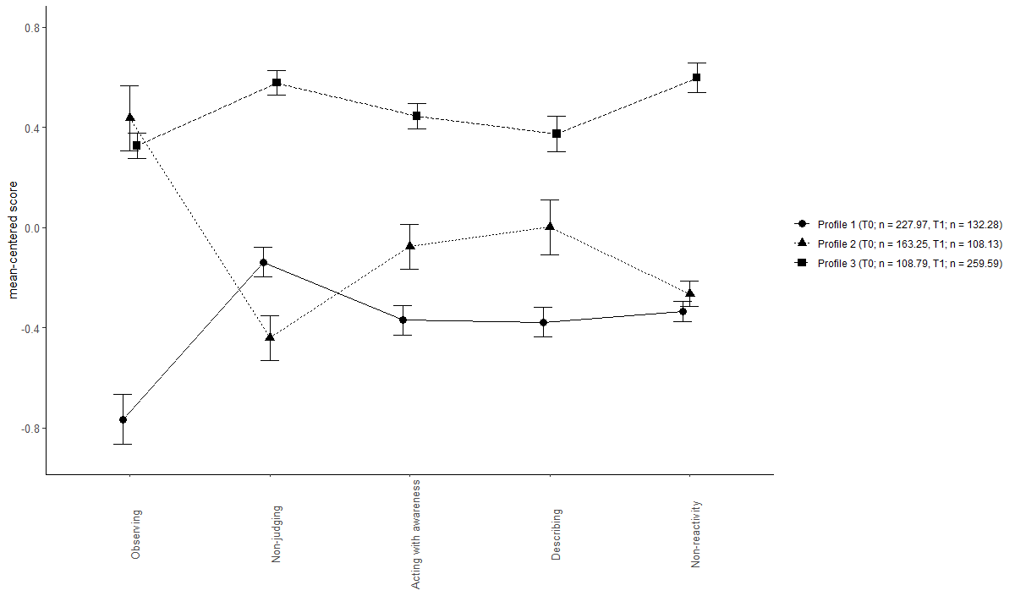
This figure displays the 3-profile solution of the LTA model for which mean scores of the FFMQ facets were held equal across time points (restricted LTA model). FFMQ facet scores were mean-centered across the different profiles. Error bars represent standard errors. The legend shows prevalences to latent profiles at baseline (T0) and post-MBCT (T1) based on the estimated model.

Supplementary Figure S2
Latent profile structure of 3-class LTA model for which facet means of the five facet mindfulness questionnaire (FFMQ) were freely estimated at each time point
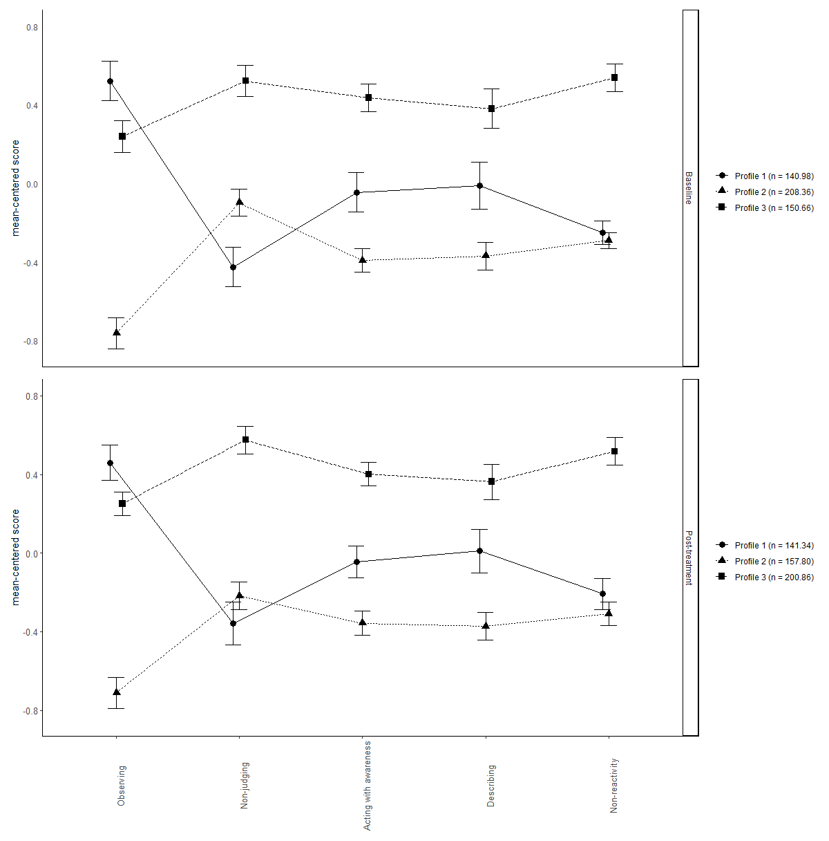
This figure displays the 3-profile solution of the LTA model for which mean scores of the FFMQ facets were freely estimated at both time points. FFMQ facet scores were mean-centered across the different profiles. Error bars represent standard errors. The legend shows prevalences to the latent profiles at baseline (upper panel) and post-MBCT (bottom panel) based on the estimated model.
Supplementary Figure S3
Latent profile structure of 5-class LTA model with restricted facet means of the five facet mindfulness questionnaire (FFMQ) across time
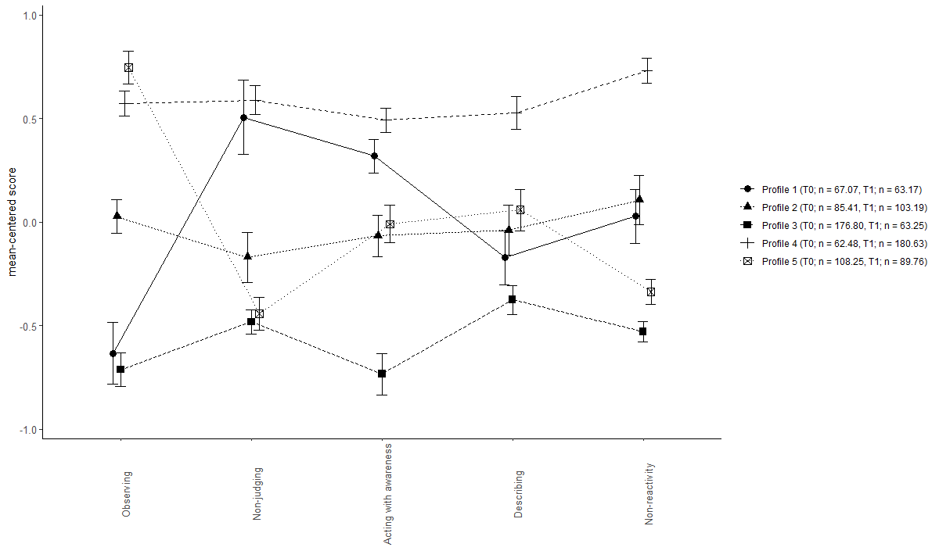
This figure displays the 5-profile solution of the LTA model for which mean scores of the FFMQ facets were held equal across time points (restricted LTA model). FFMQ facet scores were mean-centered across the different profiles. Error bars represent standard errors. The legend shows prevalences to latent profiles at baseline (T0) and post-MBCT (T1) based on the estimated model.

Supplementary Figure S4
Latent profile structure of 5-class LTA model for which facet means of the five facet mindfulness questionnaire (FFMQ) were freely estimated at each time point
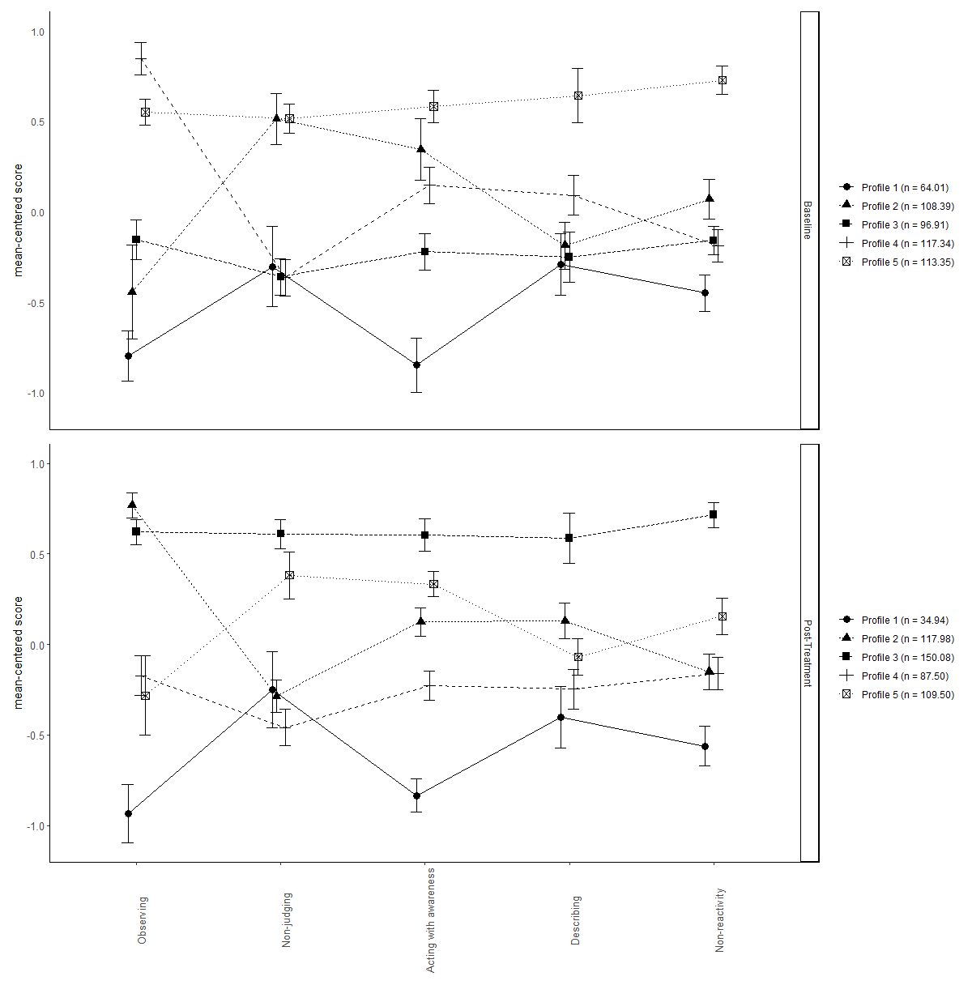
This figure displays the 5-profile solution of the LTA model for which mean scores of the FFMQ facets were freely estimated at baseline and post-MBCT. FFMQ facet scores were mean-centered across the different profiles. Error bars represent standard errors. The legend shows prevalences to the latent profiles at baseline (upper panel) and post-MBCT (bottom panel) based on the estimated model. Note that the model identified almost identical profiles at both time points, but that denomination of equivalent profiles (number assigned by Mplus) may differ across time points.

Availability of data and Mplus code for latent profile analyses
The data collection within the Radboud Data Repository (https://doi.org/10.34973/ffww-3195) contains the data file (.sav) consisting of all variables used in this study (e.g. demographic and clinical information, individual item scores and composite scores of all self-report questionnaires) and three main folders. One of the three main folders ‘N500 complete cases’ contains all files required for the analyses within the sample with patients that had both a pre- and post-treatment measurement. Within this main folder the subfolder ‘LPA’ contains the different cross-sectional LPA models from 2 (c2) up to 8 (c8) latent profiles, and the subfolder ‘LTA’ contains several additional subfolders: ‘LTAs’ contains Mplus files for invariant and variant LTA models with 3, 4 and 5 latent profiles; ‘cprobs_null’ contains the posterior probabilities for the invariant models; ‘cprobs_alt’ contains posterior probabilities for variant models; ‘BCH method’ contains all files required for estimation of distal outcomes using the manual BCH method for the measurement invariant and variant 4-profile model. The third main folder ‘N754 datasets’ contains two subfolders. The subfolder ‘LTAs full dataset (754 – 500) with ML’ contains files required for LTA analyses using all available data. The subfolder ‘LTAs IMP DATASETS’ contains files required for LTA analyses using the imputed datasets. The main folder “IMPUTATION” contains Mplus files and the .dat file required for the imputation process of missing values, resulting in 10 .dat files, numbered 1.dat-10.dat.

References Supplementary Materials

Bravo, A. J., Boothe, L. G., & Pearson, M. R. (2016). Getting personal with mindfulness: A latent profile analysis of mindfulness and psychological outcomes. Mindfulness, 7(2), 420-432. https://doi.org/https://doi.org/10.1007/s12671-015-0459-7
Bravo, A. J., Pearson, M. R., & Kelley, M. L. (2018). Mindfulness and psychological health outcomes: A latent profile analysis among military personnel and college students. Mindfulness, 9(1), 258-270. https://doi.org/https://doi.org/10.1007/s12671-017-0771-5
Calvete, E., Fernández-González, L., Echezarraga, A., & Orue, I. (2020). Dispositional mindfulness profiles in adolescents and their associations with psychological functioning and hypothalamic–pituitary–adrenal axis hormones. Journal of Youth and Adolescence, 49(7), 1406-1419. https://doi.org/https://doi.org/10.1007/s10964-019-01128-6
Ford, C. G., Wilson, J. M., Altman, N., Strough, J., & Shook, N. J. (2020). Profiles of mindfulness across adulthood. Mindfulness, 11(6), 1557-1569. https://doi.org/https://doi.org/10.1007/s12671-020-01372-z
Gu, J., Karl, A., Baer, R., Strauss, C., Barnhofer, T., & Crane, C. (2020). Latent profile analysis of the five facet mindfulness questionnaire in a sample with a history of recurrent depression. Assessment, 27(1), 149-163. https://doi.org/https://doi.org/10.1177/1073191117715114
Kimmes, J. G., Durtschi, J. A., & Fincham, F. D. (2017). Perception in romantic relationships: a latent profile analysis of trait mindfulness in relation to attachment and attributions. Mindfulness, 8(5), 1328-1338. https://doi.org/https://doi.org/10.1007/s12671-017-0708-z
Lam, K. F., Lim, H. A., Kua, E. H., Griva, K., & Mahendran, R. (2018). Mindfulness and cancer patients’ emotional states: a latent profile analysis among newly diagnosed cancer patients. Mindfulness, 9(2), 521-533. https://doi.org/https://doi.org/10.1007/s12671-017-0794-y
Lecuona, O., García-Rubio, C., de Rivas, S., Moreno-Jiménez, J. E., & Rodríguez-Carvajal, R. (2022). Unraveling Heterogeneities in Mindfulness Profiles: a Review and Latent Profile Analysis of the Five Facet Mindfulness Questionnaire Short-Form (FFMQ-SF) in the Spanish Population. Mindfulness, 1-16. https://doi.org/https://doi.org/10.1007/s12671-022-01939-y
Lubke, G., & Neale, M. C. (2006). Distinguishing between latent classes and continuous factors: Resolution by maximum likelihood? Multivariate Behavioral Research, 41(4), 499-532. https://doi.org/https://doi.org/10.1207/s15327906mbr4104_4
Pearson, M. R., Lawless, A. K., Brown, D. B., & Bravo, A. J. (2015). Mindfulness and emotional outcomes: Identifying subgroups of college students using latent profile analysis. Personality and Individual Differences, 76, 33-38. https://doi.org/https://doi.org/10.1016/j.paid.2014.11.009
Sahdra, B. K., Ciarrochi, J., Parker, P. D., Basarkod, G., Bradshaw, E. L., & Baer, R. (2017). Are people mindful in different ways? Disentangling the quantity and quality of mindfulness in latent profiles and exploring their links to mental health and life effectiveness. European Journal of Personality, 31(4), 347-365. https://doi.org/https://doi.org/10.1002/per.2108
Stanmyre, J. F., Mills, D. J., Anthony, W. L., & Nower, L. (2022). Mindfulness Profiles Among Gamblers: Exploring Differences in Gambling Behaviors, Motivations, Cognitions, and Mental Health. Mindfulness, 13(2), 339-350. https://doi.org/https://doi.org/10.1007/s12671-021-01791-6
Wang, J., Wei, L., Zhu, L., & Schroevers, M. J. (2022). Profiles of mindfulness in cancer patients and associations with psychological outcomes and coping strategies: A person‐centered approach. Journal of Clinical Psychology. https://doi.org/https://doi.org/10.1002/jclp.23346
Zhang, J., Deng, X., Huang, L., Zeng, H., Wang, L., & Wen, P. (2019). Profile of trait mindfulness and its association with emotional regulation for early adolescents. Personality and Individual Differences, 147, 12-17. https://doi.org/https://doi.org/10.1016/j.paid.2019.04.008

