Supplementary Materials
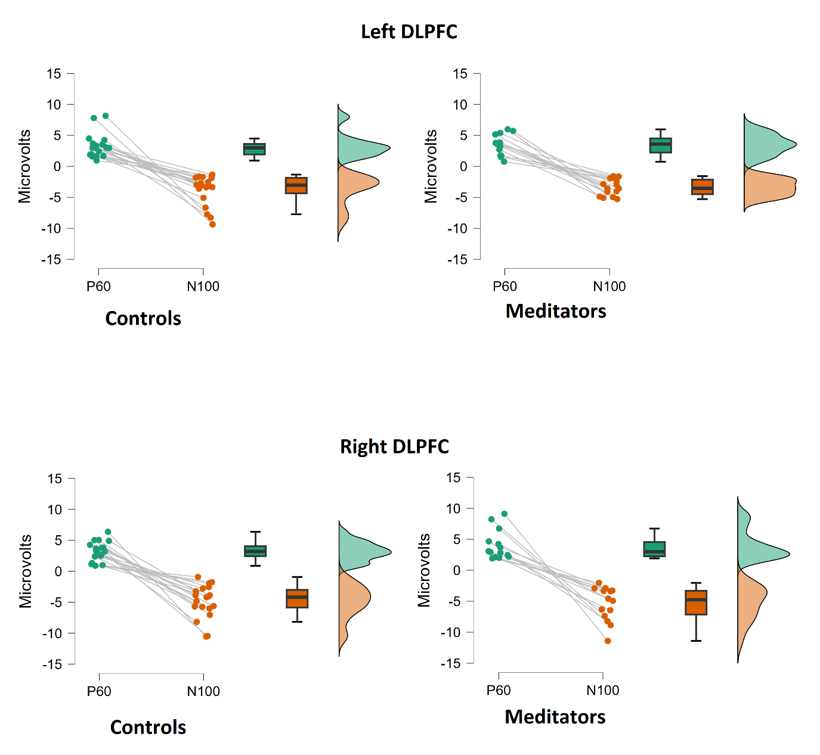
Supplementary Fig. S1. P60 and N100 deflection amplitudes (calculated as the difference between the peak of the P60 and N100 deflection and the mean of the largest opposite value to the peak of the deflection within 50ms of the peak on each side of the peak). These values were used to compute the P60/N100 ratio.
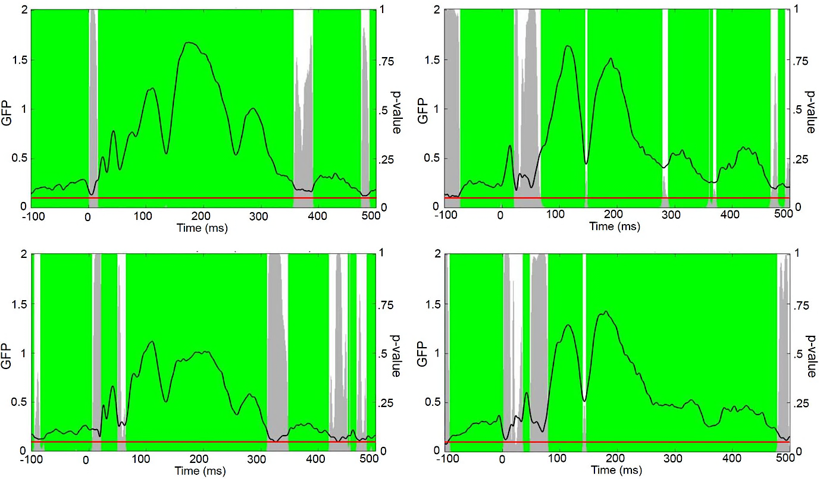
a
b
c
d
Supplementary Fig. S2. Topographical Consistency Test of Neural Response to TMS: Comparisons between groups and conditions are presented: a and c for controls; b and d for meditators. Conditions correspond to c and d for left dorsolateral prefrontal cortex post-stimulation at the F3 electrode, and a and b for right dorsolateral prefrontal cortex post-stimulation at the F4 electrode. Graphs display Global Field Power (GFP) variations over time, with TMS delivery marked at time = 0. The GFP measure, involving the rectification of the TEP, results in the distinct waveform appearance shown. The p-threshold is indicated by a solid red line (0.05). White sections denote non-significant periods (p < 0.05) with inconsistent neural source activations, while grey contours reflect the p-value's temporal trajectory. Green regions highlight consistent neural activity, predominantly observed between 80-310ms. Inconsistencies are evident for meditators from 0-80ms and controls between 310-390ms

Statistical Analysis
Assumption Checks and Outlier Detection
Prior to conducting statistical analyses, we implemented a number of assumption checks and outlier detection procedures: Chi-square tests were used to verify that groups did not differ in gender and handedness. Prior to statistical analyses Shapiro-Wilk tests and visual inspection of the histograms were conducted to test for normality. TMS-EEG measures were inspected for outliers using a univariate outlier detection method (data were z-score transformed; z-scores greater than 3.29 were considered outliers). No outliers were detected using this method for the P60 or N100 amplitude, however one outlier was detected within the control group for the P60/N100 ratio, and this value was winsorized to match the next highest value.

Details of the RAGU statistical analyses implemented on the TMS-EEG data
To conduct statistical analyses in RAGU, the Global Field Power (GFP) is used as a reference-free measure of global neural response strength. GFP is equivalent to calculating the standard deviation from the average reference across all electrodes. The first step in the RAGU pipeline is to confirm that there exists a consistent activation of neural sources in response to TMS using the Topographical Consistency Test (TCT). This test ensures that significant results in subsequent RAGU analyses cannot be explained by extreme variation within a single group. To determine whether there is topographic consistency, the averaged GFP across all participants within groups and for each time point is calculated (i.e., GFP of the grand-mean map). Values of the grand-mean GFP map depend on both the amplitude and spatial consistency of active neural sources generating the scalp field. If the response to the stimulus is random across participants (i.e., no consistency; random noise) then the grand-mean GFP will average to 0 (or close to 0). However, if there is a consistency in response across individuals, the grand-mean GFP will sum to greater than 0. To statistically analyse these values, they are compared against the null-hypothesis distribution of no consistent effect. This distribution is generated by randomly shuffling the channels within individual observations so that the GFP and variation within individuals remains the same, but when averaged across subjects the grand-mean GFP is now representative of the null-distribution of no consistency (i.e., GFP values for which there is no consistency among the groups). This is then permuted 5000 times. Finally, the grand-mean GFP in the real data is compared to the grand-mean GFP values in the null distribution for each time point, with the proportion of the randomised GFP values exceeding the real observed data forming the p-value (the probability of cases in the null distribution taking values larger than the observed grand-mean GFP). The time course of p-values then forms the overall TCT indicating periods of time for which the consistency of active neural sources exceeds that of the distribution of no consistency.

