Supplemental Materials for:
Evidence that Attentional Stance Shift is Learned Rapidly, Reliably Induces Mindfulness, and Constitutes a Distinctive Marker of Cognitive Process

Table S1 The impact of a 10-min ASE on perceived stress (PSS-10) and mindfulness (EMQ) in 15 meditation novices (Study 1; see Fig. 2)
 | n | pre-test | SD | post-test | SD | Post-pre diff | SD | %  change | t | sig
Perceived Stress PSS-10 | 15 | 18.9 | 5.8 | 6.2 | 4.2 | -12.7 | 7.16 | -67.2% | 6.9 | sig**
Perceived Helplessness Subscale | 15 | 12.9 | 3.6 | 2.3 | 2.8 | -10.6 | 4.56 | -82.2% | 8.9 | sig**
Perceived Self-Efficacy Subscale | 15 | 5.9 | 2.8 | 3.9 | 2.4 | -2.0 | 3.69 | -33.9% | 2.2 | sig*
Embodied Mindfulness Questionnaire EMQ | 15 | 34.0 | 13.5 | 58.7 | 10.8 | 24.7 | 17.29 | 72.6% | 5.5 | sig**
Positive Mindfulness-Related | 15 | 41.7 | 9.2 | 62.5 | 8.0 | 20.8 | 12.19 | 49.9% | 6.6 | sig**
Negative Mindfulness-Related | 15 | 7.7 | 6.2 | 3.7 | 4.5 | -4.0 | 7.66 | -51.9% | 1.2 | NS
*p < 0.05, two-tailed, uncorrected for multiple applications, sig > 2.06
**p < 0.005, two-tailed, with Bonferroni correction for multiple applications, sig > 3.0

Table S2 Changes in stress and mindfulness in 15 MBSR practitioners practicing the Attentional Stance Exercise and their own MBSR practice (see Figs. 3, 4)

 | n | pre-test | SD | post-test | SD | post-pre diff | SD | % change | t | sig
Perceived Stress PSS-10 (ASE) | 15 | 15.1 | 6.9 | 8.3 | 6.5 | -6.8 | 9.48 | -45.0% | 2.8 | sig*
Perceived Helplessness Subscale (ASE) | 15 | 10.5 | 5.0 | 4.2 | 4.4 | -6.3 | 6.66 | -60.0% | 3.7 | sig**
Perceived Self-Efficacy Subscale (ASE) | 15 | 4.5 | 3.1 | 4.1 | 2.8 | -0.4 | 4.18 | -8.9% | 0.4 | NS
Perceived Stress PSS-10 (MBSR) | 15 | 15.1 | 6.9 | 9.2 | 6.8 | -5.9 | 9.69 | -39.1% | 2.4 | sig*
Perceived Helplessness Subscale (MBSR) | 15 | 10.5 | 5.0 | 5.0 | 4.7 | -5.5 | 6.86 | -52.4% | 3.1 | sig**
Perceived Self-Efficacy Subscale (MBSR) | 15 | 4.5 | 3.1 | 4.1 | 2.9 | -0.4 | 4.24 | 8.9% | 0.2 | NS
Embodied Mindfulness Questionnaire (ASE) | 15 | 46.6 | 11.3 | 53.9 | 10.6 | 7.3 | 15.49 | 15.7% | 1.8 | NS
Positive Mindfulness-Related (ASE) | 15 | 49.2 | 9.5 | 56.1 | 8.9 | 6.9 | 13.02 | 14.0% | 2.0 | sig*
Negative Mindfulness-Related (ASE) | 15 | 2.6 | 3.6 | 2.1 | 3.2 | -0.5 | 4.82 | -19.2% | 0.4 | NS
Embodied Mindfulness Questionnaire (MBSR) | 15 | 46.6 | 11.3 | 52.6 | 10.9 | 6.0 | 15.70 | 12.9% | 1.4 | NS
Positive Mindfulness-Related (MBSR) | 15 | 49.2 | 9.5 | 56.7 | 9.1 | 7.5 | 13.16 | 15.2% | 2.2 | sig*
Negative Mindfulness-Related (MBSR) | 15 | 2.6 | 3.6 | 4.4 | 4.2 | 1.8 | 5.53 | 69.2% | 1.3 | NS
*p < 0.05, two-tailed, uncorrected for multiple applications
**p < 0.005, two-tailed, with Bonferroni correction for multiple applications, sig > 3.0

Table S3 The impact of differences in attentional stance on dimensions of perceived stress (PSS-10) and mindfulness (EMQ; see Fig. 5)

 | n | pre-test | SD | post-test | SD | post-pre diff | SD | % change | t | sig
Perceived Helplessness Subscale (PSS-10)  (Chest stance) | 13 | 12.5 | 6.4 | 5.8 | 5.3 | -6.7 | 7.3 | -53.6% | 2.9 | sig*
Perceived Helplessness Subscale (PSS-10)  (Abdominal stance) | 13 | 9.9 | 4.7 | 3.9 | 4.0 | -6.0 | 3.7 | -60.6% | 3.5 | sig**
Positive Mindfulness-Related (EMQ)  (Chest stance) | 13 | 50.5 | 10.9 | 52.7 | 9.8 | 2.2 | 6.9 | 4.4% | 0.5 | NS
Positive Mindfulness-Related (EMQ)  (Abdominal stance) | 13 | 48.3 | 9.0 | 57.5 | 9.3 | 9.2 | 5.1 | 19 | 2.5 | sig*
*p < 0.05, two-tailed, uncorrected for multiple applications
**p < 0.005, two-tailed, with Bonferroni correction for multiple applications, sig > 3.0

Table S4 The impact of a 10-min ASE on perceived stress, mindfulness, interoceptive awareness, and positive emotions in 15 meditation novices (Study 3; see Figs. 6, 7)

 | n | pre-test | SD | post-test | SD | pre-post diff | SD | % change | t | sig
Perceived Stress PSS-10 | 15 | 22.7 | 11.1 | 9.1 | 6.3 | -13.6 | 12.76 | -59.9% | -5.7 | sig**
Perceived Helplessness Subscale | 15 | 13.3 | 3.7 | 5.0 | 3.9 | -8.3 | 5.38 | -62.4% | -8.2 | sig**
Perceived Self-Efficacy Subscale | 15 | 7.1 | 2.0 | 4.1 | 2.5 | -3.0 | 3.20 | -42.3% | -5.1 | sig**
Embodied Mindfulness Questionnaire EMQ | 15 | 32.4 | 11.2 | 52.5 | 15.4 | 20.1 | 19.04 | 62.0% | 5.6 | sig**
Positive Mindfulness-Related | 15 | 40.9 | 8.6 | 57.1 | 12.5 | 16.2 | 15.17 | 39.6% | 5.7 | sig**
Negative Mindfulness-Related | 15 | 8.5 | 4.6 | 4.6 | 4.6 | -3.9 | 6.51 | -45.9% | -3.1 | sig**
Multidimensional Assessment of Interoceptive  Awareness MAIA-2 | 15 | 107.1 | 26.1 | 141.4 | 26.5 | 34.3 | 37.19 | 32.0% | 4.9 | sig**
Gratitude Questionnaire GQ6 | 15 | 34.4 | 6.3 | 38.1 | 5.1 | 3.7 | 8.11 | 10.8% | -1.7 | NS
Contentment DPES-Cn | 15 | 23.3 | 6.3 | 27.9 | 5.6 | 4.6 | 8.43 | 19.7% | -2.1 | sig*
Compassion DPES-Cm | 15 | 28.4 | 3.0 | 26.9 | 5.0 | -1.5 | 5.83 | 5.3% | 1.0 | NS
*p < 0.05, two-tailed, uncorrected for multiple applications
**p < 0.005, two-tailed, with Bonferroni correction for multiple applications

Table S5 The impact of a 10-min ASE on stress and mindfulness with and without a gap after instruction in 20 meditation novices (Studies 1 & 3; see Figs. S1, S2)

 | n | pre-test | SD | post-test | SD | post-pre diff | SD | % change | t | sig
Perceived Stress PSS-10 (ASE) No Gap | 6 | 19.1 | 3.9 | 4.7 | 2.8
Perceived Stress PSS-10 (ASE) Gap | 20 | 19.0 | 6.0 | 8.9 | 5.9 | -10.1 | 6.4 | -59.2% | 5.3 | sig**
Perceived Helplessness Subscale (ASE) No Gap | 6 | 14.0 | 2.6 | 1.2 | 1.2
Perceived Helplessness Subscale (ASE) Gap | 20 | 12.4 | 3.7 | 4.5 | 3.9 | -7.9 | 4.1 | -63.7% | 6.5 | sig**
Perceived Self-Efficacy Subscale (ASE) No Gap | 6 | 5.7 | 2.1 | 3.5 | 2.2
Perceived Self-Efficacy Subscale (ASE) Gap | 20 | 6.6 | 2.7 | 4.4 | 2.6 | -2.2 | 3.4 | -33.3% | 2.6 | sig*
Embodied Mindfulness Questionnaire (ASE) No Gap | 6 | 29.8 | 14.6 | 64.2 | 7.2
Embodied Mindfulness Questionnaire (ASE) Gap | 20 | 34.7 | 11.5 | 52.0 | 13.7 | 17.3 | 12.4 | 49.9% | -4.3 | sig**
Positive Mindfulness-Related (ASE) No Gap | 6 | 39 | 7.6 | 67.2 | 4.2
Positive Mindfulness-Related (ASE) Gap | 20 | 41.9 | 9.1 | 56.5 | 10.9 | 14.6 | 11.6 | 34.8% | -4.6 | sig**
Negative Mindfulness-Related (ASE) No Gap | 6 | 9.2 | 8.0 | 3.0 | 3.7
Negative Mindfulness-Related (ASE) Gap | 20 | 7.3 | 4.7 | 4.5 | 4.6 | -2.8 | 3.8 | 38.4% | 1.9 | NS
*p < 0.05, two-tailed, uncorrected for multiple applications
**p < 0.005, two-tailed, with Bonferroni correction for multiple applications

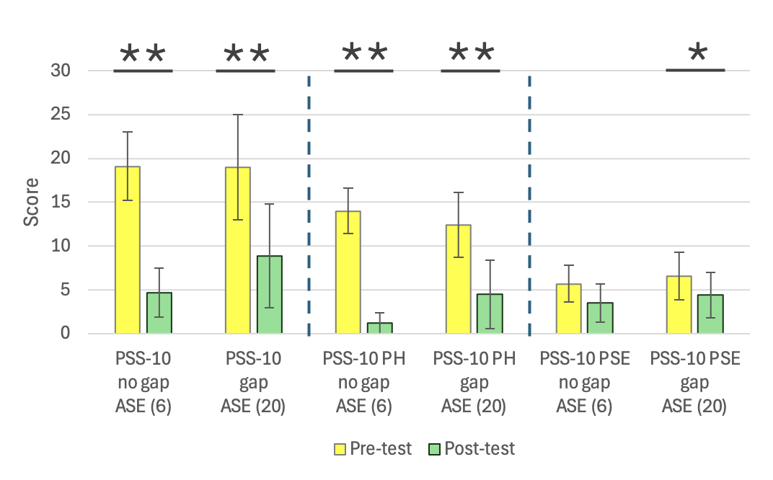
Fig. S1 The impact of a post-instruction gap on perceived stress outcomes (PSS-10)
*p < 0.05; **p < 0.005

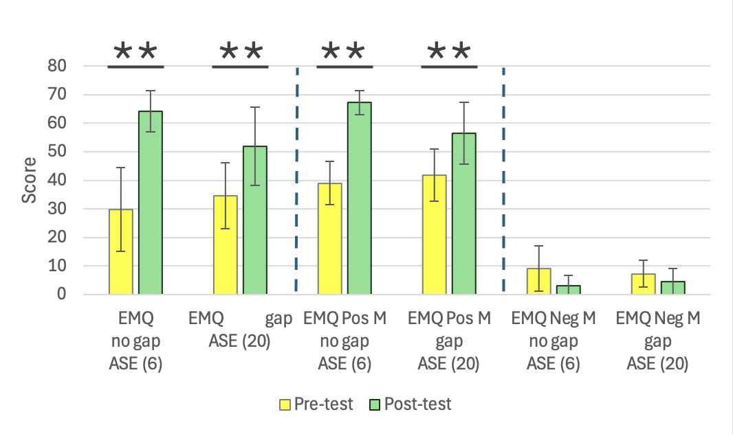
Fig. S2 The impact of a post-instruction gap on mindfulness outcomes (EMQ)
**p < 0.005

