Figure S1. Path diagrams for the Two-factor ESEM and Six-factor ESEM models

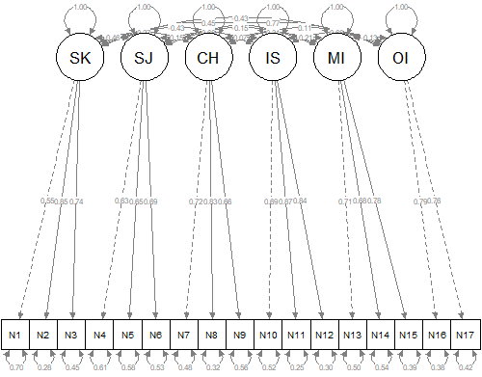
Figure S2. Path diagram of the CFA six-factor structure.

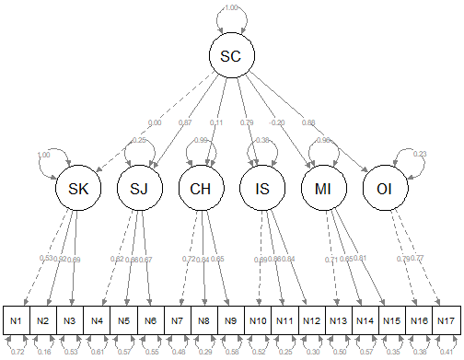
Figure S3. Path diagrams for the CFA One-hierarchical model.

Table S1.
Factor loadings and Bifactor Indices for the One-Bifactor model.
Item | G factor | Specific factors |  |  |  |  |  | Residual variance
Item | G factor | SK | SJ | CH | IS | MI | OI | Residual variance | IECV
1 | .251 | .469 |  |  |  |  |  | 0.251 | 0.223
2 | .460 | .790 |  |  |  |  |  | 0.164 | 0.253
3 | .418 | .551 |  |  |  |  |  | 0.522 | 0.365
4 | -.585 |  | .150 |  |  |  |  | 0.635 | 0.938
5 | -.524 |  | .848 |  |  |  |  | 0.006 | 0.276
6 | -.598 |  | .197 |  |  |  |  | 0.604 | 0.902
7 | -.097 |  |  | .718 |  |  |  | 0.475 | 0.018
8 | -.047 |  |  | .839 |  |  |  | 0.293 | 0.003
9 | .025 |  |  | .652 |  |  |  | 0.574 | 0.001
10 | -.583 |  |  |  | .355 |  |  | 0.534 | 0.730
11 | -.664 |  |  |  | .617 |  |  | 0.178 | 0.537
12 | -.674 |  |  |  | .456 |  |  | 0.338 | 0.686
13 | .060 |  |  |  |  | .740 |  | 0.449 | 0.007
14 | .261 |  |  |  |  | .609 |  | 0.561 | 0.155
15 | .220 |  |  |  |  | .758 |  | 0.377 | 0.078
16 | -.651 |  |  |  |  |  | .415 | 0.404 | 0.711
17 | -.678 |  |  |  |  |  | .389 | 0.389 | 0.752
ω | .807 | .829 | .777 | .785 | .845 | .773 | .753 |  | ω
ω_{H} | .331 | .597 | .256 | .782 | .301 | .726 | .202 |  | ω_{H}
ω_{H}/ω | .410 | .720 | .329 | .997 | .356 | .938 | .268 |  | ω_{H}/ω
H | .854 | .704 | .724 | .807 | .505 | .759 | .279 |  | H
FD | .895 | .889 | .957 | .899 | .766 | .875 | .583 |  | FD
ECV | .376 | .719 | .445 | .993 | .367 | .926 | .268 |  | ECV
PUC | .882 |  |  |  |  |  |  |  | PUC
Note. ω = omega; ω_{H} = omega hierarchical; ω_{H}/ω = relative omega; FD = Factor determinacy; ECV = Explained common variance; PUC = Percent of Uncontaminated Correlations.

