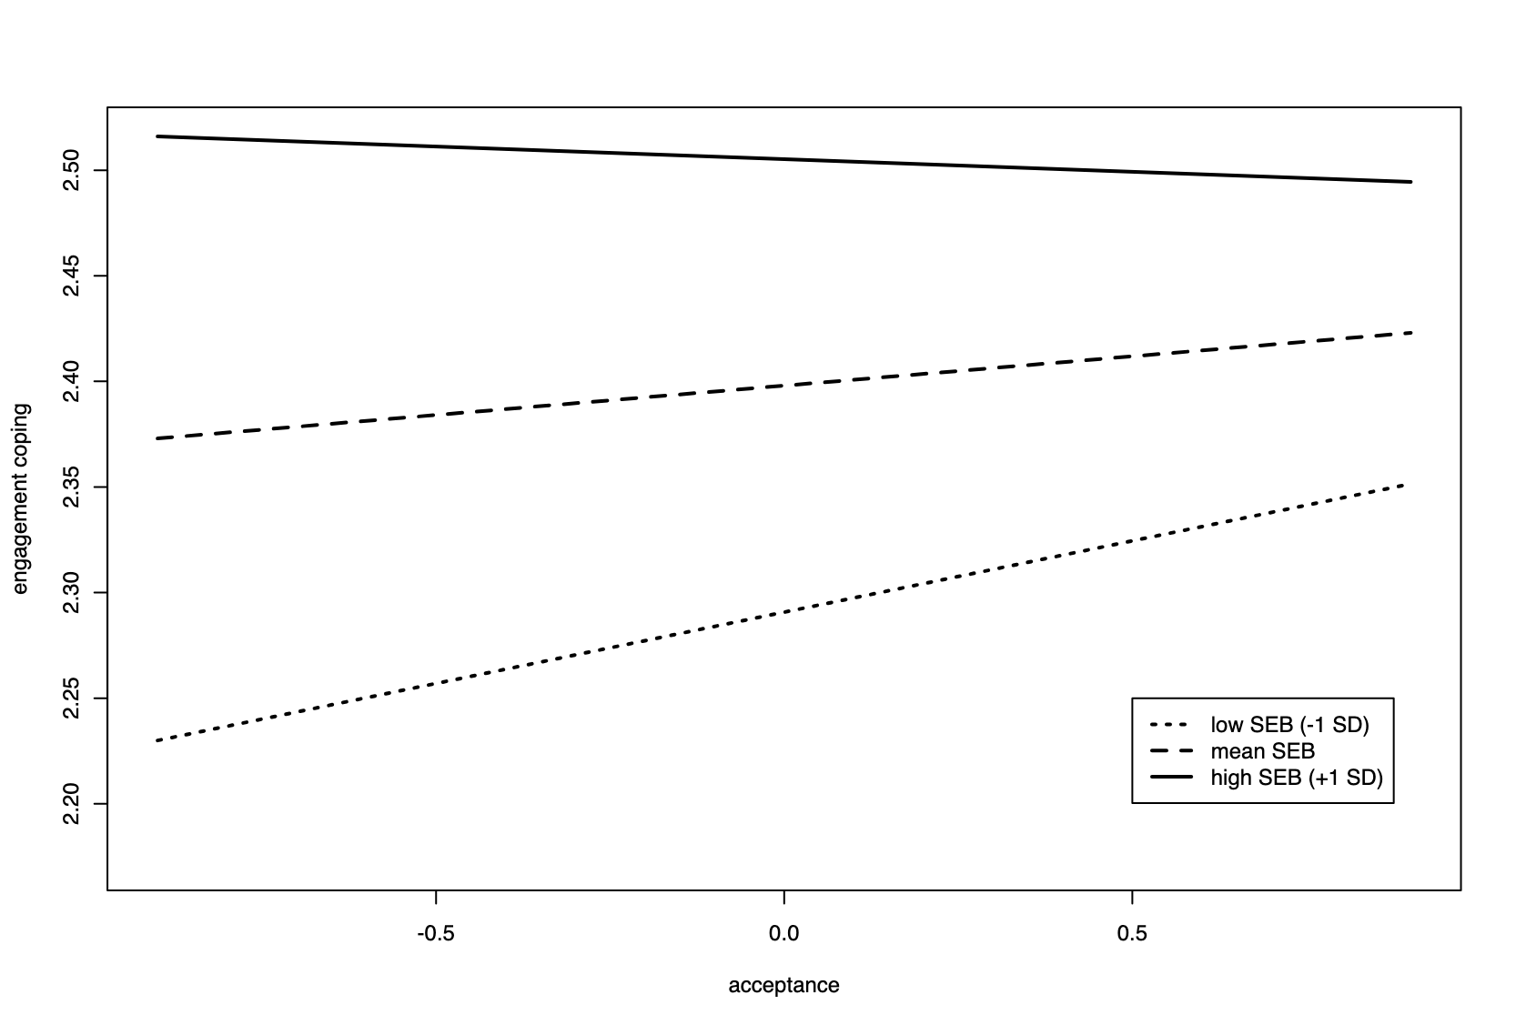

Figure S1. Relation between momentary acceptance and engagement coping as a function of self-efficacy beliefs.

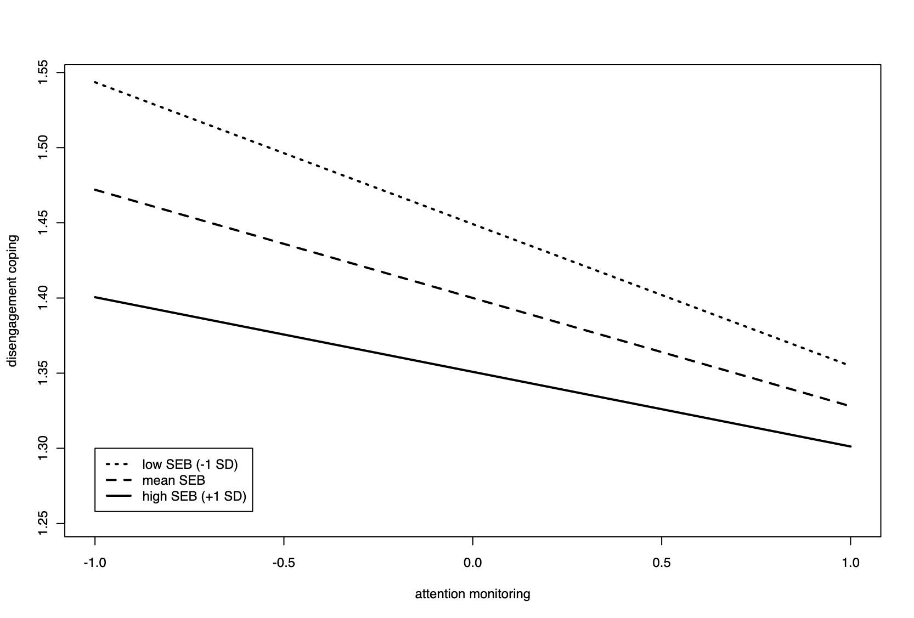

Figure S2. Relation between momentary attention and disengagement coping as a function of self-efficacy beliefs.

