Supplementary Materials

Table 1
Program comparison for two well-being courses. Mindfulness-based course participants were enrolled in Coursera’s Foundations of Mindfulness. Positive psychology course participants were enrolled in Coursera’s A Life of Happiness and Fulfillment.

 | Mindfulness-Based Course Condition | Positive Psychology Course Condition
Week 1 | Video Lessons:  - Introducing Mindfulness  - Exploring The Qualities Of Mindfulness Part 1  - Exploring The Qualities Of Mindfulness Part 2  - Strategies For Cultivating Mindfulness  Meditationª:  - Body Scan Meditation (16 min, Assigned Daily) | Video Lessons:  - Welcome To The Course  - Happiness Is A Balloon!  - Introducing The Seven Deadly Happiness Sins  - Overview Of 1st Deadly Happiness Sin: Devaluing Happiness  - Devaluing Happiness In Job-Choice  - Three Negative Misconceptions About Happiness  - Prioritize But Don't Pursue Happiness  - Why We Devalue Happiness: Part II  - Summary of Week 1 [of Coursera Course]
Week 2 | Video Lessons:  - Establishing Connection With The Body  - The Body As A Reference Point For Awareness  Meditation:  - Body Scan Meditation (16 min, Assigned Daily)  Discussion:  - 1 Hour Live Virtual Discussion Session With A Mindfulness-Based Stress Reduction Instructor. | Video Lessons:  - Effects Of Chasing Superiority On Happiness  - Is Need For Superiority Important For Success?  - Flow Is Discovered  - Characteristics Of Flow  - When Does Flow Happen  - Why Flow Enhances Happiness  - Why Flow Enhances Success  - Getting Flow Back Into Your Life  - A Practice For When Things Are Not Going Well: Self-Compassion  - A Practice For When Things Are Going Well: Gratitude  - Summary Of Week 2 [of Coursera Course]  Discussion:  - 1 Hour Live Virtual Discussion Session With A Trained Facilitator.
Week 3 | Video Lessons:  - Exploring Common Obstacles During Practice  Meditation:  - Body Scan Meditation (16 min, Every Other Day)  - Awareness Of Breath Guided Meditation (11 min, Asked To Practice 15 - 20 min, Every Other Day) | Video Lessons:  - The Need To Be Loved–Or Its Opposite: The Need To Go It Alone  - Further Evidence Of Our Social Nature  - Why Neediness Lowers Happiness  - Why Avoidance Lowers Happiness  - Secure Attachment  - An Alternative Route To Belongingness  - Evidence For The Need To Love And Give  - Why The Need To Love And Give Enhances Happiness  - The Rules For Giving: When Does Giving Enhance Happiness And Success?  - Summary Of Week 3 [of Coursera Course]
Week 4 | Video Lessons:  - Emotions, Thoughts, And The Body  Meditation:  - Body Scan Meditation (15 - 20 min, Every Other Day)  - Awareness Of Breath Guided Meditation (11 min, Asked To Practice 15 - 20 min, Every Other Day)  Discussion:  - 1 Hour Live Virtual Discussion Session With A Mindfulness-Based Stress Reduction Instructor. | Video Lessons:  - The 4th Sin: Being Overly Control Seeking  - Why Being Overly Controlling Of Others Lowers Happiness  - Why Being Overly Controlling Of Outcomes Lowers Happiness  - The Desirability For Control (DC) And Maximizer Scales  - Taking Personal Responsibility For Happiness  - Obstacles To Taking Personal Responsibility  - Internal And External Control As Compensatory Forces  - Learning Simple Emotion Regulation Strategies  - Appreciating Uncertainty And Lack Of Control  Discussion:  - 1 Hour Live Virtual Discussion Session With A Trained Facilitator.
Week 5 | Video Lessons:  - The Conditioned Mind  Meditation:  - Body Scan Meditation (New, Extended Version Recorded By Mindfulness-Based Stress Reduction Instructor, 20 min, Every Other Day)  - Awareness Of Breath Guided Meditation (New, Extended Version Recorded By Mindfulness-Based Stress Reduction Instructor, 20 min, Every Other Day) | Video Lessons:  - The Importance Of Leading A Healthier Lifestyle  - Do's And Don'ts Of A Healthier Lifestyle  - Summary of Week 4 [of Coursera Course]  - Distrusting Others And Why Trust Is Important  - Instinctive Distrust And Proactive Trust  - The (Hidden) Benefits Of Proactive Trust  - Perceived Vs Actual Trust  - Trust Scale  - Three Strategies Of Smart Trust
Week 6 | Meditation:  - Body Scan Meditation (20 min, Every Other Day)  - Awareness Of Breath Guided Meditation (20 min, Every Other Day)  Discussion:  - 1 Hour Live Virtual Discussion Session With A Mindfulness-Based Stress Reduction Instructor. | Video Lessons:  - The 6th Deadly Happiness Sin--Distrusting Life  - Process (Vs. Outcome) As A Source Of Happiness  - Pre-Occurrence Preference And Post-Occurrence Non-Judgmentalism  - Three Strategies For Instilling The Dispassionate Pursuit Of Passion  - Going Spiritual  - Summary Of Week 5 [of Coursera Course]  Discussion:  - 1 Hour Live Virtual Discussion Session With A Trained Facilitator.
Week 7 | Meditation:  - Body Scan Meditation (20 min, Every Other Day)  - Awareness Of Breath Guided Meditation (20 min, Every Other Day) | Video Lessons:  - The 7th Deadly Sin: Ignoring The Source Within  - Stepping Outside The “GATE”  - Being A Fly In The Wall  - Flying Into The Present  - The Benefits Of Mindfulness I  - The Benefits Of Mindfulness II  - Motivational Obstacles To Mindfulness  - Cognitive Obstacles To Mindfulness  - Some Other Obstacles To Mindfulness, Including Logistical Ones
Week 8 | Meditation:  - Body Scan Meditation (20 min, Every Other Day)  - Awareness Of Breath Guided Meditation (20 min, Every Other Day) | Video Lessons:  - Summary Of Week 6 [of Coursera Course]  - Two Approaches To MBA  - The 7 Happiness Sustaining Strategies

Note: Unless otherwise indicated, video lessons and guided meditations in the Mindfulness-Based Course Condition were streamed from Coursera’s “Mindfulness and Well-Being: Foundations”, while videos lessons in the Positive Psychology Course Condition were streamed from Coursera’s “A Life of Happiness and Fulfillment”.

ª A three minute “Brief Introductory Meditation” was also encouraged every week as an optional practice throughout the day as helpful. This was analogous to a brief “breathing space” meditation.

Figure 1
CONSORT Flow Diagram
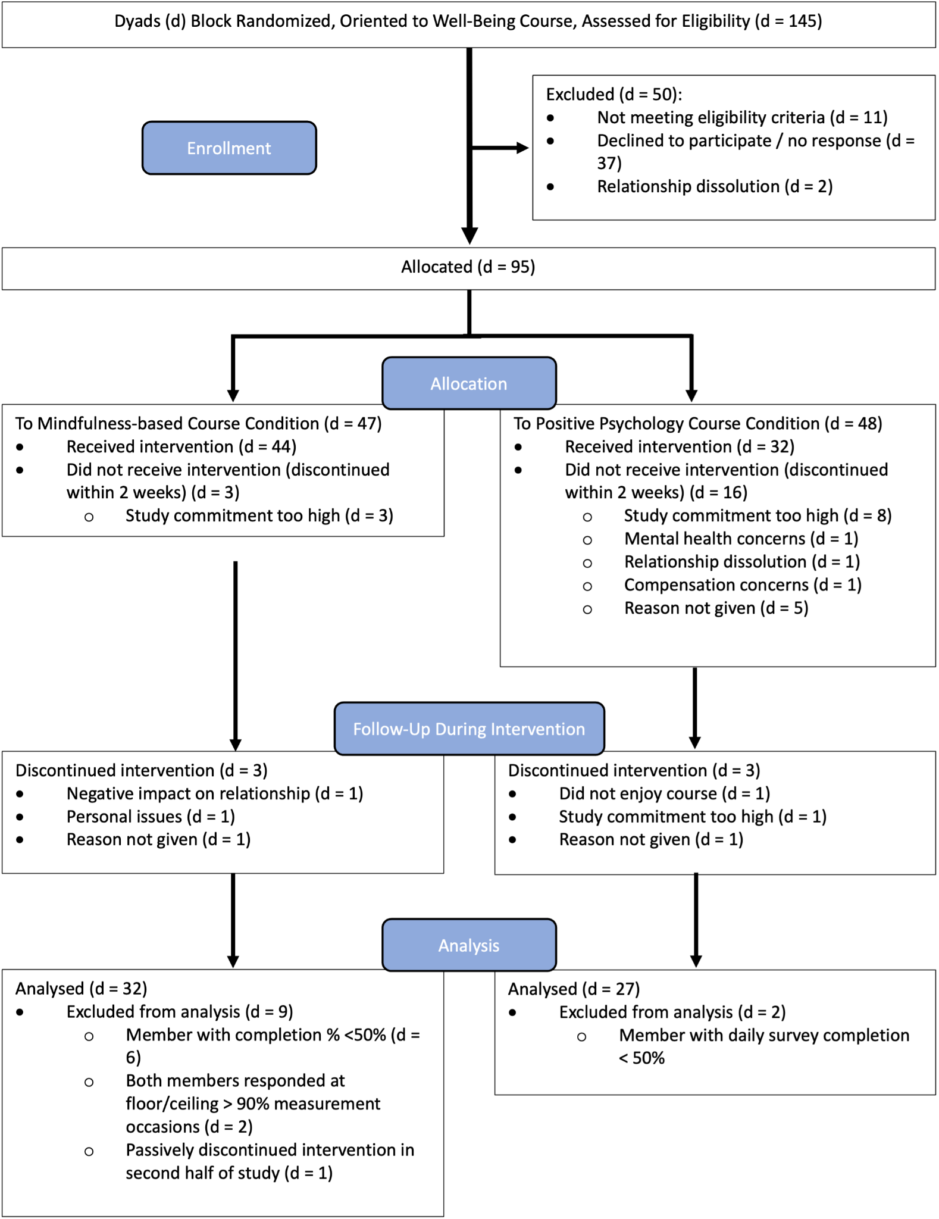
Table 2
Prospective change model of MBCC partners’ negative emotion.

Effect | Estimate | SE | 95% CI |  | p
Effect | Estimate | SE | LL | UL | p
Intercept | 7.940 | 3.525 | -0.172 | 16.053 | 0.054
Time01 | -0.254 | 0.250 | -0.767 | 0.258 | 0.318
Partner_CourseMeditationWork_in_Last_Day_Lag1_cb | -5.236 | 6.071 | -19.230 | 8.758 | 0.413
Partner_CourseMeditationWork_in_Last_Day_Lag1_cw | -0.203 | 0.193 | -0.581 | 0.175 | 0.292
mdEmotions_negative_Lag1_SQRT | -0.029 | 0.030 | -0.087 | 0.029 | 0.331
Partner_mdEmotions_negative_Lag1_SQRT_cb | 0.620 | 0.279 | -0.022 | 1.261 | 0.057
Partner_mdEmotions_negative_Lag1_SQRT_cw | 0.022 | 0.030 | -0.037 | 0.081 | 0.468
FFMQ_Nonreact_Lag1_cb | -0.005 | 0.032 | -0.080 | 0.070 | 0.892
FFMQ_Nonreact_Lag1_cw | -0.001 | 0.003 | -0.007 | 0.004 | 0.645
Partner_FFMQ_Nonreact_Lag1_cb | -0.013 | 0.020 | -0.059 | 0.033 | 0.527
Partner_FFMQ_Nonreact_Lag1_cw | -0.007 | 0.003 | -0.012 | -0.001 | 0.012
FFMQ_Observe_Lag1_cb | 0.011 | 0.036 | -0.072 | 0.093 | 0.775
FFMQ_Observe_Lag1_cw | 0.001 | 0.003 | -0.005 | 0.006 | 0.828
Partner_FFMQ_Observe_Lag1_cb | 0.018 | 0.030 | -0.052 | 0.087 | 0.574
Partner_FFMQ_Observe_Lag1_cw | 0.003 | 0.003 | -0.002 | 0.008 | 0.312
FFMQ_ActAware_Lag1_cb | -0.070 | 0.062 | -0.213 | 0.072 | 0.287
FFMQ_ActAware_Lag1_cw | 0.001 | 0.003 | -0.006 | 0.008 | 0.716
Partner_FFMQ_ActAware_Lag1_cb | 0.105 | 0.074 | -0.066 | 0.276 | 0.194
Partner_FFMQ_ActAware_Lag1_cw | -0.003 | 0.003 | -0.010 | 0.003 | 0.277
IMS_Presence_Lag1_cb | -0.001 | 0.061 | -0.142 | 0.140 | 0.984
IMS_Presence_Lag1_cw | -0.005 | 0.003 | -0.011 | 0.002 | 0.156
Partner_IMS_Presence_Lag1_cb | -0.067 | 0.069 | -0.227 | 0.093 | 0.363
Partner_IMS_Presence_Lag1_cw | <0.001 | 0.003 | -0.006 | 0.007 | 0.985
IMS_Awareness_SelfOthers_Lag1_cb | -0.031 | 0.056 | -0.159 | 0.097 | 0.591
IMS_Awareness_SelfOthers_Lag1_cw | -0.006 | 0.004 | -0.014 | 0.001 | 0.110
Partner_IMS_Awareness_SelfOthers_Lag1_cb | -0.034 | 0.055 | -0.161 | 0.093 | 0.556
Partner_IMS_Awareness_SelfOthers_Lag1_cw | 0.005 | 0.004 | -0.002 | 0.013 | 0.169
IMS_NonjudgementalAcceptance_Lag1_cb | 0.035 | 0.048 | -0.076 | 0.145 | 0.492
IMS_NonjudgementalAcceptance_Lag1_cw | -0.002 | 0.004 | -0.010 | 0.006 | 0.663
Partner_IMS_NonjudgementalAcceptance_Lag1_cb | 0.048 | 0.041 | -0.046 | 0.142 | 0.274
Partner_IMS_NonjudgementalAcceptance_Lag1_cw | -0.005 | 0.004 | -0.012 | 0.002 | 0.171
PartnerArgument_Disagreement_Lag1_cb | 7.141 | 6.710 | -8.307 | 22.590 | 0.318
PartnerArgument_Disagreement_Lag1_cw | -0.382 | 0.165 | -0.706 | -0.057 | 0.021
Partner_PartnerArgument_Disagreement_Lag1_cb | -5.395 | 8.031 | -23.901 | 13.111 | 0.521
Partner_PartnerArgument_Disagreement_Lag1_cw | -0.068 | 0.147 | -0.356 | 0.221 | 0.645
PNRQ_PositiveRelQualities_Lag1_cb | -0.091 | 0.075 | -0.264 | 0.083 | 0.262
PNRQ_PositiveRelQualities_Lag1_cw | 0.001 | 0.005 | -0.010 | 0.011 | 0.903
PNRQ_NegativeRelQualities_Lag1_cb | -0.149 | 0.184 | -0.575 | 0.276 | 0.442
PNRQ_NegativeRelQualities_Lag1_cw | 0.009 | 0.006 | -0.003 | 0.021 | 0.137
Partner_PNRQ_PositiveRelQualities_Lag1_cb | 0.019 | 0.047 | -0.089 | 0.127 | 0.695
Partner_PNRQ_PositiveRelQualities_Lag1_cw | -0.007 | 0.006 | -0.019 | 0.004 | 0.218
Partner_PNRQ_NegativeRelQualities_Lag1_cb | 0.120 | 0.193 | -0.325 | 0.566 | 0.550
Partner_PNRQ_NegativeRelQualities_Lag1_cw | 0.006 | 0.007 | -0.009 | 0.020 | 0.440

Note. Variables corresponding to a course participant’s effect on their partner are indicated with the prefix “Partner_”. Within-person (level-1) variables have the suffix “_cw”, while between-person (level-2) variables have the suffix “_cb”. Coefficients reported in the text are back-transformations of those shown in the table. CI = confidence interval; LL = lower limit; UL = upper limit

Table 3
Comparison of the intervention groups at baseline.

Questionnaire | Mindfulness mean (SD) | Positive psychology mean (SD) | t-test | Bayes Factor (BF₁₀)
Interpersonal mindfulness | 65.6 (17.0) | 60.0 (14.5) | t(138)=2.05 (p=0.042) | 1.23
PNRQ positive relationship qualities | 83.7 (16.5) | 80.1 (13.5) | t(138)=1.38 (p=0.171) | 0.44
PNRQ negative relationship qualities | 8.5 (15.0) | 8.6 (11.1) | t(138)=-0.037 (p=0.971) | 0.18
Positive emotions | 70.4 (17.3) | 61.9 (15.4) | t(138)=2.99 (p=0.003) | 10.1
Negative emotions | 25.2 (20.7) | 32.9 (24.3) | t(138)=2.04 (p=0.043) | 1.20
FFMQ | 57.8 (17.1) | 52.3 (14.5) | t(138)=1.96 (p=0.052) | 1.05

Variable | Mindfulness mean (SD) | Positive psychology mean (SD) | t-test | Bayes Factor (BF₁₀)
Age | 25.7 (5.3) | 25.3 (4.4) | t(115)=0.401 (p=0.69) | 0.21
Relationship length | 50.6 (64.7) | 29.3 (23.3) | t(138)=2.40 (p=0.18) | 2.45
Sex | 40 male/40 female/1 non-disclosed | 26 male/32 female | χ²(2)=1.08 (p=0.58) | 0.21
Native English | 26 native/55 non-native | 21 native/37 non-native | χ²(1)=0.26 (p=0.61) | 0.25
Education | 10 high school/21 some college/19 bachelor’s degree/ 21 master’s degree/10 doctoral of professional degree | 2 high school/19 some college/20 bachelor’s degree/16 master’s degree/1 doctoral of professional degree | χ²(4)=9.97 (p=0.41) | 1.20
Had regular meditation practice | 0 yes/81 no | 3 yes/55 no | χ²(1)=4.28 (p=0.04) | 3.63
Note. SD = standard deviation.

Table 4
Correlations between the main variables.

Pearson's Correlations
Variable |  |  |  | Interpersonal Mindfulness |  | PNRQ Positive Relationship Qualities |  | PNRQ Negative Relationship Qualities |  | Positive emotions |  | Negative emotions |  | FFMQ |  | Relationship Length |  | Age
1. Interpersonal Mindfulness |  | Pearson's r |  | —
 |  | p-value |  | —
2. PNRQ Positive Relationship Qualities |  | Pearson's r |  | 0.293 | *** | —
 |  | p-value |  | < 0.001 |  | —
3. PNRQ Negative Relationship Qualities |  | Pearson's r |  | -0.222 | ** | -0.615 | *** | —
 |  | p-value |  | 0.008 |  | < 0.001 |  | —
4. Positive Emotions |  | Pearson's r |  | 0.505 | *** | 0.435 | *** | -0.323 | *** | —
 |  | p-value |  | < 0.001 |  | < 0.001 |  | < 0.001 |  | —
5. Negative emotions |  | Pearson's r |  | -0.203 | * | -0.364 | *** | 0.362 | *** | -0.357 | *** | —
 |  | p-value |  | 0.016 |  | < 0.001 |  | < 0.001 |  | < 0.001 |  | —
6. FFMQ |  | Pearson's r |  | 0.496 | *** | 0.246 | ** | -0.274 | ** | 0.429 | *** | -0.462 | *** | —
 |  | p-value |  | < 0.001 |  | 0.003 |  | 0.001 |  | < 0.001 |  | < 0.001 |  | —
7. Relationship Length |  | Pearson's r |  | -0.004 |  | -0.072 |  | 0.103 |  | -0.059 |  | 0.045 |  | 0.186 | * | —
 |  | p-value |  | 0.958 |  | 0.395 |  | 0.224 |  | 0.492 |  | 0.596 |  | 0.028 |  | —
8. Age |  | Pearson's r |  | 0.010 |  | -0.171 |  | 0.188 | * | 0.018 |  | -0.201 | * | 0.161 |  | 0.531 | *** | —
 |  | p-value |  | 0.917 |  | 0.066 |  | 0.043 |  | 0.844 |  | 0.030 |  | 0.083 |  | < 0.001 |  | —
* p < 0.05, ** p < 0.01, *** p < 0.001

Additional Analyses
(Lack of) changes in relationship qualities with interventions.

We also examined dyadic linear growth models of daily positive and negative relationship qualities. Both MBCC course participants (p = 0.003) and their partners (p = 0.001) showed evidence of a decrease in negative relationship qualities over time. There was no difference between conditions for course participants (p = 0.154) or partners (p = 0.578). These results should be interpreted with caution however, since the scores were clustered near the floor, which remained evident in the residuals as well. Positive relationship qualities were also strongly skewed. Participants gave a maximal score of 100 on 18.6% of daily diary days. We reflected and log-transformed scores to create a more normal distribution. Course participants in the MBCC showed an increase in positive relationship qualities (p = 0.017), as did their partners (p = 0.003). There was again no difference between conditions for course participants (p = 0.389) or partners (p = 0.943). These results should also be interpreted with caution as scores were near ceiling and the restricted range of scores remained evident in model residuals.

Positive Emotion
May et al. (2020) found limited evidence for an impact of meditation on a partner’s daily positive emotion. In testing for the same effect in the current sample using a dyadic linear growth model, we found no significant effect of time for course participants or their partners in either condition (all p’s > 0.137). Estimates of covariance parameters showed a significant positive relationship between the slopes of participants and partners (p = 0.015). Given the pre-existing differences between the groups on positive emotions, we do not further consider these findings.

