S1
Search Strategies
From 01/01/2000 to 11/11/2024

PubMed
(mindful*[Title]) AND (school[Title/Abstract] OR preschool*[Title/Abstract] OR kindergarten*[Title/Abstract] OR college*[Title/Abstract] OR universit*[Title/Abstract] OR child*[Title/Abstract] OR adolescen*[Title/Abstract] OR youth[Title/Abstract] OR young*[Title/Abstract]) AND (intervention*[Title/Abstract] OR program*[Title/Abstract] OR trial*[Title/Abstract])

EBSCOhost APA PsycINFO
TI mindful* AND (AB school OR AB preschool* OR AB kindergarten* OR AB college* OR AB universit* OR AB child* OR AB adolescen* OR AB youth OR AB young*) AND (AB intervention* OR AB program* OR AB trial*)

Scopus
TITLE ( mindful* ) AND ( ABS ( school ) OR ABS ( preschool* ) OR ABS ( kindergarten* ) OR ABS ( college* ) OR ABS ( universit* ) OR ABS ( child* ) OR ABS ( adolescen* ) OR ABS ( youth ) OR ABS ( young* ) ) ) AND (ABS (intervention* ) OR ABS (program* ) OR ABS (trial*)) AND PUBYEAR > 1999 AND PUBYEAR < 2024

EMBASE
(mindful*).ti. and (school or preschool* or kindergarten* or college* or universit* or child* or adolescen* or youth or young*).ab. and (intervention* or program* or trial*).ab.

S2
The Assessment Criteria of RoB 2 and ROBINS-I
For RoB 2, RCTs were assessed on five domains: bias arising from the randomization process, bias due to deviations from the intended interventions, bias due to missing outcome data, bias in measurement of the outcome, and bias in selection of the reported result (Sterne et al., 2019). Each domain included a series of signaling questions that helped determine the level of bias. Based on the answers (i.e., “Yes”, “Probably yes”, “No”, “Probably no”, and “No information”) to the questions, the RoB 2 tool used an algorithm to suggest the level of bias, as low risk of bias, some concerns, or high risk of bias for each domain. An overall judgement of the study’s risk of bias was made based on the following criteria: (1) if all domains were judged as low risk of bias, the overall judgement of the study was at low risk of bias; (2) if at least one domain raised some concerns and none were at high risk of bias, then the overall judgement was some concerns; (3) if at least one domain was judged to be at high risk of bias, or if there were multiple domains with some concerns, the overall judgement was at high risk of bias (Sterne et al., 2019). In addition to the five domains mentioned above, cluster-RCTs were assessed on a sixth domain: bias arising from the timing of identification and recruitment of individual participants into clusters. The assessment criteria were similar for RCTs and cluster-RCTs.

For non-RCTs, ROBINS-I had seven domains to assess risk of bias with several signaling questions in each domain (Sterne et al., 2016). These domains included: bias due to confounding, bias in selection of participants into the study, bias in classification of interventions, bias due to deviations from intended interventions, bias due to missing data, bias in measurement of outcomes, and bias in selection of the reported result. Like RoB 2, the ROBINS-I tool used another algorithm to suggest the level of bias for each domain and then made an overall judgement of the study’s risk of bias, but there were four levels of risk of bias (i.e., low risk of bias, moderate risk of bias, serious risk of bias, and critical risk of bias), which was slightly different from the level of bias in RoB 2.

Table S3
Study Characteristics
Study | Sample (N) | Baseline demographic information | Study design | Treatment condition(s) (n) | Comparison condition(s) (n) | Mediator(s) tested | Outcome(s) tested | Assessment from baseline | Method of mediation analysis
Amutio et al. (2022) | Undergraduates in Spain (125) | Mean age = 20.71, 68.00% female | Non-RCT | Mindfulness practices (88) | Conventional teaching (37) | Mindfulness: FFMQ | Stress: PSS; Wellbeing: PHI | Baseline, post intervention at 7 weeks | PROCESS, model 4
Bergen-Cico & Cheon (2014) | University students in US (202) | Mean age = 23.17, 73.27% female | Non-RCT | MBSR + academic course on addictive behaviors (108) | Course encompassed didactic lecture and interactive response exercises (94) | Mindfulness: KIMS; Self-compassion: SCSª | Trait anxiety: STAI; Self-compassion: SCSª | Baseline, mid course at around 7 weeks, and post course at about 12 weeks | Cross-lagged path analysis, SEM
Blake et al. (2017) | Adolescents with high levels of sleep problems and anxiety symptoms in Australia (123) | Mean age = 14.48, 60.00% female | RCT | Sleep improvement intervention (63) | Active control (60) | Arousal before sleep: PSAS-S and PSAS-C; Sleep hygiene awareness: SBS | Anxiety: SCAS | Baseline, post intervention at 7 weeks | Parallel multiple mediation model; PROCESS model 4
Boxmeyer et al. (2023) | Children with elevated levels of reactive aggression in US (80) | Mean age = 10.00, 36.25% female | RCT | Mindful Coping Power (MCP) (43) | Coping Power (CP) preventive intervention (37) | Inhibitory control: EATQ | Reactive aggression: TRRPA | Baseline, post intervention, and 1 year follow-up | The ANCOVA approach, which involved two regression equations
Cary et al. (2023) | Undergraduate students in US (144) | Mean age = 21.03, 63.20% female | Non-RCT | Adapted MBSR (34) | A matched control (110) | Cognitive self-regulation: SSRQ | Anxiety: STAI | Pre-MBSR, post-MBSR, and 1-month follow-up | Bootstrapped mediation analyses
Chen et al. (2022) | Volunteering cadets of National Defense University in Taiwan (60) | Mean age = 20.50, 21.67% female | RCT | MBSR-MC (30) | Control without treatment (30) | Mindfulness: FFMQ (Chinese version) | Perceived stress: PSS (Chinese version) | Baseline, post intervention at 9 weeks (a week after completion) | The PROCESS with bootstrapping
Davis et al. (2018) | Young adults in residential substance use disorder treatment in US (79) | Mean age = 25.30, 35.44% female | RCT | Group mindfulness-based relapse prevention (MBRP) + TAU (44) | Treatment as usual plus 12 step/self-help (35) | Stress: PSS | Substance use: SFS; Craving: the Craving Scale from the GAIN assessment instrument | Assessments during treatment (baseline, 2 weeks, 1 month) and for 6-month post-treatment (12 assessments) | Structural equation mediation models
Davis et al. (2019) | Young adults in residential substance use disorder treatment in US (79) | Mean age = 25.30, 35.44% female | RCT | Group mindfulness-based relapse prevention (MBRP) + TAU (44) | Treatment as usual plus 12 step/self-help (35) | Impulsivity: SUPPS-P | Substance use: SFS | Assessments during treatment (baseline, 2 weeks, 1 month) and for 6-month post-treatment (12 assessments) | SEM with bootstrapping
Dvořáková et al. (2022) | First year undergraduates in US (109) | Mean age = 18.20, 66.05% female | RCT | Learning to BREATHE (L2B) (55) | Wait-list control (54) | Mindfulness: MAAS;  Use of mindfulness practice | Distress: PHQ and GAD; Life satisfaction: SWL | Baseline, post intervention, 3- month follow-up | SEM
Fazia et al. (2023) | Medical students in Italy (362) | Mean age = NA, NA% female | RCT | Mindfulness-Based Intervention (MBI) (174) | Passive control (188) | Attentional control: AC-S and AC-D; Emotional regulation: DERS | Wellbeing: WEMWBS | Baseline, 5 weeks after intervention, 3-month follow-up | Multiple mediation models
Fung et al. (2019) | Ninth grade students in US (145) | Mean age = 13.99, 67.59% female | RCT | Learning to BREATHE (L2B) (79) | Wait-list control (66) | Emotion regulation: ERQ-CA; Rumination: the Rumination Subscale of CRSQ; Emotional approach coping: EACS; Avoidance fusion: AFQ-Y8 | Internalizing problems: YSR; Stress: PSS | Baseline, post intervention, 3-month follow-up | Hierarchical regression analyses, PROCESS
Gan et al. (2023) | Chinese college students (128) | Mean age = 21.36, 68.75% female | RCT | MBSR (64) | Wait-list control (64) | Mindfulness: FFMQ | Burnout: LBUS | Baseline, post intervention, 3-month follow-up | PROCESS, model 4
García-Rubio et al. (2023) | Spanish children in grades 3-6 (344) | Mean age = 9.58, 49.20% female | RCT | GrowingUp Breathing mindfulness-based program (170) | Wait-list control (174) | Mindfulness: CAMM; Emotion regulation: ERS-SCS-T | Anxiety: STAIC; Life satisfaction: SLSS; Emotional symptoms: ES-SDQ-T | Baseline, post intervention at 9 weeks, 3-month follow-up | PROCESS, model 4
Gu et al. (2018) | Students and staff at a university in England (214) | Mean age = 24.20, 72.90% female | RCT | MBSH intervention (83) | Classical music active control (68); wait-list control (63) | Mindfulness: FFMQ-SF; Worry: PSWQ; Self-compassion: SCSª | Stress: PSS | Baseline, mid-intervention at 7 days, post-intervention at 14 days | Bias-corrected bootstrapping
Hanley et al. (2019) | Norwegian medical and clinical psychology students (288) | Mean age = 23.81, 76.04% female | RCT | Modified Mindfulness-Based Stress Reduction (MBSR) training (144) | Control condition receiving no mindfulness training (144) | Neuroticism: BCI | Psychological distress: GHQ | Baseline, post-intervention, two-year post-training follow-up, four-year post-training follow-up, six-year post-training follow-up | Univariate latent growth curve model
Hilt et al. (2023) | Adolescents with moderate-to-high levels of rumination in US (152) | Mean age = 13.72, 58.55% female | RCT | A mobile app (CARE): mindfulness practices + mood monitoring (72) | Mood monitoring-only control (80) | Rumination: CRSQ | Parent-reported internalizing symptoms: PSC; Anxiety: MASC; Depression: CDI | Baseline, post intervention at 3 weeks, 6 weeks, 12 weeks, 6 months (3 follow-ups post-intervention) | PROCESS,  model 4
Hilt et al. (2024) | Ruminative adolescents in US (152) | Mean age = 13.72, 58.55% female | RCT | A mobile app (72) | Mood monitoring-only control (80) | Rumination: CRSQ; Mindfulness: FFMQ | Rumination: CRSQ; Depression: CDI | Baseline, post intervention at 3 weeks, 6 weeks, 12 weeks, 6 months | PROCESS, parallel mediation model and serial mediation model
Hindman et al. (2015) | Undergraduate and graduate students in US (34) | Mean age = 22.35, 88.24% female | Non-RCT | Mindful Stress Management (MSM) (13); Mindful Stress Management-Informal (MSM-I) (11) | Wait-list control (10) | Mindfulness: FFMQ; Self-compassion: SCSª; Worry: PSWQ; Rumination: RRS; Psychological inflexibility: AAQ-II; Decentering: EQ | Stress: DASS 21 | Baseline, post intervention at 8 weeks | Simple and multiple mediation models with bootstrapping
Kennes et al. (2024) | Adolescents in Netherlands (352) | Mean age = 13.86, 52.27% female | Non-RCT | Mindfulness intervention (116) | No treatment (236) | Positive and negative emotions: the Kidscreen-52 | Wellbeing: MHC‐SF‐A; Behavioral and emotional problems: SDQ | Baseline, one week after the intervention | Multi-level mediation models
Kubota & Nixon (2020) | Female university students in Australia (53) | Mean age = 22.63, 100.00% female | RCT | Mindfulness + Psychoeducation (26) | Relaxation + Psychoeducation (27) | Rumination: PTQ and RTQ-10 | Intrusion: 5-min intrusion monitoring tasks | Baseline, post-practice, day 3, day 7, 1-week follow-up | PROCESS with bootstrapping
Küchler et al. (2023) | College students in Germany (344) | Mean age = 25.65, 74.71% female | RCT | StudiCare Mindfulness (online): unguided group (109); "Guidance on Demand" group (108) | Wait-list control (127) | Mindfulness: FMI; Self-efficacy: SES; Cognitive fusion: CFQ-D; Cognitive reappraisal and expressive suppression: ERQ; Alexithymia: TAS-20 | Depression: PHQ-9 | Baseline, 4 weeks, post intervention at 8 weeks | Longitudinal mediation analyses using SEM
Lima-Araujo et al. (2022) | Graduate and undergraduate students in Brazil (40) | Mean age = 24.15, 50.00% female | RCT | Mindfulness training (MT) (20) | Active control (20) | Interoceptive sensibility: MAIA | Anxiety: STAI-S | Baseline, post intervention | Nonparametric bootstrapping confidence intervals approach
Liu et al. (2022) | Chinese undergraduates (164) | Mean age = 20.69, 88.41% female | RCT | MBCT (82) | Control without intervention (82) | Mindfulness: FFMQ | Health risk behavior: AHRBI | Baseline, post intervention | Structural equation mediation models
Liu et al. (2024) | Chinese high school students with risk of depression and sleep disorders (104) | Mean age = 14.06, 53.19% female | RCT | MBCT (52) | Wait-list control (52) | Problematic mobile phone use: SAS-S (Chinese version) | Depression: DASS-21 (Chinese version); Sleep disorders: PSQI | Baseline, post intervention at 4 weeks, 2-month follow-up | PROCESS with bootstrapping
Lo et al. (2020) | Hong Kong children with ADHD (100) | Mean age = 6.25, 17.00% female | RCT | Family-based mindfulness intervention (50) | Wait-list control (50) | Child’s attention and hyperactivity symptoms (ADHD): SWAN; Child's attention conflict monitoring: ANT | Child externalizing and internalizing problems: CBCL | Baseline, post intervention | PROCESS with bootstrapping
Long et al. (2021) | College students in US (208) | Mean age = NA, 73.00% female | Non-RCT | Mindfulness-based coping program (81) | Wait-list control (127) | Mindfulness: MAAS; Executive function: Attention and Inhibitory Control Subscales of ATQ-SF; Coping: Short Form of the COPE Inventory; Social connection: PRWO of the Psychological Well-being; Self-compassion: SCS-SF | Wellbeing (flourishing, resilience, happiness): FS, BRS, SHS | Baseline (3 months prior to the intervention), pre-test (one week before the intervention), post-test (one week after the intervention) or follow-up (3 months after the intervention) | Regression models
Martínez-Rubio et al. (2022) | Undergraduates in Spain (30) | Mean age = 22.29, 83.33% female | RCT | Adapted MBCT for university students (MCBP for University Life) (15) | Wait-list control (15) | Mindfulness: FFMQ-SF; Decentering: EQ; Self-compassion: SCS-SF; Experiential avoidance: AAQ-II | Stress: PSS;  Psychopathology: GHQ-12 | Baseline, post intervention | Simple mediation analysis using ordinary least squares path analysis
Modrego-Alarcón et al. (2021) | Spanish university students (280) | Mean age = 22.25, 78.93% female | RCT | Mindfulness-based program (MBP) (93); MBP + Virtual reality (VR) (93) | Relaxation (94) | Mindfulness: FFMQ; Self-compassion: SCSª | Stress: PSS | Baseline, post intervention, 6-month follow-up | Parallel multiple mediation model
Montero-Marin et al. (2022) | Teenagers in UK secondary schools (8376) | Mean age = 12.20, 53.83% female | RCT | SBMT (4232) | TAU (4144) | Mindfulness: CAMM; Executive function: BRIEF-2 | Depression: CES-D; Wellbeing: WEMWBS | Baseline, preintervention, post intervention, 1-year follow-up | Simple mediation analyses
Parcover et al. (2018) | College students in US (271) | Mean age = 19.54, 81.18% female | Non-RCT | Mindfulness-based intervention (162) | No treatment (109) | Mindfulness: FFMQ | Depression, anxiety, and stress: DASS | Baseline, post intervention, 3 weeks follow-up | PROCESS
Roux & Philippot (2020) | Adolescent boys recruited in a residential service for youth in Belgium (48) | Age range = 12.00-19.00, 0.00% female | Non-RCT | MBP + TAU (24) | Wait-list control + TAU (24) | Impulsivity: UPPS-P | Externalizing problems: CBCL | Baseline, during intervention, post intervention | PROCESS
Scafuto et al. (2024) | Adolescents in Italy (361) | Mean age = 13.45, 52.63% female | RCT | Gaia program (210) | Wait-list control (151) | Emotion regulation: ERQ (Italian version) | Psychological wellbeing: PWB (Italian version); Psychological distress: HADS (Italian version) | Baseline, one week after intervention, and 3 months after intervention | SEM
Schulte-Frankenfeld & Trautwein (2022) | Part-time working university students in Germany (99) | Mean age = 24.75, 67.68% female | RCT | Mindfulness-based mobile intervention (50) | Wait-list control (49) | Mindfulness: German version of FMI; Emotion regulation: German version of ERQ | Stress: German version of PSS-10; Self-regulation: SRS-10 | Baseline, post intervention at 8 weeks | Two-condition within-participant statistical mediation pathway analysis; multiple mediation model
Sears & Kraus (2009) | College students in US (57) | Mean age = 22.80, 59.00% female | Non-RCT | Brief meditation focused on attention (19); brief meditation focused on loving kindness (17); longer meditation combining both attentional and loving kindness aspects of mindfulness (11) | Control (10) | Cognitive distortions: IBS | Anxiety: BAI; Affect: PANAS; Hope: HS | Baseline, post intervention | Baron and Kenny (1986) approach
Shapiro et al. (2008) | Undergraduates in US (47) | Age range = 18.00-24.00, 80.00% female | RCT | MBSR (16); EPP (16) | Wait-list control (15) | Mindfulness: MAAS | Stress: PSS; Rumination: Subscale of RRQ | Baseline, post intervention, 8 weeks follow-up | Time-constant models in hierarchical linear models
Sousa et al. (2021) | University students in Brazil (40) | Mean age = 24.15, 50.00% female | RCT | Mindfulness training (MT) (20) | Active control (20) | Mindfulness: SMS | Affect: PANAS; Anxiety: STAI; Stress: PSS | Baseline, post intervention at 3 days | Second-stage moderated mediation model
Ștefan et al. (2018) | College students at risk for social anxiety in Romania (46) | Mean age = 18.92, 89.13% female | RCT | MBSR (22) | Wait-list control (24) | Emotion regulation: the COPE Inventory; Self-compassion: SCS-SF | Social anxiety: LSAS-SR; Stress: PSS | Baseline, post intervention (one week after the completion) | PROCESS, model 4
Sun et al. (2022) | Young adult students with elevated anxiety and/or depressive symptoms during quarantine in China (114) | Mean age = 22.21, 73.70% female | RCT | Mindfulness-based mobile health (mHealth) (57) | Time-and attention-matched social support-based mHealth control (57) | Emotion suppression: the Emotional Suppression subscale of ERQ (Chinese version) | Anxiety: GAD; Depression: PHQ-9 | Baseline, post intervention (1 month), 2-month follow-up (2 months post-baseline) | MacArthur approach
Tan & Martin (2015) | Adolescents with mixed mental health disorders in Australia (91) | Mean age = 15.40, 75.00% female | RCT | Mindfulness + TAU (46) | TAU (45) | Mindfulness: CAMM | Depression, anxiety and stress: DASS-21 | Baseline, post intervention and 3-month follow-up | Regression mediation models
Van Der Gucht et al. (2018) | Students from secondary schools in Belgium (408) | Mean age = 15.40, 63.61% female | RCT | SBMT (201) | Control without intervention (207) | Cognitive reactivity: Short Form of LEIDS-R; Self-coldness: SCS-SF | Depression, anxiety and stress: DASS-21 | Baseline, post intervention, follow-up (6 months after completion) | Moderated cross-lagged mediation
Weis et al. (2021) | University students in US (32) | Mean age = 19.75, 78.10% female | Non-RCT | Koru Mindfulness (NA) | Wait-list control (NA) | Mindfulness: CAMS-R | Anxiety: BAI; Stress: PSS | Baseline (week 2), post intervention (week 7), follow-up (week 14); | PROCESS with pretest outcomes as covariates
Wimmer et al. (2019) | University students in Germany (169) | Mean age = 24.87, 63.91% female | Non-RCT | MBSR with yoga (53); MBSR without yoga (43) | Active control (awareness activities) (42); passive control without intervention (31) | Emotion regulation: ERQ; Distraction and rumination: RSQ | Depression and anxiety: HADS‐D; Mood: PANAS | Baseline, post intervention | PROCESS, model 4
Yue et al. (2024) | Chinese junior high school students (202) | Mean age = 14.14, 49.50% female | RCT | Brief meditation intervention (BMI) (103) | Active control (99) | Mindfulness: MAAS (Chinese version); Self-efficacy: GSES | Test anxiety: TAS | Baseline, in the middle of intervention, post intervention, and 1 month after the intervention | Chain mediation model
Zaw et al. (2022) | Voluntary participants from the alumni of the Ship for South-East Asian Youth Program in Myanmar (25) | Mean age = NA, NA% female | RCT | Mindful self-compassion (MSC) (13) | Wait-list control (12) | Acceptance (mindfulness): PHLMS | Stress: PSS | Baseline, post intervention | PROCESS
Zhang & Zhang (2023) | Chinese high school students (80) | Mean age = 15.89, 48.75% female | Non-RCT | Mindfulness-based intervention (40) | TAU (40) | Mindfulness: FFMQ;  Emotion dysregulation: DERS; Self-control: SCS^{b} | Aggression: BPAQ | Baseline, post intervention | Multiple mediation models
Note. AAQ-II = Acceptance and Action Questionnaire-II; AC-S = Attention Control Shifting; AC-D = Attention Control Distraction; AFQ-Y8 = Short Form of the Avoidance and Fusion Questionnaire for Youth; AHRBI = Adolescent Health Related Risky Behavior Inventory; ANT = Child Attention Network Test; ATQ-SF = Adult Temperament Questionnaire-Short Form; BAI = Beck Anxiety Inventory; BCI = Basic Character Inventory’s Neuroticism Scale; BPAQ = Buss-Perry aggression question (BPAQ); BRIEF-2 = Behavior Rating Inventory of Executive Function, Second Edition; BRS = Brief Resilience Scale; CAMM = Child and Adolescent Mindfulness Measure; CAMS-R = Cognitive and Affective Mindfulness Scale-Revised; CBCL = Child Behavior Checklist; CDI = Children's Depression Inventory; CES-D = Center for Epidemiological Studies for Depression Scale; CFQ-D = Cognitive Fusion Questionnaire; CRSQ = Children’s Response Styles Questionnaire; DASS = Depression, Anxiety, and Stress Scales; DERS = Difficulties in Emotion Regulation Scale; EACS = Emotional Approach Coping Scale; EATQ = Early Adolescent Temperament Questionnaire; EQ = Experiences Questionnaire; ERQ = Emotion Regulation Questionnaire; ERQ-CA = Emotion Regulation Questionnaire for Children and Adolescents; ERS-SCS-T = Emotional Regulation Skills subscale of the Social Competence Scale-Teacher Version; ES-SDQ-T = Emotional Symptoms subscale of the Strengths and Difficulties Questionnaire-Teacher Version; FFMQ = Five Facet Mindfulness Questionnaire; FFMQ-SF = Five Facet Mindfulness Questionnaire-Short Form; FMI = Freiburg Mindfulness Inventory; FS = Flourishing Scale; GAD = Generalized Anxiety Disorder Scale; GHQ = General Health Questionnaire; GHQ-12 = General Health Questionnaire-12-item Version; GSES = General Self‐efficacy Scale; HADS-D = Hospital Anxiety and Depression Scale; HS = Hope Scale; IBS = Irrational Beliefs Scale; KIMS = Kentucky Inventory of Mindfulness Skills; LBUS = Learning Burnout of University Student; LEIDS-R = Revised Leiden Index of Depression Sensitivity; LSAS-SR = Liebowitz Social Anxiety Scale-Self-Report; MAAS = Mindful Attention Awareness Scale; MAIA = Multidimensional Assessment of Interoceptive Awareness; MASC = Multidimensional Anxiety Scale for Children; MHC-SF-A = Mental Health Continuum‐Short Form for Adolescents; PANAS = Positive and Negative Affect Scale; PHI = Pemberton Happiness Index; PHLMS = Philadelphia Mindfulness Scale; PHQ = Primary Health Questionnaire; PHQ-9 = Patient Health Questionnaire; PRWO = Positive Relations with Others Subscale; PSAS-C = Presleep Arousal Scale - Cognitive Subscale; PSAS-S = Presleep Arousal Scale - Somatic Subscale; PSC = Pediatric Symptom Checklist; PSQI = Pittsburgh Sleep Quality Index; PSS = Perceived Stress Scale; PSWQ = Penn State Worry Questionnaire; PTQ = Perseverative Thinking Questionnaire; PWB = Psychological Well-Being Scales; RCT = Randomized Controlled Trial; RRQ = Rumination and Reflection Questionnaire; RRS = Ruminative Response Scale; RSQ = Response Style Questionnaire; RTQ-10 = Repetitive Thinking Questionnaire; SAS-S = Smartphone Addiction Scale-Short Version; SBMT = School-based Mindfulness training; SBS = Sleep Beliefs Scale; SCAS = Spence Children’s Anxiety Scale; SCSª = Self-Compassion Scale; SCS^{b} = Self-Control Scale; SCS-SF = Self-Compassion Scale-Short Form; SDQ = Strengths and Difficulties Questionnaire; SEM = Structural Equation Modeling; SES = Self-efficacy Scale; SFS = Substance Frequency Scale; SHS = Subjective Happiness Scale; SLSS = Students Life Satisfaction Scale; SMS = State Mindfulness Scale; SRS-10 = Self-regulation Scale; SSRQ = Short Self-Regulation Questionnaire; STAI = Spielberger’s State–Trait Anxiety Inventory; STAIC = Trait-Anxiety subscale of the State-Trait Anxiety Inventory for Children; STAI-S = State-Trait Anxiety Inventory; SUPPS-P = Short Form of the UPPS-P Impulsive Behavior Scale; SWAN = Strengths and Weaknesses of Attention-Deficit/Hyperactivity Disorder Symptoms and Normal Behavior Scale; SWL = Satisfaction with Life Scale; TAS = Test Anxiety Scale; TAS-20 = Toronto Alexithymia Scale; TAU = Treatment as Usual; TRRPA = Teacher Report of Reactive and Proactive Aggression; UPPS-P = UPPS-P Impulsive Behavior Scale; WEMWBS = Warwick-Edinburgh Mental Wellbeing Scale; YSR = Youth Self Report
S4
Exploratory Meta-analysis on Biased Processing of Self Summarized in the Narrative Synthesis
We pooled the four mediation studies with worry, cognitive distortions, or cognitive reactivity as mediators, and stress, anxiety, or hope as a single mental health outcome, and found that the mediation effects were non-significant on mental health (ES = -0.08, 95% CI -0.17 to 0.02, z = -1.64, p = 0.10) with a moderate between-studies heterogeneity (I² = 66.15%, p = 0.03).

Fig. S5
Indirect Effects of Biased Processing of Self on Mental Health (k = 4)
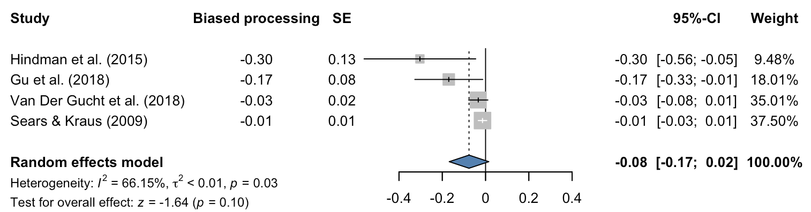

Fig. S6
The Summary Risk of Bias 2.0 Assessment of Each RCT
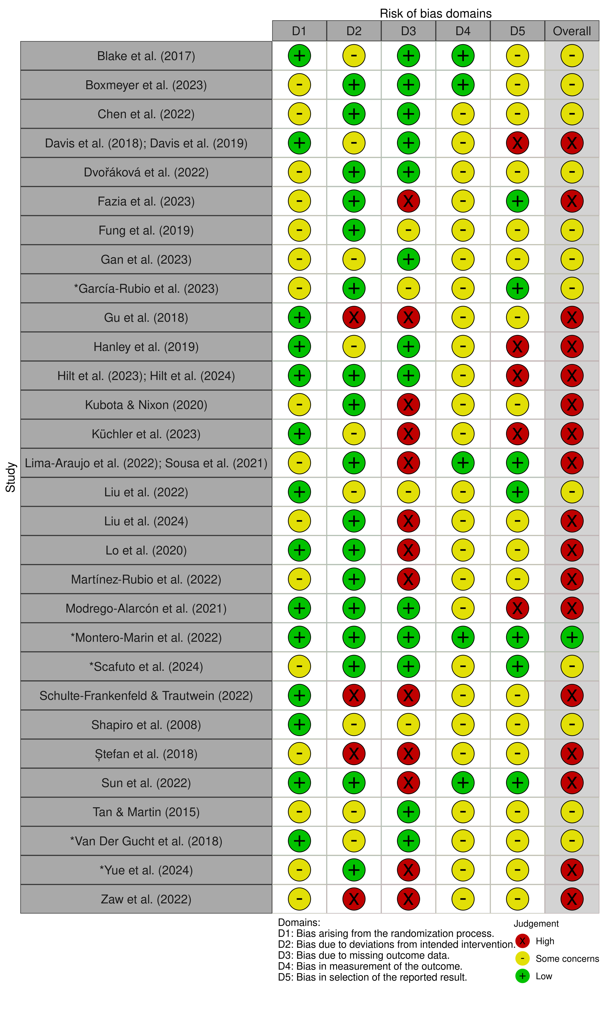
Note. * Indicates a cluster-RCT; One study may contain two reports in a single table cell.

Fig. S7
The Summary ROBINS-I Assessment of Each non-RCT
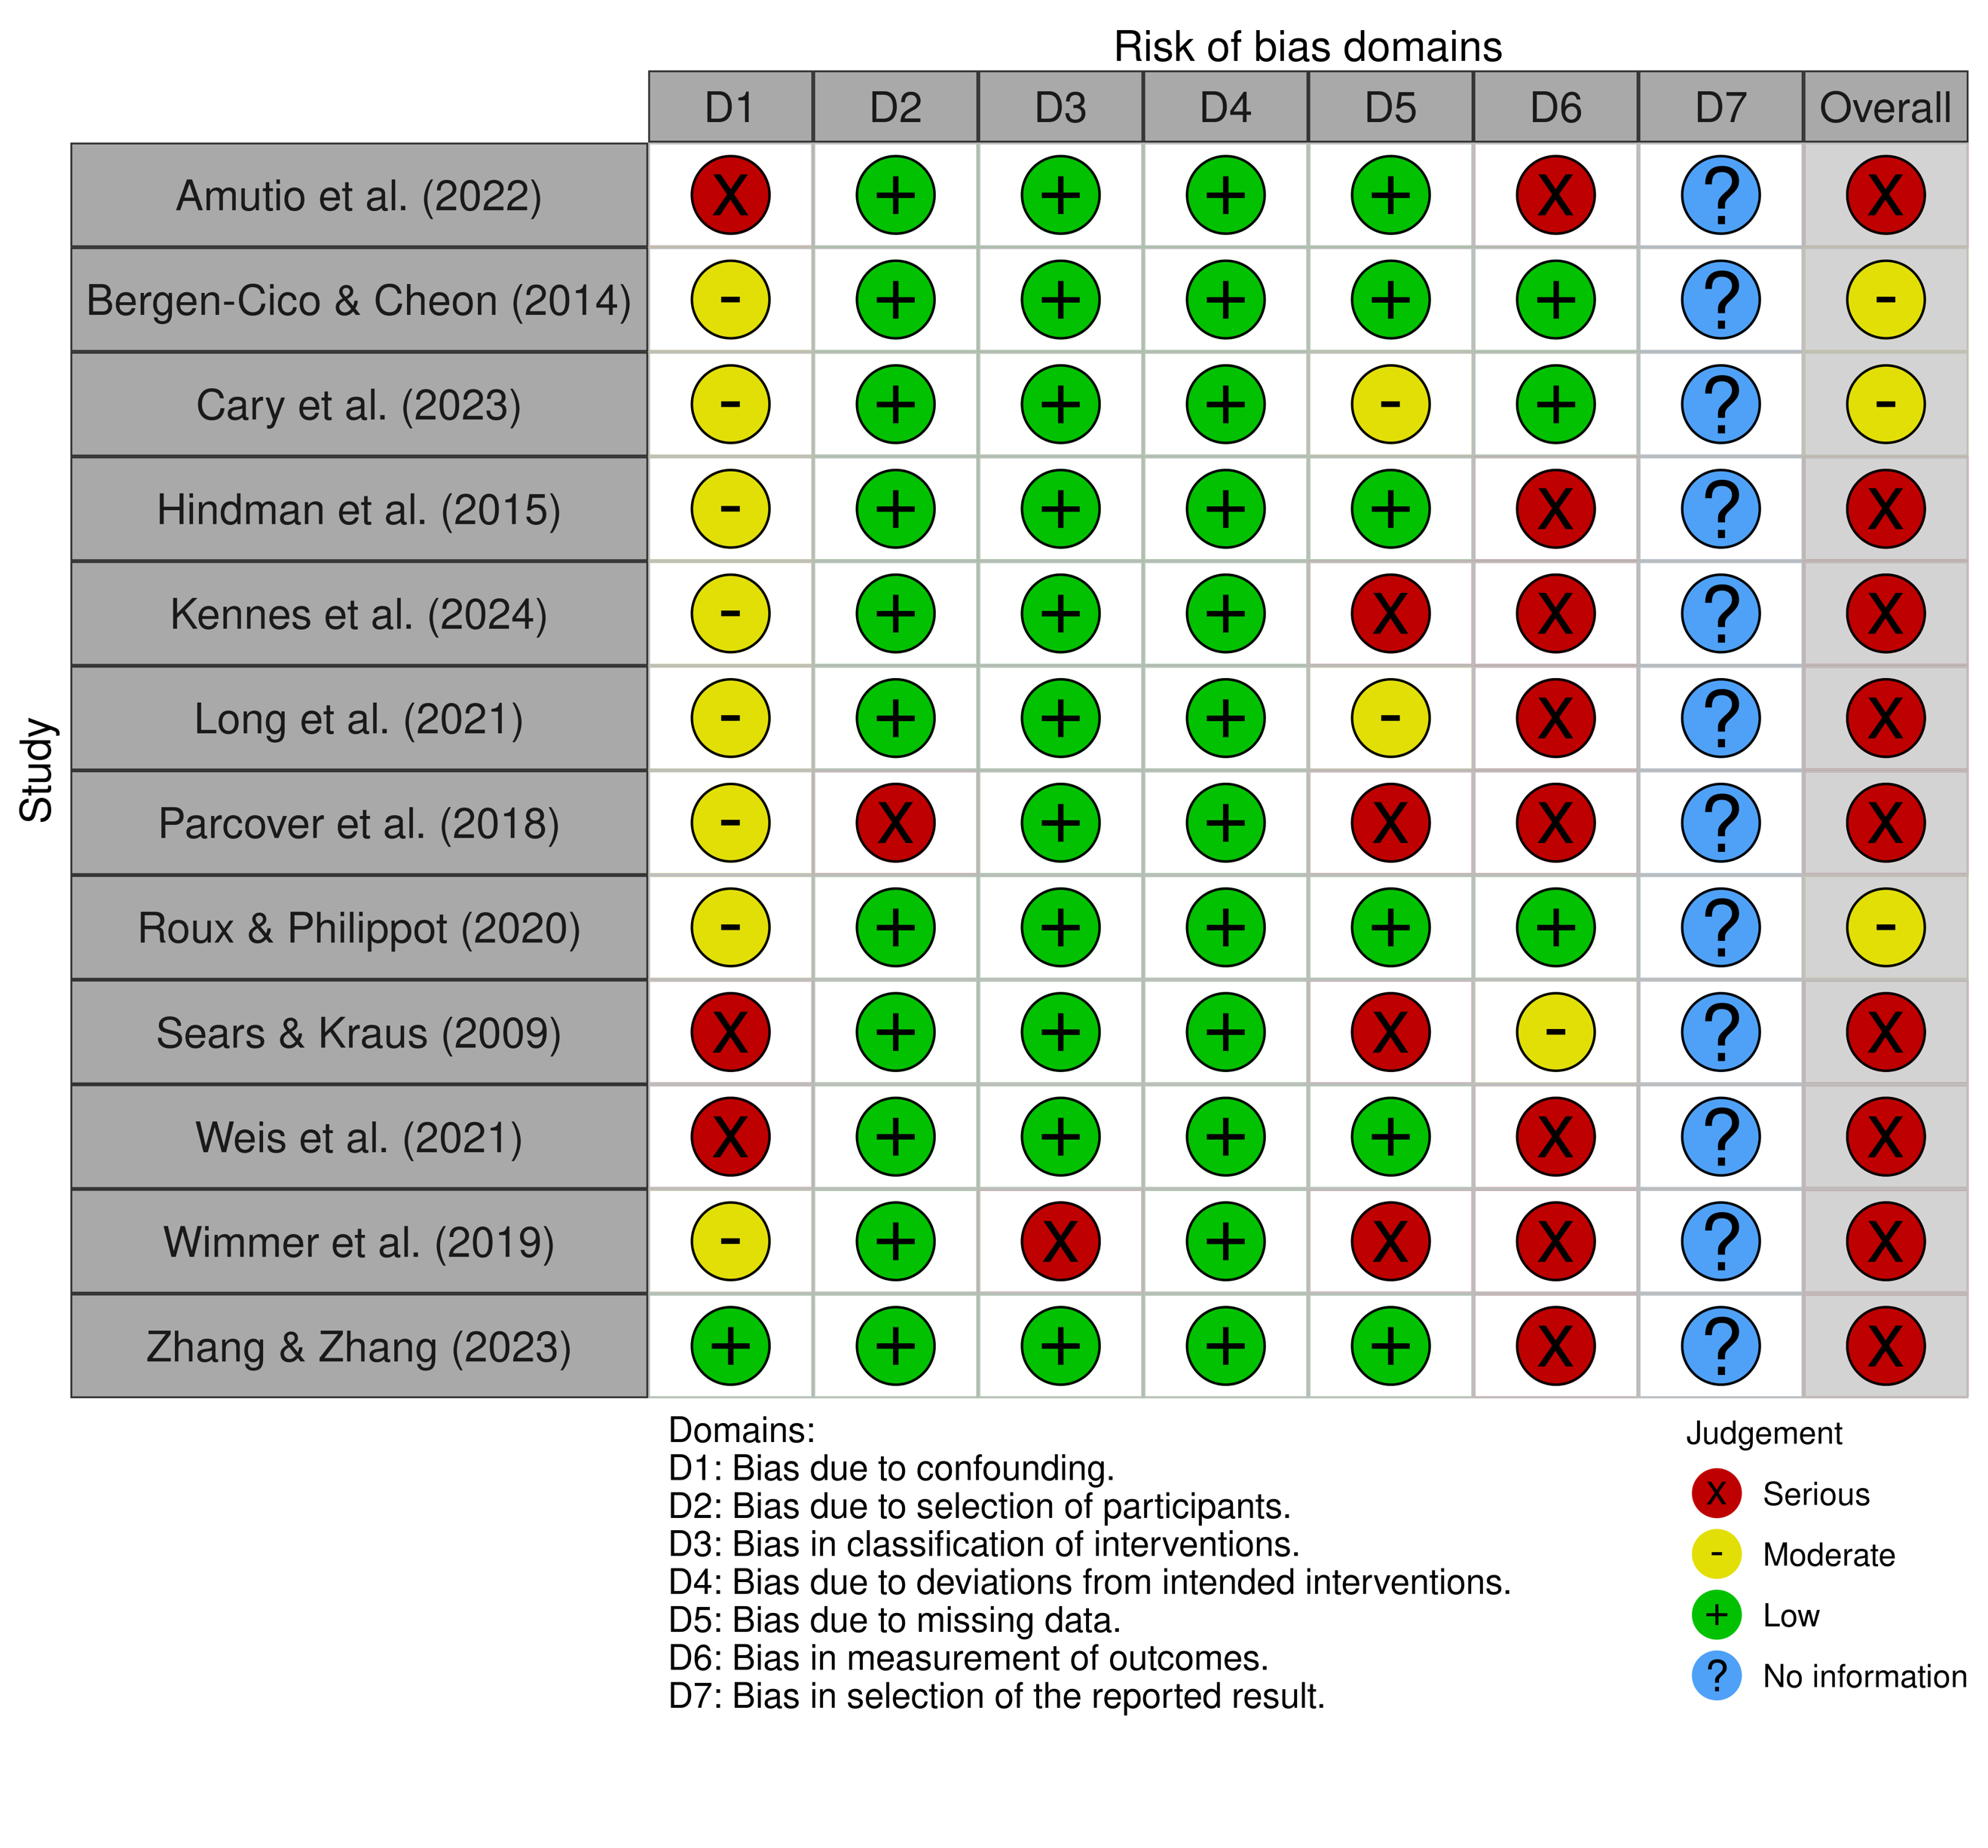

Table S8
Program Characteristics
Study | Program | Format | Content | Intervention dosage  (hour) | Duration (week) | Facilitator(s)
Amutio et al. (2022) | Mindfulness practices | In-person | Brief explanation; body scan; awareness and observation of sensations of breathing; observing thoughts and emotions; paying attention to sounds | 1.52 | 7.00 | Recorded audio instructions; no information about the narrator or recording process
Bergen-Cico & Cheon (2014) | Mindfulness-based stress reduction (MBSR) | In-person | Mindfulness practices in MBSR | 35.00 | 14.00 | A course professor; no information about his/her education or mindfulness training
Blake et al. (2017) | Sleep SENSE intervention | In-person | Sleep education; mindfulness of breath; practices of mindful attention, breath, and body scan; cognitive behavioral model; strategies for managing stress and worry; home practice | 10.50 | 7.00 | A trained teacher in clinical psychology
Boxmeyer et al. (2023) | Mindful Coping Power (MCP) | In-person | Mindfulness practices such as breath awareness, yoga, body scan, mindful eating, mindful listening, and thought awareness; cognitive behavioral preventive interventions for youth (CP) | 16.67 | 25.00 | Five clinicians with training in CP and MBSR and personal mindfulness practices
Cary et al. (2023) | Adapted MBSR | In-person | Mindfulness practices in MBSR such as mindfulness of breath, body scan, yoga, and observing thoughts and emotions | 8.00 | 8.00 | A certified MBSR instructor
Chen et al. (2022) | MBSR for military cadets (MBSR-MC) | In-person | Psychoeducation; mindfulness practices and assignments, such as body scan, sitting meditation with awareness of breath, and mindful movement; introducing application of mindfulness into daily living | NA | 8.00 | NA
Davis et al. (2018); Davis et al. (2019) | Group mindfulness-based relapse prevention (MBRP) | In-person | Attentive to personal triggers, present focus awareness, acceptance versus avoidance, responding to emotional and physical experiences in skillful ways, intrusive thought recognition, kindness in action, home practice, etc. | 12.00 | 4.00 | Two clinicians with training in MBRP
Dvořáková et al. (2022) | Learning to BREATHE (L2B) (MBSR adaptation) | In-person | Mindfulness practices to manage stress and regulate emotions, such as body scan, loving-kindness practice; home practice | 10.67 | 6.00 | Two trained facilitators in L2B under supervision of the program developer
Fazia et al. (2023) | Mindfulness-based Intervention (MBI) | Online | Integral Meditation (MI) including breathing, focusing attention, release of physical tensions etc.; dietary advice; brief yoga; online lecture | 7.50 | 5.00 | An expert meditator trainer; no further information
Fung et al. (2019) | Learning to BREATHE (L2B) (MBSR adaptation) | In-person | Body awareness (Body); understanding and working with thoughts (Reflection); understanding and working with feelings (Emotion); integrating awareness of thoughts, feelings and bodily sensations (Attention); reducing harmful self-judgments (Tenderness); integrating mindful aware- ness into daily life (Habit); home practice | 10.00 | 12.00 | Two advanced doctoral psychology students with training in L2B
Gan et al. (2023) | MBSR | In-person | Homework review; theoretical teaching; experiential practice (e.g., body scan, sitting meditation); group discussion; homework assignment (6 days per week with at least 30 mins each day) | 12.00 | 8.00 | A trained mindfulness teacher with over 2 years of personal mindfulness practices
García-Rubio et al. (2023) | GrowingUp Breathing mindfulness-based program | In-person | Mindfulness practices in three modules (Attention, Self-regulation, and Kindness); psychoeducation | 7.50 | 9.00 | Two certified MBSR and MBCT instructors with experience of delivering mindfulness to children
Gu et al. (2018) | Mindfulness-based self-help (MBSH) intervention "Learning Mindfulness Online" | Online learning portal | 5 sections: what is mindfulness; daily mindfulness practice; daily practice FAQ; my daily journal; study information, help and assistance | NA | 2.00 | Online platform; audios were recorded by clinical psychologists with training in teaching mindfulness
Hanley et al. (2019) | Modified MBSR training | In-person | Standard practices and exercises in MBSR but the time on exercise, didactic teaching, and reflection was shortened; home practice | 10.50 | 7.00 | Six certified MBSR instructors
Hilt et al. (2023); Hilt et al. (2024) | A mobile app (CARE) | Mobile app | Notifications to use the app three times a day | NA | 3.00 | A mobile app; no information about the narrator of the audio recordings
Hindman et al. (2015) | Mindful Stress Management (MSM) (adapted from MBSR, MBCT and ACT) | In-person | Psychoeducation; formal mindfulness meditations; informal mindfulness practice; discussion; home practice | 6.00 | 8.00 | A clinical doctoral student with training in DBT and experience of MBSR course; a mindfulness teacher with personal practice for 10 years
Kennes et al. (2024) | Think Happy-Be Happy (THBH) | In-person | A combination of mindfulness-based practices with the application of strengths | 6.00 | 8.00 | Two trainers with psychology degrees or trainings, and expertise in mindfulness
Kubota & Nixon (2020) | Mindfulness (MBSR adapted) | In-person | Practicing mindfulness taught by the audio over 7 days | NA | 1.00 | Audio recording from study (Vinci et al., 2014); no further information
Küchler et al. (2023) | StudiCare Mindfulness | Online platform | 7 core modules and 2 boosters: elements adapted from ACT, MBSR, general stress management techniques, and various forms of materials; home practice | 5.83 | 7.00 | Online platform; no information about the narrator or recording process of audios
Lima-Araujo et al. (2022);  Sousa et al. (2021) | Mindfulness training (MT) | In-person | Body scan; breath awareness | 1.50 | 0.43 | Audio recording; no information about the narrator or recording process
Liu et al. (2022) | Mindfulness-based cognitive therapy (MBCT) | In-person | Guided mindfulness (e.g., body scan, sitting meditation); discussion; experiential exercises; daily practice; home practice | 20.00 | 8.00 | A certified MBCT teacher with mindfulness practices for 18 years
Liu et al. (2024) | Adapted MBCT | In-person | Psychological education; guided mindfulness practices (e.g., sitting meditation, body scan); an inquiry into and discussion of the participants’ experiences during the training; home practice | 6.00 | 4.00 | A teacher with a doctoral degree in psychology
Lo et al. (2020) | Family-based mindfulness intervention | In-person | Mindfulness training for parents (e.g., stress of being a parent, respond to children mindfully) and mindfulness intervention for children (e.g., attention, mindful movement, feeling and accepting feelings) | 8.00 | 8.00 for child; 6.00 for parent | Certified instructors in “Mindfulness Matters” training and had a professional degree in social work, education, or clinical psychology
Long et al. (2021) | Mindfulness-based coping program | In-person | A combination of mindfulness practices (e.g., body scan, breathing practice) and cognitive-behavioral coping and emotion regulation strategies | 9.00 | 6.00 | Four facilitators had certificates in mindfulness programs and at least 3 years of teaching mindfulness.
Martínez-Rubio et al. (2022) | MCBP for University Life (adapted MBCT for university students) | In-person | Short theoretical explanations; formal mindfulness practices; enquiry of the experiences during practice; homework review; home practice | 9.00 | 6.00 | A mindfulness teacher with training in MBCT (8 years of teaching), Compassion-Focused Therapy etc.
Modrego-Alarcón et al. (2021) | Mindfulness-based program (MBP) | In-person | Psychoeducation; mindfulness practices; self-compassion exercises | 9.00 | 6.00 | Clinical psychologists with training in mindfulness, VR, or muscle relaxation therapy
Montero-Marin et al. (2022) | .b intervention (adapted from MBCT) | In-person | Mindfulness skills training; applying mindfulness to daily lives; psychoeducation | 6.67 | 10.00-12.00 (one term) | School teachers with training in .b program and experience of MBCT-L course
Parcover et al. (2018) | Mindfulness-based intervention (MBI) | In-person | Mindfulness meditation with focused attention on the breath, open monitoring of thoughts, and orientation toward values-driven behavior | 3.00 | 3.00 | A licensed mental health professional or postdoctoral level trainee, graduate psychology students
Roux & Philippot (2020) | Mindfulness-based program | In-person | Emotion psychoeducation; mindfulness-based training, such as automatic pilot, body awareness, focused attention, and non-judgment | 13.33 | 16.00 | A psychologist trained in MBCT and another psycho-motor therapist trained in MBP for adolescents
Scafuto et al. (2024) | Gaia program | In-person | 4 modules: motivation to participate in Gaia; body self-awareness; emotional self-awareness and empathy; global and ecological self-awareness | 12.00 | 12.00 | Teachers with Gaia training
Schulte‐Frankenfeld & Trautwein (2022) | Mindfulness-based mobile intervention "Balloon" | Smartphone app | Mindfulness and meditation practices, such as using breathing and other body sensation to ground awareness in the present moment, observing thoughts and feelings, and cultivating care towards oneself and others | 9.50 | 8.00 | Smartphone app; no information about the narrator or recording process of audios
Sears & Kraus (2009) | Mindfulness intervention | In-person | Brief meditation focused on attention; brief meditation focused on loving kindness; longer meditation combining both attentional and loving kindness aspects of mindfulness; home practice | 24.00 | 12.00 | An instructor from a meditation center who completed Spirit Rock Meditation Center’s Community Dharma Leader Program
Shapiro et al. (2008) | MBSR | In-person | Mindfulness practices, such as mindful sitting meditation, body scan, mindful movement, 3-minute breathing space, and loving kindness meditation | 12.00 | 8.00 | An instructor with training in MBSR
Ștefan et al. (2018) | Adapted MBSR | In-person | Psychoeducation; formal and informal mindfulness practices; home practice; Facebook group | 10.50 | 6.00 | A certified trainer in CBT with 1 year of teaching mindfulness
Sun et al. (2022) | Mindfulness for Growth and Resilience (adapted from MBSR and MBCT) | Online platforms | Zoom for group mindfulness training (e.g., experiential and group learning of mindfulness); WeChat-based miniprogram for didactic learning and daily mindfulness practice | 4.00 | 4.00 | A licensed psychologist and an MBSR teacher
Tan & Martin (2015) | Taming the adolescent mind (TAM) (adapted from MBSR) | In-person | Learning to regulate attention; observer of present moment; acceptance; being mindful; mindfulness and beyond; formal and informal mindfulness practices; home practice; discussion | NA | 5.00 | No information about the facilitator’s training or expertise
Van Der Gucht et al. (2018) | School-based mindfulness training (SBMT) (adapted from MBSR and MBCT) | In-person | Learning to become non-judgmentally aware of thoughts, feelings and sensations, automatic pilots; skillful responses; mindfulness practices | 13.33 | 8.00 | Three certified instructors in SBMT
Weis et al. (2021) | Koru Mindfulness | In-person | Brief activity to focus attention; introduction of mindfulness skills; meditation practices (e.g., diaphragmatic and dynamic breathing, body scan meditation, walking meditation); home practice; discussions | 5.00 | 4.00 | A certified KM counsellor
Wimmer et al. (2019) | MBSR with/without yoga | In-person | Psychoeducation; formal and informal mindfulness practices; coping with difficulties; discussions; home practice | 12.00 | 16.00 | Authors of this paper who engaged in mindfulness practices over years
Yue et al. (2024) | Brief meditation intervention (BMI) | In-person | Guided meditation with relaxation music; mindful breathing and body scan; positive suggestions | 4.33 | 8.00 | School teachers; no information about the training
Zaw et al. (2022) | Mindful self-compassion (MSC) | Online | Formal (sitting meditation) and informal (daily activities) mindful self-compassion practices | 22.50 | 9.00 | An authorized MSC trainer and the third author of the paper as a facilitator
Zhang & Zhang (2023) | Mindfulness-based intervention (MBI) (MBSR adapted) | In-person | Psychoeducation; mindfulness meditations and gentle yoga; discussions; home practice | 16.00 | 8.00 | An instructor with training in MBSR supervised by a research psychologist with expertise in MBSR

Table S9
The Summary of Study Quality of Mediation Studies
Study | C1 | C2 | C3 | C4 | C5 | C6 | Overall quality
Amutio et al. (2022) | No | Yes | No | No | No | No | Unsatisfactory
Bergen-Cico & Cheon (2014) | No | Yes | Yes | Yes | Yes | No | Satisfactory
Blake et al. (2017) | Yes | Yes | Yes | Yes | No | No | Satisfactory
Boxmeyer et al. (2023) | Yes | Yes | No | No | No | No | Unsatisfactory
Cary et al. (2023) | No | Yes | No | No | No | No | Unsatisfactory
Chen et al. (2022) | Yes | Yes | No | Yes | No | No | Unsatisfactory
Davis et al. (2018); Davis et al. (2019) | Yes | Yes | No | Yes | Yes | No | Satisfactory
Dvořáková et al. (2022) | Yes | Yes | Yes | Yes | No | No | Satisfactory
Fazia et al. (2023) | Yes | Yes | Yes | Yes | No | No | Satisfactory
Fung et al. (2019) | Yes | Yes | Yes | Yes | No | No | Satisfactory
Gan et al. (2023) | Yes | Yes | Yes | No | No | No | Unsatisfactory
García-Rubio et al. (2023) | Yes | Yes | Yes | Yes | No | No | Satisfactory
Gu et al. (2018) | Yes | Yes | Yes | Yes | Yes | No | Good
Hanley et al. (2019) | Yes | Yes | Yes | No | No | No | Unsatisfactory
Hilt et al. (2023); Hilt et al. (2024) | Yes | Yes | Yes | No | No | No | Unsatisfactory
Hindman et al. (2015) | No | Yes | No | Yes | No | No | Unsatisfactory
Kennes et al. (2024) | No | Yes | Yes | Yes | No | No | Unsatisfactory
Kubota & Nixon (2020) | Yes | Yes | No | Yes | No | No | Unsatisfactory
Küchler et al. (2023) | Yes | Yes | Yes | Yes | Yes | No | Good
Lima-Araujo et al. (2022); Sousa et al. (2021) | Yes | Yes | No | No | No | No | Unsatisfactory
Liu et al. (2022) | Yes | Yes | Yes | No | No | No | Unsatisfactory
Liu et al. (2024) | Yes | Yes | Yes | No | No | No | Unsatisfactory
Lo et al. (2020) | Yes | Yes | Yes | Yes | No | No | Satisfactory
Long et al. (2021) | No | Yes | Yes | Yes | No | No | Unsatisfactory
Martínez-Rubio et al. (2022) | Yes | Yes | No | Yes | No | No | Unsatisfactory
Modrego-Alarcón et al. (2021) | Yes | Yes | Yes | Yes | No | No | Satisfactory
Montero-Marin et al. (2022) | Yes | Yes | Yes | Yes | No | No | Satisfactory
Parcover et al. (2018) | No | Yes | Yes | No | No | No | Unsatisfactory
Roux & Philippot (2020) | No | Yes | No | Yes | Yes | No | Unsatisfactory
Scafuto et al. (2024) | Yes | Yes | Yes | Yes | No | No | Satisfactory
Schulte‐Frankenfeld & Trautwein (2022) | Yes | Yes | Yes | Yes | No | No | Satisfactory
Sears & Kraus (2009) | No | Yes | No | No | No | No | Unsatisfactory
Shapiro et al. (2008) | Yes | Yes | No | No | No | No | Unsatisfactory
Ștefan et al. (2018) | Yes | Yes | No | Yes | No | No | Unsatisfactory
Sun et al. (2022) | Yes | Yes | Yes | No | No | No | Unsatisfactory
Tan & Martin (2015) | Yes | Yes | Yes | No | No | No | Unsatisfactory
Van Der Gucht et al. (2018) | Yes | Yes | Yes | Yes | No | No | Satisfactory
Weis et al. (2021) | No | Yes | No | No | No | No | Unsatisfactory
Wimmer et al. (2019) | No | Yes | No | Yes | No | No | Unsatisfactory
Yue et al. (2024) | Yes | Yes | Yes | Yes | Yes | No | Good
Zaw et al. (2022) | Yes | Yes | No | Yes | No | No | Unsatisfactory
Zhang & Zhang (2023) | No | Yes | Yes | Yes | No | No | Unsatisfactory
Note. C1: Is this an RCT? C2: Is there a control group in which the mediator was also assessed? C3: Is there a sufficient sample size of n ≥ 40 per condition? C4: Are there multiple mediators? C5: Does it meet the temporality criterion defined by 3 or more assessments of mediator in the treatment phase? C6: Is there direct experimental manipulation of the mediator?

Table S10
Summary of the Mediation Effects of Self-regulation on Mental Health Outcomes
Mechanism | Definition | Findings (Mediation)
Self-Regulation | Ongoing, adaptive modulation of internal states or behaviors | Tertiary students  Significant mediation for anxiety (Cary et al., 2023)
Self-Control | Ability to regulate impulses and behaviors | Adolescents  Did not mediate aggression in high school students (Zhang & Zhang, 2023)
Cognitive Reappraisal | Reframing a situation’s meaning to alter emotional impact | Tertiary students  Mixed: Mediated depression in one study (Wimmer et al., 2019), but not in the other (Küchler et al., 2023); Did not mediate positive/negative affect, anxiety (Wimmer et al., 2019), stress, or self-regulation (Schulte-Frankenfeld & Trautwein, 2022)  Adolescents  Mediated psychological wellbeing (Scafuto et al., 2024), but not psychological distress (Scafuto et al., 2024), internalizing problems, or stress (Fung et al., 2019)
Expressive Suppression | Inhibiting or suppressing emotional expression once aroused | Tertiary students  Not a mediator for depression, anxiety, positive/negative affect, stress, or self-regulation across four studies (Küchler et al., 2023; Schulte-Frankenfeld & Trautwein, 2022; Sun et al., 2022; Wimmer et al., 2019)  Adolescents  Mediated reductions in internalizing behavior problems and stress (Fung et al., 2019), but not psychological distress or wellbeing (Scafuto et al., 2024)
Distraction | Shifting attention away from emotional stimuli before response generation | Tertiary students  Mediated anxiety and depression, but not for positive/negative affect (Wimmer et al., 2019)
Emotion Regulation (Composite) | Broad construct encompassing multiple regulation strategies | Tertiary students  Mediated wellbeing in one study (Fazia et al., 2023)  Adolescents  Mediated aggression (Zhang & Zhang, 2023)  Children  Mediated emotional symptoms, but not anxiety or life satisfaction (García-Rubio et al., 2023)
Rumination | Repetitive, passive focus on distress as a cognitive avoidance strategy | Tertiary students  Mediated anxiety, but not positive/negative affect, depression (Wimmer et al., 2019), stress (Hindman et al., 2015), or intrusion (Kubota & Nixon, 2020)  Adolescents  Mediated stress (Fung et al., 2019), internalizing symptoms (Fung et al., 2019; Hilt et al., 2023), depression, and anxiety (Hilt et al., 2023)
Coping / Emotional Approach Coping | Behavioral or cognitive efforts to manage stressors / Using emotional processing to manage stressors | Tertiary students  Coping mediated psychological wellbeing (Long et al., 2021)  Adolescents  Emotional approach coping did not mediate internalizing problems or stress (Fung et al., 2019)
Impulsivity / Sensation seeking | Tendency to act without forethought / Seeking sensation | Tertiary students  Positive and negative urgency mediated reduced substance use, while lack of premeditation, lack of perseverance, and sensation seeking did not (Davis et al., 2019)  Adolescents  Urgency and sensation seeking did not mediate externalizing problems (Roux & Philippot, 2020)

