Supplementary Tables and Figures

Table S1. Results from demographic comparison of included and excluded participants
Variable |  | Excluded | Included | p | Test | Missing
n |  | 774 | 1389
Age (Mean (SD)) |  | 64.18 (13.28) | 49.41 (16.83) | <0.001 | t-test | 0.70
Gender | Female | 213 (27.60) | 659 (47.40) | <0.001 | $$χ^{2}$$ | 0.00
 | Male | 560 (72.40) | 726 (52.30)
 | Other | 0 (0.00) | 4 (0.30)
Race | White | 680 (89.60) | 980 (70.60) | <0.001 | $$χ^{2}$$ | 0.70
 | Black or African American | 59 (7.80) | 280 (20.20)
 | Asian | 5 (0.70) | 36 (2.60)
 | Native Hawaiian or Other Pacific Islander | 0 (0.00) | 1 (0.10)
 | American Indian or Alaska Native | 3 (0.40) | 9 (0.60)
 | More than one race | 6 (0.80) | 58 (4.20)
 | Other | 6 (0.80) | 25 (1.80)
Hispanic ethnicity | Hispanic or Latino | 43 (5.70) | 315 (22.70) | <0.001 | $$χ^{2}$$ | 0.70
 | Not Hispanic or Latino | 716 (94.30) | 1074 (77.30)
Education | Completed 11 or fewer years | 4 (0.50) | 10 (0.70) | <0.001 | $$χ^{2}$$ | 1.00
 | Graduated from high school or GED completed | 151 (20.10) | 292 (21.00)
 | Graduated from two-year college | 107 (14.20) | 220 (15.80)
 | Completed master’s degree | 170 (22.60) | 224 (16.10)
 | Graduated from four-year college | 183 (24.30) | 425 (30.60)
 | Completed some post college education | 85 (11.30) | 158 (11.40)
 | Completed professional degree or PhD | 52 (6.90) | 60 (4.30)
Marital Status | Single | 86 (11.40) | 372 (26.80) | <0.001 | $$χ^{2}$$ | 1.00
 | Married/in a domestic partnership | 552 (73.40) | 847 (61.00)
 | Divorced | 52 (6.90) | 111 (8.00)
 | Separated | 8 (1.10) | 13 (0.90)
 | Widowed | 54 (7.20) | 46 (3.30)
Income | Under $25,000 | 48 (6.40) | 176 (12.70) | <0.001 | $$χ^{2}$$ | 1.00
 | 25k - 49,999 | 112 (14.90) | 300 (21.60)
 | 50k - 99,999 | 267 (35.50) | 520 (37.40)
 | 100k - 149,999 | 142 (18.90) | 223 (16.10)
 | 150k- 199,999 | 78 (10.40) | 73 (5.30)
 | 200k- 249,999 | 36 (4.80) | 29 (2.10)
 | 250k - 299,999 | 9 (1.20) | 18 (1.30)
 | 300k or more | 15 (2.00) | 10 (0.70)
 | Prefer not to say | 45 (6.00) | 40 (2.90)
Note: Table does not display open response frequencies

Table S2. Comparison of CFA model fit indices using MLR and WLSMV estimators (n = 1389)
Model  (n = 1389) | Estimator |  | $${SBχ}^{2}$$  or ${Scaledχ}^{2}$ | $$df$$ | Robust CFI | SRMR | Robust RMSEA | Robust RMSEA [90% CI] | AIC | BIC
1. Six-factor model |  | MLR | 114.15 | 39 | 0.99 | 0.03 | 0.04 | 0.03 - 0.05 | 45917.07 | 46121.29
1. Six-factor model |  | WLSMV | 304.87 | 39 | 0.98 | 0.03 | 0.06 | 0.05 - 0.07 | - | -
2. Higher-order model |  | MLR | 1043.83 | 48 | 0.82 | 0.14 | 0.14 | 0.13 - 0.15 | 47095.16 | 47252.25
2. Higher-order model* |  | WLSMV | 3161.33 | 48 | 0.78 | 0.15 | 0.22 | 0.21- 0.22 | - | -
3. Two-factor model |  | MLR | 360.11 | 53 | 0.95 | 0.05 | 0.07 | 0.07 - 0.08 | 46205.05 | 46335.96
3. Two-factor model |  | WLSMV | 804.58 | 53 | 0.93 | 0.05 | 0.09 | 0.09-0.10 | - | -
4. One-factor model |  | MLR | 1874.77 | 54 | 0.68 | 0.16 | 0.18 | 0.17 - 0.18 | 48156.39 | 48282.07
4. One-factor model |  | WLSMV | 3887.37 | 54 | 0.63 |  | 0.21 | 0.21- 0.22 | - | -
  0.17
* Robust fit indices were not available for this second-order model with WLSMV due to current implementation limitations in the R package lavaan.
Table S3. Descriptive statistics for SCS-SF scores by race (CFA analytic sample, n = 1389)
Group | n | SK | SJ | CH | I | M | OI | SCS Total | PSS | PHQ-4 | SCBCS
Asian | 36 | 6.14 (1.68) | 4.86 (2.14) | 5.92 (2.05) | 5.11 (2.00) | 7.08 (1.68) | 4.78 (2.27) | 33.89 (9.61) | 18.42 (6.58) | 5.05 (3.66) | 23.97 (5.78)
Black/African American | 280 | 7.38 (1.80) | 6.53 (2.17) | 6.78 (1.96) | 6.40 (2.32) | 7.92 (1.75) | 6.85 (2.42) | 41.84 (8.22) | 13.24 (7.76) | 2.50 (3.31) | 26.38 (5.98)
Multiracial | 58 | 5.91 (2.02) | 5.31 (2.36) | 6.21 (1.98) | 5.00 (2.11) | 6.95 (1.77) | 5.29 (2.43) | 34.67 (9.41) | 18.57 (7.72) | 4.11 (3.86) | 26.48 (5.80)
Native American/AN | 1 | 6.00 (—) | 6.00 (—) | 6.00 (—) | 6.00 (—) | 6.00 (—) | 6.00 (—) | 36.00 (—) | 20.00 (—) | 0.00 (—) | 20.00 (—)
Native Hawaiian/PI | 9 | 6.11 (1.36) | 5.78 (1.92) | 6.89 (1.17) | 5.56 (2.13) | 7.33 (1.22) | 5.89 (2.20) | 37.56 (5.59) | 19.11 (3.48) | 4.00 (2.94) | 23.11 (8.43)
Other/Unknown | 25 | 6.64 (1.44) | 6.16 (1.93) | 6.48 (1.73) | 5.88 (1.86) | 7.36 (1.55) | 6.64 (1.98) | 39.16 (6.57) | 15.52 (8.06) | 3.00 (3.94) | 25.52 (7.50)
White | 980 | 6.79 (1.92) | 5.84 (2.28) | 6.62 (2.05) | 5.78 (2.25) | 7.53 (1.76) | 6.07 (2.48) | 38.63 (9.11) | 14.46 (7.96) | 3.43 (3.52) | 24.68 (6.40)
Note. Values are mean (SD). Groups with n < 10 are presented descriptively and should be interpreted cautiously. Omnibus tests for SCS total scores are reported in the main text.

Table S4. Descriptive statistics for SCS-SF scores by Hispanic/Latino ethnicity (CFA analytic sample, n = 1389)
Group | n | SK | SJ | CH | I | M | OI | SCS Total
Hispanic/Latino | 315 | 7.16 (1.87) | 5.69 (2.23) | 7.14 (1.97) | 5.43 (2.27) | 7.68 (1.78) | 5.77 (2.57) | 38.87 (7.43)
Not Hispanic/Latino | 1074 | 6.75 (1.91) | 6.01 (2.28) | 6.46 (2.01) | 5.98 (2.25) | 7.53 (1.75) | 6.29 (2.45) | 39.02 (9.50)

Figure S1. Model 1 six-factor correlated model visual representation
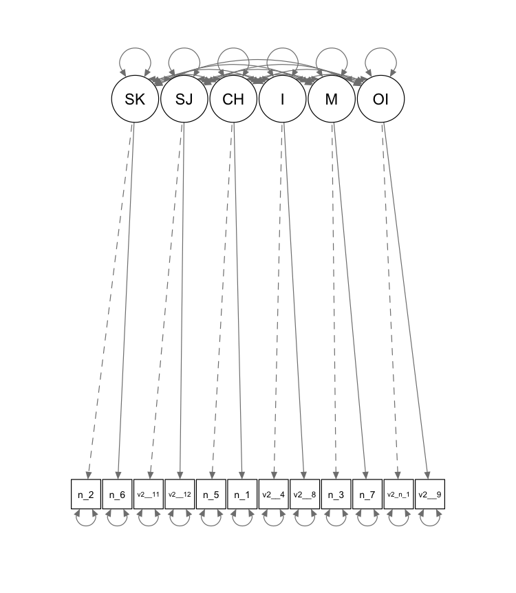

Figure S2. Model 2 higher-order model visual representations
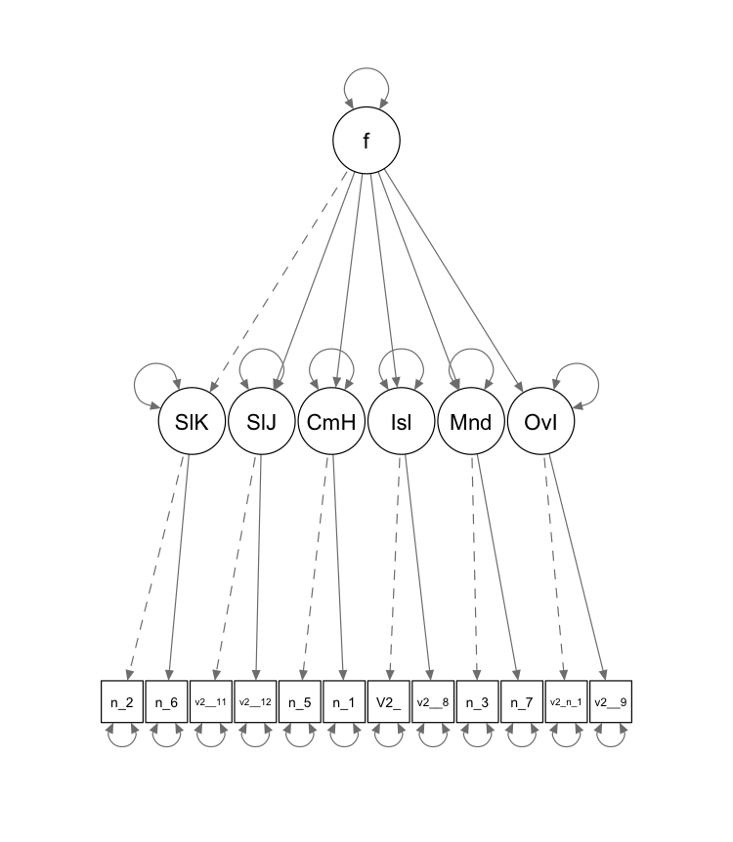
Figure S3. Model 3 two-factor correlated model visual representation
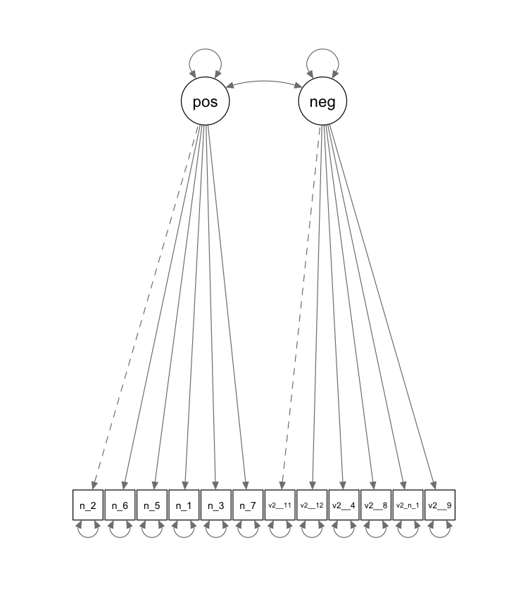

Figure S4. Model 4 one-factor model visual representation
