Supplementary Table 1. Risk of bias evaluation of included studies

Supplemantary Table 1-1. Evaluation of randomized studies
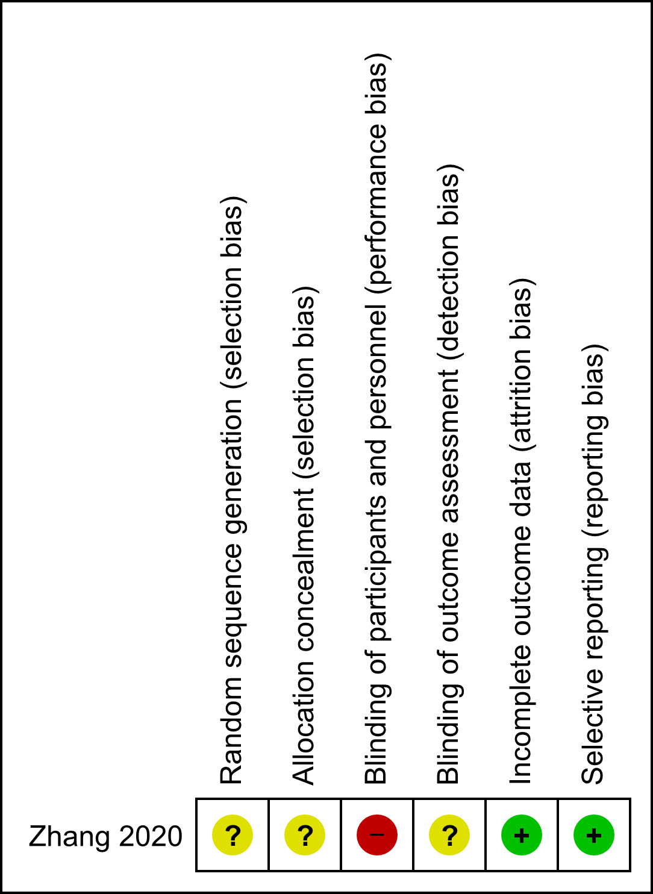
Only one study (Zhang et al, reference 6) was a randomized trial included in meta-analysis. This study was an open-label phase 2 study and ways of random sequence generation, allocation concealment, and blinding of outcome assessment were not documented in pulication and registry.
Green: Low risk of bias, Yellow: Unclear bias, Red: High risk of bias

Supplementary Table 1-2. Evaluation of non-randomized studies
Authors | Selection |  |  |  | Comparability | Outcome
 | Representative of the exposed cohort | Selection of the non-exposed cohort | Ascertainment of exposure | Outcome of interest not present at the start of the study |  | Assessment of outcomes | Sufficient follow-up time | Adequacy of follow-up | Total Score | Ref
Yamaguchi | * | - | * | * | - | * | * | * | 6 | 6
Sorbye | * | - | * | * | - | * | * | * | 6 | 7
Okuma | - | - | * | * | - | * | * | * | 5 | 8
Lu | * | - | * | * | - | * | * | * | 6 | 9
Iwasa | * | - | * | * | - | * | * | * | 6 | 10
Okita | - | - | * | * | - | * | - | - | 3 | 11
Chin | - | - | * | * | - | * | * | * | 5 | 12
Yoon | * | - | * | * | - | * | * | * | 6 | 13
Patta | * | - | * | * | - | * | * | * | 6 | 14
Walter | * | - | * | * | - | * | * | * | 6 | 15
Brandi | * | - | * | * | - | * | * | * | 6 | 16
Heetfeld | * | - | * | * | - | * | * | * | 6 | 17
Bongiovanni | * | - | * | * | - | * | * | * | 6 | 18
Hudson | - | - | * | * | - | * | * | * | 5 | 19
Sakamoto | - | - | * | * | - | * | * | - | 4 | 20
Kim | * | - | * | * | - | * | * | * | 6 | 21
Gerard | * | - | * | * | - | * | * | * | 6 | 22
Pulvirenti | - | - | * | * | - | * | * | * | 5 | 23
9-star Ottawa Newcastle Scale was used to evaluate quality of non-randomized studies included in meta-analysis. Main factors of comparability are age and sex. Additional factor of comparability is primary site of neuroendocrine carcinoma.

