Additional file 1: Figure S1. Survival Outcomes by Primary Malignancy
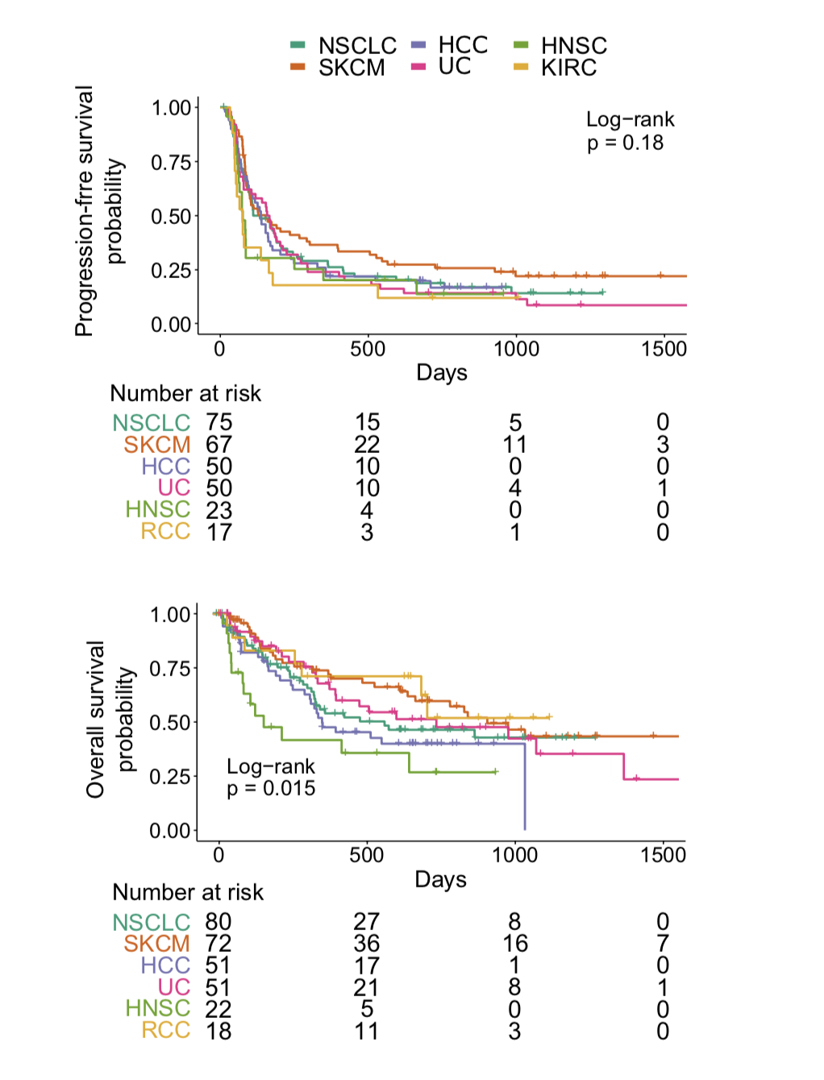

HCC: Hepatocellular carcinoma; HNSC: Head and neck squamous cancer; NSCLC: Non-small cell lung cancer; RCC: Renal cell carcinoma; UC Urothelial carcinoma

Additional file 1: Figure S2. Bone Metastasis-Associated Progression Free Survival and Overall Survival Outcomes by Primary Malignancy

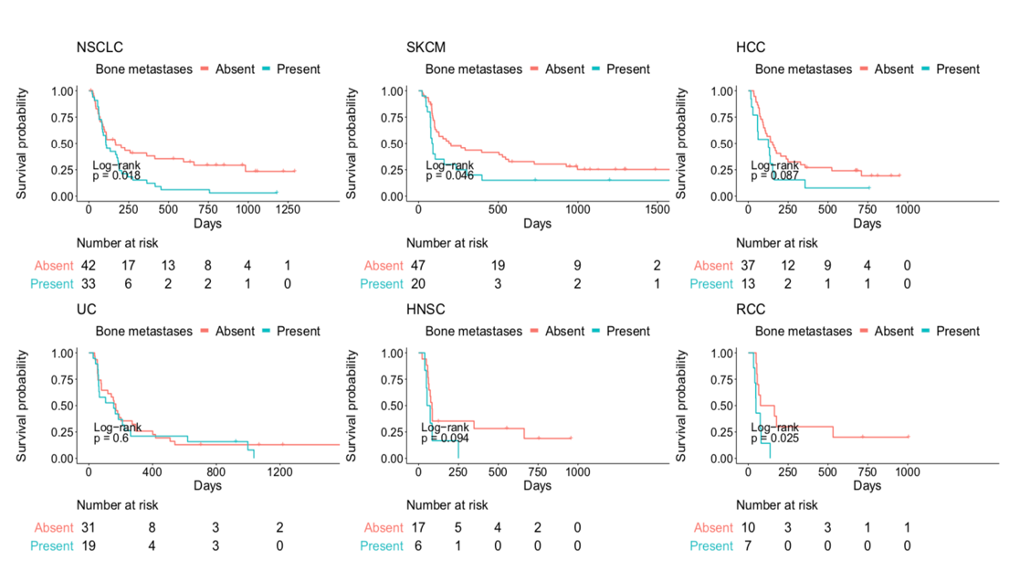
- Progression Free Survival

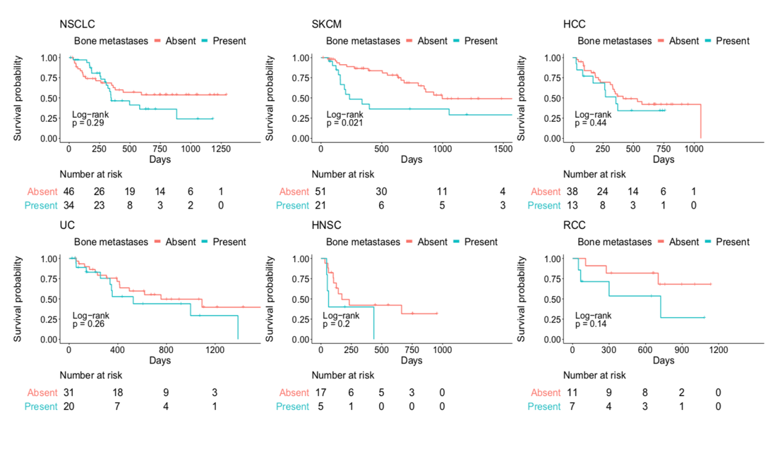
- Overall Survival

HCC: Hepatocellular carcinoma; HNSC: Head and neck squamous cancer; NSCLC: Non-small cell lung cancer; RCC: Renal cell carcinoma; SKCM: melanoma; UC Urothelial carcinoma

