Comprehensive Analysis of Ferroptosis-Related Genes for Clinical and Biological Significance in Hepatocellular Carcinoma

Qixian Wu ^{1, 2, 4}, Zhenlin Tan ^{1, 4}, Yu Xiong ³, Chengxin Gu ¹, Jingdon Zhou ², Hui Yang ^{1, *}, Jiyuan Zhou ^{1, *}

- Department of Gastroenterology, the Second Affiliated Hospital of Guangzhou Medical University, Guangzhou, China
- Guangzhou Medical University, Guangzhou, China
- Intervention and Cell Therapy Center, Peking University Shenzhen Hospital, Shenzhen, China
- These authors contributed equally to this work.

*Corresponding author:
Jiyuan Zhou, M.D., Ph. D
E-mail: jyzhou03@bjmu.edu.cn

Hui Yang, M.D., Ph. D
E-mail: yanghui@gzhmu.edu.cn
Additional file Figure 3

A
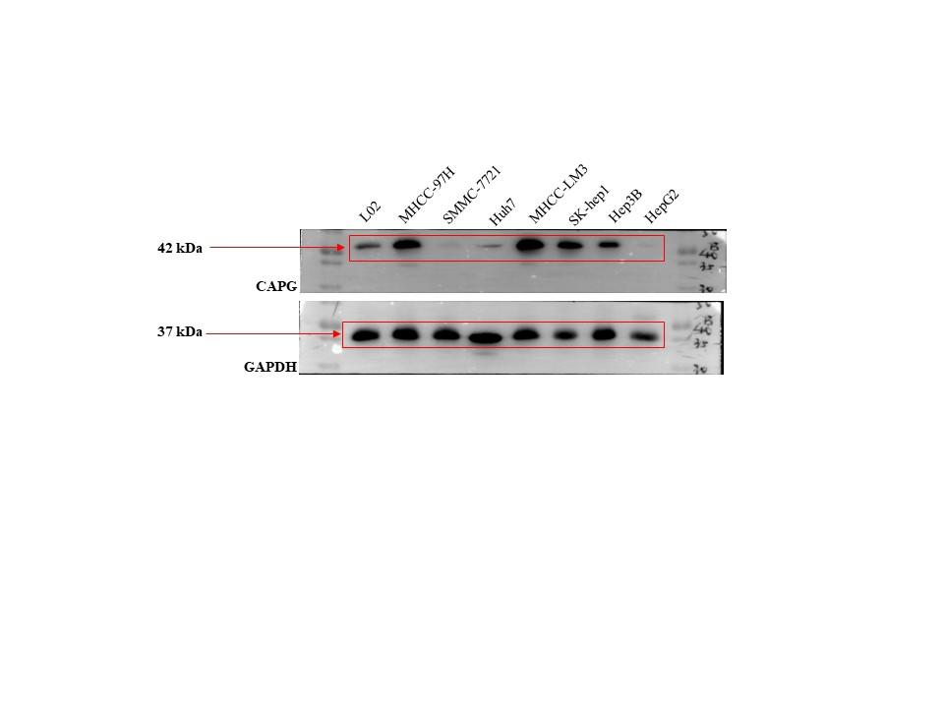

B
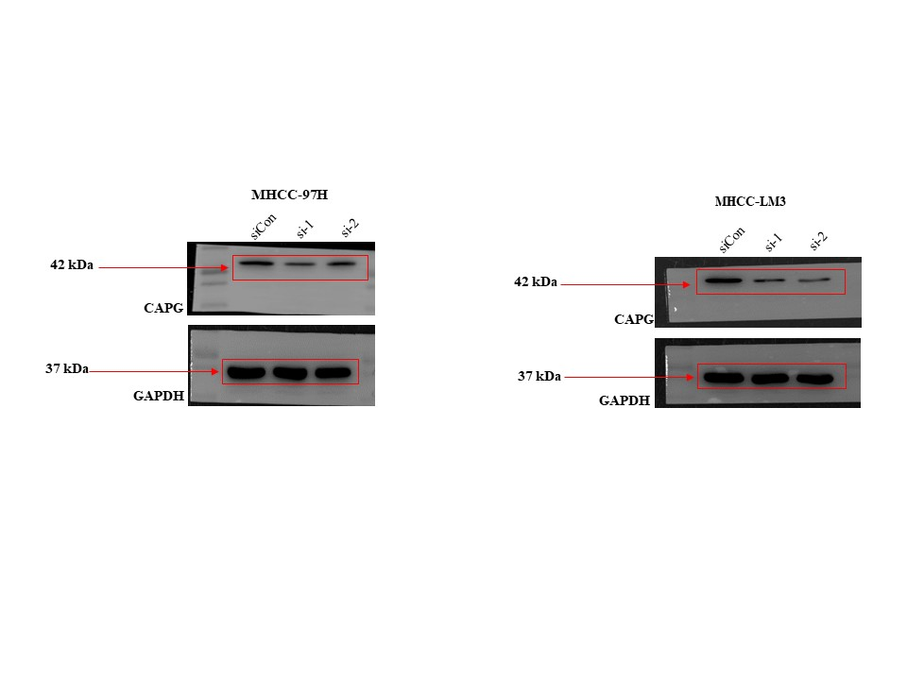

C
