Title
Virus-like particle-based delivery of Cas9/guide RNA ribonucleoprotein efficiently edits the brachyury gene and inhibits chordoma growth in vivo

Authors
Yunping Hu¹*, Baisong Lu², Zhiyong Deng³, Fei Xing⁴, Wesley Hsu¹*

Affiliations
¹ Department of Neurological Surgery, Wake Forest University School of Medicine, Medical Center Boulevard, Winston-Salem, NC 27157, USA
² Wake Forest University Institute for Regenerative Medicine, Medical Center Boulevard, Winston-Salem, NC 27157, USA

³ Department of Physiology and Pharmacology, Wake Forest University School of Medicine, Medical Center Boulevard, Winston-Salem, NC 27157, USA

⁴ Department of Cancer Biology, Wake Forest University School of Medicine, Medical Center Boulevard, Winston-Salem, NC 27157, USA

*Corresponding authors

Wesley Hsu, email: whsu@wakehealth.edu

Yunping Hu, email:yhu@wakehealth.edu

Supplementary Data

Supplementary Table S1. Sequences of sgRNA targeting brachyury

Gene name |  | Primers
sgRNA a | forward | 5’-ACCGggcctacctggtcagtgtcg-3’
 | reverse | 5’-AAACcgacactgaccaggtaggcc-3’
sgRNA b | forward | 5′- ACCGgtgctgaaggtgaacgtgtc-3’
 | reverse | 5’- AAACgacacgttcaccttcagcac-3’
sgRNA c | forward | 5’-CACCGtagcgcgtctccccgctcctc-3’
 | reverse | 5’-AAACgaggagcggggagacgcgctaC-3’
sgRNA d | forward | 5’-CACCgcaggaagccttcctctcagt-3’
 | reverse | 5’-AAACactgagaggaaggcttcctgc-3’

Supplementary Table S2. Primers for quantitative real-time PCR
Gene name |  | Primers
Brachyury | forward | 5’-AGACTGGAGAGTTGGG-3’
 | reverse | 5’- CAGGTGGTCCACTCGGTACT-3’
Cas9 | forward | 5’-GGAACCGCTGGAGAGCAACT-3’
 | reverse | 5’-GTCCCTATCGAAGGACTCTGGCA-3’
GAPDH | forward | 5′-CATGAGAAGTATGACAACAGCCT-3′
 | reverse | 3′-AGTCCTTCCACGATACCAAAGT-5′

Supplementary Fig. 1S

Brachyury gRNA

Marker Vehicle a+c a+d b+c b+d

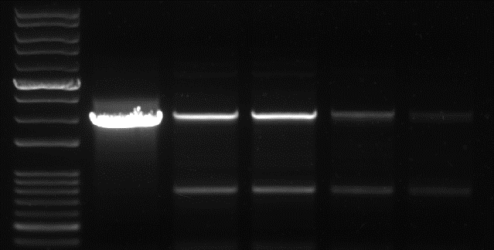
1k
800
700
3k
2k
Wild type/Brachyury
Deletion

The representative PCR analysis showing deletion caused by brachyury sgRNAs.
Supplementary Fig. 2

JHC7
UCH2
Time (h) 0 12 24 48 96
Time (h) 0 12 24 48 96
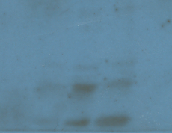
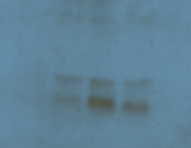
160 kDa
45 kDa
160 kDa
Cas9
β-actin

Cas9

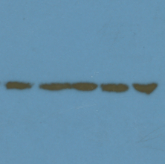

45 kDa
β-actin

The representative Western blot analysis of Cas9 expression in JHC7 and UCH2 cells treated with VLP-packaged brachyury gRNA a+c (50 ng) for up to 96 h.

a
Supplemental Fig. S3
JHC7
VLP-packaged brachyury gRNA
Marker Vehicle a+c a+d b+c b+d
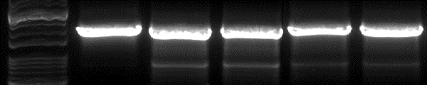

3k
2k
Wild type/Brachyury

1k
Deletion
800
700

UCH2
VLP-packaged brachyury gRNA
Marker Vehicle a+c a+d b+c b+d
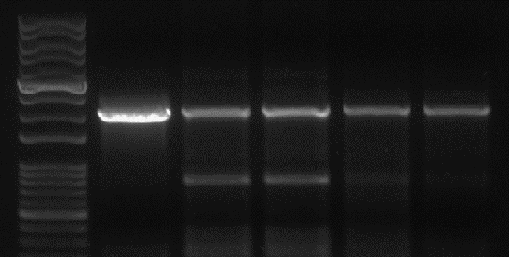

3k
Wild type/Brachyury
2k
1k
Deletion
700
800

VLP-packaged brachyury gRNA
UCH2
JHC7
b
VLP-packaged brachyury gRNA
Vehicle a+c a+d b+c b+d
Vehicle a+c a+d b+c b+d
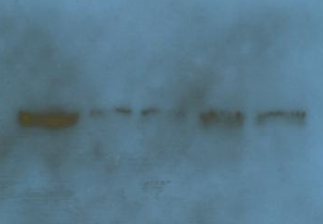
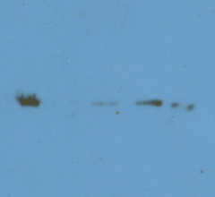

Brachyury

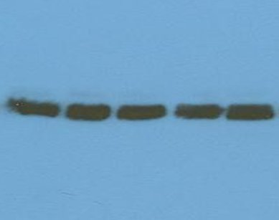
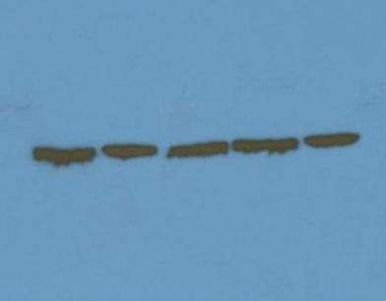

β-actin

#
#
#
#
*
*
*
*
c

a. The representative PCR analysis showing deletion caused by VLP-packaged brachyury gRNAs in JHC7 and UCH2 cells. b. The representative Western blot analysis of brachyury expression in JHC7 and UCH2 cells treated with vehicle (medium) or VLP-packaged brachyury gRNAs (50 ng) for 48 h. c. JHC7 and UCH2 cells were treated with VLP-packaged brachyury gRNAs (50 ng) for 48 h. Cell viability was measured by trypan blue exclusion assay. Data were presented as mean ± SD (n=3). * P < 0.05, vs Vehicle in the same cell line; # P < 0.05, vs a+c or a+d in the same cell line.

