Supporting Information

Natural Killer Cells Modified with a Gpc3 Aptamer Enhance Adoptive Immunotherapy for Hepatocellular Carcinoma

Youshi Zheng^{2,3}, Zisen Lai², Bing Wang^{2,3}, Zuwu Wei^{2,3}, Yongyi Zeng^{1,2,3}, Qiuyu Zhuang^{2,3*},Xiaolong Liu^{2,3,4*}, Kecan Lin^{1,2,4}*.
- Liver Disease Center, The First Affiliated Hospital of Fujian Medical University, Fuzhou 350005, China.
- The United Innovation of Mengchao Hepatobiliary Technology Key Laboratory of Fujian Province, Mengchao Hepatobiliary Hospital of Fujian Medical University, Fuzhou, P. R. China.
- Mengchao Med-X Center, Fuzhou University, Fuzhou, P. R. China.
- Fujian Provincial Clinical Research Center for Hepatobiliary and Pancreatic Tumors
*Corresponding authors: Qiuyu Zhuang, Xiaolong Liu & Kecan Lin
Email: qiuyuzhuang@outlook.com, xiaoloong.liu@gmail.com & kclin2002@126.com.

Results
Table S1. The detailed information of aptamer sequences
Name | Sequence from 5’ to 3’
DBCO-GPC3 aptamer | DBCO-TAACGCTGACCTTAGCTGCATGGCTTTACATGTTCCA-FAM
Random-DBCO-GPC3 aptamer | DBCO-TgAtGaTtAaCgTcGtTaCcTtGaTcTgCgTaTcCtA-FAM
The minuscule letters represent mutations.

Figure S1
Figure S1. A. Western Blot for the expression of GPC3 protein in HepG2 cells and HeLa cells. B-C. The surface expression level of GPC3 on HepG2 (B) and HeLa cells (C) evaluated by FACS.

Figure S2
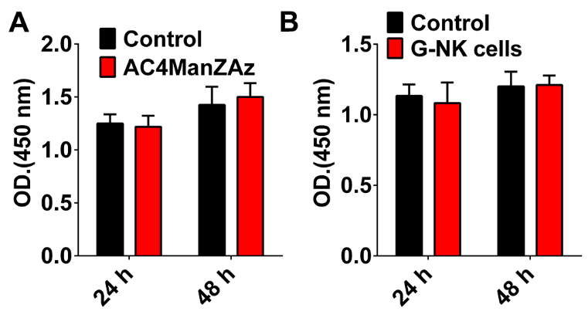
Figure S2. A. The viability of NK cells incubated with Ac4ManNAz for 24 h and 48 h, respectively. NK cells without Ac4ManNAz were served as the control group. B. The viability of G-NK cells for 24 h and 48 h. Analyzed by cell counting kit-8 (CCK8) assays. NK cells treated with Ac4ManNAz were served as the control group. The statistical analysis was performed with the ANOVA analysis (*p < 0.05, **p < 0.01), the data are presented as the mean ± SD, n=3.

Figure S3
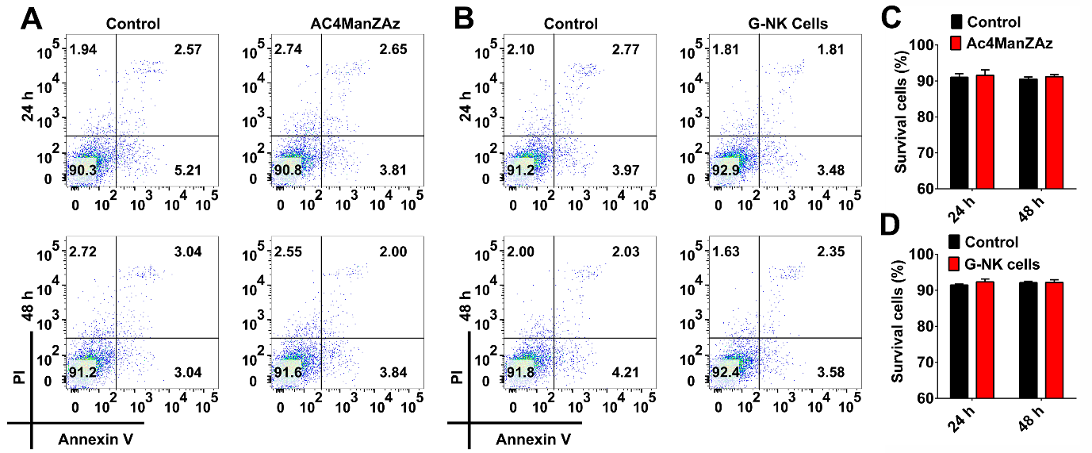
Figure S3. A and C The apoptosis/necrosis of NK cells incubated with Ac4ManNAz (50 μM) for 24 h and 48 h, respectively. NK cells without Ac4ManNAz were served as the control group. B and D The apoptosis/necrosis of G-NK cells for 24 h and 48 h. Analyzed by FACS. NK cells treated with Ac4ManNAz were served as the control group. The statistical analysis was performed with the ANOVA analysis (n=3,*p < 0.05, **p < 0.01).

Figure S4
Figure S4. A. The activation of NK cells was analyzed by staining CD3⁻/CD56⁺ and CD3⁻/CD16⁺. B. The phenotype of G-NK cells treated for another 48 h.

Figure S5
Figure S5. CLSM images of HeLa cells treated with NK^{ICG} cells for 1 h at the E/T ratio of 10:1 and then washing twice with PBS. Scale bar, 20 μm.

Figure S6
Figure S6. CLSM images of HeLa cells treated with R^{FAM}-NK^{ICG} cells for 1 h at the E/T ratio of 10:1 and then washing twice with PBS. Scale bar, 20 μm.

Figure S7
Figure S7. CLSM images of HeLa cells treated with G^{FAM}-NK^{ICG} cells for 1 h at the E/T ratio of 10:1 and then washing twice with PBS. Scale bar, 20 μm.

Figure S8
Figure S8. The specific targeting property of NK cells, R-NK cells and G-NK cells evaluated by FACS.

Figure S9
Figure S9.The cell viability of HepG2 cells when co-incubated with G-NK cells, R-NK cells or NK cells (E/T=10:1) evaluated by LDH cytotoxicity assay. The statistical analysis was performed with the ANOVA analysis (*p < 0.05, **p < 0.01), the data are presented as the mean ± SD, n=5.

Figure S10
Figure S10. Cytotoxicity of G-NK cells for GPC3⁻ Tumor cells. A. Apoptosis of HeLa cells incubated with NK, R-NK and G-NK cells for 1h and washed twice to remove unbinding NK cells, and then further incubated for 24 h at the E/T ratio of 10:1. B. Apoptosis of HepG2 cells incubated with NK, R-NK and G-NK cells at E/T ratio of 10:1. The statistical analysis was performed with the ANOVA analysis (*p < 0.05, **p < 0.01), the data are presented as the mean ± SD, n=3.

Figure S11
Figure S11. A. Western Blot for the expression of GPC3 protein in HepG2, Huh7 and Hep3B cells. B-C. The surface expression level of GPC3 on Huh7 (B) and Hep3B cells (C) evaluated by FACS.

Figure S12
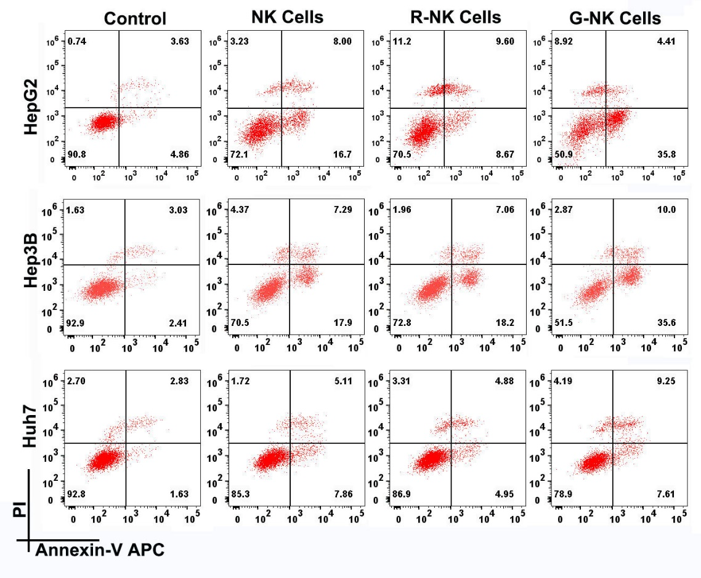
Figure S12. The cytotoxicity of G-NK cells toward HepG2, Hep3B and Huh7 cells. The HepG2, Hep3B and Huh7 cells when co-incubated with NK cells, R-NK cells and G-NK cells (E/T=10:1) for 1h and washed twice to remove unbinding NK cells, and then further incubated for 24 h evaluated by FACS.

Figure S13
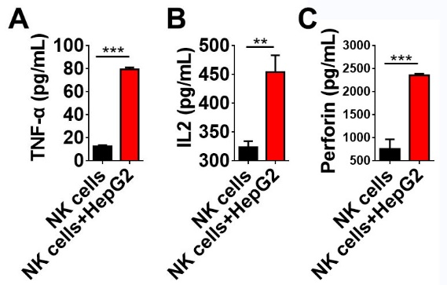
Figure S13. The cytokines secreted by NK cells with or without coincubating with HepG2 cells.

Figure S14
Figure S14. A. Ex vivo NIR fluorescence images of tumors and other major organs after treating with R-NK cells or G-NK cells for 24 h. ICG was excited by 808 nm. B. Relative fluorescence intensity of ICG in NK cells, R-NK cells or G-NK cells as indicated A. The fluorescence intensity was calculated by Image J. Statistical analysis was performed by two-tailed paired sample Student’s t-tests (*p < 0.05, **p < 0.01), n = 3.

Figure S15
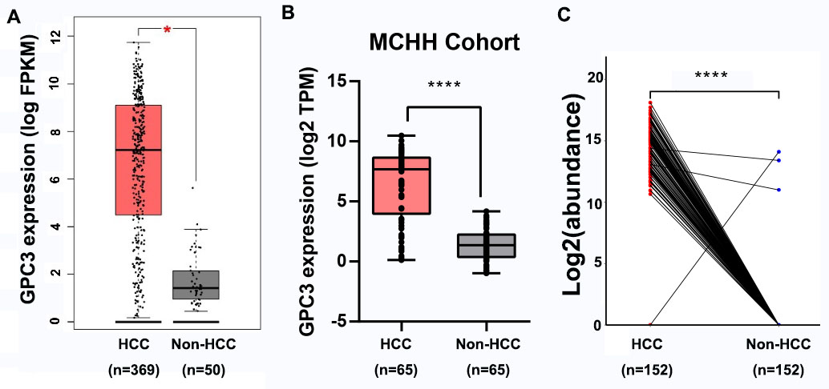
Figure S15. A.The expression of GPC3 in HCC tumours of TCGA cohort using the online TCGA analysis tool (http://gepia.cancer-pku.cn/). *p < 0.05. B-C. The expression of GPC3 in HCC patients using RNA-seq and MS. ****p < 0.0001.

