Suppression of the long non-coding RNA LINC01279 triggers autophagy and apoptosis in lung cancer by regulating FAK and SIN3A
Jiancong Wu^{1#}, Xiaobi Huang^{1#}, Xiaofang Li², Honglian Zhou¹, Xiaorao Chen¹, Yongyang Chen¹, Yudong Guo¹, Jian Huang³, Hanqing Huang³, Zhong Huang¹, Guoan Chen⁴, Zhixiong Yang¹*, Jian Zhang⁴*, Wenmei Su^{1,5}*
¹Department of Pulmonary Oncology, Affiliated Hospital of Guangdong Medical University, Zhanjiang, 524000, China
²Center for Pathological Diagnosis and Research, Affiliated Hospital of Guangdong Medical University, Zhanjiang, 524000, China
³Department of Thoracic Surgery, Maoming People's Hospital, Maoming, 525000, China
⁴School of Medicine, Southern University of Science and Technology, Shenzhen 518055, China
⁵Guangdong Provincial Key Laboratory of Autophagy and Major Chronic Non-communicable Diseases, Affiliated Hospital of Guangdong Medical University, Zhanjiang, 524000, China

Running title: LINC01279 regulates LUAD progression.

#Jiancong Wu and Xiaobi Huang contributed equally.
*Correspondence: Wenmei Su (suwenmei123@hotmail.com), Zhixiong Yang (yangzhixiong068@126.com), and Jian Zhang (jianzhang008@hotmail.com)

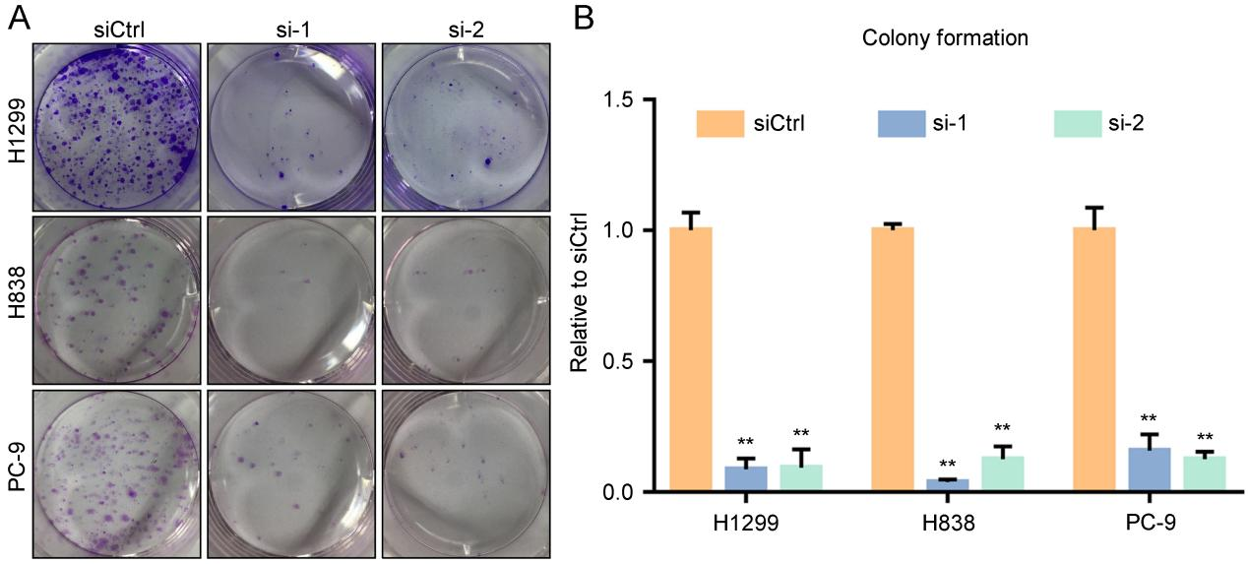

Supplementary Figure S1. (A) Knockdown of LINC01279 in H1299, H838 and PC-9 cells prevents colony formation. (B) Quantification of colony formation. Values were normalized to siCtrl-treated conditions. Data are the mean ± s.e.m. from three independent experiments (**, P <0.01).

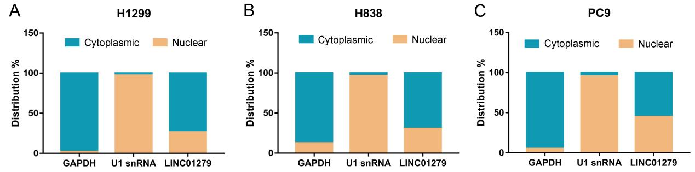

Supplementary Figure S2. (A-C) RT-qPCR analyses of cytoplasmic and nuclear distributions of LINC01279 in H1299, H838 and PC-9 cells. GAPDH and U1 snRNA were used as controls for the preparation of cytoplasmic and nuclear RNAs, respectively.
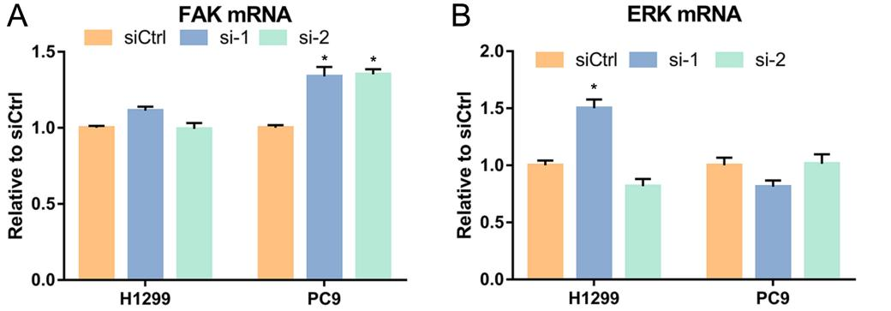
Supplementary Figure S3. (A, B) RT-qPCR analyses of the expression of FAK and ERK mRNAs after LINC01279 knockdown in H1299 and PC-9 cells. Values were normalized to siCtrl-treated conditions. Data are the mean ± s.e.m. from three independent experiments (*, P < 0.05).

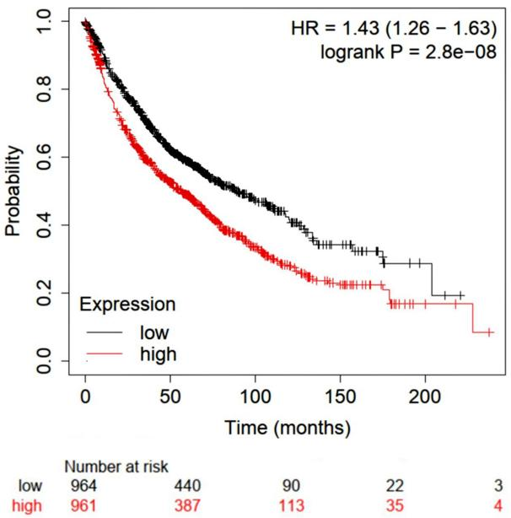

Supplementary Figure S4. Correlation between ERK expression and probability of survival in patients with LUAD. Analysis using the Kaplan-Meier method (cut-off value at 50%) shows that high level of ERK expression is related to poor patient survival (HR=1.43, 1.26-1.63, logrank P= 2.8e-08).

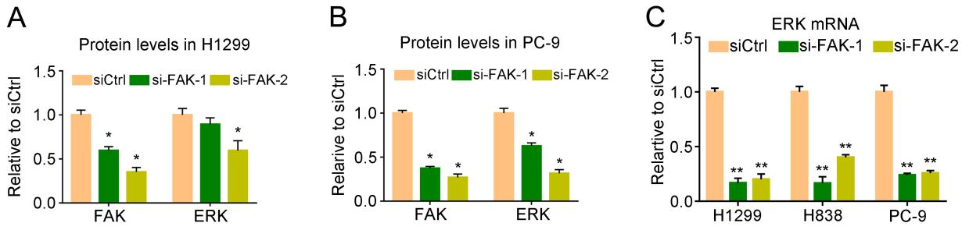
Supplementary Figure S5. Quantification of FAK and ERK protein levels and RT-qPCR analyses of ERK mRNA levels following FAK knockdown. (A, B) Knockdown of FAK in H1299 and PC-9 cells significantly decreases ERK proteins levels. (C) Knockdown of FAK significantly inhibits ERK mRNA levels in H1299, H838 and PC-9 cells. Statistical data are expressed as the mean ± s.e.m. from three independent experiments (*, P < 0.05; **, P < 0.01).
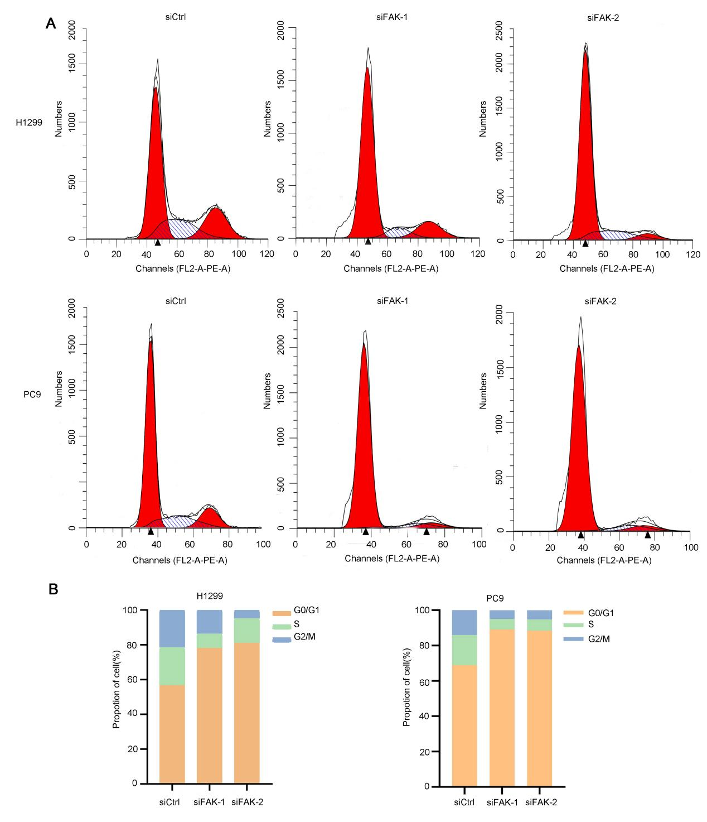
Supplementary Figure S6. Silencing FAK suppresses cell cycle progression in vitro. (A, B) Effects on cell cycle progression analyzed by flow cytometry after downregulation of FAK.

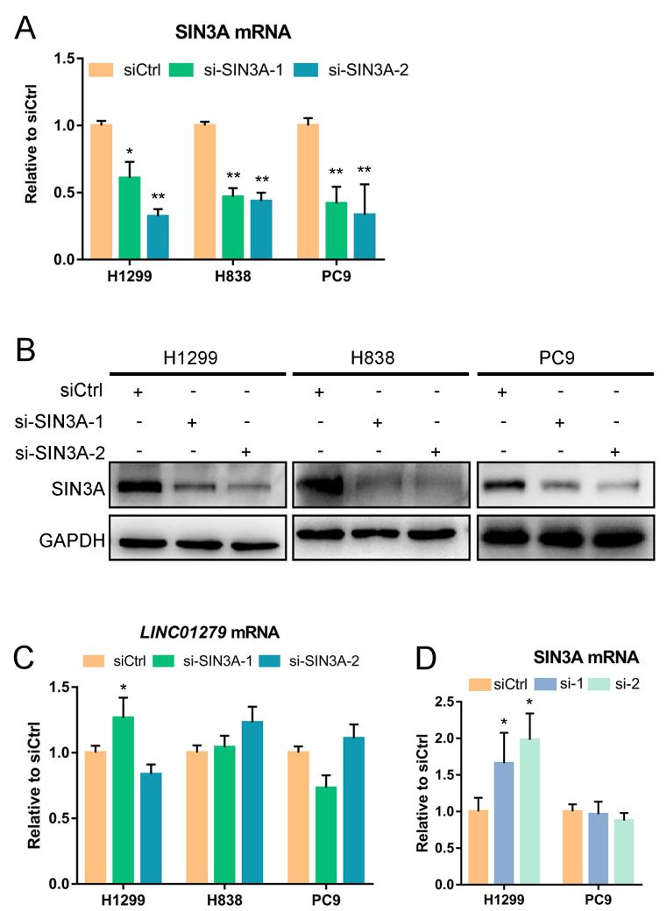
Supplementary Figure S7. Efficiency of SIN3A knockdown. (A) RT-qPCR analyses show the efficiency of SIN3A knockdown in H1299, H838 and PC-9 cells. (B) Western blot analyses show reduced SIN3A protein levels following SIN3A knockdown in NSCLC cell lines. (C) Knockdown of SIN3A in NSCLC cell lines has no significant effects on the expression of LINC01279. (D) Knockdown of LINC01279 in H1299 and PC-9 cells does not reduce the expression of SIN3A mRNA.

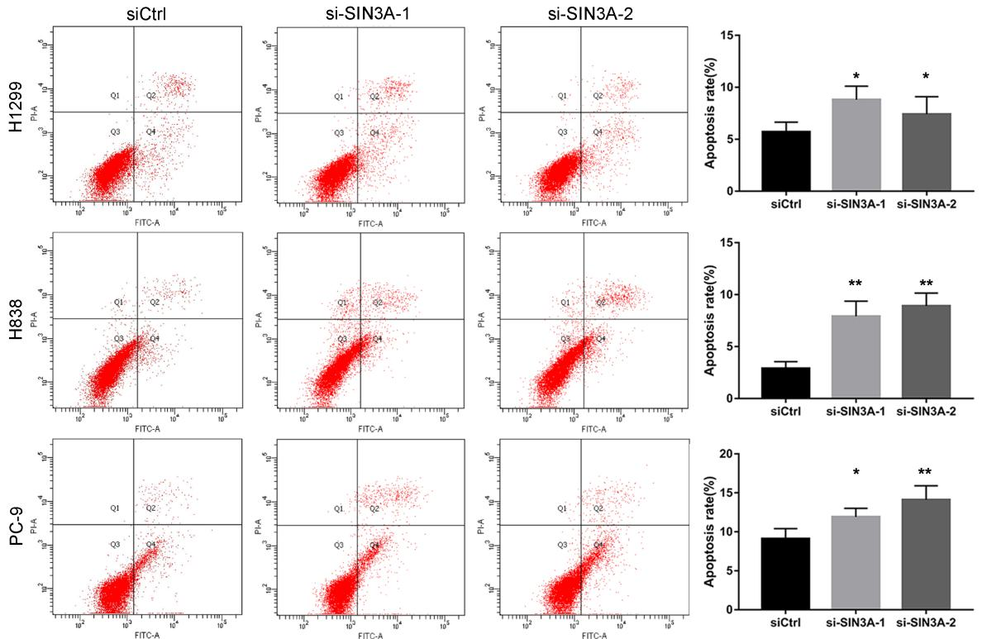

Supplementary Figure S8. Knockdown of SIN3A induces apoptosis. Flow cytometry analyses show increased apoptosis following knockdown of SIN3A in H1299, H838 and PC-9 cells. Data are the mean ± s.e.m. from three independent experiments (*, P < 0.05; **, P < 0.01).

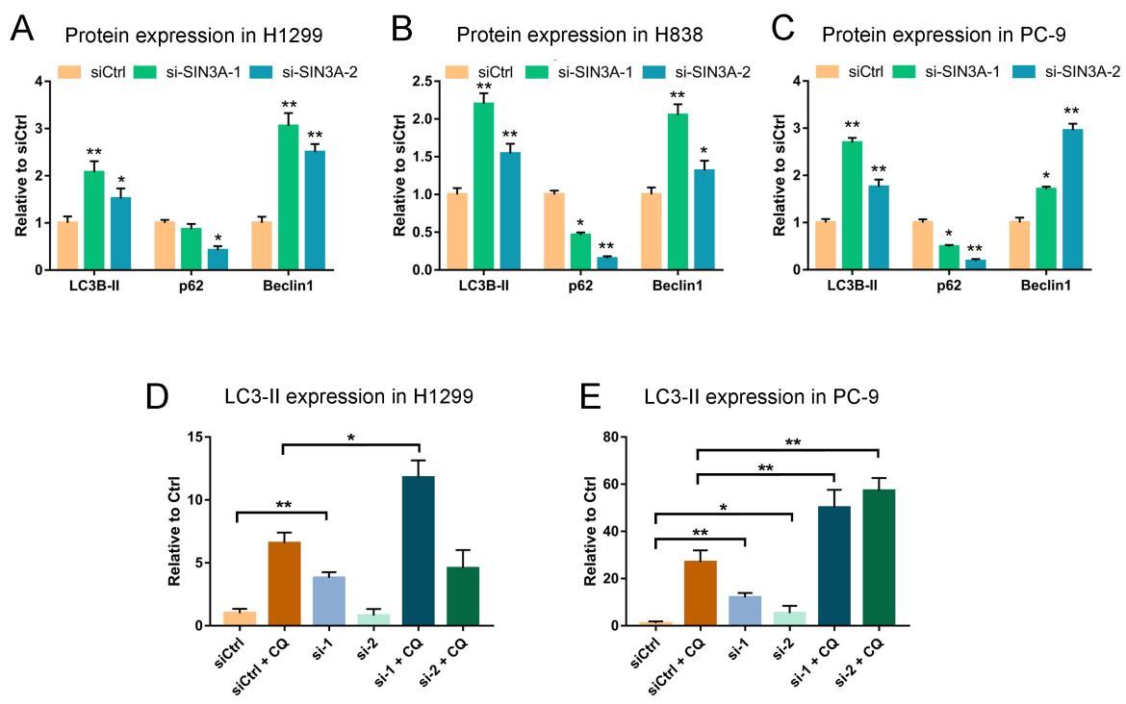
Supplementary Figure S9. Knockdown of LINC01279 and SIN3A activates autophagy. (A-C) Quantification of LC3-II, p62 and Beclin-1 protein levels from western blot results shown in Figure 7D. (D, E) Increased autophagy flux following knockdown of LINC01279. Quantification of LC3-II levels from western blot results shown in Figure 7E. Statistical data are expressed as the mean ± s.e.m. from three independent experiments (*, P < 0.05; **, P < 0.01).

Gene name | Sequences
LINC01279 #1 | 5’-GCCUGUACUUACUUGCUAATT-3’  5’-UUAGCAAGUAAGUACAGGCTT-3’
LINC01279 #2 | 5’-UGAGAAAGAUUAUGGGAUUTT-3’  5’-AAUCCCAUAAUCUUUCUCATT-3’
FAK #1 | 5’-GAACCUCGCAGUCAUUUAUTT-3’  5’-AUAAAUGACUGCGAGGUUCTT-3’
FAK #2 | 5’-CUUUGGCGGUUGCAAUUAATT-3’  5’-UUAAUUGCAACCGCCAAAGTT-3’
SIN3A #1 | 5’-GCAGUCAGCUACGGGAAUUTT-3’  5’-AAUUCCCGUAGCUGACUGCTT-3’
SIN3A #2 | 5’-CCUCAGGUCUACAAUGAUUTT-3’  5’-AAUCAUUGUAGACCUGAGGTT-3’
siRNA negative control | 5’-UUCUCCGAACGUGUCACGUTT-3’  5’-ACGUGACACGUUCGGAGAATT-3’
Supplementary Table S1. siRNA sequences used in this study.

Supplementary Table S2. PCR primer sequences used in this study.
Gene name | Primer ID | Primer Sequence (5'-3')
LINC01279 | LINC01279-F | CAGGGTTGCCACAAACCTTC
LINC01279 | LINC01279-R | ATGCCAGTATGGTAATAGGTCCA
FAK | FAK-F | AGCCGCAGAGATCACCTTTCATTG
FAK | FAK-R | ATTGCTTGAGCCTGGGAGTTTGAG
ERK | ERK-F | ATGGTGTGCTCTGCTTATGATA
ERK | ERK-R | TCTTTCATTTGCTCGATGGTTG
SIN3A | SIN3A-F | CAGCTACGTCTCAAAGAACCTA
SIN3A | SIN3A-R | GCATGAATGGTGAACATCTCTC
GAPDH | GAPDH-F | GTCAAGGCTGAGAACGGGAA
GAPDH | GAPDH-R | AAATGAGCCCCAGCCTTCTC
U1 | U1-F | ACCTGGCAGGGGAGATACCA
U1 | U1-R | GAAAGCGCGAACGCAGTCC

Supplementary Table S3. Antibodies used in this study.
PARP (Cell Signaling Technology, 9532)
p-AKT (Cell Signaling Technology, 4056)
p-ERK (Cell Signaling Technology, 4370)
ERK (Cell Signaling Technology, 9102)
GAPDH (Sigma, AB2302)
SIN3A (Cell Signaling Technology, 8056)
LC3B-II (abcam, ab192890)
FAK (Cell Signaling Technology, 3285)
p53 (abcam, ab32049)
p62 (Cell Signaling Technology, 5114)
p70 (Cell Signaling Technology, 2708)
Beclin1 (Cell Signaling Technology, 3495)
AMPK (Cell Signaling Technology, 5832)
p-AMPK (Cell Signaling Technology, 2535)
Ki-67 (Cell Signaling Technology, 9129)

